**Technology Used -** MVC, Web Api, C#, jQuery,SQL,HTML5,CSS,BootStrap.

**Version Used -** VS 2015, .Net FrameWork 4.5.2,SQL 2014, Web Api 2,BootStrap 4.

**Design Pattern -** Factory Design pattern

**Instruction to Run the application**

1. Run the Database script. Which is inside the project solution folder with name “CRUD.sql”
2. Create folder in C drive with name “Error” - This is used to log the exception in text file. You can change path from web config, if you want to give other path.
3. Run CRUD_API and CRUD_WEB project at the same time. For this right click on solution and go to properties.

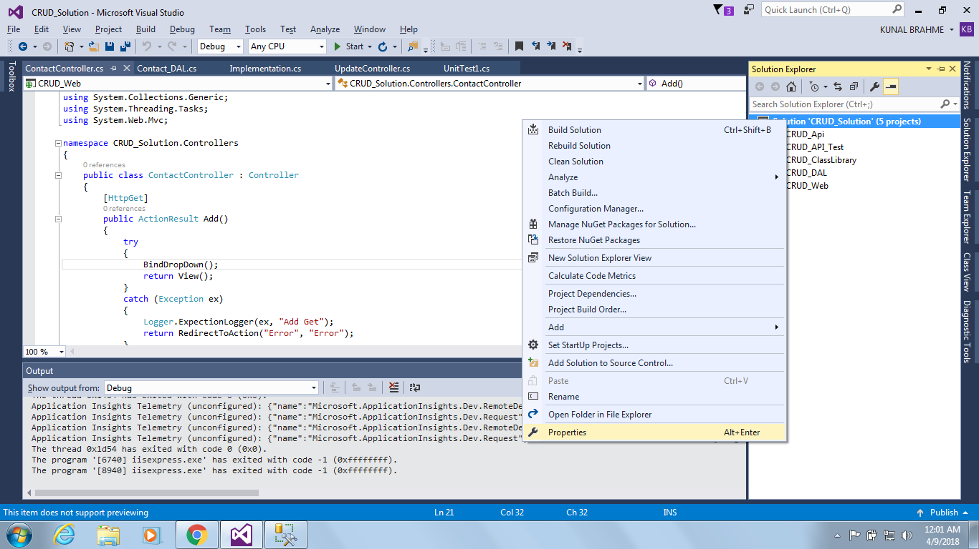

Select multiple startup projects and select Action as “Start” for CRUD_Web and CRUD_API as shown in screenshot below.

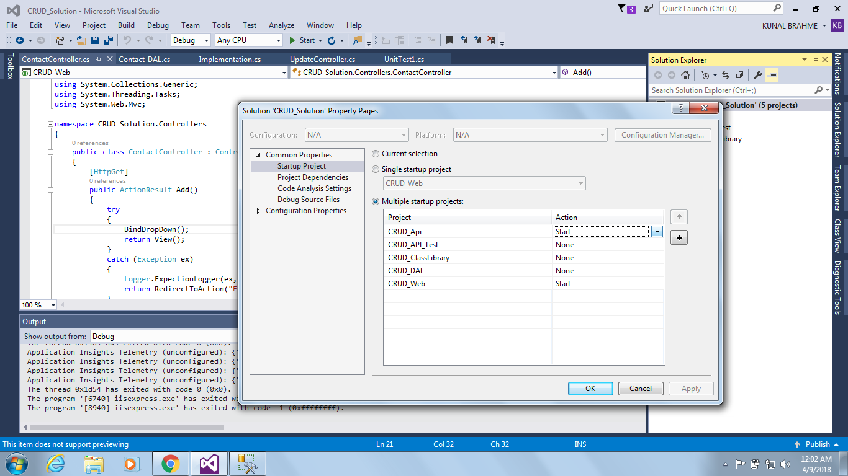

**Some Project Highlights**

1. We can use this application to add, edit, delete and update contact details.
2. Factory design pattern implemented in web api.
3. UI is developed in MVC, Business logic is handled by web api and class libraries.
4. Database interaction is handled by DAL layer which is a class library project.
5. Common classes are used, resources are shared.
6. SOLID principle are used.
7. BootStrap version 4 is used which is latest in market.
8. All the validation are applied.
9. Unit testing project is also added.

**Screens**

**Landing Page and Contact us Page are same**

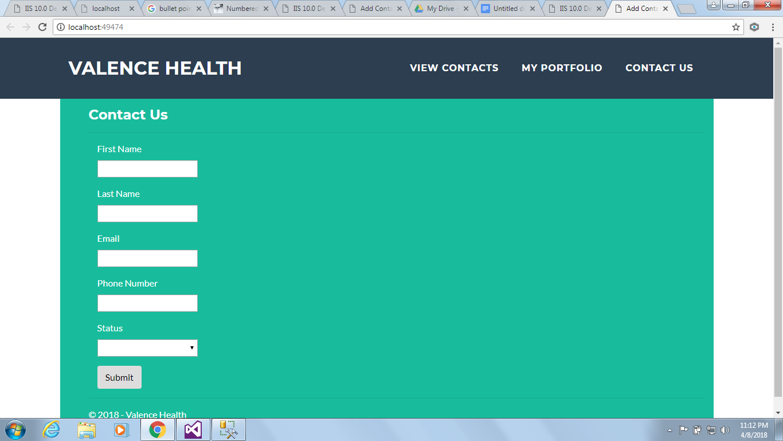

**View Contact List**

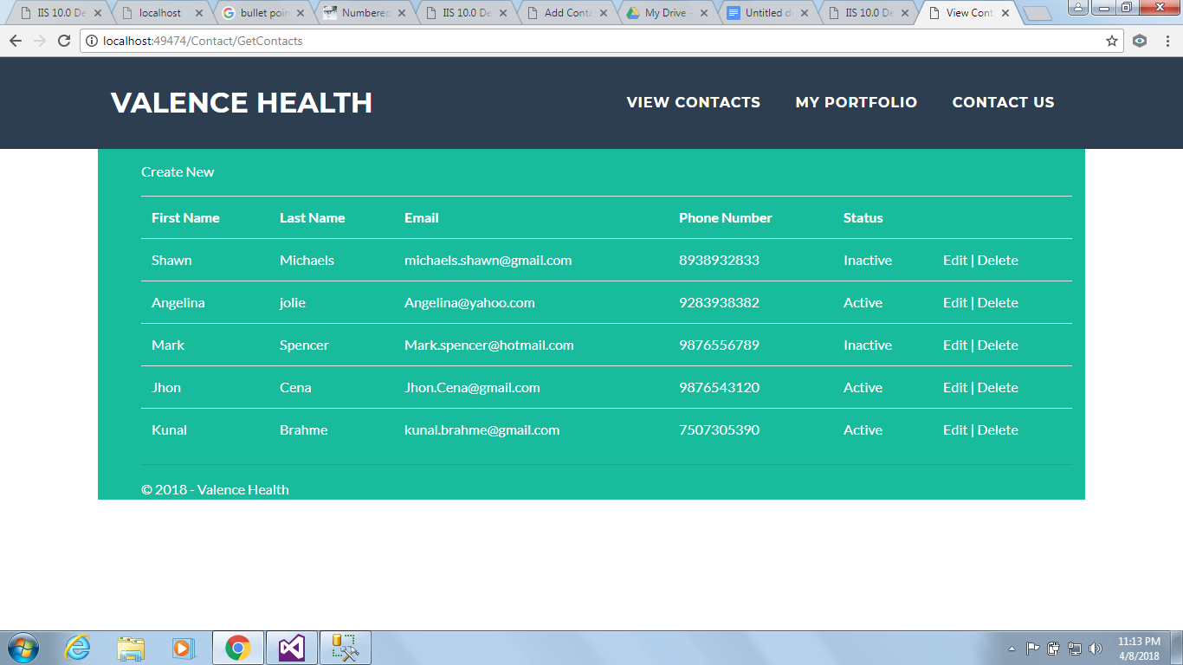

**Update records**

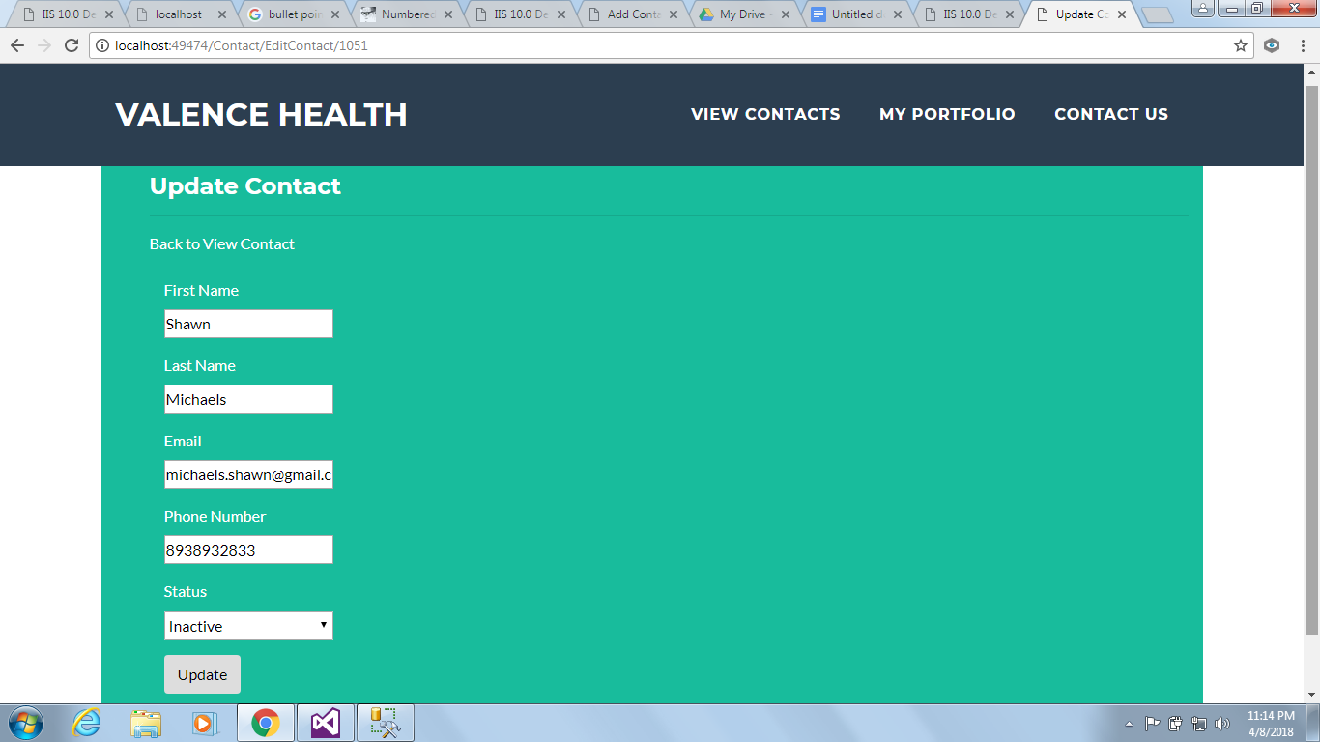

**My Portfolio**

