INTRO-

The **Taguchi method** involves reducing the variation in a process through robust design of experiments. The overall objective of the method is to produce high quality product at low cost to the manufacturer. The Taguchi method was developed by Dr. Genichi Taguchi of Japan who maintained that variation. Taguchi developed a method for designing experiments to investigate how different parameters affect the mean and variance of a process performance characteristic that defines how well the process is functioning. The experimental design proposed by Taguchi involves using orthogonal arrays to organize the parameters affecting the process and the levels at which they should be varies. Instead of having to test all possible combinations like the factorial design, the Taguchi method tests pairs of combinations.

The Taguchi arrays can be derived or looked up. Small arrays can be drawn out manually; large arrays can be derived from deterministic algorithms. Generally, arrays can be found online. The arrays are selected by the number of parameters (variables) and the number of levels (states).

**Philosophy of the Taguchi Method**

1. **Quality should be designed into a product, not inspected into it.** Quality is designed into a process through system design, parameter design, and tolerance design. Parameter design, which will be the focus of this article, is performed by determining what process parameters most affect the product and then designing them to give a specified target quality of product. Quality "inspected into" a product means that the product is produced at random quality levels and those too far from the mean are simply thrown out.
2. **Quality is best achieved by minimizing the deviation from a target. The product should be designed so that it is immune to uncontrollable environmental factors.** In other words, the signal (product quality) to noise (uncontrollable factors) ratio should be high.
3. **The cost of quality should be measured as a function of deviation from the standard and the losses should be measured system wide.** This is the concept of the loss function, or the overall loss incurred upon the customer and society from a product of poor quality. Because the producer is also a member of society and because customer dissatisfaction will discourage future patronage, this cost to customer and society will come back to the producer.

## Taguchi Loss Function

The goal of the Taguchi method is to reduce costs to the manufacturer and to society from variability in manufacturing processes. Taguchi defines the difference between the target value of the performance characteristic of a process, τ, and the measured value, y, as a loss function as shown below.

l(y)=kc(y−τ)2l(y)=kc(y−τ)2

The constant, *kc*, in the loss function can be determined by considering the specification limits or the acceptable interval, delta.

kc=CΔ2kc=CΔ2

The difficulty in determining *kc* is that τ and C are sometimes difficult to define.

## Determining Parameter Design Orthogonal Array

The effect of many different parameters on the performance characteristic in a condensed set of experiments can be examined by using the orthogonal array experimental design proposed by Taguchi. Once the parameters affecting a process that can be controlled have been determined, the levels at which these parameters should be varied must be determined. Determining what levels of a variable to test requires an in-depth understanding of the process, including the minimum, maximum, and current value of the parameter. If the difference between the minimum and maximum value of a parameter is large, the values being tested can be further apart or more values can be tested. If the range of a parameter is small, then less values can be tested or the values tested can be closer together.

Knowing the number of parameters and the number of levels, the proper orthogonal array can be selected. Using the array selector table shown below

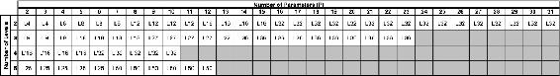

## Analyzing Experimental Data

Once the experimental design has been determined and the trials have been carried out, the measured performance characteristic from each trial can be used to analyze the relative effect of the different parameters. To demonstrate the data analysis procedure, the following L9 array will be used, but the principles can be transferred to any type of array.

it can be seen that any number of repeated observations (trials) may be used. Ti,j represents the different trials with i = experiment number and j = trial number.

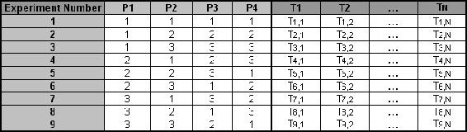

To determine the effect each variable has on the output, the signal-to-noise ratio, or the SN number, needs to be calculated for each experiment conducted. The calculation of the SN for the first experiment in the array above is shown below for the case of a specific target value of the performance characteristic. In the equations below, yi is the mean value and si is the variance. yi is the value of the performance characteristic for a given experiment.

SN_{i}}=10\log\frac{\bar{y_{i}}^2}{{s_{i}}^2}

SNi=10logy¯2is2i

SNi=10log⁡y¯i2si2

where

y¯i=1Ni∑u=1Niyi,uy¯i=1Ni∑u=1Niyi,u

s2i=1Ni−1∑u=1Ni(yi,u−y¯i)

si2=1/Ni−1∑u=1Ni(yi,u−y¯i)

and

* i is the experimental number,
* u is the trial number, and
* Ni is the numb er of trials for experiment i

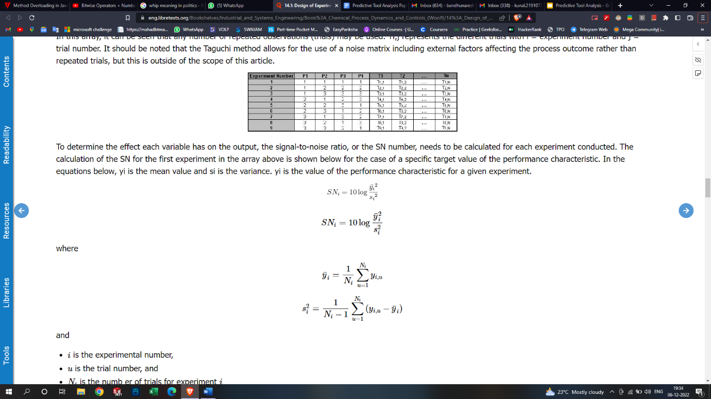

## Advantages and Disadvantages

An advantage of the Taguchi method is that it emphasizes a mean performance characteristic value close to the target value rather than a value within certain specification limits, thus improving the product quality. Additionally, Taguchi's method for experimental design is straightforward and easy to apply to many engineering situations, making it a powerful yet simple tool. It can be used to quickly narrow down the scope of a research project or to identify problems in a manufacturing process from data already in existence. Also, the Taguchi method allows for the analysis of many different parameters without a prohibitively high amount of experimentation

The main disadvantage of the Taguchi method is that the results obtained are only relative and do not exactly indicate what parameter has the highest effect on the performance characteristic value. Also, since orthogonal arrays do not test all variable combinations, this method should not be used with all relationships between all variables are needed. The Taguchi method has been criticized in the literature for difficulty in accounting for interactions between parameters. Another limitation is that the Taguchi methods are offline, and therefore inappropriate for a dynamically changing process such as a simulation study.

## Other Methods of Experimental Design

Two other methods for determining experimental design are factorial design and random design. For scenarios with a small number of parameters and levels (1-3) and where each variable contributes significantly, factorial design can work well to determine the specific interactions between variables

**Experimental Design #1: Factorial Design** By looking at the # variables and # states, there should be a total of 54 experiments because (3impellers)(3speeds)(3controllers)(2valves)=54. Here's a list of these 54 experiments:

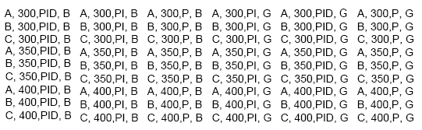

**Experimental Design #2: Taguchi Method** Since you know the # of states and variables, you can refer to the table above in this wiki and obtain the correct Taguchi array. It turns out to be a L9 array.

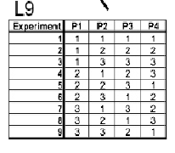

With the actual variables and states, the L9 array should look like the following:

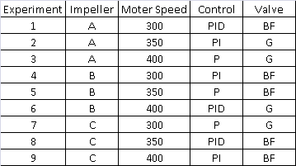

**Experimental Design #3: Random Design**

Since we do not know the number of signal recoveries we want and we don't know the probabilities of each state to happen, it will be difficult to construct a random design table. It will mostly be used for extreme large experiments.