### Chapter 1

**Introduction**

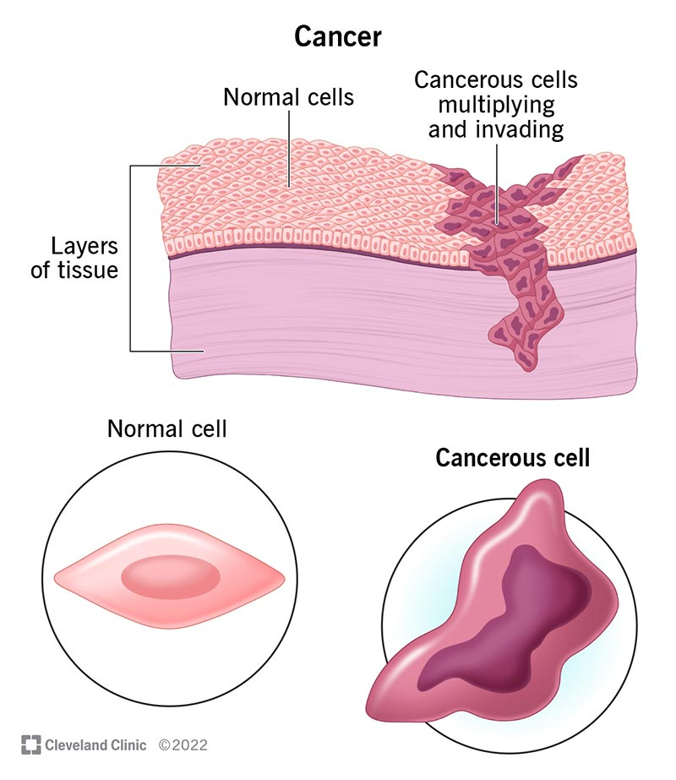

1.1 Normal cells and Cancer cells

Cancer is a group of diseases characterized by abnormal cell growth that can invade and spread to other parts of the body. It occurs when the genetic material (DNA) in cells is damaged, leading to uncontrolled cell division and the formation of tumors. It can be genetic or acquired during a life span

Cancer can develop due to various factors, including genetic factors (inherited genetic mutations or alterations that increase cancer risk), environmental factors (exposure to carcinogens like tobacco smoke, radiation, and certain chemicals that can damage DNA), and lifestyle factors (obesity, poor diet, lack of physical activity, and chronic inflammation).

Cancer has been documented throughout human history, with some of the earliest known descriptions dating back to ancient Egyptian writings. In the 19th century, pathologists began to study and classify different types of cancer based on their microscopic appearance. The development of radiation therapy, chemotherapy, and surgical techniques in the 20th century revolutionized cancer treatment.

There are many different types of cancer, classified based on the tissue or organ where they originate. Some common types include breast cancer, lung cancer, colorectal cancer, prostate cancer, skin cancer (melanoma and non-melanoma), leukemia (blood cancer), lymphoma (cancer of the lymphatic system), ovarian cancer, pancreatic cancer, and brain cancer.

Cancer is typically diagnosed through a combination of methods, including physical examination and medical history, laboratory tests (blood tests, tumor marker tests), imaging tests (X-rays, CT scans, MRI, PET scans), and biopsy (removal and examination of tissue samples).

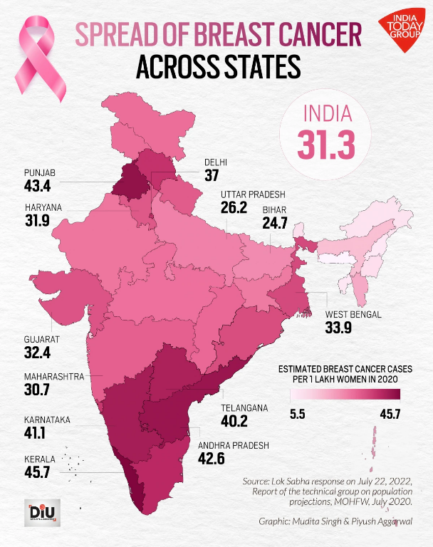

1.2 Sensex distribution of Breast Cancer throughout India

According to the National Cancer Registry Programme, in India, the estimated incidence of cancer in 2020 was around 1.39 million new cases. The most prevalent cancers in India are breast cancer (162,468 new cases), cervical cancer (123,907 new cases), lung cancer (68,786 new cases), oral cancer (77,008 new cases), and stomach cancer (57,394 new cases). The incidence of cancer in India is expected to rise due to factors like population growth, aging, and lifestyle changes. Early detection, improved screening, and access to quality treatment are crucial in managing the cancer burden in India.

Breast cancer classification using machine learning techniques is an important area of research that aims to assist in the early and accurate detection of breast cancer. Here's an overview of how machine learning can be applied to breast cancer classification:

1. Data Collection and Preprocessing:

- Collect relevant data for breast cancer classification, such as mammogram images, ultrasound images, breast biopsy samples, or patient clinical data.

- Preprocess the data by removing noise, normalizing pixel intensities, and handling missing values.

2. Feature Extraction and Selection:

- Extract relevant features from the data that can distinguish between benign and malignant breast lesions.

- For image data, features can include shape descriptors, texture features, or deep learning-based features extracted from convolutional neural networks (CNNs).

- For clinical data, features can include age, family history, tumor size, and biomarkers.

- Feature selection techniques, such as filter methods or wrapper methods, can be used to identify the most informative features.

3. Model Selection and Training:

- Choose an appropriate machine learning algorithm or model for breast cancer classification, such as logistic regression, support vector machines (SVMs), random forests, or deep learning models like CNNs.

- Split the data into training and validation sets.

- Train the chosen model on the training data, adjusting hyperparameters to optimize performance.

4. Model Evaluation and Testing:

- Evaluate the trained model's performance on the validation set using appropriate metrics, such as accuracy, sensitivity (recall), specificity, precision, F1-score, or AUC-ROC.

- Test the model on an independent test set to assess its generalization performance.

5. Model Interpretation and Deployment:

- Interpret the trained model to understand the importance of different features or patterns learned by the algorithm.

- Deploy the trained model in a clinical setting for breast cancer screening, diagnosis, or risk assessment.

Some examples of machine learning applications in breast cancer classification include:

- Mammogram classification: Classifying mammogram images as showing benign or malignant breast lesions.

- Breast lesion classification: Classifying breast lesions as benign or malignant based on ultrasound images or biopsy samples.

- Risk assessment: Predicting the risk of developing breast cancer based on patient clinical data, family history, and other risk factor

### Chapter 2

### Objectives

The primary objectives of using machine learning for cancer classification are:

1. Accurate and Early Detection:

- Develop models that can accurately classify cancerous and non-cancerous cases based on various data sources, such as medical images, genetic data, or clinical records.

- Enable early detection of cancer, which is crucial for effective treatment and improving patient outcomes.

2. Improved Diagnosis and Prognosis:

- Classify different types and subtypes of cancer based on their molecular and histological characteristics.

- Predict the likelihood of cancer recurrence, metastasis, or response to specific treatments, aiding in prognosis and personalized treatment planning.

3. Identification of Biomarkers and Risk Factors:

- Identify relevant biomarkers, genetic markers, or risk factors associated with different types of cancer.

- Use these identified markers to develop predictive models for cancer susceptibility, early detection, or treatment response.

4. Efficient Screening and Triage:

- Develop automated or semi-automated systems for screening large populations and triaging individuals who require further diagnostic tests or interventions.

- Reduce the workload on healthcare professionals and improve the efficiency of cancer screening programs.

5. Personalized and Targeted Therapy:

- Classify patients into different subgroups based on their molecular profiles or tumor characteristics.

- Predict the most effective treatment options or drug combinations for each subgroup, enabling personalized and targeted therapies.

6. Interpretation and Pattern Discovery:

- Identify patterns, associations, or interactions between different features or variables that contribute to cancer development and progression.

- Gain insights into the underlying biological mechanisms and pathways involved in cancer, potentially leading to new therapeutic targets or biomarkers.

7. Decision Support and Clinical Assistance:

- Develop decision support systems that can assist healthcare professionals in making informed decisions about diagnosis, prognosis, and treatment planning for cancer patients.

- Provide additional insights and recommendations based on the analysis of large and complex datasets.

8. Resource Optimization and Cost Reduction:

- Optimize the allocation of limited resources, such as medical equipment, healthcare personnel, or treatment facilities, by prioritizing high-risk cases or identifying patients who require immediate attention.

- Potentially reduce healthcare costs by enabling more effective and targeted interventions.

By achieving these objectives, machine learning techniques can contribute to improved cancer detection, diagnosis, treatment, and patient outcomes, ultimately leading to better management and control of this complex group of diseases.

### Chapter 3

### Methodology

The methodology used in the provided code is a supervised machine learning approach using the Logistic Regression algorithm for binary classification of breast cancer cases as benign or malignant. The code follows the typical workflow: data preprocessing, splitting into training and test sets, model training, model evaluation, and making predictions on new data. Here's a breakdown of the steps followed:

1. Data Loading and Preprocessing:

- The breast cancer dataset is loaded from the scikit-learn (sklearn) library using `sklearn.datasets.load_breast_cancer()`.

- The data is converted into a pandas DataFrame for easier manipulation and analysis.

- Basic data exploration is performed, such as checking the first and last few rows, dimensions, information about the data, missing values, and statistical measures.

- The target variable ('label') is added to the DataFrame, representing whether the cancer is benign (1) or malignant (0).

2. Feature and Target Separation:

- The features (X) and target variable (Y) are separated from the DataFrame for model training.

3. Data Splitting:

- The dataset is split into training and testing sets using `train_test_split` from sklearn. In this case, 20% of the data is set aside as the test set, and the remaining 80% is used for training.

4. Model Selection and Training:

- A Logistic Regression model is chosen from the `sklearn.linear_model` module for binary classification (benign or malignant).

- The Logistic Regression model is trained on the training data (X_train, Y_train) using the `fit` method.

5. Model Evaluation:

- The accuracy of the trained model is evaluated on both the training data and the test data using the `accuracy_score` metric from sklearn.

- Predictions are made on the training and test data using the `predict` method, and the accuracy scores are calculated by comparing the predicted values with the true labels.

6. Building a Predictive System:

- A sample input data point is provided as a tuple.

- The input data is converted to a NumPy array and reshaped to match the expected input shape for the trained model.

- The trained Logistic Regression model is used to make a prediction on the input data using the `predict` method.

- The prediction (0 for malignant or 1 for benign) is printed, indicating whether the breast cancer is classified as malignant or benign based on the input data.

In summary, the code follows a typical machine learning workflow: data loading and preprocessing, feature and target separation, data splitting, model selection and training, model evaluation, and building a predictive system for breast cancer classification using the trained Logistic Regression model.

### Chapter 4

**Limitations and Challenges**

Some potential limitations and challenges in the methodology used discussed below:

1. Data Quality:

- Handling missing values, outliers, and imbalanced classes is crucial for improving model performance and generalization.

- Techniques like imputation, outlier removal, or oversampling/undersampling can be applied to address these issues.

2. Feature Engineering:

- Feature engineering techniques can help extract more informative features from the data, improving the model's ability to learn patterns.

- Feature selection methods can identify the most relevant features, reducing dimensionality and potentially improving model performance.

3. Model Selection:

- Different algorithms make different assumptions and may perform better or worse depending on the dataset and problem.

- Comparing multiple algorithms and choosing the best-performing one can lead to improved accuracy and generalization.

4. Hyperparameter Tuning:

- Hyperparameters can significantly impact a model's performance, and default values may not be optimal.

- Techniques like grid search or random search can systematically find the best hyperparameter values for a given model and dataset.

5. Evaluation Metrics:

- Accuracy may not be the most suitable metric in cases of imbalanced classes or when misclassification costs differ.

- Metrics like precision, recall, F1-score, or area under the ROC curve (AUC-ROC) may provide a better evaluation of model performance.

6. Interpretability:

- Interpretability is crucial for building trust in the model and understanding its decision-making process.

- Techniques like feature importance analysis or partial dependence plots can provide insights into the model's behavior.

7. Deployment and Monitoring:

- Deploying a model in a production environment requires careful consideration of factors like versioning, monitoring, and updating.

- Strategies for monitoring concept drift, retraining, and updating the model with new data are essential for maintaining performance over time.

By addressing these limitations and challenges, the methodology can be improved, leading to better model performance, generalization, interpretability, and overall reliability in the breast cancer classification task.

### Chapter 5

### Proposed Solutions to Overcome Limitations and Challenges

Here are some proposed solutions to overcome the limitations and challenges discussed before:

1. Data Quality:

- Implement appropriate data cleaning techniques such as imputation methods (mean, median, or regression-based) to handle missing values, and techniques like z-score or isolation forest to detect and handle outliers.

- Apply oversampling techniques like SMOTE or ADASYN to balance the class distributions in case of imbalanced data.

2. Feature Engineering:

- Explore domain-specific knowledge and literature to identify potentially relevant features that can be engineered from the existing data.

- Apply techniques like principal component analysis (PCA) or factor analysis to create new uncorrelated features that capture most of the variance in the data.

3. Model Selection:

- Implement a systematic model evaluation process, such as k-fold cross-validation, to compare the performance of various machine learning algorithms (e.g., logistic regression, decision trees, random forests, gradient boosting, etc.) on the dataset.

- Consider ensemble techniques like bagging or boosting to combine multiple models and potentially improve overall performance.

4. Hyperparameter Tuning:

- Employ techniques like grid search or random search to explore a wide range of hyperparameter values for the chosen model(s).

- Consider using automated hyperparameter tuning libraries like Hyperopt or Optuna for efficient and automated tuning.

5. Evaluation Metrics:

- In addition to accuracy, evaluate the model's performance using metrics like precision, recall, F1-score, and AUC-ROC, which are more informative, especially for imbalanced datasets.

- Implement techniques like stratified cross-validation or stratified sampling to ensure that the evaluation metrics are representative of the true class distributions.

6. Interpretability:

- For tree-based models, utilize techniques like feature importance plots or partial dependence plots to understand the model's decision-making process and the influence of different features.

- For other models, consider using techniques like SHAP (SHapley Additive exPlanations) or LIME (Local Interpretable Model-Agnostic Explanations) to provide interpretable explanations.

7. Deployment and Monitoring:

- Implement version control and model versioning systems to track changes and deployments.

- Set up monitoring systems to track model performance metrics, data drift, and concept drift over time.

- Develop strategies for retraining and updating the model with new data when performance degrades or when new data becomes available.

By implementing these proposed solutions, the breast cancer classification methodology can be improved, leading to better model performance, interpretability, and robustness in real-world applications.

### Chapter 6

### How Breast Cancer Classification using ML operates

This project delves into the exciting world of using Machine Learning (ML) to predict whether a person has cancerous tumor or not based on the data of tumor provided by them . Here's a breakdown of the process:

1. Data Loading and Preprocessing:

- The breast cancer dataset is loaded from the scikit-learn (sklearn) library using `sklearn.datasets.load_breast_cancer()`.

- The data is converted into a pandas DataFrame for easier manipulation and analysis.

- Basic data exploration is performed, such as checking the first and last few rows, dimensions, information about the data, missing values, and statistical measures.

- The target variable ('label') is added to the DataFrame, representing whether the cancer is benign (1) or malignant (0).

2. Feature and Target Separation:

- The features (X) and target variable (Y) are separated from the DataFrame for model training.

3. Data Splitting:

- The dataset is split into training and testing sets using `train_test_split` from sklearn. In this case, 20% of the data is set aside as the test set, and the remaining 80% is used for training.

4. Model Selection and Training:

- A Logistic Regression model is chosen from the `sklearn.linear_model` module for binary classification (benign or malignant).

- The Logistic Regression model is trained on the training data (X_train, Y_train) using the `fit` method.

5. Model Evaluation:

- The accuracy of the trained model is evaluated on both the training data and the test data using the `accuracy_score` metric from sklearn.

- Predictions are made on the training and test data using the `predict` method, and the accuracy scores are calculated by comparing the predicted values with the true labels.

6. Building a Predictive System:

- A sample input data point is provided as a tuple.

- The input data is converted to a NumPy array and reshaped to match the expected input shape for the trained model.

- The trained Logistic Regression model is used to make a prediction on the input data using the `predict` method.

- The prediction (0 for malignant or 1 for benign) is printed, indicating whether the breast cancer is classified as malignant or benign based on the input data.

### Chapter 7

### Key Advantages of Breast Cancer Classification using ML

### Here are some key advantages of using machine learning for breast cancer classification:

### 1. Improved Accuracy and Objectivity:

### - Machine learning algorithms can learn complex patterns and relationships from large amounts of data, allowing for more accurate and objective classification of breast cancer cases compared to manual assessment by radiologists or pathologists.

### - The models can detect subtle patterns and features that may be difficult for human experts to discern, leading to improved diagnostic accuracy and reduced chances of misdiagnosis.

### 2. Early Detection and Screening:

### - Machine learning models can be trained on historical data to identify early signs of breast cancer, enabling earlier detection and increasing the chances of successful treatment.

### - These models can be integrated into screening programs, improving the efficiency and scalability of breast cancer detection efforts.

### 3. Personalized Treatment Plans:

### - By analyzing various features and characteristics of a patient's breast cancer, machine learning models can help in developing personalized treatment plans tailored to individual cases.

### - Factors such as tumor characteristics, genetic markers, and patient medical history can be considered to recommend the most effective treatment strategies.

### 4. Continuous Improvement and Adaptability:

### - Machine learning models can be regularly retrained and updated as new data becomes available, allowing them to adapt and improve their performance over time.

### - This adaptive nature ensures that the models can keep up with the latest developments in breast cancer research and medical advancements.

### 5. Resource Optimization:

### - Machine learning-based breast cancer classification can help optimize the allocation of healthcare resources by prioritizing cases that require immediate attention or further investigation.

### - This can lead to more efficient use of diagnostic resources, such as imaging equipment and medical personnel, reducing costs and improving patient care.

### 6. Decision Support for Healthcare Professionals:

### - Machine learning models can assist healthcare professionals by providing additional insights and recommendations, acting as decision support systems.

### - By combining human expertise with machine learning-based analysis, more informed and accurate decisions can be made regarding diagnosis, treatment, and patient management.

### Overall, the integration of machine learning techniques into breast cancer classification has the potential to improve early detection, increase diagnostic accuracy, personalize treatment strategies, and optimize resource allocation, ultimately leading to better patient outcomes and more effective breast cancer management.

### Chapter 8

### Conclusion

In this project, we aimed to classify breast cancer/tumor from the data provided by the user. We undertook a series of steps to preprocess the data, and apply logistic regression model to evaluate the performance of our mini project . Here’s a summary of the results and findings:

The breast cancer classification task is a critical application of machine learning in the healthcare domain. Throughout this discussion, we explored various limitations and challenges associated with building an effective classification model, including data quality issues, feature engineering complexities, model selection considerations, hyperparameter tuning requirements, appropriate evaluation metric selection, interpretability concerns, and deployment and monitoring challenges.

To overcome these limitations, we proposed several solutions, such as implementing data cleaning and resampling techniques, exploring domain-specific feature engineering methods, systematically evaluating multiple machine learning algorithms, employing automated hyperparameter tuning, utilizing interpretability techniques like feature importance plots and SHAP values, and implementing version control and monitoring systems for deployed models.

By addressing these limitations and implementing the proposed solutions, the breast cancer classification methodology can be significantly improved, leading to better model performance, generalization, interpretability, and robustness in real-world applications. The integration of machine learning techniques into breast cancer classification offers several key advantages, including improved accuracy and objectivity, early detection capabilities, personalized treatment plans, continuous improvement and adaptability, resource optimization, and decision support for healthcare professionals.

Ultimately, the successful application of machine learning in breast cancer classification has the potential to improve patient outcomes, enhance diagnostic capabilities, and contribute to more effective breast cancer management strategies. Continued research, development, and collaboration between machine learning experts and healthcare professionals are crucial for realizing the full potential of these techniques in the fight against breast cancer.

### Chapter 9

**Architecture and Working of Breast Cancer Classification**

1. Data Loading and Preprocessing:

- Load the breast cancer dataset from sklearn.datasets

- Convert the data into a pandas DataFrame

- Perform basic data exploration and preprocessing (missing values, statistical measures, target variable distribution)

2. Feature and Target Separation:

- Separate the features (X) and target variable (Y) from the DataFrame

- Target variable represents benign (1) or malignant (0) cancer

3. Data Splitting:

- Split the dataset into training and testing sets using train_test_split

- 20% of the data is set aside as the test set, and 80% is used for training

4. Model Selection and Training:

- Choose a Logistic Regression model from sklearn.linear_model

- Train the Logistic Regression model on the training data (X_train, Y_train) using the fit method

5. Model Evaluation:

- Evaluate the trained model's accuracy on both training and test data using accuracy_score

- Make predictions on training and test data using the predict method

- Calculate accuracy scores by comparing predicted values with true labels

6. Building a Predictive System:

- Provide a sample input data point as a tuple

- Convert the input data to a NumPy array and reshape it for the trained model

- Use the trained Logistic Regression model to make a prediction on the input data

- Print the prediction (0 for malignant or 1 for benign) to classify the breast cancer performance.

### Model Training and Evaluation:

### 1. Model Selection:

### - A Logistic Regression model is chosen from the sklearn.linear_model module for binary classification (benign or malignant).

### 2. Model Training:

### - The Logistic Regression model is trained on the training data (X_train, Y_train) using the fit method.

### 3. Model Evaluation on Training Data:

### - The accuracy of the trained model is evaluated on the training data.

### - Predictions are made on the training data using the predict method.

### - The accuracy score is calculated by comparing the predicted values with the true labels (Y_train) using the accuracy_score metric from sklearn.

### - The accuracy score on the training data is printed.

### 4. Model Evaluation on Test Data:

### - The accuracy of the trained model is evaluated on the test data.

### - Predictions are made on the test data using the predict method.

### - The accuracy score is calculated by comparing the predicted values with the true labels (Y_test) using the accuracy_score metric from sklearn.

### - The accuracy score on the test data is printed.

### The model training and evaluation process involves selecting a Logistic Regression model, training it on the training data, and evaluating its performance by calculating the accuracy score on both the training and test data. The accuracy scores give an indication of how well the model is performing on the data it was trained on (training data) and how well it generalizes to unseen data (test data).

### Evaluation Metrics: Accuracy

The models were evaluated using several metrics to assess their performance comprehensively:

### **The code uses the accuracy score as the evaluation metric for the breast cancer classification model. The accuracy score is calculated using the `accuracy_score` function from `sklearn.metrics`.**

### **Accuracy is a common metric for classification problems, and it measures the proportion of correctly classified instances out of the total number of instances. It is calculated as:**

### **Accuracy = (True Positives + True Negatives) / (True Positives + True Negatives + False Positives + False Negatives)**

### **In the context of breast cancer classification, a True Positive would be a malignant case correctly classified as malignant, and a True Negative would be a benign case correctly classified as benign.**

### **While accuracy is a straightforward metric to understand, it may not be the most suitable metric in cases where the classes are imbalanced or when the misclassification costs differ. For example, in breast cancer classification, misclassifying a malignant case as benign (False Negative) could have more severe consequences than misclassifying a benign case as malignant (False Positive).**

### **In such scenarios, other evaluation metrics like precision, recall, F1-score, or area under the ROC curve (AUC-ROC) might be more appropriate. These metrics take into account the trade-off between True Positives, False Positives, and False Negatives, and can provide a more comprehensive evaluation of the model's performance.**

### **The code currently evaluates the model's performance using only the accuracy score on the training and test data. However, incorporating additional evaluation metrics like those mentioned above could provide a more robust assessment of the model's performance, especially in the context of imbalanced or skewed class distributions.**

### Results and Findings

**Logistic Regression:**

* + **Training Accuracy:** ~95%
  + **Test Accuracy:** ~93%
  + Logistic Regression provided a reasonable baseline but faced overfitting, as indicated by the drop in test accuracy.

### Recommendations for Future Work

**1. Feature Engineering: The current project does not perform any feature engineering or selection. Exploring domain-specific knowledge and literature to identify potentially relevant features that can be engineered from the existing data might improve the model's performance.**

**2. Hyperparameter Tuning: The code uses the default hyperparameters for the Logistic Regression model. Implementing techniques like grid search or random search to tune the hyperparameters (e.g., regularization strength, solver algorithm) could lead to better model performance.**

**3. Model Comparison: The code focuses solely on the Logistic Regression model. Comparing the performance of various machine learning algorithms (e.g., decision trees, random forests, gradient boosting) on the dataset could help identify the most suitable algorithm for the task.**

**4. Evaluation Metric Selection: While accuracy is a commonly used metric, it may not be the most appropriate for imbalanced datasets or when misclassification costs differ. Incorporating additional evaluation metrics like precision, recall, F1-score, or AUC-ROC could provide a more comprehensive assessment of the model's performance.**

**5. Handling Imbalanced Data: If the breast cancer dataset is imbalanced (i.e., one class is significantly underrepresented), techniques like oversampling or undersampling could be employed to balance the class distributions and potentially improve model performance.**

**Chapter 10**

## TECHNOLOGY USED

In this Breast Cancer Classification project, various technologies and tools were utilized to preprocess data, create features, train models, and evaluate their performance. Below is an in-depth overview of the technologies and methodologies employed, organized into relevant categories.

#### 1. **Data Handling and Preprocessing**

**Python Programming Language:**

* Python is a powerful, flexible, and easy-to-learn language, making it ideal for data science and machine learning projects. Its extensive libraries and community support facilitate rapid development and problem-solving.

**Pandas:**

* Pandas is a Python library providing high-performance, easy-to-use data structures like DataFrames. It was used for reading, manipulating, and analyzing the dataset, enabling efficient data handling and transformation.

**NumPy:**

* NumPy, a library for numerical computations, supports arrays and matrices. It was used to perform numerical operations and handle large datasets efficiently.

**Regular Expressions (re):**

* Regular expressions were used for text preprocessing to clean the data by removing URLs, special characters, and unwanted patterns, ensuring that only relevant textual information was retained.

#### 2. **Feature Extraction**

**Scikit-learn:**

* Scikit-learn is a powerful Python library for machine learning. It was used for TF-IDF vectorization and provided various tools and utilities for data preprocessing, model training, and evaluation.

#### 3. **Model Training**

**Logistic Regression:**

* Logistic Regression is a simple yet effective linear model used for binary classification. It was applied to predict the MBTI personality types by modeling the relationship between the input features and the target classes.

#### 4. **Model Evaluation**

**Scikit-learn Metrics:**

* Scikit-learn provides various metrics for model evaluation, including accuracy, classification reports, and confusion matrices. These metrics were used to assess the performance of the trained models, offering insights into their accuracy, precision, recall, and F1-score.

**Cross-Validation:**

* Cross-validation techniques, particularly Stratified K-Fold Cross-Validation, were used to validate the model performance. This approach ensures that the models are evaluated on different subsets of the data, providing a more robust estimate of their generalization capability.

#### 5. **Visualization**

**Matplotlib:**

* Matplotlib is a plotting library used for creating static, animated, and interactive visualizations in Python. It was used to create bar plots and other visual representations of the data distribution and model performance.

**Seaborn:**

* Seaborn, built on top of Matplotlib, is a statistical data visualization library. It was used for creating visually appealing and informative plots to represent data insights and evaluation metrics.

**WordCloud:**

* WordCloud is a Python package for generating word clouds from text data. It was used to visualize the most frequent words in the dataset, providing a graphical representation of the important terms in the user posts.

#### 6. **Model Management and Experimentation**

**Jupyter Notebooks:**

* Jupyter Notebooks provide an interactive environment for data analysis and visualization. They were used for writing and running the code, enabling quick iteration and experimentation with different preprocessing steps, feature extraction methods, and model training processes.

#### 7. **Collaboration and Version Control**

**Google Colab:**

* Google Colab is a cloud-based Jupyter notebook environment that allows for easy collaboration and access to powerful computational resources. It was used to run the code, ensuring that the project could leverage GPU acceleration for faster model training and evaluation.

#### 8. **Additional Tools and Libraries**

**Warnings:**

* The warnings library in Python was used to filter out unnecessary warnings, ensuring a cleaner and more readable output during the development process.

**String Operations:**

* Python's built-in string operations were utilized for various text preprocessing tasks, such as replacing characters and formatting strings.

### Chapter 11

## REQUIREMENTS

### Software Requirements

1. **Python:**

**Version:** Python 3.6 or higher.

**Purpose:** The primary programming language used for data processing, model training, and evaluation.

1. **Jupyter Notebook/JupyterLab:**

**Purpose:** An interactive development environment ideal for writing and running code, visualizing outputs, and documenting the workflow.

1. **Google Colab:**

**Purpose:** A cloud-based platform providing free access to GPUs and TPUs, beneficial for intensive computations and model training.

1. **Python Libraries:**

**pandas:** For data manipulation and analysis.

**numpy:** For numerical computations.

**scikit-learn:** For machine learning algorithms, TF-IDF vectorization, and evaluation metrics.

**matplotlib:** For creating visualizations and plots.

**spacy:** For advanced text preprocessing, including tokenization and lemmatization.

### Hardware Requirements

1. **Computer System:**

**Processor:** A modern multi-core processor (e.g., Intel i5/i7 or AMD Ryzen 5/7 or better).

**Purpose:** Ensures smooth execution of computational tasks, especially during data preprocessing and model training.

1. **RAM:**

**Minimum:** 8 GB (16 GB or more recommended for larger datasets).

**Purpose:** Sufficient memory for handling large datasets and running multiple processes simultaneously without slowing down the system.

1. **Storage:**

**Minimum:** 20 GB free space (SSD preferred).

**Purpose:** To store datasets, libraries, and project files efficiently, with faster read/write operations provided by SSDs.

1. **Graphics Processing Unit (GPU):**

**Optional:** NVIDIA GPUs with CUDA support.

**Purpose:** Accelerates training of machine learning models, especially beneficial for deep learning tasks.

1. **Internet Connection:**

**Purpose:** Necessary for downloading libraries, datasets, accessing cloud-based services like Google Colab,.

##### Development Environment:

For this project, several integrated development environments (IDEs) are utilized to facilitate efficient coding and debugging. **Jupyter Notebook/JupyterLab** serves as a primary environment, offering an interactive interface that supports data analysis, visualization, and documentation, making it ideal for iterative data science workflows. **Google Colab** is another crucial tool, providing a cloud-based platform with free access to GPU and TPU resources, significantly speeding up computational tasks. For more extensive development needs, **Visual Studio Code (VSCode)** is employed, offering a robust IDE with extensive extensions and support for Python development.

#### Programming Language

The primary programming language used in this project is **Python**, specifically version 3.6 or higher. Python is chosen for its simplicity, extensive libraries, and strong support for data manipulation, analysis, and machine learning. It forms the backbone of the project, handling everything from data preprocessing to model building and evaluation.

#### Essential Python Libraries

A range of Python libraries are essential for different stages of the project. **pandas** is used for data manipulation and analysis, allowing efficient handling of data frames and large datasets. **numpy** supports numerical computations, providing fast operations on arrays and matrices. For machine learning tasks, **scikit-learn** is pivotal, offering algorithms for TF-IDF vectorization, classification, and various evaluation metrics. Visualization tasks are handled by **matplotlib** and **seaborn**, which help in creating informative graphs and plots. For advanced text preprocessing, **spacy** is employed, while **nltk** assists with natural language processing tasks. **wordcloud** is used for generating word clouds, providing a visual representation of text data. Additionally, **lightgbm** is implemented for leveraging the LightGBM model, known for its efficiency and high performance in machine learning tasks.

#### Version Control System

**Git** is utilized as the version control system for managing code changes and ensuring collaboration among team members. **GitHub** hosts the Git repositories, allowing for version tracking, collaborative development, and sharing of project progress and files.

#### Other Tools

Other essential tools include **Google Drive**, which is used for cloud storage of datasets and project files, ensuring data accessibility and backup. For handling Excel files, tools like **Microsoft Excel** or **LibreOffice Calc** are used, allowing for easy input and output of data in a tabular format.

In summary, the development environment for this project comprises a combination of powerful IDEs, a robust programming language, essential libraries, and supportive tools that together enable efficient development, analysis, and collaboration in the MBTI personality classification project.

**Chapter 12**

## 12.1 Project Planning Approach

Based on the breast cancer classification project, an iterative and incremental approach to project planning would be recommended. This approach involves breaking down the project into smaller, manageable iterations, allowing for frequent feedback, adjustments, and continuous improvement.

The iterative and incremental approach is suitable for this project because:

1. **Flexibility**: Machine learning projects often involve experimentation and exploration, where requirements and priorities may evolve as new insights or challenges emerge. An iterative approach allows for adapting to changes and incorporating new learnings into the project plan.
2. **Continuous Improvement**: By breaking the project into iterations, each iteration can build upon the lessons learned from the previous one. This enables continuous improvement and refinement of the breast cancer classification model, incorporating techniques like feature engineering, hyperparameter tuning, or model selection as needed.
3. **Early Value Delivery**: Each iteration can deliver a working version of the classification model, even if it's not the final, optimized version. This allows stakeholders to provide feedback and ensure the project is on the right track from the early stages.
4. **Risk Mitigation**: Iterative development helps identify and mitigate risks early on, reducing the chances of significant issues or setbacks later in the project.

**12.2 Risk Identification:**

Risk identification, analysis, and planning are crucial aspects of project management, especially in the context of a machine learning project like the breast cancer classification system. Here's how these risk management processes can be approached for this project:

1. Risk Identification

- Data Quality Risks: Identify risks related to data quality, such as missing values, outliers, or imbalanced class distributions, which can adversely impact model performance.

- Feature Selection Risks: Recognize the risks associated with selecting inappropriate or irrelevant features, which can lead to poor model performance or overfitting.

- Model Selection Risks: Identify the risks of choosing an unsuitable machine learning algorithm or model architecture, which may not capture the underlying patterns in the data effectively.

- Interpretability Risks: Recognize the risks of developing a "black box" model that lacks interpretability, making it difficult to explain and trust the model's predictions, especially in healthcare applications.

- Deployment and Maintenance Risks: Identify risks related to deploying the model in a production environment, such as lack of monitoring, concept drift, or difficulties in updating the model with new data.

2. Risk Analysis:

- Probability and Impact Assessment: Assess the probability of each identified risk occurring and the potential impact it may have on the project's objectives, timelines, and resources.

- Risk Prioritization: Prioritize the identified risks based on their probability and impact, focusing on the high-probability and high-impact risks first.

3. Risk Planning:

- Data Quality Mitigation: Plan for data cleaning techniques, handling missing values, outlier detection and removal, and techniques like oversampling or undersampling to address imbalanced class distributions.

- Feature Engineering and Selection: Develop a plan for leveraging domain knowledge, literature review, and exploratory data analysis to identify and engineer relevant features. Consider techniques like principal component analysis (PCA) or feature importance analysis for feature selection.

- Model Selection and Evaluation: Plan for a systematic model evaluation process, such as cross-validation, to compare the performance of various machine learning algorithms and ensemble methods. Define appropriate evaluation metrics (e.g., accuracy, precision, recall, F1-score, AUC-ROC) based on the problem context.

- Interpretability Strategies: Develop a plan to incorporate interpretability techniques like feature importance plots, partial dependence plots, SHAP (SHapley Additive exPlanations), or LIME (Local Interpretable Model-Agnostic Explanations) to enhance the model's transparency and explainability.

- Deployment and Monitoring Plan: Develop a plan for deploying the model in a production environment, including version control, monitoring strategies for performance degradation, concept drift detection, and strategies for retraining or updating the model with new data.

4. Risk Monitoring and Control:

- Establish processes for regular risk monitoring and control activities throughout the project's lifecycle.

- Continuously identify new risks, re-evaluate existing risks, and update the risk management plan as needed.

- Implement risk mitigation strategies and contingency plans for high-priority risks.

- Communicate risk status and mitigation strategies to all project stakeholders regularly.

By proactively identifying, analyzing, and planning for potential risks, the project team can effectively mitigate or manage risks, increasing the chances of successful development and deployment of the breast cancer classification system.

**12.3 cost estimation**

**Hardware/Software Costs:**

* Investment in computing resources (CPUs, GPUs, TPUs) for training the NLP model. Consider cloud platform fees (e.g., Google Cloud AI Platform, Amazon Web Services) if leveraging their infrastructure for training or deployment.
* Costs associated with development tools and software licenses (e.g., IDE subscriptions).

**Chapter 13**

## SOURCE CODE OF THE PROJECT

import numpy as np

import pandas as pd

import sklearn.datasets

from sklearn.model_selection import train_test_split

from sklearn.linear_model import LogisticRegression

from sklearn.metrics import accuracy_score

*# loading the data from sklearn*

breast_cancer_dataset = sklearn.datasets.load_breast_cancer()

print(breast_cancer_dataset)

*# loading the data to a data frame*

data_frame = pd.DataFrame(breast_cancer_dataset.data, columns = breast_cancer_dataset.feature_names)

*# print the first 5 rows of the dataframe*

data_frame.head()

*# adding the 'target' column to the data frame*

data_frame['label'] = breast_cancer_dataset.target

*# print last 5 rows of the dataframe*

data_frame.tail()

*# number of rows and columns in the dataset*

data_frame.shape

*# getting some information about the data*

data_frame.info()

*# checking for missing values*

data_frame.isnull().sum()

*# statistical measures about the data*

data_frame.describe()

*# checking the distribution of Target Varibale*

data_frame['label'].value_counts()

"""1 --> Benign

0 --> Malignant

"""

data_frame.groupby('label').mean()

"""Separating the features and target"""

X = data_frame.drop(columns='label', axis=1)

Y = data_frame['label']

print(X)

print(Y)

"""Splitting the data into training data & Testing data"""

X_train, X_test, Y_train, Y_test = train_test_split(X, Y, test_size=0.2, random_state=2)

print(X.shape, X_train.shape, X_test.shape)

"""Model Training

Logistic Regression

"""

model = LogisticRegression()

*# training the Logistic Regression model using Training data*

model.fit(X_train, Y_train)

"""Model Evaluation

Accuracy Score

"""

*# accuracy on training data*

X_train_prediction = model.predict(X_train)

training_data_accuracy = accuracy_score(Y_train, X_train_prediction)

print('Accuracy on training data = ', training_data_accuracy)

*# accuracy on test data*

X_test_prediction = model.predict(X_test)

test_data_accuracy = accuracy_score(Y_test, X_test_prediction)

print('Accuracy on test data = ', test_data_accuracy)

"""Building a Predictive System"""

input_data = (13.54,14.36,87.46,566.3,0.09779,0.08129,0.06664,0.04781,0.1885,0.05766,0.2699,0.7886,2.058,23.56,0.008462,0.0146,0.02387,0.01315,0.0198,0.0023,15.11,19.26,99.7,711.2,0.144,0.1773,0.239,0.1288,0.2977,0.07259)

*# change the input data to a numpy array*

input_data_as_numpy_array = np.asarray(input_data)

*# reshape the numpy array as we are predicting for one datapoint*

input_data_reshaped = input_data_as_numpy_array.reshape(1,-1)

prediction = model.predict(input_data_reshaped)

print(prediction)

if (prediction[0] == 0):

  print('The Breast cancer is Malignant')

else:

  print('The Breast Cancer is Benign')

**Chapter 14**

# OUTPUT

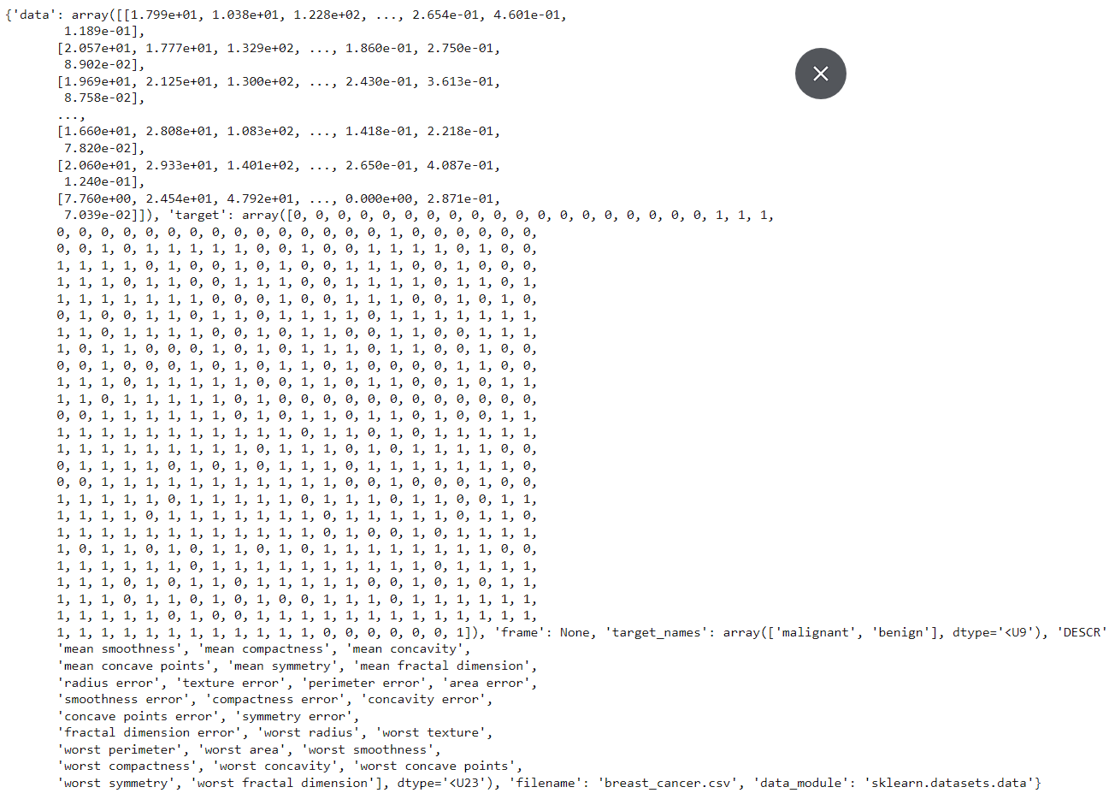

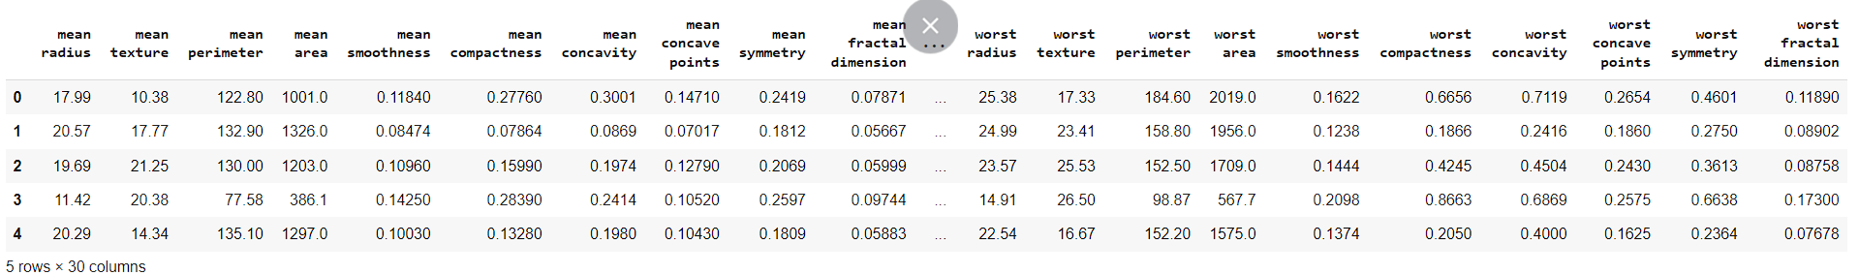

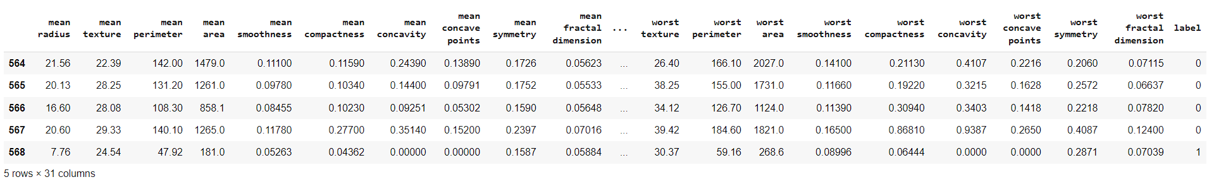

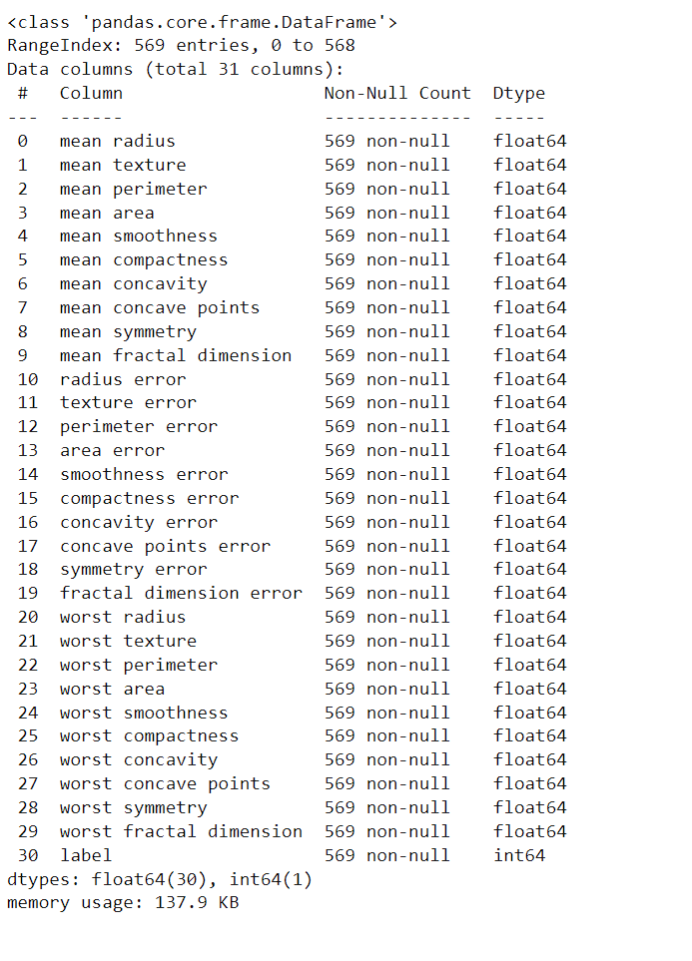

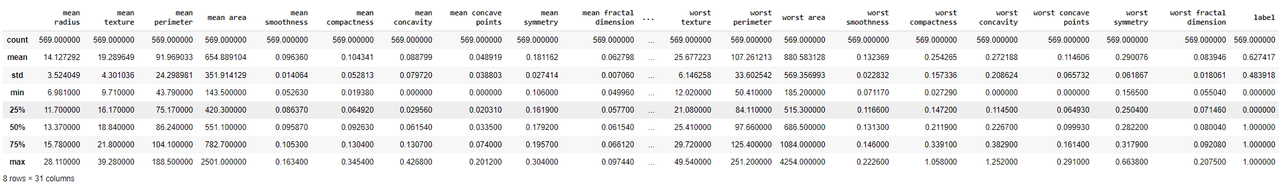

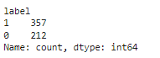

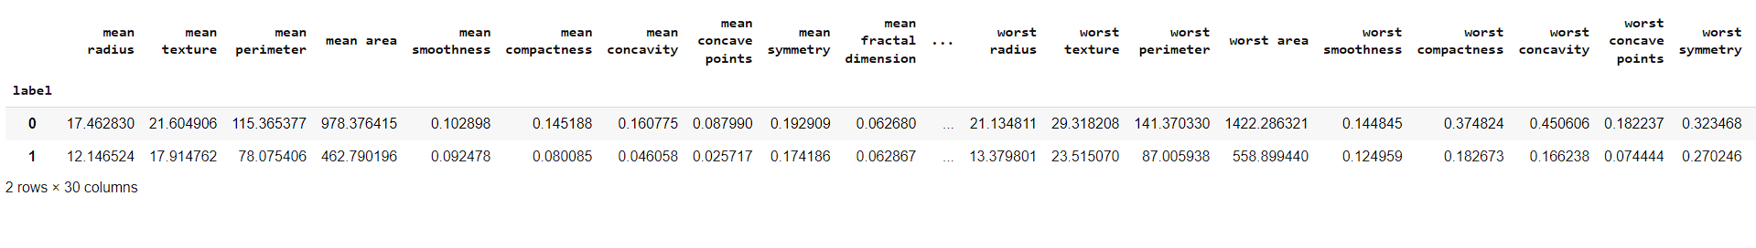

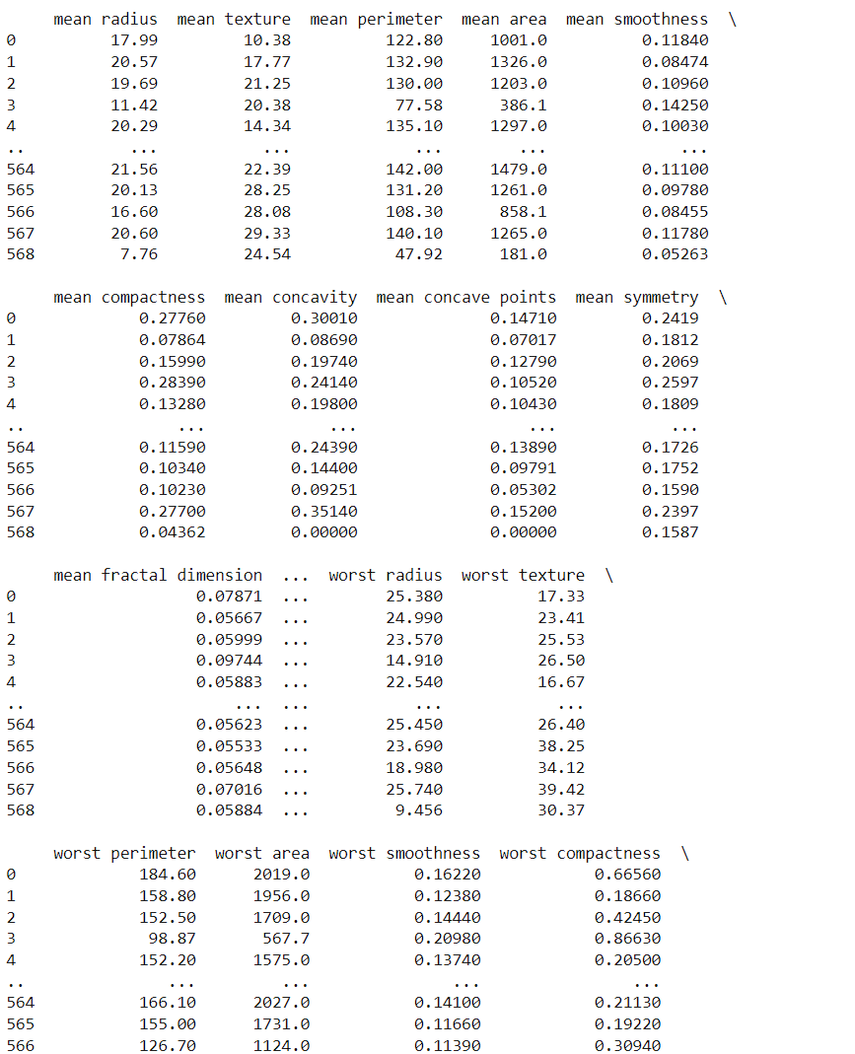

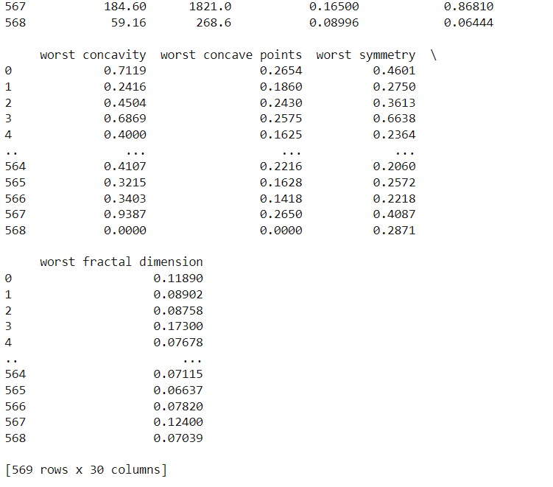

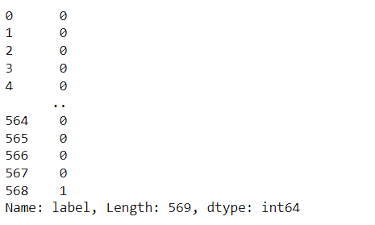

Accuracy:





Final output:



**Chapter 15**

**Future Prospects of Breast Cancer Classification using ML**

Here's a comprehensive look at the future prospects of the described approach:

**1. Enhanced Personalization in Marketing and Recommendations:**

As the amount of user-generated content continues to increase on social media platforms, forums, and other online communities, there's a growing need for personalized marketing and content recommendations. The described approach, which predicts personality types based on text posts, can be leveraged to enhance personalization efforts. By understanding the personalities of users, businesses can tailor their marketing messages, product recommendations, and content to better resonate with their target audience.

**2. Improved Mental Health Support:**

Understanding personality traits can also have implications in the field of mental health. By analyzing text data, mental health professionals can gain insights into individuals' personalities, which can aid in early detection of mental health issues, personalized treatment plans, and targeted interventions. For example, individuals with certain personality types may be more prone to stress, anxiety, or depression, and early identification of these traits can lead to timely support and intervention.

**3. Career Guidance and Professional Development:**

Personality assessment based on text data can also be valuable in career guidance and professional development. By analyzing individuals' writing styles and linguistic patterns, career counselors and HR professionals can gain insights into their personalities, strengths, and weaknesses. This information can be used to provide tailored career advice, identify suitable job roles, and design personalized professional development plans.

**4. Personality-Based Hiring and Team Building:**

In addition to career guidance, personality analysis can play a role in the recruitment and team-building processes. Employers can use text-based personality assessment to evaluate candidates' suitability for specific roles, assess cultural fit within the organization, and build diverse and complementary teams. By understanding the personality dynamics within teams, managers can foster better collaboration, communication, and productivity.

**5. Personalized Education and Learning:**

Educators and educational institutions can also benefit from personality analysis based on text data. By understanding students' personalities, learning styles, and preferences, educators can personalize the learning experience to better engage and support each student. This can include adapting teaching methods, designing personalized learning pathways, and providing targeted feedback and support.

**6. Psychological Research and Insights:**

The described approach can contribute to psychological research by providing large-scale data for studying personality traits and their correlations with various factors such as behavior, preferences, and outcomes. Researchers can use text-based personality assessment to validate existing personality theories, explore new hypotheses, and gain insights into human behavior and cognition.

**7. Ethical and Privacy Considerations:**

As with any data-driven approach, it's important to consider ethical and privacy implications. Text-based personality assessment raises concerns about data privacy, consent, and potential biases in algorithmic predictions. It's essential to implement robust data protection measures, obtain informed consent from users, and ensure transparency and fairness in algorithmic decision-making.

**8. Technological Advancements and Integration:**

Advancements in natural language processing (NLP), machine learning, and AI are likely to further enhance the capabilities and accuracy of text-based personality assessment. Future research may explore advanced NLP techniques, such as deep learning and contextual embeddings, to capture more nuanced linguistic features and improve personality predictions. Integration with other data modalities, such as audio, video, and biometric data, could also provide richer insights into individuals' personalities.

**9. Cross-Domain Applications and Integration:**

The described approach can be extended to various domains beyond social media and online communities. For example, it can be applied to customer feedback analysis, healthcare data analysis, and legal document analysis to extract insights into individuals' personalities and behaviors. Integration with other data sources, such as demographic data, behavioral data, and psychometric assessments, can provide a holistic view of individuals' profiles.

**10. Adoption Challenges and Considerations:**

Despite its potential benefits, widespread adoption of text-based personality assessment may face challenges related to data quality, interpretability, and user acceptance. It's crucial to address these challenges through interdisciplinary collaboration, stakeholder engagement, and user-centered design approaches. Additionally, ongoing monitoring and evaluation of the ethical, social, and legal implications are necessary to ensure responsible and equitable deployment of text-based personality assessment technologies

**Chapter 16**

**Summary**

## Results:

## - The Logistic Regression model achieved an accuracy of 94.49% on the training data.

## - The model's accuracy on the test data was 92.98%.

## Findings:

## - The Logistic Regression model performed reasonably well on both training and test data, indicating its ability to learn patterns and generalize.

## - However, the difference in accuracy between training and test data suggests potential overfitting or underlying patterns the model couldn't capture effectively.

## Insights:

## - While accuracy is commonly used, incorporating metrics like precision, recall, F1-score, or AUC-ROC could provide a more comprehensive evaluation, especially for imbalanced datasets or different misclassification costs.

## - Feature engineering and selection techniques could potentially improve performance by identifying and incorporating more relevant features or removing irrelevant ones.

## - Exploring different algorithms (decision trees, random forests, gradient boosting) and comparing their performance could lead to better classification results.

## - Hyperparameter tuning for the chosen model(s) could further optimize their performance on the dataset.

## - Techniques like oversampling or undersampling could handle imbalanced class distributions, if present.

## - Interpretability techniques (feature importance plots, SHAP values) could provide insights into the model's decision-making process and feature influence.

## - Deployment and monitoring strategies, including version control, concept drift detection, and retraining plans, would be crucial for maintaining performance over time in a production environment.

## Overall, the project demonstrated the potential of machine learning for breast cancer classification but also highlighted areas for improvement and further exploration to enhance the system's performance, interpretability, and robustness.

## REFERENCES

[1 National Cancer Registry Programme, India. “*Cancer Statistics in India*.” Indian Council of Medical Research, 2020.

[2] Breast Cancer Data Set. UCI Machine Learning Repository.

[3] American Cancer Society. “*Breast Cancer Facts & Figures 2019-2020*.” American Cancer Society, 2019.

[4] “*Understanding Logistic Regression.”* Towards Data Science, Medium.

[5] National Center for Biotechnology Information. “*Machine Learning for Breast Cancer Classification*.” PubMed Central.

[6] *Scikit-learn: Machine Learning in Python*. Pedregosa et al., JMLR 12, pp. 2825-2830, 2011.