EXPERMINENT-1
AIM-Implement Image Preprocessing and Edge Detection
CODE PICTURE


OUTPUT

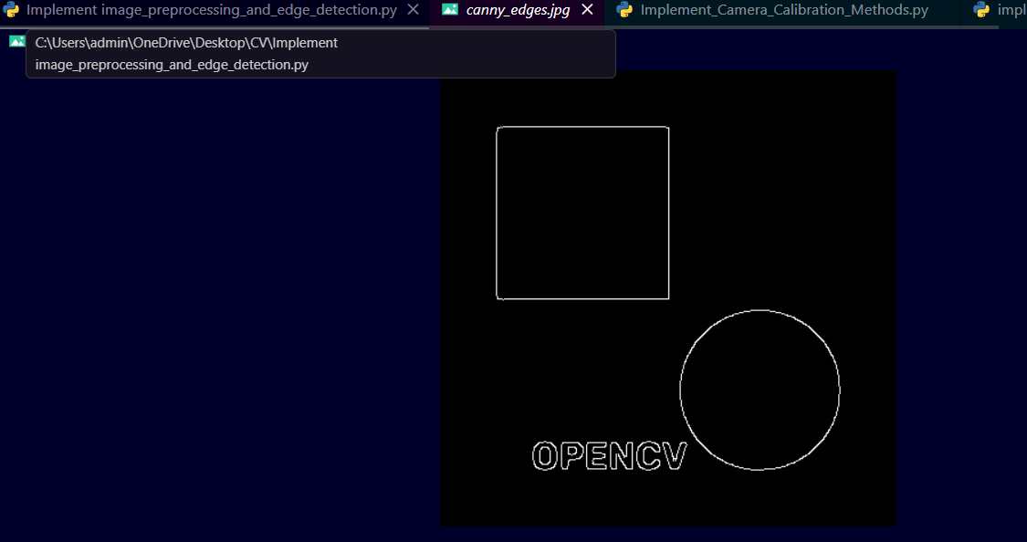


EXPERMINENT-2
AIM- Implement camera calibration methods.
CODE PICTURE

OUTPUT

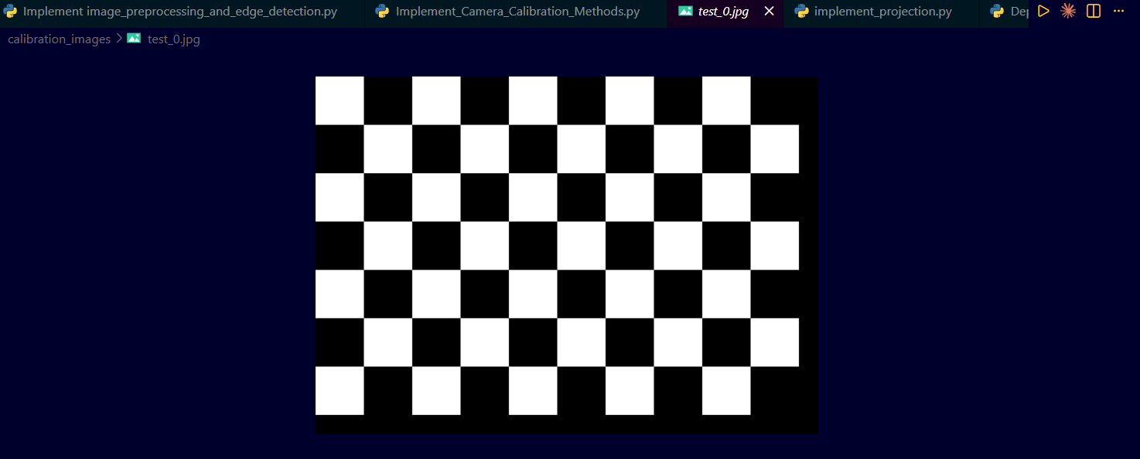


EXPERMINENT-3
AIM- Implement Projection
CODE PICTURE

OUTPUT



EXPERMINENT-4
AIM-Determine depth map from the stereo pair.

CODE PICTURE





EXPERMINENT-5
AIM- Construct 3D model from Stereo pair
CODE PICTURE
OUTPUT
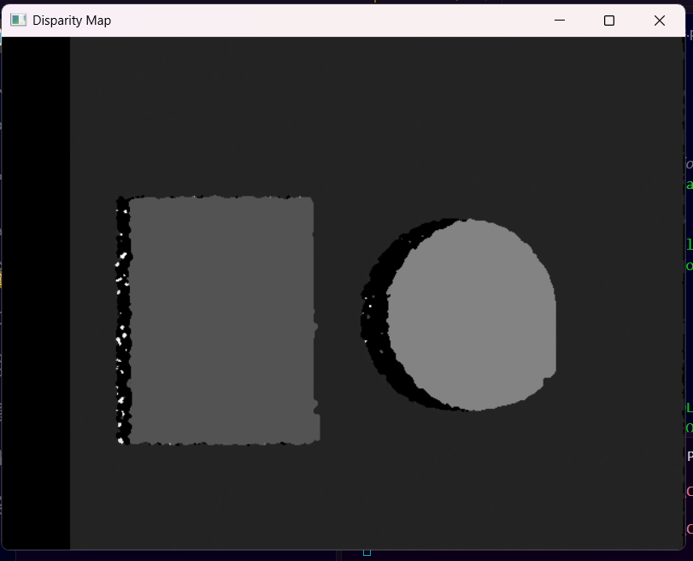

EXPERMINENT-6
AIM- Implement Segmentation methods
CODE PICTURE

OUTPUT
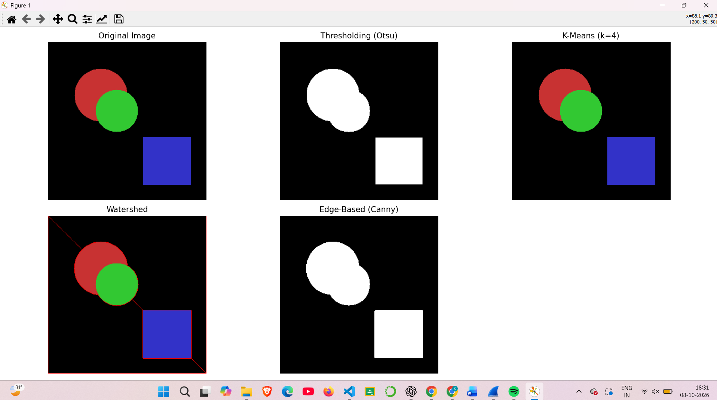
EXPERMINENT-7
AIM- Construct 3D model from defocus image
CODE PICTURE

OUTPUT
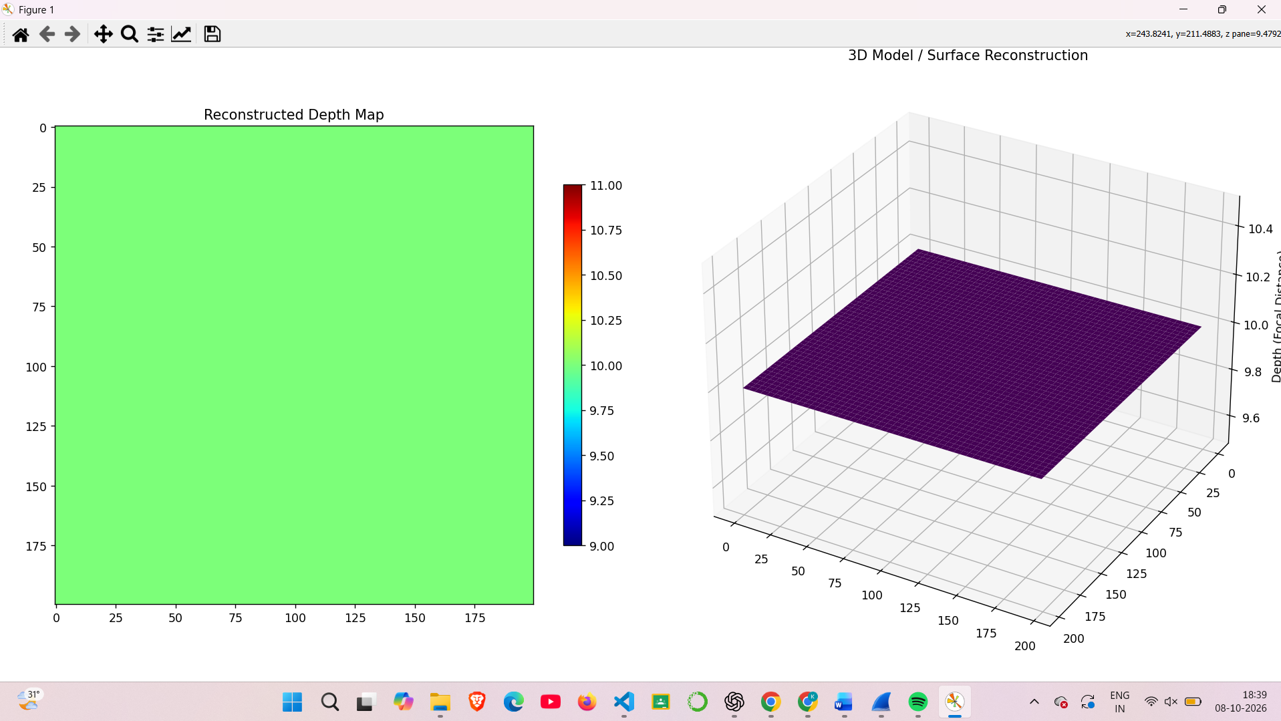
EXPERMINENT-8
AIM- Construct 3D model from Images
CODE PICTURE

OUTPUT
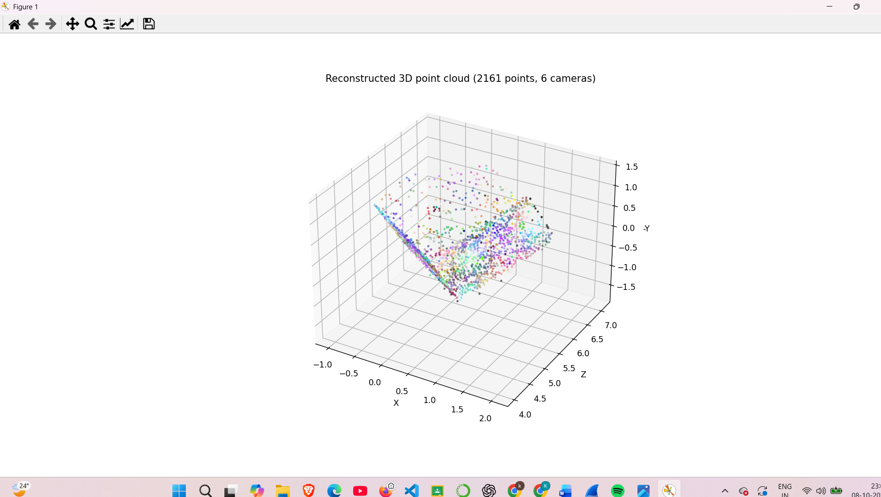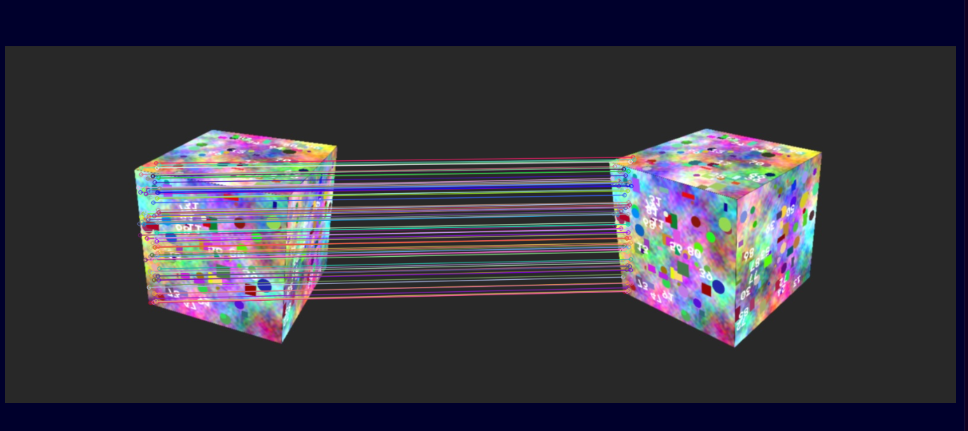

EXPERMINENT-9
AIM- Implement optical flow method
CODE PICTURE

OUTPUT

EXPERMINENT-10
AIM- Implement optical flow method
CODE PICTURE
OUTPUT
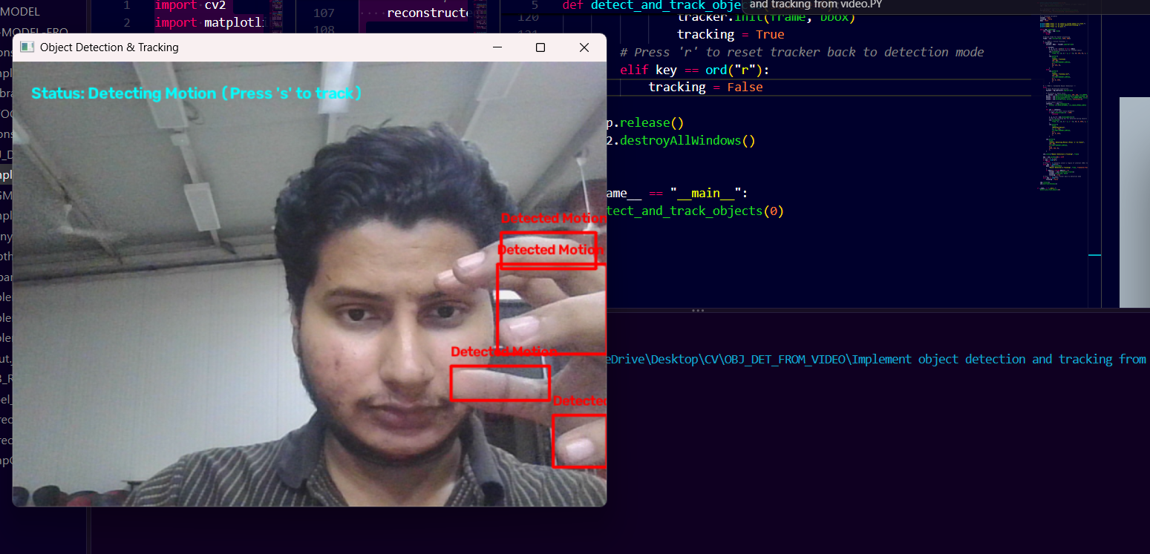
EXPERMINENT-11
AIM- Face detection and Recognition
Input
• A group/portrait image at images/faces.jpg for detection.
• A folder of labelled known-face images (one sub-folder per person) at images/known_faces/, or a webcam stream.
Theory
Face detection locates the regions of an image that contain human faces. Classical detectors such as the Haar cascade classifier use integral images and a boosted cascade of simple features, while modern detectors use CNNs. Face recognition then identifies whose face it is: each detected face is converted into a feature vector (an embedding, or LBPH/Eigenface features) and compared with the stored features of known people. The face is assigned the identity with the smallest distance, provided the distance is below a chosen threshold; otherwise it is labelled unknown.
Algorithm
• Read the input image and convert it to grayscale.
• Load the Haar cascade (or DNN) face detector and detect faces.
• Draw bounding boxes around every detected face.
• Extract features from the training images of known people and train the recognizer (e.g. LBPH).
• Predict the identity and confidence for each detected face.
• Label each face with the name and display/save the result.
CODE PICTURE


OUTPUT
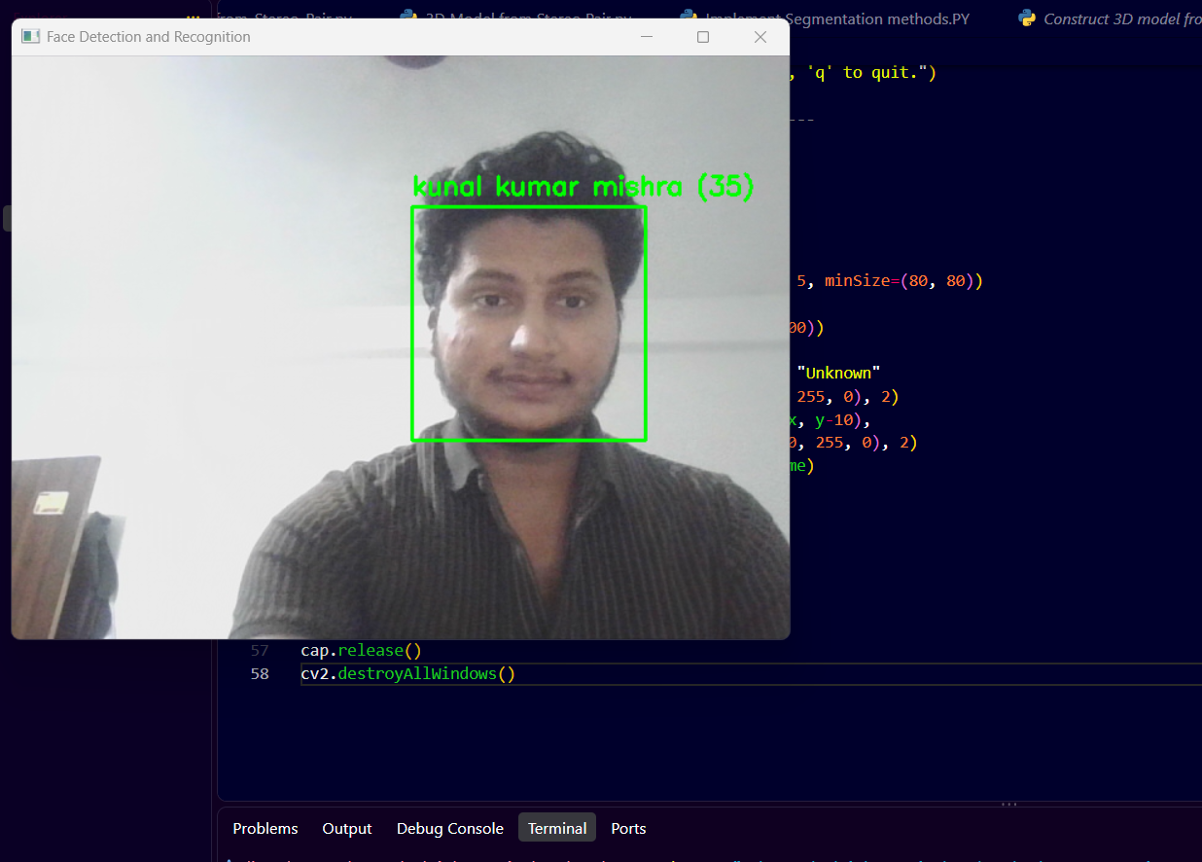

Expected Output
The original image with a bounding box around every face, labelled with the recognized person's name (or "Unknown") and a confidence value.
Observation
• Detection accuracy drops for rotated, partially occluded or very small faces.
• Recognition depends on lighting, pose and expression; more training images per person improve results.
• A strict distance threshold reduces false matches but increases the number of "Unknown" labels.
Result
Faces were detected and recognized successfully in the input image.
EXPERMINENT-12
AIM- Object detection from dynamic Background for Surveillance
Input
• A surveillance video at videos/surveillance.mp4, or a live camera feed.
Theory
In surveillance, the camera scene often contains a dynamic background (waving trees, water, changing illumination) along with genuinely moving objects. Background subtraction models each pixel as a mixture of Gaussians (MOG2) or with a K-nearest-neighbour model, and updates the model continuously so gradual background changes are absorbed. Pixels that do not fit the background model are marked as foreground. Shadows are removed by thresholding, noise is cleaned with morphological opening/closing, and connected foreground regions of sufficient area are reported as moving objects with bounding boxes.
Algorithm
• Open the video and create a background subtractor (MOG2/KNN).
• Read each frame and apply the subtractor to obtain the foreground mask.
• Threshold the mask to remove shadows.
• Apply morphological opening and dilation to remove noise and fill holes.
• Find contours and discard those smaller than a minimum area.
• Draw bounding boxes on the moving objects and display the result.
CODE PICTURE


OUTPUT
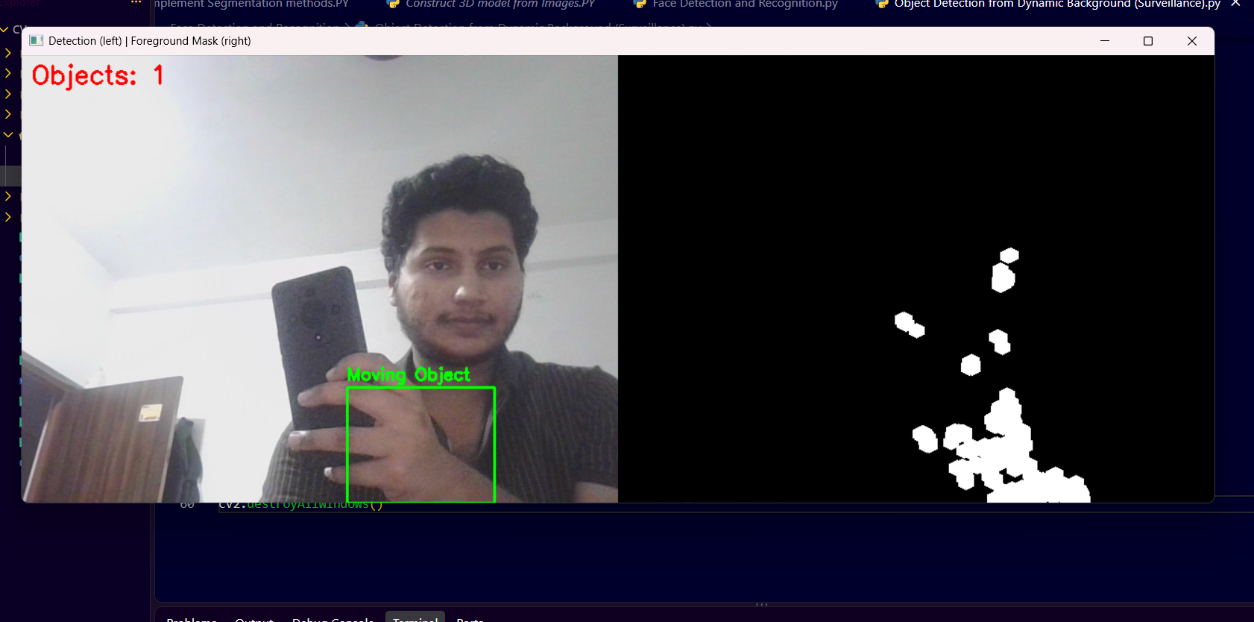

Expected Output
A video window showing the original frame with bounding boxes on moving objects, alongside the binary foreground mask in which moving objects appear white on a black background.
Observation
• The adaptive background model learns slow changes and keeps dynamic background from being detected as foreground.
• Objects that stop moving gradually merge into the background.
• Sudden illumination changes, shadows and camera shake can produce false detections.
Result
Moving objects were detected from a dynamic background using adaptive background subtraction.
EXPERMINENT-13
AIM- Content based video retrieval
Input
• A database of video clips in videos/database/.
• A query video clip or query frame at videos/query.mp4.
Theory
Content-based video retrieval (CBVR) searches a video collection using the visual content of the videos rather than text tags. A video is first divided into shots using frame-to-frame histogram differences, and a key frame is chosen from every shot. Low-level features such as colour histograms, texture (LBP) or edge histograms are extracted from the key frames and stored as feature vectors. The query is processed the same way, and its feature vector is compared with the database using a distance measure (Euclidean, chi-square or histogram correlation). The videos with the smallest distance are returned as the most similar results.
Algorithm
• Read each database video and detect shot boundaries using histogram difference.
• Select a key frame from each shot.
• Extract colour-histogram (and optionally texture) features from the key frames and store them.
• Read the query video and extract its key-frame features.
• Compute the similarity/distance between the query and every database entry.
• Rank the videos by similarity and display the top-N matches.
CODE PICTURE

OUTPUT


Expected Output
A ranked list (with similarity scores) of the database videos most similar to the query, along with the matching key frames displayed side by side.
Observation
• Colour-histogram features are fast and robust to small motion but ignore spatial layout.
• Retrieval quality depends on correct shot detection and good key-frame selection.
• Combining colour, texture and motion features improves retrieval precision.
Result
Videos similar to the query clip were retrieved using key-frame content features.
EXPERMINENT-14
AIM- Construct 3D model from single image
Input
• A single RGB image at images/single.jpg.
• A pretrained monocular depth-estimation model (e.g. MiDaS) available through PyTorch Hub, or an approximate focal length for back-projection.
Theory
A single image has no direct depth cue like stereo disparity, but depth can be inferred from monocular cues such as perspective, texture gradient, relative size, shading and occlusion. A pretrained deep network (for example MiDaS) learns these cues and predicts a relative inverse-depth map for every pixel. Each pixel (u, v) with depth Z can then be back-projected into 3D using X = (u - cx)Z/fx and Y = (v - cy)Z/fy, and the coloured points form a point cloud or a surface mesh. Without camera calibration the reconstructed model represents relative, not metric, depth.
Algorithm
• Read the input image and convert it from BGR to RGB.
• Load the pretrained depth-estimation model and its transforms.
• Predict the depth map and resize it to the image size.
• Normalize the depth map and display it.
• Back-project every pixel to 3D using the depth values and assumed camera intrinsics.
• Display the coloured point cloud/3D surface plot.
CODE PICTURE


OUTPUT
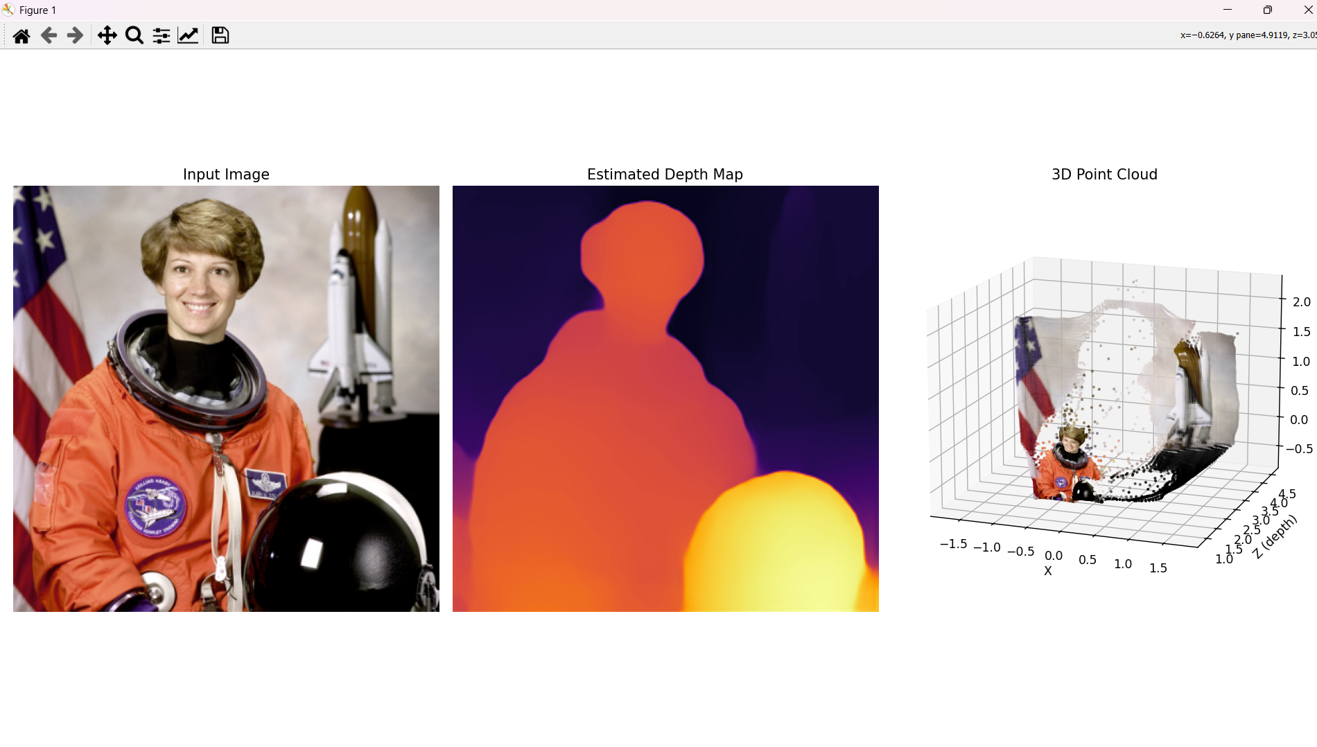

Expected Output
The input image, its estimated depth map, and a 3D point cloud/surface in which nearer regions have different depth values from distant regions.
Observation
• The network gives good relative depth, but absolute scale is ambiguous.
• Depth edges are smooth and thin structures may be blurred.
• Reflective, transparent and textureless surfaces give less reliable depth.
Result
A relative 3D model was constructed from a single image using monocular depth estimation.

