

SHREEYASH COLLEGE OF ENGINEERING & TECHNOLOGY CHHTRAPATI SAMBHAJINAGAR
Affiliated to Dr. Babasaheb Ambedkar Technological University lonere

MINI PROJECT
Academic year : 2025 - 26

TITLE OF PROJECT

PDF Merger

Programme :- Computer Science and Engineering Course :- Python Programming

Sr.No | Group Members | Enrollment No
1. | Om Ratnakar Kshirsagar | 2502112111242530
2. | Kunal Balu Dhayde | 2502112111242537
3. | Aniket Sukhadev Devkar | 2502112111242506

Guided By :-
Prof. Kiran. S. Rajput
(Assistant Professor)
Department of Computer Science & Engineering



SHREEYASH COLLEGE OF ENGG. &
TECHNOLOGY,CHHTRAPATI SAMBHAJINAGAR
(Affiliated to Dr. Babasaheb Ambedkar Technological University lonere)

CERTIFICATE

This is to certify that Mr. Kunal Balu Dhayde. Enrollment No. 2502112111242537
of Fourth Semester Degree in Computer Science and Engineering of Institute , Shreeyash College of Engineering & Technology Affiliated to Dr. Babasaheb Ambedkar Technological University lonere has completed Micro Project Satisfactorily in subject – Python Programming for the academic year 2025 – 26 .

Date: 07/05/2026
Place:- Chh. Sambhaji Nagar

Prof. Kiran. S. Rajput Dr. Ganesh wayal
GUIDE HOD

Dr.B.M.Patil
Principal

ACKNOWLEDGEMENT

I would like to express my sincere gratitude to everyone who contributed to the successful completion of this Exam Scheduling project.
First and foremost, my heartfelt thanks go to the Prof. Kiran. S. Rajput for their invaluable guidance, support, and constructive feedback throughout the development process. Their expertise and encouragement were instrumental in shaping this project.
I am also deeply grateful to the Prof. Kiran. S. Rajput for providing the resources and tools necessary to carry out this project.
Special thanks to my friends and family for their constant encouragement and patience during the development phase. Your belief in my abilities kept me motivated.

Finally, I extend my appreciation to all the users and testers who provided helpful feedback to enhance the functionality and usability of the Exam Scheduling. Your contributions helped make this project a success.

INDEX

SR.NO | CONTENTS | PAGE NO.
1 | Abstract | 1
2 | Introduction | 2
3 | Scope Of Project | 3
4 | Advantages & Disadvantages | 4
5 | Real Time Uses & Application | 5
6 | Benefits to community | 6
7 | Program | 7
8 | Output | 8
9 | Conclusion | 9

ABSTRACT

PDF Merger (Mini Project)

The PDF Merger is a Python-based mini project developed to combine multiple PDF files into a single PDF document efficiently. In many offices, schools, colleges, and organizations, users often need to merge different PDF reports, notes, forms, certificates, or documents into one file for better management and sharing. Performing this task manually is difficult and time-consuming. This project automates the entire process using Python programming.

The project is created using the PyPDF2 library in Python, which provides functions for reading, writing, and merging PDF files. The user selects multiple PDF files, and the program combines them sequentially into a single output PDF. The generated merged file maintains the original content and page order of the selected PDFs.

This project demonstrates practical implementation of:

File handling

Python libraries

Automation

User interaction

Document management

The PDF Merger project is simple, user-friendly, and useful for students, teachers, offices, and businesses. It reduces manual effort, saves time, and improves productivity.

Page No. 1

INTRODUCTION

In today’s digital world, PDF (Portable Document Format) files are widely used for sharing documents because they preserve formatting and are supported on almost every device. Many times users need to combine several PDF documents into one single file. For example:
- Students combine assignment pages
- Companies combine reports
- Teachers merge question papers
- Offices combine official documents

Manually merging PDFs using online tools may cause:
- Privacy issues
- Internet dependency
- File size limitations
- Data security risks

To solve this problem, the PDF Merger project is developed using Python. Python is a powerful programming language that supports automation and file processing. By using the PyPDF2 module, the program can easily read and merge multiple PDF files.

The project provides an easy solution where users only need to provide the names of PDF files, and the software automatically merges them into a new PDF document.
This mini project improves understanding of:
- Python programming
- External libraries
- File operations
- Automation concepts

Page No. 2

SCOPE OF PROJECT

The scope of the PDF Merger project is broad because PDF files are used in almost every field.
Scope Areas
Educational Sector
- Combining assignments
- Merging notes
- Creating project reports
- Combining question papers
Business Sector
- Merging invoices
- Combining reports
- Preparing presentations
- Documentation management
Government Offices
- Combining scanned documents
- Managing digital records
- Creating official document sets
Personal Use
- Combining certificates
- Merging eBooks
- Organizing personal files
Future Enhancements
The project can be improved by adding:
- GUI interface using Tkinter
- Drag-and-drop feature
- Password-protected PDFs
- PDF splitting functionality
- Cloud storage support
- Page reordering option
The project has real-world usability and can be expanded into professional document management software.
Page No. 3

ADVANTAGES & DISADVANTAGES

Advantages

Easy to Use
The project is simple and user-friendly.
Saves Time
Multiple PDFs can be merged quickly.
Automation
Reduces manual effort.
Secure
Offline merging keeps data safe.
Lightweight
Requires very little system resources.
Cross Platform
Works on Windows, Linux, and macOS.

Disadvantages

No GUI
Basic version works in terminal only.
Limited Features
Cannot edit or rearrange pages.
Dependency
Requires external Python library.
Large File Handling
Very large PDFs may consume more memory.
Page No. 4

REAL TIME USES & APPLICATION

Real-Time Applications of PDF Merger
Schools and Colleges
- Combining assignments
- Merging notes and study material
Offices
- Preparing reports
- Combining invoices and bills

Banking Sector
- Combining customer documents
- Generating account reports

Hospitals
- Managing patient records
- Combining medical reports

Government Sector
- Maintaining official digital records

Publishing Industry
- Combining eBook chapters
- Creating magazines and journals
Page No. 5

BENEFITS TO COMMUNITY

Community Benefits of PDF Merger

Paperless Work
Promotes digital document management.

Time Saving
People can merge files instantly.

Easy Documentation
Improves organization of files.

Educational Help
Students and teachers can manage documents efficiently.

Environment Friendly
Reduces paper usage.

Cost Effective
Free and open-source implementation using Python.
The project helps individuals and organizations improve productivity and document handling.
Page No. 6

PROGRAM

from random import sample

import PyPDF2

def merge_pdfs(pdf_files, output_filename):

"""

Merges a list of PDF files into a single PDF.

Args:

pdf_files (list): A list of PDF file paths to be merged.

output_filename (str): The filename of the output merged PDF.

"""

merger = PyPDF2.PdfMerger()

try:

for filename in pdf_files:

with open(filename, 'rb') as pdf_file:

pdf_reader = PyPDF2.PdfReader(pdf_file)

merger.append(pdf_reader)

merger.write(output_filename)

print(f"File merged successfully into {output_filename}")

except Exception as e:

print(f"An error occurred: {e}")

finally:

merger.close()

pdf_files = ["1.pdf", "php.pdf", "php1.pdf"]

output_file = "merged.pdf"

merge_pdfs(pdf_files, output_file)
OUTPUT
Page No. 7

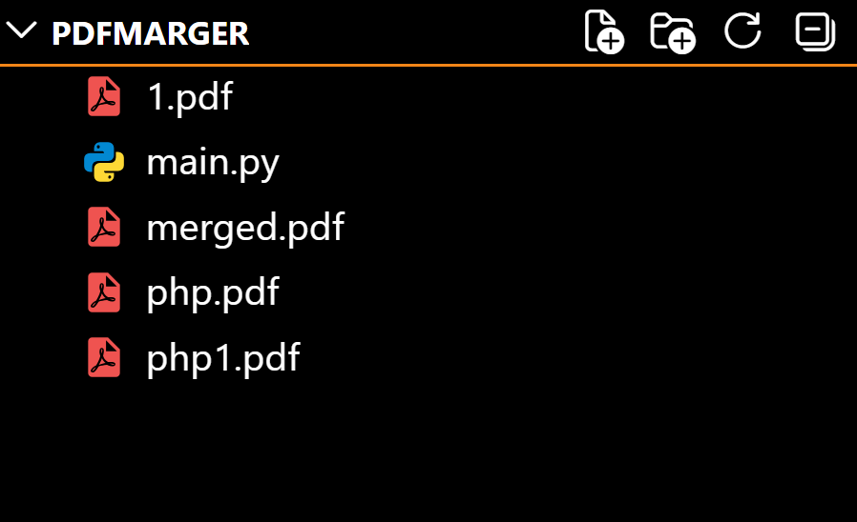

CONCLUSION
Page No. 8

The PDF Merger mini project is a simple yet highly useful Python application that automates the process of combining multiple PDF files into one document. The project demonstrates practical use of Python libraries, file handling, and automation concepts. By using the PyPDF2 library, the program performs fast and efficient PDF merging while maintaining the original document quality. The project saves time, reduces manual work, and improves document organization. This project is beneficial for students, offices, businesses, and organizations where PDF document management is important. It also provides a strong foundation for advanced projects involving PDF editing, document processing, and automation. Overall, the PDF Merger project is an effective and practical mini project that showcases the power and simplicity of Python programming in real-world applications.

Page No. 9

