**Stone Paper Scissors**

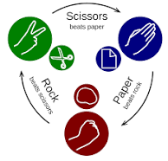

Rules -

● Paper beats Rock

● Rock beats Scissors

● Scissors beats Paper

Tested Output on 4 players when there moves are generated randomly by computer:

Since the moves are generated by computer randomly so we don’t know who is the winer among first two and how to pass the winner of first round to compete with other competetors.

So I decided to divide the matches between 3 rounds:

Round 1: player 1 & player 2 o/p- round1_winner

Round 2: round1_winner & player 3 o/p- round2_winner

Round 3: round2_winner & player 4 o/p- round3_winner

Note: round3_winner is the final winner in all cases.

Now the tested output on 10 different case example:

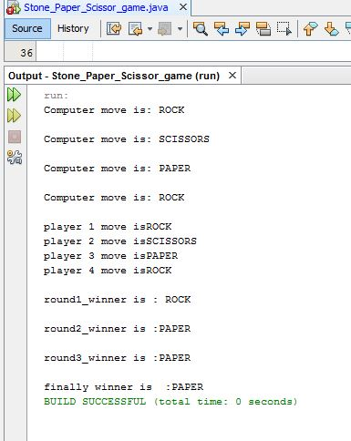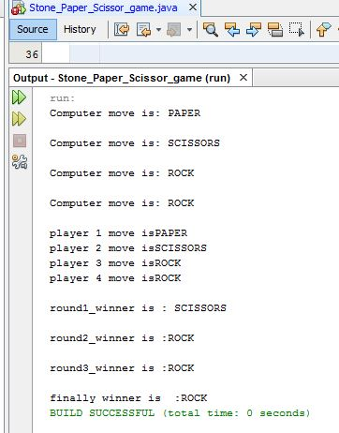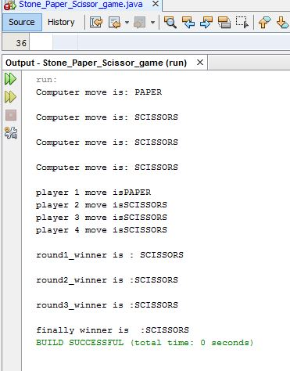

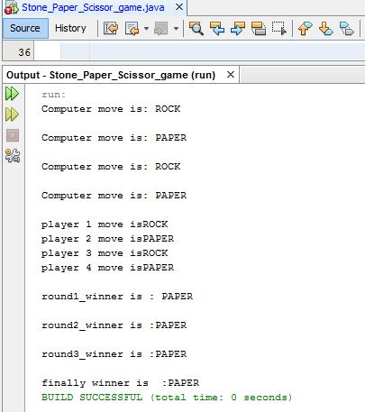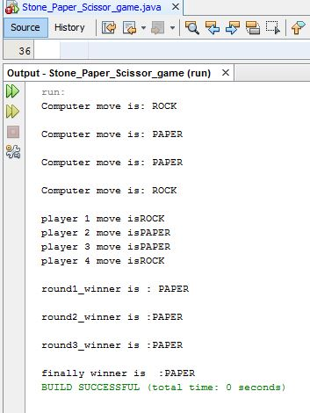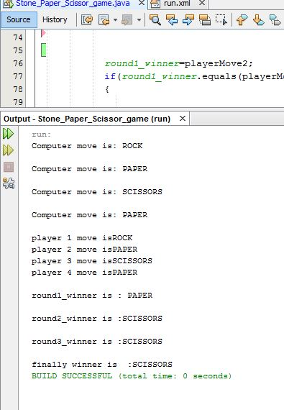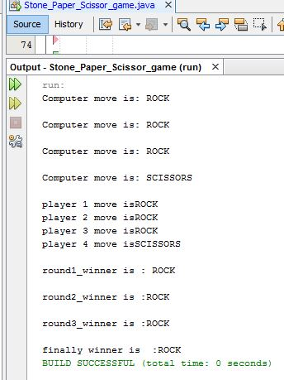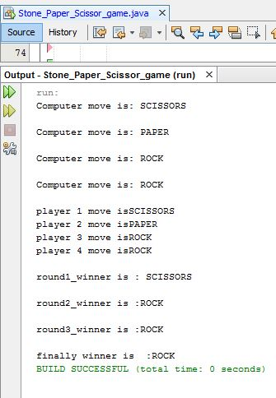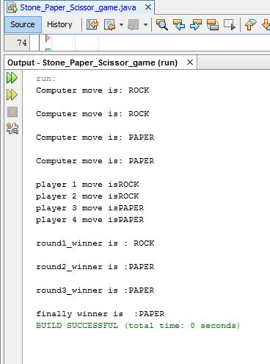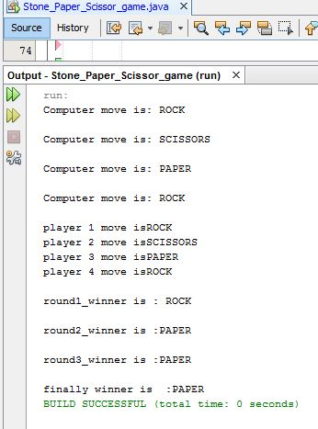

Hope you understand well & try to implement it in more efficient manner.