Look Like This

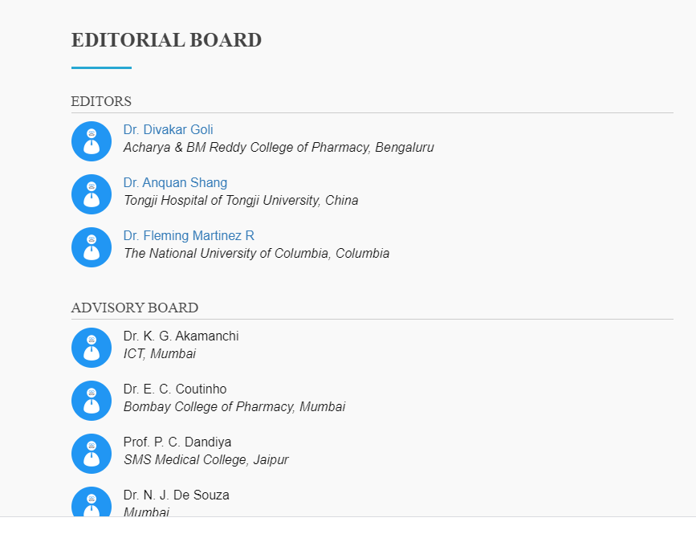

**Add Subpoints**

* Editor-In-Chief
* Managing Editor
* Editorial Board Members
* Advisory Board Members