**Lab Assignment 3**

 I. Create a servlet file which takes two text boxes for User Name and Password. Check the validity, if username and password is valid send redirect to the HTML page, otherwise post back to the current page with appropriate error message. (use database connection).

Answer:

Index.html

<!DOCTYPE html>

<html>

<head>

<meta charset=*"ISO-8859-1"*>

<title>Insert title here</title>

</head>

<body>

<form action=*"Servlet1"* method=*"post"*>

Username: <input type=*"text"* name=*"uname"*/><br>

Password: <input type=*"text"* name=*"pass"*/><br>

<input type=*"submit"* value=*"OK"*/>

</form>

</body>

</html>

Servlet1.java

**import** java.io.IOException;

**import** java.io.PrintWriter;

**import** java.sql.Connection;

**import** java.sql.DriverManager;

**import** java.sql.PreparedStatement;

**import** java.sql.ResultSet;

**import** javax.servlet.ServletException;

**import** javax.servlet.annotation.WebServlet;

**import** javax.servlet.http.HttpServlet;

**import** javax.servlet.http.HttpServletRequest;

**import** javax.servlet.http.HttpServletResponse;

/**

* Servlet implementation class Servlet1

*/

@WebServlet("/Servlet1")

**public** **class** Servlet1 **extends** HttpServlet {

**private** **static** **final** **long** ***serialVersionUID*** = 1L;

**protected** **void** doPost(HttpServletRequest request, HttpServletResponse response)

**throws** ServletException, IOException {

response.setContentType("text/html");

PrintWriter out = response.getWriter();

String name = request.getParameter("uname");

String password = request.getParameter("pwd");

**try** {

Class.*forName*("com.mysql.jdbc.Driver");

Connection conn = DriverManager.*getConnection*("jdbc:mysql://localhost:3306/java_mini_project_login", "root", "pooja_1997");

PreparedStatement ps = conn.prepareStatement("SELECT * FROM login WHERE username=?" );

ps.setString(1, name);

ResultSet rs = ps.executeQuery();

**if** (rs.next()) {

**if**(name.equals(rs.getString(2)) && password.equals(rs.getString(3))){

out.println("Welcome," + rs.getString(2));

}

**else** {

out.println("<center><b>Invalid Username or Password</b></center>");

}

}

}**catch** (Exception e) {

e.printStackTrace();

}

}

}

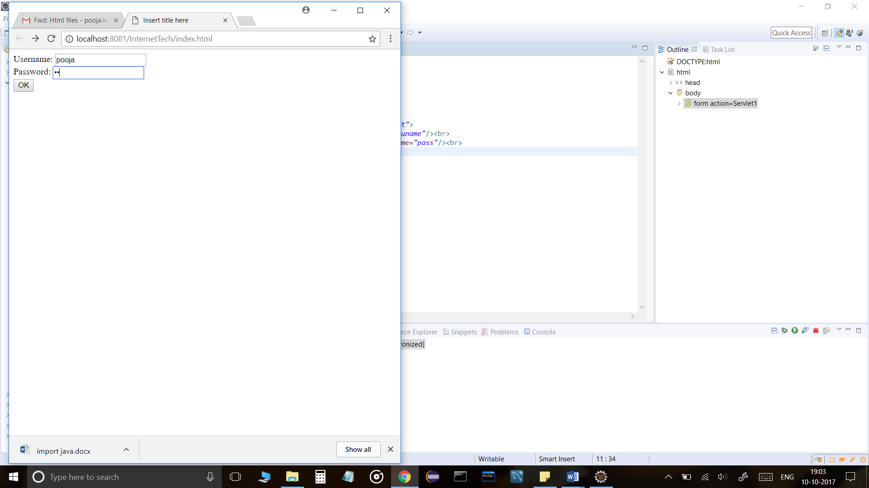

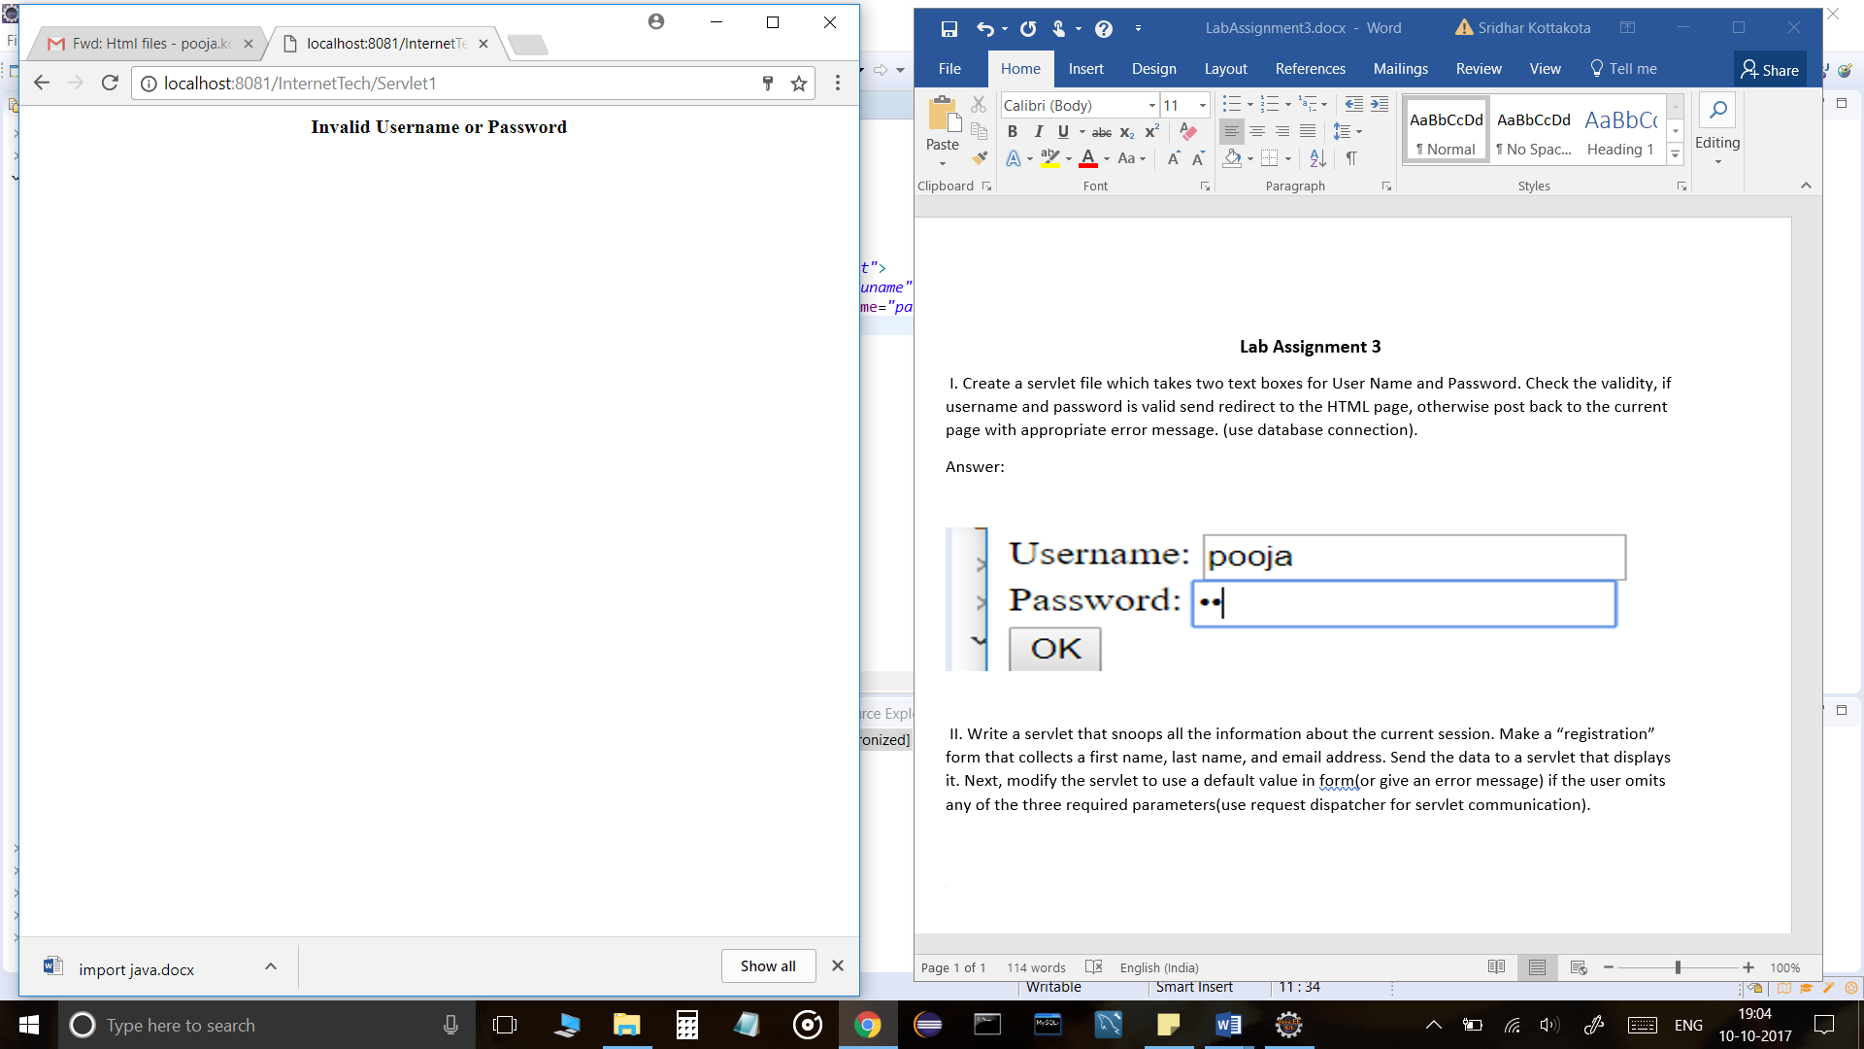

 II. Write a servlet that snoops all the information about the current session. Make a “registration” form that collects a first name, last name, and email address. Send the data to a servlet that displays it. Next, modify the servlet to use a default value in form(or give an error message) if the user omits any of the three required parameters(use request dispatcher for servlet communication).

Answer:

Index.html

<!DOCTYPE html>

<html>

<head>

<meta charset=*"ISO-8859-1"*>

<title>Insert title here</title>

</head>

<body>

<form action=*"Servlet2"* method=*"post"*>

Name:<input type=*"text"* name=*"uname"*

placeholder=*"Enter your first name..."* required=*"required"*><br>

Mobile:<input type=*"text"* name=*"mobile"*

placeholder=*"Enter your mobile..."* required=*"required"*><br>

Password:<input type=*"password"* name=*"passwd"* required=*"required"*><br>

<input type=*"submit"* name=*"submit"* value=*"Register"*><br>

</form>

</body>

</html>

Servlet2.java

**import** java.io.IOException;

**import** java.io.PrintWriter;

**import** java.sql.Connection;

**import** java.sql.DriverManager;

**import** java.sql.PreparedStatement;

**import** javax.servlet.RequestDispatcher;

**import** javax.servlet.ServletException;

**import** javax.servlet.annotation.WebServlet;

**import** javax.servlet.http.HttpServlet;

**import** javax.servlet.http.HttpServletRequest;

**import** javax.servlet.http.HttpServletResponse;

**import** javax.servlet.http.HttpSession;

/**

* Servlet implementation class Servlet2

*/

@WebServlet("/Servlet2")

**public** **class** Servlet2 **extends** HttpServlet {

**private** **static** **final** **long** ***serialVersionUID*** = 1L;

**protected** **void** doPost(HttpServletRequest request, HttpServletResponse response)

**throws** ServletException, IOException {

PrintWriter out = response.getWriter();

String name = request.getParameter("uname");

String mobile = request.getParameter("mobile");

String password = request.getParameter("passwd");

**try** {

Class.*forName*("com.mysql.jdbc.Driver");

Connection conn = DriverManager.*getConnection*("jdbc:mysql://localhost:3306/java_mini_project_login", "root", "pooja_1997");

PreparedStatement ps = conn.prepareStatement("INSERT INTO login(username,password,mobileno) VALUES(?,?,?)");

PreparedStatement ps1 = conn.prepareStatement("SELECT * FROM login");

ps.setString(1, name);

ps.setString(3, mobile);

ps.setString(2, password);

**int** i = ps.executeUpdate();

**if** (i > 1) {

HttpSession session = request.getSession();

session.setAttribute("username", name);

RequestDispatcher rd = request.getRequestDispatcher("Servlet2");

rd.forward(request, response);

}

} **catch** (Exception e) {

e.printStackTrace();

}

}

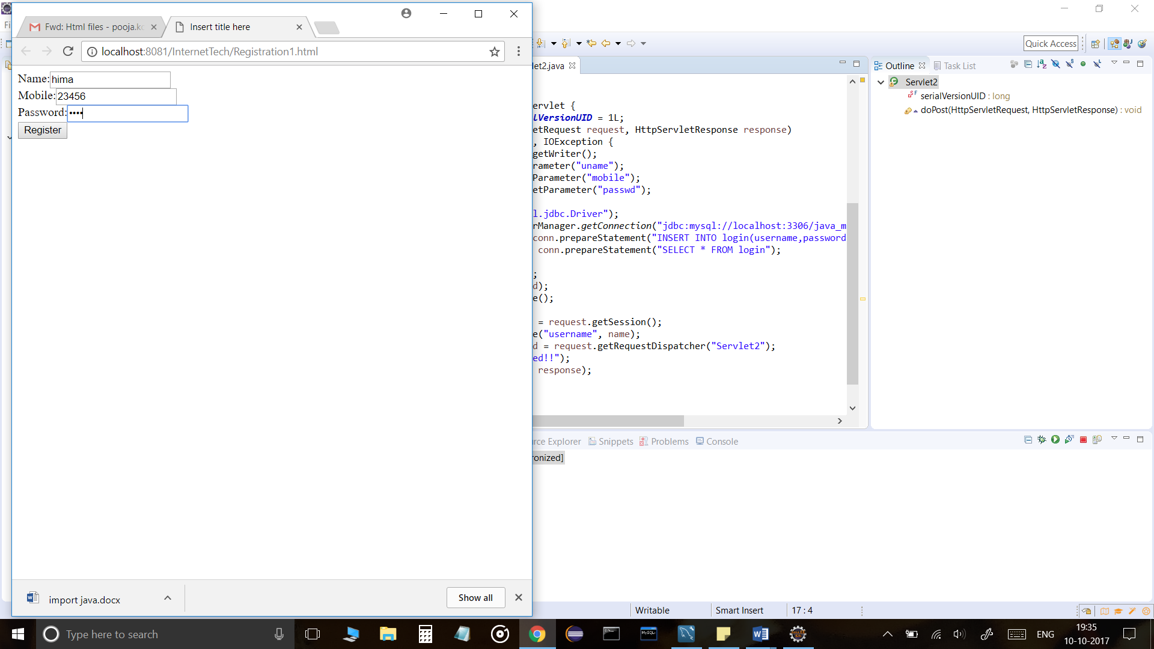

https://ci6.googleusercontent.com/proxy/RnNZfQn2o2xpggJQqefCOervMbPIci5mujDPJnvl43kv6Rtxjyh5gHN_JKVzeU-aaGz3pePFgxfoAAtZJZNx8mveVTc-11j98EfuAJVcumUenA=s0-d-e1-ft#https://ssl.gstatic.com/ui/v1/icons/mail/images/cleardot.gif