**Lab assignment 5**

1.      Write JSP Script which accepts user name and nick name from user. At first visit, display message “Hello user name” and for next successive requests, display “Hello nick name”. Use user name if visit count is odd and nick name if visit count is even. (use declaration scripting elements)

Answer:

**Index.html**

<!DOCTYPE html>

<html>

<head>

<meta charset=*"ISO-8859-1"*>

<title>Insert title here</title>

</head>

<body>

<form action=*"nickname.jsp"*>

User Name:<input type=*"text"* name=*"name"*><br>

Nick Name:<input type=*"text"* name=*"nick"*><br>

<input type=*"submit"* value=*"Submit"*>

</form>

</body>

</html>**Nickname.jsp**

<%@ page language=*"java"* contentType=*"text/html; charset=ISO-8859-1"*

pageEncoding=*"ISO-8859-1"*%>

<!DOCTYPE html PUBLIC "-//W3C//DTD HTML 4.01 Transitional//EN" "http://www.w3.org/TR/html4/loose.dtd">

<html>

<head>

<meta http-equiv=*"Content-Type"* content=*"text/html; charset=ISO-8859-1"*>

<title>Insert title here</title>

</head>

<body>

<%

String nick=request.getParameter("nick");

String uname=request.getParameter("name");

session.setAttribute("name",uname);

session.setAttribute("nick",nick);

%>

<a href=*"output.jsp"*>Output</a>

</body>

</html>**Output.jsp**

<%@ page language=*"java"* contentType=*"text/html; charset=ISO-8859-1"*

pageEncoding=*"ISO-8859-1"*%>

<!DOCTYPE html PUBLIC "-//W3C//DTD HTML 4.01 Transitional//EN" "http://www.w3.org/TR/html4/loose.dtd">

<html>

<head>

<meta http-equiv=*"Content-Type"* content=*"text/html; charset=ISO-8859-1"*>

<title>Insert title here</title>

</head>

<body>

<%!**int** visitCount=0; %>

<%

**if**(session==request.getSession(**false**))

{

**if**(visitCount%2!=0)

{

String uname= (String)session.getAttribute("name");

out.println("Hello,"+uname);

}

**else**

{

String nick=(String)session.getAttribute("nick");

out.println("Hello,"+nick);

}

visitCount++;

}

%>

</body>

</html>**Output:**

Odd count:

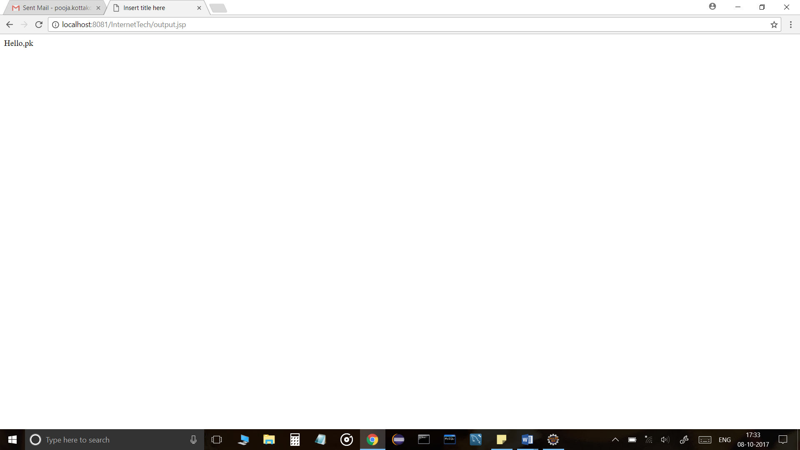

Even count: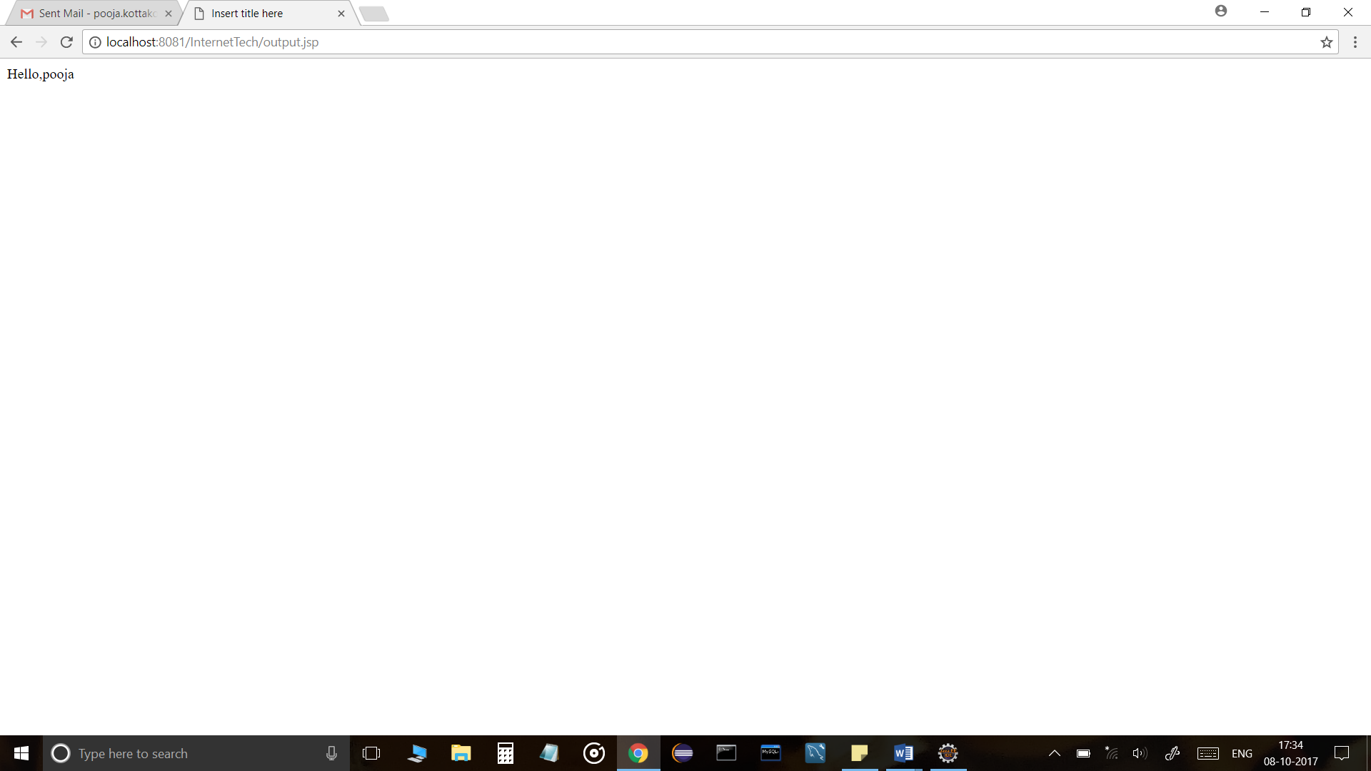

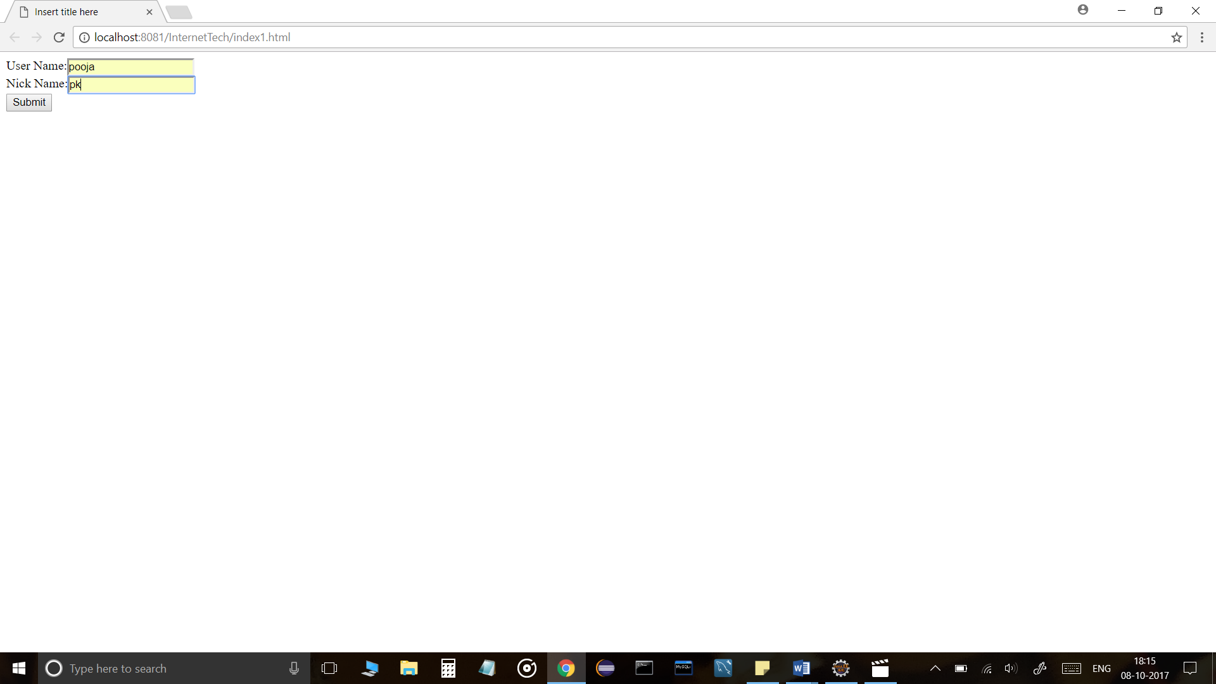

2.      Write JSP code to generate department wise monthly attendance reports of employee

Answer:

Index.html

<!DOCTYPE html>

<html>

<head>

<meta charset=*"ISO-8859-1"*>

<title>Insert title here</title>

</head>

<body>

<form action=*"attendance.jsp"* method=*"get"*>

Department:<input type=*"text"* name=*"dept"* /><br>

Month:<input type=*"text"* name=*"mon"* /><br>

<input type=*"submit"* value=*"Search"* /><br>

</form>

</body>

</html>

Attendance.jsp

<%@page import=*"java.sql.ResultSet"*%>

<%@page import=*"java.sql.SQLException"*%>

<%@page import=*"java.sql.PreparedStatement"*%>

<%@page import=*"java.sql.DriverManager"*%>

<%@page import=*"java.sql.Connection"*%>

<%@ page language=*"java"* contentType=*"text/html; charset=ISO-8859-1"*

pageEncoding=*"ISO-8859-1"*%>

<!DOCTYPE html PUBLIC "-//W3C//DTD HTML 4.01 Transitional//EN" "http://www.w3.org/TR/html4/loose.dtd">

<html>

<head>

<meta http-equiv=*"Content-Type"* content=*"text/html; charset=ISO-8859-1"*>

<title></title>

</head>

<body>

<%

String dept = request.getParameter("dept");

**int** month = Integer.parseInt(request.getParameter("mon"));

Class.forName("com.mysql.jdbc.Driver");

Connection con = DriverManager.getConnection("jdbc:mysql://localhost:3306/java_mini_project_login", "root", "pooja_1997");

java.sql.PreparedStatement st = con.prepareStatement("select * from login where name=? and id=?");

st.setString(1, dept);

st.setInt(2, month);

ResultSet rs = st.executeQuery();

out.println("NAME " + "MONTH " + "ATTENDANCE");

**while** (rs.next()) {

out.println("Yes" + " " + rs.getString(3) + " " + rs.getString(4) + " ");

%>

</body>

</html>

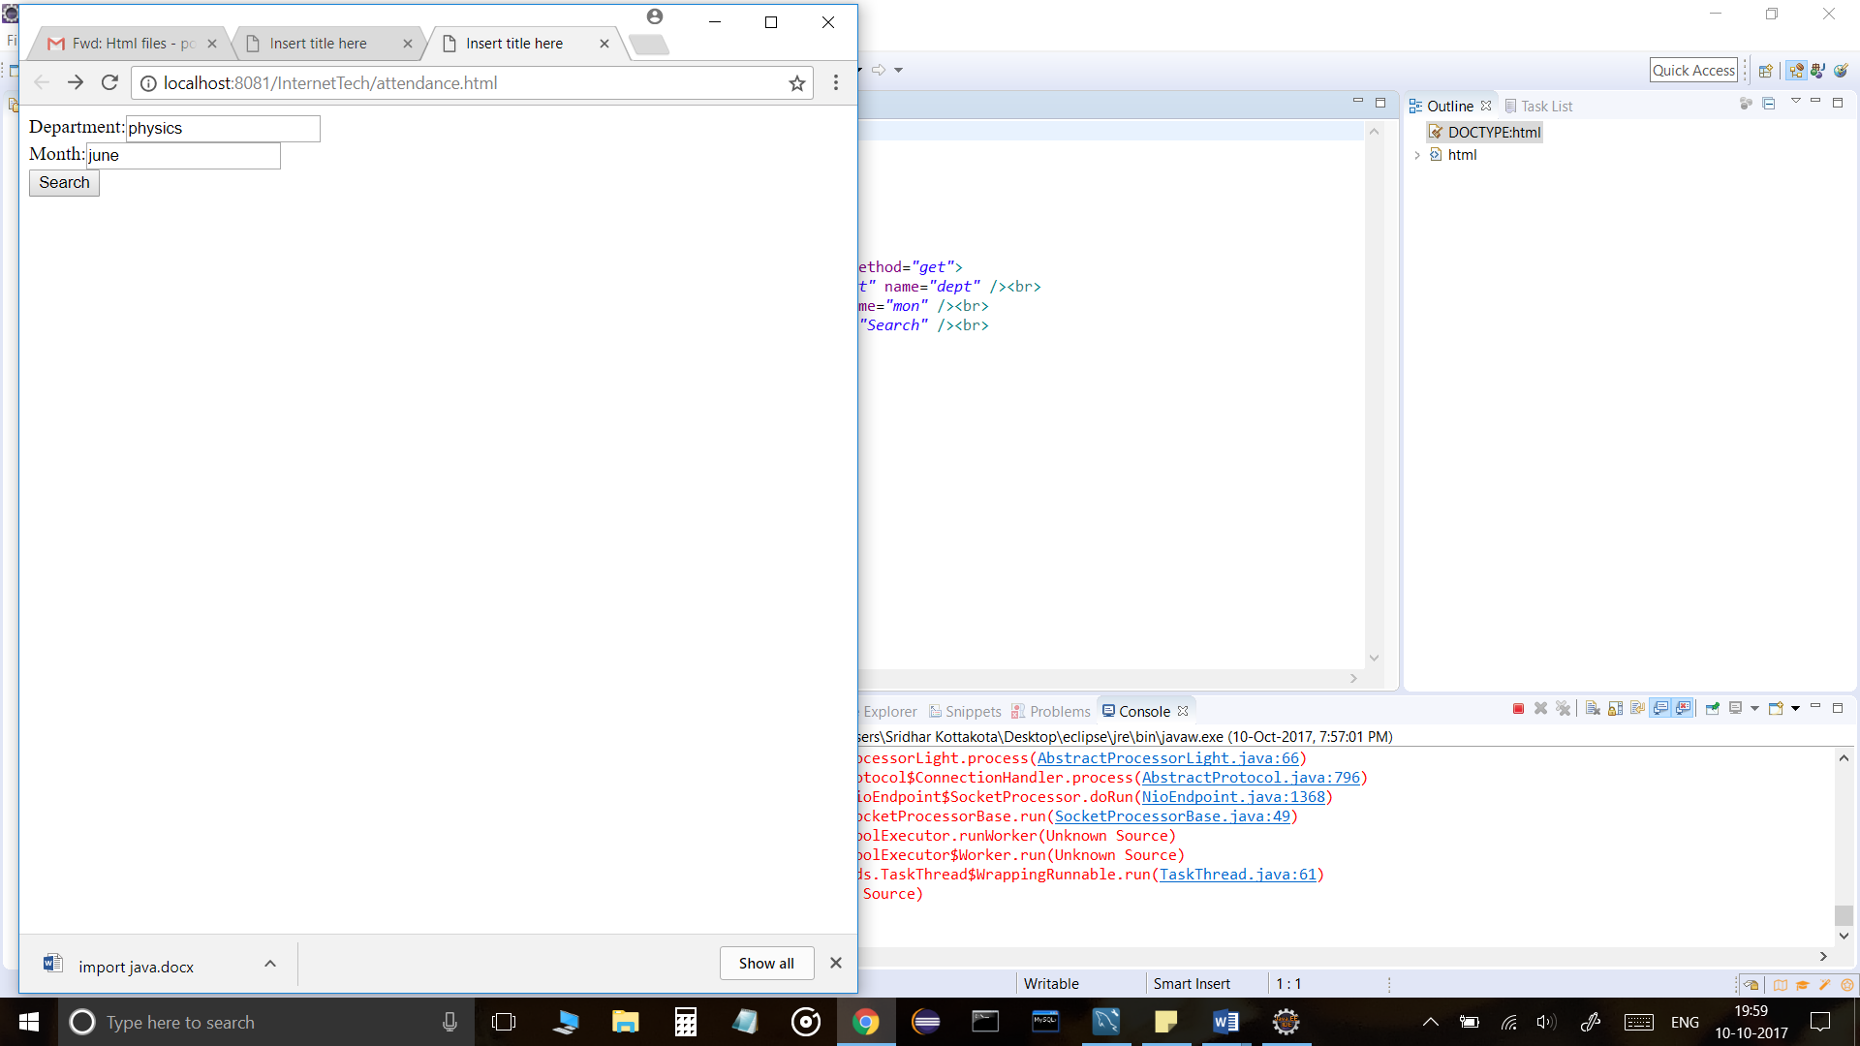

3.      Write JSP code which adds the student education details in a database through Java bean. Also display the student details who have secured first class in their graduation.

Answer:

Index.html

<!DOCTYPE html>

<html>

<head>

<meta charset=*"ISO-8859-1"*>

<title></title>

</head>

<body>

<h1>Student Registration</h1>

<form action=*"student.jsp"* method=*"post"*>

Name:<br><input type=*"text"* name=*"name"*><br>

Year:<br><input type=*"text"* name=*"year"*><br>

Total Marks:<br><input type=*"text"* name=*"marks"*><br>

<br><input type=*"submit"* value=*"Submit"*>

</form>

</body>

</html>

MyBean.java

**public** **class** MyBean **implements** java.io.Serializable {

/**

*

*/

**private** **static** **final** **long** ***serialVersionUID*** = 1L;

**private** String name;

**private** **int** year;

**private** **int** totalMarks;

**public** String getName() {

**return** name;

}

**public** **void** setName(String name) {

**this**.name = name;

}

**public** **int** getYear() {

**return** year;

}

**public** **void** setYear(**int** year) {

**this**.year = year;

}

**public** **int** getTotalMarks() {

**return** totalMarks;

}

**public** **void** setTotalMarks(**int** totalMarks) {

**this**.totalMarks = totalMarks;

}

}

Student.jsp

<%@page import=*"java.sql.ResultSet"*%>

<%@page import=*"java.sql.SQLException"*%>

<%@page import=*"java.sql.PreparedStatement"*%>

<%@page import=*"java.sql.DriverManager"*%>

<%@page import=*"java.sql.Connection"*%>

<%@ page language=*"java"* contentType=*"text/html; charset=ISO-8859-1"*

pageEncoding=*"ISO-8859-1"*%>

<!DOCTYPE html PUBLIC "-//W3C//DTD HTML 4.01 Transitional//EN" "http://www.w3.org/TR/html4/loose.dtd">

<html>

<head>

<meta http-equiv=*"Content-Type"* content=*"text/html; charset=ISO-8859-1"*>

<title>Insert title here</title>

</head>

<body>

<jsp:useBean id=*"obj"* class=*"MyBean"*></jsp:useBean>

<jsp:setProperty property=*"name"* name=*"obj"* param=*"name"* />

<jsp:setProperty property=*"year"* name=*"obj"* param=*"year"* />

<jsp:setProperty property=*"marks"* name=*"obj"* param=*"marks"* />

<%!**public** String[] displayData() **throws** ClassNotFoundException, SQLException {

MyBean mb = **new** MyBean();

String name;

Class.forName("java.sql.jdbc.Driver");

Connection conn = DriverManager.getConnection("jdbc:mysql://localhost:3306/java_mini_project_login", "root", "pooja_1997");

PreparedStatement stmt = conn.prepareStatement("INSERT INTO student VALUES(?,?,?)");

PreparedStatement stmt1 = conn.prepareStatement("SELECT * FROM student WHERE marks>270");

stmt.setString(1, mb.getName());

stmt.setInt(2, mb.getYear());

stmt.setInt(3, mb.getTotalMarks());

**int** i = stmt.executeUpdate();

ResultSet rs = stmt.executeQuery();

String[] list = **new** String[100];

**int** j = 0;

**if** (i > 0) {

**while** (rs.next()) {

list[j] = rs.getString("marks");

j++;

}

}

**return** list;

}%>

<%

String[] list = displayData();

**for** (**int** i = 0; i < list.length; i++) {

out.println(list[i]);

}

%>

</body>

</html>

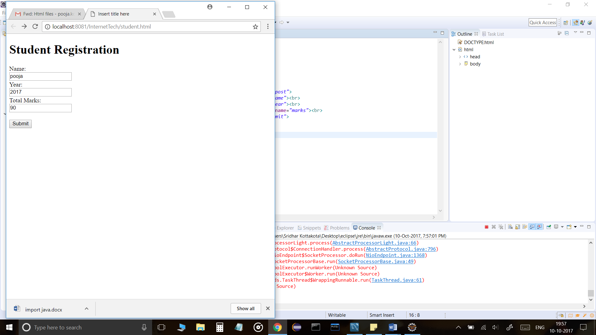

4.  Write a JSP that will allow a user to enter two values, select a type of mathematical operation to apply against them, and then upon clicking Submit, will display the result of the operation.  
An example of the default entry form:  
A valid code must also have:  
-one jsp only – Math.jsp – that submits to itself  
-four types of operations – add, subtract, multiply, divide  
-display some kind of error if the user attempts to divide by 0

Answer:

Index.html

<!DOCTYPE html>

<html>

<head>

<meta charset=*"ISO-8859-1"*>

<title>Insert title here</title>

</head>

<body>

<form action=*"Math.jsp"*>

Value1:<input type=*"text"* name=*"value1"*> <br>

Value2:<input type=*"text"* name=*"value2"*> <br>

<input type=*"radio"* name=*"Add"* value=*"ops"*>Add<br>

<input type=*"radio"* name=*"Subtract"* value=*"ops"*>Subtract<br>

<input type=*"radio"* name=*"Multiply"* value=*"ops"*>Multiply<br>

<input type=*"radio"* name=*"Divide"* value=*"ops"*>Divide<br>

<input type=*"submit"* value=*"Submit"*/>

</form>

</body>

</html>

Math.jsp

<%@ page language=*"java"* contentType=*"text/html; charset=ISO-8859-1"*

pageEncoding=*"ISO-8859-1"* errorPage=*"error.jsp"*%>

<!DOCTYPE html PUBLIC "-//W3C//DTD HTML 4.01 Transitional//EN" "http://www.w3.org/TR/html4/loose.dtd">

<html>

<head>

<meta http-equiv=*"Content-Type"* content=*"text/html; charset=ISO-8859-1"*>

<title>Insert title here</title>

</head>

<body>

<%

**int** num1 = Integer.parseInt(request.getParameter("value1"));

**int** num2 = Integer.parseInt(request.getParameter("value2"));

**int** result = 0;

String opt=request.getParameter("ops");

**if**(opt.equals("Add")){

result=num1+num2;

}

**else** **if**(opt.equals("Subtract")){

result=num1-num2;

}

**else** **if**(opt.equals("Multiply")){

result=num1*num2;

}

**else**

result=num1/num2;

out.println("Result is " + result);

%>

</body>

</html>

Error.jsp

<%@page isErrorPage=*"true"*%>

<%@ page language=*"java"* contentType=*"text/html; charset=ISO-8859-1"*

pageEncoding=*"ISO-8859-1"*%>

<!DOCTYPE html PUBLIC "-//W3C//DTD HTML 4.01 Transitional//EN" "http://www.w3.org/TR/html4/loose.dtd">

<html>

<head>

<meta http-equiv=*"Content-Type"* content=*"text/html; charset=ISO-8859-1"*>

<title>Insert title here</title>

</head>

<body>

<h1>Sorry an exception Occurred</h1>

<p>Here is an exception trace</p>

<pre>

<%

out.println(exception.getStackTrace());

%>

</pre>

</body>

</html>

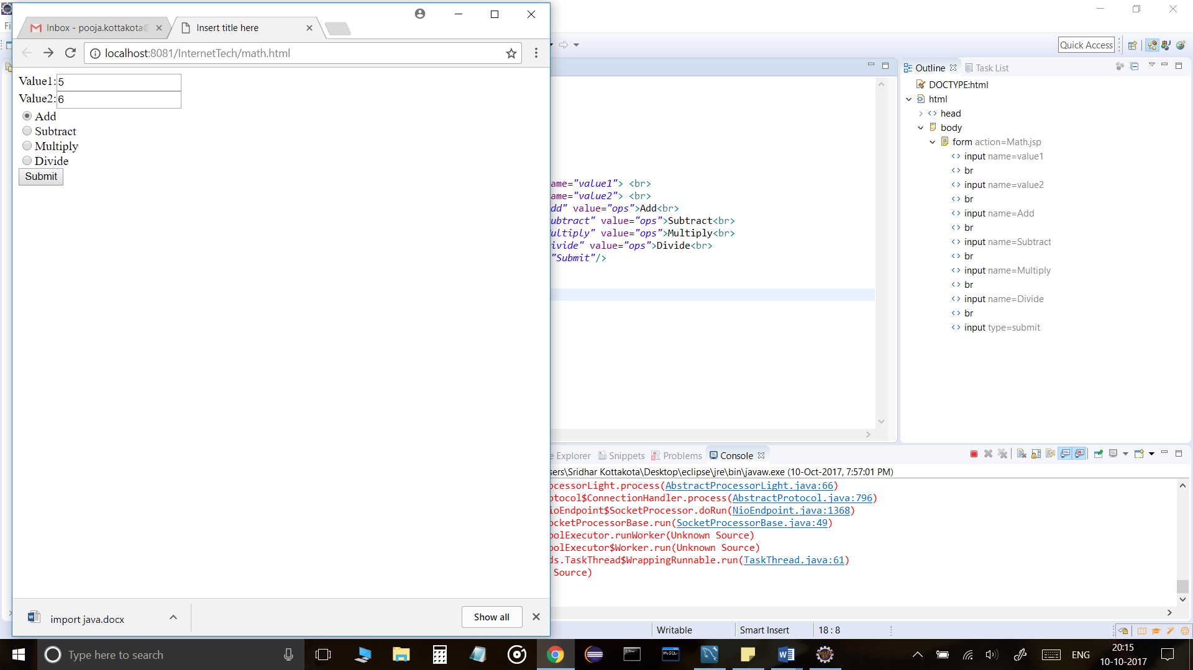

https://ssl.gstatic.com/ui/v1/icons/mail/images/cleardot.gif