Used Car Price Analysis and Prediction
Team Learning Guide and Technical Project Documentation

This guide explains the complete machine learning mini-project in plain language. It is designed for team members who need to understand the problem, dataset, preprocessing choices, model pipelines, evaluation results, Streamlit dashboard, and the exact steps required to reproduce or extend the work.
Main conclusion: on the same 80:20 held-out test split, the Random Forest model produced substantially lower prediction errors and a higher R squared score than Multiple Linear Regression. The conclusion is specific to this dataset and experiment; it is not a guarantee for every used-car market or future dataset.
Project fact | Value
Dataset | cardekho_dataset.csv
Clean records | 15,411
Reference year for age | 2026
Train and test design | 80:20 split with random state 42
Dashboard | Streamlit local application with three pages

Contents
- 1 Problem statement and project objectives
- 2 Dataset and data quality audit
- 3 Pipeline overview
- 4 Feature engineering and preprocessing
- 5 Exploratory data analysis
- 6 Models and training protocol
- 7 Evaluation metrics and real results
- 8 Interpreting predictions and feature importance
- 9 Dashboard guide
- 10 Project structure and key files
- 11 Reproducing the project
- 12 Limitations and future improvements
- 13 Team handover checklist

1 Problem Statement and Project Objectives
Used-car prices depend on multiple interacting factors such as vehicle age, brand, kilometres driven, fuel, transmission, engine capacity, power, and market conditions. A manual price estimate is difficult because no single factor determines value. The project builds regression models that estimate selling price from recorded vehicle characteristics.
The work is a methodology-based adaptation of the project specification. It compares a transparent baseline, Multiple Linear Regression, with Random Forest, a non-linear ensemble method. The implementation is intentionally kept understandable for a Machine Learning lab mini-project rather than being an over-engineered production system.
- Load and validate a CarDekho CSV without fabricating data.
- Audit missing values, duplicates, and invalid records before modelling.
- Use a fixed, reproducible train/test split for a fair comparison.
- Prevent target leakage by excluding selling price from model inputs.
- Save complete fitted pipelines so dashboard predictions use the same preprocessing as training.
- Present actual test metrics, diagnostic plots, and an interactive dashboard.

2 Dataset and Data Quality Audit
The supplied data file is an expanded CarDekho-style dataset. It contains vehicle descriptions, brand and model fields, age, kilometres driven, seller and fuel details, transmission, mileage, engine size, maximum power, seats, and selling price. The source uses vehicle_age rather than manufacturing year, so that field is treated as the usable age variable.
Audit item | Observed result | Decision
Rows before cleaning | 15,411 | Retained for audit
Exact duplicate rows | 0 | Remove only if present
Invalid or non-positive prices | 0 | Remove because target would be invalid
Negative kilometres | 0 | Remove because value is impossible
Implausible car age | 0 | Remove if age is below 0 or above 126
Rows after cleaning | 15,411 | Used in split and modelling

No automatic statistical outlier removal was applied. Expensive cars can be legitimate observations; removing every high value can bias a used-car model toward cheaper vehicles. Instead, the team should inspect extreme records if a result looks suspicious and document any domain-based decision.

3 Pipeline Overview
The following sequence keeps the training process reproducible and avoids leakage. Each arrow represents a concrete source module or saved artifact in the project.
Stage | What happens | Output
1 Load | Find CSV and normalize varied column names | Validated dataframe
2 Audit | Count missing values and duplicates; reject impossible core values | data_audit.json
3 Engineer | Parse numeric values and use a fixed car-age rule | Cleaned feature table
4 Explore | Create distributions, scatter plots, box plots, and correlations | reports/figures PNGs
5 Split | Create one 80:20 random split with seed 42 | train.csv and test.csv
6 Train | Fit preprocessing and each model only on train rows | Two joblib pipelines
7 Evaluate | Predict the untouched test set and calculate metrics | CSV metrics and diagnostic plots
8 Serve | Load saved pipeline for dashboard estimates | Streamlit application

4 Feature Engineering and Preprocessing

4.1 Feature selection
The baseline model uses six numeric features and four categorical features. This strikes a balance between useful information and a pipeline that can be explained clearly in a viva. The target, selling_price, is never passed to either model as an input.
Type | Features | Why included
Numeric | car_age, km_driven, mileage, engine, max_power, seats | Represent age, usage, efficiency, size, performance, and capacity
Categorical | fuel, seller_type, transmission, brand | Capture major non-numeric vehicle and market categories
Excluded from baseline | raw selling_price, raw name/model text, index column | Target must not leak; high-cardinality text is unnecessary for the first lab baseline

4.2 Transformations
- Header normalization maps variants such as Fuel Type to the shared internal name fuel.
- The utility parser extracts numeric values from strings with units, such as kmpl, cc, or bhp, and turns malformed values into missing values rather than inventing numbers.
- If year is available, car_age equals 2026 minus year. In this dataset, the supplied vehicle_age field is used directly.
- Numeric columns use median imputation. The median is robust to extreme values and is calculated from training data only.
- Categorical columns use most-frequent imputation followed by OneHotEncoder(handle_unknown='ignore'). This creates a safe numeric representation while allowing a new dashboard category without a crash.
All transformations are assembled in a scikit-learn ColumnTransformer inside each Pipeline. Calling fit happens only on the training partition. The fitted imputer, encoder, and estimator are saved together, so the dashboard never refits preprocessing on one new car.

5 Exploratory Data Analysis
EDA is used to understand the target distribution, spot unusual patterns, and decide whether selected predictors appear relevant. The charts are descriptive: they reveal associations, not causal effects.
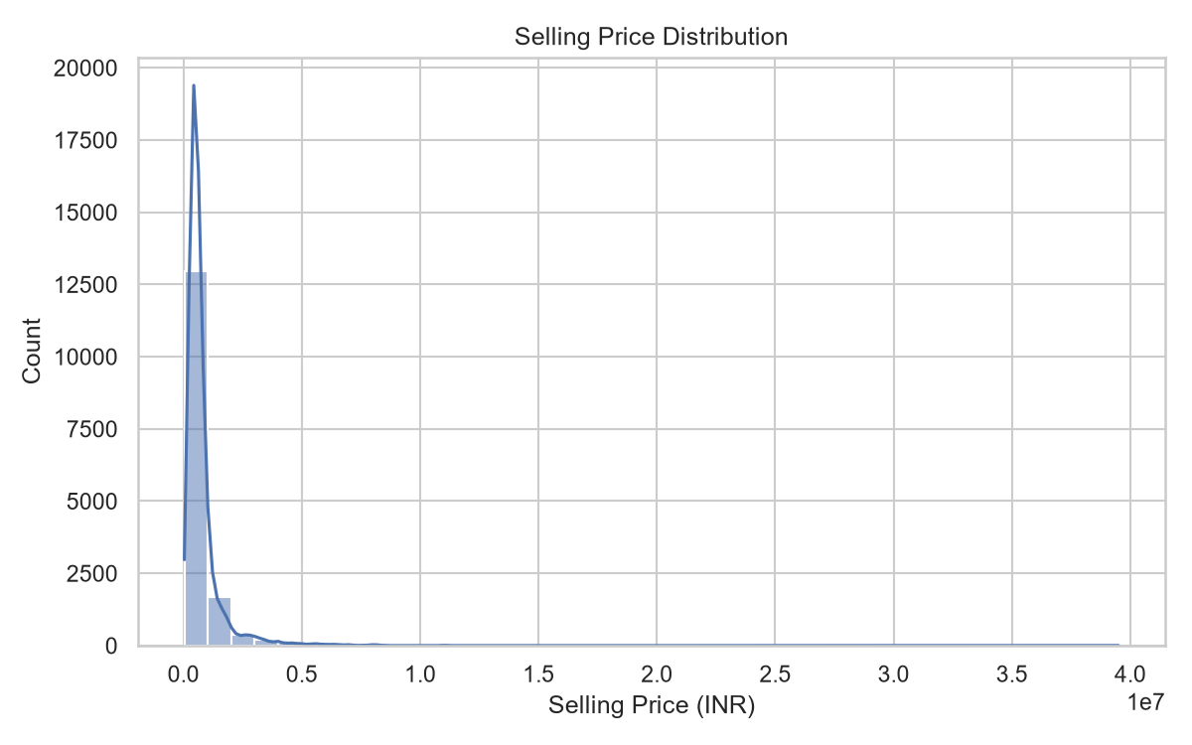
Figure 1. Distribution of selling prices in the cleaned CarDekho dataset.
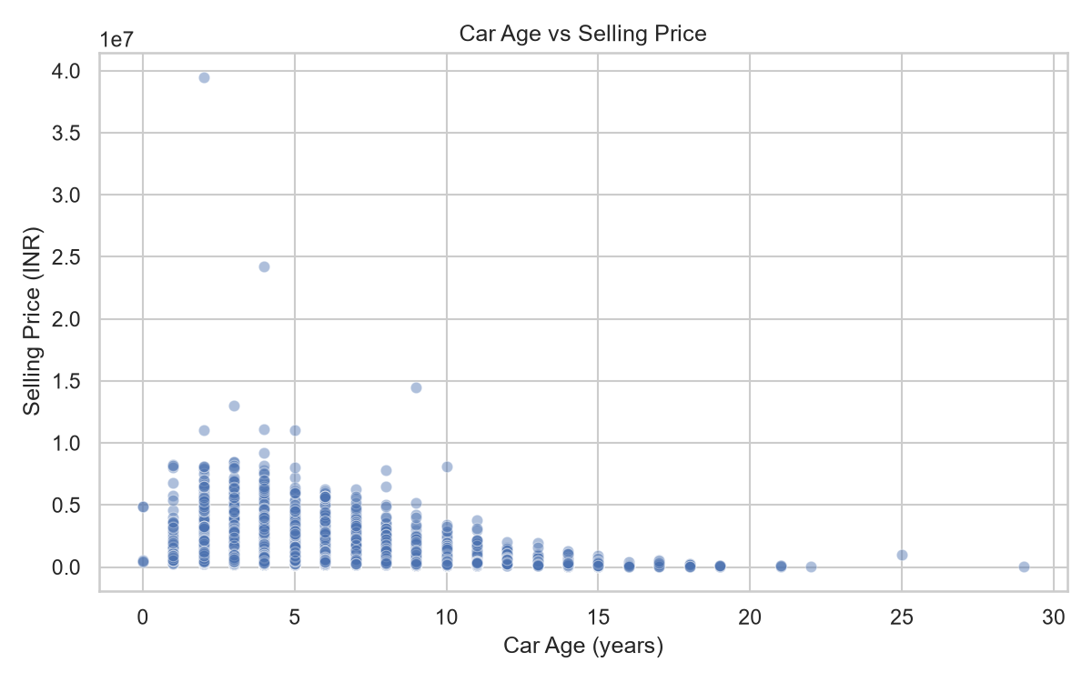
Figure 2. Selling price against car age. Younger cars often have higher price ranges, but spread remains substantial.
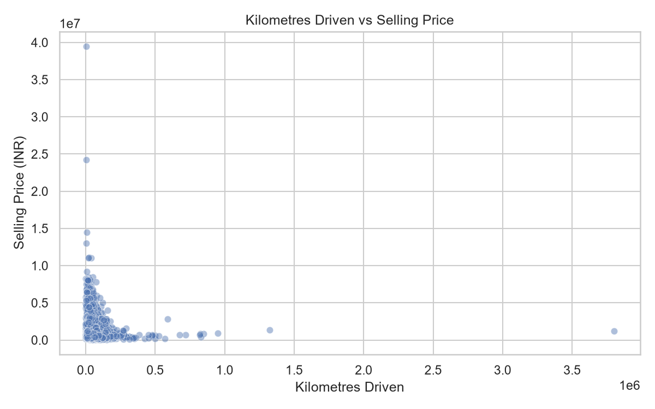
Figure 3. Selling price against kilometres driven. Usage is informative but not sufficient by itself.
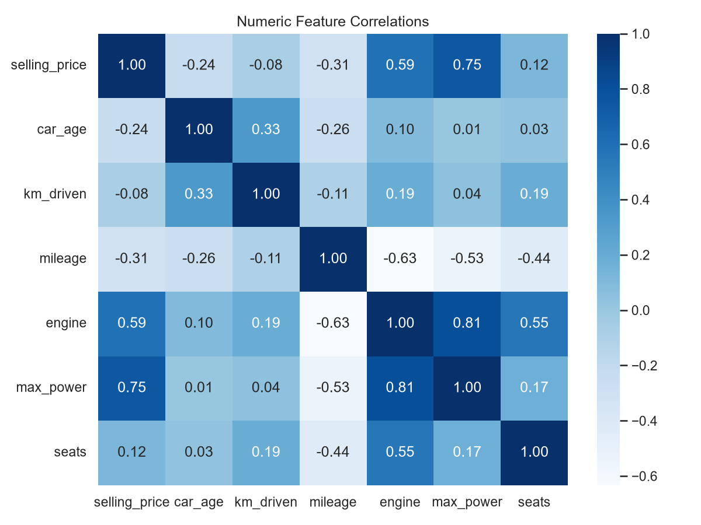
Figure 4. Correlation heatmap for numeric fields. Correlation only describes linear association.

6 Models and Training Protocol

6.1 Shared experiment setup
The cleaned dataset is divided once: 80 percent for training and 20 percent for testing. The random_state is fixed at 42. Both models receive the same training rows and the same untouched test rows. This matters because different splits can make a model look better or worse purely through sampling variation.
Model | Implementation | Purpose in comparison
Multiple Linear Regression | sklearn.linear_model.LinearRegression | Simple, interpretable baseline that assumes an additive linear relationship after encoding.
Random Forest Regressor | 200 trees, random_state 42, n_jobs -1 | Ensemble of decision trees that can capture non-linear patterns and interactions.

6.2 Multiple Linear Regression
Linear regression learns one coefficient per transformed feature and estimates price as an intercept plus a weighted sum of feature values. It is useful as a baseline because the relationship is easy to describe. However, used-car pricing often contains thresholds and interactions, such as power being valued differently by brand or age, that a simple linear form may not model well.

6.3 Random Forest
Random Forest trains many decision trees on varied samples and averages their predictions. A tree can split the data into regions, allowing non-linear patterns to be learned. Averaging many trees generally stabilizes individual-tree predictions. Here the forest uses 200 estimators, a fixed seed, and parallel CPU work where available.

7 Evaluation Metrics and Real Results
All metrics below were calculated from the 3,083-row held-out test set. They are not training scores and are not manually entered values.
Model | MAE | RMSE | R squared
Multiple Linear Regression | Rs 270,497.21 | Rs 491,948.78 | 0.6785
Random Forest Regressor | Rs 101,425.77 | Rs 224,771.95 | 0.9329

7.1 How to read the metrics
- MAE, Mean Absolute Error: the average absolute difference between actual and predicted prices. Lower is better. Random Forest averages about Rs 101,426 absolute error on this test set, compared with about Rs 270,497 for linear regression.
- RMSE, Root Mean Squared Error: squares errors before averaging, so large misses receive more penalty. Lower is better. Random Forest also has the lower RMSE.
- R squared: the share of variation in the test target explained by the model relative to a simple mean baseline. Higher is generally better on the same test set. It is not percentage accuracy and does not mean every prediction is correct.
Result interpretation: Random Forest is the preferred saved model for this experiment because it has lower MAE and RMSE and higher R squared on the same held-out data. This does not prove that Random Forest will always win on another dataset, another time period, or a different split.
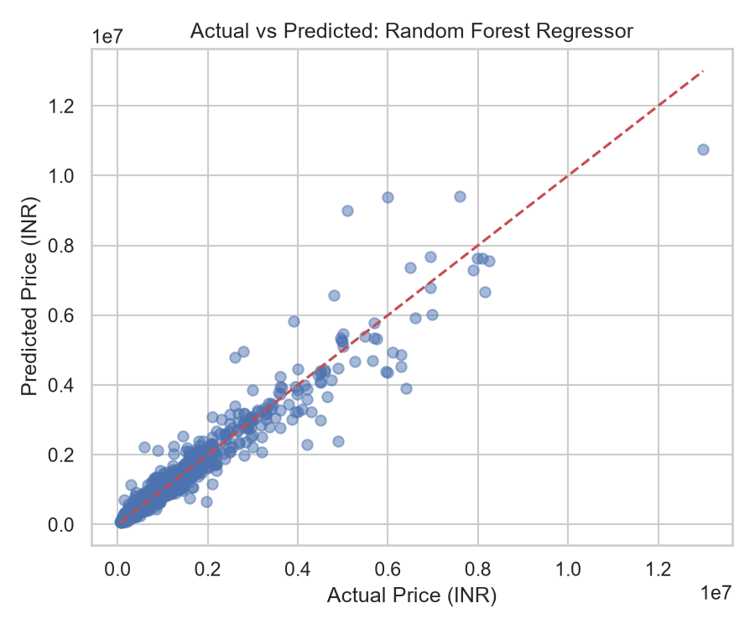
Figure 5. Random Forest actual-versus-predicted test prices. Points near the diagonal have small error.
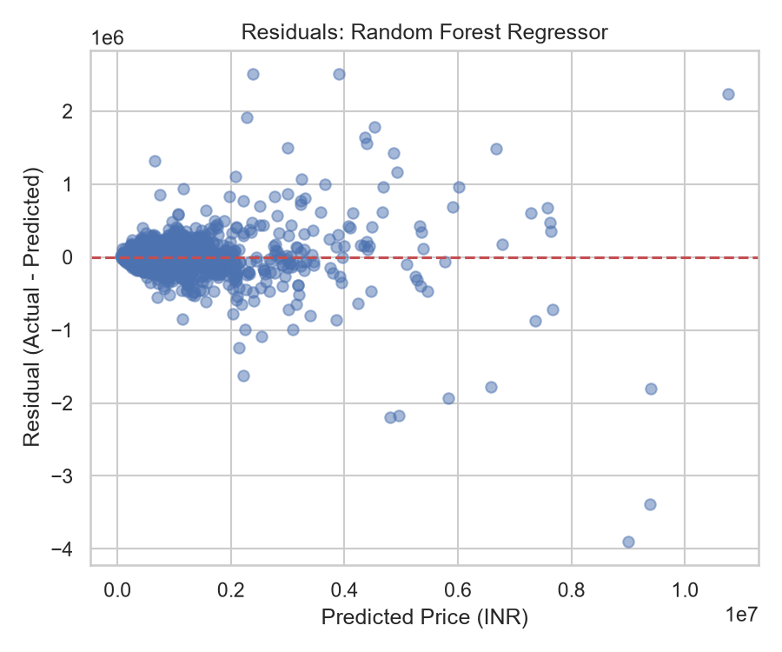
Figure 6. Random Forest residuals. A useful residual plot has no strong systematic pattern around zero.

8 Feature Importance and Responsible Interpretation
Random Forest can report how much each transformed feature reduced impurity across the trees. This is a useful model diagnostic, but it does not prove that changing a feature causes a price change. Correlated predictors and category frequency can affect importance scores.
Transformed feature | Importance | Team interpretation
numeric__max_power | 0.658 | Strong predictive association in this fitted forest
numeric__car_age | 0.130 | Strong predictive association in this fitted forest
numeric__km_driven | 0.054 | Strong predictive association in this fitted forest
numeric__mileage | 0.049 | Strong predictive association in this fitted forest
categorical__brand_Ferrari | 0.038 | Useful but smaller predictive association
numeric__engine | 0.028 | Useful but smaller predictive association
categorical__brand_Land Rover | 0.007 | Useful but smaller predictive association
categorical__brand_Rolls-Royce | 0.006 | Useful but smaller predictive association

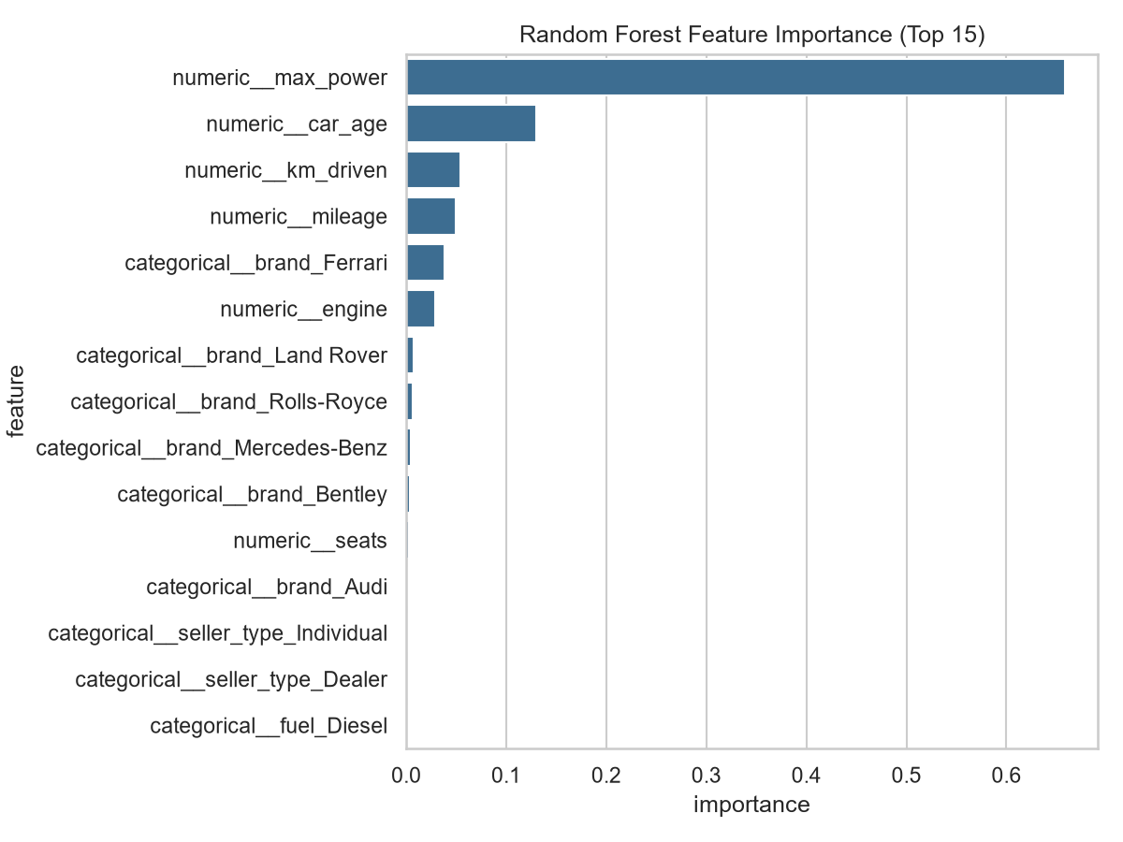
Figure 7. Top Random Forest feature importances. Values describe predictive use, not causation.

9 Streamlit Dashboard Guide
The dashboard is a local demonstration application. Launch it from the project root after installing requirements and generating the model artifacts. It reads saved files instead of retraining in the browser.
Page | What team members can do | Data source
Price Prediction | Enter a vehicle profile and compare Linear Regression and Random Forest estimates. | Saved joblib pipelines and metadata
Data Analysis | Review clean-row KPIs, preview data, and view EDA plots. | cleaned_cardekho.csv and EDA figures
Model Performance | Compare test metrics, actual-versus-predicted plots, residuals, and feature importance. | model_metrics.csv, test_predictions.csv, evaluation figures

- The prediction page labels prices as estimates, not guaranteed market values.
- Form controls use validation ranges for year, kilometres, mileage, engine, power, and seats.
- Unknown categories are handled safely by the OneHotEncoder setting. They may still reduce prediction reliability if far from training data.
- If artifacts are missing, the page gives a command to train/evaluate rather than showing a traceback.

10 Project Structure and Key Files
Location | Responsibility
app/streamlit_app.py | Dashboard landing page and navigation overview
app/pages/ | Price Prediction, Data Analysis, and Model Performance pages
app/utils.py | Shared display, artifact-loading, and compact chart-grid helpers
data/raw/ | Original supplied CSV; never overwritten by scripts
data/processed/ | Cleaned data, audit, and reproducible train/test files
src/config.py | Paths, random seed, reference year, aliases, and feature settings
src/data_preprocessing.py | Schema mapping, cleaning, split creation, and EDA charts
src/feature_engineering.py | Numeric parsing and car-age derivation
src/train_model.py | Pipeline construction, model fitting, and artifact saving
src/evaluate_model.py | Held-out metrics, predictions, diagnostics, and importance chart
src/predict.py | Reusable saved-pipeline prediction function
models/ | Saved pipelines, metadata, metrics, test predictions, importance CSV
reports/ | Figures, report-ready markdown, and this team guide
tests/ | Schema/preprocessing and saved-model prediction tests

11 Reproducing the Project
Use Windows PowerShell from the project root. Keep the raw dataset in data/raw and avoid renaming its required columns without updating the alias mapping.
Step | Command or action | Expected outcome
1 | python -m venv .venv | Creates isolated Python environment
2 | .venv\Scripts\Activate.ps1 | Activates environment
3 | pip install -r requirements.txt | Installs pandas, scikit-learn, Streamlit, plotting, and tests
4 | python -m pytest | Runs preprocessing and saved-model prediction tests
5 | python -m src.data_preprocessing | Writes cleaned data, audit, split, and EDA figures
6 | python -m src.train_model | Fits and saves both full model pipelines
7 | python -m src.evaluate_model | Writes actual metrics, predictions, and diagnostic figures
8 | streamlit run app\streamlit_app.py | Starts the local dashboard, usually at localhost:8501

Recommended team workflow: do not change code and compare metrics at the same time. First make one documented change, then rerun tests, preprocessing if needed, training, evaluation, and finally confirm that the dashboard still loads artifacts.

12 Limitations and Future Improvements
- The model is trained on one CarDekho dataset version. Different cities, time periods, taxes, supply conditions, and data collection methods can change price relationships.
- Vehicle condition, accident history, service records, trim, location, and on-road price are not all represented. Missing drivers of price limit accuracy.
- The dataset contains an age field rather than a full manufacturing-year workflow. The dashboard converts a manufacturing year into age using fixed reference year 2026.
- Random Forest feature importance is not causal evidence. It should be paired with domain knowledge and more careful explanation methods if used for decisions.
- A future extension may test gradient boosting, cross-validation, hyperparameter tuning, price-log transformation, and separate error analysis by fuel or brand. Extensions must preserve the same no-leakage evaluation discipline.

13 Team Handover Checklist
- Know the target: selling_price in INR.
- Explain why train/test splitting occurs before fitting preprocessing.
- Explain why both models use the same fixed split.
- Explain MAE, RMSE, and R squared without calling R squared accuracy.
- State that Random Forest is better on this held-out experiment, not universally.
- Know where model pipelines, metrics, EDA plots, and dashboard pages are stored.
- Never hardcode a prediction or metric in slides, documentation, or the app.
- Rerun tests and evaluation whenever model code or the dataset changes.

References
1. Project specification: Used Car Price Analysis and Prediction Using Machine Learning. Local project requirements and reproducibility rules.
2. Longania, C., Potharaju, S. P., and Deore, S. (2021). Price Prediction for Pre-Owned Cars Using Ensemble Machine Learning Techniques. Recent Trends in Intensive Computing. DOI: 10.3233/APC210194. Used as supporting background; it is distinct from the Gao 2024 paper named in the project specification.
3. CarDekho dataset supplied with this project: cardekho_dataset.csv. Results in this guide were generated from that exact local file.

