ANALYTICS REPORT·JUNE 2026
Supply Chain
Delivery & Profitability
Performance Analysis

Prepared by Kunal K. Hiwase

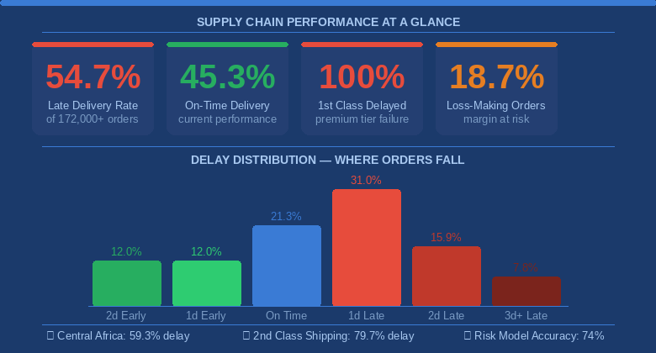

Table of Contents
1. Executive Summary 3

2. Business Context & Objectives 4

3. Key Performance Indicators 5

4. Profitability Analysis 6

5. Delivery Performance Analysis 7

6. Operational Bottleneck Detection 8

7. Root Cause Analysis 10

8. Time-Based Delay Patterns 12

9. Predictive Delivery Risk System 13

10. Strategic Recommendations 14

11. Conclusion 15

1. Executive Summary
This report examines the delivery operations of a global e-commerce supply chain to understand why shipments are failing, quantify the financial impact, and provide leadership with a clear action plan.
The central finding is stark: more than half of all customer orders are delivered late. This is not the result of isolated incidents — it reflects a deep, systemic misalignment between operational capability and the delivery commitments made to customers.

Summary of Key Findings
Finding | Result
Late Delivery Rate | 54.7%
On-Time Delivery Rate | 45.3%
Total Orders Analysed | 172,000+
Highest Delay Region | Central Africa — 59.3%
First Class Shipping Delay Rate | 100%
Second Class Shipping Delay Rate | 79.7%
Loss-Making Orders | 18.7%
Predictive Risk Model Accuracy | 74%

⚠ Critical Alert: Every single First-Class order — the company's premium offering — was delivered late. Customers paying for speed received the worst service. This is the most urgent operational failure requiring immediate action.

📌 Business Opportunity: The root causes are known, measurable, and fixable. Addressing premium shipping alignment, payment processing delays, and seasonal planning could move the company from reactive problem management to proactive delivery excellence.

2. Business Context & Objectives
The company operates a large-scale global e-commerce supply chain, managing order fulfilment across multiple geographies, customer segments, product departments, and shipping tiers. As the business has scaled, delivery reliability has deteriorated — creating a growing gap between what customers expect and what operations consistently deliver.

The Business Problem
Customers are routinely receiving products later than promised. At a rate of 54.7%, late delivery has shifted from an exception to the expected operating norm. This carries compounding costs:
- Customer trust and loyalty erosion over repeated failed promises
- Increased service and support costs from delivery complaints
- Revenue risk from customers migrating to more reliable competitors
- Damage to brand reputation across key markets

Analytical Objectives
This analysis was conducted to answer four core business questions:
- Where is delivery performance breaking down — by region, shipping mode, and product category?
- What are the root causes driving the highest concentration of delays?
- How are delivery failures affecting order-level profitability?
- Can high-risk orders be identified early, before delays occur?

3. Key Performance Indicators
The following metrics define the current state of operations and provide the baseline against which future improvements should be measured.

172K+  Total Orders Analysed | ~95K  Late Deliveries | 54.7%  Late Delivery Rate | 45.3%  On-Time Rate

3 Days  90th Pct. Delay Window | 18.7%  Loss-Making Orders | 79.7%  2nd Class Delay Rate | 100%  1st Class Delay Rate

📊 Performance Context: Late delivery is not an outlier event — it is the dominant outcome. More customers experience delayed shipments than receive on-time delivery. At this volume, the problem is structural, not operational noise.

4. Profitability Analysis
Order-level profitability was analysed to evaluate the financial health of the fulfilment model. While the majority of transactions remain profitable, a substantial minority are generating losses that erode overall margins.

Profitability Category | Share of Orders
Profitable Orders | 80.6%
Loss-Making Orders | 18.7%
Break-Even Orders | 0.7%

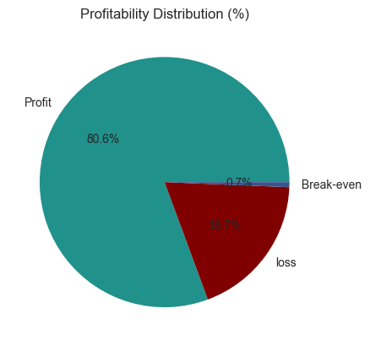
Figure 1 — Order Profitability Distribution

💡 Key Insight: Nearly 1 in 5 orders loses money. At 172,000+ orders per cycle, this represents tens of thousands of loss-generating transactions. Pricing strategy, discount policies, and delivery cost recovery all require review to close this margin gap.

5. Delivery Performance Analysis
A detailed breakdown of delivery timing reveals that the majority of delays are concentrated within a narrow window. The problem is not catastrophic multi-day failures — it is a high volume of small, repeatable delays accumulating into a systemic performance issue.

Delivery Outcome | Share of Orders
2+ Days Early | 12.0%
1 Day Early | 12.0%
On Schedule | 21.3%
1 Day Late | 31.0%
2 Days Late | 15.9%
3+ Days Late | 7.8%

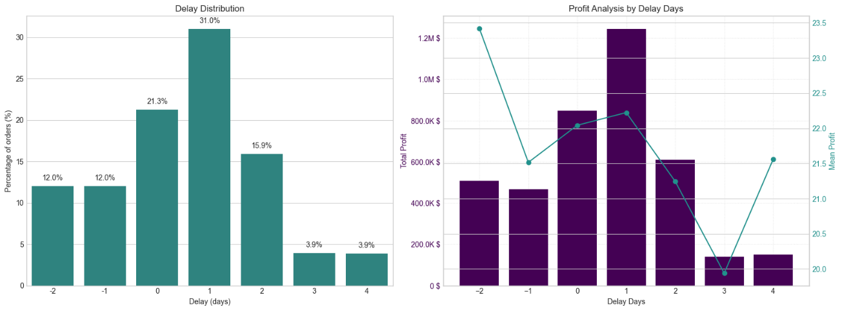
Figure 2 — Delay Distribution and Profit Impact by Delay Duration

💡 Key Insight: 31% of all orders — the single largest group — arrive exactly one day late. This points to a systemic gap in fulfilment timing rather than carrier failure. Closing just this one-day gap through improved scheduling and processing cutoffs would dramatically improve on-time delivery rates. Profitability remains stable across delay durations, confirming this is an operational — not financial — problem.

6. Operational Bottleneck Detection
Delay rates were analysed across six key operational dimensions to pinpoint where the fulfilment process is failing most severely. The findings reveal a company-wide operating model failure rather than a regional or category-specific problem.

Regional Performance
Region | Delay Rate
Central Africa | 59.3%
Southeast Asia | 56.0%
South Asia | 56.0%

Regional delay rates are tightly clustered between 54% and 60%. The narrow range rules out localised logistics failures and confirms a systemic issue at the operating model level.

Shipping Mode Performance
Shipping Mode | Delay Rate
First Class | 100%
Second Class | 79.7%
Standard Class | 39.8%

The inversion of expectations here is the most critical structural finding. Premium shipping is performing significantly worse than standard shipping — customers who pay the most receive the least reliable service.

Customer Segment & Department Performance
Dimension | Category | Delay Rate
Customer Segment | Home Office | 55.3%
Customer Segment | Consumer | 54.6%
Customer Segment | Corporate | 54.5%
Product Dept. | Health & Beauty | 57.2%
Product Dept. | Pet Shop | 56.7%
Product Dept. | Technology | 56.3%

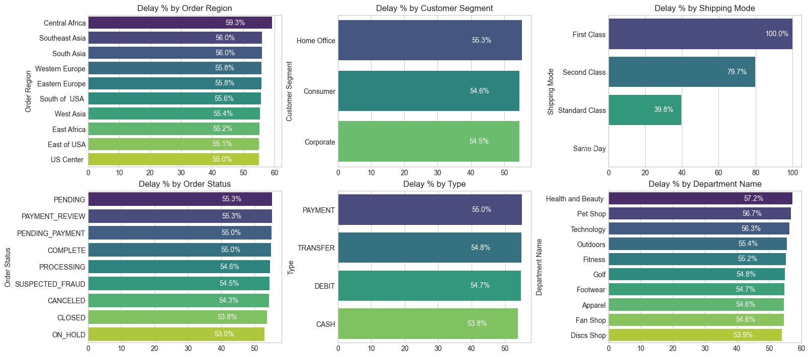
Figure 3 — Six-Dimension Operational Bottleneck Dashboard

⚠ Critical Finding: First Class shipping has a 100% delay rate and Second Class 79.7%. No customer segment is insulated — Corporate, Consumer, and Home Office all experience 54–55% delay rates. Health & Beauty, Pet Shop, and Technology departments warrant dedicated inventory and warehouse audits.

7. Root Cause Analysis
Central Africa was selected for deep-dive root cause investigation due to its position as the highest-delay region. The analysis identifies the specific operational triggers responsible for the majority of failures — findings that apply broadly across the network.

Primary Delay Drivers — Central Africa
Root Cause | Delay Rate
First Class Shipping | 100%
Second Class Shipping | 82.5%
Suspected Fraud Flag in Processing | 82.1%
Orders Pending Payment Review | 80.0%
Orders in Pending Status | 69.1%

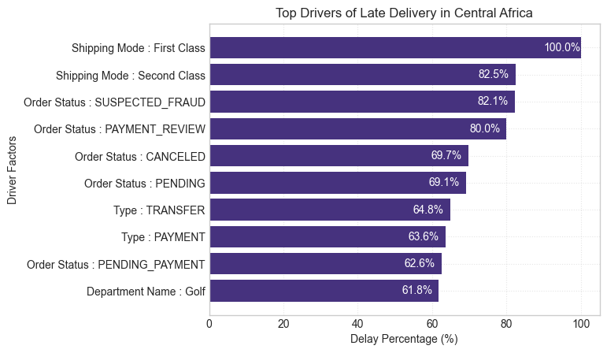
Figure 4 — Top Drivers of Late Delivery — Central Africa

💡 Key Insight: Two distinct failure modes emerge: (1) a shipping configuration problem where premium modes cannot meet promised timelines, and (2) an internal processing bottleneck where payment verification, fraud screening, and order approval workflows add days to fulfilment before a package enters the carrier network.

Three Root Problems

1. Premium Shipping Capability Gap
First and Second-Class shipping tiers are systematically over-promising. Carrier agreements, routing, or capacity allocations are insufficient to meet timeline commitments. This is a product design and contract management issue, not a logistics execution problem.

2. Internal Order Processing Delays
Payment verification, fraud screening, and manual approval queues add significant lag before orders are released for fulfilment. These internal delays compound with carrier transit time, making on-time delivery impossible even when carriers perform correctly.

3. High-Risk Product Categories
Health & Beauty, Pet Shop, and Technology departments show elevated delay rates likely reflecting inventory availability issues, warehouse picking complexity, or supplier lead time variability.

8. Time-Based Delay Patterns
Delivery delay rates were mapped across three time dimensions — month, day of week, and hour of day — to identify predictable capacity and demand pressure points that operations teams can plan around.

Monthly Peaks
Month | Delay Rate
December | 55.5%
August | 55.3%
September | 55.2%

December delays are attributable to peak holiday demand. August and September spikes suggest a secondary demand cycle — likely back-to-school and mid-year promotions — that strains warehouse and carrier capacity.

Peak Processing Hours
Hour of Day | Delay Rate
8:00 PM | 57.3%
11:00 AM | 56.4%
1:00 PM | 56.1%

The 8 PM peak aligns with end-of-day order processing cutoffs — evening orders likely miss same-day processing windows and roll to the next day's queue. Mid-morning and lunchtime peaks reflect high-volume processing bottlenecks.

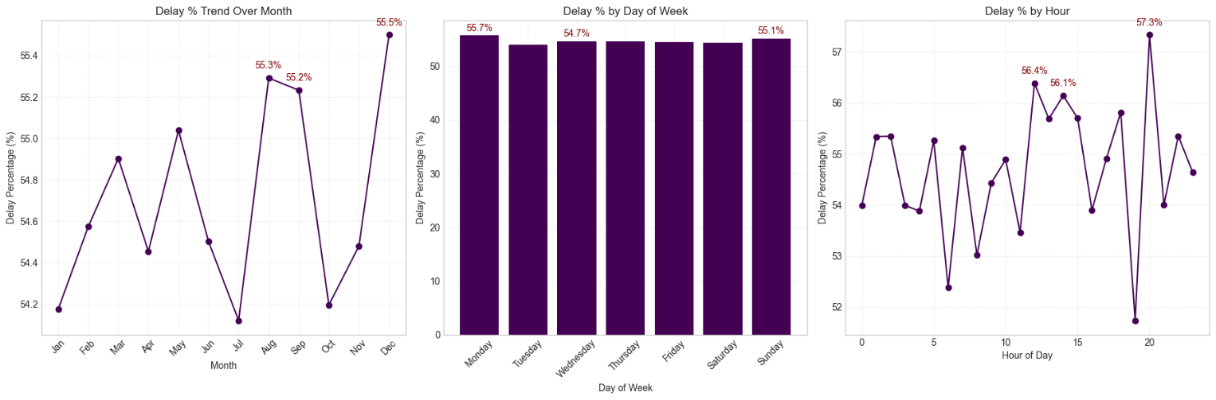
Figure 5 — Delay Rate by Month, Day of Week, and Hour of Day

💡 Key Insight: Time-based patterns are predictable — and therefore preventable. Increased staffing during August, September, and December, combined with extended processing cutoff windows during peak hours, would directly reduce delay rates without requiring infrastructure investment.
9. Predictive Delivery Risk System
A predictive risk model was developed to identify orders likely to be delivered late before the failure occurs. The goal is to shift the organisation from reactive problem resolution to proactive order management.

Model Performance
Performance Metric | Result
Overall Prediction Accuracy | 74%
Late Orders Correctly Identified | 75%
Late Predictions That Proved Correct | 78%

Business Value
The predictive system enables three practical business capabilities:
- Early intervention — fulfilment teams can prioritise flagged orders before they fall behind schedule
- Proactive customer communication — at-risk customers can be notified in advance, reducing complaint volume
- Capacity planning — operations can identify high-risk order cohorts and pre-allocate resources accordingly

📈 Commercial Impact: A 74% accurate early warning system can meaningfully reduce avoidable delays. Even a 10% reduction in the late delivery rate shifts approximately 9,500 orders per cycle from late to on-time — with direct impact on customer satisfaction, churn, and support costs.

10. Strategic Recommendations
The following recommendations are organised by business urgency. Each is directly traceable to a finding in this report and addresses a root cause rather than a symptom.

● CRITICAL PRIORITY
Fix First Class and Second-Class Shipping
Every First-Class order is delivered late. Customers paying a premium receive the worst service. Immediate action is required to realign the product promise with operational reality.
- Audit carrier agreements and renegotiate timelines where commitments cannot be met
- Adjust advertised delivery windows to reflect actual capability until service levels recover
- Increase dedicated capacity for premium tiers or temporarily suspend sales until performance is restored

● HIGH PRIORITY
Accelerate Internal Order Processing
Payment verification and fraud review workflows are delaying order release before packages enter the carrier network. Reducing internal processing time directly reduces delivery delay without carrier involvement.
- Implement automated approval for low-risk orders to eliminate manual review backlogs
- Set internal processing SLAs — target release within 2 hours of order placement
- Review fraud screening thresholds that may be flagging legitimate orders unnecessarily

● MEDIUM PRIORITY
Build Seasonal Capacity in Advance
August, September, and December are consistently high-delay months. These peaks are predictable and should be managed through proactive planning.
- Increase warehouse staffing and carrier allocations from late July and November onwards
- Pre-position inventory for high-demand categories before peak periods begin
- Extend order processing cutoff windows during peak months

Investigate High-Delay Product Departments
- Conduct warehouse inventory audits for Health & Beauty, Pet Shop, and Technology
- Review supplier lead times and safety stock levels for these categories

● LOW PRIORITY
Deploy Predictive Risk System in Operations
- Integrate risk flags into the warehouse management system to prioritise at-risk orders
- Create automated customer notifications for orders flagged as high-risk
- Use model outputs in weekly operations reviews to track risk reduction over time

11. Conclusion
The data tells a clear story: this company has a predictable, measurable, and fixable delivery performance problem. With 54.7% of orders arriving late, late delivery has become the standard customer experience rather than the exception.

The good news is that this is not a capacity crisis requiring major capital investment. The analysis reveals three concentrated failure points — premium shipping misconfiguration, internal processing delays, and seasonal planning gaps — that together account for the majority of delivery failures.

Current State Summary
- Over 95,000 orders per analysis period are delivered late
- First and Second-Class shipping tiers have failed completely as products
- Nearly 1 in 5 orders generates a financial loss
- Delay patterns are concentrated, predictable, and therefore preventable

Path Forward
The business has a clear opportunity to move from reactive problem management to proactive delivery excellence. With root causes identified and a predictive risk model in place, the foundation exists for meaningful improvement. The priority is execution.
- Immediate: Realign premium shipping promise with operational capability
- Short-term: Automate internal processing workflows to remove pre-carrier delays
- Seasonal: Implement advance capacity planning for August, September, and December
- Ongoing: Integrate predictive risk alerts into daily operations

🎯 Leadership Message: The gap between customer expectations and operational performance is measurable, locatable, and closeable. The priority actions in this report — if executed with discipline — would position the business to achieve on-time delivery rates above 70% within two to three operational cycles.

