**What is Java?**

* Java is a general purpose, object oriented programming language.
* General purpose – We can able to develop all types of application using java.
* Object Oriented – In java main component/ basic build block is class.

**Java Code Execution Flow**

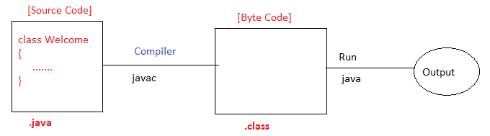

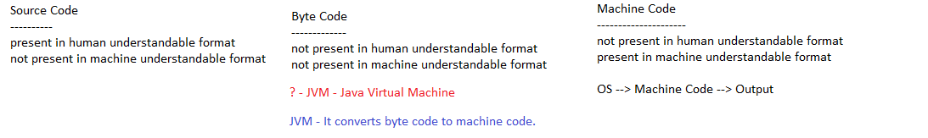

**Setup development environment**

**Install JDK (Java Development Kit)**

Step 1: Verify that it is already installed or not

Open command prompt and execute below commands:

***javac***

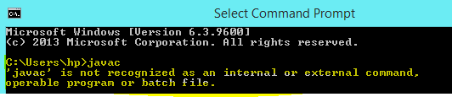

Step 2: Download JDK

* Click on the link: <https://www.oracle.com/java/technologies/downloads/>
* Search for Java 8, Choose type of operating system.

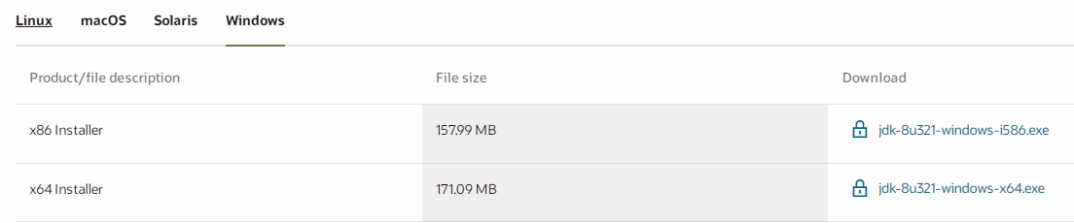

* Create an account, Sign-in and download

Step 3: Install JDK

Double click on ***jdk-8u321-windows-x64.exe*** file

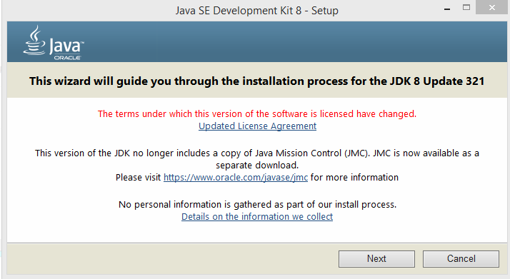

Step 4: Set the Path

Right click on "this PC". It can be named as "My Computer" in some systems. Choose "properties" from the options.

**Writing your first Java program**

Step1: Open any editor (Notepad, Edit plus, Sublime text etc.)

Step2: Write below java program

class Welcome

{

public static void main(String args[])

{

System.out.println("Welcome to Java World !!");

}

}

Step3: Save this program in a file (e.g. ***Welcome.java***).

Note: It is always recommended to give file name same as main class name.

Step4: Open command prompt and go to source code location.

Step5: Compile Java Program.

***Syntax: javac filename***

***javac Welcome.java***

Step6: Run Java Program.

***Syntax: java Main-Class-Name***

***Java Welcome***