DM 5.0 License

Introduction
In general DM 5.0 will be adhering to the licensing guide lines outlined in the “Guide to License Requirements” documentation that has been put together by Marcus Erickson. This document is available on our BBS Sharepoint site.
The DM 5.0 product specific behavior is listed in the following sections.

License Key Storage
The DM 5.0 license key (trial or production) will be stored in the Repository.

License Features
- License type
  - Production
  - Trial
- Expiration date
  - Specific expiration date
  - None (Permanent license)
- Number of monitored SQL Servers
- License version – this version will be hard coded to 5.0 and will not be checked in DM 5.0 for license verification.
- Node locking
  - Enterprise version – no node locking
  - Tied to the Repository SQL Server instance name

Trial License Generation
Whenever the Management Service finds there are no license keys in the repository, it will generate a trial license with the following characteristics and insert it into the repository.
- License type = Trial
- 15 monitored SQL Servers
- Expires in 14 days from the creation date of the repository database
- Node-locked to the repository instance
In trial mode DM 5.0 will be fully functional. We are not disabling any features of the product in a trial mode.

Invalid Keys
Most error checking is done by the server or in common code shared by both the server and client. It is not sufficient to do error checking only on the client because keys can be added directly to the LicenseKeys table, bypassing the client. Also, two clients could run concurrently and attempt to add the same key. Both would succeed if the server did not check for duplicate keys.
Keys are checked both when updating the LicenseKeys table and when the keys are read from the table.
Examples of invalid keys include the following.
- Future keys: Keys with a creation date in the future are not allowed. Such keys can be created by setting the computer’s clock ahead and generating a key.
- Unparseable keys: For example, keys that can’t be deserialized because of typos.
- Keys for other products.
- Keys for other repositories (scope).
- Expired keys: These are in a bit of a gray area between valid and invalid. See “Incompatible keys” (next).
- Incompatible keys: Multiple keys are allowed only if they are all permanent production keys. Keys are sorted by the DateAddedUtc field of the LicenseKeys table. If the first valid key is a trial key or has an expiration date, it must be the only key (others will be flagged with errors). If the first valid key is a permanent production key, any other keys that are not permanent production keys will be flagged with errors. In this logic, an expired key is considered valid. For example, if the first key in the table is expired (but passes all other tests), subsequent keys are considered incompatible because there can only be one key with an expiration date.
- Duplicate keys: To find duplicate keys, non case-sensitive comparisons are done after removing dashes and leading and trailing spaces. If duplicate keys exist, the first one encountered is accepted and the others are flagged with errors.
The license dialog will display all license keys found in the repository, including any invalid ones that may exist in the license table. Invalid keys will be shown with an appropriate error message. Parseable keys will be shown with the type, expiration date, and the number of licensed servers.
The license dialog will show the sum of the licensed servers from the valid keys. The same number will be used for license enforcement by the Management Service.

Entering License Keys
When entering a new key, the license dialog will either add it to the existing keys or replace them. Adding occurs if the new key and all existing keys are permanent production keys. Otherwise the new key must replace all existing keys. A new key is allowed to replace existing keys if it is valid (not expired, etc.) and the number of licensed servers is at least the number of monitored servers. The dialog will ask the user for confirmation before replacing the existing keys.
Trial keys can replace production keys and vice-versa since there is no difference in functionality between trail and production keys. The only significance of trial vs. production is that multiple trial keys are not allowed.

Removing License Keys
Keys can be removed via the license dialog. However, a key cannot be removed if it would cause a license violation where one did not already exist. If a license violation already exists, any and all keys can be removed.

Client-Side Enforcement
The client will check the license status whenever it connects to the repository (i.e. at startup and from the Connect To Repository dialog). The client will read the license keys directly from the repository after a successful connection is established. However, all updates to the LicenseKeys table are done through the Management Service so the service can apply the updates immediately.
There may be a mix of valid and invalid keys in the database. The invalid keys are essentially ignored for the purpose of license enforcement. The limit (count) fields of the valid keys are added up and the sum is checked against the number of monitored servers. If the client detects a problem with the license, it will display a message that depends on which of these four conditions exist.
- No valid keys.
- License is expired.
- License count is exceeded.
- License is about to expire.
In each case, the user is given an opportunity to fix the problem. Except for the last case (warning of impending expiration), the user must either fix the license to get past the check, or connect to a different repository.

No Valid Keys
If you see this message, it means there are no keys in the database or the keys that are there are all invalid. An expired key is a special case that results in a different message. One way to get this message is to start the client before the Management Service has generated the trial key.
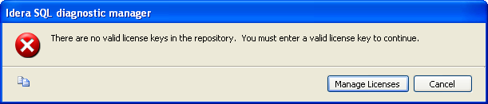
The “Manage Licenses” button displays the license keys dialog. After exiting the dialog, the license is checked again (whether or not any changes are made there), which could result in another one of these messages being displayed. The user is locked in a loop until he either fixes the license problem or clicks Cancel. The Cancel button cancels the process of connecting to the repository and displays the Repository Connection dialog. The user can then specify a different repository. If he specifies the same repository, he will see the same message again.

License is Expired
This message means the first “valid” key found was expired, but passed all other checks.
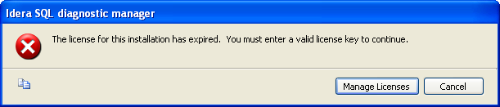

License Count Exceeded
This message means that the sum of the count fields of the valid licenses is less than the number of managed servers. In this case, there are two ways to fix the problem: Add a key to raise the license count or remove some monitored servers. In either case, the license is rechecked after the leaving the corresponding dialog.
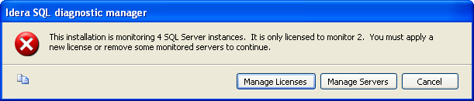

Near Expiration
This message is displayed when the license is going to expire in less than 10 days. This is not an error condition, so there is a Continue button instead of a Cancel button. The user can launch license keys dialog or just continue into the application. If he launches the license keys dialog, the license will be checked again when he exits the dialog.
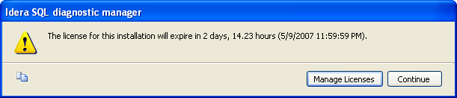

Server-Side Enforcement
The Management Service will read the license keys from the database and check for violations at these times.
- At startup.
- When adding or removing monitored servers.
- When updating the license keys.
Invalid license keys are ignored. If all valid license keys have expired or the number of licensed servers is less than the number of monitored servers, the following occurs.
- Scheduled data collection stops for all servers.
- All traces on the monitored SQL Servers stops.
- New monitored servers cannot be added.
If the Management Service finds there are no license keys in the database, it will generate a trial key as described earlier.

