

**Specification**

**for**

**08/05/10**

IderaLogo

Proprietary and Confidential to BBS Technologies, Inc.

**© 2010 BBS Technologies, Inc.; all rights reserved.**

# Revision history:

|  |  |  |
| --- | --- | --- |
| **When?** | **Who?** | **What?** |
| 08/09/2010 | Robert | First Draft |

# Table of Contents

1. Revision history: ii

2. Table of Contents iii

3. Requirements 1

3.1. Overview/Purpose 1

3.2. Use Cases 1

3.3. Feature/Function Market Requirements 1

3.3.1. Required Functions 1

3.3.2. Non-Supported Functions 2

3.4. Open Questions 2

4. Functional Design 3

4.1. User Interfaces 3

4.2. Installation and Upgrade 6

4.3. Permissions and other Required Configuration 6

4.4. Licensing Issues 6

4.5. Dependencies 6

4.5.1. Dependencies on Idera Software 6

4.5.2. Third-Party Software Required on the Customer Machine 6

4.5.3. Third-Party Software Required Internally 6

5. Internal Design 7

5.1. Architecture 7

5.2. Installation Issues 7

5.3. Schedule 7

5.3.1. Work Breakdown and Sizings 7

5.3.2. Areas of Risk 7

6. Quality Assurance Considerations 8

6.1.1. Overview 8

7. Documentation Considerations 8

8. Bibliography 8

# Requirements

## Overview/Purpose

This feature will implement Data Alerts. These are alerts genterated based on data changing. This has many uses from detecting unauthorized price and salary changes to unauthorized changes to stock trades and bank transactions. This feature will add one data alert – alert when a numerical column value changes.

## Use Cases

1. Users should receive alerts when data values change.
2. Users should be able to view these data alerts in the alerts view.
3. Users should be able to create and configure these alerts from the Alerts ribbon in the Administration view.
4. Users should receive an alert when the value of a column changes.

## Feature/Function Market Requirements

### Required Functions

#### Data Alerts

Data Alerts are a new type of alerts that will be created based on data changes. This feature only include one new alert – alerting when the value of a column changes.

##### Alert When a Column Value Changes

###### Alert Description

This new data alert will be generated when the value of a column changes. The user will selected a column to be monitor, a comparison operator and a value for comparison. The only columns available for this alert will be numeric columns that have set up for Before and After Data Auditing. The comparison operators will be: =, <, >, <=, >=, !=.

###### Work Flow

Alert Rule Creation

1. The user will click New Data Rule from the Alert Rules tab on the Administration ribbon.
2. A New Data Alert Rule wizard will be displayed.
3. The first page of the wizard will display a tree view of available columns for alerting. (see Section 4.1) Only columns that have been setup for BAD auditing will be available to data alerting. If a desired column is missing from the data alert wizard, it needs to be added the BAD auditing before it will be available for data alerting.
4. The user will select a column, a comparison operator and a value for comparison against.
5. The following information will be just like the status alerts. Alert level, email and event log will all be options.
6. The alert rule will be displayed on the alert rules tab along with staus rules and event rules.

Alert Generation

The data alerts will be processed along with the event alerts. But instead of using the data in the events table, it will use the data in the DataChanges and ColumnChanges tables. Just like the event alerts, the data alerts will be processed in blocks of 5000 events at a time. There is consideration being given to removing that limit but that is not a part of this feature.

When processing the BAD events for the new data alert, it will compare the column value to the comparison value in the data alert rule. If that comparison is true, an alert will be generated.

Here is an example default message for the alert. “The value in column [column] is [comparison operator] [value from the alert rule]. This was changed by user: [username]”

#### Changes to the Alerting Framework

Event Alerts and Status Alerts will stay the same.

* A new Data Alert button will be added to the Alert Rules ribbon
* A new wizard is being created to maintain Data Alert rules. See Figure 2 in Section 4.

### Non-Supported Functions

* The new alert will not include alerts on string data or blog data.

## Open Questions

1. Should the Data Alerts be displayed with the Event Alerts? Unlike the Status Alerts, they are similar and have similar data.

# Functional Design

## User Interfaces

Fig 1. The data alert rules will be added in the via the Alert Rules tab in the Administration view.

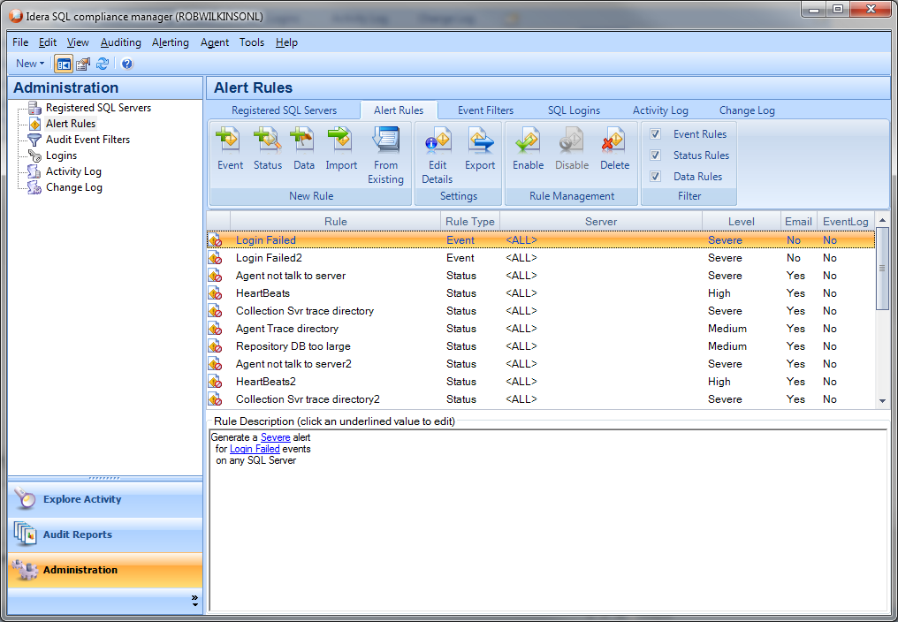

Fig 2. This is the Add a Data Alert wizard. Currently there is only one alert of this type so the first page of the wizard will have a description of the alert.

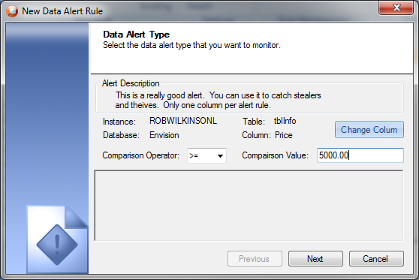

When the user clicks Change Column, a dialog will be displayed that shows all the columns available for this alert. This dialog will only include numeric columns that have been set up for BAD Auditing.

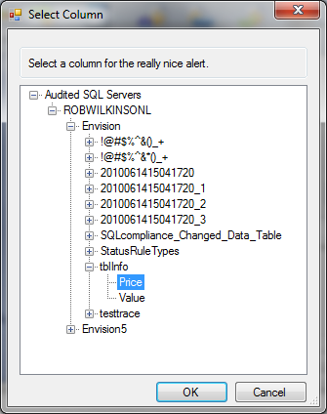

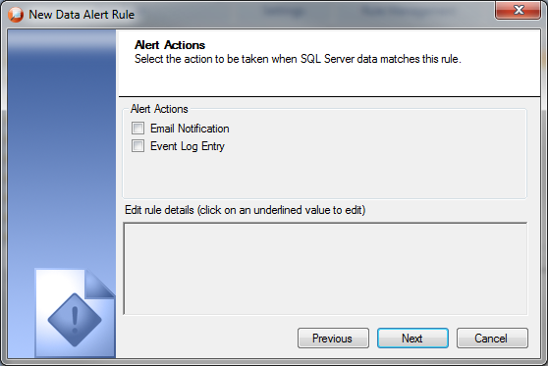

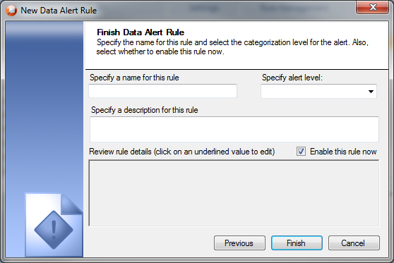

## Installation and Upgrade

None

## Permissions and other Required Configuration

The user must have modify rights to add alert rules. Otherwise, everything will be read only.

## Licensing Issues

None

## Dependencies

None

### Dependencies on Idera Software

None

### Third-Party Software Required on the Customer Machine

None

### Third-Party Software Required Internally

None

# Internal Design

## Architecture

An overview of the architecture behind this feature – how it works, components, communication between components etc

* Collection Server Changes
  + The Data Alert processing will be done with the Event Alert processing.
  + Repository Changes –

The clustered index on the ColumnChanges table is the columned. This is a very bad decision because there will be very few unique entries in this column. The clustered index will be changed to be a combination of the columnId and the dcId. The dcId is the unique Id from the DataChanges table.

## Installation Issues

None.

## Schedule

### Work Breakdown and Sizings

|  |  |  |
| --- | --- | --- |
| Component | Who | Sizing (Days) |
| Repository Changes | Robert | 1 |
| Collection Server Changes to process the alert | Robert | 2 |
| Data Alert Wizard | Robert | 3 |
| New Data Alert View | Robert | 2 |
| Testing | Robert | 1 |
| **Total** |  | **9** |

### Areas of Risk

None

# Quality Assurance Considerations

### Overview

Need to verify existing alerting doesn’t have problems with the new alerting rules.

Need to make sure data alerts don’t show in event alerts grids or reports.

# Documentation Considerations

* The new alerts will need to be documented in the help.
* There will be a new wizard and ribbon UI changes that will need to be reviewed for proper grammar, wording, etc.

# Bibliography