For a RAG (Retrieval-Augmented Generation) application, the vector database design is more important than the choice of vector database itself. A poorly designed vector structure will produce poor retrieval results even with the best vector database.
For your use case (Insurance Broker dealing with multiple Motor Insurance products from different insurers), I would recommend designing the vector database in the following way.

1. Overall Architecture
Insurance Documents
(PDFs, Brochures, FAQs)
|
v
Document Processing
(OCR, Parsing, Cleaning)
|
v
Chunking Strategy
|
v
Metadata Enrichment
|
v
Embedding Generation
|
v
Vector Database
(Pinecone/Qdrant)
|
v
LLM Query

2. Collection Design
Instead of keeping everything in one vector collection, divide by business domain.
Collection | Purpose
motor_products | Motor insurance product details
motor_claims | Claim process and documents
motor_underwriting | Underwriting rules
motor_exclusions | Exclusions and conditions
faqs | Frequently asked questions
regulatory | IRDAI guidelines

Example
Collection:
motor_products

3. Document Chunking Strategy
This is where most RAG systems fail.
Avoid:
Fixed chunk = 1000 words
Prefer:
Semantic chunking
Example brochure:
HDFC ERGO Private Car Policy

Section 1:
Own Damage Cover

Section 2:
Third Party Liability

Section 3:
Add-on Covers

Section 4:
Exclusions
Store each section separately:
{
"text": "Zero depreciation cover provides...",
"section": "Add-on Covers"
}

Recommended chunk size:
Document | Chunk size
Insurance brochure | 300-600 tokens
FAQs | One FAQ = One chunk
Tables | One table = One chunk
Policy wording | Section based

4. Metadata Design
Metadata is critical.

Example:
{
"insurer": "HDFC ERGO",
"product": "Private Car Insurance",
"product_type": "Motor",
"vehicle_type": "Private Car",
"coverage_type": "Own Damage",
"section": "Add-on Cover",
"addon": "Zero Depreciation",
"version": "2026",
"effective_date": "2026-04-01",
"document_type": "Brochure",
"source_file": "hdfc_motor_brochure.pdf",
"page_no": 32
}
This allows filtering:
SQL: Find:
Insurer = HDFC
Vehicle = Private Car
Section = Add-on
before vector search.

5. Embedding Model
For insurance domain, use a good embedding model.
Recommended:
Model | Quality
OpenAI text-embedding-3-large | Excellent
OpenAI text-embedding-3-small | Very good
BAAI bge-large | Excellent open source
e5-large-v2 | Excellent open source
Example:
{
"id":"chunk_1001",
"embedding":[0.123,0.345,...],
"text":"Zero depreciation cover...",
"metadata":{...}
}

6. Vector Database Schema

Example in a vector database like Qdrant:
{
"id": "motor_001",
"vector": [1536 dimensions],
"payload": {
"insurer":"ICICI Lombard",
"product":"Private Car",
"vehicle":"Car",
"coverage":"OD",
"addon":"RTI",
"page":45,
"version":"2026"
}
}

7. Hybrid Search Design
Do not rely only on vectors.
Use:
Hybrid Search
= Vector Search + Keyword Search + Metadata Filtering

Example query:
Which insurer provides return to invoice cover for electric vehicles?
Execution:
Metadata filter:
vehicle=EV

Keyword:
return to invoice

Semantic search:
similarity search
This gives much better results.

8. Parent-Child Retrieval

For insurance, use a Parent-Child architecture.
Example:

Parent Document
ICICI Lombard Private Car Policy

Child Chunks
Add-on cover
Zero depreciation
Exclusions
Claim process
Documents required

Store:
parent_id = ICICI_motor_2026
child_id = ICICI_motor_2026_chunk_45
When a chunk is retrieved, return the entire section from the parent document.

9. Versioning Strategy
Insurance products change frequently.
HDFC Motor Policy
v2024
v2025
v2026
Metadata:
{
"product":"Private Car",
"version":"2026",
"effective_date":"2026-04-01",
"active":true
}

Never overwrite old vectors.

10. Recommended Database Structure for Your Insurance Broker

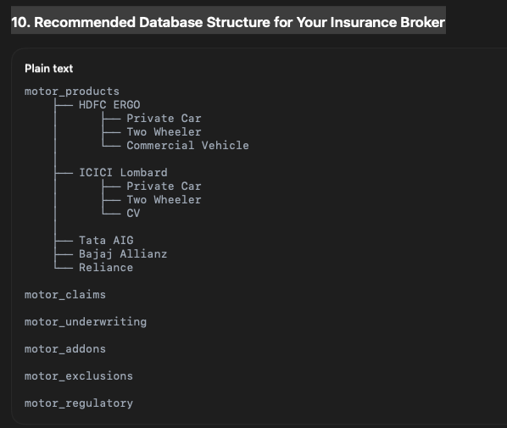

11. Which Vector Database Should You Choose?

Database | Recommendation
Qdrant | Best for insurance RAG (open source)
Pinecone | Best managed service
Weaviate | Good for enterprise
Milvus | Good for very large scale
pgvector | Good if already using PostgreSQL
For an insurance broker with 10-20 insurers and thousands of product documents, I would recommend:
LLM : GPT-5 / Claude
Embedding : text-embedding-3-large
Vector DB : Qdrant
Retrieval : Hybrid Search + Reranking
Framework : LangGraph or LlamaIndex
Storage : PostgreSQL + Object Storage

This architecture typically achieves 85-95% retrieval accuracy for insurance product advisory and comparison use cases.

When your PDF contains tables, you should never split the table arbitrarily into fixed-size chunks. In insurance documents, tables usually contain the most important information such as IDV ranges, premium rates, add-ons, underwriting rules, and claim documents.
The best practice is to treat each table as a separate semantic object.

1. Example Insurance PDF Table
Suppose your brochure contains:
Add-on Cover | Private Car | EV Car | Age Limit
Zero Dep | Yes | Yes | 7 Years
Engine Protect | Yes | Yes | 10 Years
Return To Invoice | Yes | No | 5 Years

2. Convert Table into Structured Text
Convert the table into natural language.
Document: ICICI Lombard Motor Policy
Section: Add-on Cover

Zero Depreciation cover is available for:
- Private Car : Yes
- Electric Vehicle : Yes
- Maximum vehicle age : 7 years

Engine Protect cover is available for:
- Private Car : Yes
- Electric Vehicle : Yes
- Maximum vehicle age : 10 years

Return To Invoice cover is available for:
- Private Car : Yes
- Electric Vehicle : No
- Maximum vehicle age : 5 years
This becomes one chunk.

3. Store Original Table as Metadata
{
"chunk_type":"table",
"insurer":"ICICI Lombard",
"product":"Private Car",
"section":"Add-on Cover",
"text":"Return To Invoice cover is available...",
"table_data":{
"cover":"Return To Invoice",
"private_car":"Yes",
"ev":"No",
"age_limit":"5 years"
}
}

This allows:
- semantic search
- filtering
- displaying the original table

4. Large Tables
- Suppose the PDF contains:
Make | Model | Variant | IDV
Maruti | Swift | VXI | 7,50,000
Maruti | Swift | ZXI | 8,20,000
Hyundai | Creta | SX | 15,00,000
Convert every row into a chunk:
Chunk 1:
Manufacturer: Maruti
Model: Swift
Variant: VXI
IDV: 750000

Chunk 2:
Manufacturer: Maruti
Model: Swift
Variant: ZXI
IDV: 820000

Chunk 3:
Manufacturer: Hyundai
Model: Creta
Variant: SX
IDV: 1500000

5. Decision Matrix
Table Type | Chunk Strategy
Add-on benefits | Entire table = one chunk
Feature comparison | Entire table = one chunk
Claim process matrix | Entire table = one chunk
Premium slab | Entire table = one chunk
Vehicle master data | One row = one chunk
Insured Declared Value (IDV) table | One row = one chunk
Underwriting rules | One rule = one chunk

6. Recommended Metadata
{
"document":"hdfc_motor_2026.pdf",
"page":45,
"chunk_type":"table",
"table_name":"Add-on Cover Matrix",
"insurer":"HDFC ERGO",
"product":"Private Car",
"section":"Add-ons",
"embedding_text":"Zero Dep available for private cars and EV vehicles upto 7 years",
"raw_table":"<original json table>"
}

7. Recommended Pipeline for Insurance PDFs

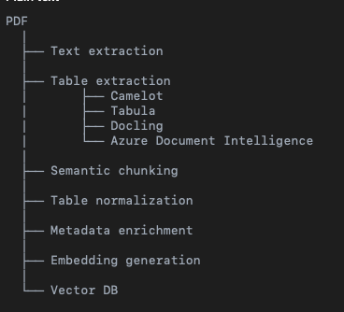

8. For Motor Insurance RAG (your use case)

I would classify chunks into:
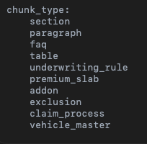

This enables queries such as:
“Which insurer offers Return To Invoice for EV vehicles?”
Or “Show all insurers providing Zero Dep for vehicles older than 5 years.”

without losing the table structure during vector retrieval.
For insurance RAG systems, 50% of the retrieval quality comes from how you chunk tables, not from the LLM or the vector database itself.

Define vector
In your Motor Insurance RAG system, you don’t manually define the vector itself (the vector is generated by the embedding model). What you define is:
- What text goes into the embedding model
- What metadata accompanies the vector
- How the vector record is structured
Think of it as:
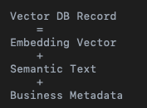

Example 1: Add-on Cover Table
Suppose your PDF has:
Add-on | Private Car | EV | Max Age
Zero Dep | Yes | Yes | 7 Years
RTI | Yes | No | 5 Years
You should create a chunk like:
Document: ICICI Lombard Private Car Policy

Add-on cover: Zero Depreciation

Coverage available:
- Private Car: Yes
- Electric Vehicle: Yes
- Maximum vehicle age: 7 years

This add-on covers depreciation deduction during claim settlement.

Then generate the embedding:
embedding = embedding_model.embed(chunk_text)

Complete Vector Record
{
"id": "ICICI_ADDON_001",

"vector": [0.234,-0.892,...],

"payload": {

"insurer": "ICICI Lombard",
"product": "Private Car",
"vehicle_type": "Private Car",
"chunk_type": "addon",

"addon_name": "Zero Depreciation",

"text":
"Zero depreciation cover is available
for private cars and electric vehicles
upto vehicle age of seven years.",

"page": 45,

"source_file":
"icici_private_car_2026.pdf",

"version": "2026"
}
}

Example 2: Premium Table

Pdf:
Vehicle Age | Premium
0-3 Years | 3000
3-5 Years | 4500
5-7 Years | 7000

Create one vector per row:

{
"text":
"Zero depreciation premium for vehicles
aged between 0 and 3 years is INR 3000.",
"metadata":{
"vehicle_age":"0-3",
"premium":"3000"
}
}

Example 3: Underwriting Rule
PDF:
RTI cover available only for vehicles upto 5 years old.

Vector
{
"id":"UW_001",
"vector":[...],
"payload":{
"chunk_type":"underwriting",
"rule":"RTI age restriction",
"vehicle_age":"5",
"text":
"Return to invoice cover is available only for vehicles upto five years old."
}
}

Example 4: FAQ
PDF:
Q: Is Zero Dep available for EV?
A: Yes, upto 7 years.
Vector:
{
"chunk_type":"faq",
"question": "Is zero depreciation available for EV?",
"answer": "Yes, available upto 7 years.",
"text": "Question: Is zero depreciation available for electric vehicles? Answer: Yes, upto 7 years."
}

Recommended Payload Schema for Insurance RAG
{
"id":"",

"vector":[1536 values],

"payload":{

"insurer":"",
"product":"",
"lob":"motor",

"vehicle_type":"",
"policy_type":"",

"chunk_type":"",

"section":"",
"sub_section":"",

"addon_name":"",
"coverage_type":"",
"exclusion_type":"",

"document_type":"",
"page_number":"",

"effective_date":"",
"version":"",

"text":""
}
}

