

MANAV RACHNA INTERNATIONAL INSTITUTE OF RESEARCH AND STUDIES
(Deemed to be University under section 3 of the UGC Act, 1956)

SCHOOL OF ENGINEERING AND TECHNOLOGY
Department of Computer Science and Engineering

LAB MANUAL
for

PROGRAMMING USNIG R
(BCS-DS-473)

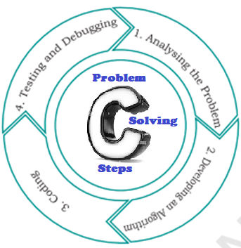



PREFACE

This laboratory manual is designed for the B.Tech programme offered by the Department of Computer Science & Engineering, SET, MRIIRS, for the subject “Programming Using R (BCS-DS-473)”. This lab manual may be used as instructional book for students, faculty members and instructors to assist in performing and understanding the experiments. In this manual algorithms, flowcharts, R-programs and viva questions are explained as per the university syllabus and some numerical problems related to some algorithms are explained. This manual is available in electronic form at the University’s official website.

VISION OF THE DEPARTMENT

To empower the graduates to be technologically adept, innovative, self-motivated and responsible citizens, possessing human values and contribute significantly towards being a center of excellence in providing globally standard education, through a conducive Teaching and Research environment, that responds swiftly to the challenges of the ever-changing world.

MISSION OF THE DEPARTMENT

- To achieve academic excellence by imparting in-depth knowledge to the students through effective pedagogies and hands-on experience on the latest tools and technologies.
- To pursue interdisciplinary research that will serve the needs of the entire global community.
- To prepare students to be continuous learners in a connected world and imbibe professional skills and ethical responsibilities in them.
- To strengthen the industry-Academia interface that will help the graduates to emerge as leaders in academics or an inspiring revolutionary in entrepreneurship.

PROGRAMME EDUCATIONAL OBJECTIVES (PEOs)

- Graduates will exhibit technical proficiency and leadership to become qualified engineers paving the way for a prosperous career in industry, consultancy, education, and allied areas related to the subjects of Computer Science and Engineering.
- Graduates will commit to sustainable development, identify the real-life gaps and mobilize the requirements, and propose an innovative solution while maintaining ethical, professional, and social obligations.
- Graduates will continue their education throughout their lives thereby creating and disseminating knowledge based on research and challenging problem-solving strategies.

PROGRAMME SPECIFIC OUTCOMES (PSOs)

Engineering Graduates will be able to:
- Legacy Software: Upgrade and maintain legacy software systems by using modern techniques, programming skills, and tools.
- Development of Software Systems: Develop, test and maintain Software systems for business and other applications, that meets the automation needs of the society and industry.
- Research and Development: Cultivate the field of computing and its latest trends, to pursue teaching, research & development activities and to work effectively in a team.

PROGRAMME OUTCOMES (POs)

Engineering Graduates will be able to:

- Engineering Knowledge: Apply knowledge of mathematics, natural science, computing, engineering fundamentals and an engineering specialization as specified in WK1 to WK4 respectively to develop to the solution of complex engineering problems.

- Problem Analysis: Identify, formulate, review research literature and analyze
complex engineering problems reaching substantiated conclusions with consideration for sustainable development. (WK1 to WK4)

- Design/Development of Solutions: Design creative solutions for complex engineering problems and design/develop systems/components/processes to meet identified needs with consideration for the public health and safety, whole-life cost, net zero carbon, culture, society and environment as required. (WK5)

- Conduct Investigations of Complex Problems: Conduct investigations of complex engineering problems using research-based knowledge including design of experiments, modelling, analysis & interpretation of data to provide valid conclusions (WK8).

- Engineering Tool Usage: Create, select and apply appropriate techniques, resources and modern engineering & IT tools, including prediction and modelling recognizing their limitations to solve complex engineering problems. (WK2 and WK6)

- The Engineer and The World: Analyze and evaluate societal and environmental aspects while solving complex engineering problems for its impact on sustainability with reference to economy, health, safety, legal framework, culture and environment. (WK1, WK5, and WK7).

- Ethics: Apply ethical principles and commit to professional ethics, human values, diversity and inclusion; adhere to national & international laws. (WK9).

- Individual and Collaborative Team work: Function effectively as an individual, and as a member or leader in diverse/multi-disciplinary teams.

- Communication: Communicate effectively and inclusively within the engineering community and society at large, such as being able to comprehend and write effective reports and design documentation, make effective presentations considering cultural, language, and learning differences

- Project Management and Finance: Apply knowledge and understanding of
engineering management principles and economic decision-making and apply these to one’s own work, as a member and leader in a team, and to manage projects and in multidisciplinary environments.

- Life-Long Learning: Recognize the need for, and have the preparation and ability for i) independent and life-long learning ii) adaptability to new and emerging technologies and iii) critical thinking in the broadest context of technological change. (WK8)

OUR VALUES

DO’s & DON’Ts
DO’s

- Keep your Lab area neat and clean.
- Respect others and work quietly.
- Cellphones are to be turned off during Lab periods.
- Turn off the machine once you are done using it.
- Keep your files organized.
- Always maintain an extra copy of all your important data files.
- Students should be aware of office ergonomic guidelines for correct posture when using computer equipment.
- Please treat fellow users of the laboratory, and all equipment within the laboratory, with the appropriate level of care and respect.

Don’ts

- Do not eat or drink inside the laboratory.
- Avoid stepping on electrical wires or any other computer cables.
- Do not insert metal objects such as clips, pins and needles into the computer casings. They may cause fire.
- Do not remove anything from the computer laboratory without permission.
- Do not touch, connect or disconnect any plug or cable without your teacher/ laboratory Technician’s permission.
- Do not misbehave in the computer laboratory.
- Do not play any Game in the laboratory.
- Do not plug in external devices without scanning them for computer viruses.
- Students should not attempt to repair, open, tamper or interfere with any of the computer, printing, cabling, air conditioning or other equipment in the laboratory.
- Do not personalize the computers, for example: installing screen savers, changing the desktop background or changing the video and audio settings.
- Do not install or download any software or modify or delete any system files on any lab computers.
- Do not read or modify other users' files.
- If you leave the lab, do not leave your personal belongings unattended.

IMPORTANT INFORMATION FOR STUDENTS
- Students must read the lab manual and make necessary preparation for each session PRIOR TO coming to the lab.

- Each lab session will last for approximately two hours, within which there will be time for Instructor’s demonstration, lab experiments and question answers.

- For all the programs / practical, the system (Hardware and Software) requirements are given below:

Hardware
Intel Pentium IV processor-based CPU/2.0 GHz/512 MB RAM/80 GB HDD/104 keys keyboard/15” SVGA
Software
- Microsoft Windows XP SP2
- Microsoft VsCode or RStudio

  - Students must work on all programs listed in the index page along with their algorithms and flow charts, wherever required.

- In each experiment, there are some questions, those must be answered by the student.

- At the end of each experiment students must obtain signature with date from their faculty members concerned on the result and outcome.

- Lab file must be verified by the faculty member at provided / regular time interval.

- Lab file and assignments must be written in the student’s own handwriting; no printed copy will be accepted by the faculty members.

- Students must be in the lab on time for the lab period. No late coming is allowed without prior consent from the respective faculty member. Failure to do so may eliminate your mark for that lab session.

- Duplicated(copied) lab assignment: the source and duplicate will be considered void

INTRODUCTION
This laboratory manual is designed to support hands-on learning of the R Programming Language through practical experiments and exercises. The experiments included in this manual aim to strengthen data-analysis and problem-solving skills, and help students understand fundamental R concepts such as data types and objects, control structures, functions, vectors, matrices, lists, data frames, data import/export, statistical summaries, data visualization, and basic data science workflows.
This manual is organized in such a way that students can directly use it in the laboratory. Each laboratory experiment comprises:
Statement of the problem
Algorithm
Flowchart
R Code
Results/Output
Viva Questions & Answers
Students must follow this sequence to conduct any problem-solving experiment in the computer laboratory and write their report accordingly. Students are advised to write the algorithm first and then the R code.

CONTENT
Sl. No | Experiment Description | CO  Map. | Page No
 | Lab Rubrics | -- | 1
1 | Basics of R, R data types and objects, reading and writing data | CO1 | 2
2 | Control structures, functions, scoping rules | CO1 | 3
3 | Loop functions, date and time | CO1 | 4
4 | Vectors, data frames, list, matrices and writing functions | CO1 | 5
5 | Importing data (csv, xls, txt etc) | CO1 | 6
6 | Mean, Median, Mode using vector | CO2 | 7
7 | Plotting with ggplot2 | CO5 | 7-8
8 | Data Analysis in R Studio: Regression analysis, correlation analysis | CO2 | 9
9 | Graphs, plots: bar chart, box plot, pie chart, dot plots, scatter plots | CO5 | 10
10 | A data science project - more advanced | CO6 | 11-12
11 | Sort a given data frame by multiple column(s) | CO4 | 12-13
12 | Vector arithmetic and subsetting | CO4 | 14
13 | Row and column index of maximum and minimum value in a matrix | CO4 | 14
14 | List containing a vector, matrix and list; access elements | CO4 | 15-16
15 | Compute sum, median, standard deviation of a dataset | CO2 | 16-17
16 | Histograms and box plots of clinic and radiology visits | CO5 | 18
17 | Matrix creation and multiplication | CO4 | 19
18 | Radiology data means/SD; airquality dataset; ordering a data frame | CO2 | 19
19 | Scatter plot and simple linear regression of radiology vs clinic visits | CO2 | 20
20 | Recommender system and 3D graph using dplyr | CO6 | 21
21 | Visualization of COVID-19 data for India | CO5 | 20
22 | Design a system for fake news detection | CO6 | 48-49
23 | Viva Question Bank with Solutions |  | 50-53

Rubrics for PPS Lab

Performance Indicator (PI) | Course Outcome | Unsatisfactory [1] | Developing [2] | Satisfactory [3] | Exemplary [4]
Understand R syntax and basic data types/objects | BCS-DS-473.1 | Not able to understand the basics of R programming | Knows the basic data types in R | Can explain and use all R data types and objects | Has deep, fluent command of R syntax and objects
Perform statistical tests and computations using R | BCS-DS-473.2 | Doesn't know basic statistical functions in R | Knows basic statistical functions (mean, median, sd) | Can perform standard statistical tests using R | Can select and apply the appropriate statistical test for a given problem
Analyze data sets and present findings using R packages | BCS-DS-473.3 | Cannot import or organize a data set in R | Can import and inspect a data set | Can analyze a data set and summarise findings | Can analyze and present findings clearly using appropriate R packages
Execute operations on various data types/structures | BCS-DS-473.4 | Doesn't know vectors, matrices, lists or data frames | Knows the basic structures but struggles to manipulate them | Can manipulate vectors, matrices, lists and data frames confidently | Can combine multiple data structures to solve non-trivial problems
Visualize data using different graphs/charts | BCS-DS-473.5 | Cannot generate any plot in R | Can generate a basic plot with base R | Can generate multiple chart types with appropriate labelling | Can design clear, well-labelled visualizations using ggplot2 and base graphics
Design and develop solutions for real analytical problems | BCS-DS-473.6 | Cannot approach a real-world analytical problem | Can attempt a simplified version of a real problem | Can design an end-to-end solution for a moderate analytical problem | Can design, build and evaluate a complete data science solution

PROGRAM 1. Write a R program to demonstrate the basic data types and objects in R, and to write data to a file and read it back.

Algorithm:
- START
- DECLARE variables of different R data types: numeric, integer, character, logical, complex
- DISPLAY the class/type of each variable using class() and typeof()
- CREATE a data frame containing sample student records
- WRITE the data frame to a CSV file using write.csv()
- READ the CSV file back into R using read.csv()
- DISPLAY the imported data
- STOP

FLOWCHART
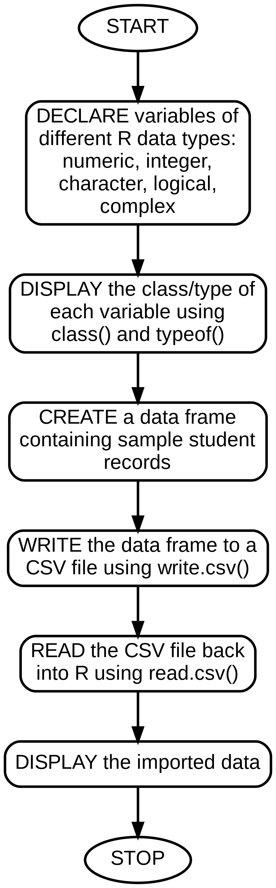
Code:-
num_var <- 25.5
int_var <- 10L
char_var <- "R Programming"
logi_var <- TRUE
complex_var <- 3 + 2i

cat("Numeric :", class(num_var), "\n")
cat("Integer :", class(int_var), "\n")
cat("Character:", class(char_var), "\n")
cat("Logical :", class(logi_var), "\n")
cat("Complex :", class(complex_var), "\n")

df <- data.frame(Name = c("Amit", "Riya", "Kunal"),
Marks = c(85, 90, 78))
write.csv(df, "students.csv", row.names = FALSE)

data_read <- read.csv("students.csv")
print(data_read)

Output:-
Numeric : numeric
Integer : integer
Character: character
Logical : logical
Complex : complex
Name Marks
1 Amit 85
2 Riya 90
3 Kunal 78

PROGRAM 2. Write a R program to demonstrate control structures (if-else, for, while), user-defined functions, and lexical scoping rules.

Algorithm:-
- START
- DEFINE a function using if-else to classify a number as positive, negative or zero
- DEFINE a function using a for loop to print the first N natural numbers
- DEMONSTRATE a while loop that prints iteration numbers
- DEMONSTRATE lexical scoping using a global variable and a local variable of the same name
- CALL all functions and display the results
- STOP
FLOWCHART
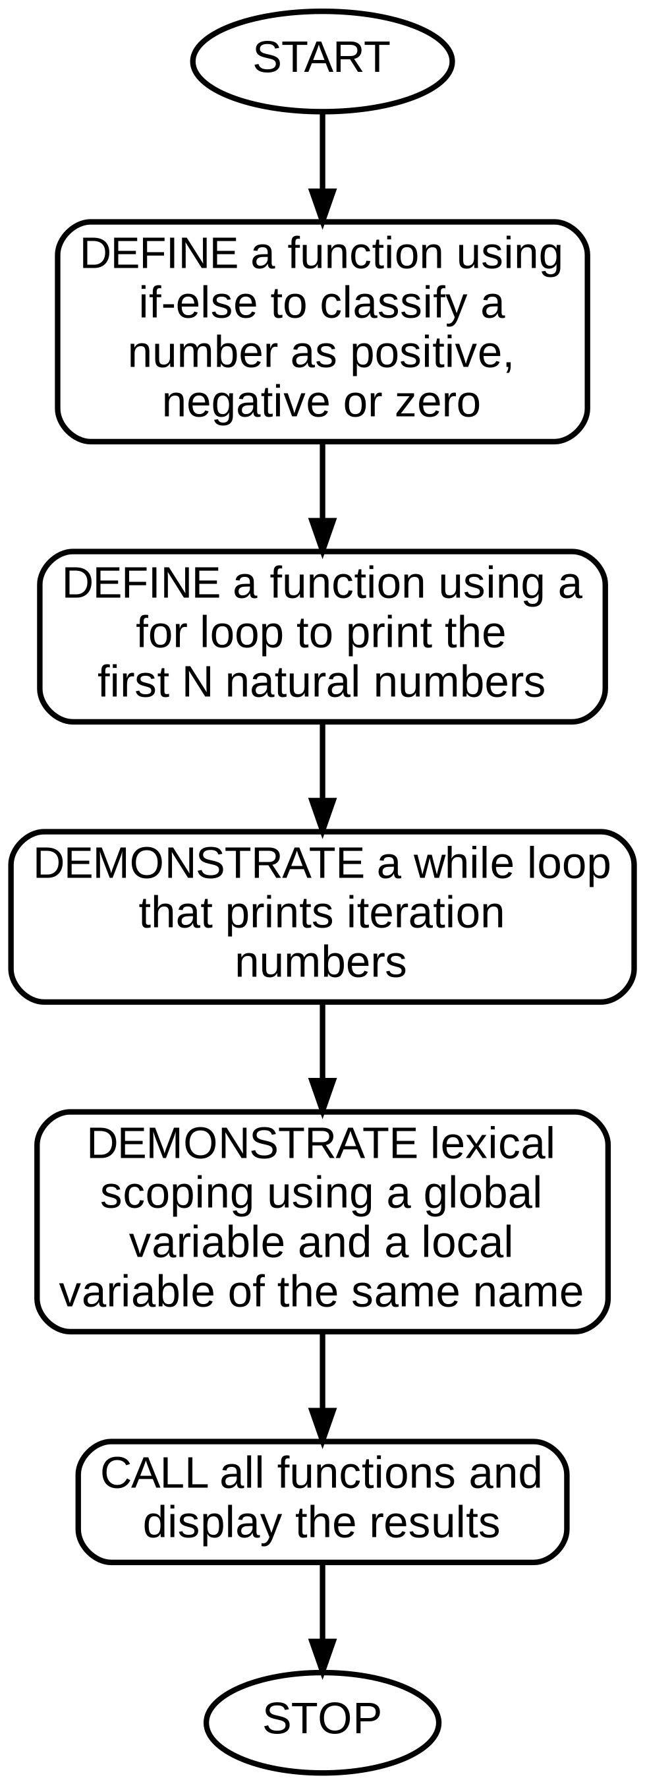
Code:-
check_number <- function(x) {
if (x > 0) "Positive"
else if (x < 0) "Negative"
else "Zero"
}
//number <- as.numeric(readline("Enter your number "))
print(check_number(-5))

print_natural <- function(n) {
for (i in 1:n) cat(i, " ")
cat("\n")
}
print_natural(5)

i <- 1
while (i <= 3) {
cat("Iteration:", i, "\n")
i <- i + 1
}

x <- 10
scope_demo <- function() {
x <- 20
cat("Inside function, x =", x, "\n")
}
scope_demo()
cat("Outside function, x =", x, "\n")

Output:-
[1] "Negative"
1 2 3 4 5
Iteration: 1
Iteration: 2
Iteration: 3
Inside function, x = 20
Outside function, x = 10

PROGRAM 3. Write a R program to demonstrate the apply family of loop functions (lapply, sapply, tapply) and functions for handling date and time.

Algorithm:-
- START
- CREATE a numeric vector
- APPLY lapply() and sapply() to compute the square of each element
- CREATE a vector of scores with corresponding group labels
- USE tapply() to compute the group-wise mean of the scores
- OBTAIN the current system date and time using Sys.Date() and Sys.time()
- FORMAT and DISPLAY the date and time
- STOP
FLOWCHART
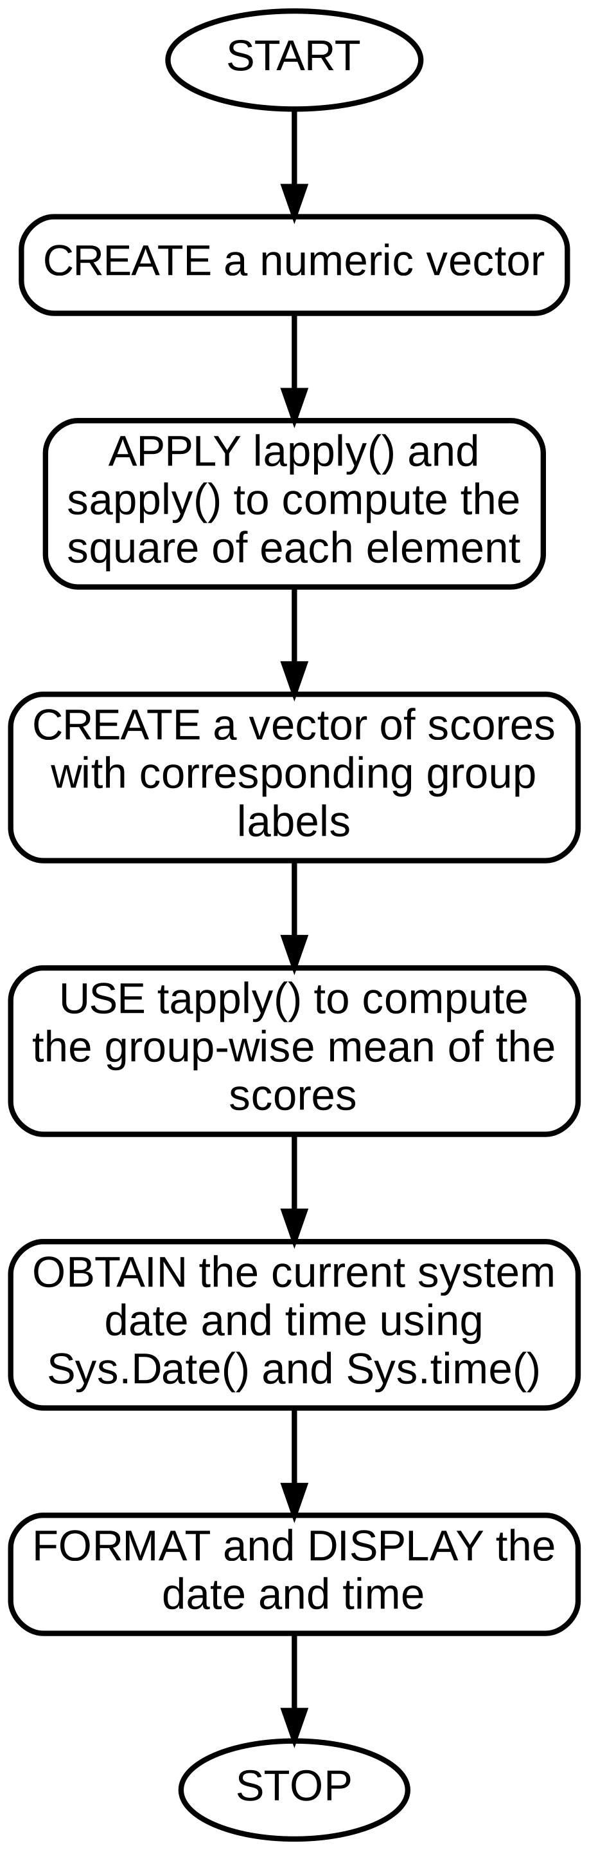
Code:-
nums <- c(1, 2, 3, 4, 5)
sq_list <- lapply(nums, function(x) x^2)
sq_vec <- sapply(nums, function(x) x^2)
print(sq_vec)

scores <- c(80, 90, 70, 85, 60)
grp <- c("A", "B", "A", "B", "A")
print(tapply(scores, grp, mean))

today <- Sys.Date()
now <- Sys.time()
cat("Today's date :", format(today, "%d-%m-%Y"), "\n")
cat("Current time :", format(now, "%H:%M:%S"), "\n")

Output:-
[1] 1 4 9 16 25
A B
70.00000 87.50000
Today's date : 26-07-2026
Current time : 10:15:32

PROGRAM 4. Write a R program to create and manipulate vectors, matrices, lists and data frames, and to write a user-defined function that operates on them.

Algorithm:-
- START
- CREATE a numeric vector, a matrix, a list and a data frame
- PERFORM basic indexing operations on each structure
- DEFINE a function that accepts a vector and returns its mean and standard deviation
- CALL the function and display the result
- STOP

FLOWCHART
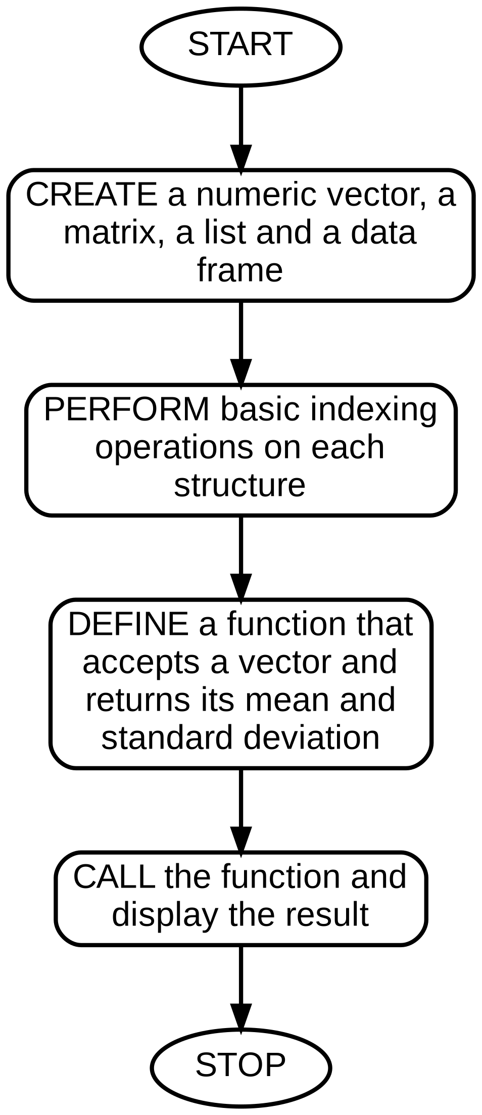
Code:-
v <- c(10, 20, 30, 40)
m <- matrix(1:9, nrow = 3, ncol = 3)
l <- list(name = "R", version = 4.3, active = TRUE)
df <- data.frame(ID = 1:3, Name = c("A", "B", "C"))

cat("Vector :", v, "\n")
cat("Matrix[2,2] :", m[2,2], "\n")
cat("List name :", l$name, "\n")
print(df)

stats_fn <- function(x) list(mean = mean(x), sd = sd(x))
print(stats_fn(v))

Output:-
Vector : 10 20 30 40
Matrix[2,2] : 5
List name : R
ID Name
1 1 A
2 2 B
3 3 C
$mean
[1] 25

$sd
[1] 12.90994

Algorithm:-

PROGRAM 5. Write a R program to import data from CSV, TXT and Excel (xlsx) files into R.

- START
- CREATE sample data and write it out as a .csv file and a .txt file
- READ the .csv file using read.csv()
- READ the .txt file using read.table()
- INSTALL and LOAD the readxl package to read a .xlsx file using read_excel()
- DISPLAY the imported data frames using str() and head()
- STOP

FLOWCHART
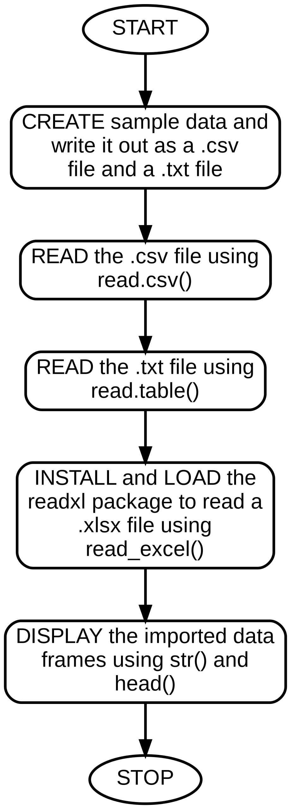
Code:-
df <- data.frame(ID = 1:4, Product = c("Pen","Book","Bag","Pencil"), Price = c(10,150,600,5))
write.csv(df, "products.csv", row.names = FALSE)
write.table(df, "products.txt", sep = "\t", row.names = FALSE)

csv_data <- read.csv("products.csv")
txt_data <- read.table("products.txt", header = TRUE, sep = "\t")

str(csv_data)
print(head(txt_data))

# For Excel files:
# install.packages("readxl")
# library(readxl)
# xls_data <- read_excel("products.xlsx")
# print(xls_data)

Output:-
'data.frame': 4 obs. of 3 variables:
$ ID : int 1 2 3 4
$ Product: chr "Pen" "Book" "Bag" "Pencil"
$ Price : num 10 150 600 5
ID Product Price
1 1 Pen 10
2 2 Book 150
3 3 Bag 600
4 4 Pencil 5

Algorithm:-

PROGRAM 6. Write a R program to compute the mean, median and mode of a given numeric vector.

- START
- CREATE a numeric vector of sample values
- COMPUTE the mean using mean()
- COMPUTE the median using median()
- DEFINE a custom function to compute the mode, since R has no built-in mode() for this purpose
- DISPLAY the mean, median and mode
- STOP

FLOWCHART
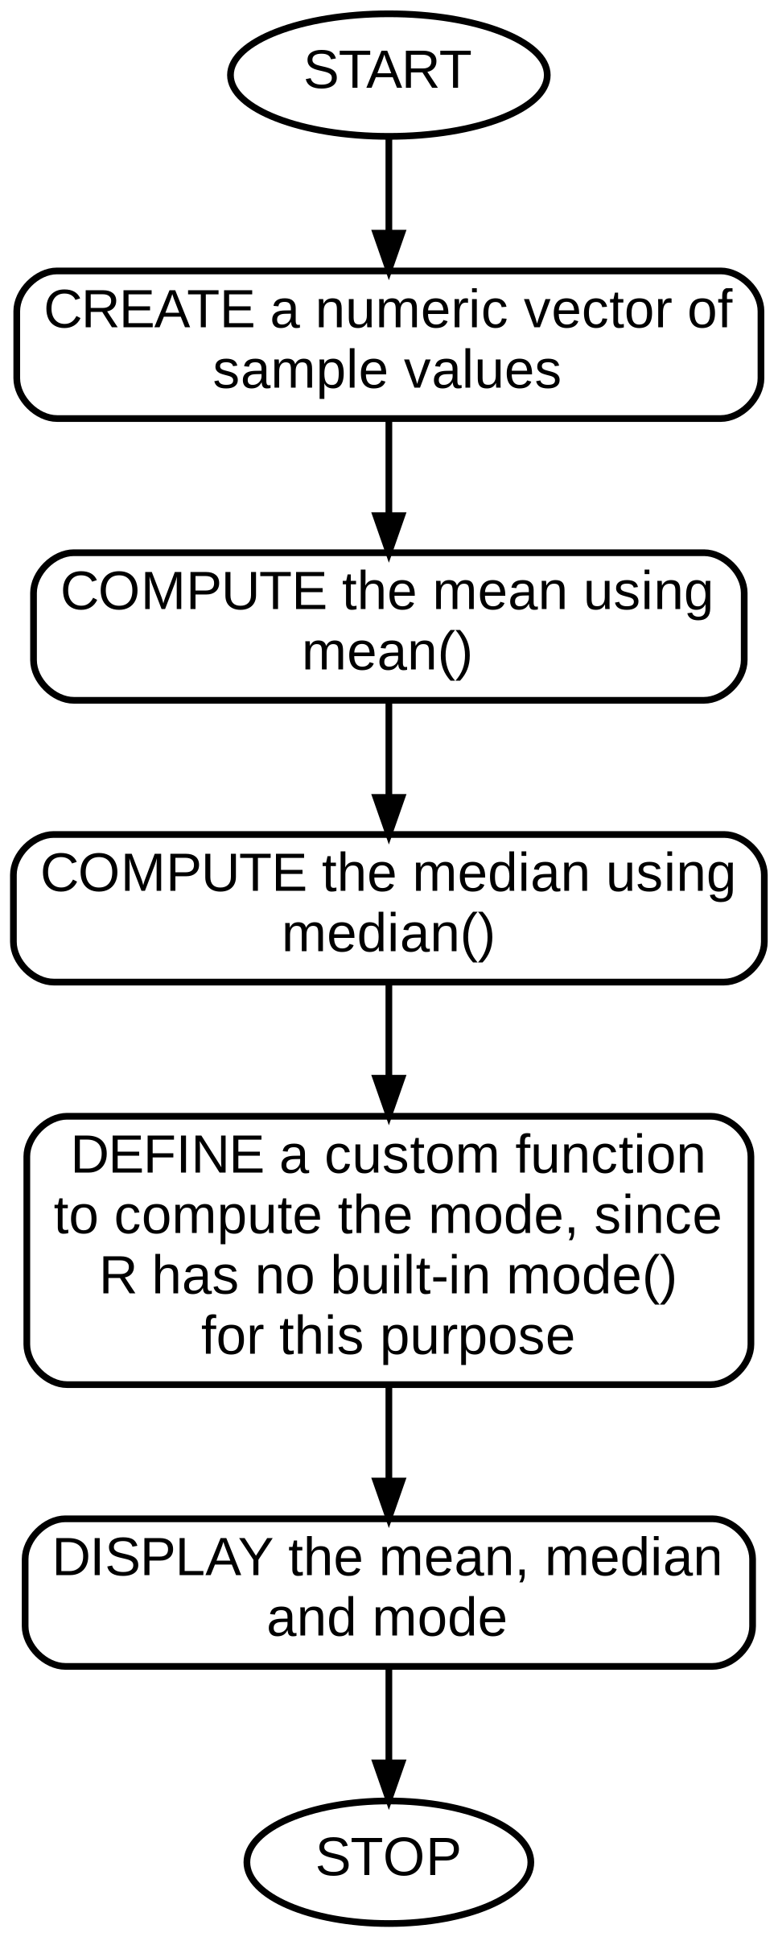
Code:-
data_vec <- c(12, 15, 12, 18, 20, 15, 12, 22)

mean_val <- mean(data_vec)
median_val <- median(data_vec)

get_mode <- function(x) {
uniq_x <- unique(x)
uniq_x[which.max(tabulate(match(x, uniq_x)))]
}
mode_val <- get_mode(data_vec)

cat("Mean :", mean_val, "\n")
cat("Median :", median_val, "\n")
cat("Mode :", mode_val, "\n")

Output:-
Mean : 15.75
Median : 15
Mode : 12

Algorithm:-

PROGRAM 7. Write a R program to create basic plots (scatter plot and bar chart) using the ggplot2 package.
- START
- INSTALL and LOAD the ggplot2 package
- CREATE a data frame with sample values
- USE ggplot() with geom_point() to build a scatter plot
- USE ggplot() with geom_bar() to build a bar chart
- ADD titles and axis labels using labs()
- DISPLAY the plots
- STOP

FLOWCHART
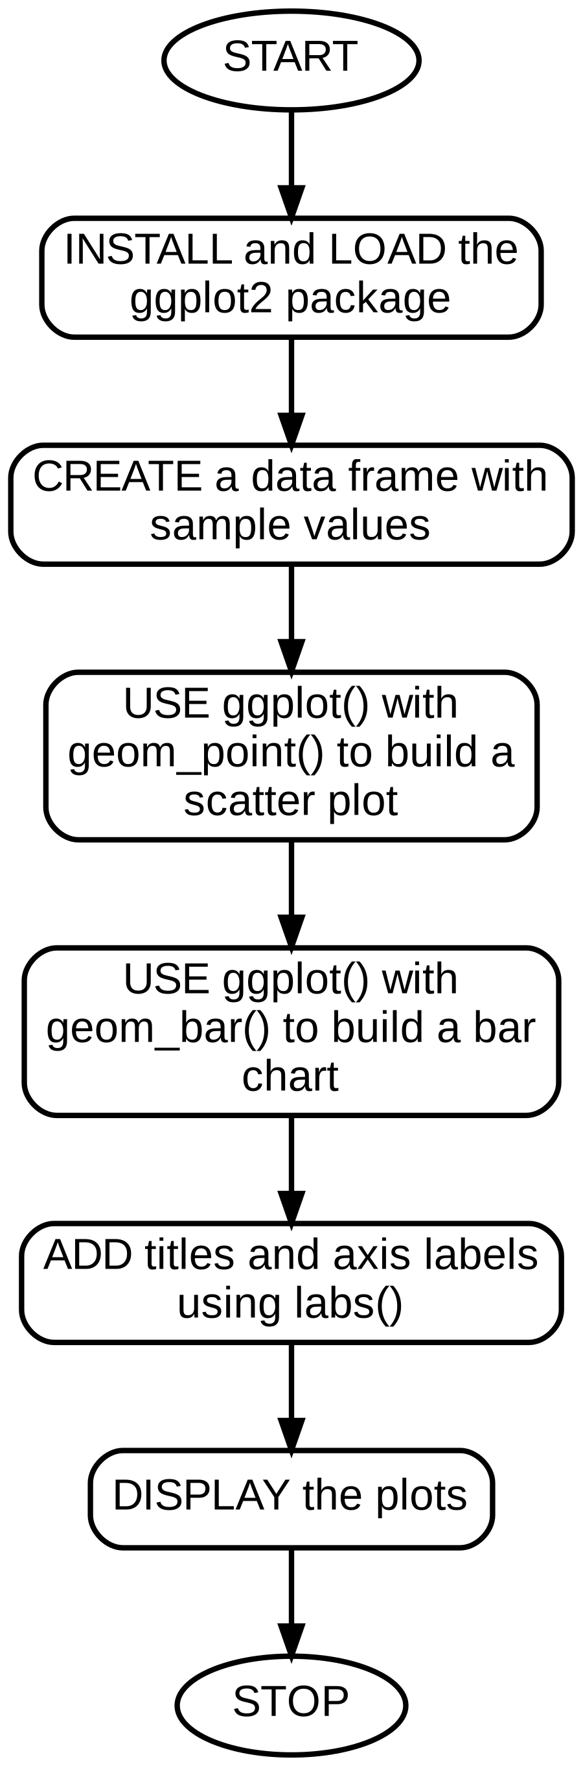
Code:-
# install.packages("ggplot2")
library(ggplot2)

df <- data.frame(Subject = c("Maths","Science","English","R Prog"),
Score = c(85, 78, 92, 88))

ggplot(df, aes(x = Subject, y = Score)) +
geom_point(size = 4, color = "blue") +
labs(title = "Score Scatter Plot", x = "Subject", y = "Score")

ggplot(df, aes(x = Subject, y = Score, fill = Subject)) +
geom_bar(stat = "identity") +
labs(title = "Score Bar Chart", x = "Subject", y = "Score")

Output:-
(Two plot windows are generated: a scatter plot of Score vs
Subject, and a coloured bar chart of Score by Subject, each
titled and labelled on both axes.)

Algorithm:-

PROGRAM 8. Write a R program to perform simple linear regression and correlation analysis between two numeric variables

- START
- CREATE two related numeric vectors, e.g. hours studied and marks obtained
- COMPUTE the correlation coefficient using cor()
- FIT a linear regression model using lm()
- DISPLAY the model summary with coefficients and R-squared
- PREDICT a value using the fitted model
- STOP

FLOWCHART
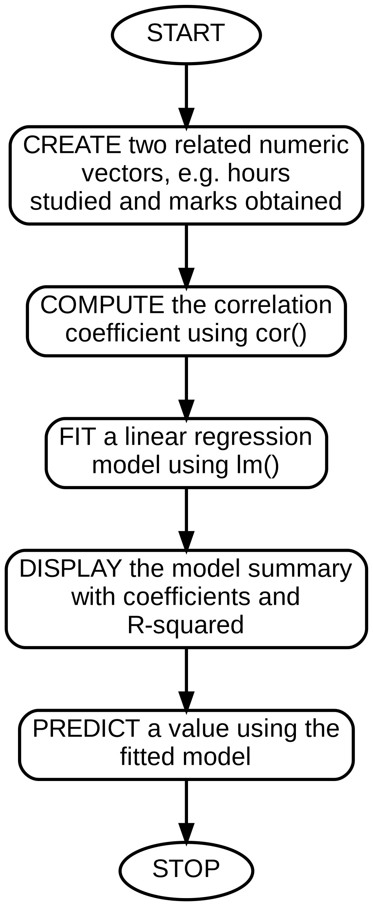
Code:-
hours <- c(1, 2, 3, 4, 5, 6, 7)
marks <- c(35, 40, 50, 55, 65, 72, 80)

correlation <- cor(hours, marks)
cat("Correlation coefficient:", correlation, "\n")

model <- lm(marks ~ hours)
print(summary(model))

new_pred <- predict(model, data.frame(hours = 8))
cat("Predicted marks for 8 hours:", new_pred, "\n")

Output:-
Correlation coefficient: 0.9945735

Coefficients:
Estimate Std. Error t value Pr(>|t|)
(Intercept) 26.9286 1.6842 15.99 1.14e-05
hours 7.6786 0.3712 20.69 3.10e-06
Multiple R-squared: 0.9892

Predicted marks for 8 hours: 88.36

Algorithm:-

PROGRAM 9. Write a R program to draw a bar chart, box plot, pie chart, dot plot and scatter plot using R's base graphics.
- START
- CREATE sample numeric/categorical data
- DRAW a bar chart using barplot()
- DRAW a box plot using boxplot()
- DRAW a pie chart using pie()
- DRAW a dot plot using dotchart()
- DRAW a scatter plot using plot()
- STOP

FLOWCHART
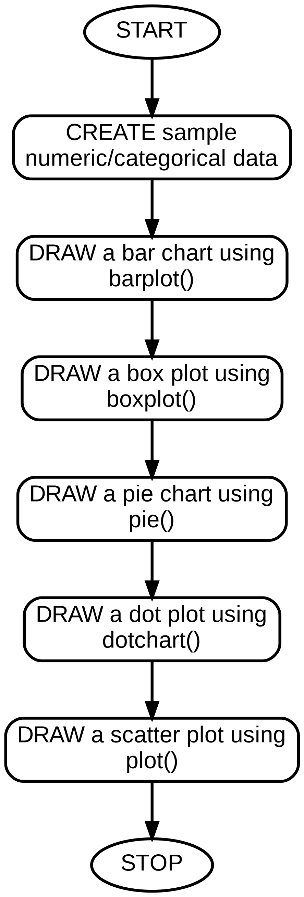
Code:-
sales <- c(120, 150, 90, 200)
names(sales) <- c("Q1","Q2","Q3","Q4")

barplot(sales, main = "Quarterly Sales", col = "steelblue")

boxplot(mtcars$mpg, main = "Box Plot of MPG", ylab = "Miles per Gallon")

pie(sales, main = "Sales Share by Quarter")

dotchart(sales, main = "Dot Plot of Sales")

plot(mtcars$wt, mtcars$mpg, main = "Weight vs MPG",
xlab = "Weight", ylab = "MPG", pch = 19, col = "darkred")

Output:-
(Five separate plot windows are generated: a bar chart of
quarterly sales, a box plot of the mtcars mpg column, a pie
chart of sales share, a dot plot of sales, and a scatter plot
of car weight against mpg.)

Algorithm:-

PROGRAM 10. Write a R program that performs an end-to-end mini data science workflow: load a dataset, clean it, summarise it, and visualise a key relationship.

- START
- LOAD the built-in mtcars dataset
- CHECK for missing values and view the structure using str() and summary()
- GROUP the data by number of cylinders and compute the average mpg per group
- VISUALISE the relationship between horsepower and mpg with a scatter plot
- FIT a simple linear model to quantify the relationship
- REPORT the key findings
- STOP

FLOWCHART
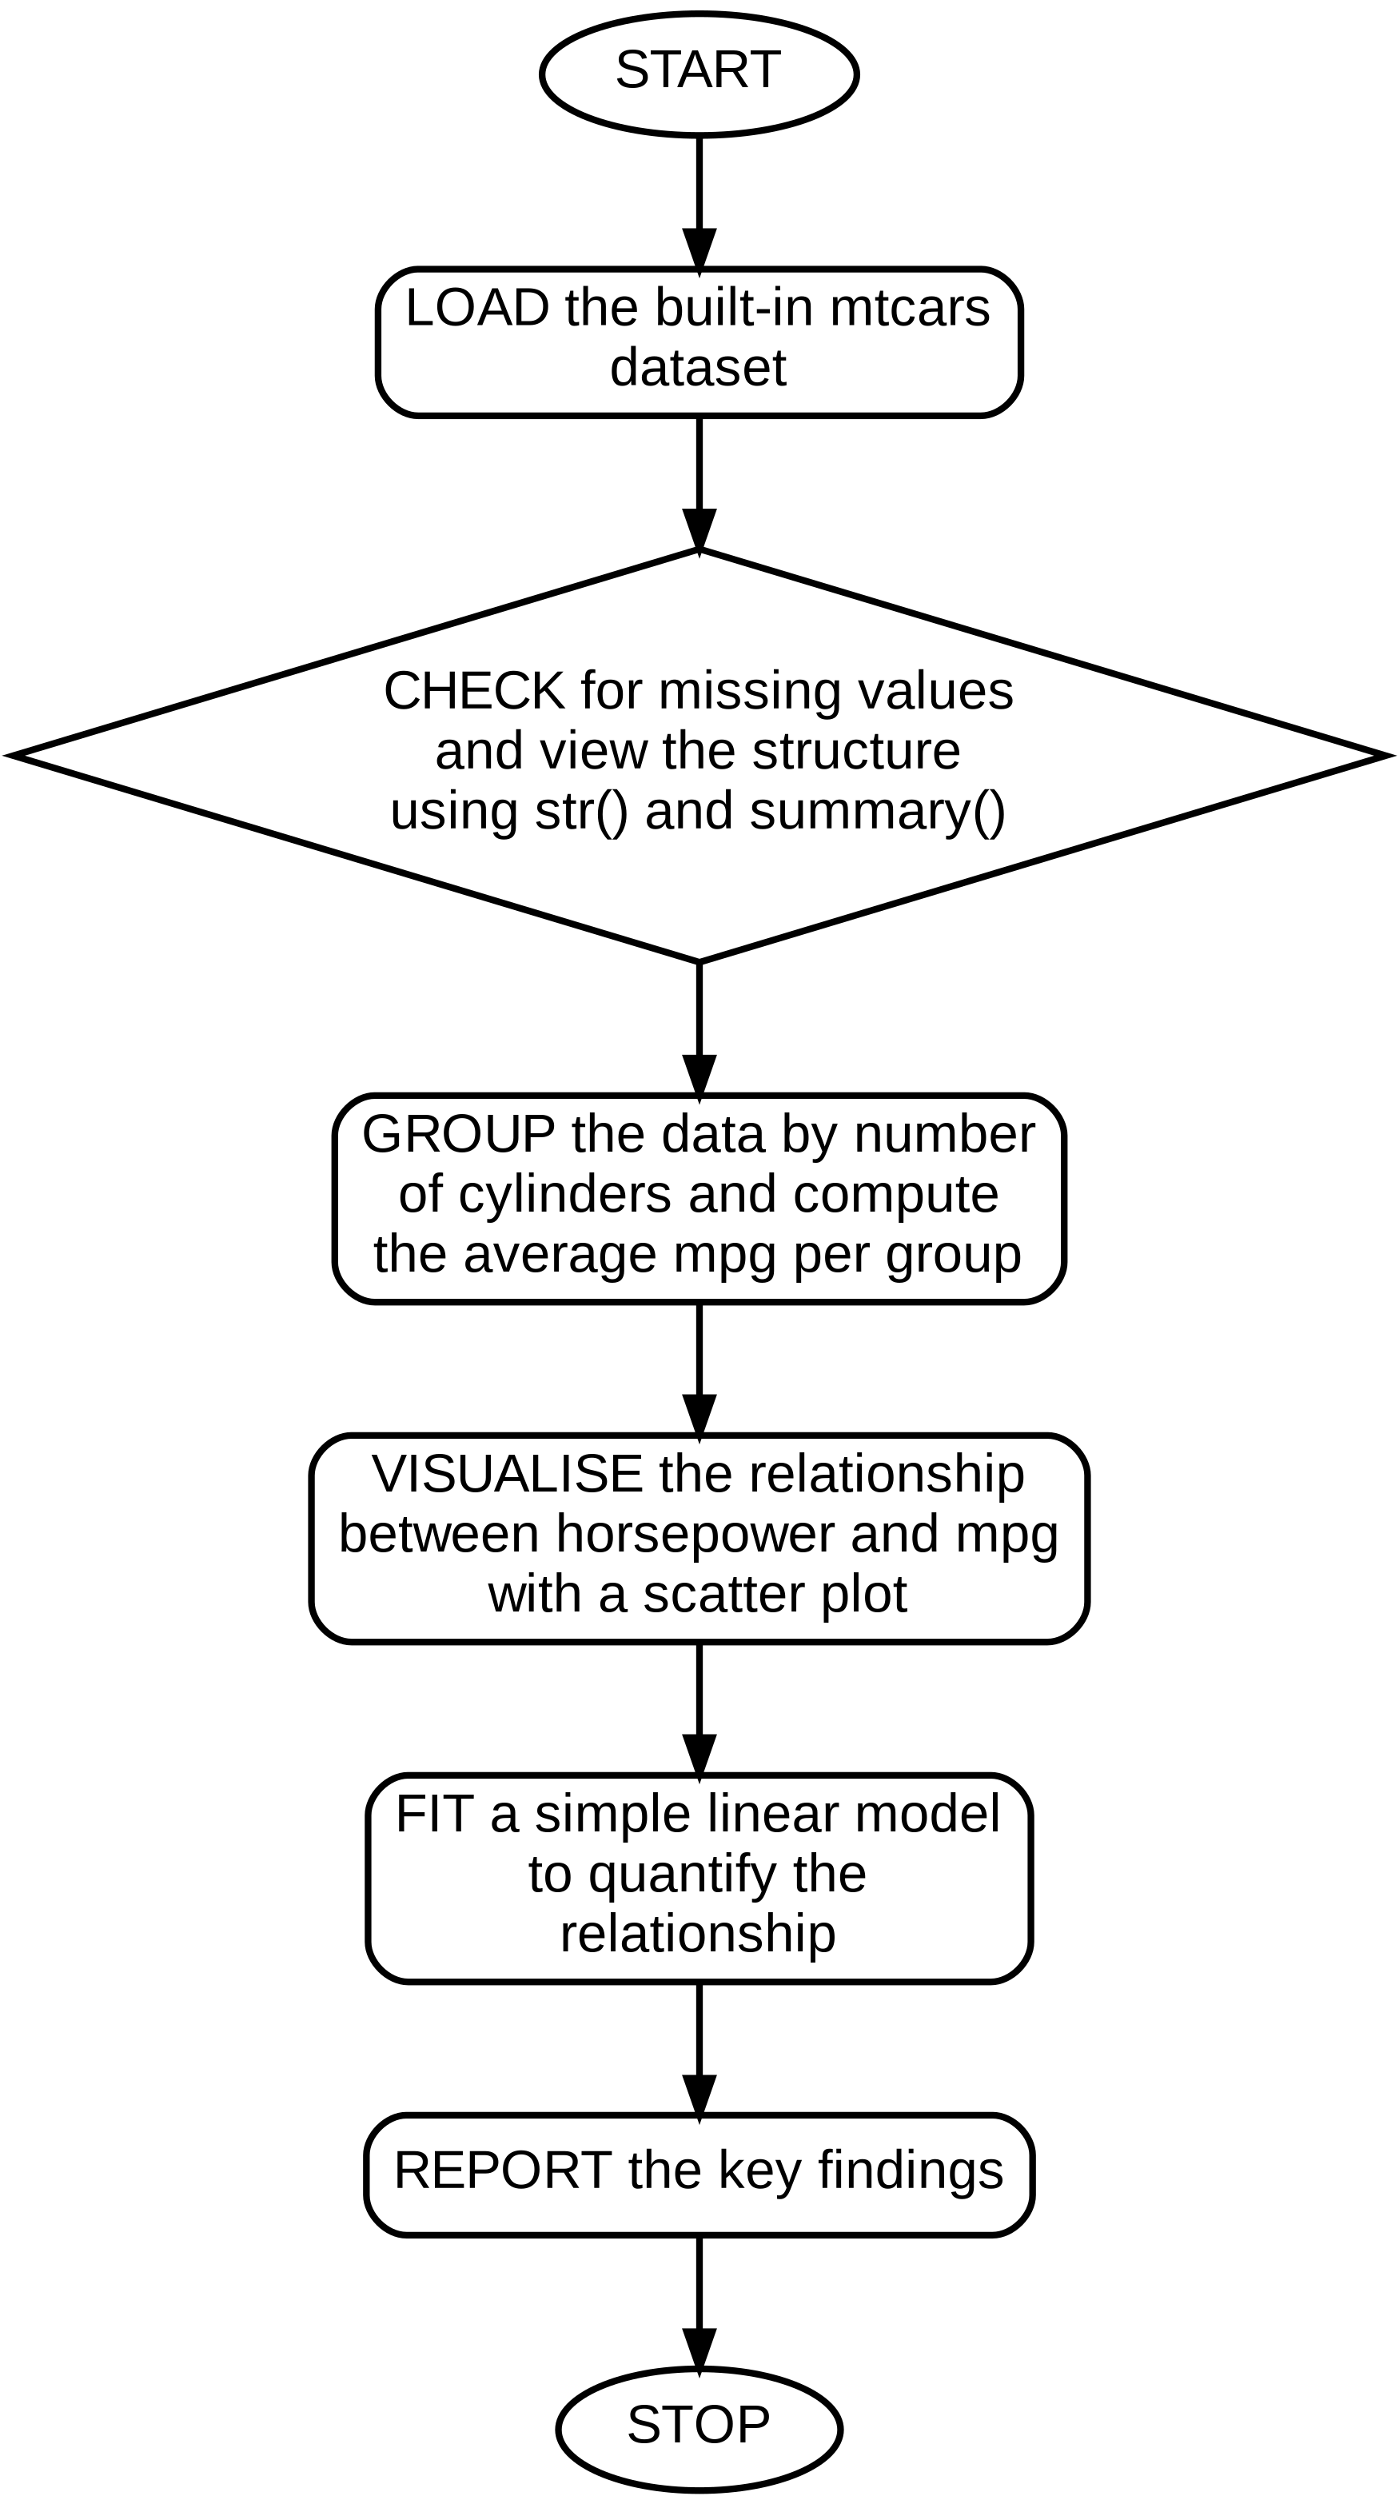
Code:-
data(mtcars)
str(mtcars)
summary(mtcars$mpg)

avg_mpg_by_cyl <- aggregate(mpg ~ cyl, data = mtcars, FUN = mean)
print(avg_mpg_by_cyl)

plot(mtcars$hp, mtcars$mpg, main = "Horsepower vs MPG",
xlab = "Horsepower", ylab = "MPG", pch = 19, col = "darkgreen")

model <- lm(mpg ~ hp, data = mtcars)
cat("R-squared:", summary(model)$r.squared, "\n")

Output:-
cyl mpg
1 4 26.66364
2 6 19.74286
3 8 15.10000
R-squared: 0.6024373

Algorithm:-

PROGRAM 11. Write a R program to sort a given data frame by more than one column
- START
- CREATE a data frame with at least two columns suitable for sorting
- SORT the data frame by the first column in ascending order and the second column in descending order using order()
- DISPLAY the sorted data frame
- STOP
FLOWCHART
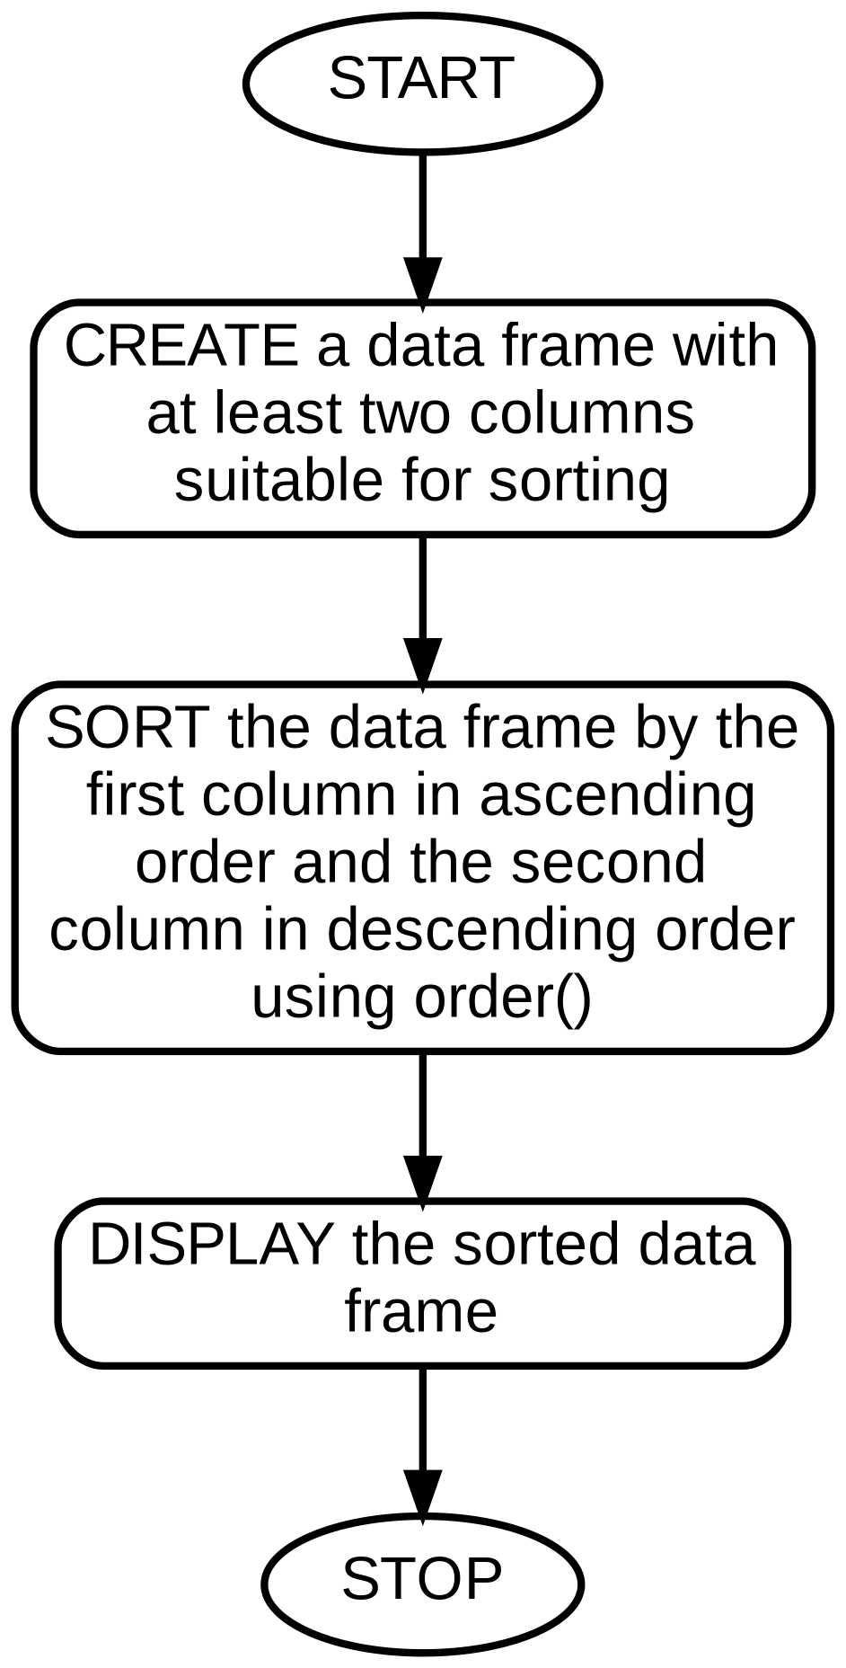
Code:-
df <- data.frame(
Dept = c("CSE","CSE","ECE","ECE","CSE"),
Name = c("Ravi","Meera","Amit","Sita","Kiran"),
Marks = c(78, 92, 85, 74, 92)
)

sorted_df <- df[order(df$Dept, -df$Marks), ]
print(sorted_df)

Output:-
Dept Name Marks
2 CSE Meera 92
5 CSE Kiran 92
1 CSE Ravi 78
3 ECE Amit 85
4 ECE Sita 74

PROGRAM 12. Create vectors a = (5,10,...,160) and b = (87,86,...,56) in R. Multiply them element-wise to get vector d, then find the 19th-21st elements of d, elements of d less than 2000, count elements greater than 6000, elements of a not in another vector, and test which elements exceed 10.

Algorithm:-
- START
- CREATE vector a as a sequence from 5 to 160 in steps of 5
- CREATE vector b as a sequence from 87 down to 56
- MULTIPLY a and b element-wise to get vector d
- EXTRACT the 19th, 20th and 21st elements of d
- FILTER elements of d that are less than 2000
- COUNT elements of d greater than 6000
- FIND elements of a vector not present in another vector using setdiff()
- TEST which elements of a given vector are greater than 10
- STOP

FLOWCHART
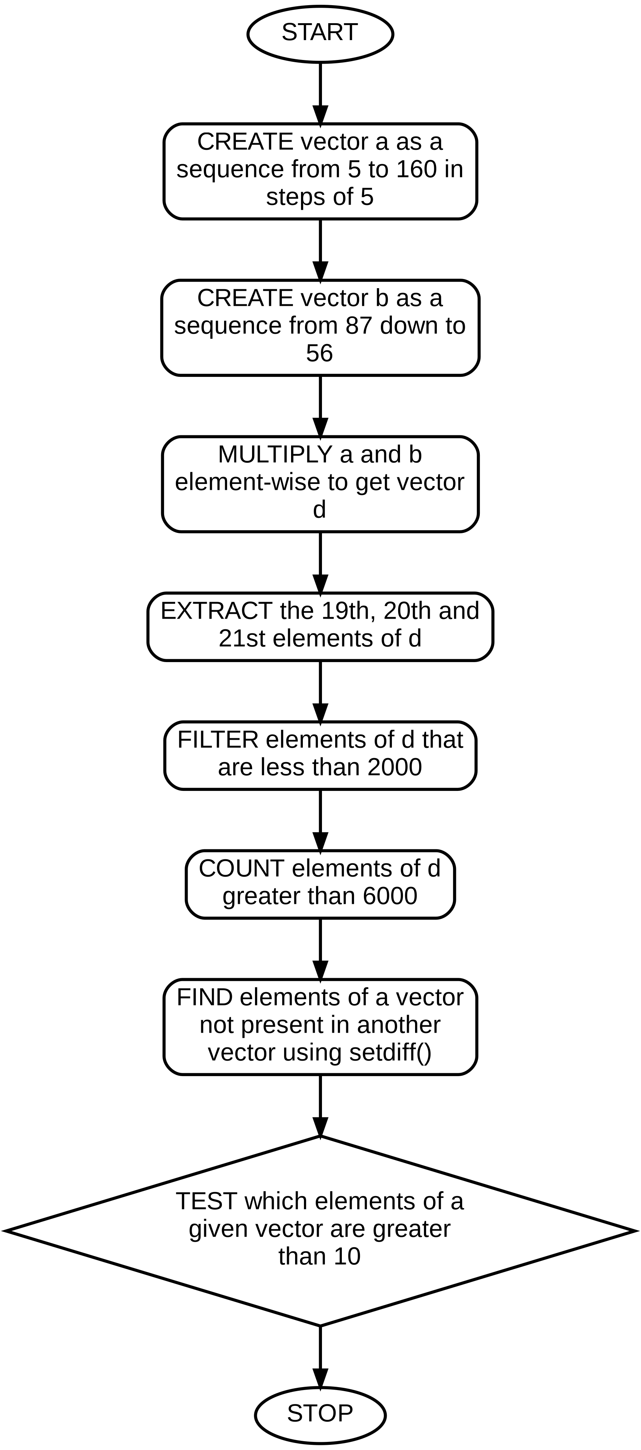
Code:-
a <- seq(5, 160, by = 5)
b <- seq(87, 56, by = -1)
length(b) <- length(a) # align lengths, pad with NA if needed
b[is.na(b)] <- tail(b[!is.na(b)], 1)

d <- a * b
cat("d[19:21] :", d[19:21], "\n")
cat("d < 2000 :", d[d < 2000], "\n")
cat("Count d > 6000 :", sum(d > 6000), "\n")

x <- c(1,2,3,4,5)
y <- c(3,4,5,6,7)
cat("In x but not in y:", setdiff(x, y), "\n")
cat("Elements of x > 10:", x > 10, "\n")

Output:-
d[19:21] : 5590 5850 5904
d < 2000 : 435 852 1251 1632 1995
Count d > 6000 : 4
In x but not in y: 1 2
Elements of x > 10: FALSE FALSE FALSE FALSE FALSE

Algorithm:-

PROGRAM 13. Write a R program to find the row and column index of the maximum and minimum value in a given matrix.

- START
- CREATE a matrix of sample numeric values
- FIND the maximum value using max() and its position using which(mat == max(mat), arr.ind = TRUE)
- FIND the minimum value using min() and its position similarly
- DISPLAY the row and column indices
- STOP

FLOWCHART
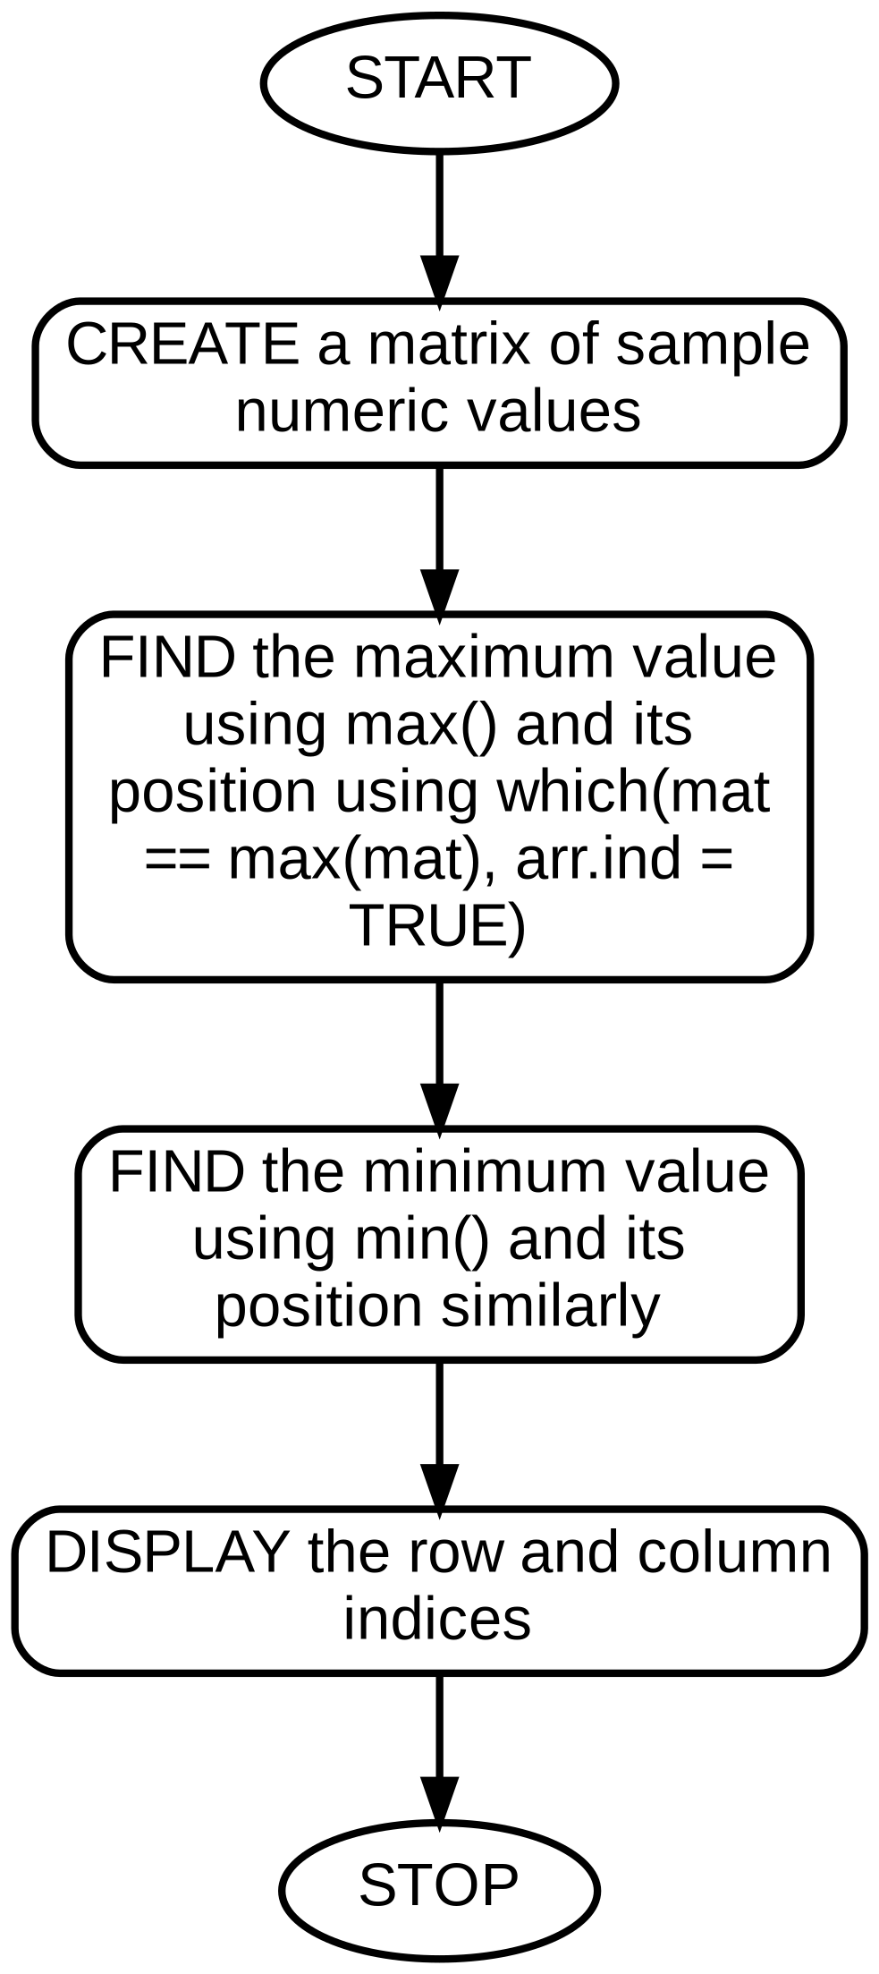
Code:-
mat <- matrix(c(4, 9, 2, 7, 15, 3, 8, 1, 6), nrow = 3, byrow = TRUE)
print(mat)

max_val <- max(mat)
min_val <- min(mat)
max_pos <- which(mat == max_val, arr.ind = TRUE)
min_pos <- which(mat == min_val, arr.ind = TRUE)

cat("Maximum value:", max_val, "at row", max_pos[1], "col", max_pos[2], "\n")
cat("Minimum value:", min_val, "at row", min_pos[1], "col", min_pos[2], "\n")

Output:-
[,1] [,2] [,3]
[1,] 4 9 2
[2,] 7 15 3
[3,] 8 1 6
Maximum value: 15 at row 2 col 2
Minimum value: 1 at row 3 col 2

Algorithm:-

PROGRAM 14. Write a R program to create a list containing a vector, a matrix, and a list, and give names to the elements of the list. Access the first and second elements of the list.

- START
- CREATE a numeric vector
- CREATE a matrix
- CREATE a nested list
- COMBINE all three into a single named list using list()
- ACCESS the first element using [[1]] or $name
- ACCESS the second element similarly
- STOP

FLOWCHART
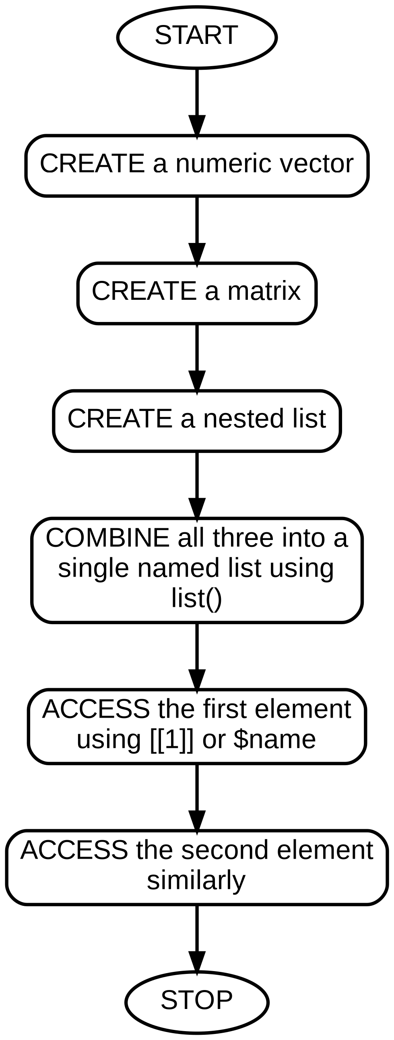
Code:-
my_vector <- c(10, 20, 30)
my_matrix <- matrix(1:6, nrow = 2)
my_list <- list(x = 1, y = "hello")

combined <- list(Vector = my_vector, Matrix = my_matrix, List = my_list)

cat("First element (Vector):\n"); print(combined[[1]])
cat("Second element (Matrix):\n"); print(combined[[2]])
cat("Accessed by name:\n"); print(combined$List)

Output:-
First element (Vector):
[1] 10 20 30
Second element (Matrix):
[,1] [,2] [,3]
[1,] 1 3 5
[2,] 2 4 6
Accessed by name:
$x
[1] 1

$y
[1] "hello"

Algorithm:-

PROGRAM 15. Using a sample clinical/radiology-style dataset, write a R program to compute the sum, median and standard deviation of the data.

- START
- CREATE / IMPORT a numeric dataset (e.g. monthly visit counts)
- COMPUTE the sum using sum()
- COMPUTE the median using median()
- COMPUTE the standard deviation using sd()
- DISPLAY all three statistics
- STOP

FLOWCHART
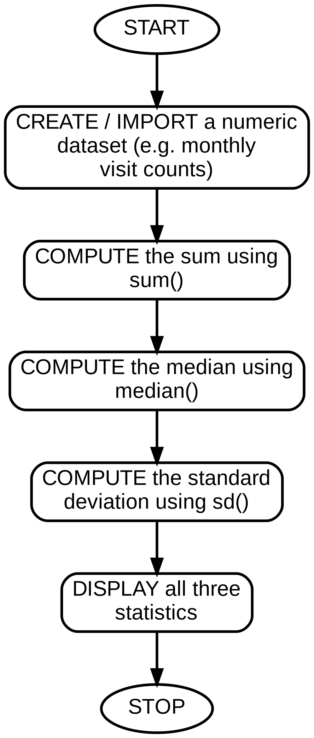
Code:-
visits <- c(210, 195, 230, 180, 205, 240, 190, 215, 225, 200)

total_sum <- sum(visits)
median_val <- median(visits)
sd_val <- sd(visits)

cat("Sum :", total_sum, "\n")
cat("Median :", median_val, "\n")
cat("Standard Deviation:", round(sd_val, 2), "\n")

Output:-
Sum : 2090
Median : 207.5
Standard Deviation: 18.55

Algorithm:-

PROGRAM 16. From sample clinic and radiology visit data, write a R program to draw and examine histograms and box plots (as two separate plots) for each variable.

- START
- CREATE two numeric vectors representing clinic visits and radiology visits
- DRAW a histogram of clinic visits using hist()
- DRAW a histogram of radiology visits using hist()
- DRAW a box plot of clinic visits using boxplot()
- DRAW a separate box plot of radiology visits using boxplot()
- COMPARE the shape/spread visible in each pair of plots
- STOP

FLOWCHART
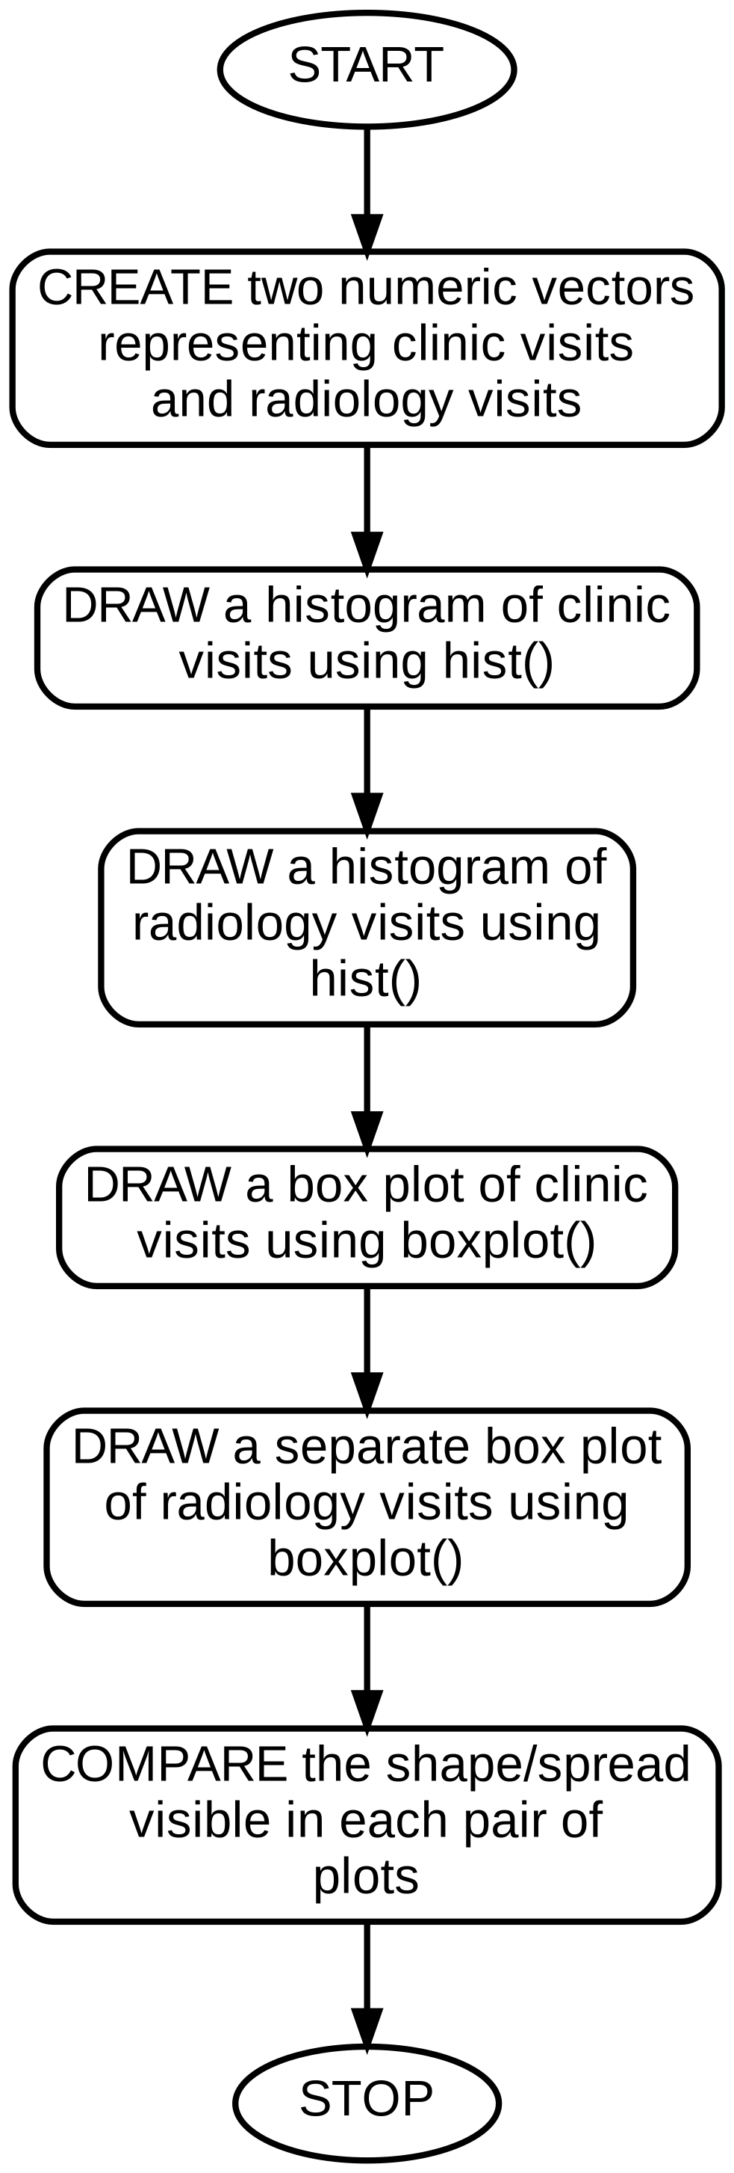
Code:-
clinic_visits <- c(120,135,110,150,140,125,160,145,130,155)
radiology_visits <- c(45, 50, 38, 60, 55, 42, 65, 58, 48, 62)

hist(clinic_visits, main = "Histogram of Clinic Visits",
xlab = "Visits", col = "lightblue")
hist(radiology_visits, main = "Histogram of Radiology Visits",
xlab = "Visits", col = "lightgreen")

boxplot(clinic_visits, main = "Box Plot of Clinic Visits")
boxplot(radiology_visits, main = "Box Plot of Radiology Visits")

Output:-
(Four separate plot windows: histograms of clinic and
radiology visits, each showing a roughly symmetric spread,
followed by two individual box plots, one per variable, showing
median and quartile range with no extreme outliers.)

Algorithm:-

PROGRAM 17. Use R to create two matrices and perform the indicated matrix multiplication.

- START
- CREATE the first matrix A
- CREATE the second matrix B with compatible dimensions for multiplication
- MULTIPLY A and B using the %*% operator
- DISPLAY the resulting matrix
- STOP

FLOWCHART
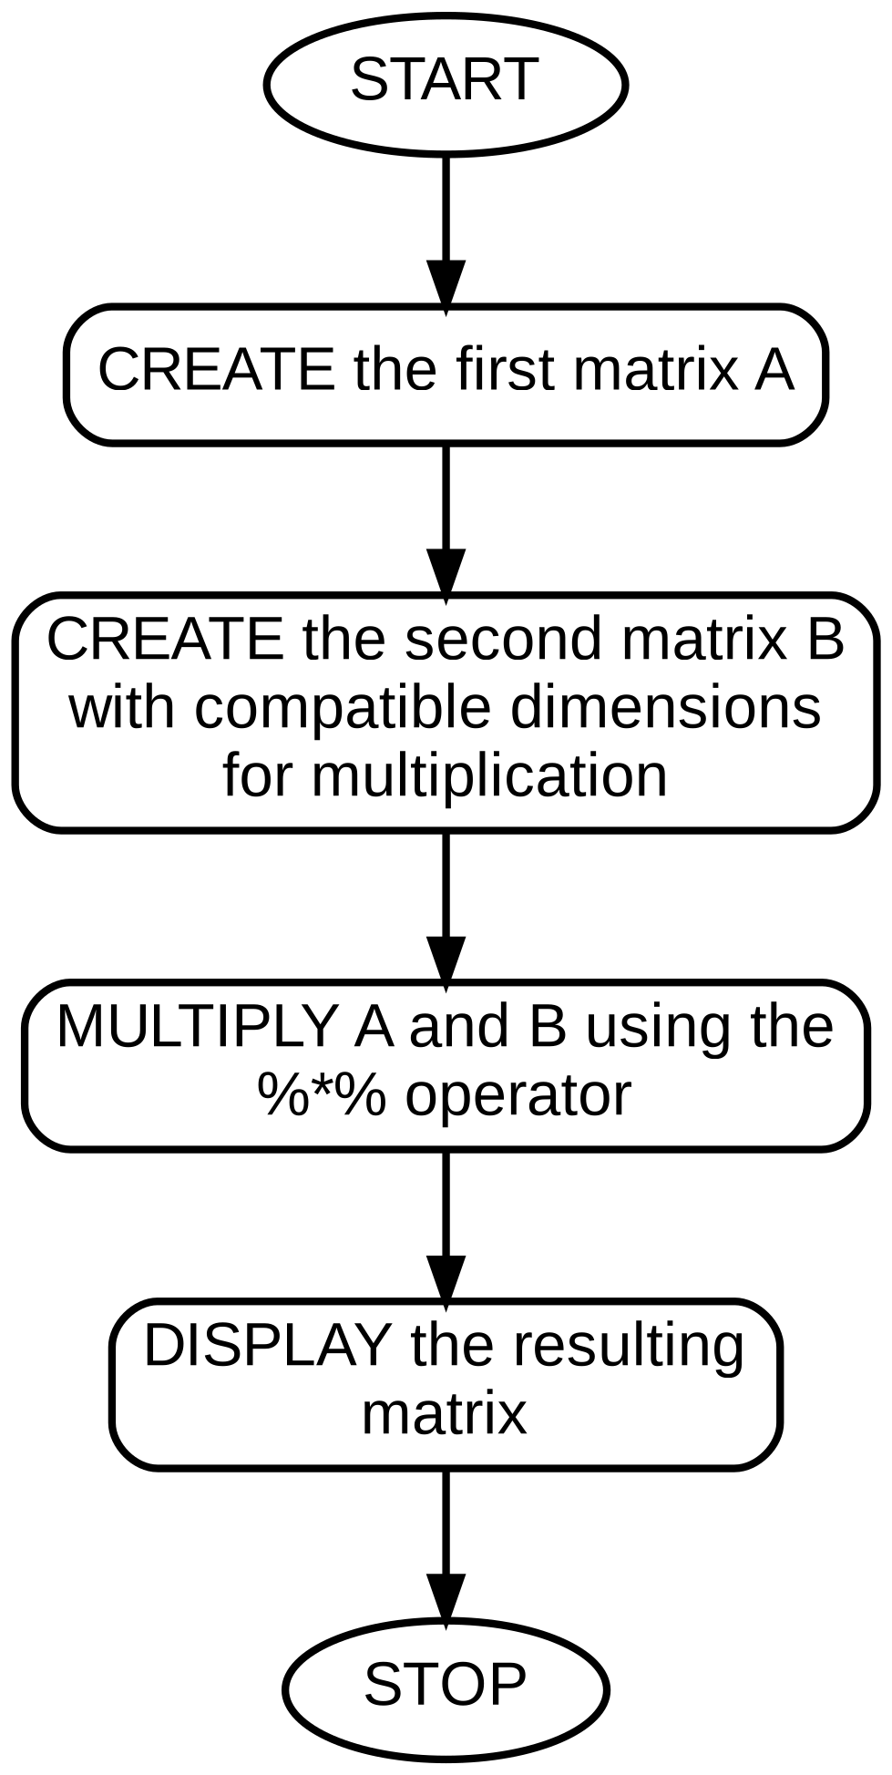
Code:-
A <- matrix(c(1,2,3,4,5,6), nrow = 2, byrow = TRUE)
B <- matrix(c(7,8,9,10,11,12), nrow = 3, byrow = TRUE)

print(A)
print(B)

C <- A %*% B
print(C)

Output:-
[,1] [,2] [,3]
[1,] 1 2 3
[2,] 4 5 6
[,1] [,2]
[1,] 7 8
[2,] 9 10
[3,] 11 12
[,1] [,2]
[1,] 58 64
[2,] 139 154

PROGRAM 18. Using sample radiology hospital data for several months, compute the means and standard deviations of the data variables (excluding month). Also, load the built-in airquality dataset, check whether it is a data frame, and order it by the first and second columns.

Algorithm:-
- START
- CREATE / IMPORT the radiology dataset (month, radiology visits, patient-days, clinic visits)
- COMPUTE the mean and standard deviation of each numeric column (excluding month) using sapply()
- LOAD the built-in airquality dataset
- CHECK whether it is a data frame using is.data.frame()
- ORDER the airquality data frame by its first and second columns using order()
- DISPLAY the results
- STOP

FLOWCHART
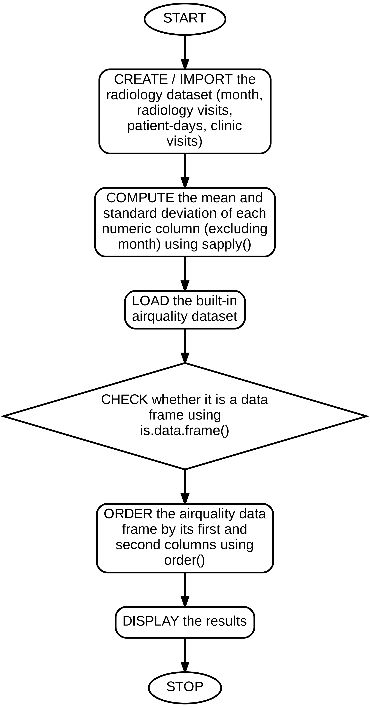
Code:-
radiology <- data.frame(
Month = 1:6,
RadiologyVisits = c(210,195,230,180,205,240),
PatientDays = c(1500,1420,1600,1350,1480,1650),
ClinicVisits = c(320,300,340,290,310,355)
)

stats <- sapply(radiology[,-1], function(x) c(Mean = mean(x), SD = sd(x)))
print(stats)

data(airquality)
cat("Is data frame:", is.data.frame(airquality), "\n")

ordered_aq <- airquality[order(airquality[,1], airquality[,2]), ]
print(head(ordered_aq))

Output:-
RadiologyVisits PatientDays ClinicVisits
Mean 210.0000 1500.000 319.1667
SD 21.7025 113.076 23.1809
Is data frame: TRUE
Ozone Solar.R Wind Temp Month Day
1 41 190 7.4 67 5 1
2 36 118 8.0 72 5 2
3 12 149 12.6 74 5 3
...

Algorithm:-

PROGRAM 19. From sample radiology data, construct a scatter plot of clinic visits (x) versus radiology visits (y), perform simple linear regression of radiology visits on clinic visits, add the regression line, and comment on the fit.

- START
- CREATE vectors for clinic visits and radiology visits
- DRAW a scatter plot of radiology visits against clinic visits using plot()
- FIT a simple linear regression model using lm(radiology ~ clinic)
- ADD the fitted regression line to the scatter plot using abline()
- EXAMINE the R-squared value to comment on the goodness of fit
- STOP

FLOWCHART
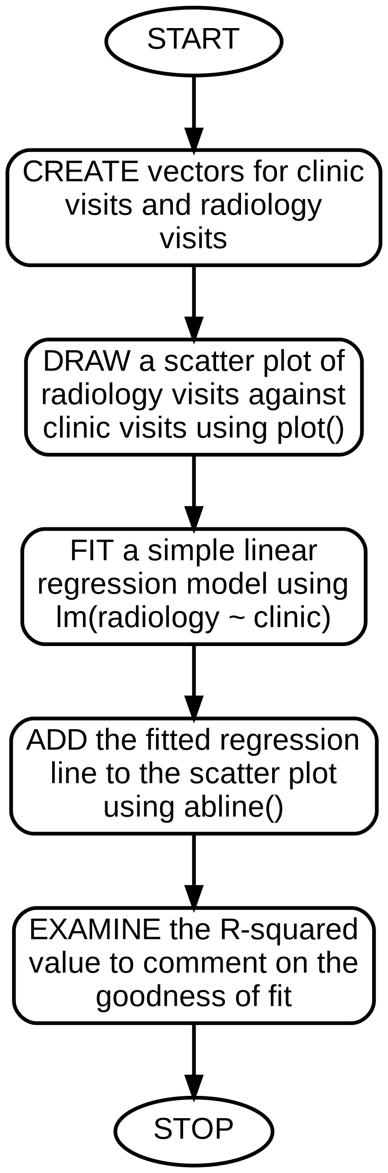
Code:-
clinic_visits <- c(320,300,340,290,310,355,335,315)
radiology_visits <- c(210,195,230,180,205,240,225,208)

plot(clinic_visits, radiology_visits,
main = "Radiology Visits vs Clinic Visits",
xlab = "Clinic Visits", ylab = "Radiology Visits",
pch = 19, col = "blue")

model <- lm(radiology_visits ~ clinic_visits)
abline(model, col = "red", lwd = 2)

print(summary(model))

Output:-
Coefficients:
Estimate Std. Error t value Pr(>|t|)
(Intercept) -33.9421 17.8412 -1.902 0.1057
clinic_visits 0.7583 0.0562 13.492 1.24e-05
Multiple R-squared: 0.9636

Comment: The R-squared of ~0.96 indicates a strong positive
linear relationship — radiology visits rise closely in step
with clinic visits, so a linear model fits the data well.

Algorithm:-

PROGRAM 20. Write a R program to build a simple item-based recommender system using dplyr, and generate a 3D graph of sample data.

- START
- LOAD the dplyr package for data manipulation and the scatterplot3d (or plotly) package for 3D graphing
- CREATE a small user-item ratings dataset
- USE dplyr to compute the average rating per item and rank items
- RECOMMEND the top-rated items to the user
- GENERATE a 3D scatter plot of three numeric variables
- STOP

FLOWCHART
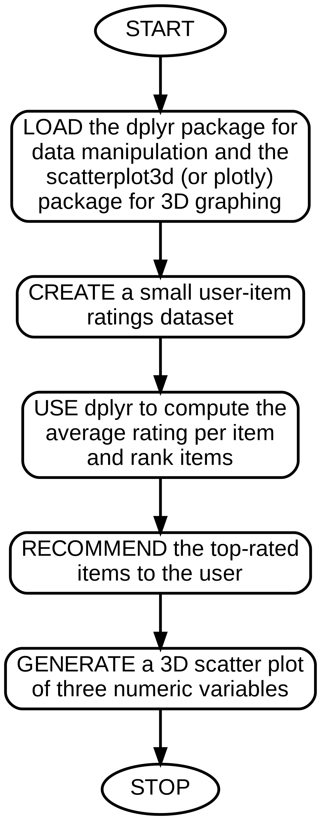
Code:-
# install.packages(c("dplyr","scatterplot3d"))
library(dplyr)
library(scatterplot3d)

ratings <- data.frame(
User = c("U1","U1","U2","U2","U3","U3"),
Item = c("A","B","A","C","B","C"),
Rating = c(4,5,3,4,5,2)
)

recommendations <- ratings %>%
group_by(Item) %>%
summarise(AvgRating = mean(Rating)) %>%
arrange(desc(AvgRating))
print(recommendations)

x <- c(1,2,3,4,5); y <- c(5,4,3,2,1); z <- c(2,4,6,8,10)
scatterplot3d(x, y, z, main = "3D Scatter Plot", color = "blue", pch = 16)
Output:-
# A tibble: 3 x 2
Item AvgRating
<chr> <dbl>
1 B 5
2 A 3.5
3 C 3

(A 3D scatter-plot window is generated plotting x, y and z.)

Algorithm:-

PROGRAM 21. Write a R program to design a visualization of sample COVID-19 case data for India (daily/monthly trend of cases).

- START
- CREATE / IMPORT a sample dataset of dates and confirmed COVID-19 case counts for India
- CONVERT the date column to Date type using as.Date()
- PLOT the trend of cases over time using ggplot2's geom_line()
- ADD a title and axis labels
- OPTIONALLY highlight the peak using geom_point()
- STOP

FLOWCHART
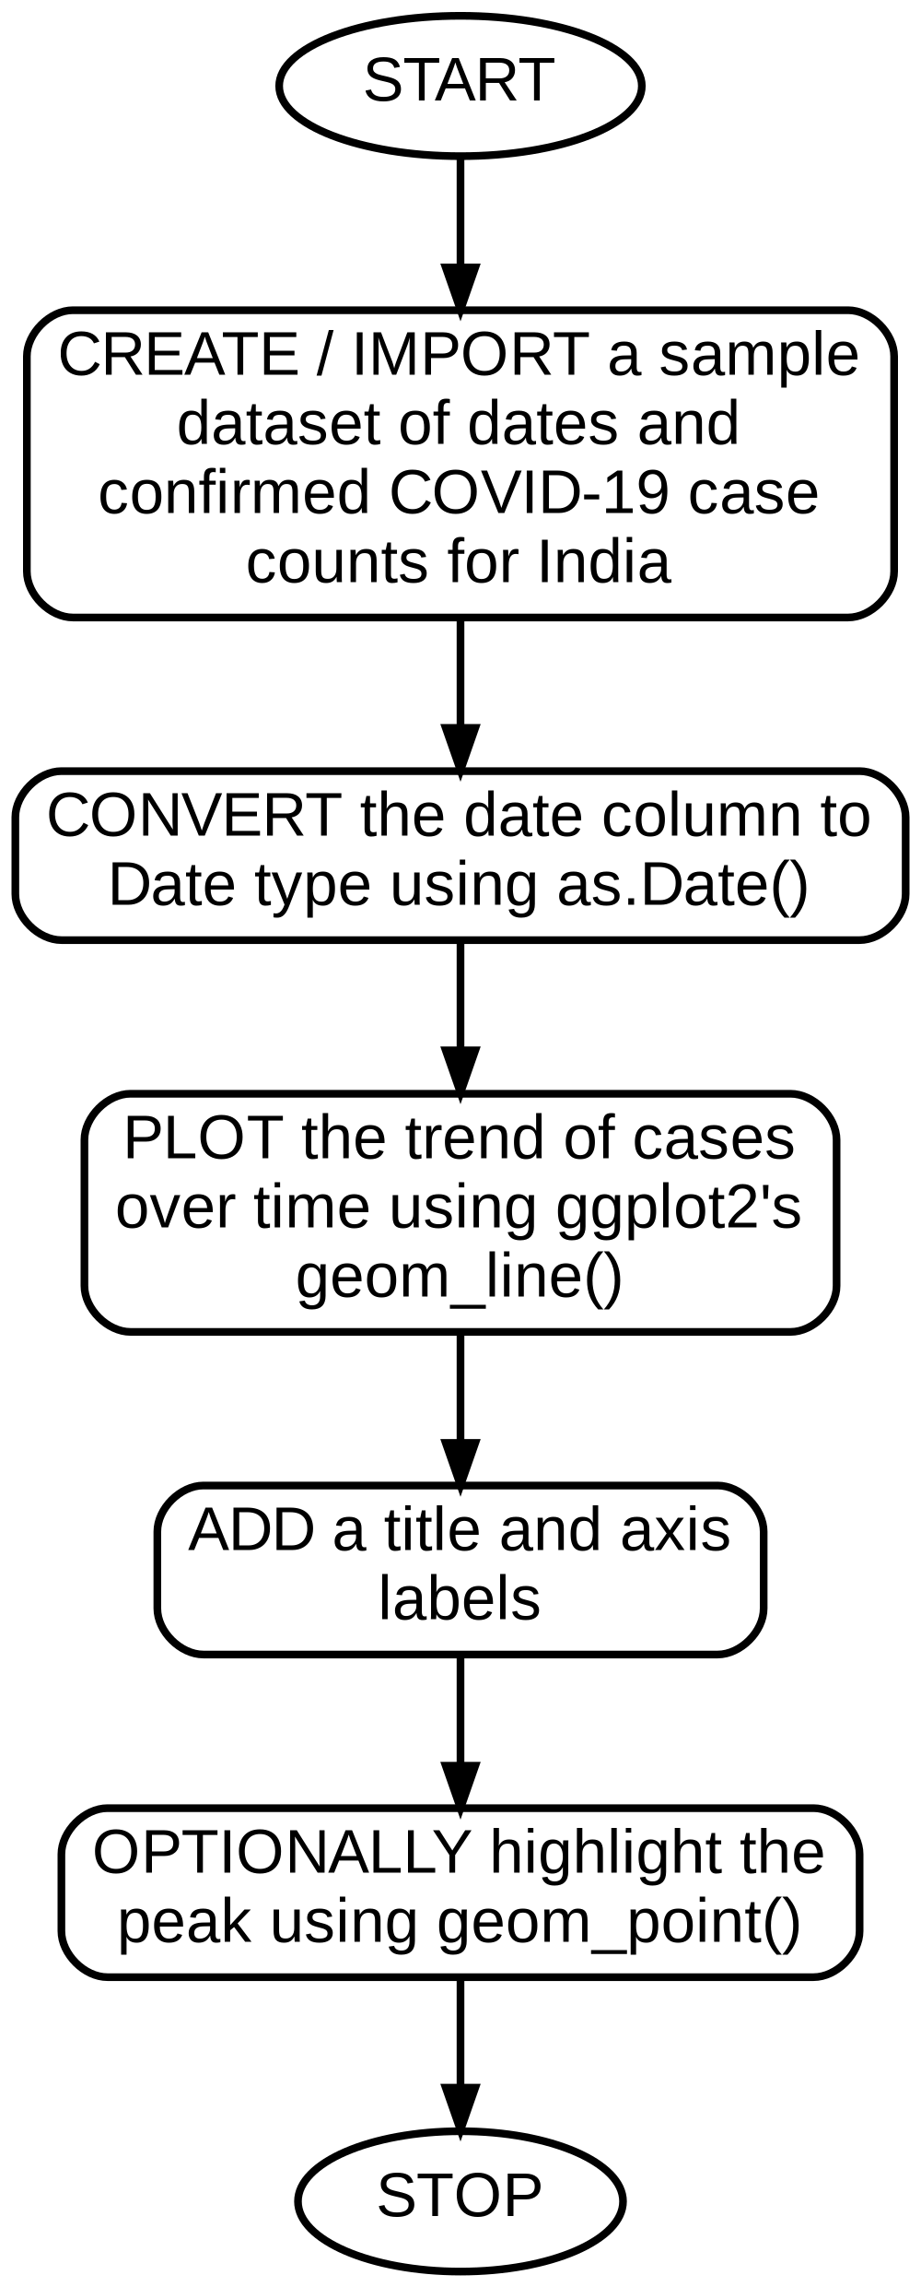
Code:-
library(ggplot2)

covid_data <- data.frame(
Date = as.Date(c("2021-04-01","2021-04-08","2021-04-15",
"2021-04-22","2021-04-29","2021-05-06")),
Cases = c(72000, 131000, 234000, 314000, 379000, 412000)
)

ggplot(covid_data, aes(x = Date, y = Cases)) +
geom_line(color = "red", size = 1) +
geom_point(color = "darkred") +
labs(title = "COVID-19 Weekly Confirmed Cases - India (Sample Data)",
x = "Date", y = "Confirmed Cases") +
theme_minimal()

Output:-
(A line plot is generated showing an upward trend of weekly
confirmed COVID-19 cases in India across the sample dates,
peaking at the last data point.)

Algorithm:-

PROGRAM 22. Write a R program outline to design a basic fake news detection system using text features and a classification model.

- START
- IMPORT a labelled dataset of news articles (text and a Real/Fake label)
- PRE-PROCESS the text: convert to lowercase, remove punctuation and stopwords using the tm package
- CONVERT the cleaned text into a Document-Term Matrix (DTM) / TF-IDF matrix
- SPLIT the data into training and test sets
- TRAIN a classification model (e.g. Naive Bayes or logistic regression) on the training set
- PREDICT labels for the test set and EVALUATE accuracy using a confusion matrix
- STOP

FLOWCHART
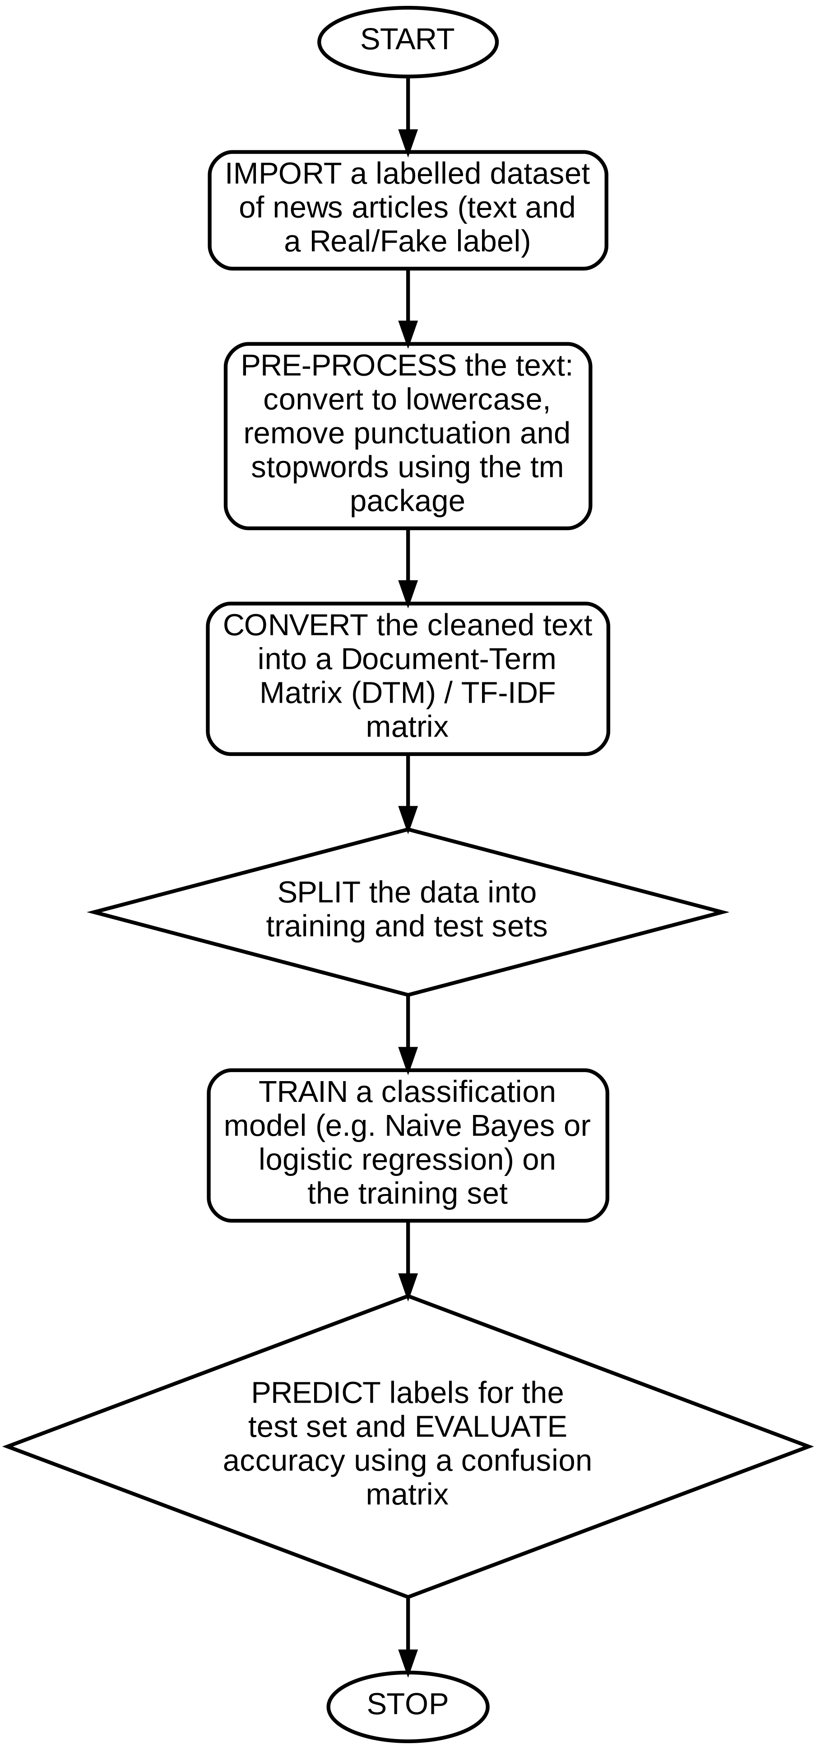
Code:-
# install.packages(c("tm","e1071","caret"))
library(tm)
library(e1071)
library(caret)

news <- data.frame(
text = c("Government announces new policy for economy",
"Aliens land in city park, government hides truth",
"Election results confirmed by officials",
"Miracle cure discovered, doctors hate this trick"),
label = c("Real","Fake","Real","Fake")
)

corpus <- VCorpus(VectorSource(news$text))
corpus <- tm_map(corpus, content_transformer(tolower))
corpus <- tm_map(corpus, removePunctuation)
corpus <- tm_map(corpus, removeWords, stopwords("english"))

dtm <- DocumentTermMatrix(corpus)
dtm_matrix <- as.data.frame(as.matrix(dtm))
dtm_matrix$label <- factor(news$label)

set.seed(1)
train_idx <- createDataPartition(dtm_matrix$label, p = 0.75, list = FALSE)
train_set <- dtm_matrix[train_idx, ]
test_set <- dtm_matrix[-train_idx, ]

model <- naiveBayes(label ~ ., data = train_set)
pred <- predict(model, test_set)
print(confusionMatrix(pred, test_set$label))

Output:-
(Output shows a confusion matrix comparing predicted vs actual
Real/Fake labels on the held-out test set, along with the
overall classification accuracy of the Naive Bayes model.)

23.Viva Questions and Answer

1. What is the difference between class() and typeof() in R?
Ans. class() returns the object's class as used by R's object system, while typeof() returns its underlying storage mode; e.g. typeof(1L) is "integer" but typeof(1) is "double", though both may report class "numeric"-like values.
2. Which function is used to import a CSV file into R?
Ans. read.csv() (or read.table() with sep=",") imports a CSV file into R as a data frame.
3. What is lexical scoping in R?
Ans. Lexical scoping means R resolves a free variable in a function using the environment where the function was defined, not the environment from which it is called.
4. What is the difference between a for loop and a while loop?
Ans. A for loop iterates a fixed, known number of times over a sequence, while a while loop repeats as long as a given condition remains TRUE.
5. What is the difference between lapply() and sapply()?
Ans. lapply() always returns a list, whereas sapply() tries to simplify the result into a vector or matrix when the output allows it.
6. Which function returns the current system date and time in R?
Ans. Sys.Date() returns the current date and Sys.time() returns the current date-time.
7. How does a list differ from a vector in R?
Ans. A vector stores elements of a single atomic type, whereas a list can hold elements of different types and even other lists or data frames.
8. How do you access the second column of a data frame df?
Ans. Using df[,2], df[["ColumnName"]], or df$ColumnName.
9. Which package is commonly used to read Excel files in R?
Ans. The readxl package (function read_excel()) is commonly used, along with alternatives like openxlsx and xlsx.
10. What does the str() function do?
Ans. str() displays the internal structure of an R object, including the data types and a preview of values for each column of a data frame.
11. Why does R not provide a built-in mode() function for statistical mode?
Ans. In R, mode() is reserved for returning the storage mode/type of an object (e.g. "numeric", "list"); the statistical mode has to be computed with a custom function using tabulate() and match().
12. What does median() return for an even-length vector?
Ans. It returns the average of the two middle values once the vector is sorted.
13. What is the role of aes() in ggplot2?
Ans. aes() defines the aesthetic mappings — which variables in the data are mapped to visual properties such as x, y, colour or fill.
14. Which geom is used to draw a bar chart in ggplot2?
Ans. geom_bar() (or geom_col() when the bar heights are already summarised) is used to draw bar charts.
15. What does the correlation coefficient measure?
Ans. It measures the strength and direction of the linear relationship between two numeric variables, ranging from -1 (perfect negative) to +1 (perfect positive).
16. What does R-squared indicate in a regression model?
Ans. R-squared indicates the proportion of variance in the dependent variable that is explained by the independent variable(s) in the model.
17. What does a box plot show?
Ans. A box plot shows the median, quartiles, and potential outliers of a numeric variable, summarising its spread and skewness.
18. Which base R dataset is commonly used to demonstrate plots such as mtcars?
Ans. mtcars, a built-in dataset of motor car specifications, is commonly used for demonstrating base R plotting functions.
19. Why is aggregate() useful in exploratory data analysis?
Ans. aggregate() computes a summary statistic (e.g. mean) of one variable grouped by the levels of another, which is useful for quickly comparing groups.
20. What is the first step recommended before modelling any real dataset?
Ans. Exploring the data with str() and summary(), and checking for missing or anomalous values, before fitting any model.
21. How do you sort a data frame in descending order of a numeric column?
Ans. By passing the negated column to order(), e.g. df[order(-df$col), ], or using order(df$col, decreasing = TRUE).
22. What does order() return?
Ans. order() returns a permutation of row indices that would arrange the vector(s) in the requested order; this index vector is then used to reorder the data frame's rows.
23. What does setdiff(x, y) return?
Ans. It returns the elements present in x that are not present in y.
24. What does the comparison x > 10 return for a vector x?
Ans. A logical vector of the same length as x, with TRUE/FALSE for each element depending on whether it exceeds 10.
25. What does arr.ind = TRUE do in which()?
Ans. It returns array (row, column) indices instead of a single linear index, which is useful when searching within a matrix.
26. How would you find the maximum value in each row of a matrix?
Ans. Using apply(mat, 1, max), which applies max() across each row (margin = 1).
27. What is the difference between combined[1] and combined[[1]] for a list?
Ans. combined[1] returns a sub-list containing the first element (still a list), while combined[[1]] returns the first element itself, unwrapped.
28. How do you name elements of a list at creation time?
Ans. By supplying name = value pairs inside list(), e.g. list(Vector = my_vector, Matrix = my_matrix).
29. What does the standard deviation measure?
Ans. It measures the average amount by which data points deviate from the mean, indicating the spread or dispersion of the dataset.
30. Which R function computes the sample standard deviation?
Ans. sd() computes the sample standard deviation (dividing by n-1).
31. Why plot clinic and radiology visits as two separate box plots rather than one side-by-side plot?
Ans. Because the two variables are on different scales/ranges here; separate box plots make the spread of each variable clearly visible without one dominating the y-axis.
32. What does a histogram show that a box plot does not?
Ans. A histogram shows the full shape and frequency distribution of the data (e.g. skewness, modality), while a box plot summarises it into five numbers (min, Q1, median, Q3, max).
33. What operator performs matrix multiplication in R (as opposed to element-wise multiplication)?
Ans. The %*% operator performs true matrix multiplication; the ordinary * operator multiplies matrices element-wise.
34. What condition must two matrices satisfy to be multiplied together?
Ans. The number of columns of the first matrix must equal the number of rows of the second matrix.
35. How would you compute the mean of every numeric column of a data frame in one call?
Ans. Using sapply(df, mean) (optionally with na.rm = TRUE if there are missing values), which applies mean() to each column.
36. What is the airquality dataset in R?
Ans. airquality is a built-in R dataset containing daily air quality measurements (ozone, solar radiation, wind, temperature) in New York for May to September 1973.
37. What does abline(model) do after fitting a linear model?
Ans. It draws the fitted regression line (intercept and slope taken from the model object) directly onto the current scatter plot.
38. How would you judge whether a linear fit is good from the summary output?
Ans. By checking the R-squared value (closer to 1 means a better fit) and the significance (p-value) of the slope coefficient.
39. What does the %>% pipe operator do in dplyr?
Ans. It passes the result of the expression on its left as the first argument to the function on its right, allowing operations to be chained readably.
40. What is an item-based recommender approach?
Ans. It recommends items based on similarity or average rating of the items themselves (e.g. highly-rated items), rather than similarity between users.
41. Why should dates be converted using as.Date() before plotting a time trend?
Ans. So R treats the column as an actual date type rather than a character string, which allows correct chronological ordering and formatted date axis labels in the plot.
42. Which geom in ggplot2 is best suited for showing a trend over time?
Ans. geom_line(), often combined with geom_point() to mark individual observations.
42. Why must text be converted into a Document-Term Matrix before applying a classifier?
Ans. Machine learning classifiers need numeric input; a DTM/TF-IDF matrix converts unstructured text into numeric feature vectors representing word frequencies that a model can learn from.
43. Name one classification algorithm commonly used as a baseline for fake news / text classification.
Ans. Naive Bayes is a common, fast baseline for text classification, since it works well with the sparse, high-dimensional features typical of a DTM.

