LTSSM_WIH_SUBSTATE.
1.detect_state:- after fundamental reset. We come to detect state to detect any device is connect or not at end of the Link.
SUB_STATE_OF_DETECT_STATE:-
a.) DETECT.quite:- in this state we check we have any device are connect at the end of the link.
b.)DETECT.active :- If termination/device is detected, exit Detect and move to Polling; otherwise return to Quiet.
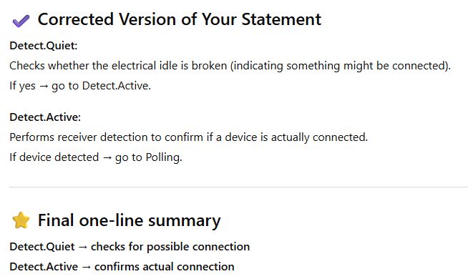
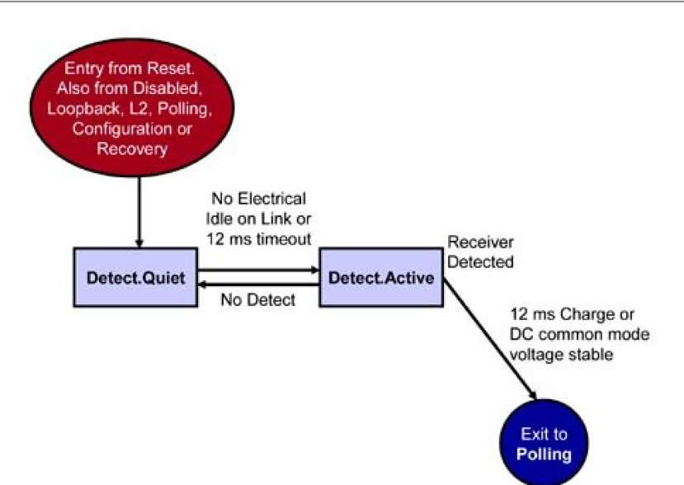
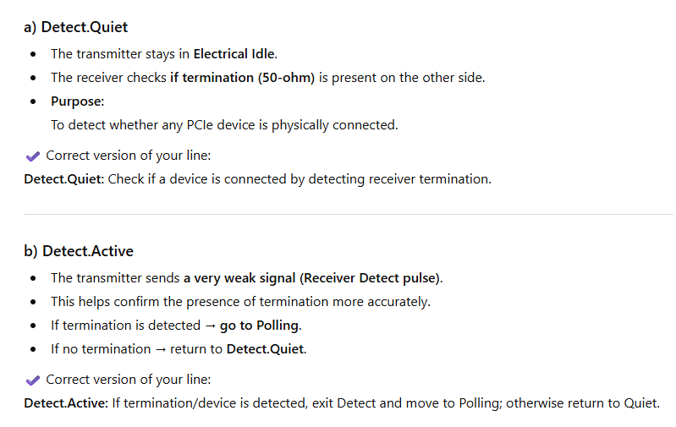
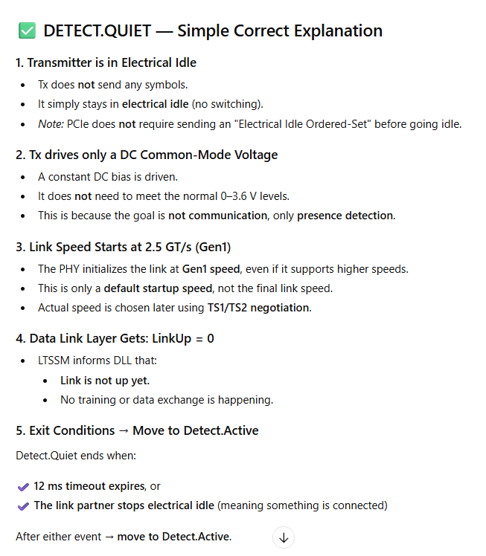
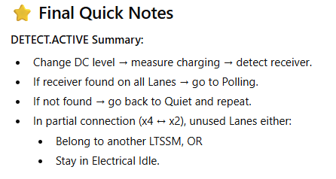
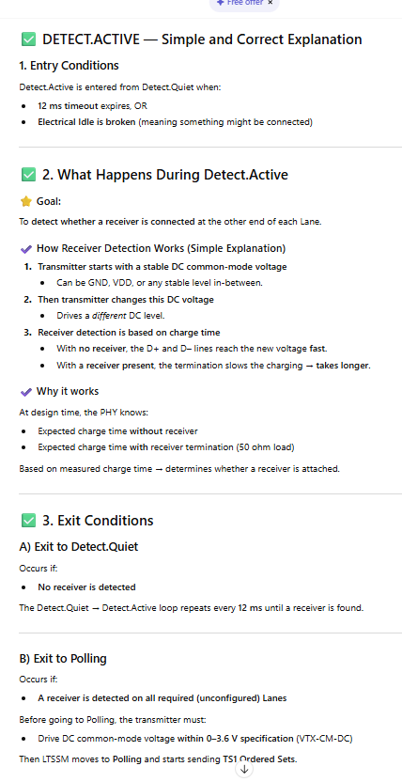
2.POLLING_STATE:- it’s use to check what device is connect how many lane,width ,size ,link have only check not established. And pass TS1 and TS2 orderset.
Exchange TS1 and TS2 Ordered-Sets
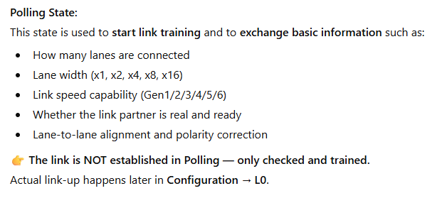

3.SUB_STATE_OF_POLLING.
a.) polling.active:- Exchange TS1/TS2 to detect lanes and polarity.
b.)polling.complience:- it’s mainly use to check electrical idle singal(it’s opattional).
c.)polling.config:- : set lane width and finalize training.
b.)polling.speed:- Negotiate and set maximum link speed.
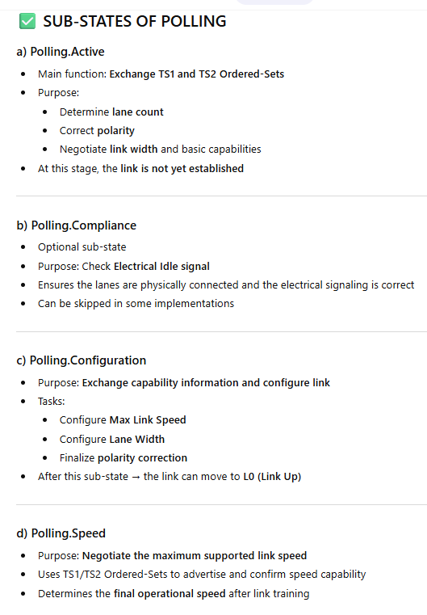
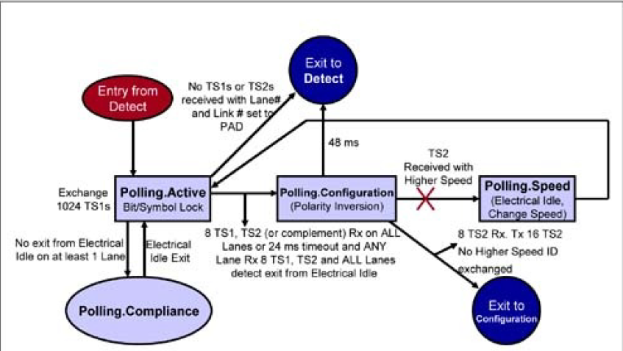

a.) POLLING_ACTIVE_STATE:-
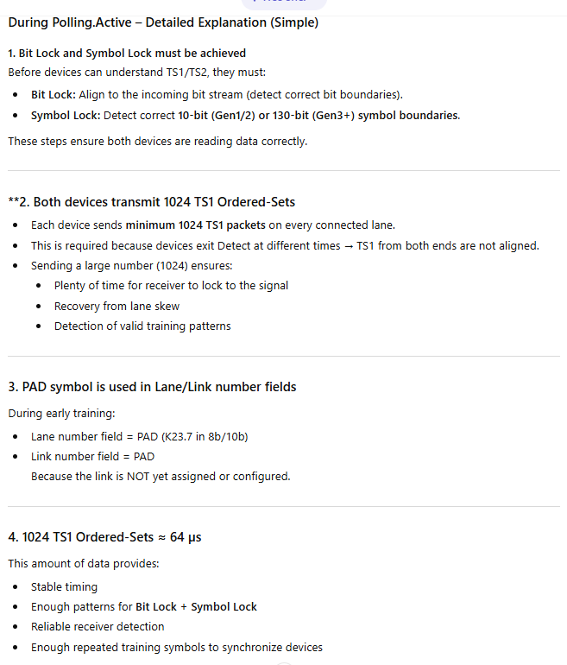
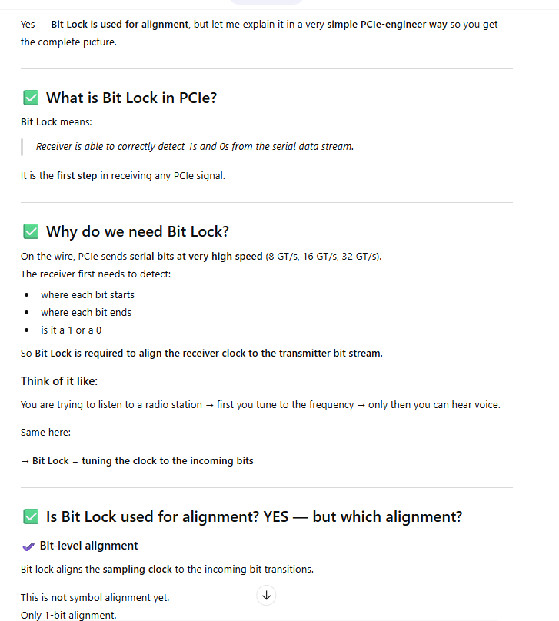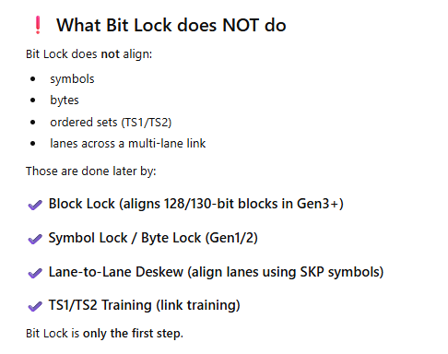
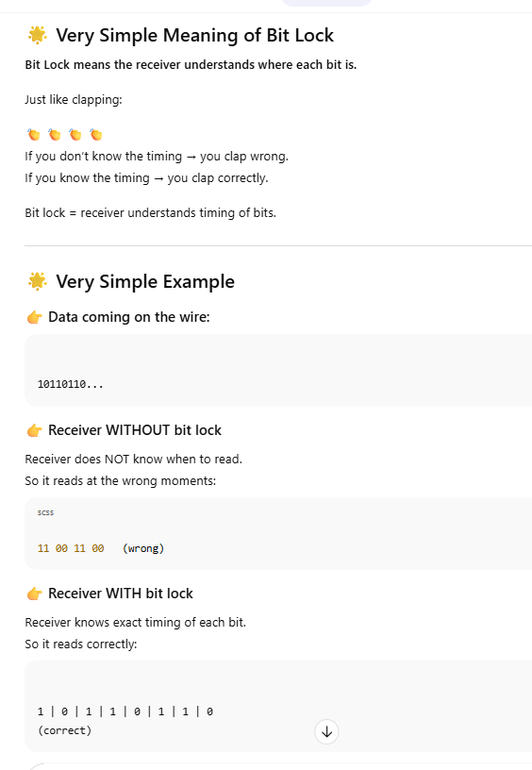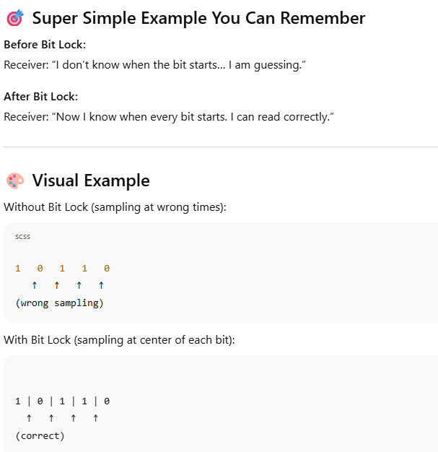

b.) SYMBOL_LOCK:- it’s use to check which encoding boundary we are using 8/10 bit ya 128/130 bit.
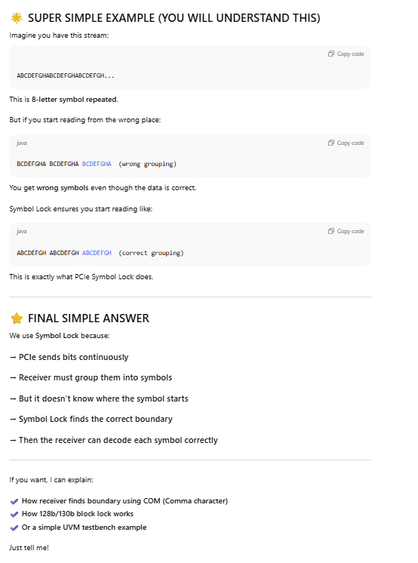
c.) PAD symbol:- add extra empty symbol end back of the packet.
PAD symbols help maintain the lane and link.
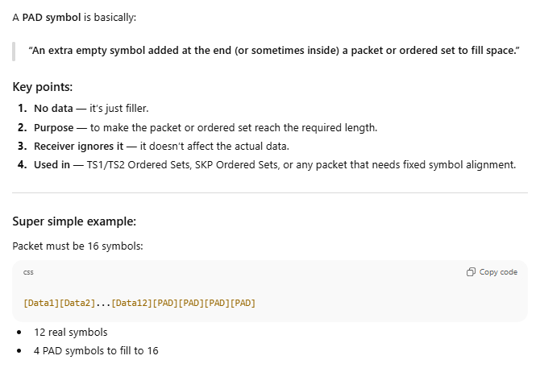

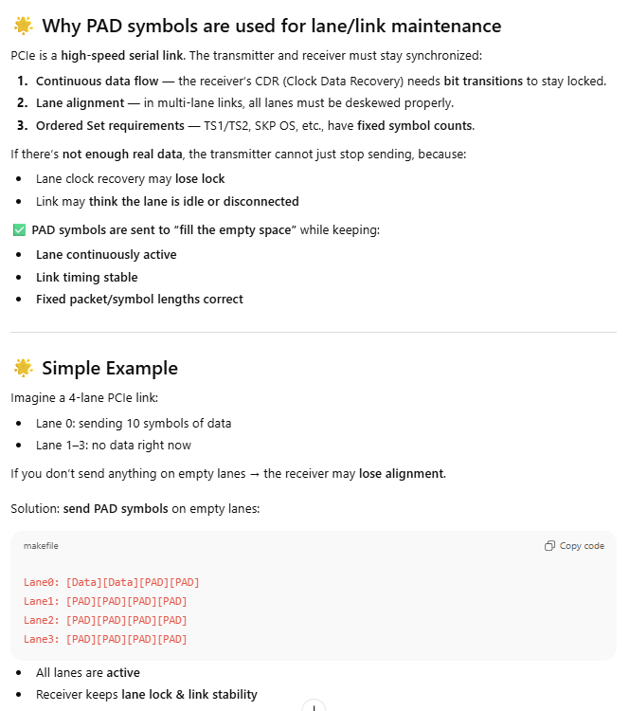
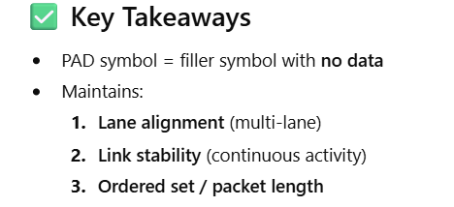
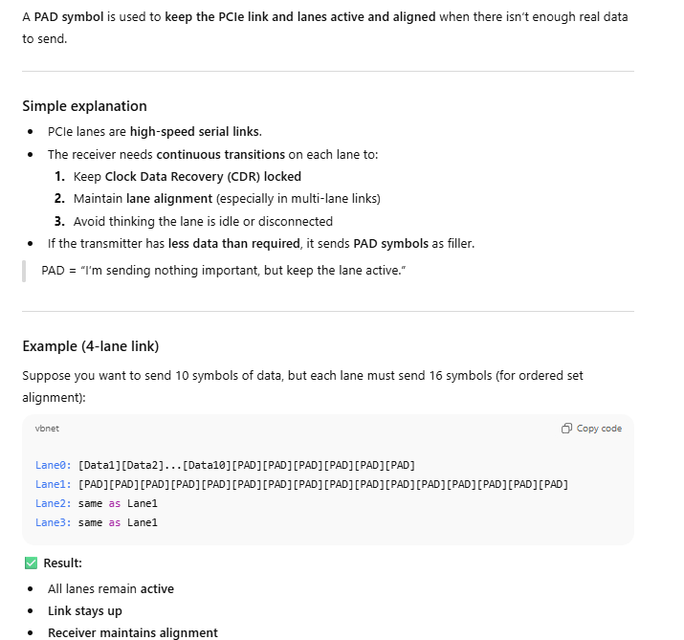

d.) POLLING.CONFIGURATION:-
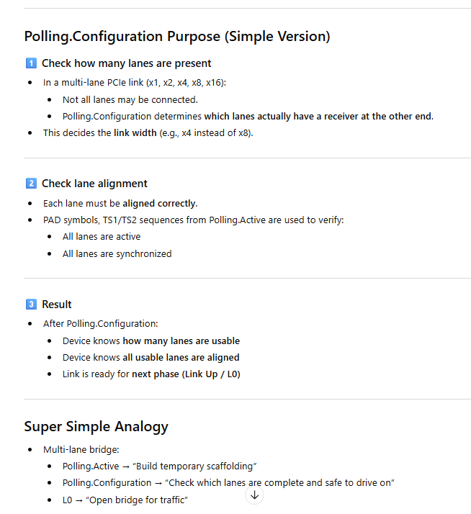
e.)POLLING.COMPILANCE:- it’s mainly use to check electrical idle are present or not. It’s optional.
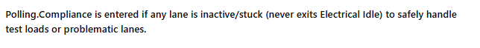
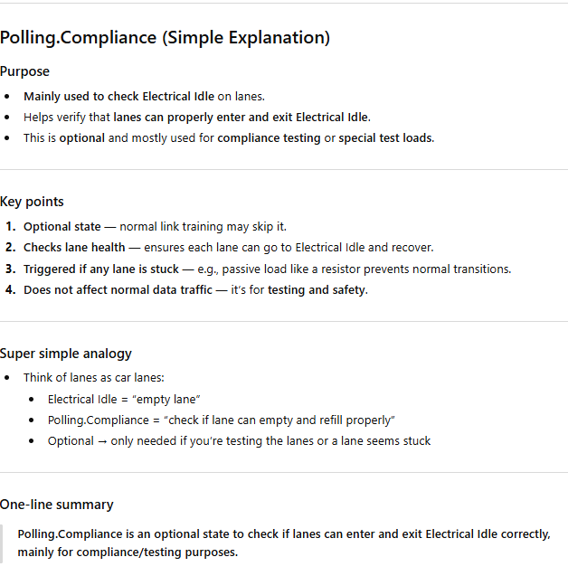
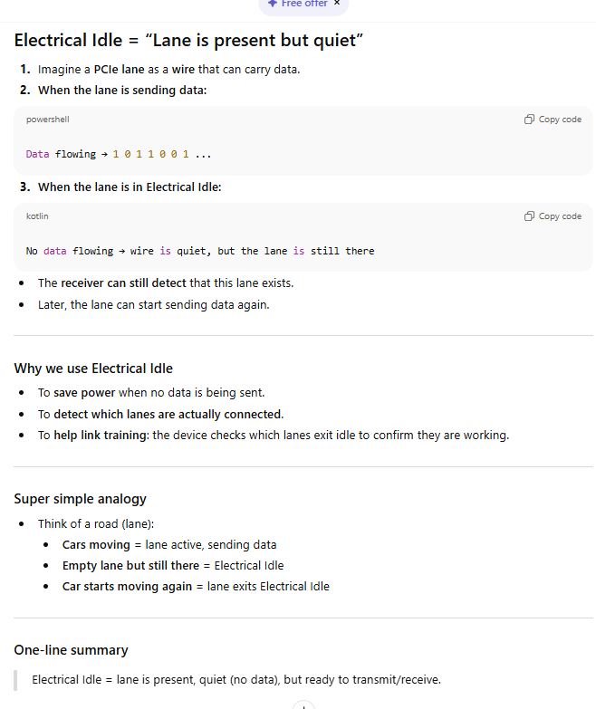
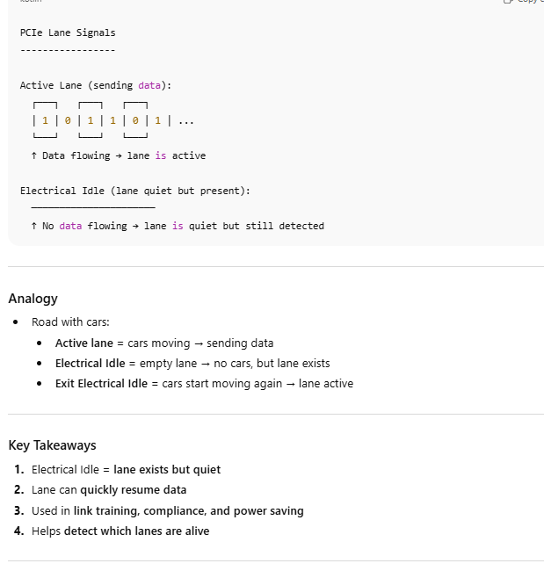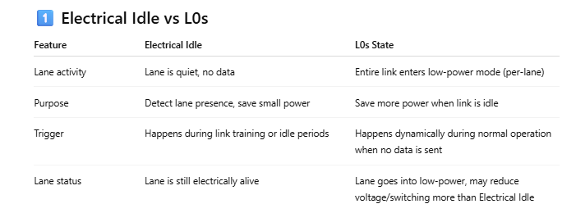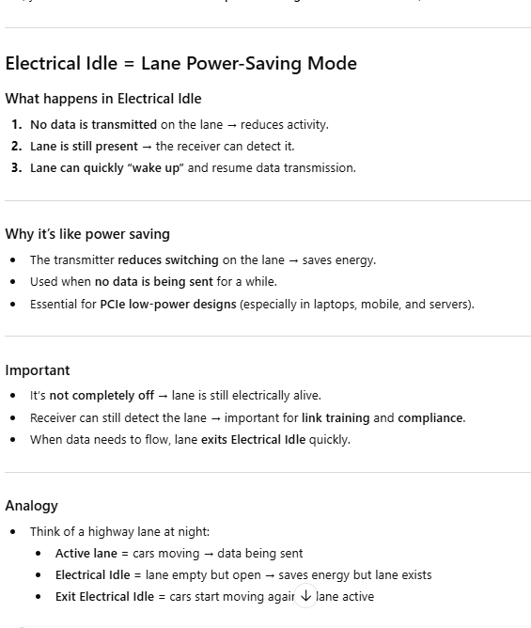

f.) polling.spped:- detect lane and link speed. Using ts1 and ts2 orderset.
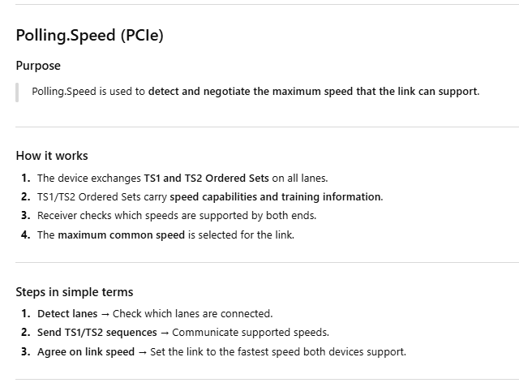

3.CONFIGURATION_STATE
CONFIGURATION_STATE:- it’s use to established the link ,lane,speed and setup the common plateform for communication.
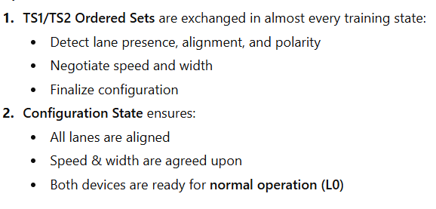
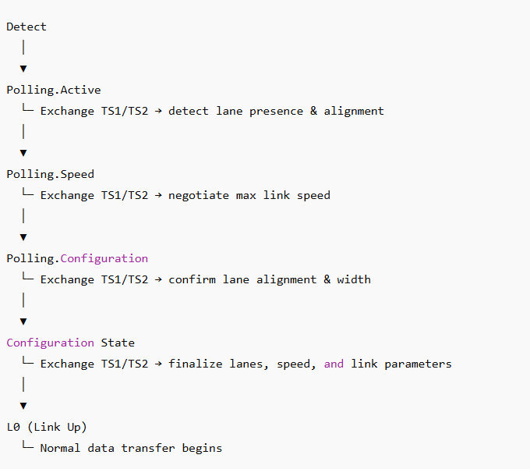
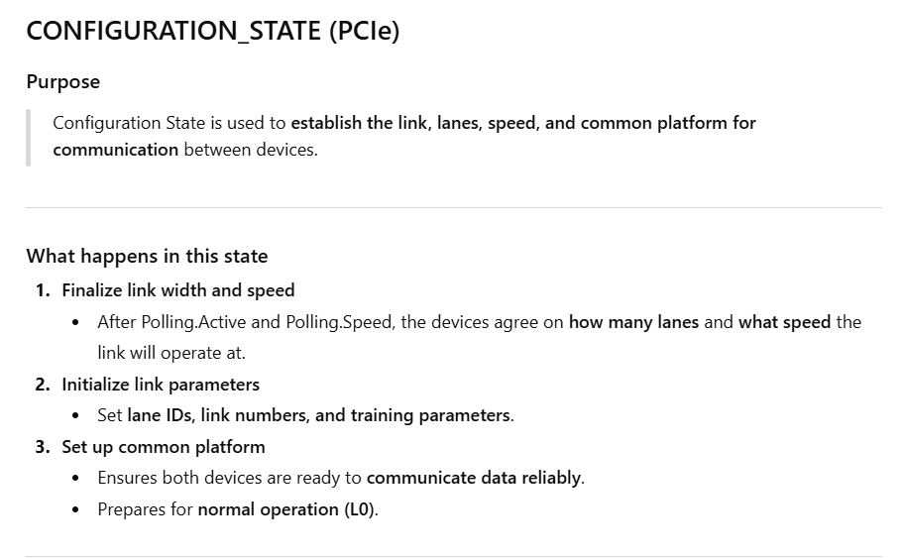
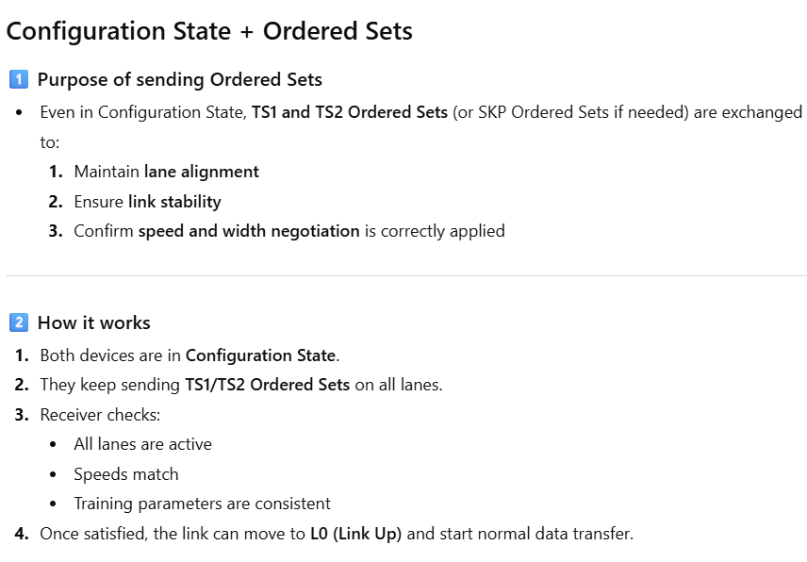

SUB_STATE:-
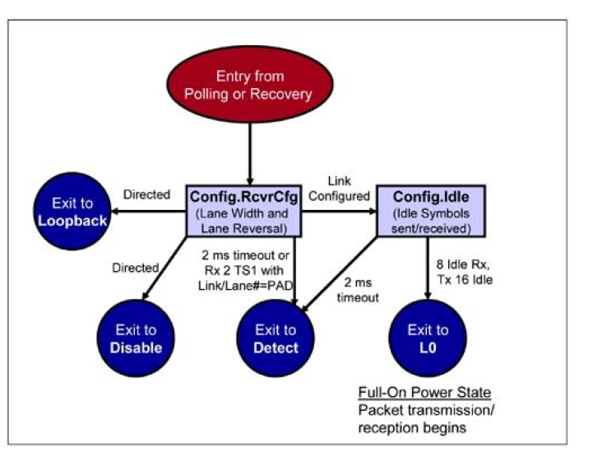
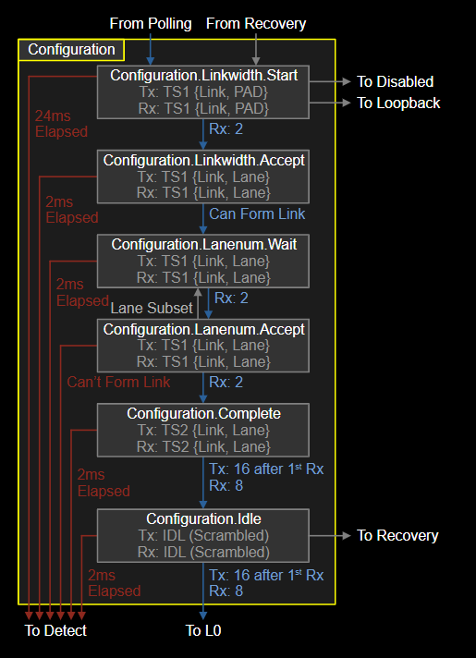
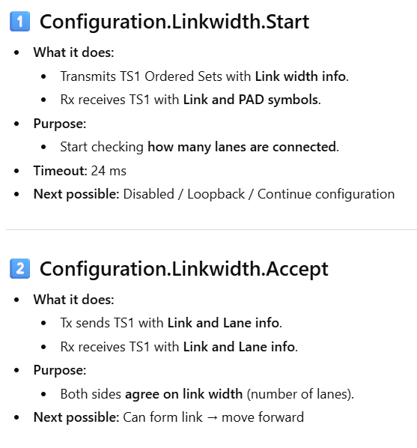
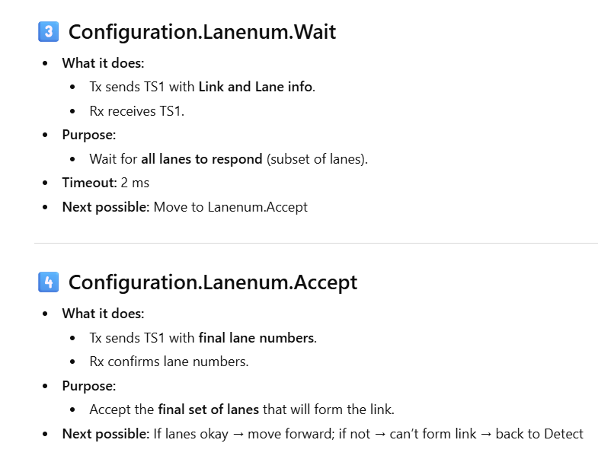
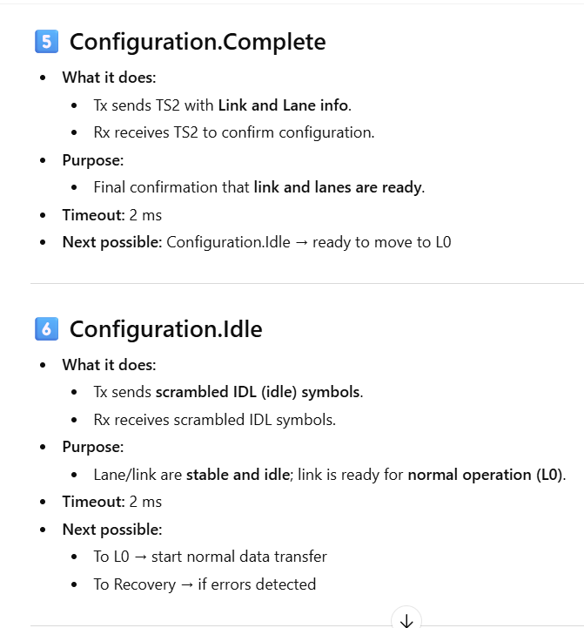

4.RECOVERY_STATE
In this state mainly use to recovery lane/link ya regenerate and also change the speed and if we go error in any state then we solve in this state.
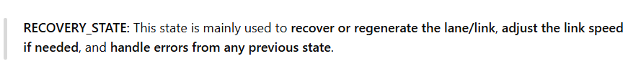
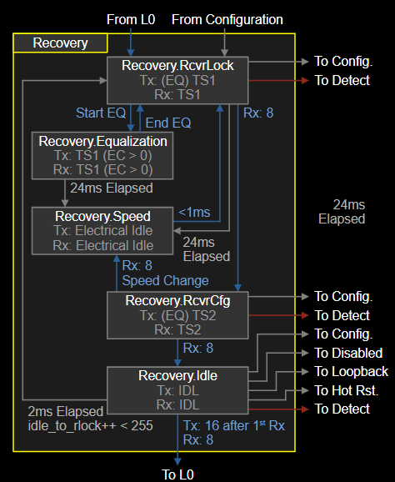

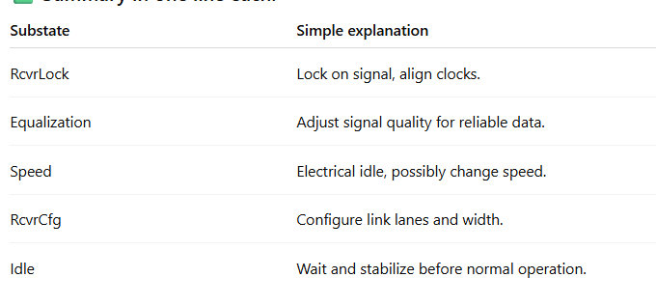

5.LOOPBACK
This state mainly use for check physical layer working correctly or not.
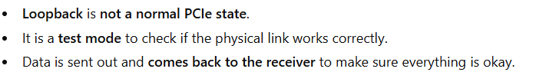
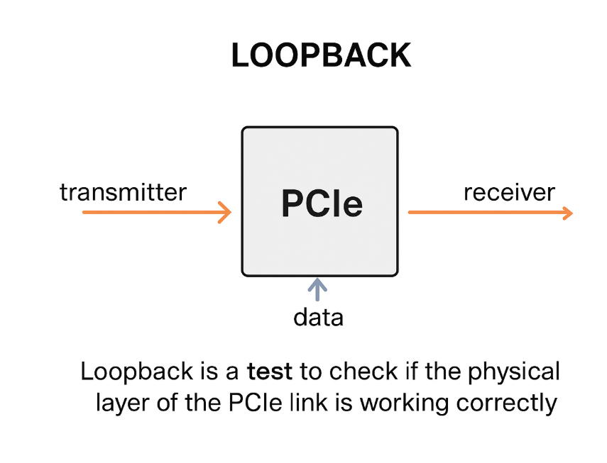

6.HOT_RESET
In this state we reset the communication.
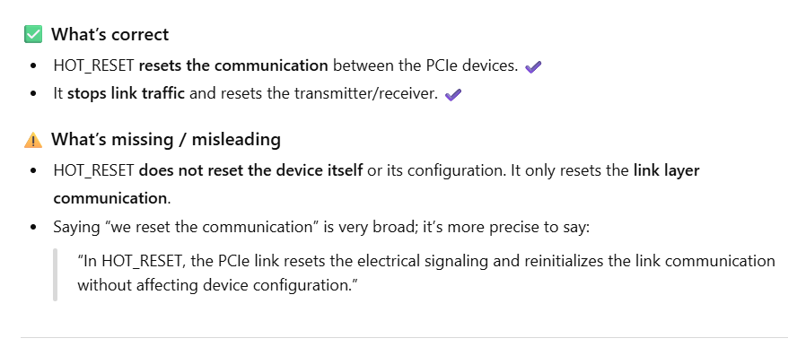
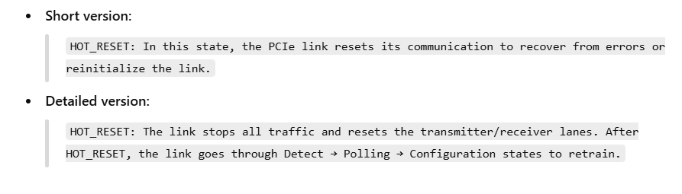

7.disable_STATE
It’s use to disable device and link.
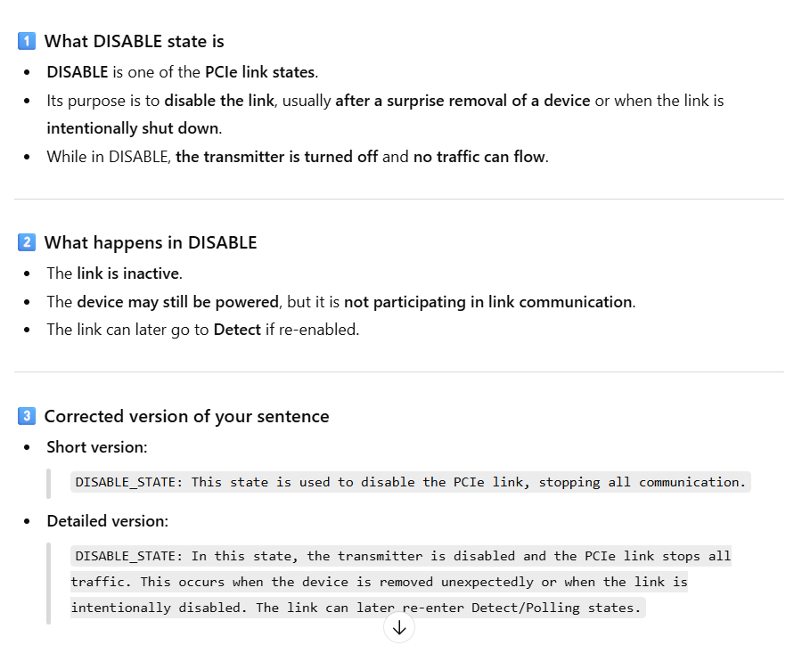

[ACTIVE AND LOW POWER STATE]

1.L0:- it’s main power state. We can do send tlp and dllp packet.
2.L0s:- low power state.
When go l0 to l0s:-
No dllp and tlp send then it’s go on L0s state.
link stops sending TLPs, but DLLPs (like L0s entry/exit DLLPs) may still be exchanged for link management.
When back to L0s to L0 state:-
RC send FTS symbol and back to L0s to l0 state.
3.L1 state:- its also deeper low power state.
When go L0s to L1 state:-
Device D-states (D0-D3hot/D3cold) are device power states, not link states.When back to L1 to L0 state:-
RC send FTS symbol and back to L0s to l1 state via recovery_state.

4.L2 state:- Very Deep low power state:-
When go L0 to l2 state:-
When device go on D3cold state .
No way come back direct go back on detect state.
