Question_answer
What interviewer may ask
Q: What is PCIe?
Ans:- It is a high-performance, high-bandwidth, packet-based, point-to-point serial interconnect used to connect processors and peripheral devices.
PCIe has a layered architecture, mainly:
- Transaction Layer
- Data Link Layer
- Physical Layer
It provides several important features such as credit-based flow control, ordering, QoS, error handling, LCRC, ECRC, LTSSM, hot-plug, and power management.
PCIe also supports different link widths and generations for scalability, and it can use switches to connect multiple devices.
Why did PCIe move from parallel PCI to serial?
Ans:- PCIe moved from the traditional parallel PCI bus to a high-speed serial interface mainly to overcome the limitations of parallel buses at higher speeds.
In a parallel bus, multiple bits are transferred simultaneously over multiple signal lines. As the speed increases, maintaining timing between all the signals becomes difficult because of signal skew, crosstalk, signal-integrity issues, and routing complexity.
PCIe uses high-speed serial differential lanes and supports multiple lane widths such as x1, x4, x8, and x16. This provides better scalability and allows higher bandwidth while simplifying high-speed board-level signaling.
For your interview: remember these 4 keywords:
Parallel → skew → signal integrity → PCIe serial scalable lanes.
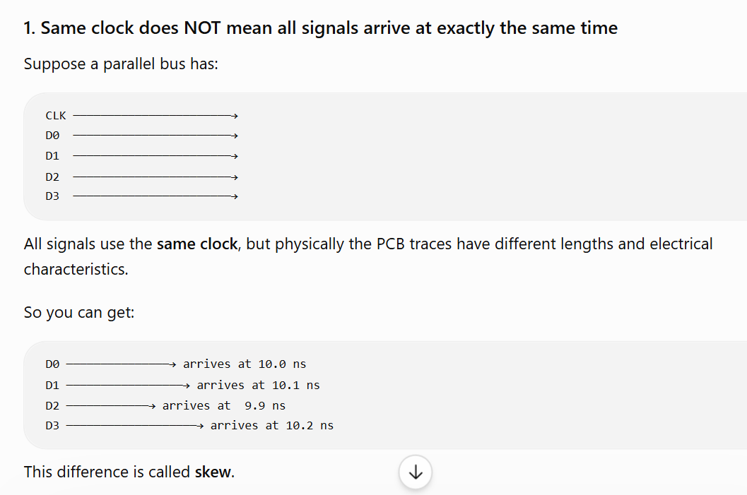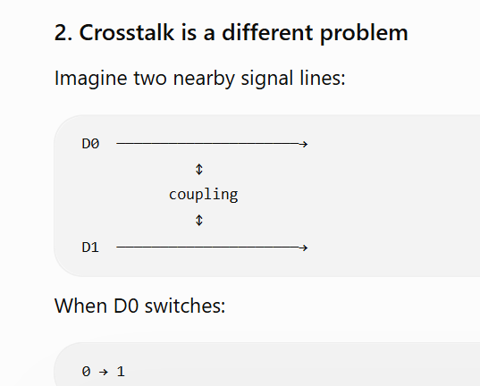
What does point-to-point mean?
Ans:- it’s mean each one talk to other like rc talk with switch and switch talk with endpoint is called point to point.
For example, an RC can have a point-to-point link with a Switch, and the Switch can have another point-to-point link with an Endpoint.
So, each PCIe link is a dedicated connection between two components rather than multiple devices sharing the same parallel bus.

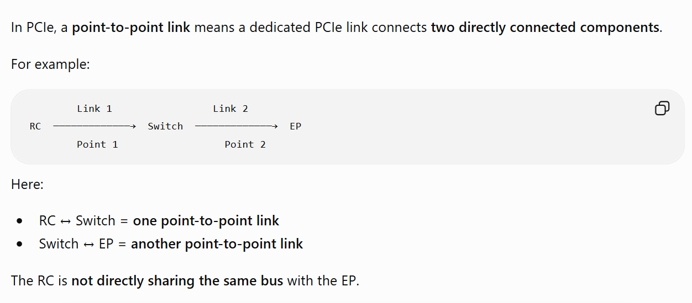
What is a packet in PCIe?
Ans:- it’s cantain everythink like if we receive data from software in transaction layer and tl layer convert into packet from by adding multiple think like :-
[header]+[actual_data]+[ECRC].

Header :- it’s cantain information about data like direction , size and everythink.
DATA:- it’s contain actual data.
ECEC:- it’s optional think , it’s use to protect packet and ( it’s enable when tlp hind bit=1) It allows the receiver to detect end-to-end corruption.

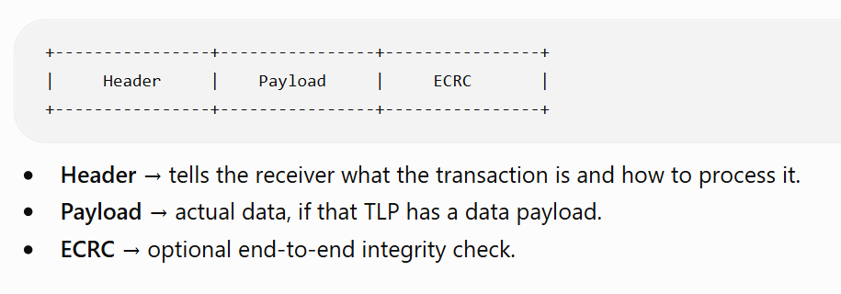

Difference between TLP and DLLP?
Ans:- TLP → carries the transaction
DLLP → manages the link

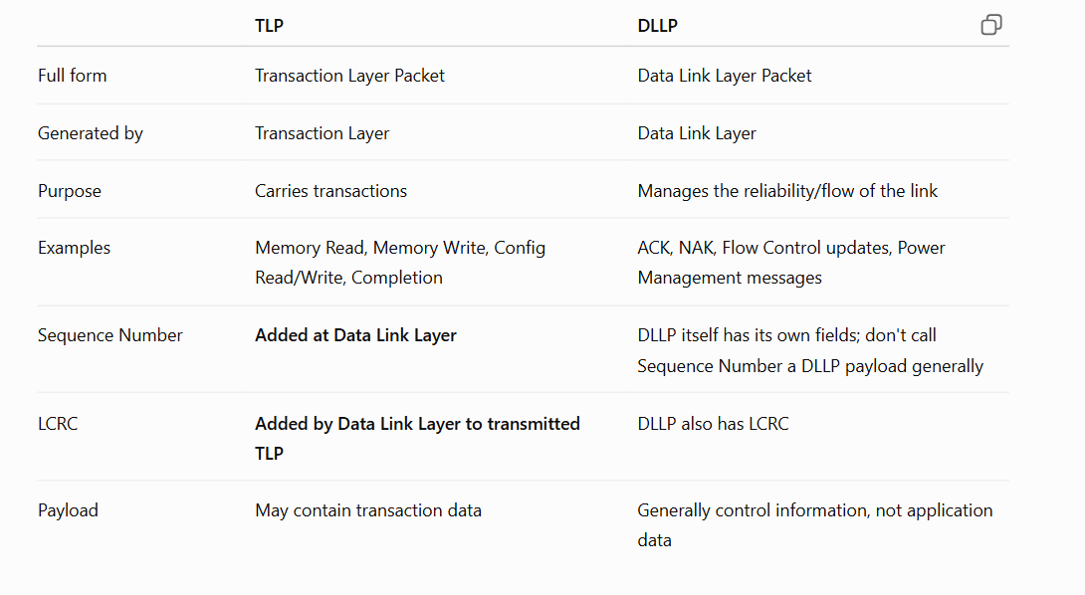
What happens if a TLP is corrupted?
Ans:- if in receiver side tlp is corrupted then receiver send nak response to data link layer via dllp packet. And then data link layer have replay buffer it’s re- transmitted tlp packet to receiver side.

TLP corruption → LCRC error detection → NAK DLLP → replay TLP → successful reception → ACK DLLP.
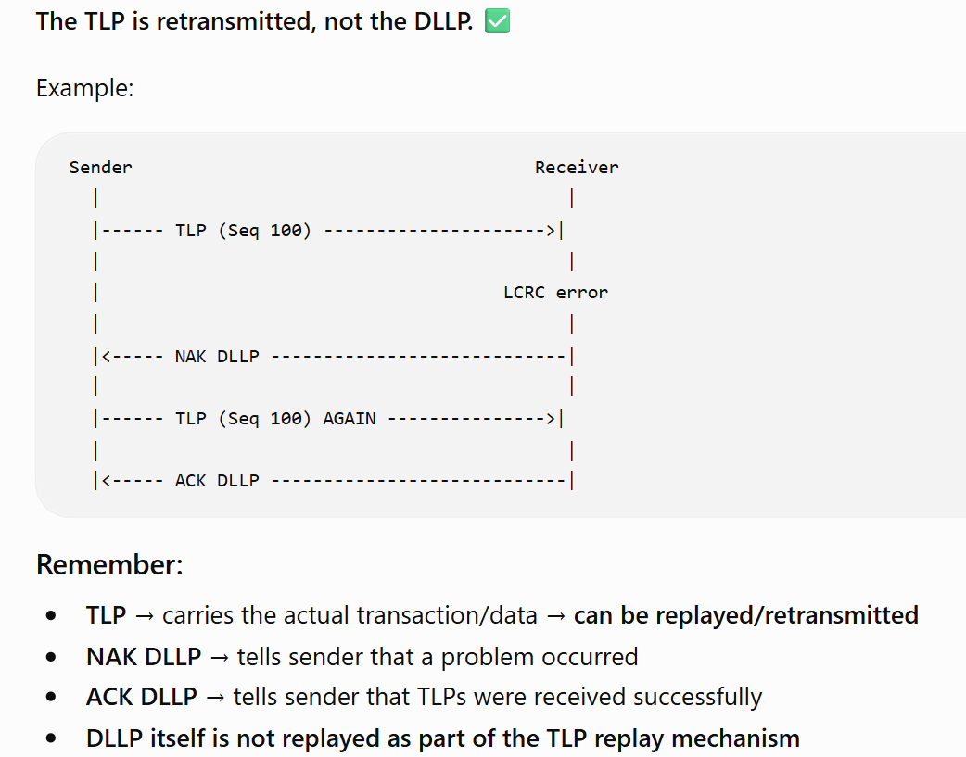
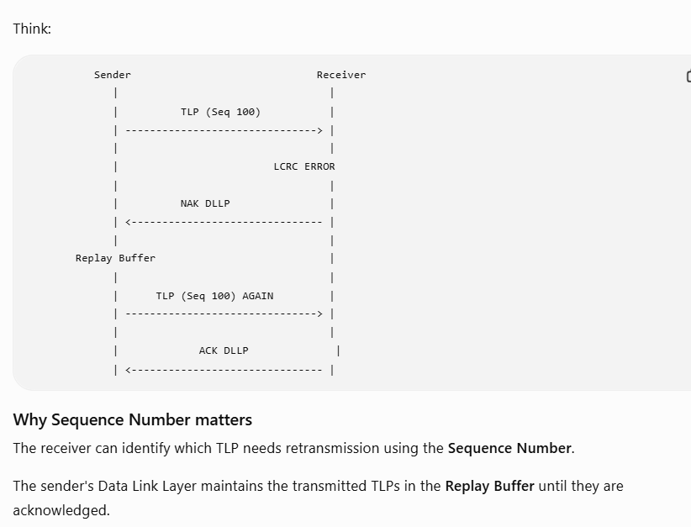
How does PCIe provide reliable delivery?
Ans:-
The receiver gets the TLP correctly, and if the TLP is corrupted or needs retransmission, PCIe detects the problem and sends the TLP again.
In PCIe, reliable delivery is mainly provided by the Data Link Layer
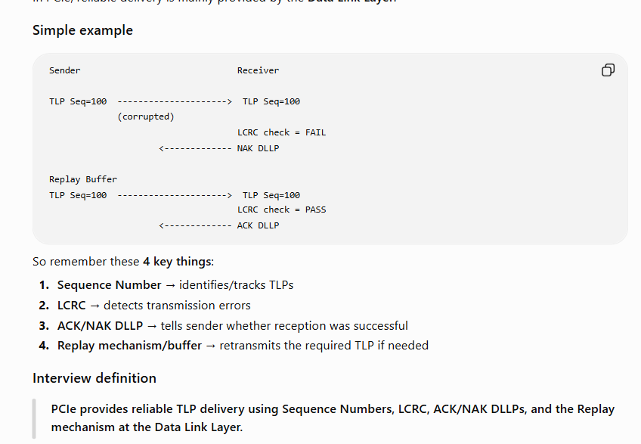

What is Sequence Number?
Ans:- it’s add in front of tlp packet for purpose of maintain order and easy to get from buffer if need to re transmitted. Seq_num size :-12 bit . these think happened in data link layer
What is LCRC?
Ans:- it’s link crc error detection. It’s add in data link layer. Size is 32 bit . it’s use to detect error ya protect our link between transmitter side and receiver side of data link layer.
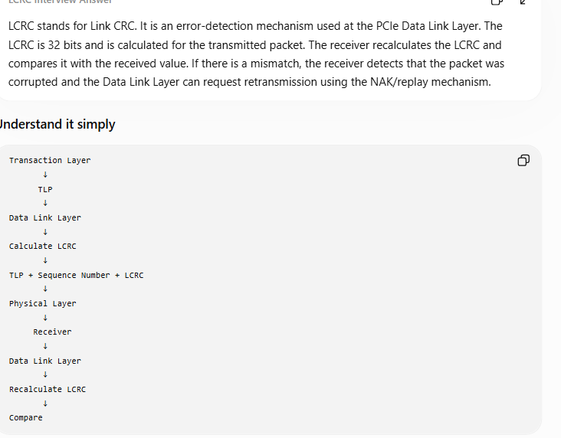
What is Replay Buffer?
Ans:- it’s use to store tlp packet. And this feature exists inside data link layer. Size of replay buffer is defined by project and client requirement and inside spec size is not mention.it’s use fifo memory to create replay buffer.
Use :- store tlp packet inside replay buffer with seq_no when we receive nak response from receiver side then we retransmitted same seq_no packet and if we receive ack then we remove the packet from buffer.
The Replay Buffer is typically implemented using memory or FIFO-like storage, but the exact implementation depends on the design architecture. The PCIe specification defines protocol requirements, while the actual buffer implementation and sizing are design-specific.
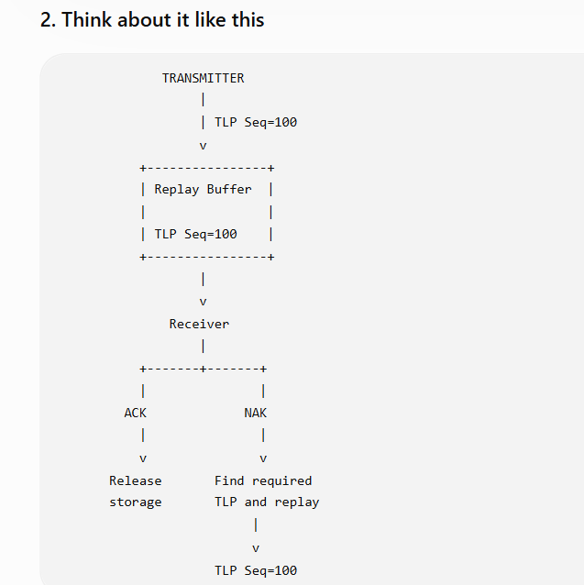
What is ACK/NAK?
Ans:- ack and nak is the one of feature in data link layer . this feature inside data link layer packet.
ACK indicates that the receiver successfully received and accepted the TLP(s).
Nak indicate packet is not successfully sent to endpoint need to re-transmit packet because is error in lcrc calculation in receiver side.
What happens if ACK is lost?
Ans:- if we lost ack then transmitter inside data link layer automatically re transmitted same same again after time frame is expire.
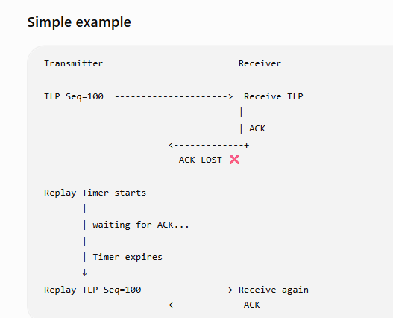
What is Replay Timer?
Ans:- Replay Timer is a timer in the Data Link Layer that detects when an expected ACK has not been received within the required time. When the timer expires, the transmitter initiates replay of the required unacknowledged TLP(s).

What happens if NAK is received?
Ans:- if we receive nak response then retransmitted same packet using seq_no.
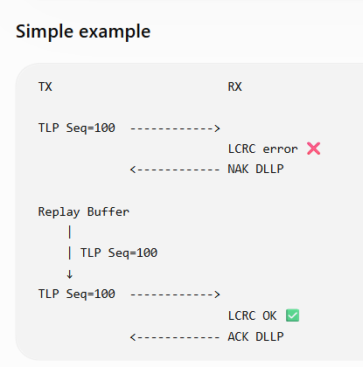
How do you verify this in UVM?
Ans:- 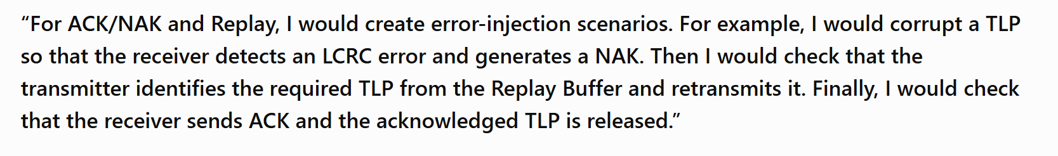
Ans:- 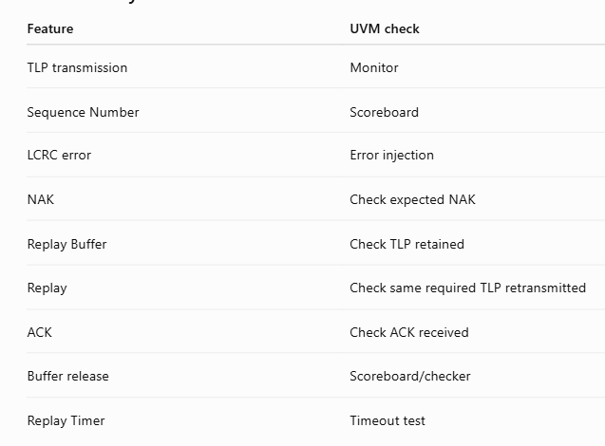

2. What are the layers?
Ans:- there are total three layer in pcie gen 4.0 ( transaction layer (it’s use for packet formation) , data link layer( it’s use for packet protection and error detection think),and last one is physical layer( it’s use to transmit use ltssm and start and end, encoding, assembling and de-assembling ans etc).
3. What is a link?
One is called multiple lane one link is called x1,x2,x4,x8,x16lane.
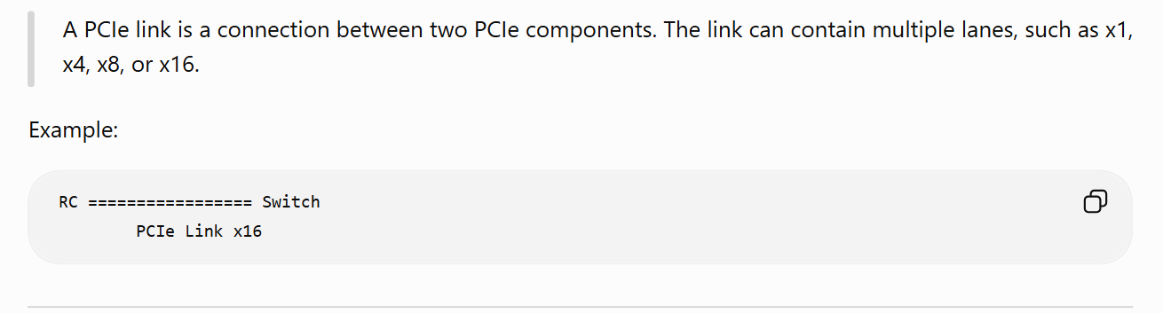
4. What is a lane?
Ans:- A PCIe lane consists of one transmit differential pair and one receive differential pair, providing bidirectional communication.
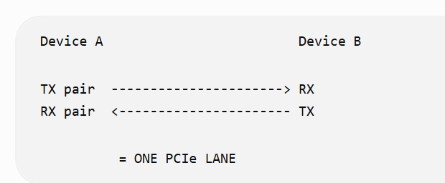
5. What is a packet?
Ans:- convert data into packet from add multiple think like data info, size info, send where info, and add error protection.
6. What is TLP?
Ans:- transaction layer packet is called convert data into packet from adding header and ecrc
[ header]+[data]+[ecrc]
7. What is DLLP?
Ans:- data link layer packet . it’s create by data link layer. It’s carry multiple think like ack/nak.
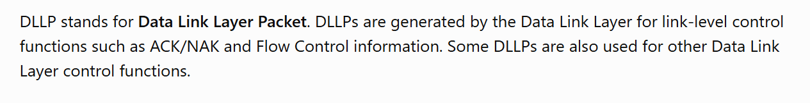
8. What does Transaction Layer do?
Ans:- convert data into packet from
The Transaction Layer handles transactions between the PCIe device and the system/application side and creates/processes TLPs. It handles transaction types such as Memory, Configuration, and Completion transactions.
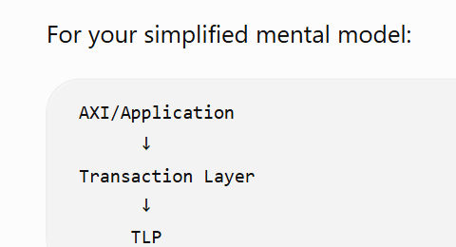

9. What does Data Link Layer do?
Ans:- add protection our tlp packet to ensure packet send to endpoint.
The Data Link Layer provides reliable delivery across a PCIe link. It uses Sequence Numbers, LCRC, ACK/NAK, Replay Buffer, and Replay mechanisms.
10. What does Physical Layer do?
Ans:- it’s do multiple think like endcoding, tlssm, assembling and de assembling and etc.
11. What is point-to-point?
Ans:- rc commicate with switch and switch communicated with endpoint its’s called point to pont communication.
12. What is full duplex?
Ans:- one lane are capable for doing both send and receive data at a same time .
13. What is link width?
Ans:- Link width is the number of lanes used by a PCIe link. Common widths include x1, x2, x4, x8, and x16.
14. What is Gen4 speed?
Ans:- 16 GT/s per lane
The GT/s means giga-transfers per second, not GB/s.
For example, a theoretical x16 Gen4 link has:
16 GT/s × 16 lanes = 256 GT/s aggregate signaling rate

15. What features require FSM?
Ans:- tlssm and data link layer fsm
• LTSSM
• Data Link Layer state/control logic
• Link initialization/training-related control
• Replay/recovery control logic

16. What features require counters?
Anns:- replay buffer, replay num , ack/nak and seq_no and etc.
Counters/registers are useful for things such as:
- Sequence Number tracking
- Replay-related tracking
- Timers
- Flow-control credits
- Packet/payload length
- Retry/replay counters where specified

17. What features require buffers?
Ans:- replay buffer
• Receive/transmit buffering
• Flow-control-related buffering
• Packet/data buffering inside implementation

18. What features require checkers?
Ans:- seq_no, lcrc and ecrc
• Sequence Number checking
• LCRC checking
• ECRC checking
• TLP format/field checking
• Protocol/order checking
• Flow-control/credit checking
• LTSSM transition checking
• Timeout checking

QUEESTION:- PCIe high-level requirements:

1. PCI-compatible software model
Ans:- Compatible means able to work together without needing major changes.
PCIe maintains a PCI-compatible software model, so existing PCI system software can enumerate and configure PCIe devices using the PCI configuration model, with minimal/no changes to existing software and drivers.
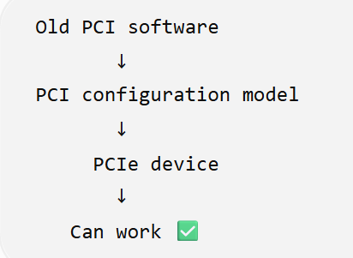

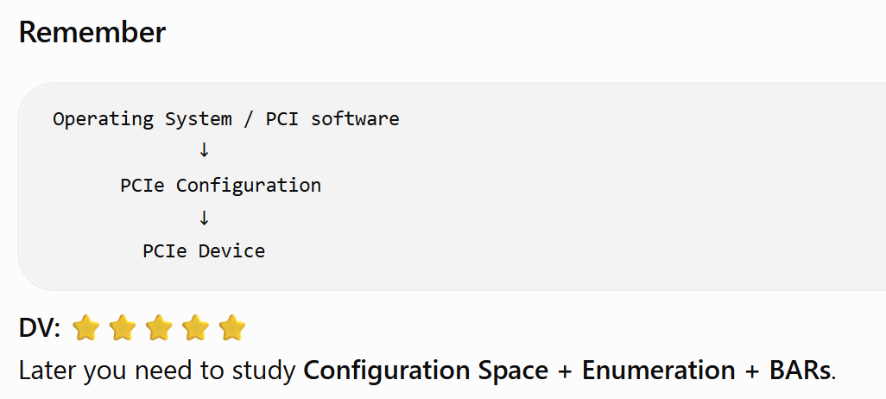
2. Low latency / low overhead
Ans:- LOW LATENCY:- data tranfer waiting or delay are less.
LOW OVERHEAD:- it’s use to take minmum extra infro about packet compare to actual data is called low overhead.
Low overhead means minimizing the extra protocol information/processing relative to the useful application data.
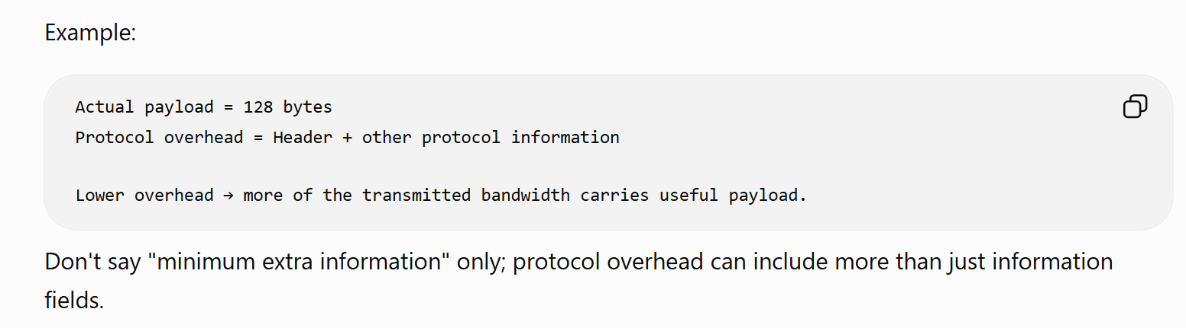

3. High bandwidth
Ans:- tranfer large amount of data per unit time.
4. Scalable using lanes + signaling rate
Ans:- PCIe scales performance by increasing the number of lanes and by increasing the signaling rate across generations. 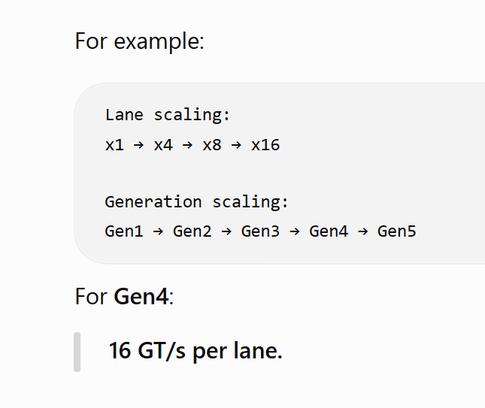
5. Multiple transaction/data types
Ans:- memory write/read, config read/write, message transaction are there.
6. Ordering rules
Ans:- it’s mainly use for maintaince the order to transfer packet each .
Ordering rules define which transactions must remain ordered relative to each other and when reordering is permitted.
Ordering rules determine whether PCIe transactions are required to remain ordered or may be reordered.

Type :- it’s have multiple of order :- 1. Id base ordering 2. Relax ordering
1. id base ordering :- it’s maintain sequence like 0,1,2,3,4
2. Relax ordering Relaxed Ordering allows certain transactions to be reordered when the applicable PCIe ordering rules permit it. like:- 1,6,3,9,0
7. Power management
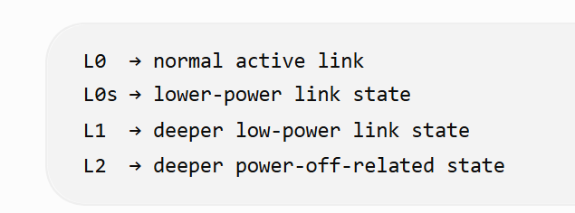
Ans:- it’s use to maintain power state like l0, l1,l0s,l2 power state
Lo:- it’s normal transfer state like(send dllp or tlp)
L0s:- L0s is a low-power link state associated with reduced power when the link is idle.
How it’s back( L0s → L0) :-
L1:-
L2:-
8. QoS
Ans:- it’s use to prioritize the transaction which one go first if multiple transction hit same time and it have feature to complete like tc/vc mapping.
QoS allows different traffic classes to receive differentiated service. PCIe uses mechanisms such as Traffic Class and Virtual Channels to support this.
PCIe uses mechanisms such as Traffic Classes (TC) and Virtual Channels (VC) to provide differentiated treatment of traffic.
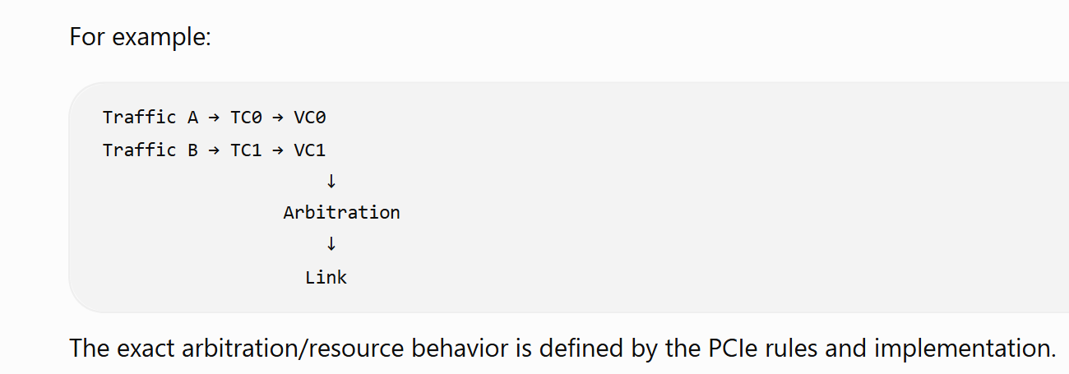
9. Hot-Plug
Ans:- PCIe Hot-Plug allows supported devices to be inserted or removed while the system is running, with the platform/software handling the corresponding events.

10. Link-level data integrity
Ans:- PCIe uses LCRC at the Data Link Layer to detect corruption of TLPs/DLLPs at the link level..

11. End-to-end data integrity
Ans:- ECRC provides end-to-end error detection for a TLP when applicable. It allows the receiving endpoint to detect corruption that occurred across the end-to-end path.
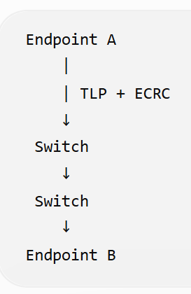

12. Error handling / AER
Ans:- PCIe provides error handling mechanisms to detect, report, and recover from different types of errors. Advanced Error Reporting (AER) provides detailed error reporting and status information for supported PCIe errors.

PCI Express Link

1. What is a PCIe Link?
Ans:- it’s build to make combination of lane is called link.
communication connection between two PCIe components.
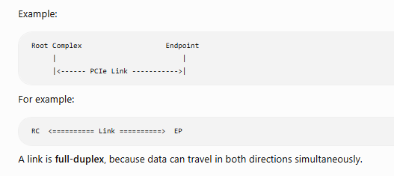

2. What does "dual-simplex" mean?
Ans:- it mean’s established the communication between both side at a same time.
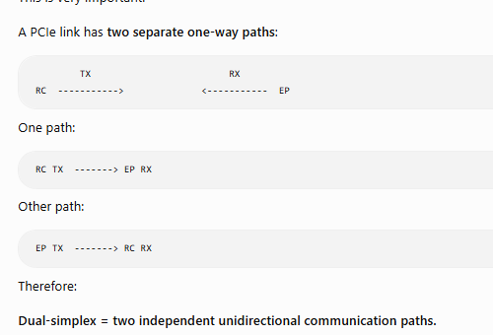

3. What is a Lane?
Ans:- combination of differential pair of receiver and transmitter is called lane .
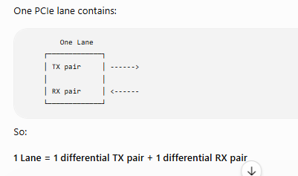.

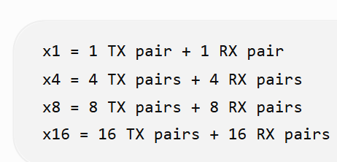

4. What is a differential pair?
Ans: - Tx and Rx electrical is called differential pair. And it’s mainly use to reduce noise.
Each TX/RX path uses two electrical signals.
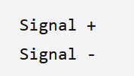

5. What does "dual unidirectional differential Links" mean?
Ans:- 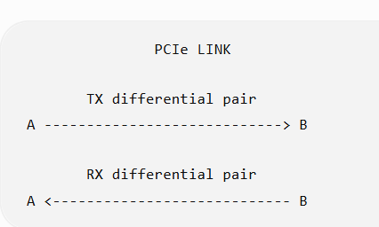

6. What does "data clock is embedded" mean?

7. Signaling Rate?
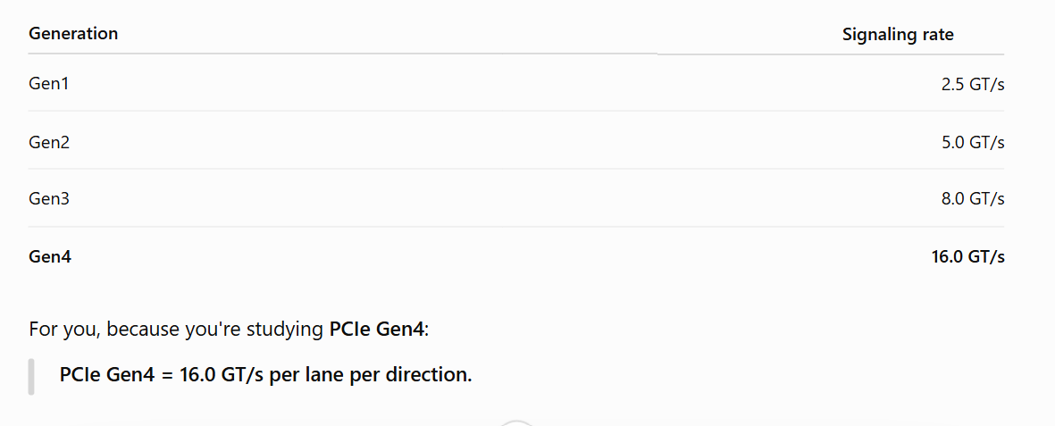
8. What does "per Lane per direction" mean?
Ans:- 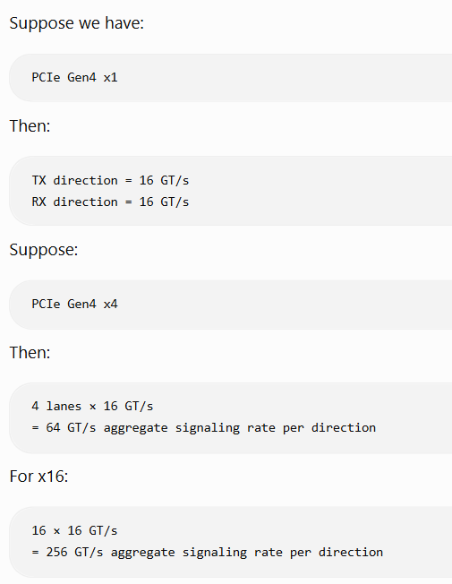

9. how can we calculate gt in gb ? (GT/s is not the same thing as GB/s.)

10. Link Width?
Ans:- Link must support at least one Lane.

11. Initialization
Ans:- During hardware initialization, each PCI Express Link is set up following a negotiation of Lane widths and frequency of operation by the two agents at each end of the Link.

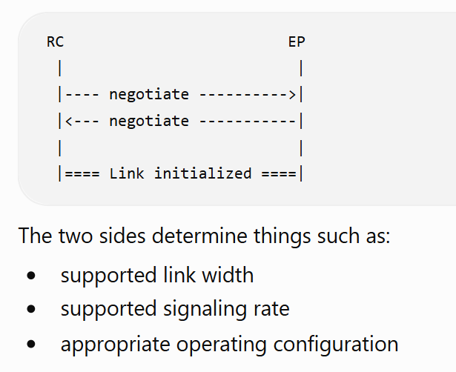

12. Why is initialization important for DV?
Ans:- 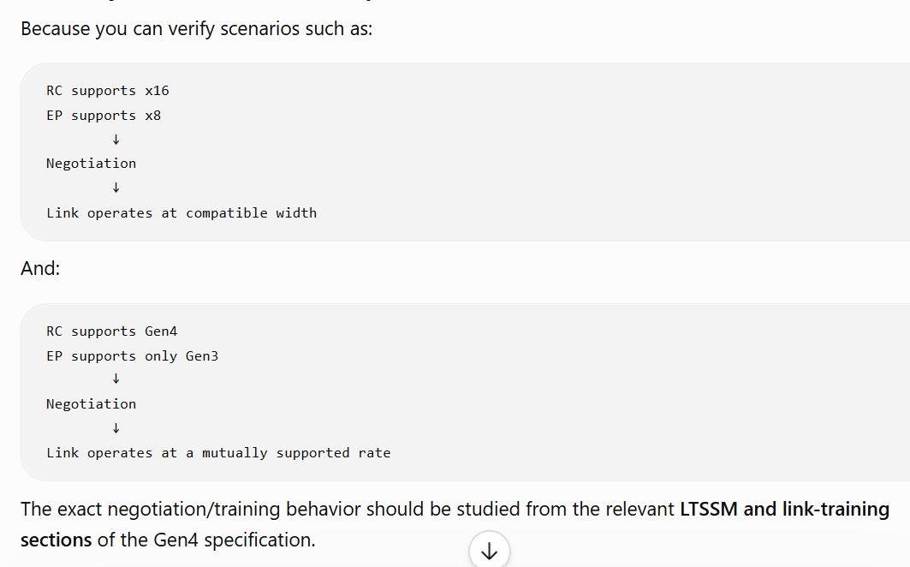 13. Symmetry?
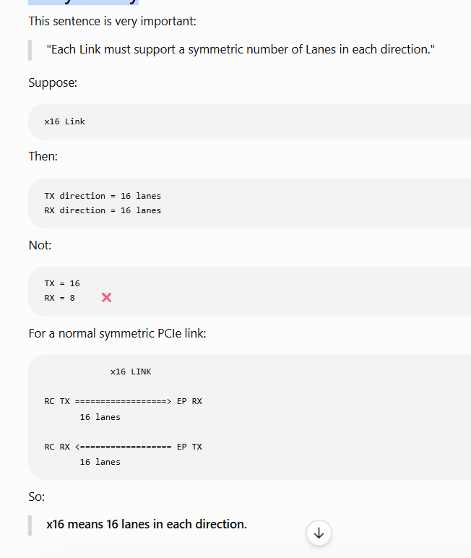

15. Very important interview questions from this section
Q1. What is a PCIe Link?
Answer:- it’s consists at least one lane is called pcie link.
PCIe Link is a communication channel between two PCIe components.

Q2. What is a PCIe Lane?
Ans:- combination of differential pair of tx and rx electrical signal is called lane.
Q3. What does x16 mean?
Ans:- x16lane’s mean’s we have x16 lane’s for transmission and x16 of receiver.
Q4. What is the Gen4 signaling rate?
Ans:- 16gt/s/per lane (it’s indicate the data transfer rate is called signaling rate).
Q5. Why does PCIe use multiple lanes?
Ans:- if we use multiple lanes then increase link bandwidth.
Q6. Is PCIe full duplex?
Yes, pcie support full duplex .
Q7. Who negotiates the link width and operating rate?
Ans:- Rc and Endpoint negotiates link width. 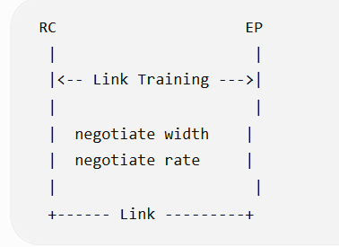
Q8. Does the OS perform this initial link negotiation?
No. The initial link setup and training are performed by hardware mechanisms; firmware/OS software is not involved in that negotiation.

PCI Express Fabric Topology
1. What is a PCIe Fabric?
Think of a PCIe fabric as the complete PCIe network/system. Like Rc, switch, endpoint.
It is made of multiple PCIe components connected through point-to-point Links.
PCIe FABRIC / HIERARCHY

Root Complex
(RC)
|
Link
|
+-------+-------+
| Switch |
+---+-------+---+
| |
Link Link
| |
EP1 EP2
Endpoint Endpoint

|
Link
|
PCIe-to-PCI Bridge

2. What is a Point-to-Point Link?
A PCIe link connects two components directly.
For example:
RC <========== PCIe Link ==========> Switch
Another link:
Switch <========== PCIe Link ==========> Endpoint
NOTE:- PCIe does not use one shared bus like old PCI.
EXAMPLE:

Old PCI:
Device 1 ----+
Device 2 ----+---- Shared Bus
Device 3 ----+

PCIe:
+------ EP1
|
RC ----------+------ Switch ------ EP2
|
+------ EP3
Each connection is a separate point-to-point PCIe link.

3. What is a Hierarchy?
Ans:- "A PCIe Hierarchy is a single PCIe fabric containing the Root Complex, Endpoints, Switches, and their interconnected PCIe Links."
A hierarchy can contain:
- Root Complex (RC)
- Endpoints (EP)
- Switch
- PCIe-to-PCI/PCI-X Bridge
- PCIe Links connecting them
For example:
CPU / Memory
|
Root Complex
|
PCIe Root Port
|
Link
|
Switch
/ | \
Link Link Link
/ | \
EP1 EP2 EP3
This entire connected PCIe structure is a PCIe Hierarchy.

4. Role of each component
Root Complex — RC
Root complex is establish the connection between CPU/memory subsystem and endpoint and it’s act like a interface is called root complex.
It’s ack as a interface between cpu and endpoint.
Simplified:
CPU / Memory
|
v
+-----------+
| Root |
| Complex |
+-----------+
|
v
PCIe Fabric
In DV, you will commonly see:
RC → EP
RC → Switch → EP

Endpoint — EP
An Endpoint is generally a PCIe device.
Examples:
- GPU
- NVMe SSD
- Network controller
- PCIe accelerator
Example:
RC
|
|
+-------- GPU (EP)

Switch
It’s is logical block . and it’s use for increase the connection of multiple endpoint device.
And The primary function of a PCIe Switch is to route and forward TLPs between its upstream and downstream ports. It can also contain logic for flow control, buffering, and TC-to-VC mapping.
A PCIe Switch is a PCIe component that allows multiple PCIe devices to communicate through a single upstream connection to the Root Complex. It contains an upstream port and multiple downstream ports, and it performs TLP routing/forwarding between ports.

A switch can have logic related to:
- TLP routing/forwarding ⭐⭐⭐⭐⭐
- Port management
- Buffering
- Flow control
- Traffic Class (TC) → Virtual Channel (VC) mapping
- Configuration transactions
- Error handling
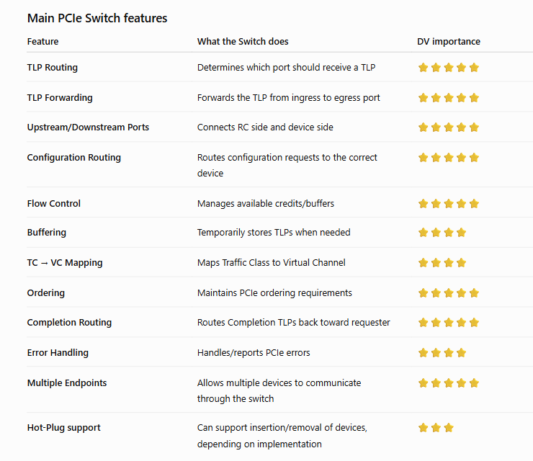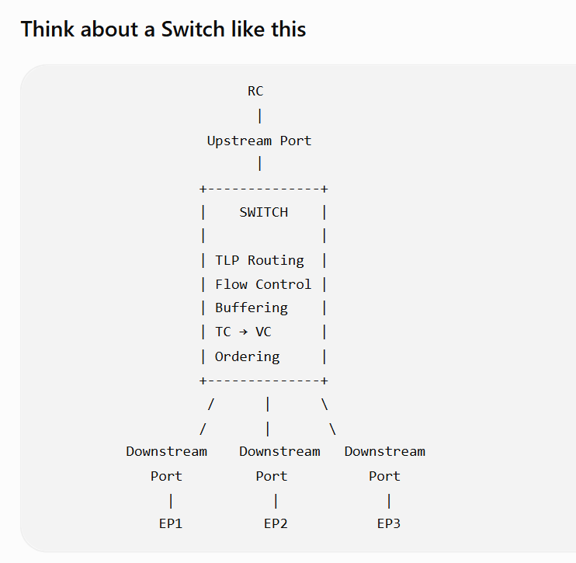

RC
|
Upstream
|
+----------+
| Switch |
+----------+
| | |
| | |
EP1 EP2 EP3
The switch has:
- Upstream Port → toward RC
- Downstream Ports → toward EPs or other PCIe devices
This becomes very important when you study PCIe routing.

PCIe-to-PCI/PCI-X Bridge
Ans:- Here, we have two think
1. pcie to pci communication :- A PCIe-to-PCI/PCI-X Bridge allows a newer PCIe system to communicate with legacy PCI or PCI-X devices.
Use :- legacy endpoint.
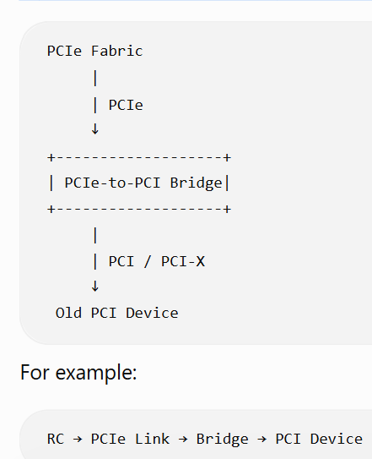

2.pcie to pcie :- PCIe communication is normally handled by PCIe components such as a Switch, not a PCIe-to-PCI bridge.

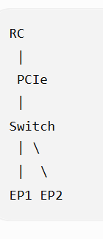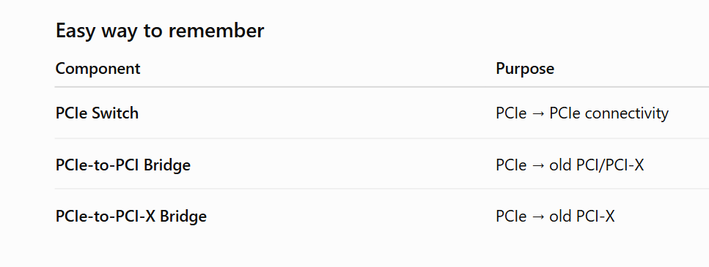
5. Most important DV concept
For your PCIe verification preparation, don't just memorize:
"Fabric contains RC, EP, Switch and Bridge."
You should understand:
Component
↓
Port
↓
PCIe Link
↓
Transaction
↓
Routing
↓
Destination
For example:
RC
|
TLP Request
|
v
Switch
/ \
/ \
EP1 EP2
Suppose RC sends:
Memory Read Request
The switch needs to determine where the request should go.
That leads directly into topics such as:
- PCIe addressing
- Configuration space
- Bus/Device/Function (BDF)
- Memory/IO routing
- Configuration routing
- Completion routing
- Switch upstream/downstream ports
- TLP header fields
- Type 0 / Type 1 configuration requests

1. What is Root Complex?
Ans:- it’s use for build communication between cpu/sub system and endpoint.
It’s just like interface.
The RC can generate Configuration Read/Write Requests as a Requester, which are used to access and configure PCIe devices.
It’s have more then one root port to connect i/o device. ach Root Port provides a separate PCIe path and can connect directly to an Endpoint or to a PCIe Switch.
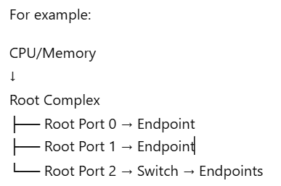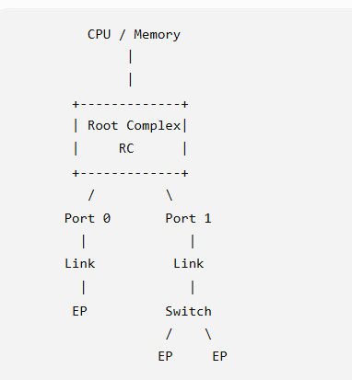

Question:- how many maximum root port have rc?
Ans:- There is no fixed maximum number of Root Ports defined by PCIe for an RC.

3. What is a "Hierarchy Domain"?
Each interface defines a separate hierarchy domain.
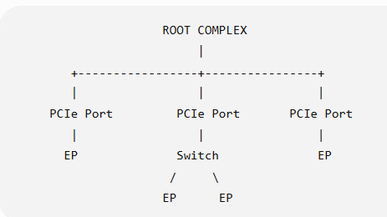

4. What is a sub-hierarchy?
A hierarchy doesn't have to be:
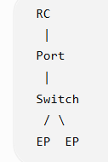
The Switch + its downstream Endpoints form a sub-hierarchy under that RC port.

5. Peer-to-Peer communication between hierarchy domains
Ans:- peer to peer communication mean’s we can establish the communication without involving rc/cpu/sub memory.
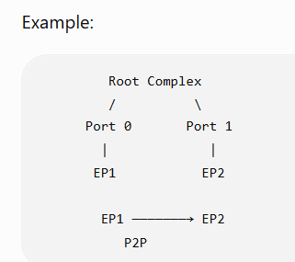
Can:
EP1 → EP2
communicate directly through the RC? :- yes
"Peer-to-peer routing between RC hierarchy domains is optional and implementation dependent."

6. RC may internally contain a Switch
Ans:- it’s rc have virtual/internal switch to do p2p communication between one root port to another root port.
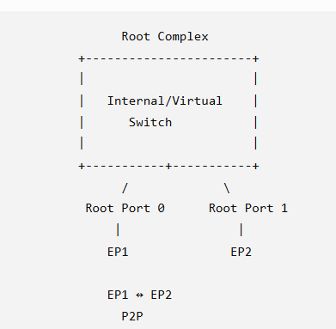
You don't necessarily see this as an external Switch.

7. RC can split packets
Ans:- RC can split packet , when we do p2p transaction.

Question:- so if we don't have p2p transaction then we split packet ?
Ans:- 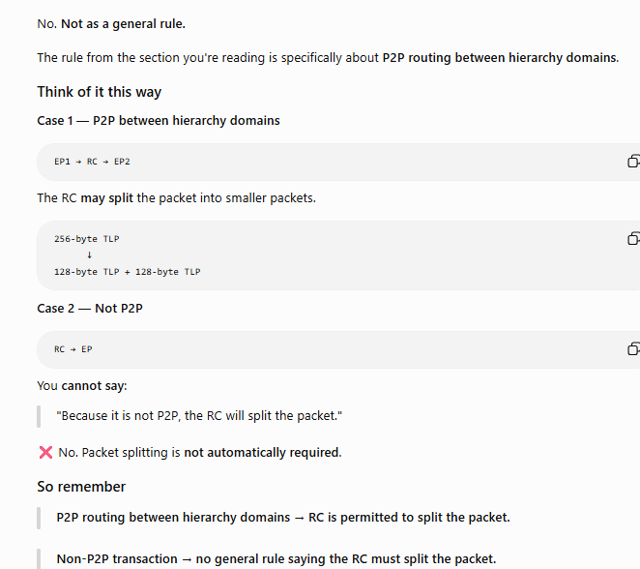
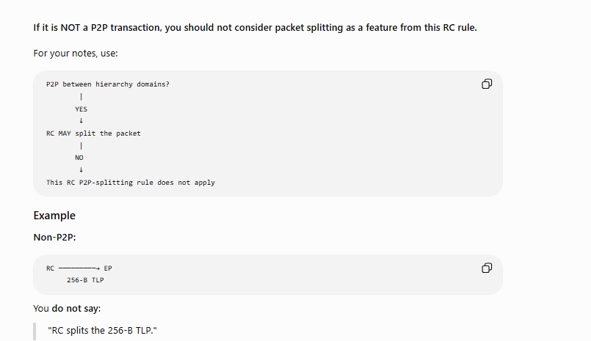

8. RC must generate Configuration Requests
An RC must support generation of Configuration Requests as a Requester.
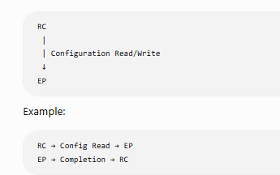
This is how the system can access PCIe configuration space.
DV scenarios
You should eventually verify:
- Configuration Read
- Configuration Write
- Correct BDF
- Valid/invalid device
- Completion response
- Configuration space access

9. I/O Requests are optional
RC is permitted to support generation of I/O Requests as a Requester.
Meaning:
Configuration Requests = must support
I/O Requests = optional
That's an important distinction.

10. Locked Requests
An RC is permitted to generate Locked Requests as a Requester.
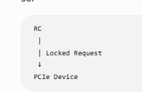

NOTE:- An RC must not support Lock semantics as a Completer.

RC features
- Root of the PCIe I/O hierarchy
- Connects CPU/memory subsystem to PCIe I/O
- Can have one or more PCIe Ports
- Each port can define a separate hierarchy domain
- Peer-to-peer routing between domains is optional
- Must support Configuration Requests as a Requester

Advanced features
- Internal real/virtual Switch
- Packet splitting for peer-to-peer routing
- Optional I/O Requests
- Optional Locked Requests as Requester
- Cannot support Lock semantics as Completer

Endpoints
1. What is an Endpoint?
Endpoint is a Function that can act as either a Requester or Completer of a PCIe transaction.
Simple meaning:
An Endpoint is a PCIe device/function that can initiate a transaction or respond to a transaction.
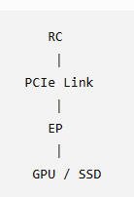

Requester vs Completer
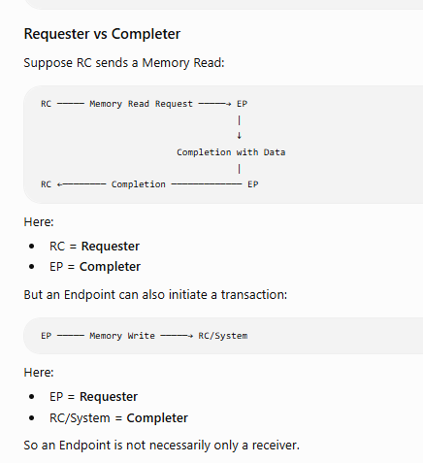
2. Endpoint can work on behalf of another device
PCIe-attached USB host controller
Think:
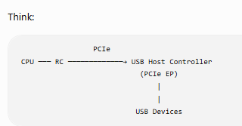

The PCIe Endpoint is the USB Host Controller, which is a PCIe device that controls another non-PCIe interface/device.
Another example:
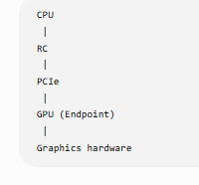

3. Three Endpoint classifications
Ans:- there are total three type of endpoint :- legacy endpoint, pcie endpoint, RCIEP
So remember:
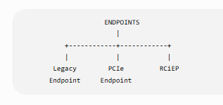
A. Legacy Endpoint
An Endpoint that follows legacy PCI compatibility behavior.(CONNECT with older version of pcie device).
B. PCI Express Endpoint
A normal PCIe Endpoint.
Examples:
- GPU
- NVMe controller
- Network controller
- PCIe accelerator
RC ───── PCIe ─────→ GPU
EP
C. RCiEP
Root Complex Integrated Endpoint
This is an Endpoint that is integrated inside the Root Complex rather than being connected through an external PCIe Link like a normal Endpoint.

RCiEP:

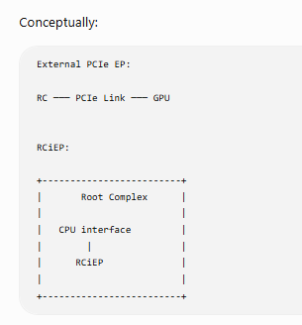
4. What is important for your DV work?
For now, focus on these Endpoint behaviors:
⭐ 1. Requester
Can generate:
- Memory Requests
- Configuration-related behavior as applicable
- Messages
- etc.
⭐ 2. Completer
Can respond to requests:
Requester → Request → Endpoint
↓
Completion
↓
Requester ← Completion
⭐ 3. TLP handling
Endpoint must correctly:
- Receive TLP
- Decode TLP
- Check address/type
- Perform operation
- Generate Completion when required
⭐ 4. Configuration Space
Endpoint has PCIe configuration registers such as:
Vendor ID
Device ID
Command
Status
BARs
...

Legacy Endpoint
Question:- what is legacy endpoint?
Ans:- it’s mainly use for connect backward compatibility device(old PCI device.).

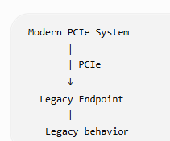

1. Type 00h Configuration Space Header
A Legacy Endpoint must be a Function with a Type 00h Configuration Space header.
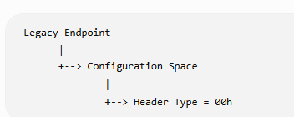

2. Configuration Requests — must be Completer
A Legacy Endpoint must support Configuration Requests as a Completer.
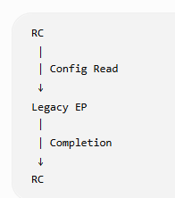
The Endpoint must respond to configuration requests.
🟢 RTL: Configuration request decoder + completion logic
🟢 TB: Config Read/Write tests

3. I/O Requests — optional
A Legacy Endpoint may support I/O Requests as a Completer.
May = optional.
RC → I/O Request → Legacy EP
The endpoint can support this, but PCIe does not require every Legacy Endpoint to implement it.
🟡 RTL: Optional
🟢 TB: If implemented, verify I/O requests.

4. Legacy Endpoint may generate I/O Requests
The Endpoint can also be a Requester of I/O transactions.
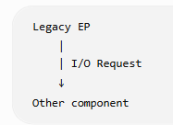
🟡 RTL: Optional
🟢 TB: Verify if the implementation supports it.

5. Lock semantics
This is important because the rules are different:
Legacy EP may support Lock as Completer
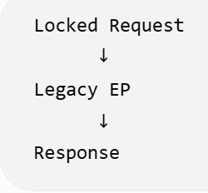
This is optional, depending on legacy software requirements.
But Legacy EP must NOT issue a Locked Request
Legacy EP ──X──> Locked Request
🔴 Must not generate Locked Requests.

6. Extended Configuration Space
A Legacy Endpoint may implement Extended Configuration Space Capabilities.
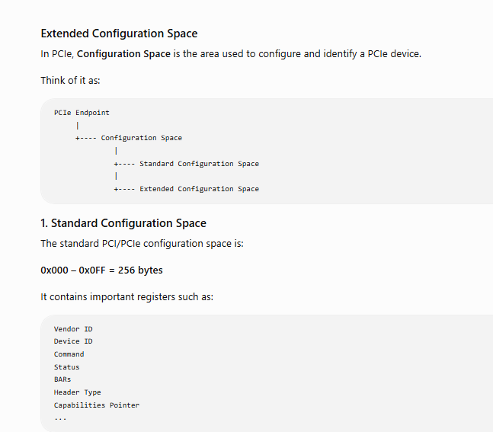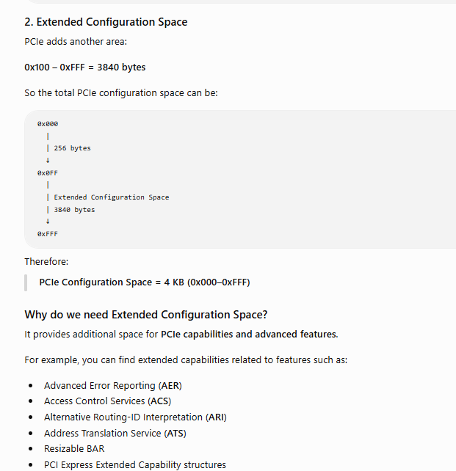

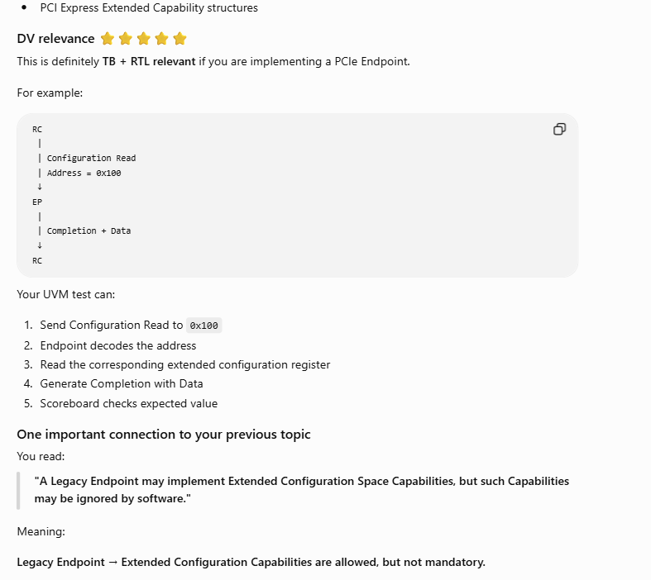
7. Address ≥ 4 GB
The specification says a Legacy Endpoint acting as a Memory Transaction Requester is not required to generate addresses ≥ 4 GB.
Simple meaning:
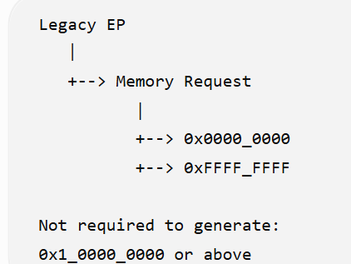
This is a capability rule, not saying that every address above 4 GB is illegal in every context.
🟡 RTL: Address-generation capability
🟢 TB: Boundary/address capability test.

8. MSI / MSI-X
This is very important for DV.
If the Legacy Endpoint requests an interrupt resource, it must support:
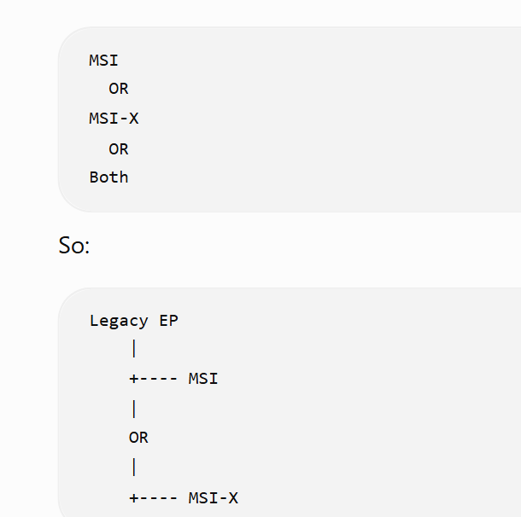
🟢 RTL: Interrupt generation logic
🟢 TB: MSI/MSI-X interrupt tests.
If MSI is implemented, the spec permits either:
- 32-bit MSI Message Address
- 64-bit MSI Message Address

9. BAR addressing
A Legacy Endpoint is permitted to support 32-bit addressing for BARs requesting memory resources.
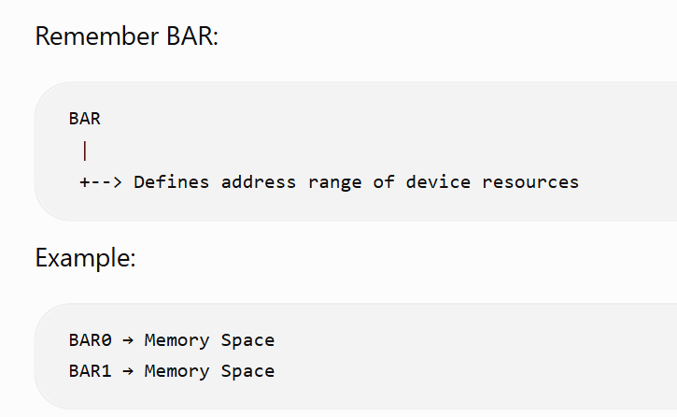

🟢 RTL: BAR registers + address decode
🟢 TB: BAR configuration and memory-access tests.

10. Must belong to an RC hierarchy
This is architecture/topology:
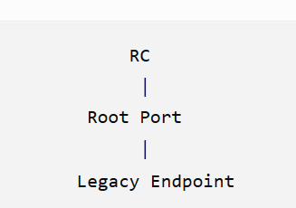
A Legacy Endpoint must appear within one of the hierarchy domains originating from the RC.
🟡 Mostly architecture
🟢 TB: Topology/enumeration can be verified.

Your interview/DV notes
I would compress this whole section into this:
LEGACY ENDPOINT

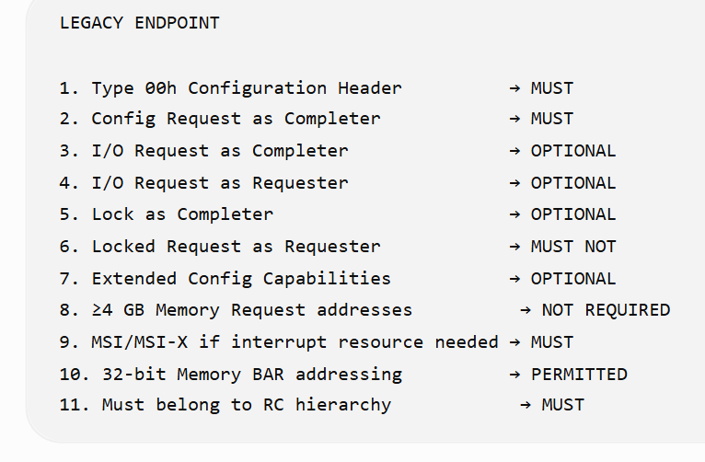

PCI Express Endpoint Rules
1. Type 00h Configuration Header
A PCI Express Endpoint must be a Function with a Type 00h Configuration Space header.
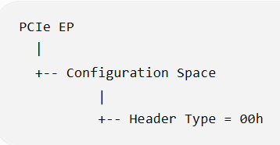
RTL: ✅ Configuration-space register
TB: ✅ Read and check Header Type.

2. Configuration Request as Completer
Must support Configuration Requests as a Completer.
Example:
RC ── Config Read ──→ EP
RC ←── Completion ─── EP
The EP must respond to Configuration Read/Write requests.
RTL: ✅
TB: ✅

3. No dependency on OS allocation of I/O resources through BAR
This is an important rule.
A PCIe Endpoint should not depend on the operating system allocating I/O-space resources through its BARs.
Why?
PCIe Endpoints are expected to use Memory Space, rather than legacy I/O Space.
This connects directly to the next rule.

4. PCIe Endpoint must NOT generate I/O Requests
This is very important.
PCIe EP ──X──→ I/O Request
A normal PCIe Endpoint does not generate PCI I/O Requests.
Instead, it primarily uses:
Memory Read
Memory Write
Configuration
Messages
Compare with Legacy Endpoint

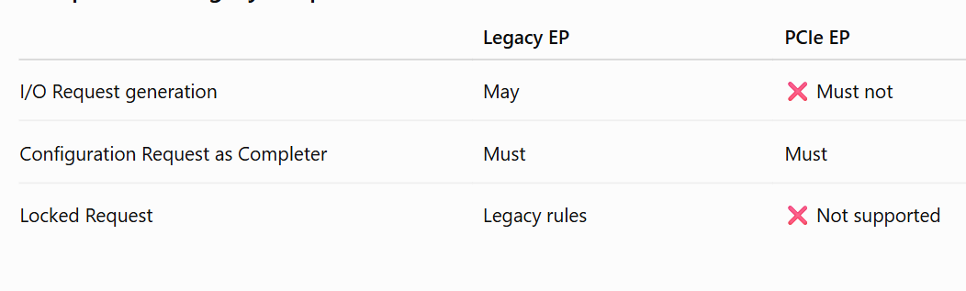
5. Locked Requests
A PCIe Endpoint:
Must not support Locked Requests as Completer and must not generate them as Requester.
So:

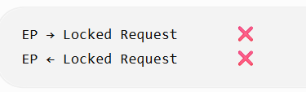
RTL: ✅ Don't generate/accept locked transactions
TB: ✅ Negative test

6. Address greater than 4 GB — VERY IMPORTANT
A PCIe Endpoint operating as a Memory Requester must be capable of generating addresses greater than 4 GB.
Why? :- Modern pcie support 64 bit addressing.
Because modern systems can have memory/resource addresses above 4 GB.
Example:

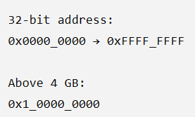
So PCIe Endpoint must support 64-bit addressing for Memory Requests.

DV test
EP → Memory Write
Address = 0x1_0000_0000
Check that the generated TLP contains the correct 64-bit address.
RTL: ⭐⭐⭐⭐⭐
TB: ⭐⭐⭐⭐⭐

7. MSI / MSI-X
If the Endpoint requests an interrupt resource:
It must support MSI or MSI-X or both.
PCIe EP

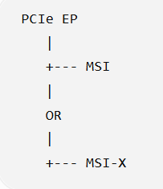

If MSI is implemented, the PCIe Endpoint must support the 64-bit MSI Message Address version.
RTL: ✅
TB: ✅

Question :- what is BAR(Base address register)?
Ans:-
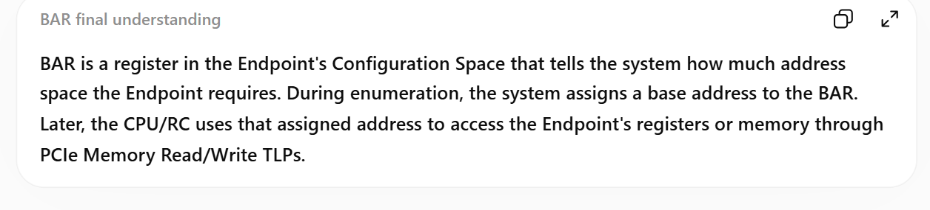
BAR is a Configuration Space register that tells the system what address range the Endpoint needs for its Memory Space or I/O Space.
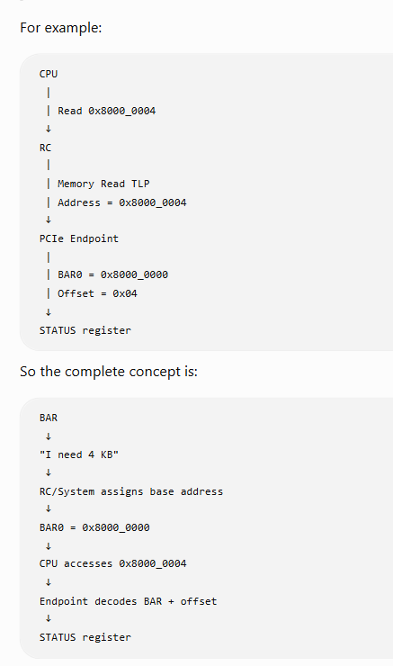
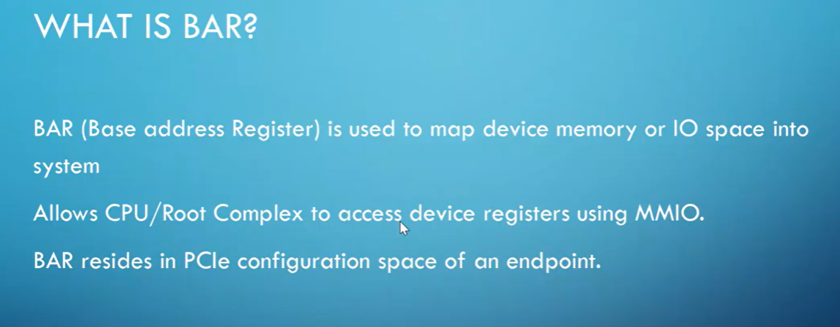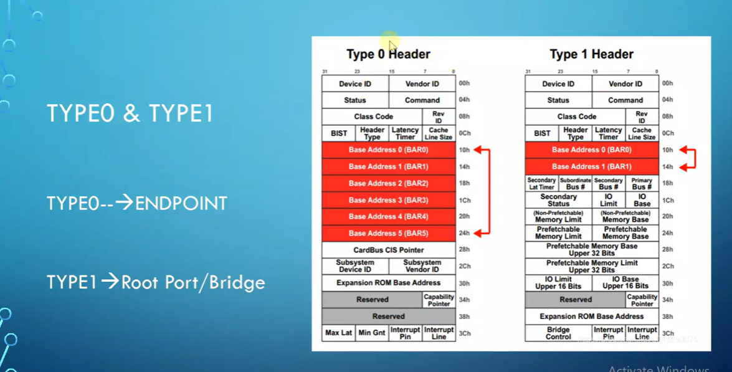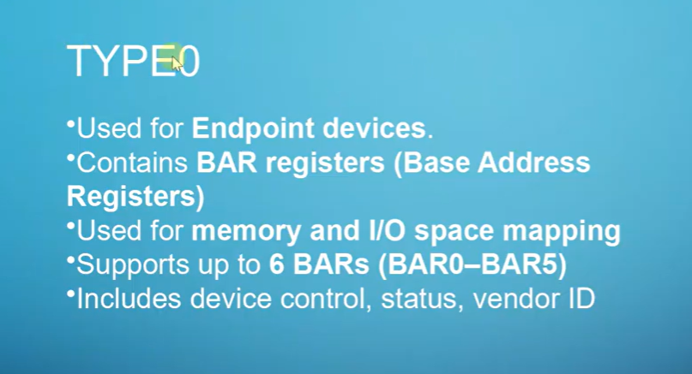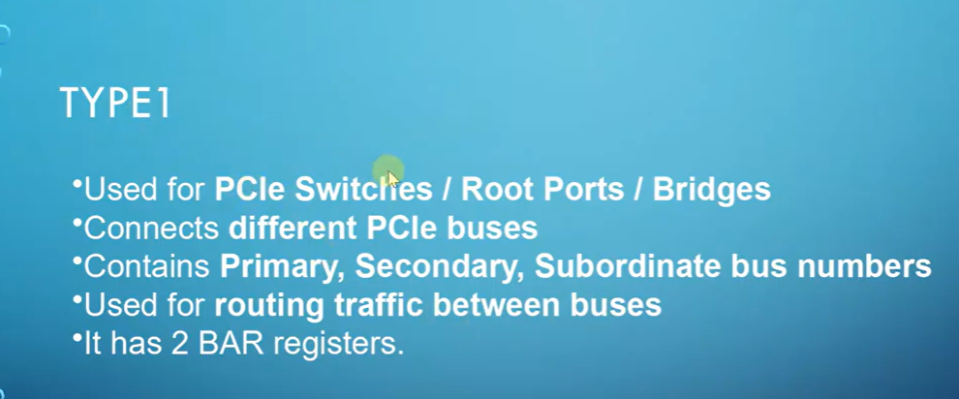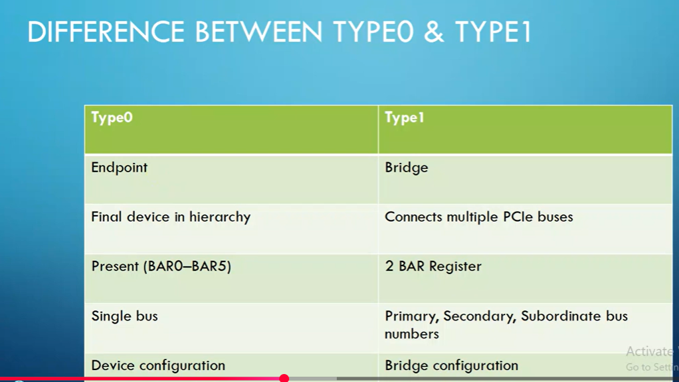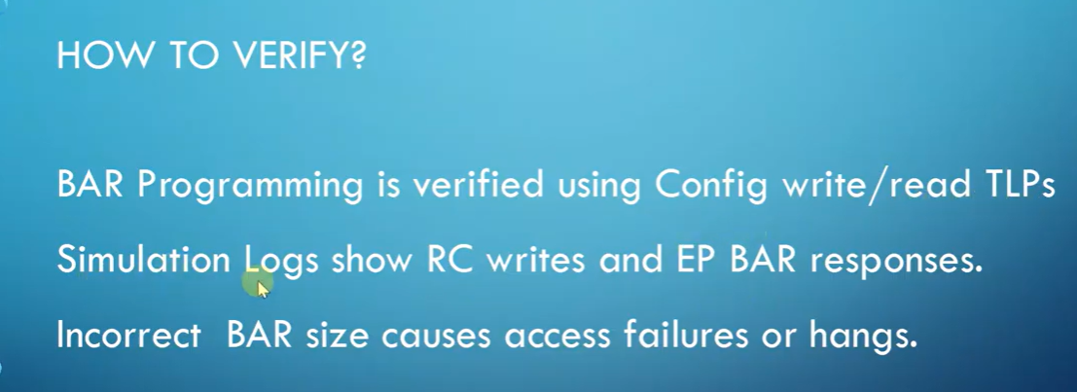

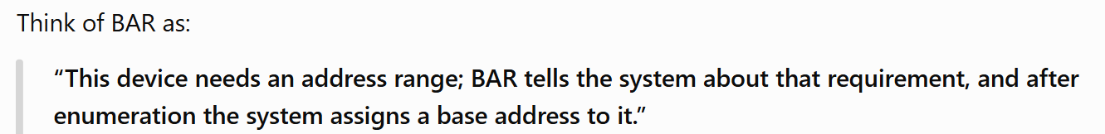
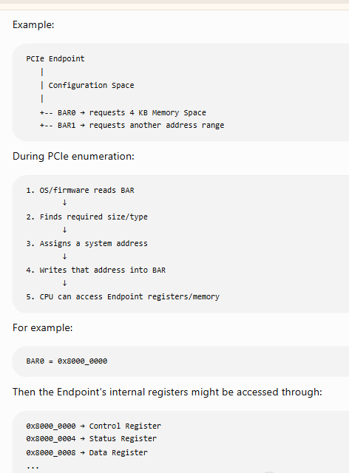
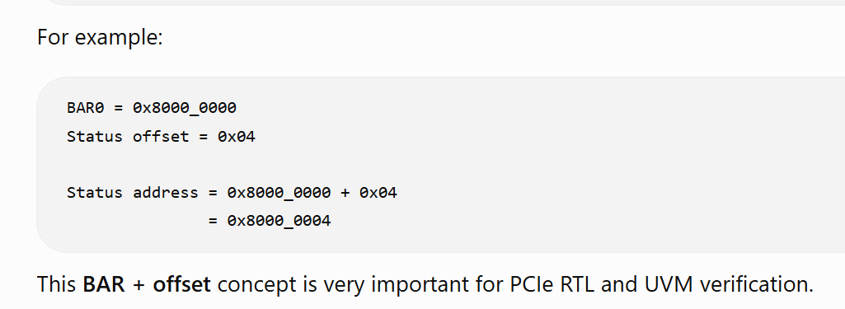
----------------------------------------------------------------------------------------------------------------------------------------------------------------------------------------------------------------------------------------------------
8. BAR Prefetchable bit
This is an important BAR rule.
Suppose:
BAR0
|
+-- Memory resource
If the memory range is prefetchable, the BAR's:
Prefetchable = 1
But there are exceptions.
The Endpoint should not mark a region prefetchable if:
- Reads have side effects, or
- The device cannot tolerate write merging.
Simple example
Normal framebuffer memory
↓
Prefetchable = 1
But:
Device control register
↓
Read may trigger an action
↓
Prefetchable = 0
Because the CPU/system should not treat such accesses as freely reorderable/cacheable in the same way.
RTL: ✅ BAR implementation
TB: ⭐⭐⭐⭐⭐

9. 64-bit addressing for Prefetchable BARs
This rule is very important:
If a BAR has Prefetchable = 1, it must support 64-bit addressing.
Conceptually:
Prefetchable BAR
|
+---- 64-bit addressing required
For a non-prefetchable BAR, 32-bit addressing is permitted.
BAR
|
+-- Prefetchable = 1
| ↓
| 64-bit
|
+-- Prefetchable = 0
↓
32-bit allowed

10. Minimum BAR memory range = 128 bytes
The specification says:
The minimum memory address range requested by a BAR is 128 bytes.
So don't design a PCIe Endpoint memory BAR with:
BAR size = 16 bytes ❌
BAR size = 32 bytes ❌
BAR size = 64 bytes ❌
Minimum:
BAR size = 128 bytes ✅
RTL: ✅ BAR decoder
TB: ✅ BAR sizing/configuration test

11. Endpoint must belong to an RC hierarchy
Example:
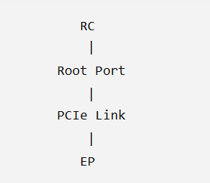
The Endpoint must exist inside one of the hierarchy domains originating from the Root Complex.
Architecture: ✅
TB: ✅ topology/enumeration testing

🔥 Most important differences: Legacy EP vs PCIe EP
This is worth remembering for interviews.
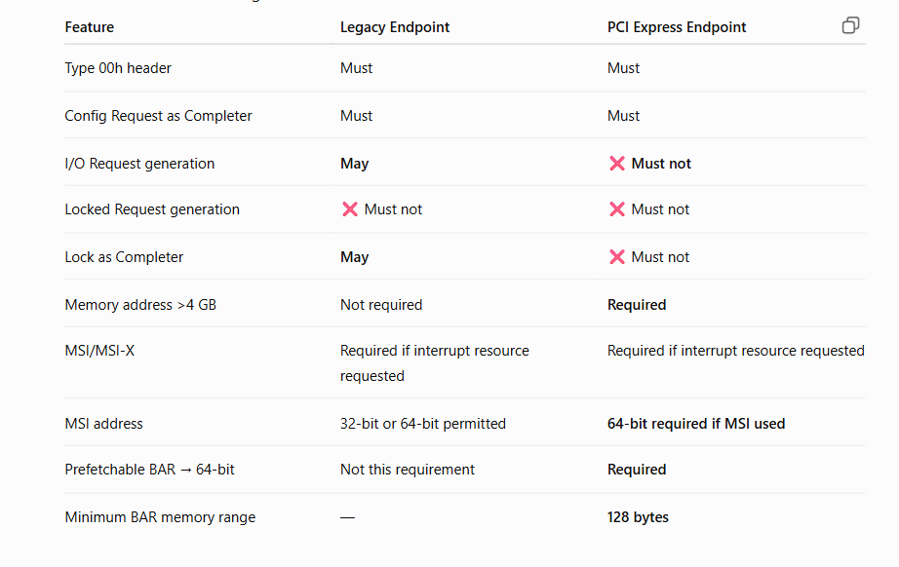

⭐ For your RTL + UVM project
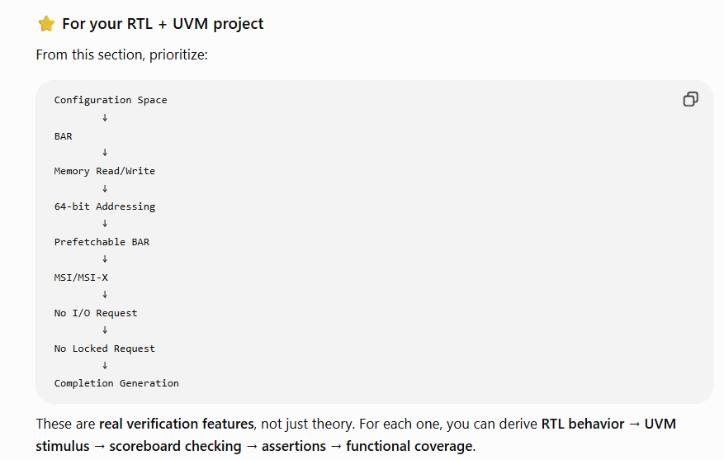.

Root Complex Integrated Endpoint Rules

What is RCiep?
Anns: An RCiEP (Root Complex Integrated Endpoint) is an Endpoint implemented inside the internal logic of the Root Complex. It is not connected through an external PCIe Link and does not appear in the hierarchy domains exposed by the Root Complex. It has common Endpoint features such as Type 00h Configuration Space, BARs, Memory Transactions, and MSI/MSI-X, but it has some special rules because it is integrated into the Root Complex.

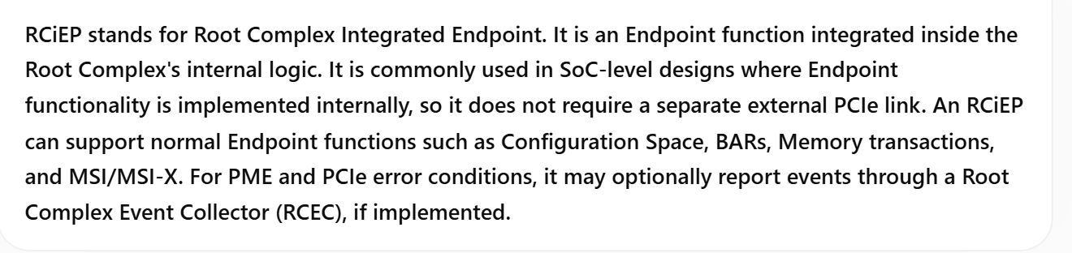
why we use this endpoint?
Ans:- We use RCiEP when the Endpoint functionality is implemented inside the Root Complex itself, so we don't need a separate external PCIe link/device for that function. 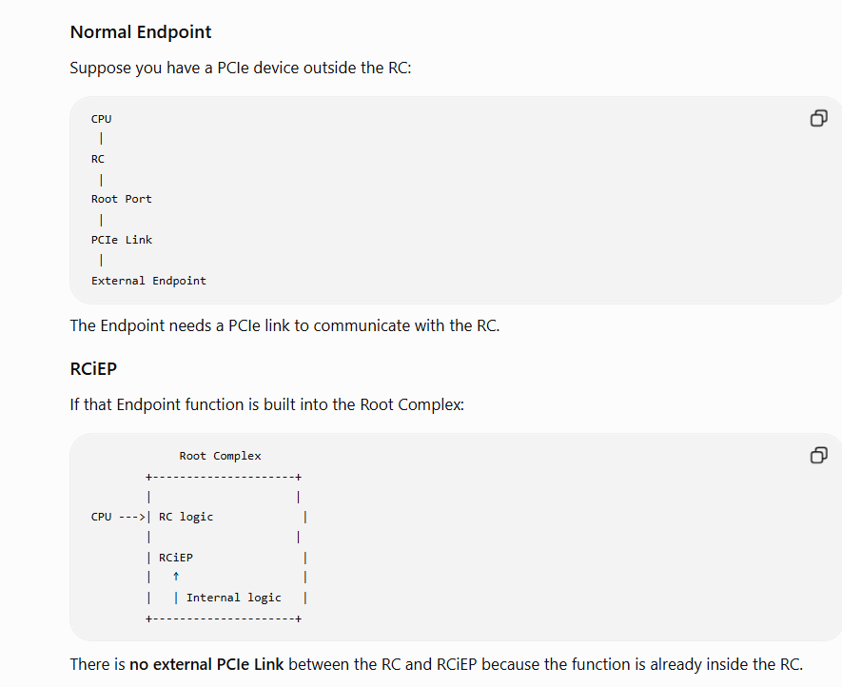 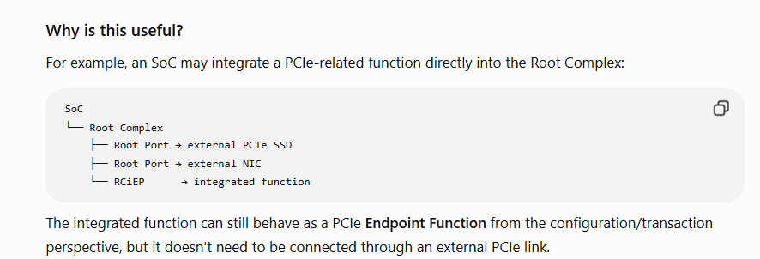

Question:- what is Root complec event collector?
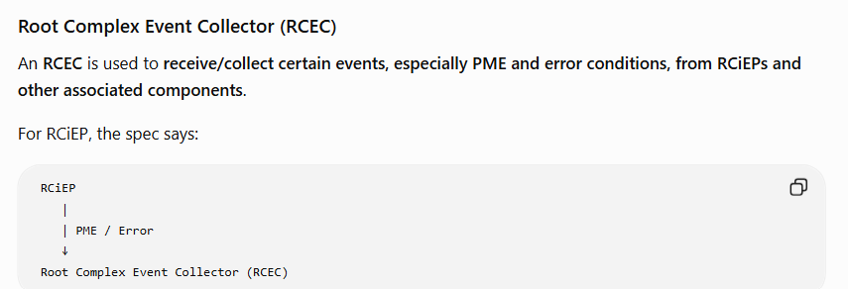

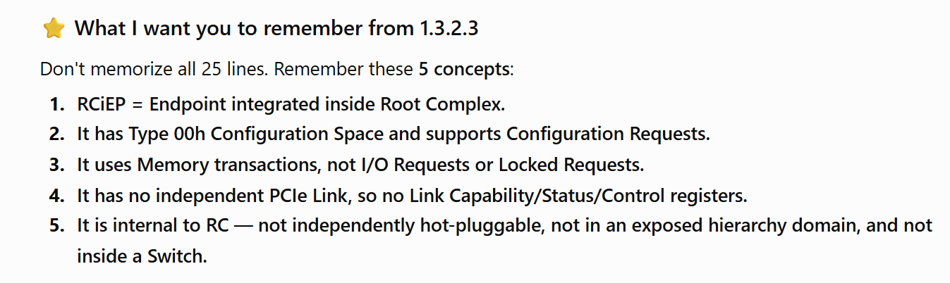
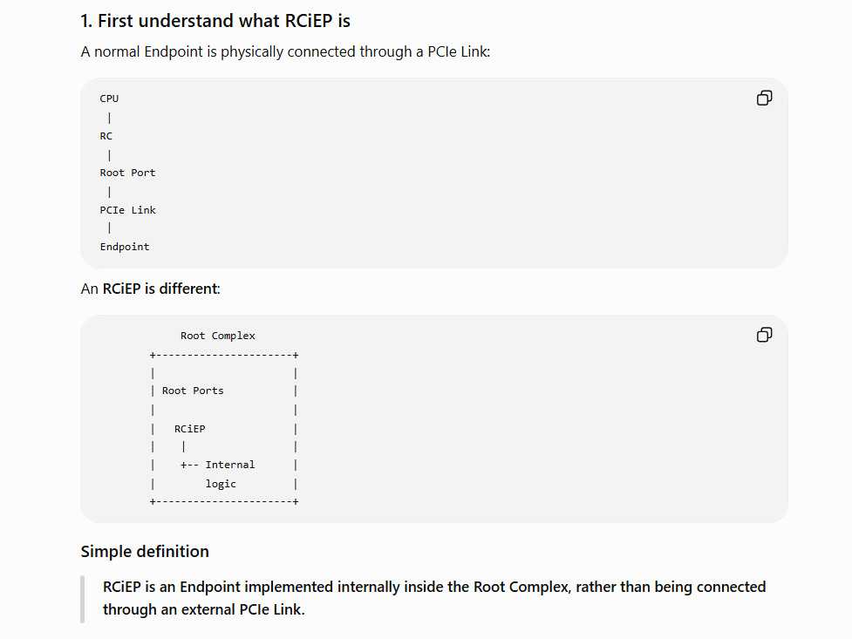
SWITCH
Question:- what is switch?
A PCIe Switch is a logical assembly of multiple virtual PCI-to-PCI Bridge devices. It provides an Upstream Port toward the Root Complex and one or more Downstream Ports toward PCIe devices. Its main function is to route and forward TLPs between the appropriate Ports using PCI Bridge routing mechanisms. A Switch also supports Flow Control, Virtual Channels, TC-to-VC mapping, and arbitration. Importantly, a Switch is not allowed to split a TLP into smaller packets.

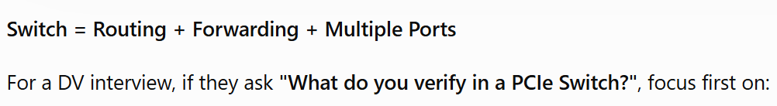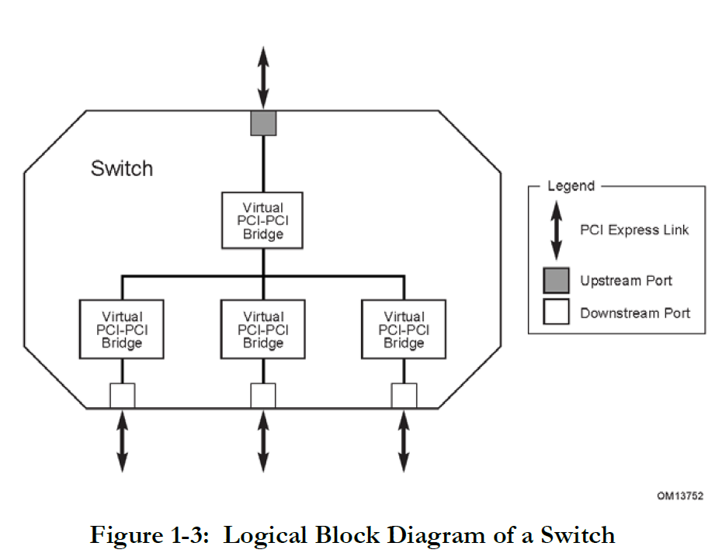
1. Switch = logical assembly of PCI-to-PCI Bridges
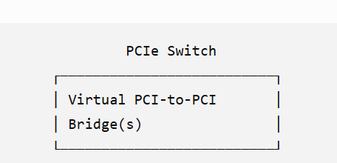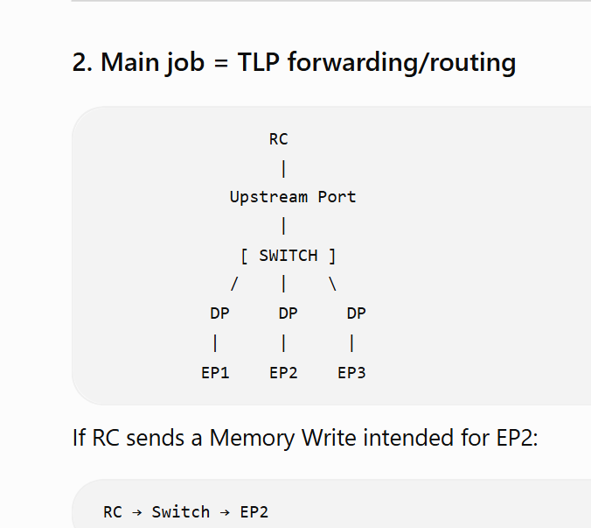
3. Switch must NOT split a TLP 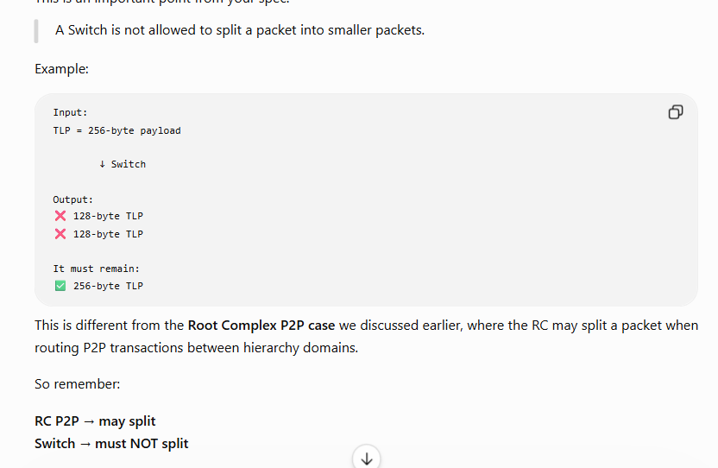
4. Switch forwards TLP types 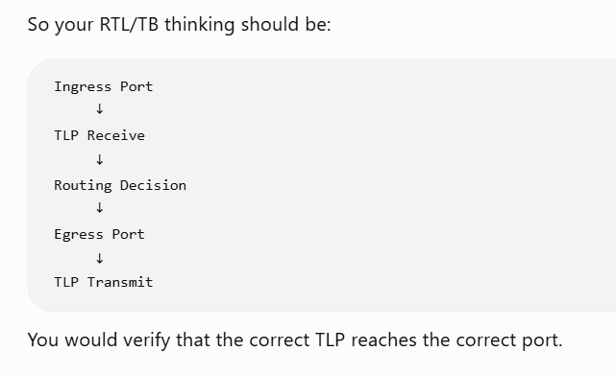 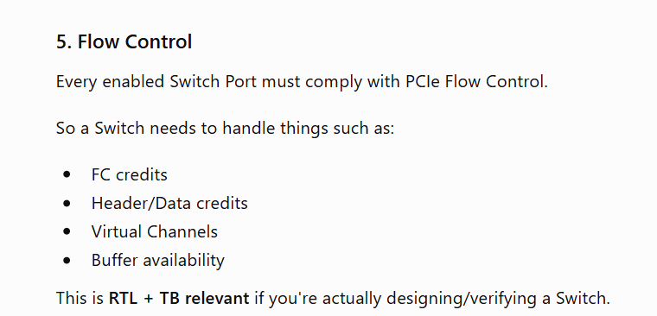 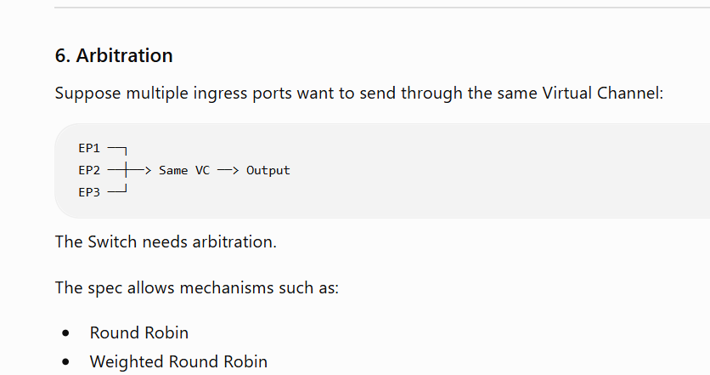
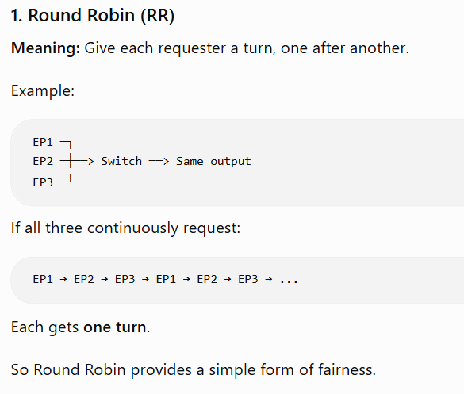
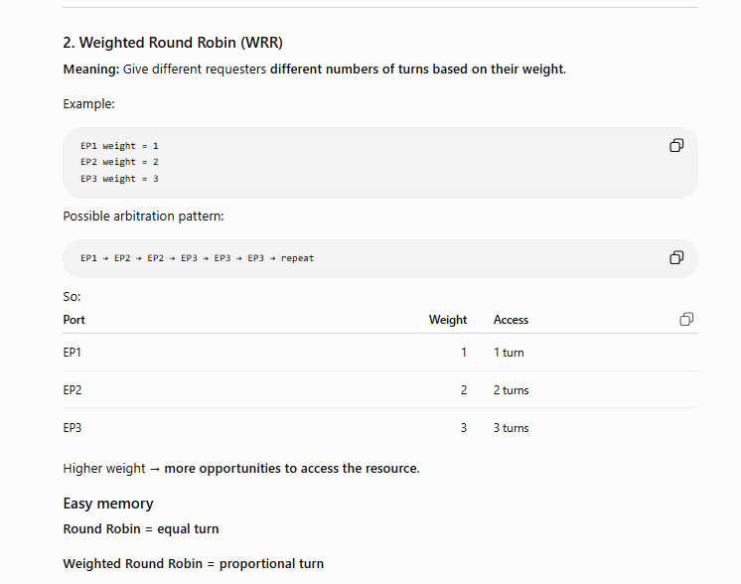

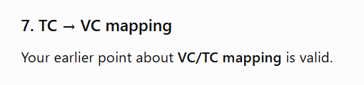

Root Complex Event Collector
RCEC is a Root Complex component that terminates PME and Error Messages from RCiEPs.
RCEC is mainly associated with RCiEPs. It is used to terminate PME and Error Messages generated by supported RCiEPs 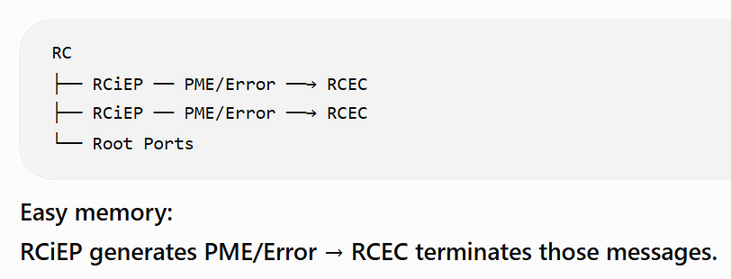
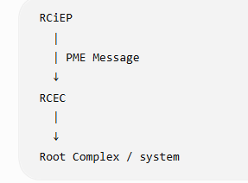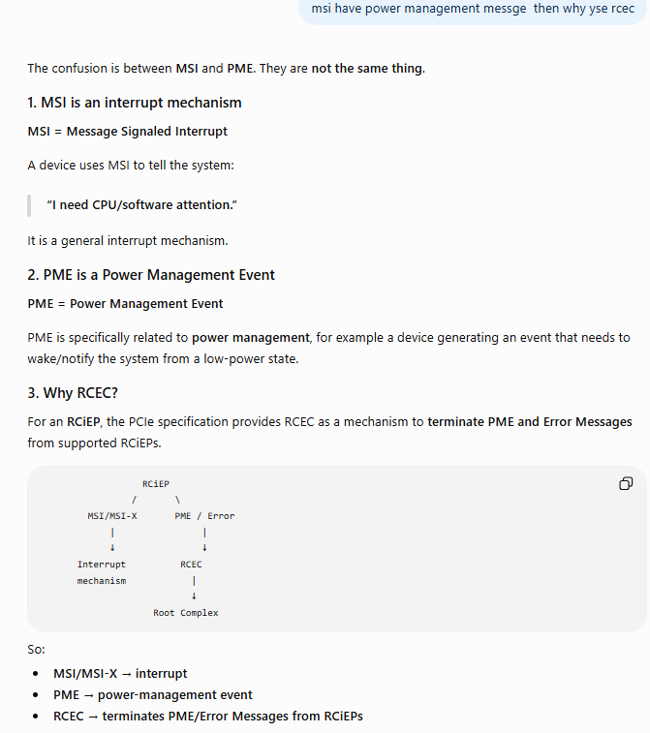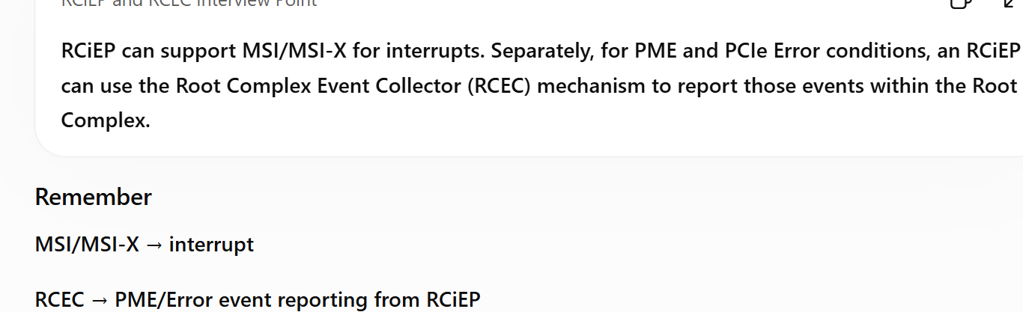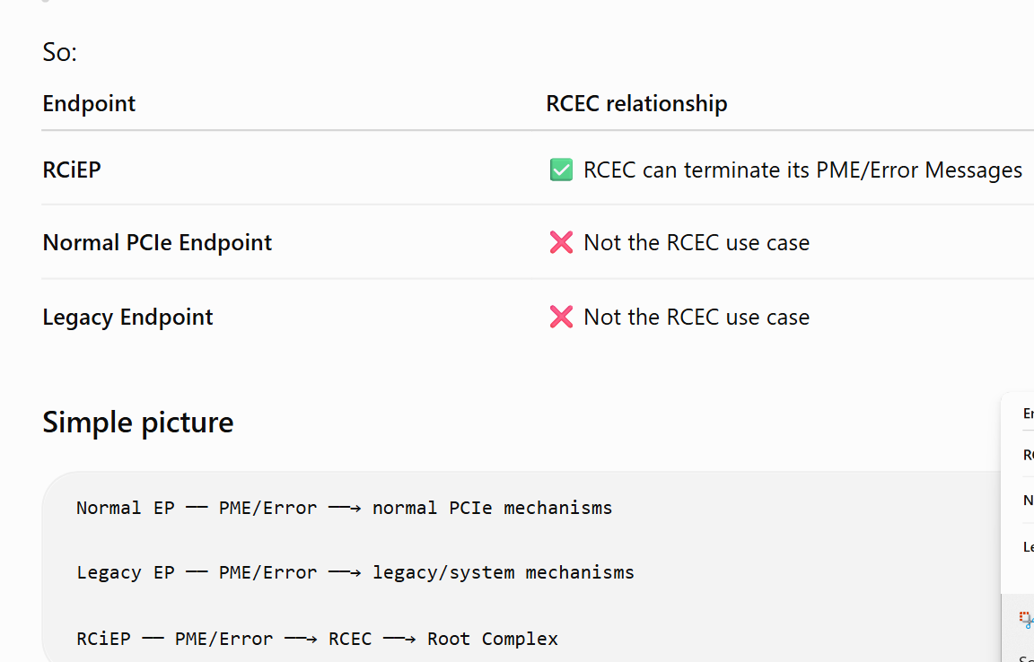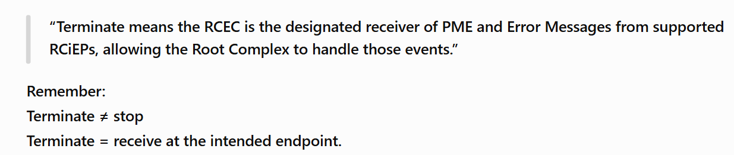

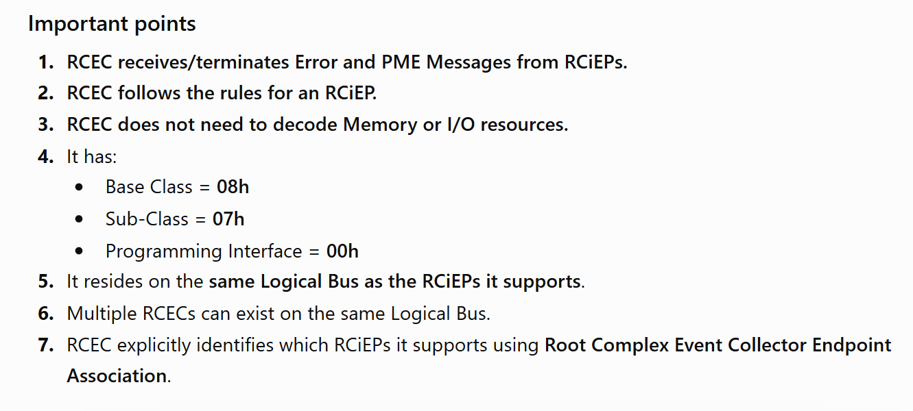

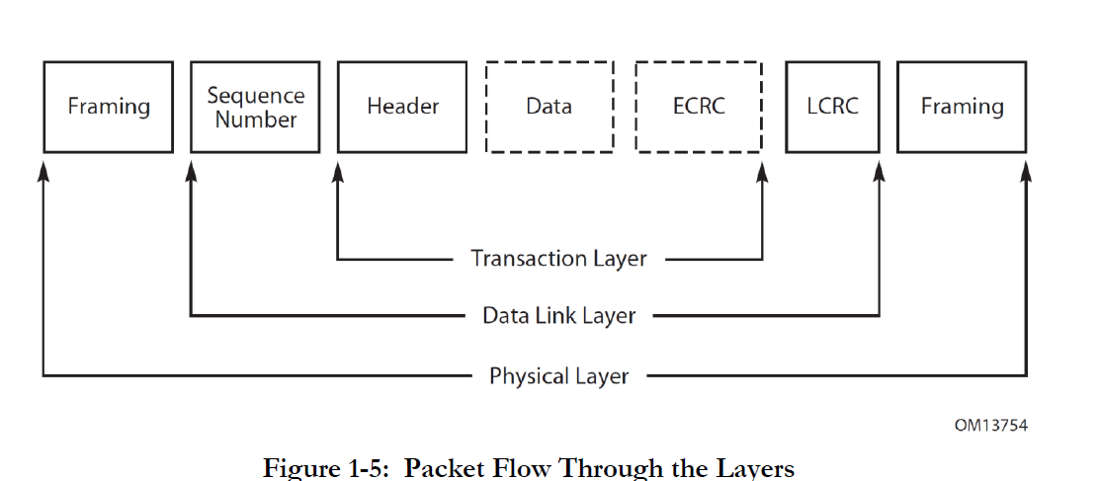

Transaction Layer
Question:- what is transaction layer?
Ans:- transaction layer mainly use to create packet for convert data into packet formed using header, data and ecrc.
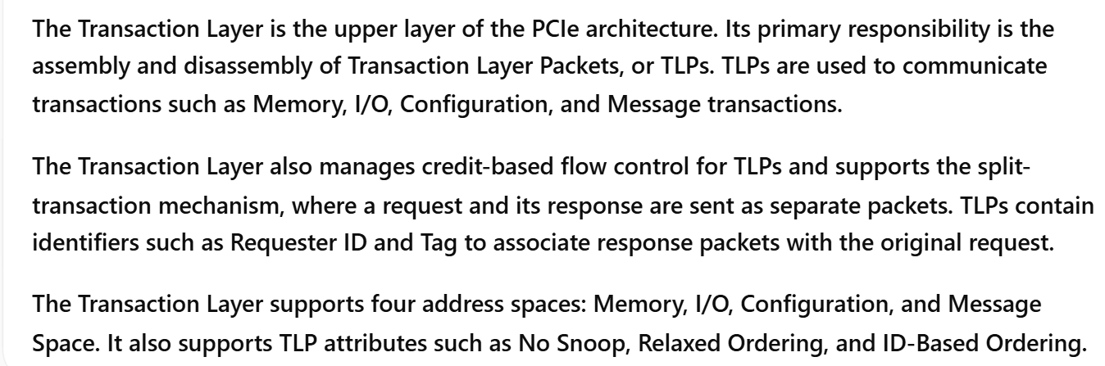

It’s have multiple feature like
1. Header :- it’s use to contains fields all detail about packet (like :- size, type of packet, source, destination, and etc).
2. ECRC:- it’s optional 32bit size . it’s use to protect data end to end TLP integrity protection..
3. Transaction layer applies PCIe ordering rules and supports attributes ( id-base and relaxed ordering).
1. Primary responsibility — Assembly/Disassembly of TLPs
2. TLP communicates transactions
TLPs are used for:
- Memory Read/Write
- I/O Read/Write
- Configuration Read/Write
- Messages
- Completions
- Some events

3. Credit-based Flow Control
Transaction Layer is responsible for managing credit-based flow control for TLPs.

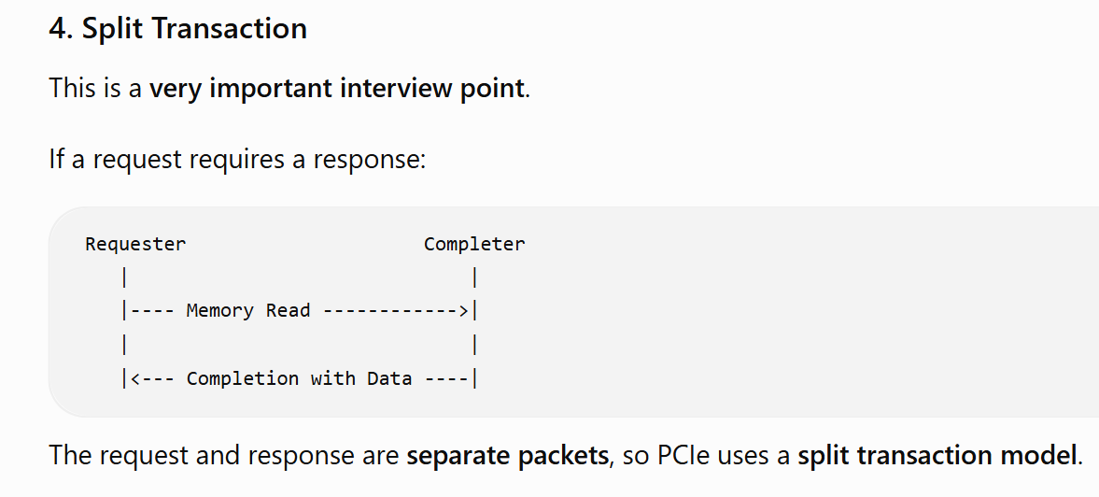

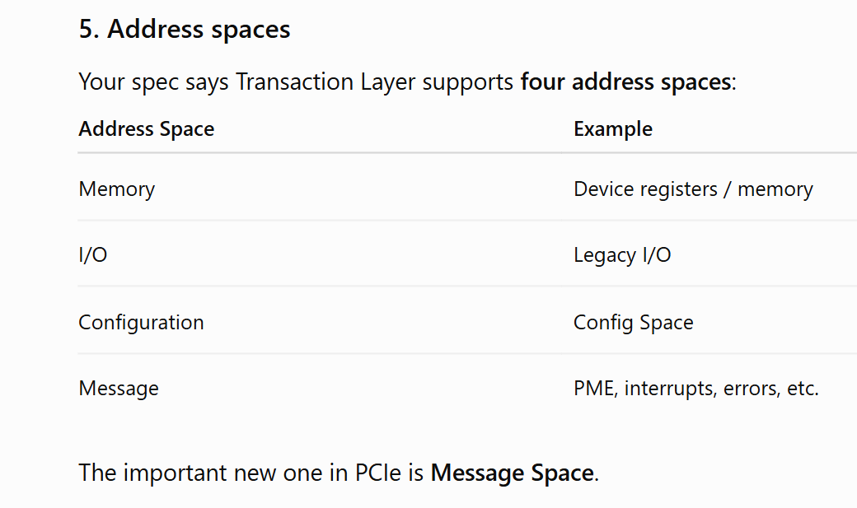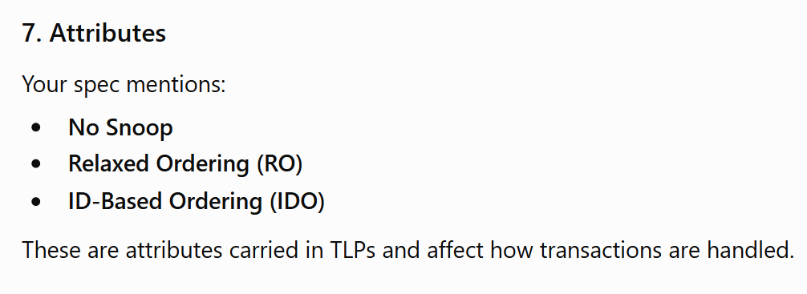
Data Link Layer
Question:- what is Data link layer?
Ans:- it’s middle layer in the pcie gen4.0. it’s use to manage the packet between transaction and physical layer.
It’s work like a interface between transaction and data link layer.
It’s add sequence number and lcrc in the packet.
It’s use data link layer packet to contain ack/nak and power management think.
It’s use data link layer fsm to manage credit flow and more think.

The Data Link Layer is the middle layer between the Transaction Layer and Physical Layer. Its primary responsibilities are link management, data integrity, error detection, and error recovery.
The Data Link Layer also generates and consumes DLLPs, which are used for link-management functions such as ACK/NAK and Flow Control.

1. Main purpose
Data Link Layer is responsible for:
- Link management
- Data integrity
- Error detection
- Error correction/recovery
- Data Link Layer provides reliable link-to-link delivery of TLPs.
2. Error recovery 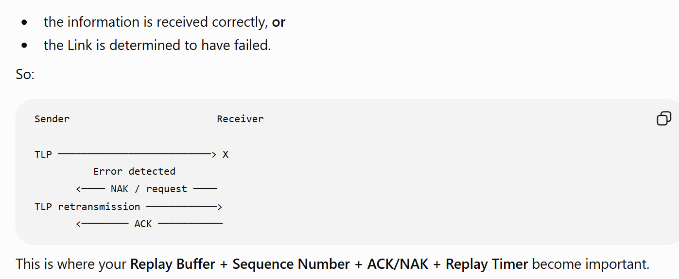

3.DLLP
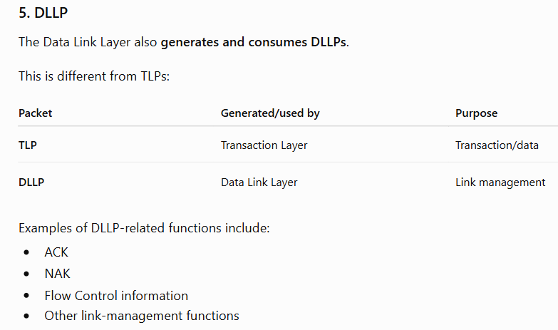

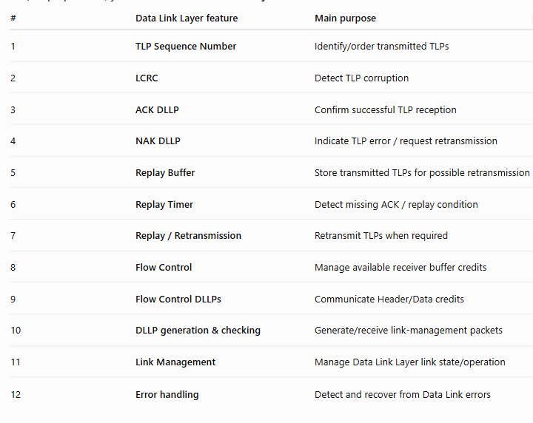

1. Replay Buffer:-
Replay Buffer stores transmitted TLPs so they can be retransmitted if necessary.
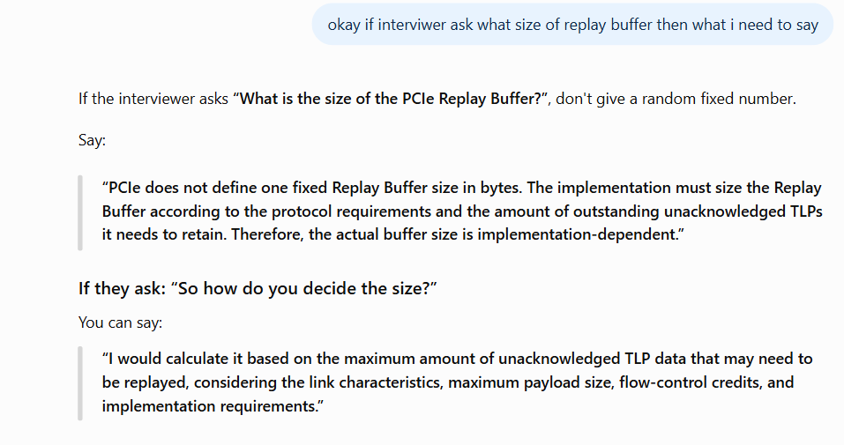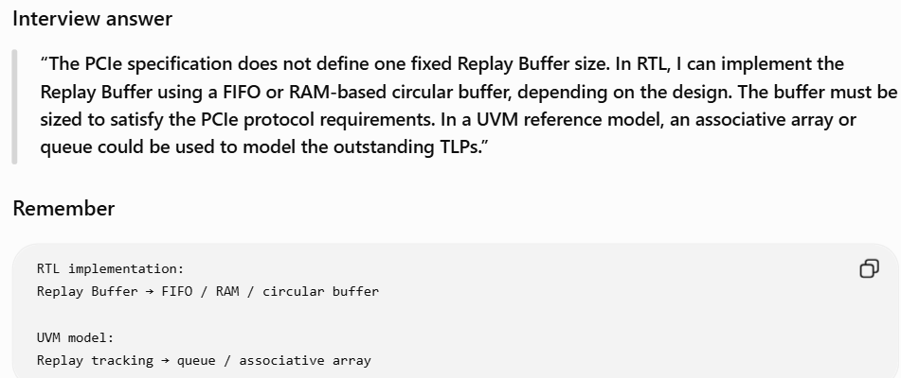

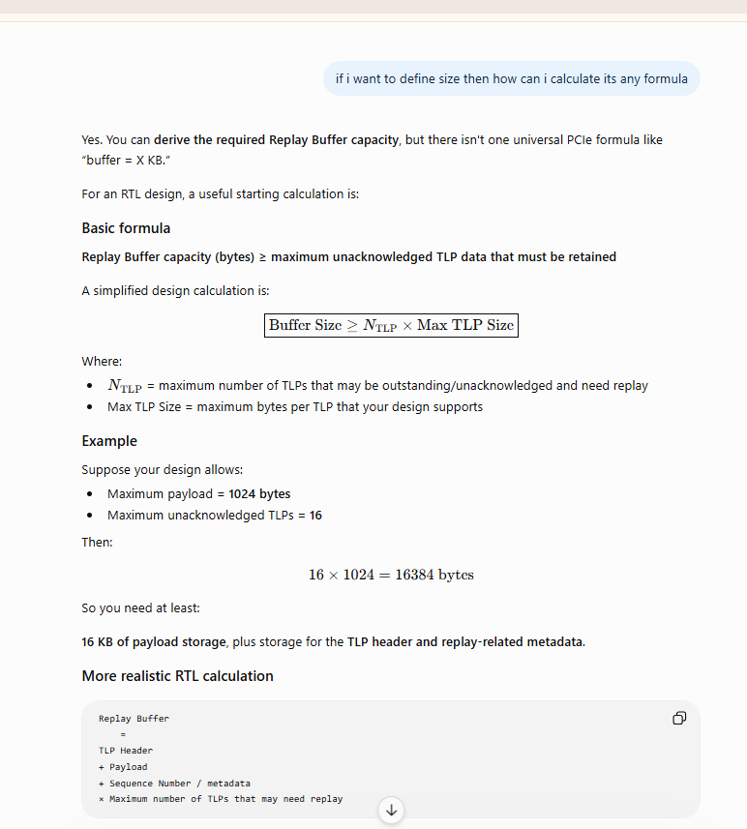
exact implementation size is not simply a fixed PCIe-spec number. 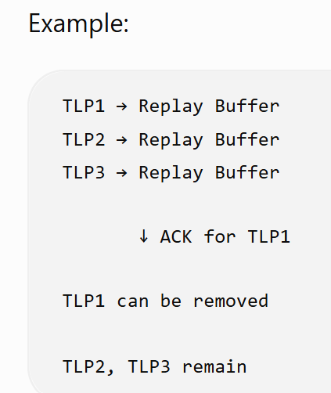

2. Replay Timer
The Replay Timer detects that an expected ACK has not been received within the required time, causing the Replay mechanism to retransmit the appropriate TLPs.
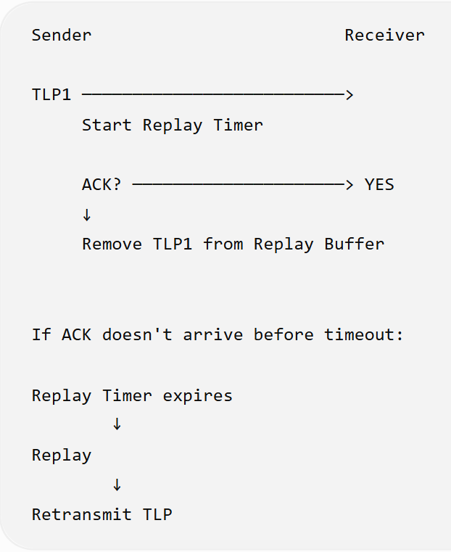

Physical Layer
1. What is the Physical Layer?
Ans:- The Physical Layer is the lowest layer of the PCIe protocol stack. It transmits and receives information over the physical PCIe link.

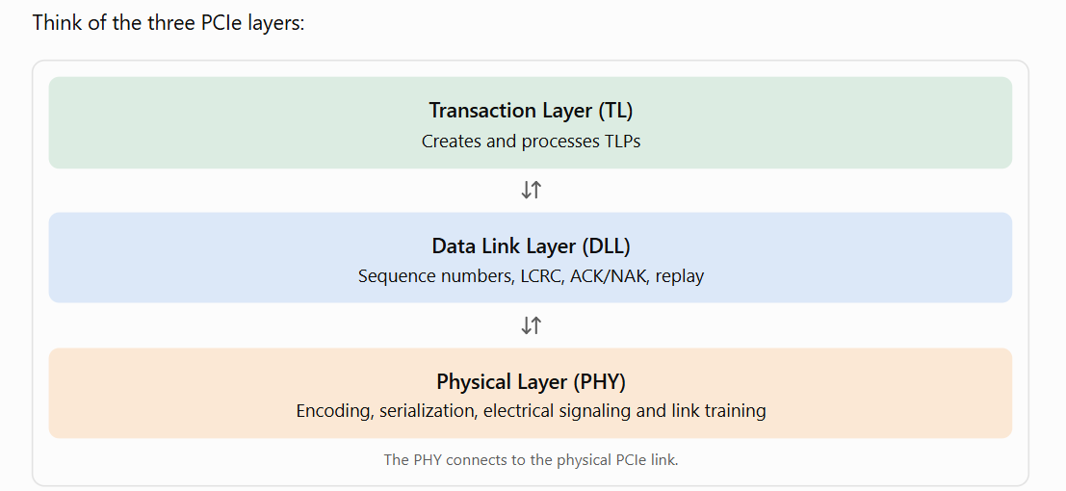

2. Understand the important features
A. Parallel-to-Serial conversion
The Data Link Layer provides data to the Physical Layer in an implementation-specific format. The PHY converts it into a serial stream for transmission.

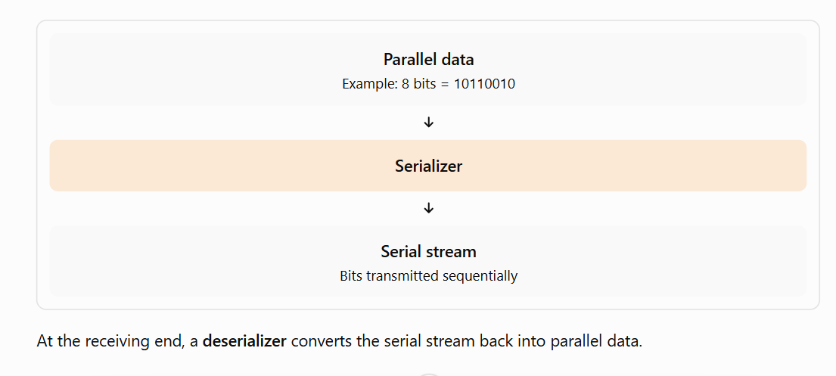
B. Driver and input buffers
- Driver: Drives the electrical signal onto the transmit lane.
- Input buffer: Receives the electrical signal from the other device.
These circuits help transfer data between two connected PCIe devices.
C. PLL (Phase-Locked Loop)
A PLL generates or synchronizes clock signals used by the PHY.
It supports the timing requirements needed for high-speed data transmission and reception.
D. Impedance matching
Impedance matching helps reduce signal reflections on the high-speed channel, improving signal integrity.
E. Link initialization and maintenance
The PHY contains logical functions that help establish and maintain a PCIe link.
For example, during link training, the devices negotiate link parameters such as supported speed and lane width.
The LTSSM (Link Training and Status State Machine) is particularly important here.
F. Speed and width
PCIe Gen4 supports a signaling rate of 16 GT/s per lane.
A link may use different lane widths, such as x1, x4, x8, or x16, depending on device capabilities and link configuration.
The PHY must operate at a compatible speed and width with the link partner.
3. What does the final paragraph mean?
Your specification says future speed upgrades and encoding techniques may only affect the Physical Layer definition.
In simple words, PCIe is designed so that improvements to the physical transmission method can be introduced without necessarily changing the higher-layer transaction model.
For example, PCIe Gen4 uses 128b/130b encoding. The higher layers still work with TLPs and their protocol rules.
Important: This does not mean every future upgrade affects only the PHY. New generations can introduce changes elsewhere when required.
A practical sequence is:
- Understand the Data Link–PHY interface.
- Study LTSSM and link initialization.
- Study lane width and link speed negotiation.
- Understand encoding and decoding.
- Develop directed tests, assertions, and functional coverage for the selected features.
For a PCIe VIP, you will often model or interact with the PHY through an abstract interface such as PIPE rather than implement the analog PHY itself.
Interview summary:
The PCIe Physical Layer is responsible for transmitting and receiving data over the physical link. It includes serialization and deserialization, electrical interface circuitry, clocking, encoding-related functions, and link initialization and maintenance. It also supports operation at compatible link speeds and widths.

Layer Functions and Services
Transaction Layer Services:- what service provide by transaction layer.
Transaction layer service provide:-
1. generate and receiveing tlp packet.
2.It supports communication between software/CPU and PCIe devices through memory, I/O, configuration, and message transactions.
3. enable and manage flow control infro
4. manage ordering and attributes.
5. tlp transaction like request and completer.
6. provide end to end Ecrc to protect packet.
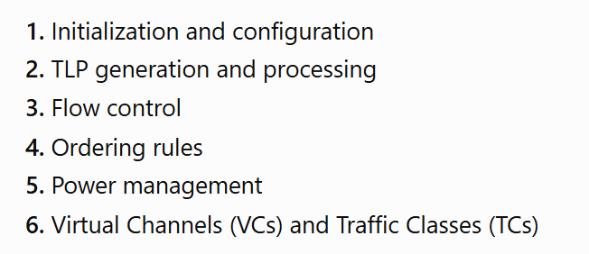
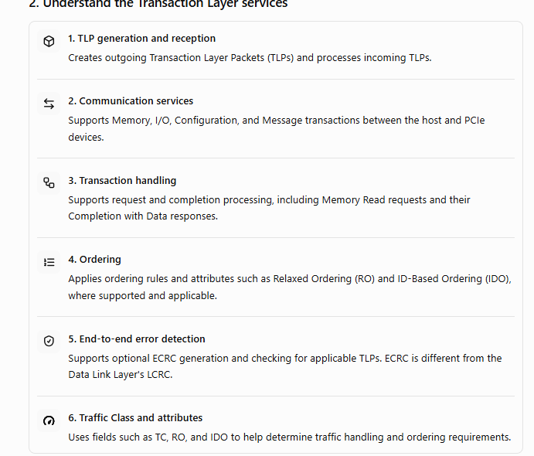

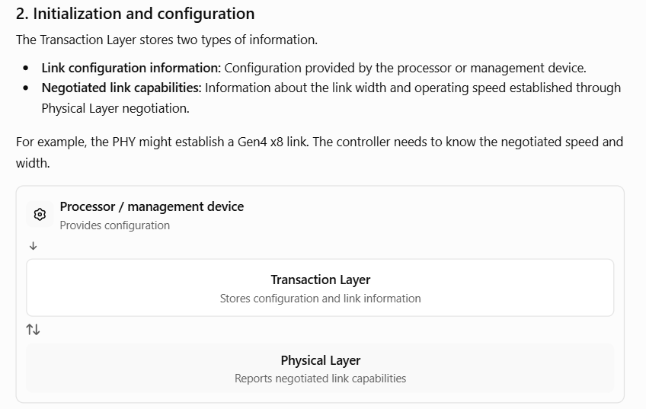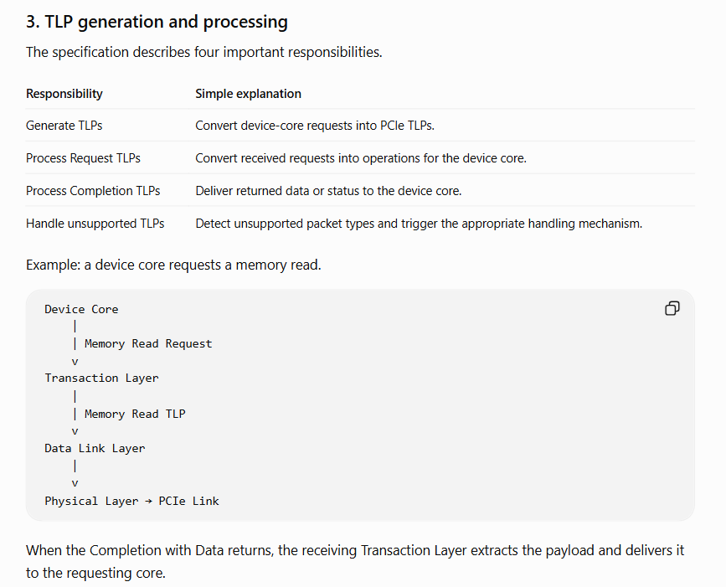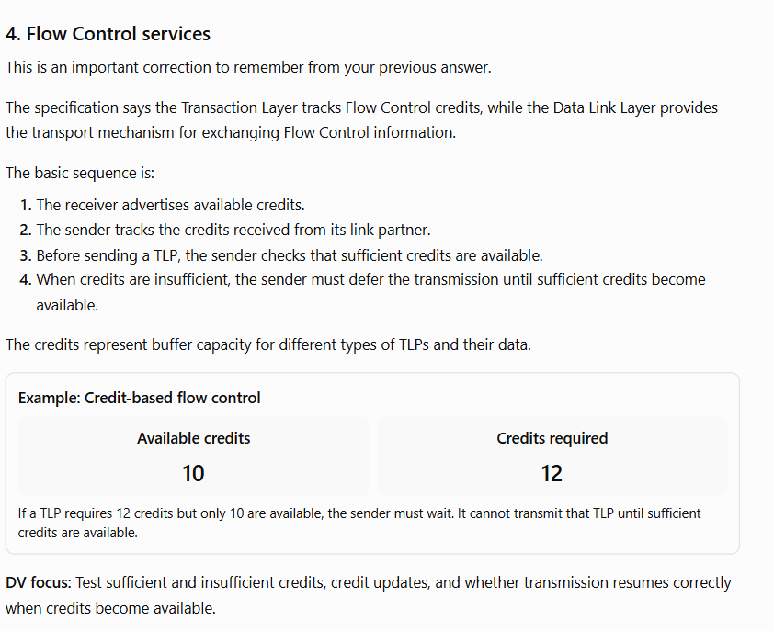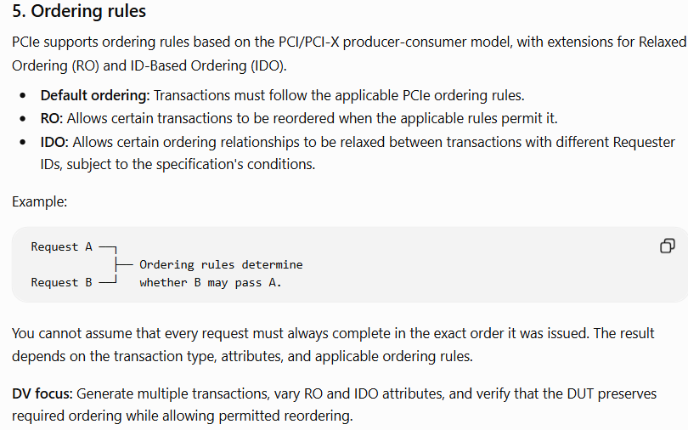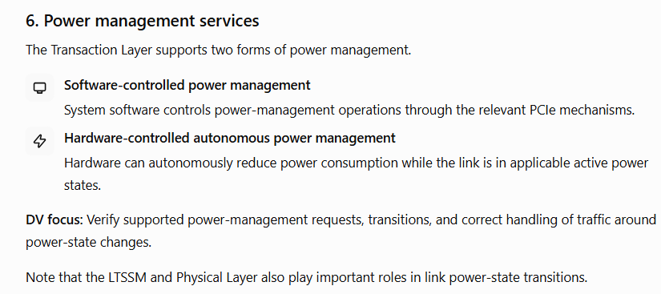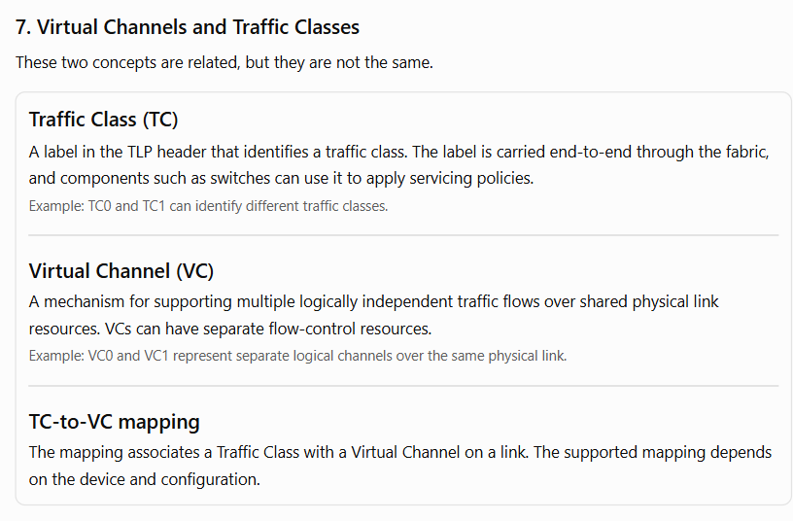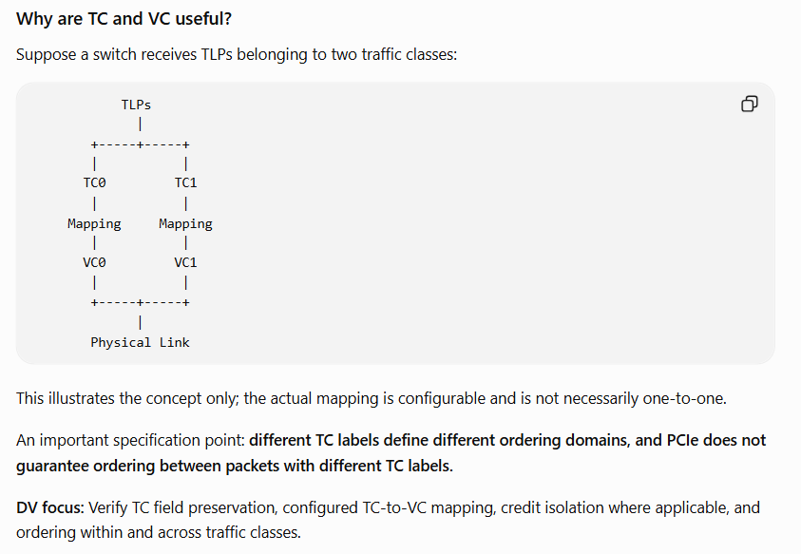

Data Link Layer Services
Data Link Layer Services:-
Data link layer is middle layer between transaction and physical layer. And manage or exchange information between both. And It handles link-level error detection using LCRC.
Service provide by data link layer:-
1. Generate DLLP packet for link management, ack/nak and flow control information exchange.
2. it have lcrc for link protection.
3. it replay buffer to store tlp packet with sequence number
4. Sequence numbers identify TLPs and support acknowledgment and replay tracking.
5. it have ack/nak for reponse/feedback.
6. it have fsm to manage credit base information and exchange.
7. replay timer.
8. roll play feature.

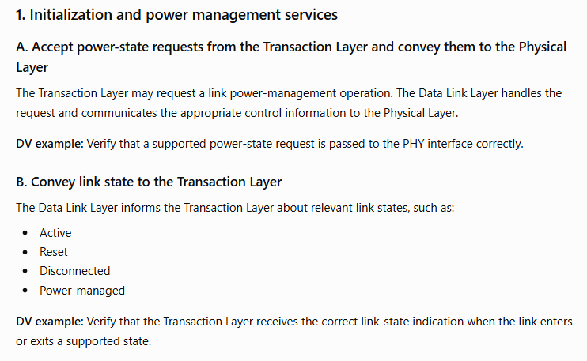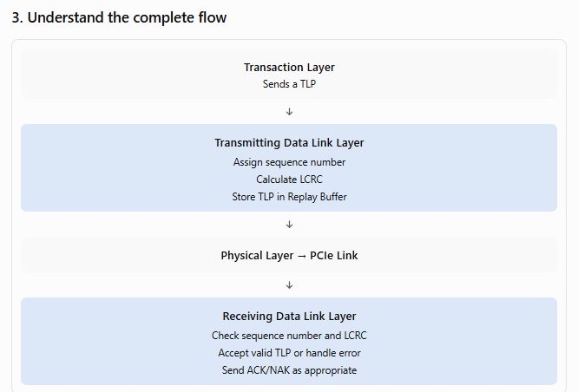

Physical Layer Services
Physical Layer Services:-
This layer use to manage between transmitter and receiver side using pipe interface.
Feature
1.encoding 128b/130b
2.parallel to serial and serial to parallel
3. Ltssm fsm
4. power management.
5. symbols
6.Lane polarity inversion

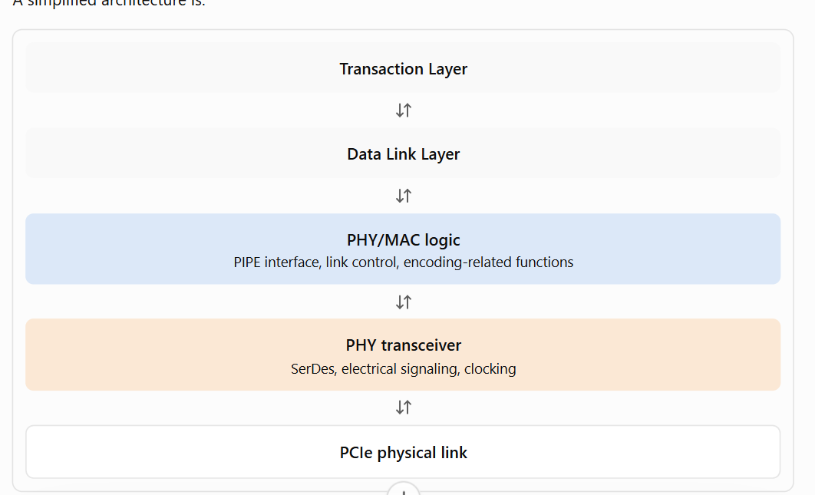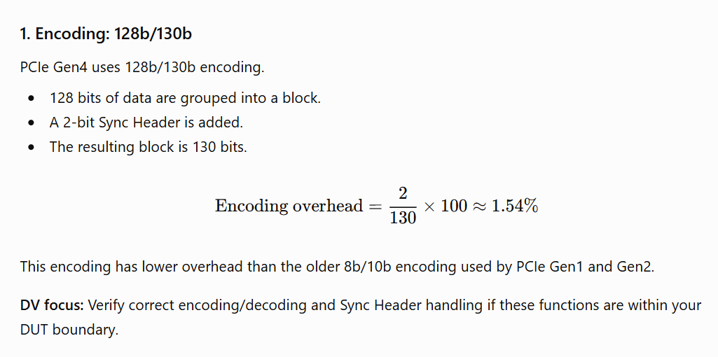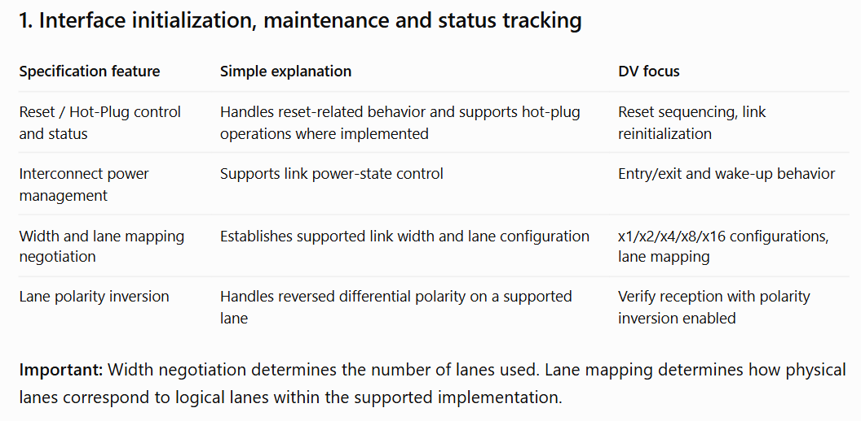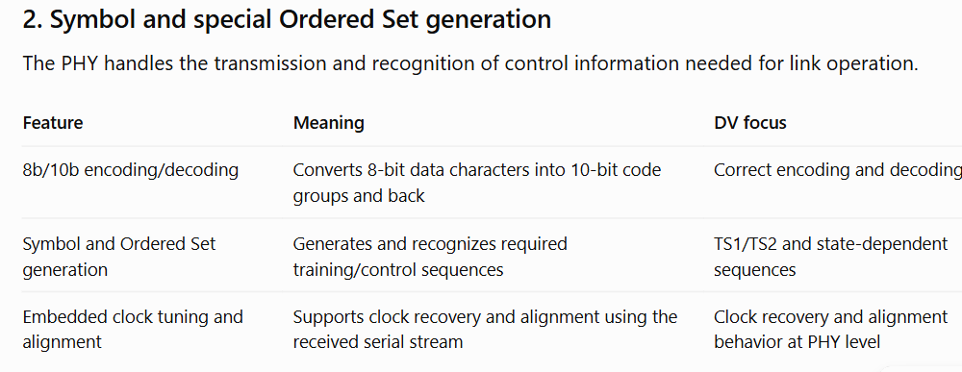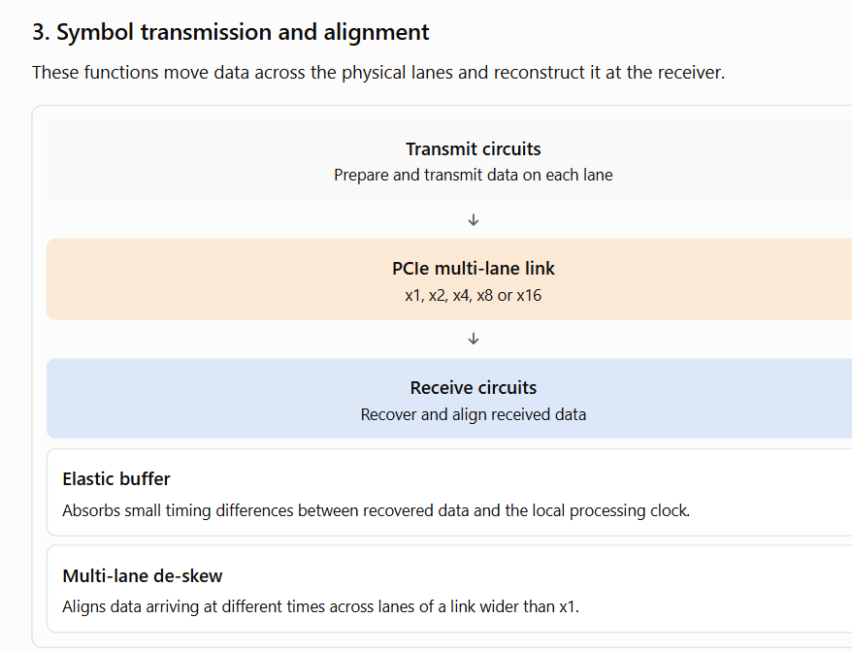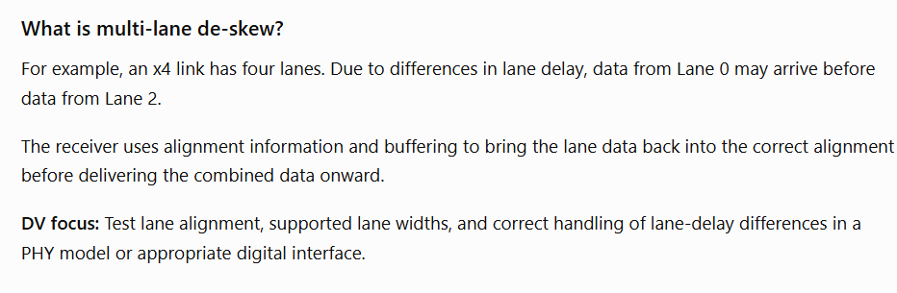

Inter-Layer Interfaces
Transaction/Data Link Interface:-
How the Transaction Layer (TL) and Data Link Layer (DLL) communicate with each other inside the PCIe controller
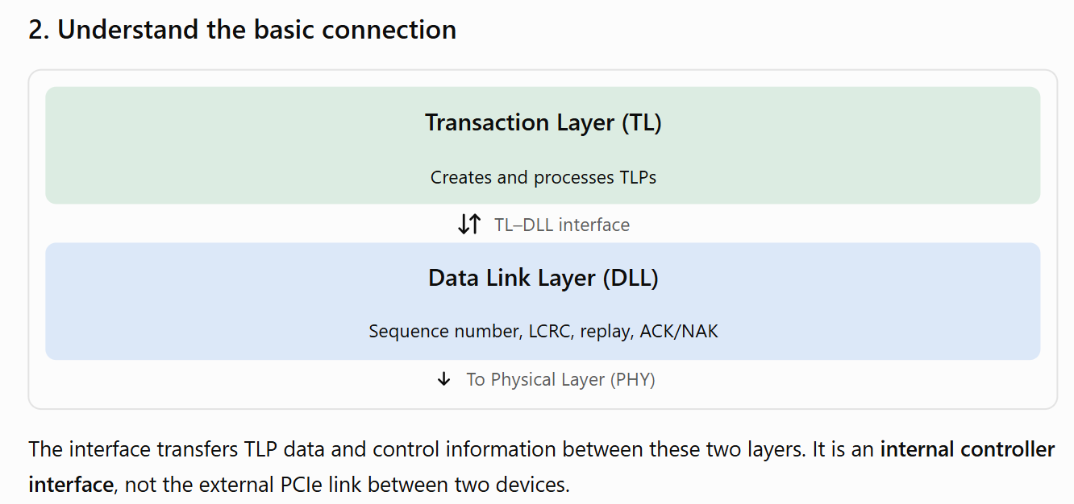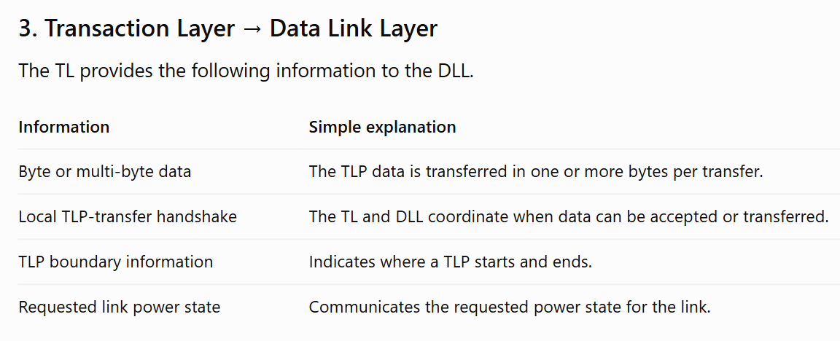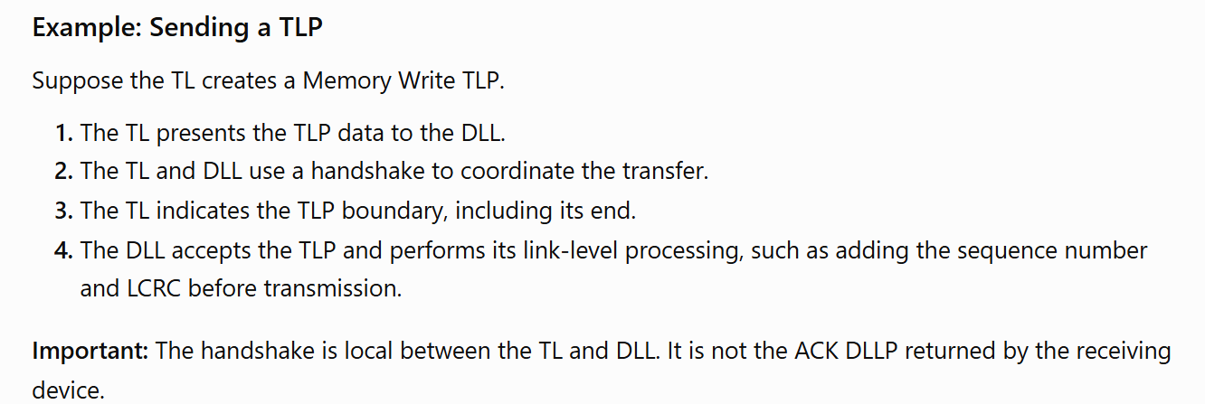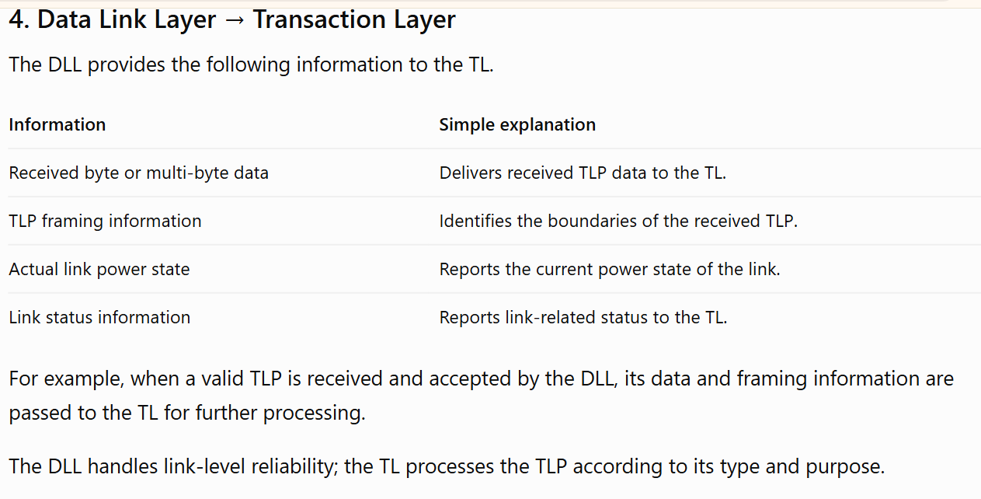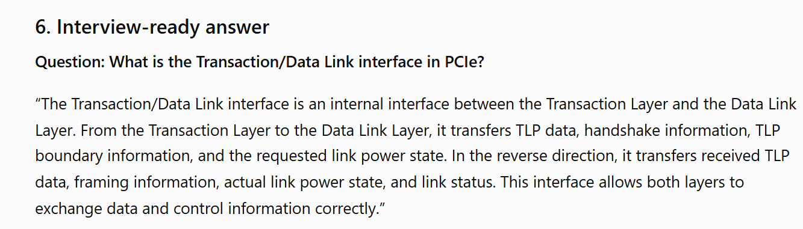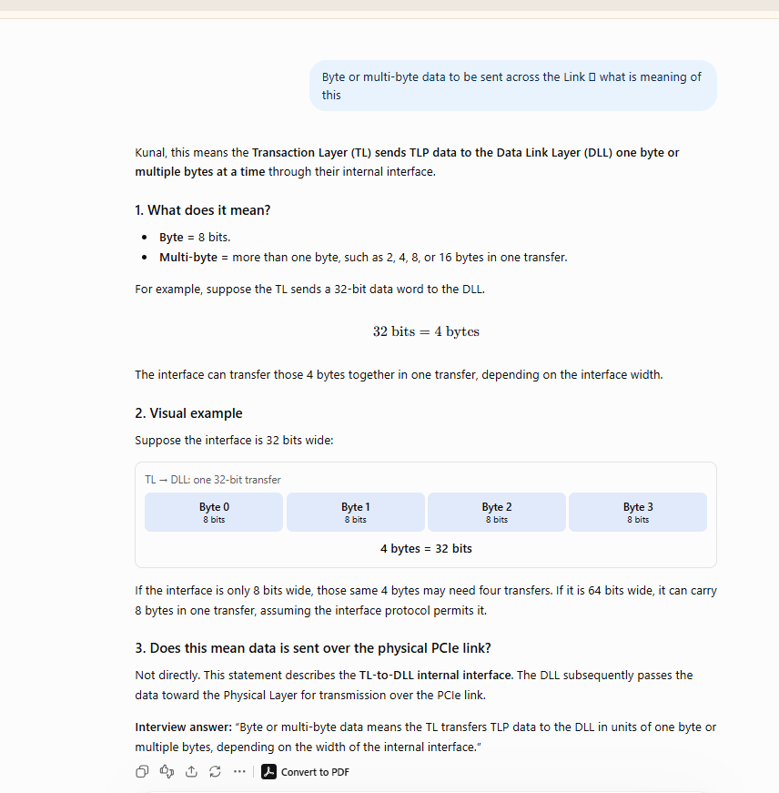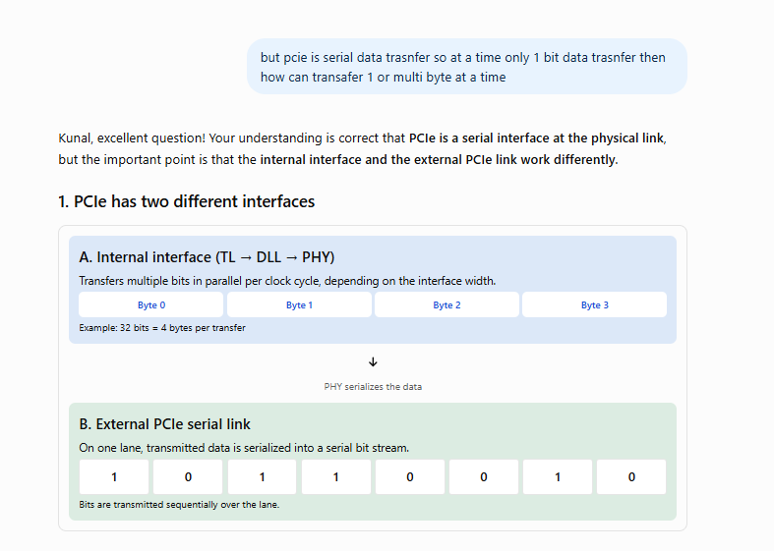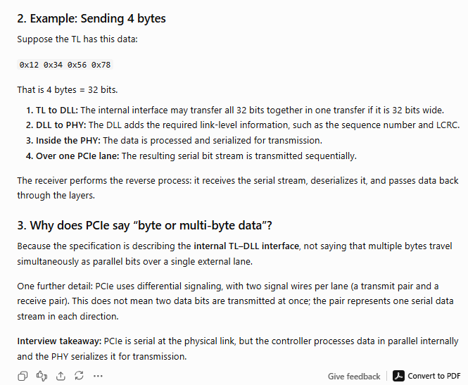

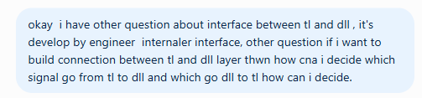
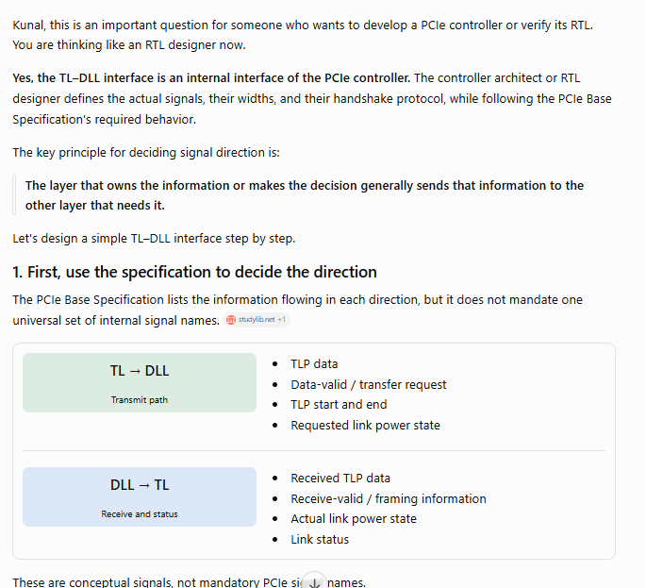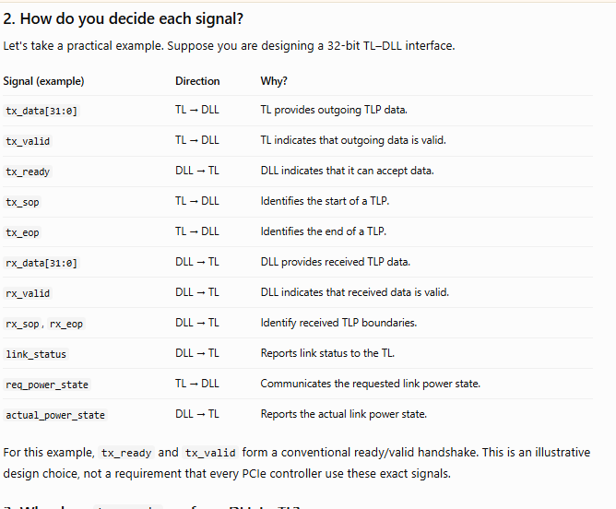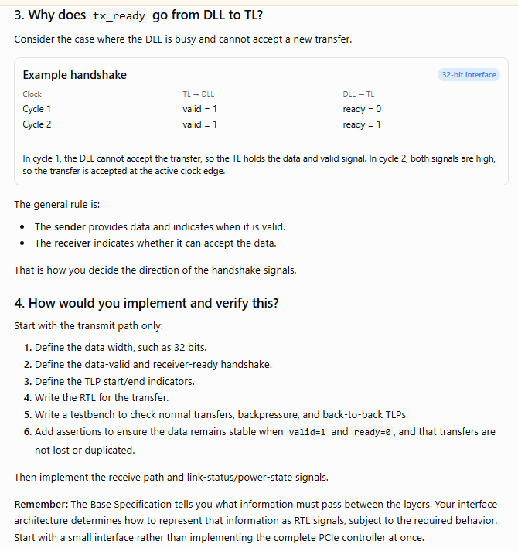

Data Link/Physical Interface
Data Link/Physical Interface
