----GIT Commands----

- git init
Initialize empty git repo
- rm -rf .git
to remove the git repo

- git status
gives git status

- git add .
add all files into staging area

- git commit -m "some text message here"
commit all changes
- git diff
shows the difference between working dir and staging area
- git diff -–staged
compare old commit with current staging area
- git commit -a -m “commit text message”
to commit the files directly (only commit previouslt added files wont commit untracked files”
- git rm filename
remove the desired file
- git mv filename newfilename
to change the filename
- git rm –-cache filename
to remove the file from getting tracked after adding it into gitignore as the file was already present inside staging
- git log -p
show changes in previous and current commit
- git log -p -3
show changes in previous 3 commit with diff
- git log –stat
short desc sunnary of commits
- git log --preety=oneline
one line commit summary
- git log --preety=short
short commit summary
- git log --preety=full
full commit summary
- git log --since=2.days
last 2day summary
- git log –preety=format:
full commit summary
- git restore –staged filename
to unstage a file from staged area
- git checkout – filename
restore old commit file changes
- git checkout -f
restore old commit changes on all files
- git remote add origin git_url
creating a remote in given github repo url
- git remote -v
shows push & fetch remote url
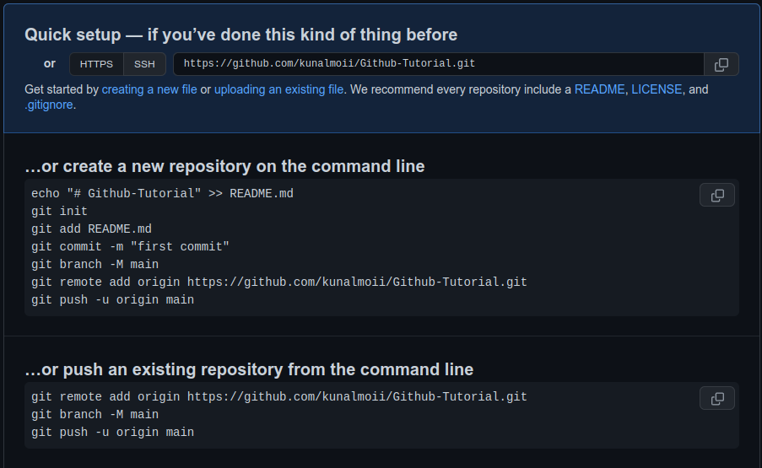
- Pushing into Github repo
- git checkout -b newbranch_name
creates a new branch with newbranch_name and takes you there automatically
- git checkout branch_name
to move back to given branch
- git branch
show all created and current branch
- git merge branch_name
merging current and other branch branch_name
git add .
git commit
git pull
- git branch -v
last commit message
- git branch -–merged
show all already merged branches
- git branch –no-merged
show non merged branches
- git branch -d branch_name
delete the branch (gives error if branch is not merged)
- git clone github_link --branch branch_name --single-branch folder/branch_name
to clone a specific branch from all branches

- comming soon

