**----GIT Commands----**

* **git init**

Initialize empty git repo

* **rm -rf .git**  
  to remove the git repo
* **git status**

gives git status

* **git add .**

add all files into staging area

* **git commit -m "some text message here"**   
  commit all changes
* **git diff**shows the difference between working dir and staging area
* **git diff -–staged**compare old commit with current staging area
* **git commit -a -m “commit text message”**to commit the files directly (only commit previouslt added files wont commit untracked files”
* **git rm filename**remove the desired file
* **git mv filename newfilename**to change the filename
* **git rm –-cache filename**to remove the file from getting tracked after adding it into gitignore as the file was already present inside staging
* **git log -p**show changes in previous and current commit
* **git log -p -3**  
  show changes in previous 3 commit with diff
* **git log –stat**short desc sunnary of commits
* **git log --preety=oneline**  
  one line commit summary
* **git log --preety=short  
  s**hort commit summary
* **git log --preety=full**full commit summary
* **git log --since=2.days**  
  last 2day summary
* **git log –preety=format:**full commit summary
* **git restore –staged filename**  
  to unstage a file from staged area
* **git checkout – filename**restore old commit file changes
* **git checkout -f**restore old commit changes on all files
* **git remote add origin git_url**creating a remote in given github repo url
* **git remote -v**shows push & fetch remote url
* **Pushin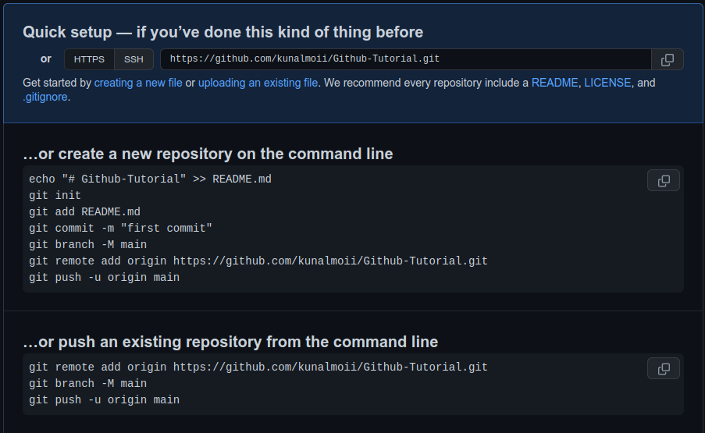g into Github repo**
* **git checkout -b newbranch_name**  
  creates a new branch with newbranch_name and takes you there automatically
* **git checkout branch_name**to move back to given branch
* **git branch**  
  show all created and current branch
* **git merge branch_name**

merging current and other branch branch_name  
git add .  
git commit

git pull

* **git branch -v**  
  last commit message
* **git branch -–merged**  
  show all already merged branches
* **git branch –no-merged**  
  show non merged branches
* **git branch -d branch_name**  
  delete the branch (gives error if branch is not merged)