----DVC Walkthrough----

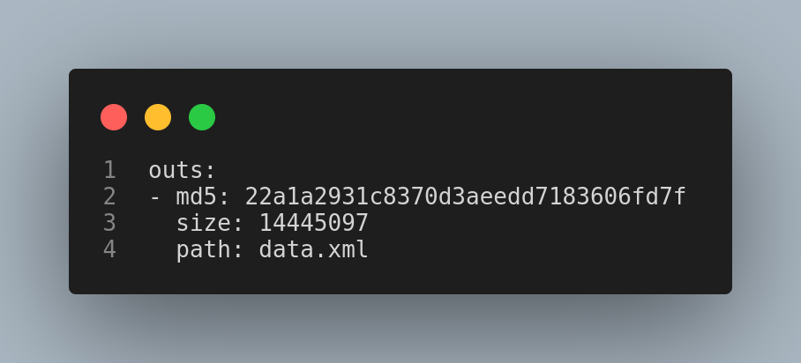
- data/data.xml.dvc --> contains address of dataset where it is stored in cloud
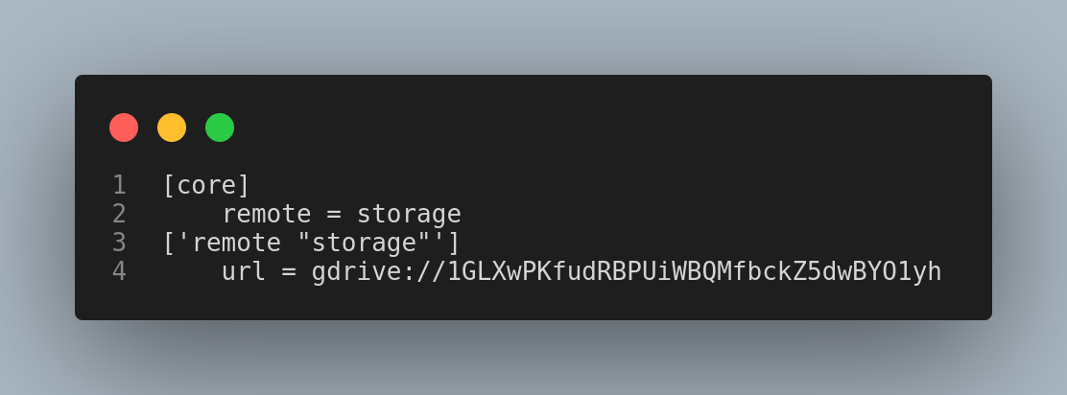
- .dvc/config --> tells where our storage is
- Initilizing git inside the working directory.
  - git init
- Initilizing dvc inside the working directory.
  - dvc init
- Creating data folder
  - mkdir data
- Grab the data set from the registry and bring it to local machine
  - dvc get https://github.com/iterative/dataset-registry get-started/data.xml -o data/data.xml
- Add data to dvc tracking

  - dvc add data/data.xml
- Follow gievn commands given in terminal then commit
  - git add data/data.xml.dvc data/.gitignore
  - git commit -m “Add raw data”
- Adding dvc remote to add data into gdrive storage
  - dvc remote add -d storage gdrive://folderlink
- Commit dvc config file and push
  - git commit .dvc/config -m “Configure remote storage”
  - dvc push
- New file will appear inside gdrive remote folder with random name.
- data.xml.dvc will go inside the git repository that will help us to point where the file is in our dvc repository i.e google drive.
- Check git logs
  - git log –oneline
- Checkout (removing) of old (first) version of dvc file
  - git checkout HEAD^1 data/data.xml.dvc
  - dvc checkout
  - git commit data/data.xml.dvc -m “Revert dataset updates”

