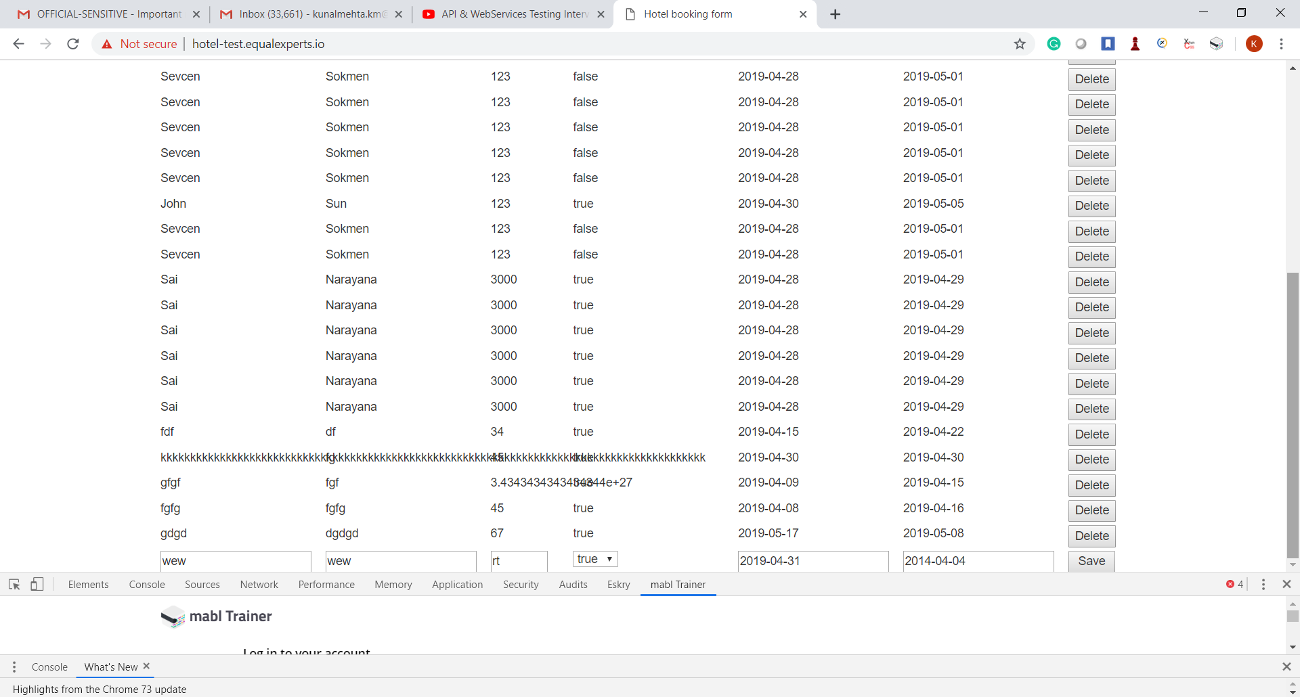

4 defects in the above screenshot

1. Names has no max length due to which overlapping between other label values is happening. UI and BE checks should be applied for length. For long names, UI should adjust and not overlap.
2. Price value is showing above behaviour as well. There are no checks applied on fractional digit of the price. usually it is 2.Same as above
3. 2nd last booking displayed on above screenshot is accepting dates in past at UI and BE both.

UI should block past date submission and BE should throw relevant error message

1. Last booking displayed on above screenshot is accepting checkin date as 2019-05-17 and checkout date as 2019-05-08. Not practical scenario. UI and BE both.
2. Though both UI and BE it is possible to enter unacceptable dates eg 2019-02-30 and 2019-04-31. BE was accepting ABCD-03-03 and saving it as 2001-03-03. In the above screenshot one of the date entered is 2019-04-31. On submission it was saved as 2019-05-01. As shown in the screenshot below.

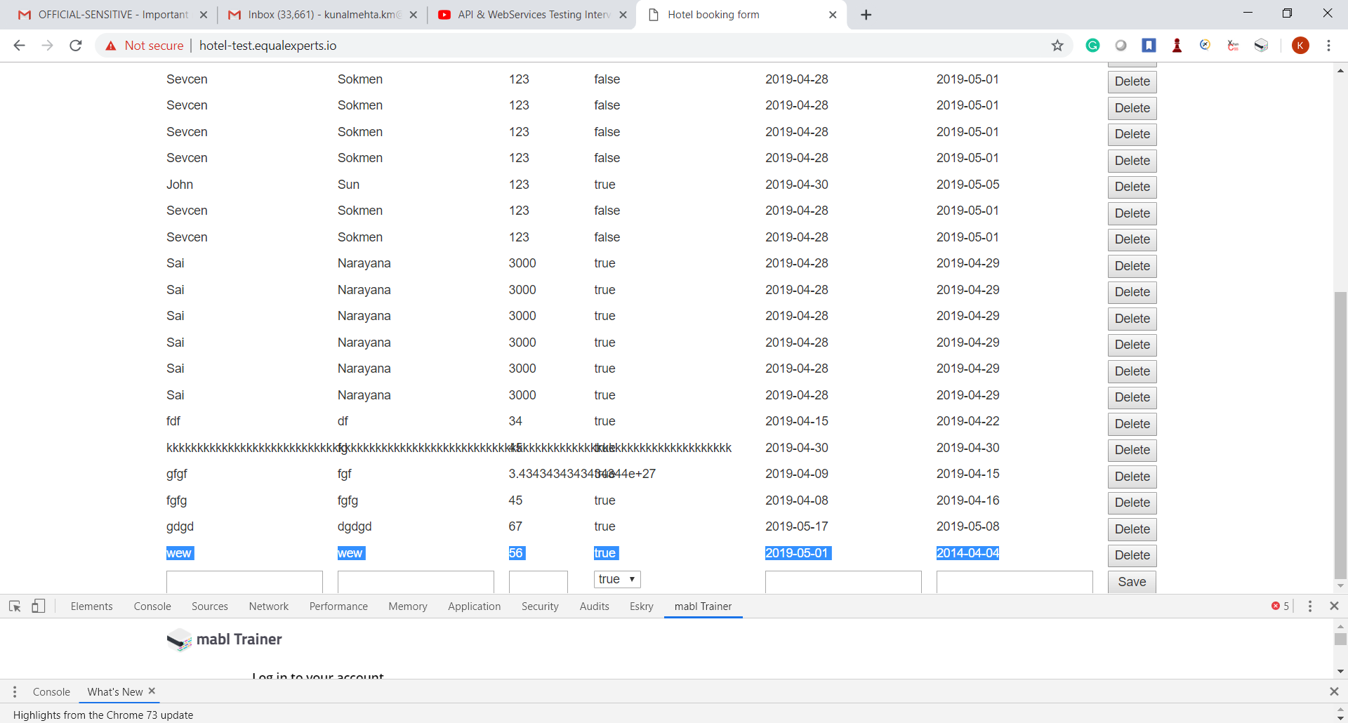

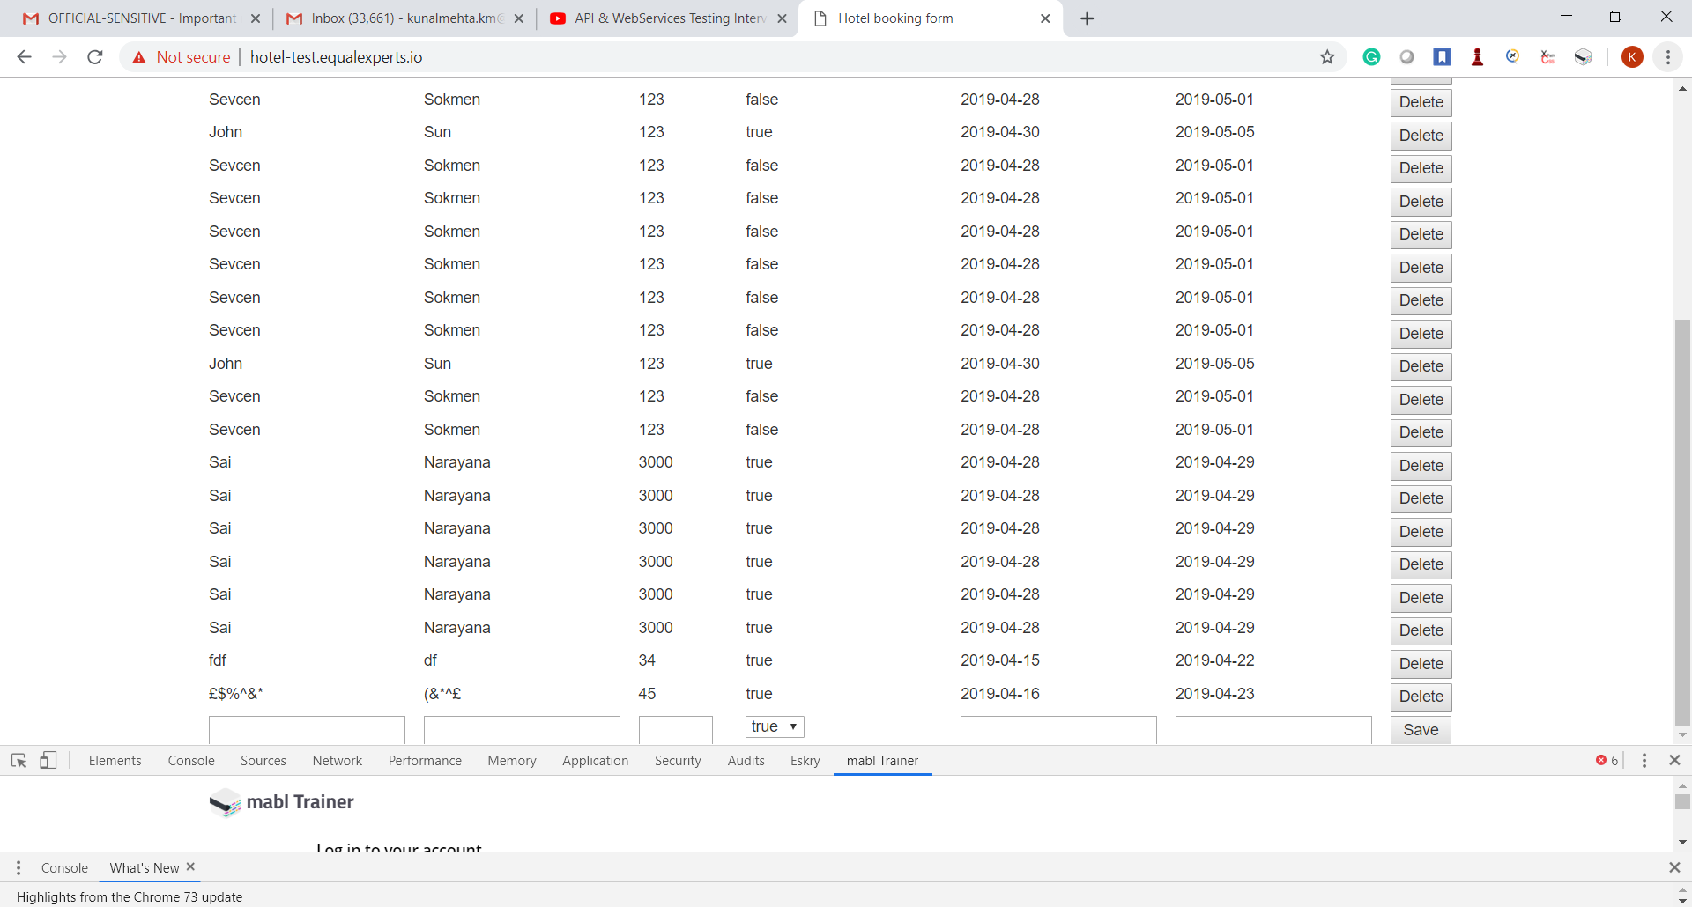

From the screenshot above

1. Names are accepting special character. Usually only – or ‘ is possible.
2. Due to no pagination , the UI looks clunky when filled up with records.

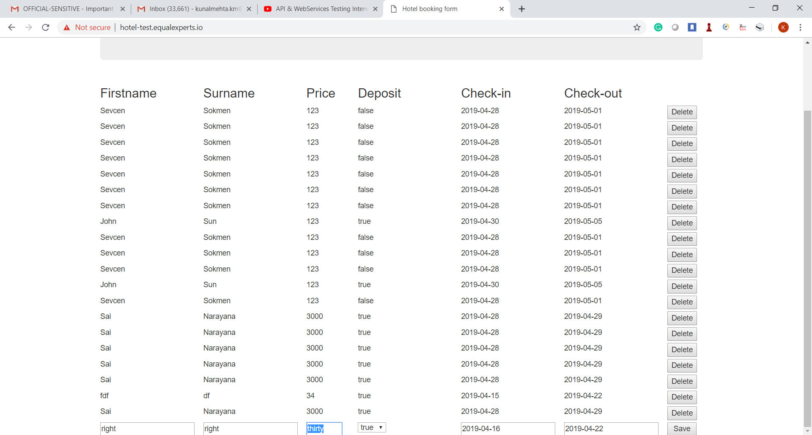

1. On submitting characters in number field price- There is no error message displayed.

There are no error message displayed for any of the other fields.

API testing- as there were no complex JSON to process firefox dev tools is used for request submission. Else tools like POSTMAN or any other specific REST clients can be used.

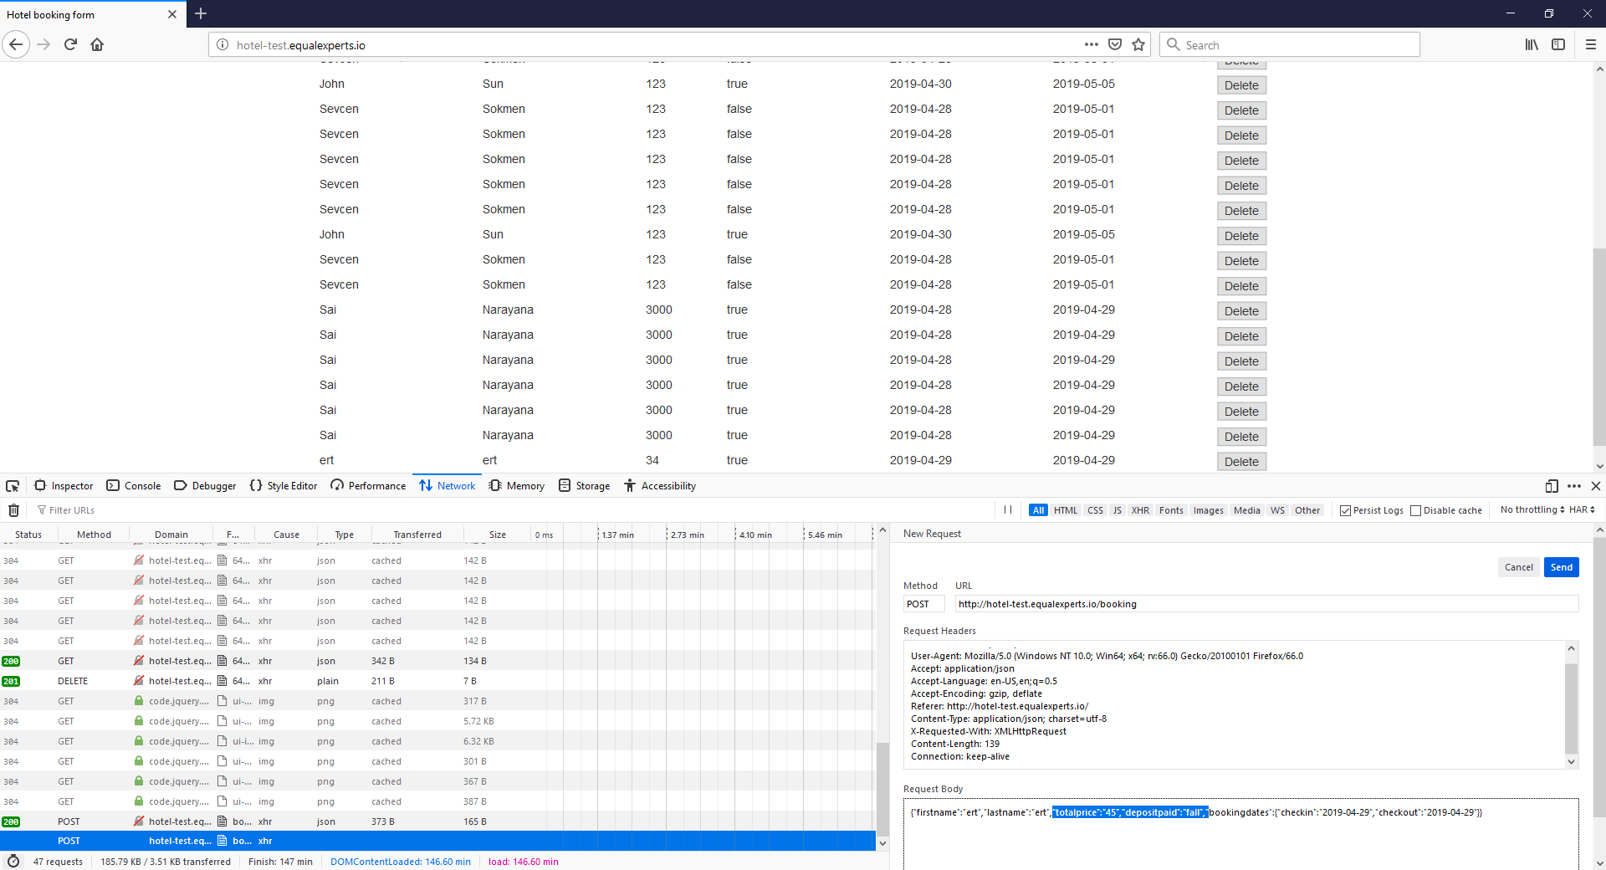

Deposit paid changed from true to ‘fall’ for a new request and on submission below behaviour is observed.

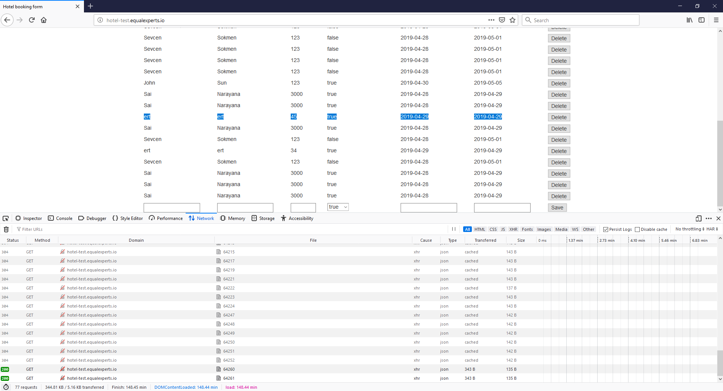

New row is created with value as true.