Design of a Thruster Solution for work class ROV and AUV

A PROJECT REPORT
SUBMITTED IN PARTIAL FULFILLMENT OF THE REQUIREMENTS FOR THE AWARD OF THE DEGRE
OF
BACHELORS OF TECHNOLOGY
IN
Mechanical Engineering

Submitted by:
Dhruv Upreti (2K21/ME/101)
Dipanshu Prasad (2K21/ME/105)
Govind Bhardwaj (2K21/ME/114)

Under the supervision of
Prof.(Mr) Raj Kumar Singh



DELHI TECHNOLOGICAL UNIVERSITY
(Formerly Delhi College of Engineering) Bawana Road, Delhi-110042 MAY 2025

DEPT. OF Mechanical Engineering
DELHI TECHNOLOGICAL UNIVERSITY
(Formerly Delhi College of Engineering) Bawana Road, Delhi-110042

CANDIDATE’S DECLARATION

We, Dhruv Upreti (2K21/ME/101), Dipanshu Prasad (2K21/ME/105) & Govind Bhardwaj (2K21/ME/114) students of B.Tech (Mechanical Engineering), hereby declare that the Project Dissertation titled “Design of a Thruster Solution for work class ROV and AUV” which is submitted by us to the Department of Mechanical Engineering, DTU, Delhi in fulfillment of the requirement for awarding of the Bachelor of Technology degree, is original and not copied from any source without proper citation. This work has not previously formed the basis for the award of any Degree, Diploma, Fellowship or other similar kind of title or recognition.

Place: New Delhi | Dhruv Upreti | Dipanshu Prasad | Govind Bhardwaj
Date: 28-May-2025 | (2K21/ME/101) | (2K21/ME/105) | (2K21/ME/114)

DEPT. OF Mechanical Engineering
DELHI TECHNOLOGICAL UNIVERSITY
(Formerly Delhi College of Engineering) Bawana Road, Delhi-110042

CERTIFICATE

I hereby certify that the Project Dissertation titled " Design of a Thruster Solution for work class ROV and AUV " which is submitted by Dhruv Upreti (2K21/ME /101), Dipanshu Prasad (2K21/ME/105) & Govind Bhardwaj (2K21/ME/114) Mechanical Engineering, Delhi Technological University, Delhi in partial fulfillment of requirement for the award of the degree of Bachelor of Technology, is record of the project work carried out by the students under my supervision. To the best of my knowledge this work has not been submitted in part or full for any Degree or Diploma to this University or elsewhere.

Place: New Delhi Prof. Raj Kumar Singh
Date: 28-May-2025 (Superviser)
Department of Mechanical Engineering
Delhi Technological University

ACKNOWLEDGEMENT

Any task that is successfully completed but does not give fair thanks to those who made it possible—without whom the project would not have been possible in the first place—is incomplete and meaningless.
Above all, we would like to express our gratitude to Prof. B B Arora, Head of the Department of Mechanical Engineering at Delhi Technological University, as well as the other faculty members in our department for their unwavering support and encouragement, genuine gratitude, and guidance throughout this project.
We owe a debt of gratitude to our supervisor, Prof. Raj Kumar Singh, Professor, Department of Mechanical Engineering, Delhi Technological University, for providing us with constant inspiration, guidance, and support as we undertook this endeavor and challenge. He also was always available to us when we needed help or advice.
We also want to take this opportunity to express our gratitude to everyone who has helped us with this difficult effort, whether directly or indirectly. We are pleased and thrilled to offer our gratitude to everyone who has supported and advised us while we have worked on this project for our minor project. Finally, but no less importantly, we express our gratitude to our parents and well-wishers for their unwavering support and continual presence in our lives whenever it is feasible.

CONTENTS
Candidates Declaration
Certificate
Acknowledgement
Abstract
CHAPTER 1: INTRODUCTION
1.1 Overview
1.2 Theory and formulae
CHAPTER 2: SIMULATION AND ANALYSIS
2.1

Calculating Thrust Force of an Underwater ROV (Remotely Operated Vehicle) Propeller

Dhruv Upreti, Dipanshu Prasad, Govind Bhardwaj
Delhi Technological University, Shahbad Daulatpur Village, Rohini, New Delhi, Delhi, 110042

Abstract: Marine or underwater thrusters are propulsion devices that incorporate a propeller connected to a motor, allowing the conversion of rotational movement to thrust to move the object they are attached to. It’s mounted on an underwater robot for propulsion and control. Thrusters are commonly used on Remotely Operated Underwater Vehicles (ROVs), Autonomous Underwater Vehicles (AUVs), and Uncrewed Surface Vessels (USVs). One of the challenges faced while incorporating such propellers is to simulate the propeller motion underwater and calculate the thrust that will be produced by the propeller. The present work aims to provide such simulation and guide on how to reproduce such simulation step-by-step.
The simulation in our work incorporates the 3D model of an asymmetrical propeller in
the duct, having as reference the T200 Thruster manufactured by Blue Robotics. The solution was derived under steady-state conditions by making use of the flow equations together with the k-ε turbulence model. The simulation is carried out on a wide range of rotational speed of propeller and in both directions. Finally the obtained result is compared with the data available by Blue Robotics.

1.1 Overview
Since the time when humans started traveling, water became one of the most important means for traveling across far distances especially for trading, exploration and transportation purposes.
In early times small wooden rafts were used, primarily for crossing the rivers, lakes,etc. With little advancement in human capabilities, small boats replaced the rafts as these boats had better maneuverability and had a better comfort. Since then, many design changes took place with the aim of improving its hydrodynamic efficiency but the major downside of traditional boats were that they rely on water current and manpower for propulsion. This imposes a size limit and speed limit, thus making boats not so convenient for very long journeys.

With the invention of the steam engine, marine vehicles were revolutionised. It not only eliminated manpower but also increased the speed and size limits of the boats. This marks the era of large marine vehicles i.e. ships. And since then, the popularity of marine vessels has increased for the purpose of trade. The reason being seaways provide the cheapest means of transportation and that's why 80% of global trade is carried out by sea.

Any water vehicle moves forward by a very simple concept, that is, Newton’s third law of motion, which states that every action has an equal and opposite reaction. When the boatman pushes the water backwards (action), then the water pushes the boat forward(reaction).

In early times an oar was used for this purpose. With advancement in science, paddle wheels (refer Fig. 1.1.1) were created. And through constant research and development modern propellers were invented.

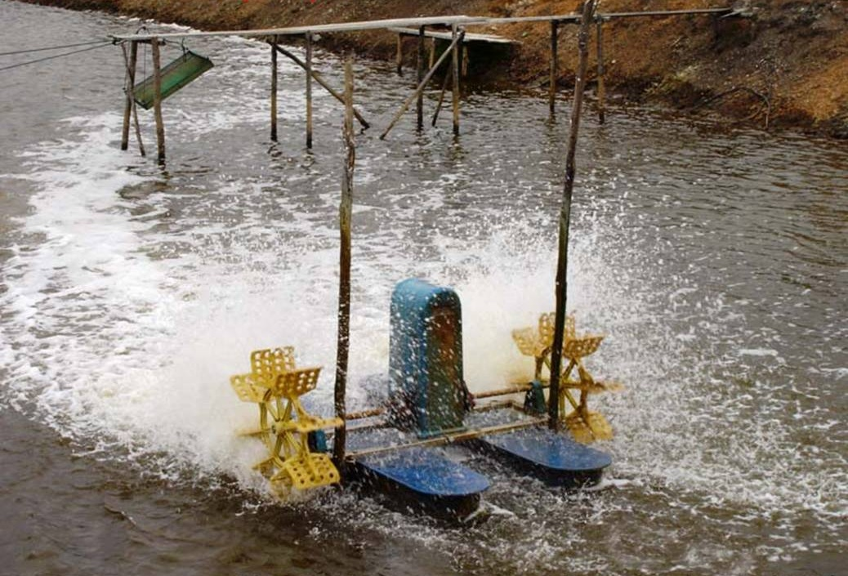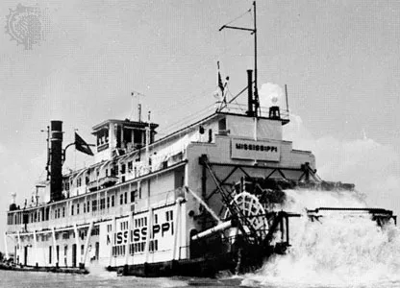
Fig 1.1.1 : Boat with Paddle Wheels

These propellers find their use in a variety of vehicles which includes boats, ships, submarines, ROVs, AUVs etc. The main components of these propellers are - shaft, blade and hub (refer Fig 1.1.2). The shaft is connected to the motor and the blades are connected to the shaft through the hub. The propeller converts the rotating energy of the blade into the thrust force. While rotating ,the blades which push the water backwards, this creates the action reaction pair and thus the marine vehicle moves forward. Research is done to improve the efficiency of the propellers and increase the thrust generated.

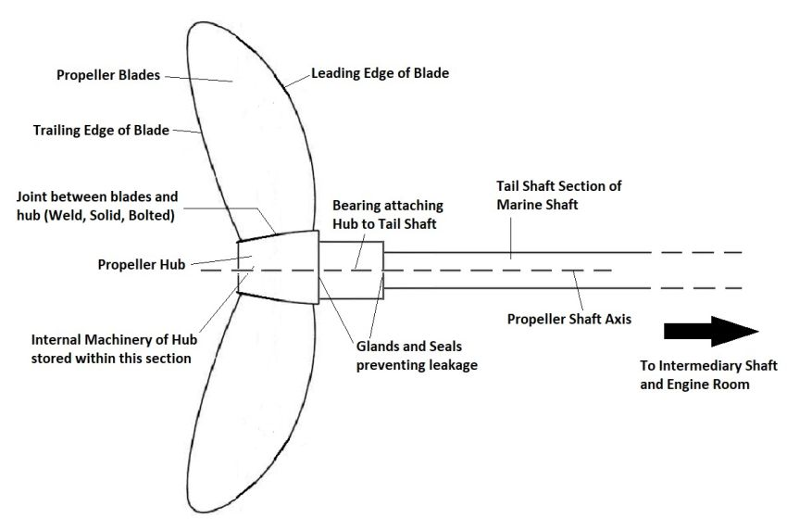
Fig 1.1.2 : Arrangement of Propeller

ROV i.e. Remotely Operated Vehicle is one of the many types of marine vehicles which is unmanned and operated remotely from the surface. These are equipped with cameras and other sensors. These propulsion devices are generally used for underwater exploration and investigation. They are also employed in tasks which are dangerous for humans. These vessels are widely used in the industries such as oil and gas, underwater archaeology, military operations etc. On the basis of the size, these ROVs can be further classified into Micro ROVs, Mini ROVs, Observation class ROVs, Work class ROVs and Heavy work class ROVs.
Ongoing research in the field of ROVs focuses on design efficiency, autonomous operations and improving energy efficiency.

During the research phase many prototypes are designed and they are needed to be tested to compute the performance. But testing so many prototypes is a cumbersome and cost intensive task thus CAE (Computer Aided Engineering) is a very important tool for testing the prototypes virtually. The major benefits of CAE softwares over traditional physical experiments are -
We can do simulations under various conditions which are hard to achieve physically. It also helps us to identify potential design flaws early in the design cycle thus saving both time and cost. These softwares has revolutionised the engineering and product development processes.
There are many CAE software for CFD (Computational Fluid Dynamics) simulations like Ansys, Openfoam, Simscale etc. but Ansys is the most widely used software due to its user-friendly interface, advanced meshing tools, and extensive post-processing features. It offers high fidelity solutions for complex engineering problems.

For marine applications, ANSYS Fluent and CFX modules are used to simulate fluid flow, turbulence, pressure distribution, and thrust generation around propeller blades. Its structural solvers compute stress, deformation, and fatigue life of rotating components.

In this research paper we have done an end to end ansys simulation on a T200 thruster (refer Fig 1.1.3) to calculate the thrust produced by the thruster. T200 is a ROV thruster manufactured by Blue Robotics.

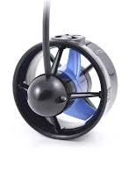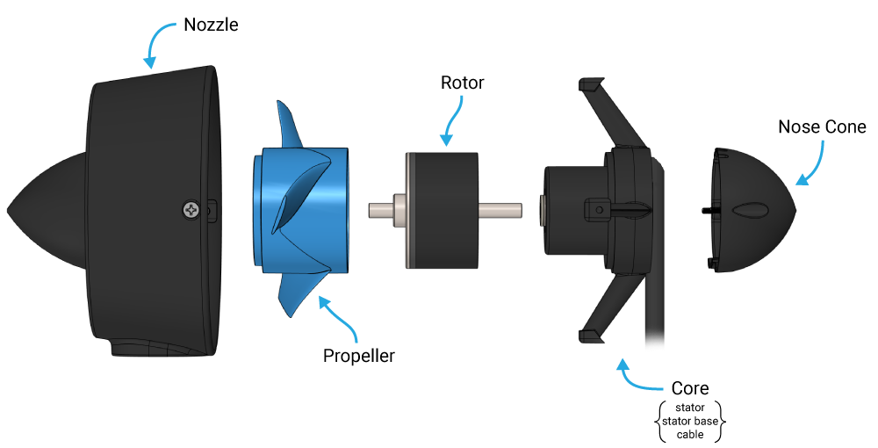
Fig 1.1.3 : T200 Thruster by BlueRobotics

Blue Robotics is a California-based company which makes high performance components like thrusters, actuators etc for marine robotos. Their T200 thruster is a compact powerful propulsion system used in a wide range of marine vehicles like ROVs, AUVs (Autonomous Underwater Vehicle). It is one of the most popular thruster globally because of its affordability,efficiency and robust design.

1.2 Theory and formulae
Thrust is the force due to which a water vehicle moves in the forward direction. It is based on Newton’s third law of motion which states that every action has an equal and opposite reaction.
There are many theories which enabled us to compute the thrust force. The first one was the momentum theory which is also known as the actuator disk theory. The propeller is assumed to be a disk which imparts a sudden change in momentum to the flow. According to this theory the thrust produced is the rate of change of momentum.
Thrust per unit annular is given by Eqn: 1.2.1.

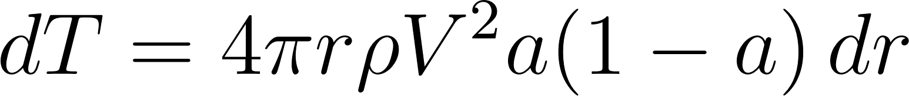
Eqn: 1.2.1
where,
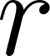 : radial distance
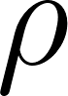 : fluid density
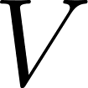: freestream axial velocity
: axial induction factor

Although this theory is simple to use and has minimal assumptions, it does ignore the blade geometry and provide inconsistent results at high thrust and heavily loaded rotors where wake interactions are significant. Thus, BET(Blade Element Theory) was developed. It accounts for the blade geometry including chord length, twists, airfoil shape etc. therefore it provides a more accurate prediction than the momentum theory. It computes the thrust by dividing each blade into small elements and calculates forces on each element independently. These forces are then integrated across the blade length to calculate the net thrust and torque.

Thrust generated by a small blade element using BET is given by Eqn: 1.2.2.

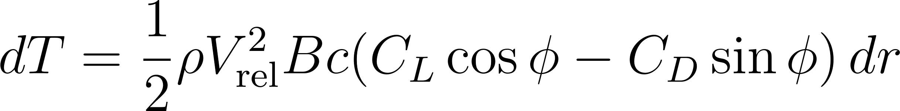
Eqn: 1.2.2

where,
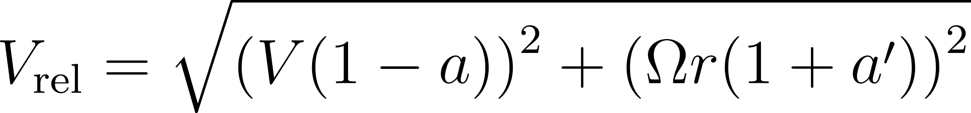
: number of blades
: local chord length
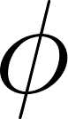: inflow angle
 : lift and drag coefficients
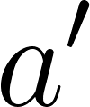: tangential induction factor

Although this theory was a major upgrade from the momentum theory, it also ignores the wake effect and does not account for the blade-vortex interactions. Thus, a more profound theory BEMT (Blade Element Momentum Theory) was introduced. It combines the Blade Element Theory and Momentum Theory to provide a more accurate result. This combination considers both local blade characteristics and global flow interactions thus improving calculation of thrust.

From momentum theory :

From BET theory :
These equations are equated and solved iteratively to compute the values of and for each blade section and thus total thrust is calculated by integration.

Although this model was better than the previous two, it also has some shortcomings. It assumes steady axisymmetric flow. Moreover BEMT can't handle turbulence flow or boundary layer development. It also provides only integral outputs like thrust and torque not full flow field data like pressure, velocity etc.

Thus, the RANS (Reynolds Averaged Navier Stokes) equation was developed to provide more accurate results. This is derived from Navie-Stokes equation by decomposing the pressure and velocity field into mean and fluctuating components and then time-averaging it. This enables the modeling of turbulent flow.

RANS momentum equation is given by Eqn: 1.2.3.

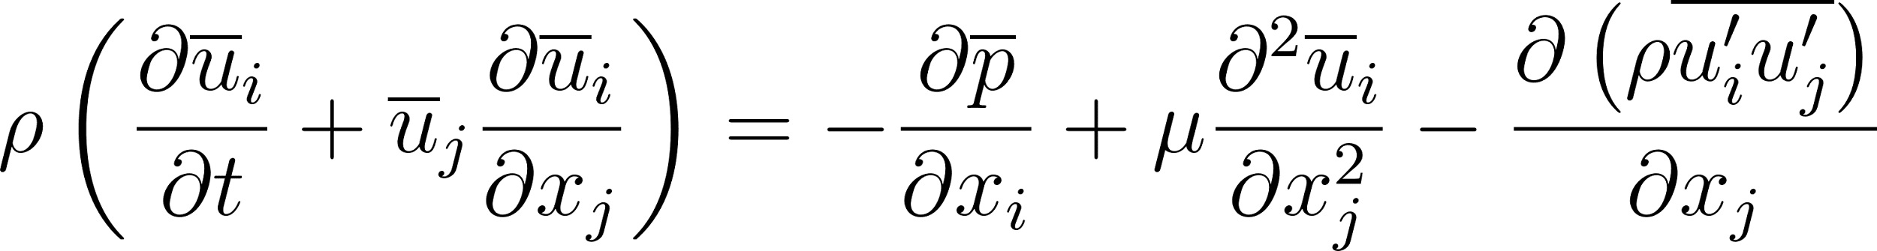
Eqn: 1.2.3

Where the term $$\rho \overline{u’_i u’_j}$$ is the Reynolds stress tensor which represents turbulent effects and needs modelling via turbulent models. This method is computationally efficient and many models have been extensively tested on this equation. It also captures the time averaged behavior and works well with complex geometries.

There are many models which are based on RANS equations. The K-ε model is one among them. It is a widely used turbulence model within the RANS framework. It models turbulence by solving two additional transport equations. One for turbulent kinetic energy (K) and another for dissipation rate of kinetic energy (ε). It incorporates these two parameters to compute the turbulent eddy viscosity ,which is given by Eqn: 1.2.4

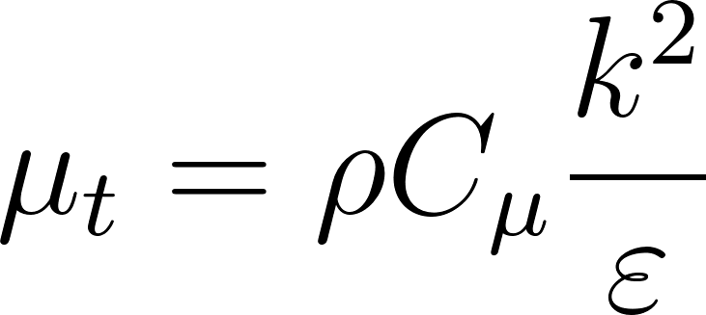
Eqn: 1.2.4
Transport equations:

- Turbulent kinetic energy (k):
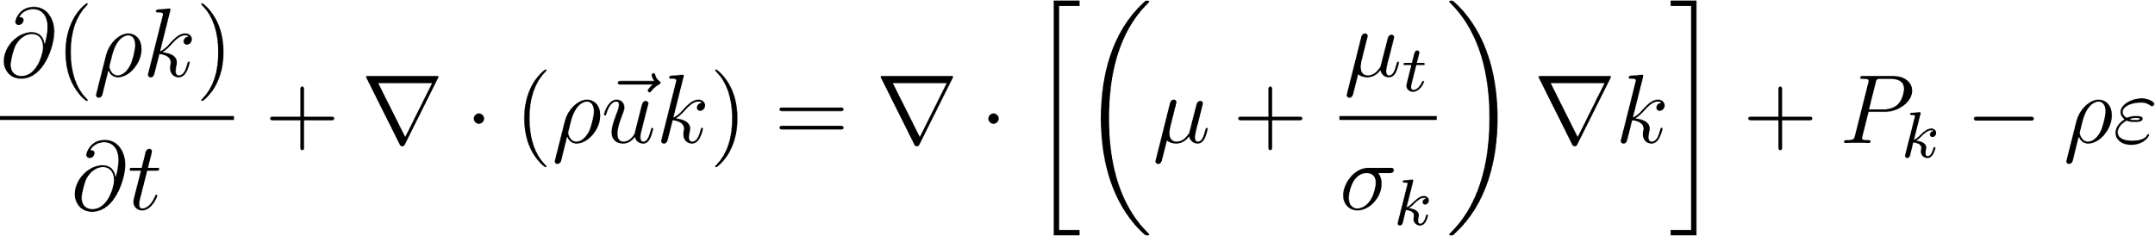
Where
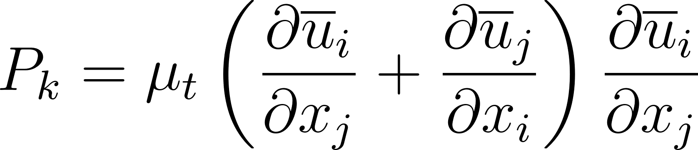

- Dissipation rate (ε)
The values of model constants are:
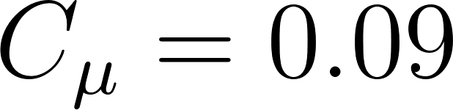
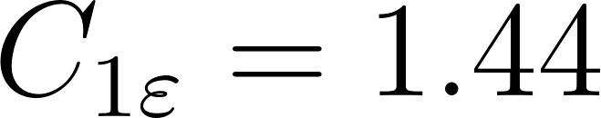
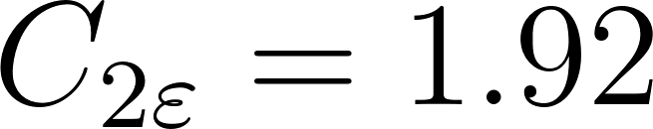
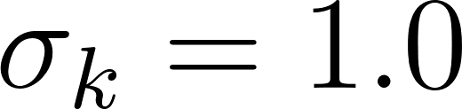
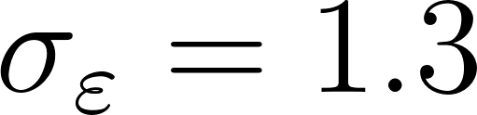.

On solving the RANS equation with k-ε model in CFD, we can resolve the pressure and shear distribution over the propeller blade and then compute the thrust via surface integration
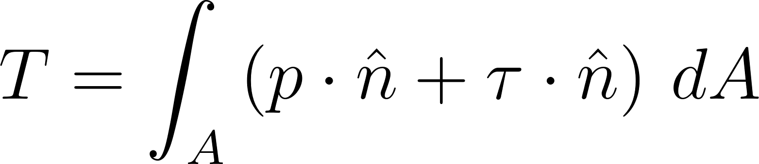

The k-ε model is popular because of its robustness and can be used to calculate the parameters in fully developed flows. Moreover it is computationally efficient therefore could be used for large scale problems. Other models like k-ω, RSM (Reynold Stress Model) are also based on the RANS equation but we will be using k-ε for our simulation purpose.

Geometry Setup
In any computational fluid dynamics (CFD) analysis, especially one involving a propeller—where minute geometric nuances and fluid-structure interactions can significantly affect results—the quality of the initial digital model cannot be overstated. The effectiveness of the entire workflow, from mesh generation to solver convergence and, ultimately, the accuracy of thrust prediction, depends on how well the initial geometry and accompanying fluid domains are described. ANSYS DesignModeler emerges as a key tool, bridging the gap between engineering intention and computational realization.

ANSYS DesignModeler is an advanced, integrated module provided as part of the ANSYS Workbench suite. It is specifically structured to facilitate the preprocessing phase of CFD and finite element analysis (FEA) projects. DesignModeler enables users to either craft geometry from the ground up or import it from an assortment of popular CAD platforms. It is compatible with parametric design, allowing for easy iteration on dimensions and features, which is crucial when performing studies that require multiple design alternatives. DesignModeler provides tools to:
- Construct or import intricate blade shapes,
- Manipulate geometric parameters for optimization studies,
- Generate the requisite fluid domains,
- Intelligently partition regions into static and rotating subdomains essential for accurate simulation,
- Assign "named selections" to simplify meshing and boundary condition application downstream.
This flexibility, combined with a logical workflow, enables even less experienced CFD engineers to achieve reliable and repeatable results.
The first and perhaps most critical step within DesignModeler is the creation of the propeller geometry itself. This process may commence with importing CAD models most commonly in
standard formats such as IGES, STEP, or Parasolid—that have been meticulously designed using dedicated software like SolidWorks, CATIA, or AutoCAD. Alternatively, DesignModeler allows users to develop the blade and hub features using its suite of sketching and surface tools.
An accurate propeller model must capture:
The 3D twist distribution along each blade (to ensure proper angle of attack at all radii),
The chord length variations from root to tip,
The specific airfoil profiles employed at each blade section,
The hub geometry, especially if slipstream or interaction with the spinner is of interest.
For advanced analyses (for example, with different numbers of blades, “scimitar” curvature, or non-uniform pitches), DesignModeler supports a range of parametric sketches that can be easily modified for design iteration.

Fluid Domain Construction
Unlike solid geometry, fluid domains are conceptual. These represent the space through which air or another working fluid flows around the propeller. It is these domains in which CFD solutions are ultimately computed.

For thrust analyses, fluid domain may be divided into two sections namely static domain and rotating domain:
Rotating (Moving) Domain: Envelops the propeller with some margin to ensure that induced flow and vortex structures are properly captured.
Static (Stationary) Domain: Encompasses the rotating domain, extends upstream and downstream to model undisturbed inlet and evolving propeller wake adequately.
Proper construction and sizing of these domains are essential.

Real-world propeller systems operate in a combination of static and moving frames. To simulate this using CFD, it is essential to represent the physical distinction between flow in the immediate vicinity of the rotating blades and the relatively stationary far-field fluid. The Multiple Reference Frame (MRF) method is the go-to approach for steady-state CFD analyses involving rotating machinery such as propellers, wind turbines, and fans.
The 'rotating domain' mathematically rotates relative to the static environment, simplifying the moving boundary problem. Inside this region, the propeller is “stationary,” and all parts revolve with a set angular velocity.
The 'static domain' comprises the surrounding, non-moving fluid. This allows for accurate imposition of boundary conditions and ensures realistic wake development downstream.
By dividing the overall fluid volume this way, complex transient mesh interfaces (as required by Dynamic Mesh or Sliding Mesh methods for fully transient analyses) are avoided, improving stability and decreasing computational demands for steady analyses.

Domain size plays a crucial role in the reliability and physical realism of CFD results. The heart of the issue is balancing two competing needs: accuracy and computational resource usage.

Implications for the Rotating Domain:

If the rotating domain is undersized, significant aerodynamic interactions—such as tip vortices, wake convergence, and pressure gradients—are artificially constrained. This truncation leads to:

Inaccurate prediction of thrust and torque.
Nonphysical behavior at the interface (velocity and pressure discontinuities).
Potential flow recirculation or non-convergent solutions.
Appropriately Sized: Expanding the rotating domain outward, especially in the radial and downstream directions, allows all local flow phenomena directly induced by the propeller action to evolve within the relevant moving frame. The result is:

Preserved tip vortex development.
Smoother, more realistic flow transfer at the static-rotating interface.
Improved accuracy in predicted thrust and induced velocity fields.
Too Large: While larger rotating domains generally improve physical fidelity, they proportionately increase the computational load. This is because mesh density requirements within this region are typically higher, given the rapid spatial change in velocity and turbulence around the blades.

Implications for the Static Domain:

Insufficient extension of the static domain, particularly upstream and downstream, introduces spurious boundary effects. Inflow or outflow conditions set too close to the propeller can artificially constrain wake evolution, adversely affecting downstream mixing and pressure recovery.
Appropriately Sized: Extending the static domain ensures wake features dissipate naturally before reaching the computational outer walls. This allows inflow and outflow conditions to remain non-intrusive and ensures a true representation of far-field flow.
A Practical Rule of Thumb: Most industry guidelines (and considerable practical experience) suggest that rotating domains should extend radially at least 1.5–2 times the propeller diameter and axially 1–2 diameters both upstream and downstream. Similarly, the static domain should be set at least 4–10 times the propeller diameter in both directions to minimize boundary-induced distortion.

Computational Cost Considerations
The main trade-off lies in the computational resources demanded by larger or more complex domains. The cost (in memory and CPU time) depends on:

Mesh density: Finer meshes are required near the propeller to resolve boundary layers and tip vortices.
Domain volume: Larger domains require more total mesh elements, especially if the rotating region is expanded.
Solver complexity: More interfaces and refined interfaces (such as rotating-stationary boundaries) increase the number of equations and iterations for convergence.
To optimize, engineers habitually conduct grid and domain independence studies. By incrementally increasing mesh density and domain size, they look for the point where further increases yield diminishing changes in the quantities of interest (in this case, thrust, torque, and overall flow structure). This “convergence” point offers a rational compromise between realism and practicality.

Brief Procedure for Domain Creation in ANSYS DesignModeler
Practical geometry construction in DesignModeler involves a structured sequence to ensure all necessary regions are captured cleanly and consistently:

1. Import or Model the Propeller
Import: If the propeller CAD exists, import it using the appropriate file format (.iges, .step, .sat, etc.).
Model: Otherwise, use the ‘Sketch’ tools to create the airfoil root and tip profiles, then ‘Loft’ between these sketches to generate a blade. Duplicate and rotate as needed for multiple blades, and create/add the central hub.
2. Creating the Rotating Fluid Domain
Draw a Cylinder or Conical Volume: Centered on the axis of rotation, set the cylinder length to extend upstream of the propeller hub (typically 1–1.5 diameters) and at least 1–2 diameters downstream. Make the cylinder’s radius at least 1.5 times the propeller tip radius.
Subtract the Propeller Solid: Use Boolean ‘Subtract’ to remove the blade and hub volumes from this rotating domain, ensuring a clean fluid volume.
3. Creating the Static Fluid Domain
Draw a Larger Box or Cylinder: Surrounding the smaller rotating domain, this will simulate the environmental air. Usually, extend at least 4–10 propeller diameters in each direction from the center.
Subtract Overlapping Volumes: Remove the rotating domain’s volume from this block/cylinder, resulting in two contiguous, non-overlapping fluid regions.
4. Defining Interfaces and Boundaries
Named Selections: Clearly define and name the interface surfaces where static and rotating domains meet (e.g., ‘rotating_interface’ and ‘static_interface’).
Boundary Surfaces: Label inlet, outlet, wall, and symmetry planes for easy assignment of CFD boundary conditions later.
5. Validation and Export

Meshing

The meshing phase is one of the most crucial steps in any computational fluid dynamics (CFD) workflow, and it holds particular importance when analyzing the thrust characteristics of a propeller. While the process might, on the surface, seem like a technical formality—simply dividing the computational domain into smaller chunks—it is, in fact, the gateway to reliable, realistic results. The choices made during meshing reverberate throughout the simulation, influencing both the physical validity of the outputs and the practical feasibility of the problem.

Understanding the Basics of Meshing
At its essence, meshing involves decomposing the continuous fluid and solid regions defined in the geometry stage (such as those created in ANSYS DesignModeler) into a finite number of discrete, non-overlapping subregions called elements. The points where these elements connect are called nodes. The entire collection of nodes and elements is known as the mesh.

With CFD, we are essentially approximating the continuous solutions of the governing fluid flow equations (the Navier-Stokes equations) at these finite nodes. The smaller and more carefully shaped these elements are—especially in areas of complex flow—the closer we are to capturing the real physical phenomena occurring around and behind the propeller.

Types of Mesh Elements: Tetrahedral vs. Hexahedral
Not all meshes are created equal. ANSYS, like most industrial CFD platforms, supports several types of element shapes, each with its own strengths, weaknesses, and optimal application areas. For propeller CFD, the two foremost contenders are tetrahedral and hexahedral elements.

1. Tetrahedral Elements (Tetra Mesh)
Tetrahedral elements—commonly known as ‘tetras’—are four-faced, pyramid-like shapes that can be packed into virtually any three-dimensional space, no matter how complex. Their greatest asset is flexibility: they conform to highly intricate or organic shapes, making them especially valuable when dealing with the curved, twisting geometry of propeller blades. Their ability to “flow” around sharp corners, thin trailing edges, and hub regions is unmatched by structured shapes.

However, this flexibility comes with a price. Tetrahedral elements, due to the way they approximate the local solution, can introduce more numerical diffusion compared to their hexahedral counterparts. This can affect the fidelity of simulation, especially in flows characterized by thin, well-ordered boundary layers—like those at the surface of a propeller blade. Therefore, while tetras are often necessary for complex regions, excessive use can impact accuracy unless the mesh is highly refined.

2. Hexahedral Elements (Hex Mesh)
Hexahedral, or “hex,” elements are cube-like six-faced volumetric shapes. When possible, they provide several advantages: greater accuracy per element, better solution stability, and lower computational cost for a given level of resolution. This is because the mathematical methods used to solve the fluid equations (finite volume or finite element methods) benefit from the regular, structured nature of hex meshes.

In propeller simulations, hex elements are typically used in regions where the geometry allows it, such as the surrounding far-field domain or the wake downstream of the propeller. They are ideal for capturing the directional nature of the flow, especially in well-ordered flows, and for resolving boundary layers near surfaces through the use of structured prism layers (discussed below).

The challenge is that hexahedral meshes are difficult to generate around very complex, organic shapes, especially when sharp transitions or highly twisted surfaces are involved.

3. Hybrid Meshes
Recognizing the strengths and limitations of each element type, most modern CFD meshes for propeller simulations are hybrids. This means using tetrahedral elements near intricately shaped regions (propeller blades, hub fillets) and transitioning to hexahedral or prismatic elements in the far field, wake, and near-wall regions. This hybrid approach allows for a practical compromise, leveraging accuracy where feasible while maintaining meshing flexibility.

Mesh Nodes and the Calculation of Flow Quantities
Each element in the mesh is defined by its corner points—the nodes. It is at these nodes where the discrete values of physical quantities (such as velocity, pressure, and turbulence variables) are stored and computed by the CFD solver.

When the CFD equations are solved, the solver:

Assigns an initial value for each variable at each node (often based on boundary conditions or an initial guess),
Evaluates how these values change due to local flows, pressure gradients, and turbulence across each element,
Iteratively updates these values until the changes become negligible (convergence).
The arrangement of nodes plays a critical role in how accurately gradients (the spatial changes in variables) are captured. An orderly, dense distribution of nodes near regions of high gradient—such as the surface of the rotating propeller blades or in the downstream wake—is essential for faithfully reproducing the physics.

Mesh Refinement: Size, Layers, and Grading
1. Importance of Mesh Size
At the heart of mesh design is the question of resolution: How small (or large) should the elements be? This is not a trivial decision—every reduction in mesh size (that is, every increase in resolution) provides the potential for greater accuracy but at the direct cost of exponentially increased memory and calculation time.

Theoretically, an infinitely fine mesh would yield results indistinguishable from a true physical experiment, but in practice, this is unattainable. Choosing an optimal mesh size is therefore a balancing act, driven by the following considerations:

Physical Phenomena: Thin boundary layers, sharp wakes, and tip vortices around a propeller demand extremely fine mesh in these regions, often down to fractions of a millimeter for high-fidelity work.
Computational Resources: Available RAM and CPU time are the limiting factors for high-resolution meshes. For large propeller simulations, even powerful research computers may find themselves taxed by extremely fine global mesh densities.
Regions of Interest: Adaptive refinement is employed—using the finest mesh where detail matters most (like the blade surface and immediate wake) and coarser mesh in regions of less physical interest (further from the blades or in relatively uniform far-field flow).
A well-resolved mesh guarantees reliable thrust and torque calculations, whereas an under-resolved mesh risks “smearing out” critical physical features, resulting in inaccurate, non-convergent, or misleading results.

2. Boundary Layer Meshing: Prism and Inflation Layers
Particularly important for propeller simulations is the accurate capture of boundary layers—the thin regions of rapidly changing velocity near the blade surface where most viscous effects take place. These are key contributors to both lift (and thus thrust) and drag.

To resolve the boundary layer, specialized mesh layers are created near the wall (blade surface):

Prism/Inflation Layers: These are thin, stacked “layers” of elements, very small at the wall and gradually increasing in thickness away from the surface. In ANSYS, these are typically prismatic or wedge-shaped elements that align with the surface normal.
The first layer thickness should be chosen to achieve a non-dimensional wall distance (Y+) suitable for the turbulence model used (often Y+ ≈ 1 for low-Re turbulence models).
If these layers are neglected, the solver may entirely miss subtle but essential near-wall physics, undermining the thrust computation, drag estimation, and even causing spurious flow separation.

Creating the Mesh in ANSYS Meshing

The meshing tool within ANSYS Workbench offers a broad array of capabilities, from fully automatic meshing—where the software decides element types and sizes based on feature recognition—to highly manual, detailed mesh control.

A typical procedure for meshing a propeller CFD problem is as follows:

Import and Inspect Geometry: Load the domains created in DesignModeler; check for small gaps, overlaps, or defects that may cause meshing to fail.

Define Named Selections: Assign names to key surfaces (inlet, outlet, propeller, interfaces) for easier application of boundary and mesh conditions.

Set Global Element Size: Choose an overall element size based on domain dimensions, estimated Reynolds number, and planned computational resources.

Apply Local Refinements:

Use body sizing or face sizing features to refine the mesh on and near the propeller surfaces, typically aiming for element sizes much smaller than the trailing edge thickness.
Apply inflation layers to the propeller blades for resolving the boundary layer.
Refine the mesh in the near-wake region to track the development of tip vortices and wake contraction.
Mesh the Rotating and Static Domains:

The rotating domain (around the propeller) often gets a finer mesh, sometimes with tetrahedral or hybrid elements, to resolve all dynamic blade effects.
The static domain, especially far from the propeller, can handle coarser, more structured hex meshes.
Check Mesh Quality: Assess quality metrics such as skewness, aspect ratio, orthogonality, and smoothness. Poor quality elements can ruin convergence, leading to errors or failed solutions.

Generate and Export: Once satisfied, generate the mesh and export it for use in the solver.

Mesh Independence and Convergence
A critical part of responsible CFD practice is to ensure that results do not strongly depend on the arbitrary choice of mesh density—a process known as mesh independence testing. This involves:

Running the same simulation at progressively finer mesh resolutions (halving element size each time, for instance).
Comparing key outputs (like calculated thrust) between runs.
Confirming that further

Solution Setup
After carefully constructing the computational mesh, the next critical stage in any computational fluid dynamics (CFD) simulation is setting up the solution physics, initializing the problem, and specifying numerical parameters. This phase determines how the equations governing fluid flow are interpreted, which models describe turbulence and wall behavior, and how physical properties such as fluid type and domain motion are represented. In my work, I followed a systematic sequence of steps for setup and solution, tailored specifically for propeller thrust estimation in a multiphase environment. These choices are explained below, both in terms of software execution and engineering rationale.

1. Physics Setup
Solver Type and Time Conditions
The very first step in setting up the simulation involved specifying the core solver physics. We made several deliberate choices here, each driven by the characteristics of the system under study.

Pressure-Based Solver: For this propeller problem, we selected “pressure-based” as the solver type. This decision is rooted in the nature of low-speed, incompressible or mildly compressible flows, where pressure-based solvers are both stable and efficient. Although density-based solvers are sometimes preferable for high-speed compressible flows (e.g., supersonic jets), the relatively slow, water-driven scenario represented by the propeller in my case fits firmly within the purview of a pressure-based solution method.

Velocity Formulation: Absolute: In the context of rotating machinery, CFD solvers typically offer both “absolute” and “relative” velocity formulations. we opted for the absolute formulation; this means that all velocity quantities, whether in the static or rotating domain, are interpreted relative to a fixed, stationary observer. This approach is the default for external flows and ensures a straightforward setup when analyzing forces and generating flow visualizations.

Transient Time Conditions: Rather than assuming a steady-state flow, which can sometimes obscure important unsteady phenomena such as vortex shedding, fluctuating thrust, or startup effects, I selected a transient simulation. In a transient approach, the solver calculates how the flow field evolves over time—a necessity for accurately capturing periodic and aperiodic dynamics in propeller aerodynamics and hydrodynamics.

Gravity Activation: Properly simulating physical environments sometimes demands the inclusion of gravitational effects, even when flow velocities are relatively low. In my setup, we enabled gravity in the Y-axis direction, assigning a value of 9.81 m/s², which reflects standard Earth gravity. This choice ensures that any buoyancy-driven flows or hydrostatic pressure effects in the vertical direction are faithfully resolved.

2. Turbulence and Near-Wall Modelling
Simulating turbulence is one of the central challenges in CFD, especially in flows involving rotating machinery like propellers, where the interaction of shear layers and vortices creates complex velocity fields.

Turbulence Model Selection: we selected the realizable k-epsilon turbulence model. This variant is a widely used, robust two-equation model that offers improved accuracy over the standard k-epsilon in flows with strong separation, recirculation, or streamline curvature—features that are characteristic around propeller blades. The “realizable” form addresses limitations of the original model by ensuring that the turbulence viscosity and kinetic energy remain physically consistent even under high strain or swirling flows.

Near-Wall Treatment: Properly resolving the thin boundary layers near solid surfaces is vital for accurately predicting drag and thrust. Here, we opted for scalable wall functions as the near-wall treatment. Wall functions bridge the gap between core turbulence models (which cannot resolve the very thin viscous sublayer for practical mesh sizes) and physical reality at the blade or hub surface. The scalable feature improves upon traditional wall functions by ensuring consistency even for extremely fine meshes, preventing algorithmic breakdowns at low non-dimensional wall distances (Y+). All other options under turbulence modelling were left at their default values, which are well-validated for the scenario at hand.

3. Fluid Material Selection
Material Choice: For both the rotating and the static domains, we chose water (specifically, H₂O<L> within ANSYS’s material library) as the working fluid. This selection reflects the actual experimental or operational scenario under study—whether the propeller is an aquatic one, such as for a boat or marine drone, or a model being experimentally tested in a water tunnel. Using consistent material definitions for both domains avoids artificial discontinuities at the static-rotating interface.
4. Cell Zones and Domain Properties
The next phase entailed explicitly instructing the solver as to which parts of the computational domain should rotate, and with what parameters, as well as which parts remain stationary.

Rotating Domain Setup:

Material: Set as water, as described above.
Mesh Motion: Mesh motion was enabled for the rotating domain, a key feature for implementing the Multiple Reference Frame (MRF) method. This allows the computational cells in this zone to “spin” at the designated angular velocity.
Rotation Axis and Velocity: The axis of rotation was aligned with the x-axis (consistent with the propeller’s principal axis in the geometrical setup), and the rotation velocity was set to 3600 revolutions per minute (rpm). This value was selected to replicate realistic operational speeds for marine or drone-scale propellers—fast enough to induce pronounced flow but within the expected structural limits of the blades.
Static Domain Setup:

Material: Again, water—ensuring a seamless flow field across the interface.
Default Settings: All other mesh and physical property settings were kept as default for the static domain, as its role is to serve as the quiescent fluid volume into which the propeller discharges or from which it draws flow. Default options are generally sufficient when no special phenomena (such as additional sources, heat transfer, or porous zones) are present.
5. Boundary Conditions
Correct boundary conditions are essential for instructing the solver how fluid enters and exits the computational region, how walls and interfaces behave, and how forces are exchanged between the propeller and the surrounding fluid.

Inlet Velocity: I set the inlet boundary with a fixed velocity of 0.001 m/s. This low value was chosen to approximate “still water” conditions—emulating the propeller acting in stationary fluid, which reflects a typical thrust test. All other inlet properties, such as turbulence intensity or reference values, were left at default, which suffices for low-speed inflow scenarios.

Other Boundaries: Other boundary settings (outlet, walls, symmetry, etc.) remained at their default values. ANSYS’s default treatments for pressure outlets, symmetry planes, and non-slip walls are well-established for propeller CFD, requiring no further intervention unless dealing with highly specialized scenarios.

Solution Strategy
With all physical and numerical parameters specified, the simulation moves to the “solution” phase—where the equations are discretized, initial conditions imposed, and the computation proceeds to deliver time-resolved data.

1. Thrust Calculation: Force Report Setup
A central goal of this simulation is to assess the propeller’s thrust—quantified as the net force generated by the blades along the intended direction of motion.

Report Definition: Within ANSYS Fluent, I created a custom report specifically for thrust calculation. This involved establishing a new “force report”:
Wall Zones: The zone corresponding to the propeller surface was selected as the “wall” from which forces would be calculated.
Force Vector: The x-direction was specified when setting up the report, as it aligns with the axis of rotation and expected thrust.
Reporting: Results were configured not only to be written to file after each calculation step but also automatically plotted, allowing real-time monitoring of force development and convergence.
This setup provides both an integrated summary (e.g., total thrust over time) and the possibility of diagnosing transient phenomena (like cyclic variations or oscillations).

2. Data Export and Monitoring
Understanding the behavior of the propeller across the entire transient simulation, rather than at a single snapshot, is extremely informative.

Calculation Activities: I configured the solver to export full result fields—essentially, snapshots of the flow variables—after every 10 timesteps. This serves a dual role:
Result Analysis: Enables examination of velocity, vorticity, and pressure distribution at arbitrary points during the simulation, invaluable for troubleshooting, validating, or visualizing the solution.
Animation Creation: The sequence of saved results can be post-processed into animations, vividly illustrating how the wake evolves and how thrust responds to changes in flow.
3. Initialization
Hybrid Initialization: Instead of initializing with a uniform guess (such as zero velocity), I used ANSYS Fluent’s “hybrid initialization” feature. This tool combines aspects of potential flow and algebraic multigrid solvers, delivering a smarter, non-uniform starting flow field. Hybrid initialization often accelerates convergence for complex, multi-domain simulations and helps avoid early solution divergence problems.
4. Time Stepping and Iterations
The transient nature of this simulation requires careful attention to timestep management, as it affects both solution stability and physical accuracy.

Time Step Size: Set at 0.015 seconds—a value chosen after consideration of expected physical timescales (e.g., the time it takes a nebula to sweep across one propeller blade). A smaller timestep provides finer temporal resolution and higher accuracy, though at increased computational effort.

Number of Timesteps: I opted for 1000 timesteps to ensure the simulation covers a reasonable ‘window’ of prop

