Twitter Real Time Data Analysis

Abstract
With the increase in social media platforms, we now have more data which is available for exploration or to get new insights about the people and their experiences. This paper provides method to capture and analyze real time data available over one of the popular social media site: Twitter. Paper presents an approach to extract meaningful information by performing sentiment analysis on live Twitter data. Analyzing Real Time data allows a company to identify success of a campaign or learn about the audience and their interest. We conclude that analyzing social media data brings transparency between companies and their customer’s interest, which in turn help companies to take better decisions.

Introduction
The rapid increase in data provides enough room for exploratory analysis on data. The growing presence in social media brings need to track their activities and interest. Data on social media sites act as an excellent resource to analyze and draw result based on the patterns/activities of users. According to the surveys conducted online about 86% of the users rely on internet for information. Huge amount of data is available on internet, most of which is left unutilized and explored. Twitter, a popular social media application taken as source of analysis, we will derive sentiments of the users regarding a company, product or services. Few challenges to such a system are reliability, high availability and low latency of the network. Recent advancement in networks and data science has made it possible to analyze real time data at efficient rate to provide immediate result to the computation.

Design
Below diagram provide overall idea about the application and its flow around different components:
Authentication and Authorization
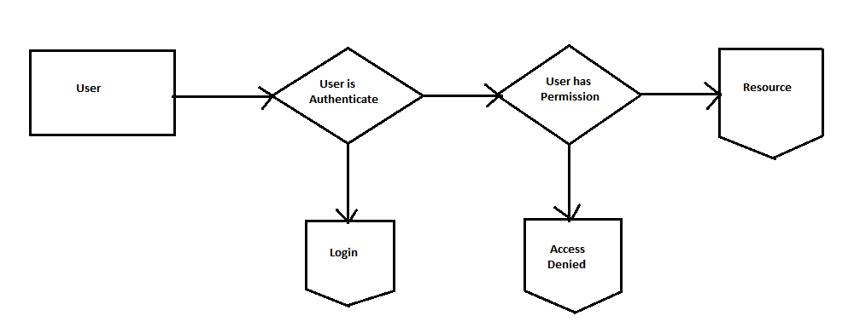
During login user will have to first register using his email ID, then user will be added into the database. The registered user will have access to the dashboard. While logging into the account users authentication will be verified against the database and permission will be given to the user to use the resource, if the user is not authenticate then the permission will be denied.
Tweets from Twitter API


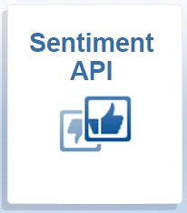
Tweets
Authentication
Tweets
Sentiment Score
Figure 1

Twitter Client

Twitter API allows collecting real time data from the tweets which can be consumed by the client application. Twitter API requires developer account to allow any client application for consumption of its live stream data.
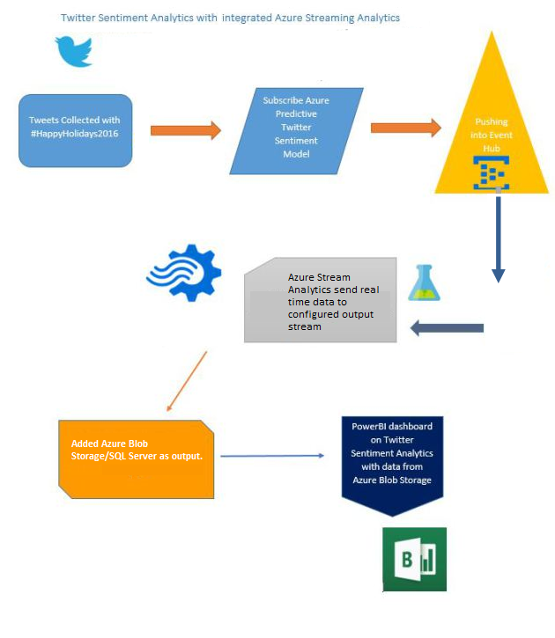
Figure 2
Real time data from the API is then forwarded for sentiment analysis. Sentiment analysis can be performed by Machine Learning API available such as provide by Sentiment140, a twitter sentiment analysis tool. Processes records are provided with polarity values like 0 for negative, 2 for neutral, 4 for positive and sent to Azure Stream Analytics.
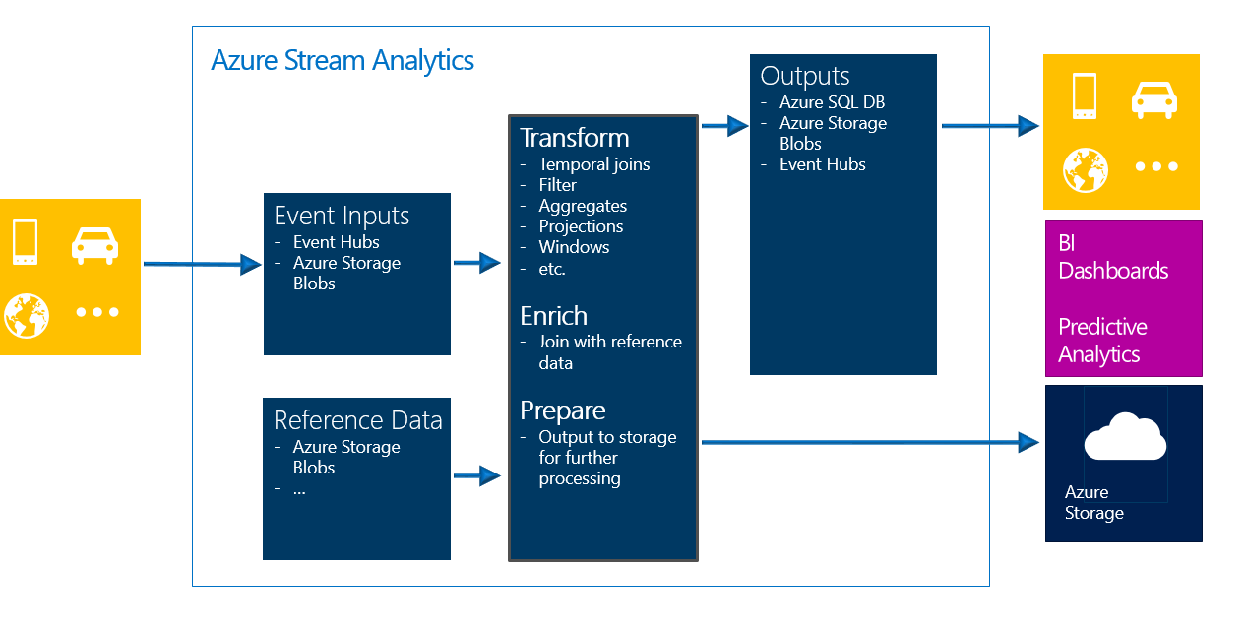
Figure 3

Azure Stream Analytics job consists of Input and Output modules which can be configured as per the needs to get and forward data in compatible format to other system components. We will use JSON as input to Stream Analytics and SQL Server/Blog storage as output. It allows us to filter and query our data from storage. Power BI or Web App can be used to develop intuitive user interface for user to get results.
Azure Web Application would act as the primary interface for user to view current live update and sentiment analysis of twitter data. Dashboard can provide deep insights about user’s interest and sentiments about services or product.
System will consist of below components:
- Authentication and Authorization Module
This module is responsible for registering of new users and allows existing users to access web application.
- Stream Analytics jobs
These jobs are created to handle live data, due to its high availability and low latency. Azure Stream Analytics provides flexibility to configure output to different storage components like Blob Storage, SQL Server Database.
- Twitter Client application
Its main job is to communicate with Twitter API for recent tweets, consume and forward it to sentiment API for sentiment analysis.
- Web Dashboard
Azure Web Application is responsible for displaying meaningful application to users.
Asp.net web site is based on MVC (Model, View and Controller).
Model: It consists of entities which are similar to the database entities and used during validation and posting the data into the database.
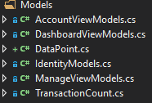
View: It provide interface and design features to provide great user experience and navigation control over the application.
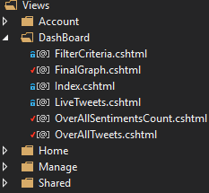
Controller: It consists of business logic and implementation of business logic. All the server side validation is done in controller.
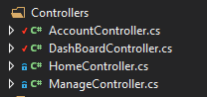
- Azure SQL Server Database
Web Application would use SQL Server for storing tweets data. Below is Entity Relationship Diagram for Database:
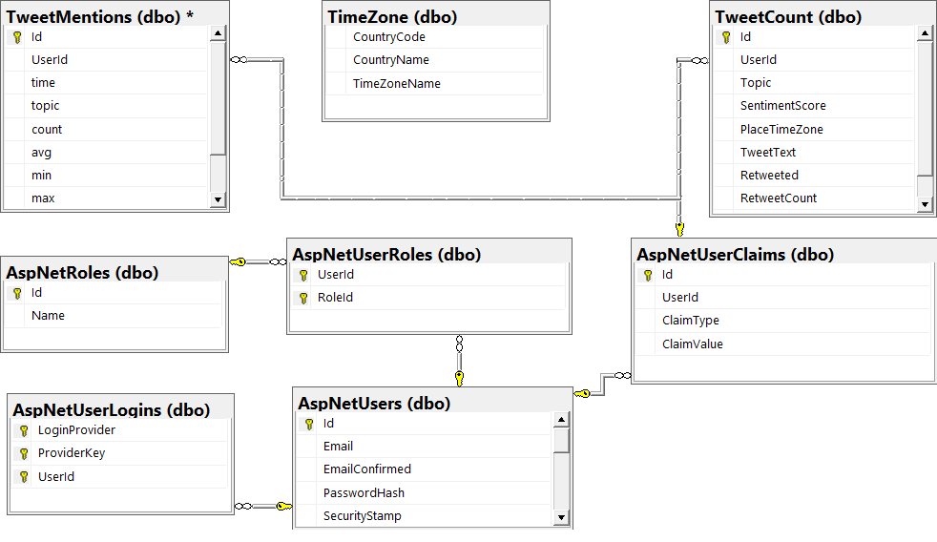
TweetCount: This Primary table is responsible for holding all the tweets data and its sentiment analysis.
TweetMentions: This table is responsible for keeping aggregated data of 5 seconds about sentiments.
TimeZone: It consists of list of time zones available around the world.
AspNetUsers: This primary table is responsible for holding registered user information.
AspNetRoles: This primary table is responsible for holding roles available for web application.
AspNetUserRoles: This table maintains relationship between AspNetRoles table and AspNetUsers table.
AspNetUserLogins: This table maintains information about logged-in users.
AspNetUserClaims: This table allow user to recover forget password by the registered user.
Overall Interaction of components within the Application
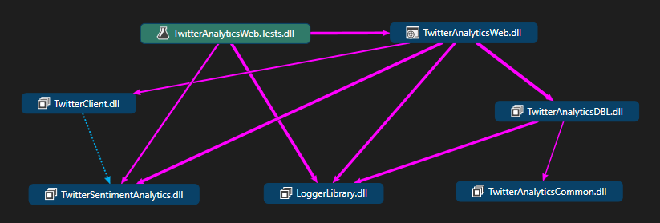
- TwitterAnalyticsWeb
It a web application which is based on MVC model. It interacts with LoggerLibrary to create logs of information and exception. It also interacts with TwitterSentimentAnalytics library to get the sentiments from twitter API. It uses TwitterClient library to push live tweets to cloud platform. TwitterAnalyticsDBL is used to create database connection and perform CRUD operation into the database.
- TwitterAnalyticsTests
It consists of unit tests to be performed on web application. It is used to check functionality and requirement of the features has met.
- LoggerLibrary
It is used to Log the information or error message into log file. It is referenced in both web and database layer of application. It acts as primary library for storing web application information and retrieving errors.
- TwitterSentimentAnalytics
It is used to read twitter live data and perform calculation of sentiment score. It is primarily used in web application since it would be used to fetch live twitter data based on the topic provided by the user on web interface.
- TwitterAnalyticsDBL
It is the database layer of the project which is used to perform CRUD operation in the database. It would be reference by “TwitterAnalyticsWeb” project to perform analytics on the data and perform database operation using this library.

Library Creation
Internal Libraries

- Logger Library
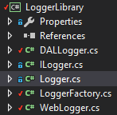
Library was implemented to serve as a purpose of logging of important application information into logs. Logs are really helpful for debug and getting application message without disrupting application functionality or crashing of application. It also provide different LOGLEVELS to Log different type of information such as ERROR for error messages, DEBUG for debugging messages and INFO for information messages.

Logger Library consists of below classes and interface:

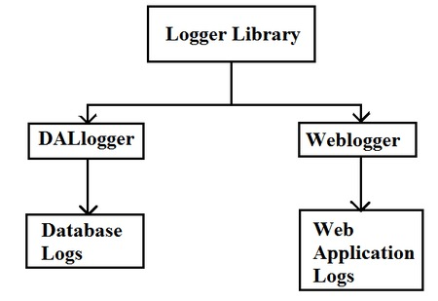

- ILogger.cs: It’s an interface which provides details about the method to be implemented by its derived classes. Any class implementing ILogger, either has to implement all the members of the Interface of should be an abstract class.

- Logger.cs: It’s an abstract class which provides abstract methods which should be overridden by implementing Logger class. It allow to create own Logger class and provide custom implementation for logging to other programmer.

- DALLogger.cs: It’s a concrete class which provides implementation details about logging information of database layer. It is used to log database layer information and error which occur at database layer. It allows application to be robust and not to crash due to errors.

- WebLogger.cs: It’s another concrete class which facilitates logging Web application information into logs. It allows Web application to log debugging or error information into logs.

- LoggerFactory.cs: It’s a concrete class which is based on factory design pattern to register logger classes and return instance of logger classes when requested.

- SentimentAnalytics
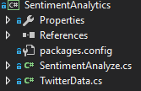
SentimentAnalytics library was developed to server the purpose for calculating sentiment analysis on the tweets provided to the library. Library is based on Façade design pattern. Library internally uses sentiment140 open source library to calculate the sentiments. It also allows creating connection with twitter API and retrieving the live tweet on the basis of the configuration provided to the library.

It consists of below classes:

- SentimentAnalyze.cs: This class is responsible for analyzing sentiment of tweets. It allows to access methods to send tweet to the library and library provides sentiment score bases on the sentiment analysis on the text.

- TwitterData.cs: This class provides retrieving tweets from Twitter API. It accepts Twitter Configuration on the basis of which it creates and validates twitter connection and fetches the live twitter data from twitter API. It also parses the data provided by the twitter API into entity and return to the calling application.

External Libraries

- Sentiment140

It’s an open source and free external library which is used to calculate sentiment of the text provide to it. We need to create HttpWebRequest to call this API and get Sentiment Score from API.

- CanvasJs

It’s a jquery library which is used to draw graph and charts on web application. It easily embeds into the web application and allows providing live update to charts and graphs.

- Asp.net identity Libraries

These are set of libraries which provide easy authentication and authorization mechanism within the asp.net application. These libraries allow also provide mechanism to perform custom task during the startup of application.

- Bootstrap

It consists of set of JavaScript’s and CSS files which are responsible to provide better user experience and interface. We can use the classes and functions available in library just by referencing the library.

- SignalR

It is responsible to send data from server to client without making browser to make whole request cycle.

- Microsoft Service Bus

This library is responsible for communication with Azure Hub and sending the live twitter data to Azure Cloud platform.

Implementation
The project has been implemented as below:

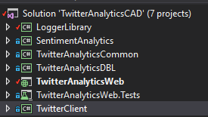

LoggerLibrary : It provides the logging library to provide logging framework from the application.

SentimentAnalytics : It provides sentiment score to the calling API and also has capability to read the live tweets from Twitter API.

TwitterAnalyticsCommon : It provide set of classes which are required across the application. These classes provide common functionality to all the other referencing libraries or application.

TwitterAnalyticsDBL : It act as a database layer and provide all the communication with database. It perfrom all CRUD operations on database with the help for function and required parameters.

TwitterAnalyticsWeb : It provide web interface to user, for getting into its account and perfrom sentiment analytics using different topics.

Modules- User Authentication and Filter Criteria

Modules-Sentiment Analysis, Twitter Records retrieval and Dashboard.

TwitterAnalyticsWeb.Tests : It consists of Unit Tests that needs to test internal functionalities and requirements.

TwitterClient : It is responsible for retrieving data from twitter using SentimentAnalytics library and sending the live tweet data along with sentiment score to Azure cloud platform form.

Layer within the Web Application

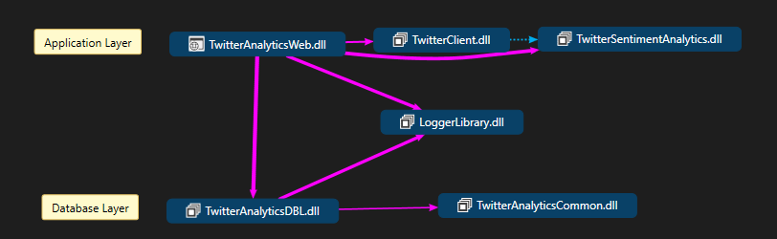

Application Layer: It provide Web user interface to user. It consists of Web project and set of libraries to help web application project achieve its business requirement and functionality.

Database Layer: It provides database access and methods to perfrom operation on database such as fetching, updating or deletion of records.

Testing

During the testing of web application below approaches has been used.

- Unit Testing: It is used to perform to check functionality and requirement has met its objective and goal. It should cover all the functionalites and features being provided by the application along with the positive and negative scenarios in which user provides positive or negative input to interface provided. We have written unit test cases which tests functionality and feature of application.

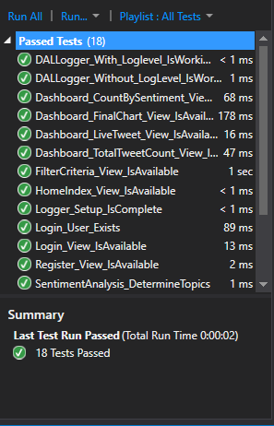

Unit Test Cases

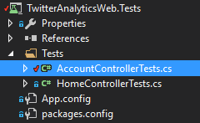
Unit test cases has been implemented for AccountController and HomeController with below results:
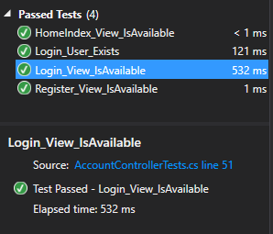

Unit Test Cases
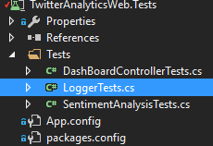
Unit test cases has been implemented for Dashboard, Logger,sentimeentanalysis controller and libraries with below results:
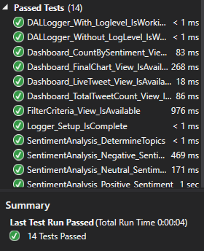

Functional Testing: We have perform functional testing to check if functionality works fine and all the requirement has been met. Functional Testing is also required to check the flow of the application and make sure each components within the application interact with one another in efficient and effective way to provide great user experience. It majorly included:
-Form Validations
-Authentication and Authorization
-Application Work flow
-Session Maintenance
-Component Interaction
-End to End Scenarios

Exploratory Testing: We also perform exploratory testing to check if any bottlenecks and loopholes within the application which could crash or harm the application.

Design Pattern

- Singleton Pattern

Singleton pattern has been implemented to main single instance of a class throughout the lifetime of an application. There have been few instances within the project where we have implemented singleton design pattern within our application.

LoggerFactory Singleton

We have single instance of LoggerFactory which could be used to create instance of different logger such as database and weblogger.

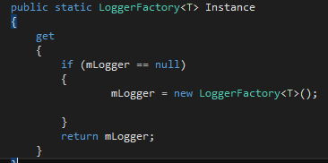

AzureConnectionManager

We have created single instance of ConnectionManager so that we donot need to create multiple connection object within the application. Same object could be re-used multiple times within the application.

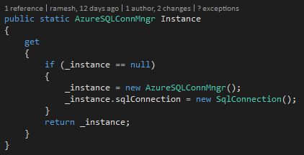

- Factory Design Pattern

Factory design pattern is primarily used to register multiple object into its collection and can be asked for instance from the collection whenever required.
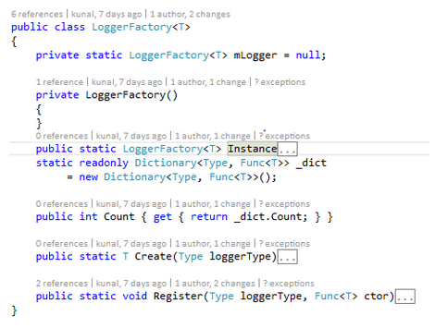

- Observer Design Pattern

We have implemented observer design pattern for subscribing the tweet to EventHub client and sending these tweet along with analyzed sentiment score to azure cloud.

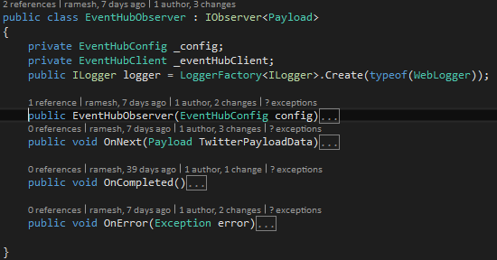

- Façade Design Pattern

“SentimentAnalytics” library act as a façade for referencing application and libraries. It is called façade because client application is unaware of implementation of SentimentAnalytics and just knows about methods to expose to it.

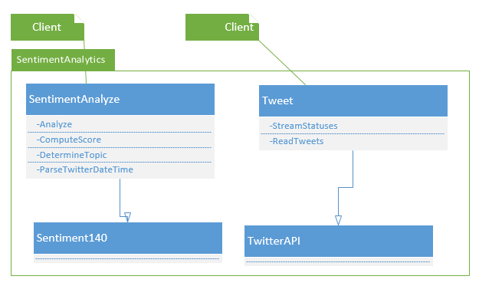

Conclusion and findings
While developing application we found that developing application with live data needs to have a scale environment as no of records being generate is sometime in huge number depending upon the peek and off-peak hours.
Apart from scale environment to handle the no. of request or events coming from client application, we also require scale database to store and manage data. It is essential to have robust database which provide CRUD operation with high efficiency and reliability.
During the analysis we also found the query execution would be significantly increase with the increase the data size, hence it depends on database and optimization techniques need to be implemented for web application to work efficiently with huge data size.
To analyze user behavior and interest against the product and services, sentiment analysis is only one of the aspects of analysis of user behavior. We should not only consider sentiment analytics to derive conclusion and result.

