MINI PROJECT REPORT
QueueLess Student Service &Smart Campus Helpdesk
Unit 1: Product Engineering & Design Thinking
prepared by Kunal Navanath Palaskar
This mini project applies the product engineering and design thinking approach described in the supplied DevOps Unit-1 guide to a college student-service problem. The guide uses a Library Management Platform as its example; this report adapts the same structure and engineering ideas to QueueLess Student Service and Smart Campus Helpdesk.
QueueLess is designed to reduce unnecessary physical waiting and make campus support more organized. Students can select a service, create a digital request, receive a ticket or queue position, and track progress. Staff can manage pending requests from a common dashboard, while administrators can review service activity.
Project Area | Purpose
Student Service | Digital service request and virtual queue
Smart Helpdesk | Issue reporting, assignment and status tracking
Engineering | Requirements, design, testing, CI/CD and deployment
Main Users | Students, staff and administrators

The report keeps the terminology and flow of the supplied guide while replacing library-specific business examples with campus service and helpdesk operations. The focus is on simple, useful software engineering rather than only writing application code.

1. Introduction to Software Product Development

1.1 Software Product Development
Software product development for QueueLess begins with understanding the campus service problem before writing the application. The team studies how students request services, how staff receive and process requests, and where waiting or repeated enquiries occur. This helps the team define a product that is useful in daily college work. The development process then connects requirements, design, architecture, coding, testing, deployment and monitoring so that the application can be improved as users provide feedback.
The supplied guide explains that modern software products are built using structured engineering frameworks rather than ad-hoc programming. Coding is one phase inside a larger lifecycle that includes research, architecture, user experience, quality assurance, automated deployment and continuous monitoring. QueueLess follows this product-centric approach because the project must solve a real student-service problem.

1.2 Programming vs. Software Engineering
In QueueLess, programming is necessary for building pages, forms, database operations and request-processing functions, but these activities are only one part of the product. Software engineering also considers how the parts work together, how users will interact with the system, how data will be protected, how changes will be tested and how the application will be maintained after deployment. This wider view helps the team avoid treating a working piece of code as the complete product.
Programming mainly focuses on translating logic and algorithms into executable code. Software product engineering has a wider scope. It considers the complete lifecycle, including requirements, architecture, database design, security, testing and operations. In QueueLess, a working queue function is not enough; the complete product must allow students and staff to perform their tasks reliably.
Dimension | Programming / Coding | Software Product Engineering
Goal | Write executable logic | Build a useful, maintainable product
Scope | Functions and scripts | Full lifecycle and system
Success | Code works | Users and operations achieve the intended outcome
Mindset | How to write the function? | What problem are we solving?

1.3 Common Causes of Project Failure
The project can face problems when the team misunderstands student requirements, selects technology without considering the campus situation, communicates poorly, or waits too long to collect user feedback. These risks can be reduced by discussing requirements with stakeholders, preparing simple prototypes and testing important workflows early. The same approach supports the reference guide's focus on business understanding and iterative development.
Projects may fail because requirements are misunderstood, technology is selected without considering the domain, teams work in communication silos, or users are involved too late. QueueLess reduces these risks through business analysis, design thinking, early prototypes and iterative testing.
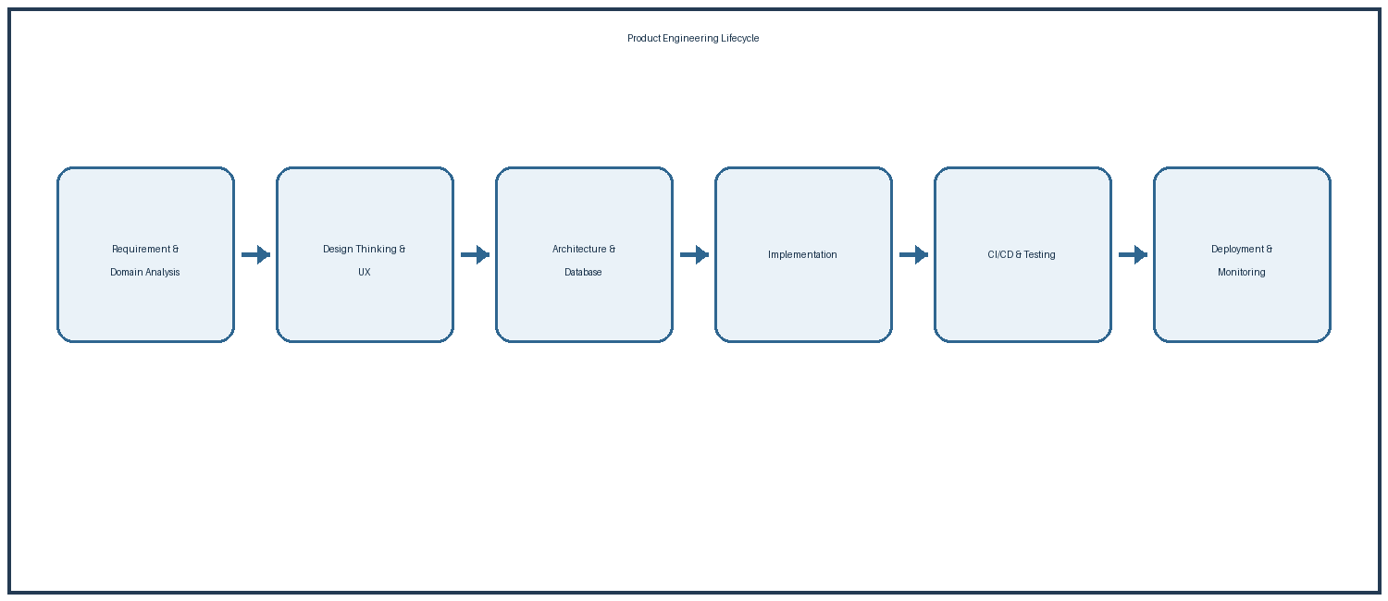

2. Business Understanding and Problem Analysis

2.1 Understanding Campus Services
Campus services can include certificate requests, identity-card support, fee-related queries, scholarship help, hostel matters, transport support, IT assistance and other student enquiries. Each service may have different information requirements and may be handled by a different staff member or department. Understanding these differences is important because QueueLess should guide the student to the correct service instead of creating another complicated process.
Before coding QueueLess, the team must understand how student services operate. College students may visit the office, examination section, scholarship desk, accounts section, library, laboratory support or other service counters. Requests may involve documents, approvals, corrections, certificates, information or technical support. When many students arrive together, staff must manage people, requests and records at the same time.

2.2 Manual Service Process
In a manual process, students may need to find the correct office, wait for their turn, explain the request and return again to ask about progress. Staff may use paper forms, registers or separate records to remember pending work. When the number of requests increases, finding a particular request and knowing its current status can take additional time. QueueLess is designed around this process so that the digital workflow reflects the actual service activity.
In a manual process, a student may travel to an office, identify the correct counter, stand in a physical line, explain the request and wait for staff attention. The student may not know how many people are ahead or whether the request has been accepted. Staff may use registers or separate records, making it harder to provide quick status updates.

2.3 QueueLess Digital Solution
QueueLess provides a common digital starting point for campus services. A student can select a service, enter the required information and submit a request. The system can create a ticket number and, where a queue is needed, assign a queue token. Staff can then see the request in a dashboard, process it and update its status. The student can use the ticket information to follow progress without repeatedly asking staff.
QueueLess changes this process into a structured digital workflow. A student selects a service, submits the required information and receives a digital ticket. The system maintains the request status and, where applicable, the virtual queue position. Staff see pending work in one dashboard and can call, process and complete requests in an orderly way.
Manual Challenge | QueueLess Approach | Expected Operational Benefit
Physical waiting line | Digital ticket / virtual queue | Better waiting visibility
Repeated status questions | Online request status | Less repeated enquiry
Paper or scattered records | Central request database | Better record tracking
Separate helpdesk notes | Structured helpdesk tickets | Clear ownership and history

2.4 Expected Business Outcome
The expected business outcome is a more organized service process rather than simply a new software interface. Students receive clearer information about their requests, staff receive a common work list, and administrators can obtain basic service information. The actual improvement should be measured during testing instead of assuming a fixed reduction in waiting time.
The business outcome is a more organized service process. The system should reduce uncertainty, improve record visibility and help staff process requests consistently. This follows the guide's principle that engineers should understand business operations before choosing technologies.

3. Design Thinking — Empathize and Define

3.1 Meaning of Design Thinking
Design Thinking is useful for QueueLess because the project involves different people with different needs. Students care about simple service access and status information, while staff care about accurate requests and manageable work. By understanding these needs before final development, the team can create a workflow that is easier to use and can be changed when testing reveals a problem.
Design Thinking is a human-centered and iterative problem-solving framework. The first step is empathy: understanding users before deciding what technology to build. For QueueLess, the team should observe students, service staff and administrators. The team can study where students wait, what information they ask for, which steps create delays and how staff currently record requests.

3.2 Empathize
During Empathize, the team can observe how students currently ask for services and how staff handle those requests. The team should pay attention to repeated questions, queue formation, missing information, unclear service ownership and delays in status communication. These observations provide a practical base for deciding what QueueLess should solve.
The student persona wants to complete a campus service without unnecessary waiting. The main frustrations can include unclear queues, repeated visits and lack of status information. The staff persona wants to process requests in the correct order, see important details and maintain accurate records. The administrator needs a wider view of service volume, pending work and completed requests.

3.3 Define the Problem
The Define stage converts observations into a clear problem statement. For QueueLess, the focus is on unnecessary waiting, uncertainty about request progress and the lack of a single view of pending work. A clear problem statement prevents the project from becoming only a collection of technical features and keeps the development connected to the campus service need.
The Define stage converts these observations into a focused problem statement: <b>Students experience unnecessary delays and uncertainty while accessing campus services because requests and physical queues are handled through disconnected manual processes, while staff lack a single real-time view of pending and completed service requests.</b>
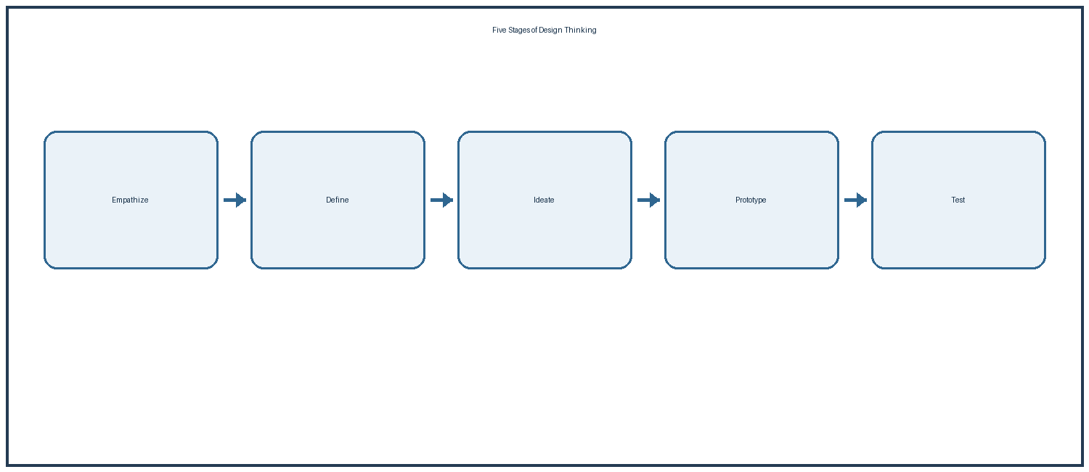

3.4 Problem Focus
Keeping the problem focused is important for a mini-project. The team does not need to automate every college activity in the first version. It should first demonstrate a clear service request, ticket, queue and status workflow. Additional features can be considered after the basic process has been tested with representative users.
This definition keeps the project focused on a user problem instead of starting with a technology choice. The same principle is used in the supplied guide's Design Thinking section.

4. Design Thinking — Ideate, Prototype and Test

4.1 Ideate
The Ideate stage allows the team to consider several possible solutions before selecting the MVP. Ideas for QueueLess include virtual queue tickets, service categories, live queue information, request tracking, staff assignment, status notifications and simple reports. The team can compare these ideas with actual user needs before deciding which features should be developed first.
After defining the problem, the Ideate stage explores possible solutions. QueueLess can consider virtual queue tickets, service selection, live queue position, estimated waiting information, status notifications, staff dashboards, service information and administrative reports. The goal is to explore useful possibilities before choosing the final implementation.

4.2 Prototype
A prototype gives students and staff something simple to review before the complete application is built. The QueueLess prototype can show the service selection screen, request form, ticket confirmation, status page and staff dashboard. The prototype does not need full backend functionality at this stage. Its purpose is to check whether the workflow and screen labels are understandable.
The Prototype stage turns these ideas into simple screens. A low-fidelity QueueLess prototype can contain a student service-selection page, request form, ticket confirmation and status screen. Staff can have a dashboard showing waiting, active and completed requests. Administrators can have a summary view for service workload and reports.

4.3 Test
Testing the prototype with representative users can reveal problems that may not be visible to the development team. A student can try to create and track a request, while a staff member can try to call the next request and change its status. The team can record where users become confused and use that feedback to improve the design.
Testing should involve the real types of people who will use the product. A student can be asked to create a ticket and check its status. A staff member can process the next request and update it. An administrator can check whether the dashboard provides useful information. The feedback can then be used to improve labels, navigation and workflow.
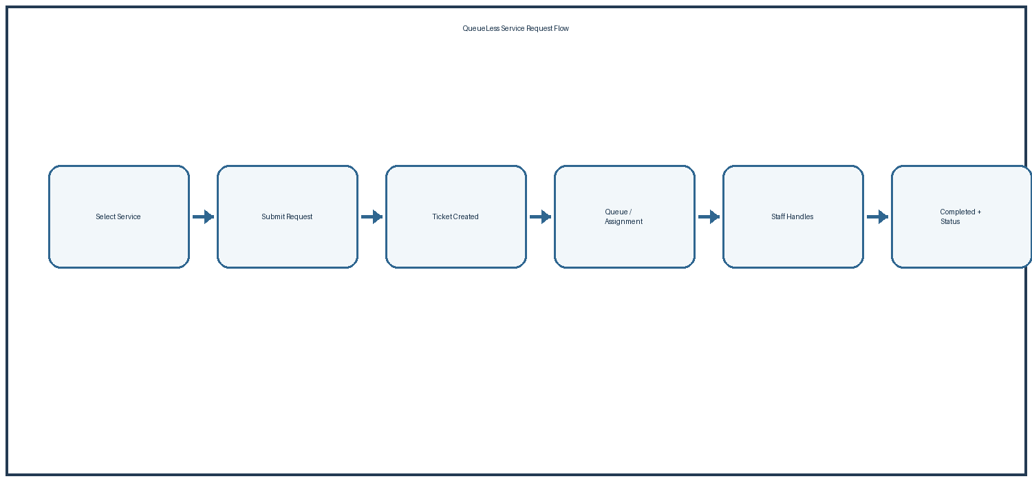

4.4 Iterative Improvement
The result of testing should return to the design process. If a form asks for unnecessary information, it can be simplified. If a status label is unclear, it can be changed. If staff need another piece of information to process a request, the workflow can be updated. This repeated improvement follows the iterative approach described in the guide.
The important point is iteration. The team should not wait until the complete application is finished before testing the user experience. Early prototypes are cheaper to change and help prevent large development effort being spent on an unsuitable workflow.

5. IBM Design Thinking and IBM Loop

5.1 IBM Design Thinking Principles
IBM Design Thinking adds a strong focus on user outcomes. For QueueLess, the outcome is not simply that a ticket record is created in a database. The useful outcome is that a student receives a clear reference for the request and can understand its progress. The project can also use diverse team roles so that development, interface design, testing and campus-service knowledge are considered together.
The supplied guide explains IBM Design Thinking through three ideas: focus on user outcomes, restless reinvention and diverse empowered teams. QueueLess can apply these ideas at mini-project scale. A technical feature should be connected to a measurable user outcome. For example, creating a database ticket is a technical action, while giving a student a clear service reference and status is the user outcome.

5.2 Restless Reinvention
Restless reinvention means that the first working release should not be treated as the final version. After QueueLess is used, the team can study feedback and service activity to find areas that need improvement. For example, repeated corrections by staff may show that a form needs clearer instructions, while repeated enquiries may show that status information needs to be easier to find.
Restless reinvention means the product should continue improving after the first working version. If students abandon requests, staff frequently correct ticket details or a particular service creates long waiting periods, the team should study the evidence and improve the workflow. This is especially useful for campus services where demand changes during admissions, examinations and scholarship periods.
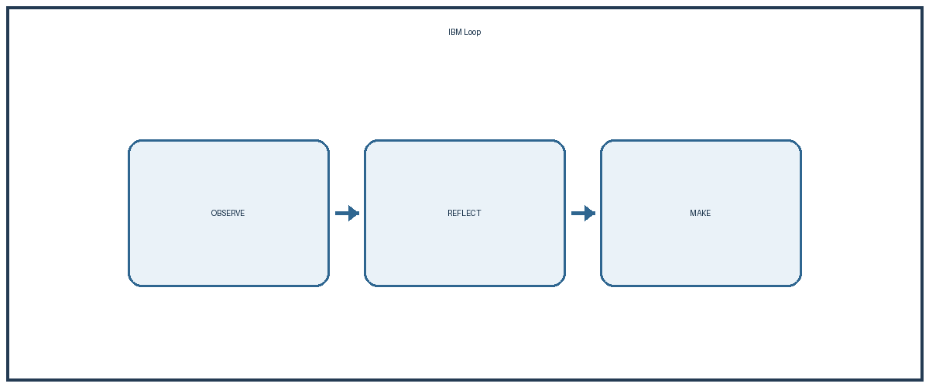

5.3 Observe, Reflect and Make
The IBM Loop connects observation with improvement. QueueLess can observe ticket activity, waiting time, request status changes and user feedback. During Reflect, the team reviews this information and identifies the most useful improvement. During Make, the team changes the interface, workflow, code or deployment process and then observes the result again.
The IBM Loop is Observe, Reflect and Make. QueueLess can observe user interactions, ticket activity, waiting time and staff actions. During Reflect, the team studies this information and identifies important improvements. During Make, the team changes the interface, workflow, code or deployment configuration. The result is a continuous improvement cycle linked with DevOps.

6. Stakeholders, User Personas and Responsibilities

6.1 Stakeholder Groups
The main business stakeholders for QueueLess are students, faculty members using supported services, service staff and college management. Engineering stakeholders include developers, UI or UX contributors and testers. Operations responsibilities may include database, hosting, deployment and monitoring work. Each group sees the system from a different point of view, so their requirements should be considered during planning and testing.
QueueLess affects several stakeholder groups. Business stakeholders include students, faculty members using supported services, service-counter staff and college management. Engineering stakeholders include developers, UI/UX contributors and testers. Operations responsibilities include database management, deployment, security and monitoring. This grouping follows the stakeholder approach used in the supplied guide.
Persona | Main Objective | Pain Point | QueueLess Feature
Student | Complete service quickly | Waiting and unclear status | Ticket, queue and status
Service Staff | Process requests accurately | Manual records and confusion | Staff queue dashboard
Administrator | Monitor service workload | No central real-time view | Reports and dashboard
Helpdesk Staff | Resolve campus issues | Scattered complaints | Categorized helpdesk tickets

6.2 User Personas
The student persona needs quick service access, a clear ticket and understandable status information. Service staff need an organized request list and simple controls for processing requests. Administrators need basic information about service demand and pending work. These personas help the team check whether each proposed feature has a clear user purpose.
The student needs a simple interface and should not need to understand the internal workflow. Staff need a dashboard that makes the next action clear and keeps the number of manual steps low. Administrators need summary information for monitoring. These different needs show why stakeholder analysis is important before finalizing system requirements.

6.3 Responsibilities
Clear responsibilities reduce confusion during both development and system use. Students create and track requests, service staff process requests assigned to their service area, and administrators manage services, users and reports. In the development team, members can also divide responsibilities for frontend, backend, database, testing and DevOps work while using a shared repository.
The platform should also define responsibility boundaries. Students create and track their requests. Service staff process requests assigned to their area. Administrators manage service configuration and reports. The engineering team maintains the software, while operations responsibilities cover deployment and system health.

7. Requirements Engineering Specification

7.1 Requirements Engineering
Requirements Engineering converts the campus problem into clear statements about what QueueLess should do and how it should behave. The requirements provide a common reference for design, development and testing. They also help the team decide whether a proposed feature belongs in the MVP or should remain a future enhancement.
Requirements Engineering converts the business problem into clear system behavior. The supplied guide separates Functional Requirements Specifications and Non-Functional Requirements Specifications. QueueLess follows the same structure so that the team can clearly distinguish what the system does from the qualities expected from it.
Requirement Type | QueueLess Requirement
Authentication | Secure access for Student, Staff and Admin roles
Service Management | Create and maintain campus service categories
Queue Management | Create ticket and maintain queue/request status
Helpdesk | Create, assign, update and close support tickets
Notifications | Show important request-status changes
Reporting | Provide basic service and ticket activity reports

7.2 Functional Requirements
Functional requirements describe the actions provided by the system. QueueLess should support user login and role-based access, service selection, request creation, ticket or token generation, request tracking and staff status updates. Administrative users should be able to manage users and services and view basic reports. Completed requests should have a clear final status so that the workflow can be followed.
Functional requirements describe actions such as creating a service request, generating a ticket, assigning a request, changing its status and completing it. The helpdesk should allow a requester to describe a problem and select a suitable category. Staff should be able to take ownership of the issue and record its progress. Administrators should be able to manage service information and view reports.

7.3 Non-Functional Requirements
Non-functional requirements describe the quality expected from the system. QueueLess should protect user information and restrict functions according to user role. Common pages should respond within a reasonable time, the service should be available during expected college use, and the code should be divided into clear modules so that future changes are easier. The interface should use simple labels and support normal desktop and mobile use.
Non-functional requirements cover security, performance, availability and maintainability. Passwords should be stored using secure hashing and sensitive communication should use HTTPS in deployment. Common operations should respond quickly under expected concurrent use. The codebase should be separated into modules so that individual parts can be tested and changed without unnecessarily affecting other functions.

8. Product Vision, MVP and Core Modules

8.1 Product Vision
The QueueLess product vision is to provide a simple digital campus helpdesk that reduces unnecessary physical waiting, organizes service requests and gives students clear information about progress. The vision connects the technical system with the actual service outcome. Every major feature should therefore be checked against the question of whether it makes the student or staff workflow clearer and easier.
The product vision for QueueLess is to provide a simple digital platform that reduces unnecessary physical waiting, organizes student service requests and gives campus staff a clear real-time view of service work. The platform should make routine services easier to access while maintaining a reliable record of requests and actions.

8.2 MVP Scope
The Minimum Viable Product contains the smallest useful set of features needed to demonstrate the QueueLess idea. It can include login, role-based access, service selection, request creation, ticket or queue-token generation, request tracking, staff dashboard functions and basic administrator controls. Keeping the MVP focused makes it easier to test the complete workflow before adding advanced features.
The Minimum Viable Product should contain the capabilities needed to prove this value. The first release can include role-based access, service selection, ticket creation, queue position or request number, request-status tracking and a basic staff dashboard. A helpdesk section can allow students to report issues and staff to update progress. An administrator view can provide basic counts and reports.
Core Module | Main Purpose
User & Role Management | Login, identity and access control
Student Service Queue | Service selection, ticket and queue tracking
Smart Campus Helpdesk | Issue reporting and support workflow
Staff Dashboard | Manage waiting and active requests
Notifications | Communicate meaningful status changes
Admin Reporting | View service activity and workload

8.3 Features for Future Release
Features such as advanced waiting-time prediction, complex integrations, mobile applications, chatbot support and advanced analytics can remain outside the first release. This does not mean that they are unimportant; they can be considered after the basic system has been tested and actual user needs are known. Separating MVP features from future features helps keep the mini-project manageable and avoids unnecessary complexity.
Advanced predictive waiting-time models, complex integrations or advanced artificial intelligence can remain outside the first release. This follows the supplied guide's MVP principle of delivering a useful core product first and deferring non-essential capabilities.

9. System Architecture and Module Design

9.1 System Architecture
The QueueLess architecture can be divided into presentation, application or business-logic, and data layers. The presentation layer provides student, staff and administrator screens. The application layer handles login, permissions, service requests, ticket generation and status changes. The data layer stores users, services, tickets, queue information and status history.
QueueLess can be organized into a presentation layer, application or business-logic layer and data layer. The presentation layer provides interfaces for students, staff and administrators. The business layer validates requests, manages queue rules, handles ticket status and enforces access control. The data layer stores users, services, tickets, helpdesk issues and status history.
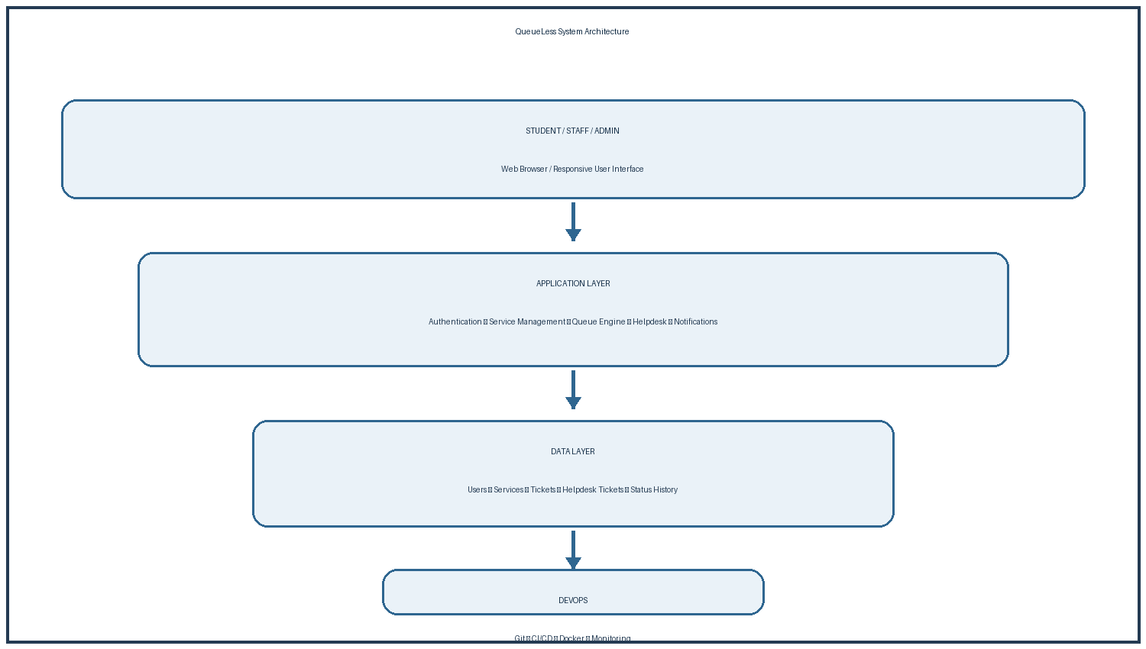

9.2 Request Processing Flow
When a student submits a request, the application first checks the user's access and validates the selected service and required information. It then creates the ticket and queue information where required and stores the record in the database. Staff can read the request from the dashboard and update its status. The student can then see the latest status through the tracking interface.
When a student submits a request, the browser sends it to the application server. The server checks permissions, validates the selected service and creates a database record. If a queue is used, the application calculates the appropriate position according to the service rules. The student then receives a ticket reference and current status.

9.3 DevOps Support
The architecture should support the development process as well as the application workflow. Source code can be maintained in Git, automated tests can run through CI, and Docker can provide a repeatable environment for the application. This separation of application responsibilities and development operations helps the team make changes in a controlled way.
The architecture also supports DevOps practices. Source code can be stored in Git, automated tests can run in CI, and the application can be packaged in a repeatable deployment format. The repository can contain application modules, database definitions, tests, documentation, Docker configuration, CI workflows and monitoring configuration, adapted from the structure shown in the supplied guide.

10. Database Design and Data Flow

10.1 Database Structure
The database is responsible for keeping the information required by the QueueLess workflow. Main records can include users, services, tickets, queue entries and status history. A ticket can be connected to the student who created it and the service selected by the student. Status history can preserve important changes so that staff actions can be understood later.
A reliable database is important because QueueLess must preserve student requests and service actions. A Users table can store identity and role information. A Services table can define available campus services. A Tickets table can store service requests and queue information. A HelpdeskTickets table can store support issues, while StatusHistory can preserve important status changes.
Entity | Important Data | Relationship
Users | User ID, name, role, contact | Creates tickets
Services | Service ID, name, description | Receives requests
Tickets | Ticket ID, status, created time | Belongs to user and service
HelpdeskTickets | Issue, category, status | Linked to requester/staff
StatusHistory | Old status, new status, time | Tracks ticket changes

10.2 Data Flow
The data flow begins when the user logs in and selects a service. After the request is submitted, the application validates the information, creates a ticket and generates a queue token when required. The record is stored and displayed to the user. Staff actions then update the ticket, while status history can keep a record of those changes.
The data flow starts when a user logs in and selects a service. The application validates the request and stores a ticket. Queue processing reads active requests and applies the service rules. When staff update the ticket, the application changes its current state and can record the change in StatusHistory. The requester then sees the latest state through the portal.

10.3 Data Safety and Integrity
Data safety requires validation of important fields, secure password handling and controlled access to administrative operations. Relationships between users, services and tickets should remain valid so that a request is not connected to the wrong record. The application should also avoid storing unnecessary personal information and should protect database credentials.
Database integrity is part of product engineering. Required information should be validated, relationships should be controlled and invalid states should be prevented where possible. Backup and recovery should also be considered for an actual deployment. These practices follow the guide's emphasis on database schema design, integrity and maintainability.

11. QueueLess Student Service and Smart Campus Helpdesk

11.1 Student Service Module
The Student Service module provides a common starting point for routine campus requests. Instead of requiring students to remember different procedures, the system can show available services and the information needed for each one. After submission, the student receives a ticket reference and can follow its progress through the platform.
The QueueLess Student Service module is intended for routine campus services where students normally wait at a counter. The student selects a service, reads its basic information and submits the required details. The system creates a digital ticket and maintains its current status. The student can use the ticket as a reference instead of repeatedly asking staff for an update.

11.2 Queue Management
Queue management organizes requests that require staff attention in an ordered way. A request can begin in Waiting, move to Active when staff start processing it, and become Completed after the service is finished. The exact queue rules can be decided by the college. If priority handling is used, the rules should be clear and consistently applied.
The queue workflow can use simple states such as Waiting, Active and Completed. A newly created request enters Waiting. When staff start processing it, the status becomes Active. After the service is completed, it becomes Completed. If information is missing, a suitable follow-up state can be used. This creates a clear digital record of the request.

11.3 Smart Campus Helpdesk
The Smart Campus Helpdesk extends QueueLess to support technical and campus problems such as computer issues, network problems, classroom equipment, portal problems and other support requests. The helpdesk can route a request to the related service team and show New, In Progress, Waiting and Completed states. This gives students one place to follow different types of campus support.
The Smart Campus Helpdesk extends the same model to technical and campus problems such as computer issues, network problems, classroom equipment issues, portal problems or other supported services. A requester submits an issue, it is categorized and assigned to the appropriate support staff. The helpdesk dashboard shows pending and active issues, while the requester can follow progress.

11.4 Common Workflow
Both student services and helpdesk requests can use the same basic principles: a clear ticket identity, status tracking, staff ownership and recorded completion. A common workflow reduces the need for separate systems for every department and makes the application easier to understand and maintain.
Both modules use the same principles: a clear ticket identity, status tracking, staff ownership and recorded completion. This makes the system easier to understand and creates a common foundation for future campus-service integrations.

12. DevOps Practices and Enterprise Engineering Roadmap

12.1 DevOps Roadmap
The QueueLess DevOps roadmap begins after the problem, requirements and system design have been understood. The team can use version control during development, automated tests during integration, Docker for consistent packaging and a suitable deployment process for the tested application. Monitoring and feedback then provide information for later improvements.
The supplied guide places DevOps automation after requirements, design and core development. QueueLess follows the same progression. The team first studies the domain, then prepares requirements and prototypes, then develops the application in manageable work items such as authentication, service management, queue handling, helpdesk and reporting.
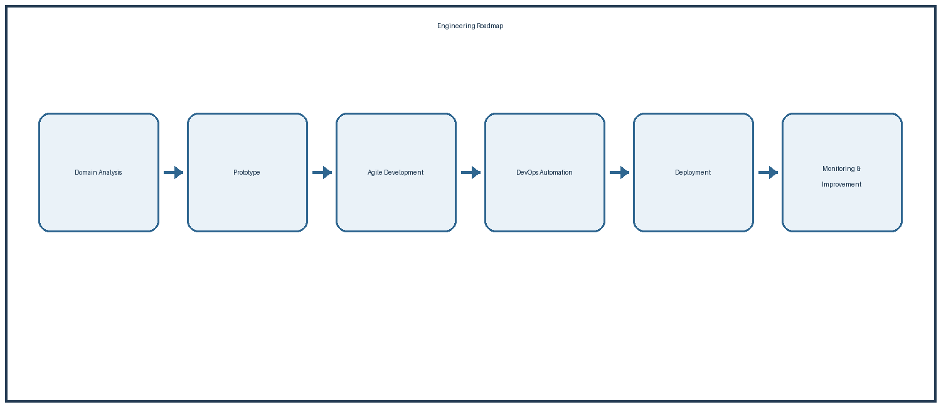

12.2 Version Control and CI
Git and a shared repository provide a history of project changes. Team members can work on feature branches and create pull requests before changes are merged. A CI workflow can install dependencies and run automated tests after code changes. This helps identify problems before new code becomes part of the stable version.
Git and a shared repository provide version control. Team members can work on branches and create commits for their changes. Before changes are merged, automated tests can verify important functions. A CI pipeline can install dependencies, run tests and check the application. This creates a repeatable quality gate instead of depending only on manual checking.

12.3 Containerization and Deployment
Docker can package the QueueLess application and its required environment so that development and deployment use a consistent setup. After tests pass, the application can be prepared for deployment to a suitable server. The deployment steps should be documented so that another team member can repeat the setup and perform a basic health check.
Containerization can provide a repeatable runtime environment. Docker configuration can define application dependencies and how the service is started. The engineering approach can later be extended with infrastructure automation tools such as Terraform or Ansible when the project requires it. For a mini-project, these tools can be presented as the next stage of the roadmap.

12.4 Monitoring and Feedback
Monitoring helps the team understand how the application behaves after deployment. Logs can show application errors and important activity, while simple metrics can provide information about request load, response time and system health. User feedback adds information about usability. These sources can guide the next improvement cycle.
Monitoring completes the improvement loop. Application logs can show errors and activity, while metrics can identify slow responses or unusual ticket load. The guide mentions Kubernetes, Prometheus and Grafana as enterprise-scale technologies. QueueLess can treat them as future production infrastructure while keeping the first implementation simple and testable.
12.5 Repository Structure
queue-less-campus-helpdesk/
├──.github/ # CI/CD workflows
├── app/ # Application source code
│ ├── modules/ # Users, services, queue, helpdesk
│ ├── database/ # Schema, migrations and models
│ └── tests/ # Unit and integration tests
├── docs/ # Requirements and architecture documents
├── docker/ # Docker configuration
├── kubernetes/ # Future deployment manifests
├── terraform/ # Future infrastructure provisioning
├── ansible/ # Future configuration automation
├── monitoring/ # Monitoring configuration
└── README.md # Setup and project instructions

13. Testing, Security, Benefits, Future Scope and Conclusion

13.1 Testing
Testing is required to confirm that QueueLess works as intended. Functional testing should verify login, role access, service selection, ticket creation, queue position, status changes and helpdesk operations. Integration testing should check communication between the application and database. Usability testing should involve students and staff so that confusing screens and unnecessary steps can be identified.

13.2 Security
Security is important because the system handles student information and service records. Access should be controlled by role, passwords should not be stored as plain text and sensitive traffic should use HTTPS in deployment. Inputs should be validated, and administrative functions should be restricted so that students cannot change service configuration or view other users' private information.
Area | Expected Result
Student Experience | Less uncertainty and clearer request status
Staff Operations | Central view of pending and active work
Administration | Basic service workload and activity visibility
Records | Structured and searchable request history
Engineering | Practical use of DevOps and product engineering

13.3 Future Scope
Future scope can include SMS or email notifications, QR-based ticket verification, improved waiting-time estimation, service-specific dashboards, analytics and integration with existing college systems. These features should be introduced based on actual user needs and feedback rather than simply adding technology.

13.4 Conclusion
In conclusion, QueueLess Student Service & Smart Campus Helpdesk applies the product engineering framework from the supplied DevOps Unit-1 guide to a campus-service domain. It begins with business understanding and user problems, moves through Design Thinking and requirements, defines an MVP and architecture, and connects development with testing, CI/CD, deployment and continuous improvement. The project therefore provides a practical mini-project model for reducing waiting, improving request visibility and making campus support more systematic.

13.5 Reference
Primary Reference: DevOps Unit-1 Mini Project Guide Document — Training & Technical Project Document, “Library Management Platform (Unit 1: Product Engineering & Design Thinking)”.

15. Testing, Security and Quality Plan

15.1 Testing Approach
Testing is an important part of the QueueLess development process because the system must work correctly for students, service staff and administrators. Testing should check the complete request flow instead of checking only whether individual pages open. The main flow starts with login, continues with service selection and ticket creation, and ends with staff processing and ticket completion. The purpose is to find errors early and make sure that the system follows the requirements defined for the project.

15.2 Functional and Integration Testing
Functional testing can be used to check important features such as student login, staff login, service selection, request creation, ticket generation, queue position, status updates and request completion. Integration testing can check whether the application correctly communicates with the database. User testing can involve a small group of students and staff who perform normal tasks and provide feedback about confusing screens, missing information or unnecessary steps.
Test Area | Example Check | Expected Result
Login | Valid student login | Student dashboard opens
Request | Create a service request | Unique ticket is generated
Queue | Join the service queue | Correct queue position is shown
Status | Staff changes request status | New status is visible to student
Access | Student opens admin page | Access is denied
Completion | Staff completes a ticket | Ticket leaves active queue

15.3 Security Practices
Security is also part of quality. Passwords should be stored using secure hashing instead of plain text. User roles should control access to student, staff and administrator functions. Input should be validated on the server, database credentials should not be exposed in public source code, and HTTPS should be used when the application is deployed. These practices help protect student information and service records.

15. Testing, Security and Quality Plan — Continued

15.4 Usability and Data Accuracy
The QueueLess quality plan should also consider usability and data accuracy. A student should be able to understand what service to select, what information to enter and where to find the ticket status without unnecessary help. Staff should be able to identify the next request, view important details and update the request without repeating the same information in different places. Administrators should receive clear basic information about service activity.

15.5 Sample Test Cases
Sample testing should include both normal and incorrect situations. The system should reject an incorrect password, prevent incomplete requests when required information is missing, keep ticket numbers linked to the correct user and service, and prevent unauthorized users from changing administrative data. When a ticket is completed, it should no longer appear as an active waiting request. These checks connect the testing process with the real workflow of QueueLess.
Test Case | Action | Expected Output
TC01 | Enter correct login details | User is logged in
TC02 | Enter incorrect password | Error message is shown
TC03 | Submit complete request | Ticket number is created
TC04 | View ticket status | Current status is displayed
TC05 | Staff updates ticket | Student sees updated status
TC06 | Complete request | Ticket becomes completed
TC07 | Open protected admin function | Unauthorized access is blocked

15.6 Continuous Testing
Testing should be repeated after important changes. This supports the DevOps approach because a new feature should not break an existing feature. Automated tests can be connected to the CI pipeline so that common checks are performed whenever code is pushed. User feedback can then be used to improve the interface and workflow in the next development cycle.

16. Project Roadmap and Sprint Plan

16.1 Development Phases
The QueueLess roadmap follows the engineering sequence described in the supplied DevOps guide. The project starts by understanding the campus service domain and then moves through Design Thinking, system design, development, DevOps, deployment and monitoring. This sequence helps the team complete the important planning work before depending heavily on implementation. It also gives the team a clear order for developing the mini-project.
Phase | Main Work | Output
Phase 1 – Domain Analysis | Study services, users and current problems | Problem and business understanding
Phase 2 – Design Thinking | Prepare personas, problem statement and ideas | User-focused design
Phase 3 – System Design | Plan architecture, database and modules | System design
Phase 4 – Development | Build frontend, backend and core features | Working QueueLess application
Phase 5 – DevOps | Git, testing, CI and Docker | Repeatable development process
Phase 6 – Deployment | Deploy tested application and document setup | Deployed application
Phase 7 – Monitoring | Check logs, performance and feedback | Improvement plan

16.2 Sprint Plan
A sprint-based plan can divide the work into smaller deliverable parts. Sprint 1 can focus on login and the basic interface. Sprint 2 can implement service requests and ticket generation. Sprint 3 can develop queue management and the staff dashboard. Sprint 4 can add the administrator dashboard and reports. Sprint 5 can focus on testing, CI and Docker packaging. Sprint 6 can complete deployment, monitoring and documentation.

16. Project Roadmap and Sprint Plan — Continued

16.3 Sprint Review and Flexibility
The sprint plan should remain flexible because user feedback may show that some workflows need changes. The team should keep the first version focused on the main QueueLess problem rather than adding too many features at once. Each sprint should have a clear goal, tested output and short review. This makes it easier to identify unfinished work and prevents large changes from being left until the final stage.
Sprint | Focus | Main Deliverables
Sprint 1 | Login and UI | Login, roles and basic screens
Sprint 2 | Requests and Tickets | Service selection and ticket creation
Sprint 3 | Queue and Helpdesk | Queue control and staff dashboard
Sprint 4 | Admin and Reports | Admin controls and basic reports
Sprint 5 | Testing and DevOps | Tests, CI workflow and Docker
Sprint 6 | Deployment | Deployment, monitoring and documentation

16.4 Enterprise Expansion
The roadmap also provides a base for future enterprise engineering. The supplied guide mentions infrastructure automation through Terraform and Ansible and production monitoring through technologies such as Kubernetes, Prometheus and Grafana. For QueueLess, these technologies can be treated as later stages after the core application is stable. The mini-project should clearly distinguish between features implemented in the current version and technologies planned for future expansion.

17. Expected Benefits, Risks and Future Scope

17.1 Expected Benefits
QueueLess is expected to provide a clearer starting point for students who need campus services. Instead of depending only on physical queues or separate informal records, students can use one platform to select a service, create a request and check its progress. Staff can receive an organized list of requests and update their status. Administrators can view basic service information and use it to understand the type and volume of requests handled by the helpdesk.
Area | Expected Benefit
Students | Clear service request process and ticket tracking
Service Staff | Organized list of pending and active requests
Administrators | Basic information about service activity
Records | Easier searching and maintenance than scattered paper records
Service Process | Better visibility of request status
Future Development | Foundation for notifications, analytics and mobile access

17.2 Project Risks
The project also has possible risks. Some users may continue to prefer the existing manual process, requirements may change, network access may not always be available, and staff may require basic training. These risks can be handled by keeping the first version simple, testing with users early, providing clear instructions, validating data, maintaining backups and keeping a support process for common problems.

17.3 Future Scope
The future scope can include SMS or email notifications, QR-based ticket verification, improved waiting-time estimation, service-specific dashboards, document upload, multilingual support, mobile application support, common-question chatbot assistance and advanced analytics. These additions should be considered after the core request and queue workflow is stable and after actual user feedback identifies useful needs.

18. Conclusion, Deliverables and Reference

18.1 Conclusion
QueueLess Student Service and Smart Campus Helpdesk applies the product engineering and Design Thinking approach from the supplied DevOps Unit-1 guide to a college student-service problem. The project begins with business understanding and user needs, then moves through Design Thinking, requirements, MVP planning, system architecture, database design, development, testing and DevOps practices. The main purpose is to make campus service requests easier to start, easier to track and easier for staff to manage.

18.2 Final Deliverables
The project deliverables include the business problem statement, product vision, MVP scope, stakeholder matrix, user personas, functional and non-functional requirements, Design Thinking activities, system architecture, database design, QueueLess workflow, DevOps plan, testing plan, project roadmap, expected benefits, risks, future scope and final documentation. These deliverables connect the different stages of software product development instead of treating the project as only a coding exercise.
Deliverable | QueueLess Version
Business Problem | Student service queues and fragmented helpdesk requests
Product Vision | Organized digital campus service platform
User Personas | Students, service staff and administrators
Requirements | Queue, service, helpdesk and quality requirements
Design Thinking | Empathize, Define, Ideate, Prototype and Test
Engineering Roadmap | Development through DevOps and monitoring

18.3 Reference
The original reference document is the DevOps Unit-1 Mini Project Guide Document, titled “Library Management Platform (Unit 1: Product Engineering & Design Thinking)”. The QueueLess report keeps the reference document's product-engineering structure, terminology and level of detail while applying the same ideas to student services and smart campus helpdesk operations.

18. Conclusion, Deliverables and Reference — Final Summary

18.4 Final Summary
QueueLess connects students, service staff and administrators through a common digital workflow. A student can identify a service, submit a request and receive a ticket or queue position. Staff can view the request, process it and update its status. Administrators can review basic service activity. The system therefore brings the main request and helpdesk activities into one organized process.

17.2 Project Risks
The project also demonstrates how DevOps ideas can support software product development. Git provides version control, CI supports automatic testing, Docker provides a repeatable application environment, deployment makes the tested application available, and monitoring provides information for future improvement. Together, these practices connect development with reliable operation.

18.6 Final Project Scope
For the mini-project stage, the focus should remain on a clear and working core workflow. Advanced features such as large-scale infrastructure automation, advanced analytics and additional notification systems can be added later when the basic system has been tested and user needs are better understood. This keeps the project simple enough to demonstrate while still providing a clear path for future development.

18.7 Closing Note
This final section completes the report by connecting the problem, users, design, requirements, architecture, implementation plan, testing, DevOps practices and future scope. It follows the same overall engineering approach described in the supplied reference guide and applies that approach to QueueLess Student Service and Smart Campus Helpdesk.

