Day 6 – 31/05/2025

Q1. List some RegEx  
Ans. ^ - starts with  
 $ - ends with  
 * - zero or more occurrences  
 + - at least one occurrence  
 ? – one or none occurrence  
 | - either or  
 \ - escape special characters  
 [] – set of characters  
 {} – exactly specified no. of occurrences  
  
Q2. If you are aware of Linux OS, can you tell me the features of Linux?  
Ans. Key Features of Linux OS –

1. Open source
2. Customizable
3. Secure
4. Flexible
5. Community Driven

Q3. What is Kernel?  
Ans. The Kernel is the core component of an OS. It manages the system’s hardware resources and provides service to applications.

Q4. BASH in Linux. Full form and explanation.  
Ans. Bourne-Again SHell(BASH) – Unix shell and command line interpreter that allows users to interact with the OS. BASH scripting is used to automate repetitive tasks.

Q5. What do you think is the difference between Linux and Windows?  
Ans. Key differences between Linux and Windows –

1. Source – Linux is open source and Windows is closed source
2. Licensing – Linux is free to use and distribute. Windows requires license purchase.
3. Security – Linux is considered due to its opensource nature. Windows does provide good security feature but still faces more security threats due to its popularity.
4. Customization – Linux offers high customization options allowing users to modify the kernel, desktop environment and software. Windows has limited customization options with a more standardized interface.
5. User Interface (UI) – Linux offers various desktop environments like GNOME, KDE and XFCE. Windows has a standardized interface, with a focus on user-friendliness.

Q6. What are the basic components of Linux? Describe each in detail with diagrams.  
Ans. Linux system has primarily three components –

1. Kernel – kernel is the core part of the Linux. It is responsible for all major activities of the OS. It has various modules and interacts directly with the hardware. It hides low level hardware details to system and apps.
2. System library – system libraries are special functions or programs using which application programs access kernels features. These libraries implement most of the functionalities of OS and do not require kernel modules code access rights.
3. System utility – system utility programs are responsible to do specialized, individual level tasks.

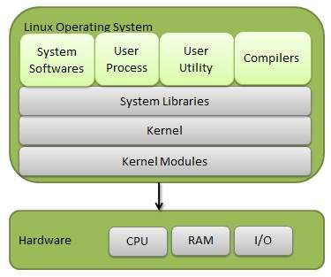

Q7. Is it legal to edit Kernel? When do you think we have to in case?  
Ans. Yes.

Q8. What is LILO?  
Ans. Linux Loader is a boot loader in Linux that allows users to select which OS or kernel to boot.

Q9. What is shell? How many shells are there and what are they?  
Ans. Shell is a command line interface used to interact with OS. There are many shells available, some of them are –

1. BASH – widely used shell in Linux, known for its customization options.
2. Zsh – powerful shell with advanced features like auto-completion, globbing and plugin support.
3. Fish – user friendly shell with features like auto-suggestions, syntax highlighting.
4. Ksh – unix shell developed by David Kon, known for its compatibility with BASH.
5. Tcsh – version of the C shell with the features like auto completion and command line editing.
6. Sh – unix shell developed by Stephen Bourne, known for its simplicity and compatibility.

Q10. What is swap space?  
Ans. Swap space is a portion of hard disk that is used as an extension to the system RAM.

Q11. What is mount? How do you mount and unmount file system in Linux?  
Ans. Mounting a file system in Linux makes a storage device accessible to OS. To mount a file system in Linux, mount command can be used. To unmount umount command can be used.

Q12. What is chmod command? how to use it?  
Ans. chmod is used change the permissions of file or folder in Linux.   
 chmod [permission] file_name

Q13. Can you add a new user account? Crate a new user in different ways.  
Ans. Yes. sudo adduser user_name.

Q14. Can you change the password of a user? How do you do that?  
Ans. Yes, by using the command passwd.

Q15. What is diff between Process and Thread?  
Ans. A process is an independent unit with its own memory space, while a thread is a light weight unit that shares memory with other threads in the same process. Processes are isolated and resource intensive, whereas threads are concurrent and share resources.

Q16. Explore grep commands.  
Ans.

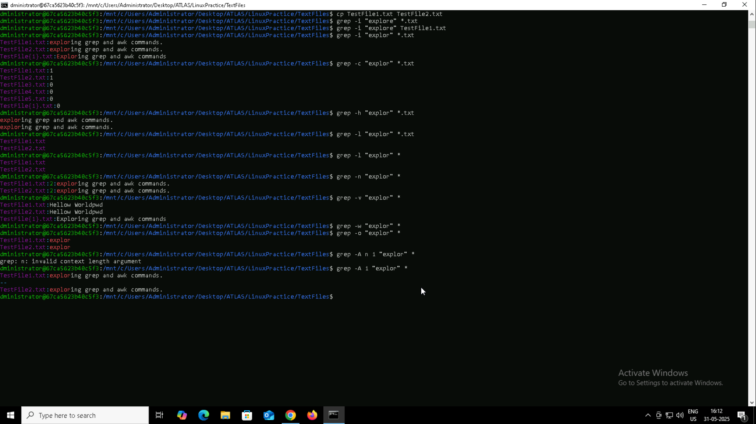

Q17. Explore awk commands.  
Ans. 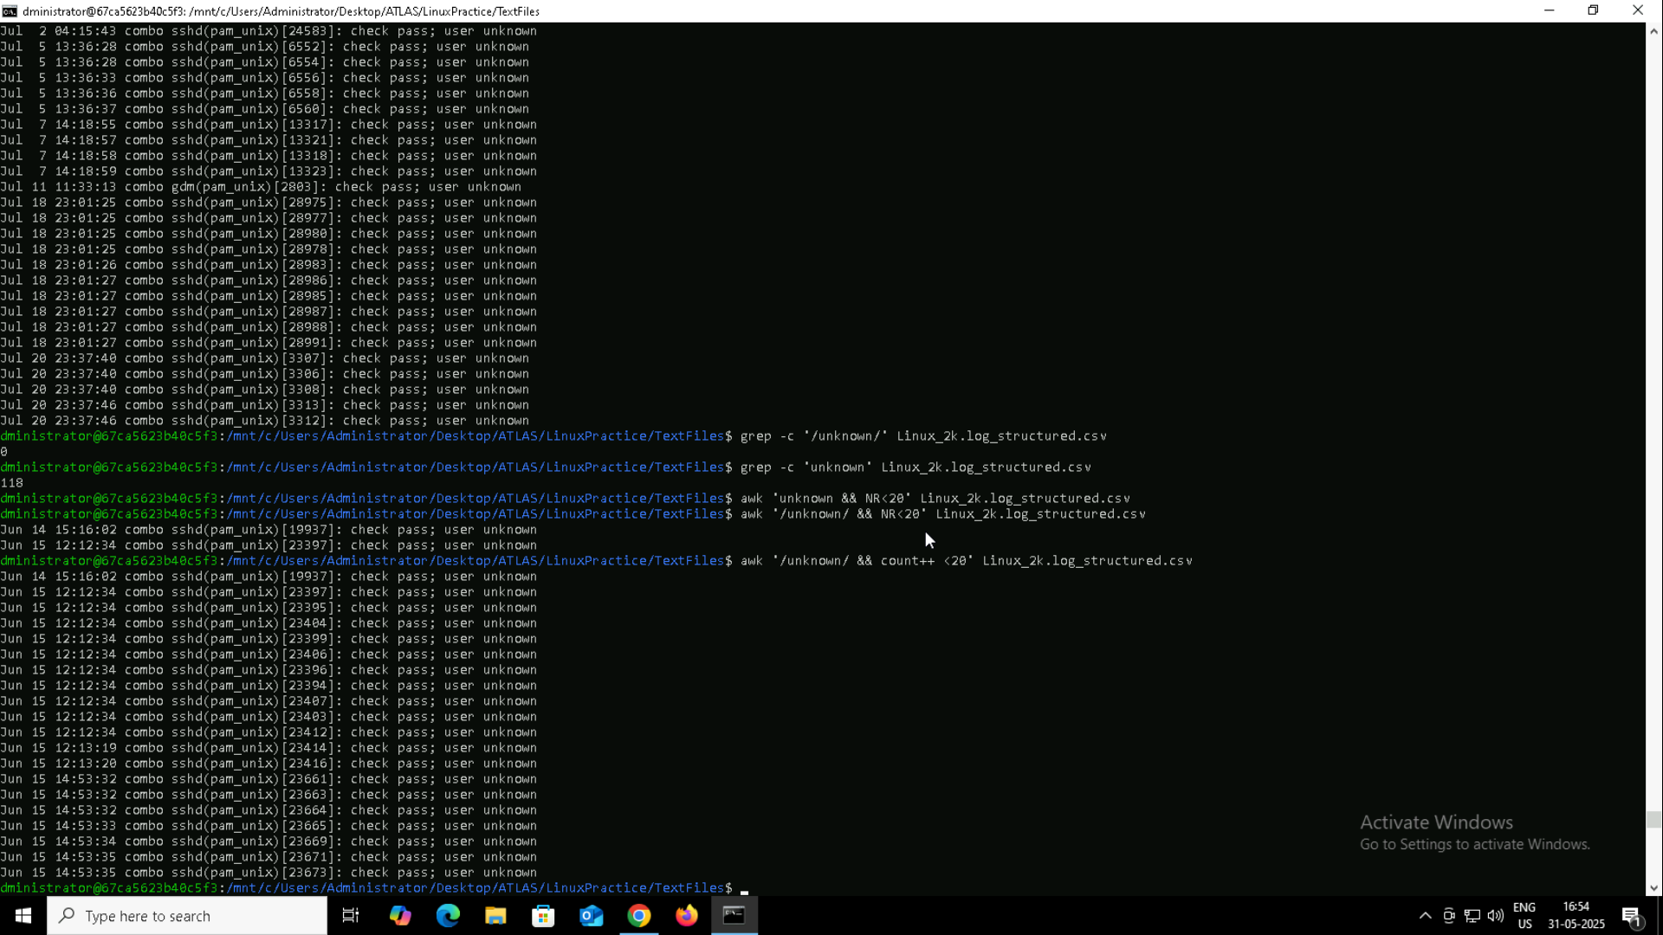



Q18. How to check file access permission in Linux?  
Ans. ls – l

Q19. What are the default permissions for a new file?  
Ans. rwxrwxrwx.

Q20. What is the command to change the permission to read only for the owner, group and other users?  
Ans. chmod 444 file_name.

Q21. Can you change the file permissions to match the following?  
owner: Read and Write  
group: Read  
other: no permissions (None)  
Ans. chmod u=rw,g=r,o= check.txt

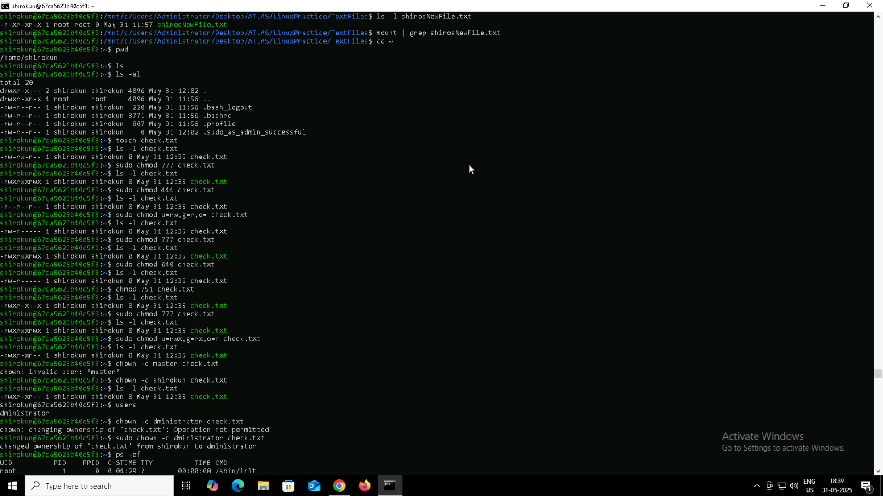

Q22. What was the command for changing the file permissions to -rw-r-----?  
Ans. chmod 640 check.txt

Q23. Change chmod. exercises permissions to -rwxr-x—x  
Ans. chmod u=rwx,g=rx,o=r check.txt

Q24. What was the command for changing the file permissions to -rwxr-x—x?  
Ans. chmod 751 check.txt

Q25. what will this command chown -c master file1.txt do?  
Ans. Changes ownership to master user if exists.

Q26. Can you define what is a process.  
Ans. Process is an instance of a program running in memory. Each process has its own memory space, system resources and security attributes. Process runs independently of each other and each process has its own program counter, stack and memory.

Q27. What is command to check foreground process and background process?  
Ans. ps -ef

Q28. Can you list all the running processes?  
Ans. Yes, using ps command.

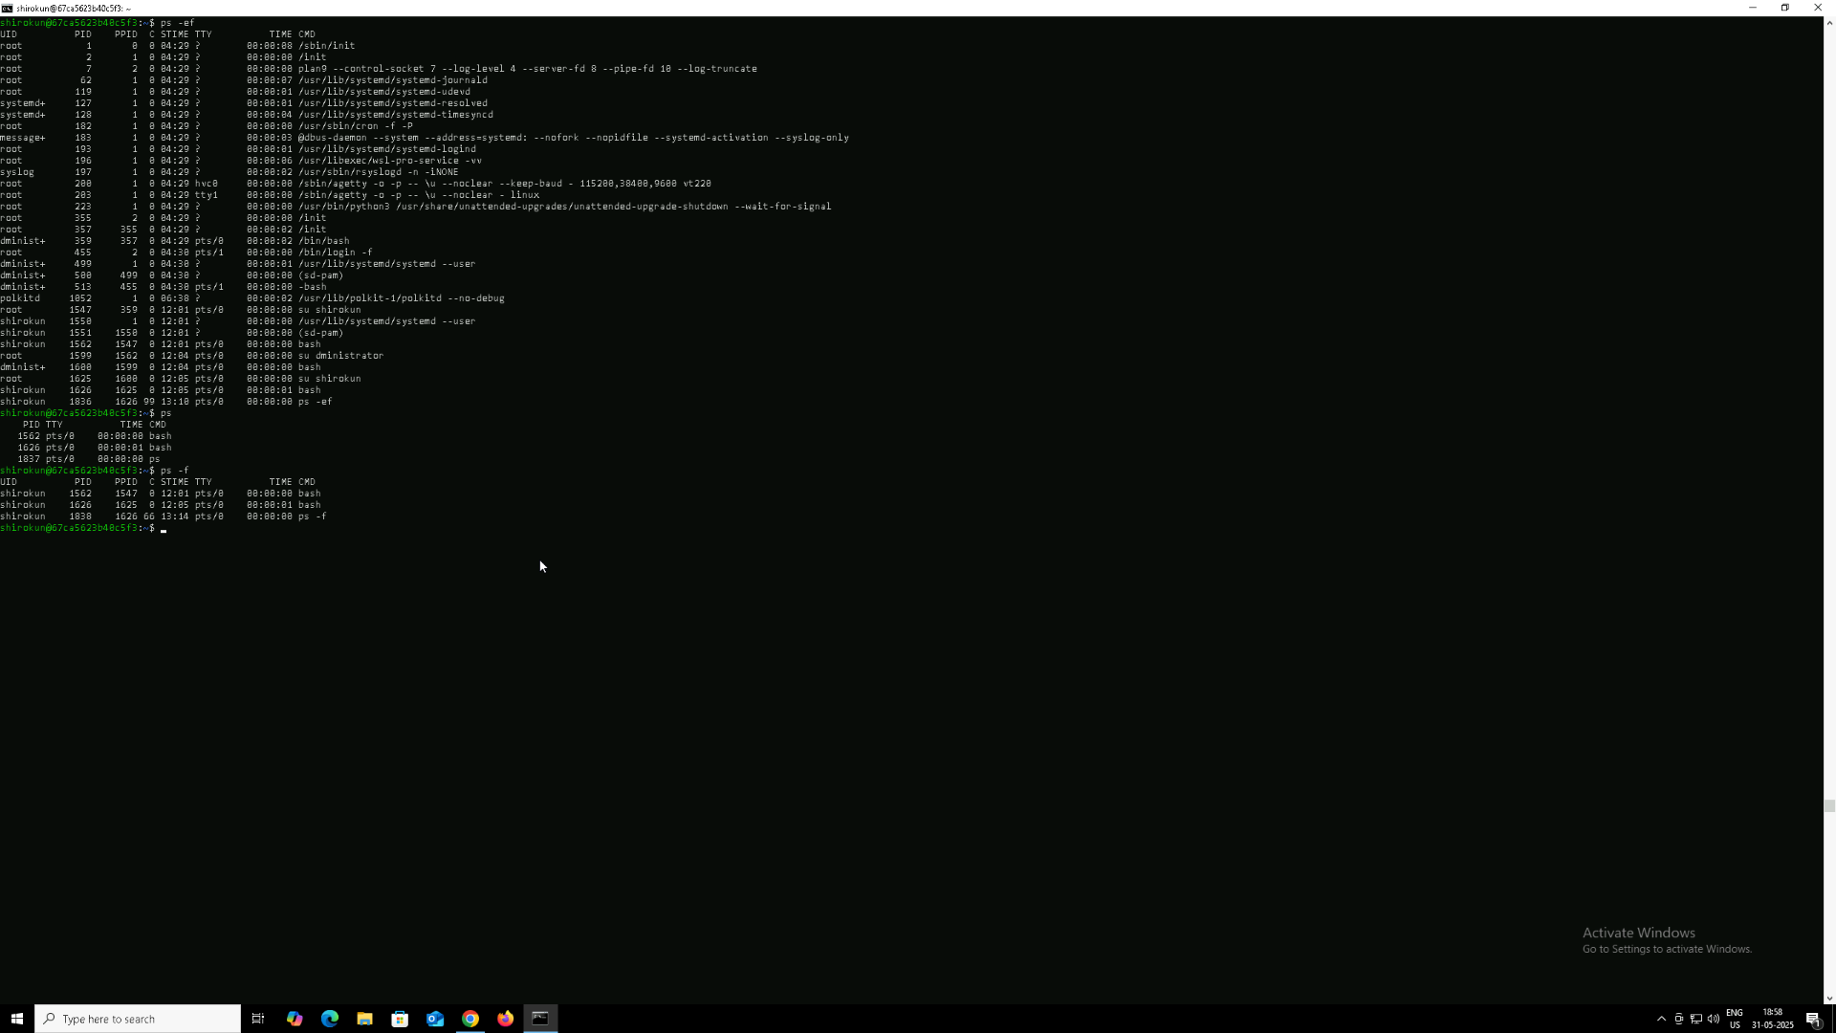

Q29. What will ps -f command do?  
Ans. ps -f command provides full format listing of process.

Q30. Can you create a variable name with your name in it  
Ans. Yes,   
 name=”Kunal”  
 echo “$name”

Q31. Can you make the above name variable read only.  
Ans. Yes,   
readonly name

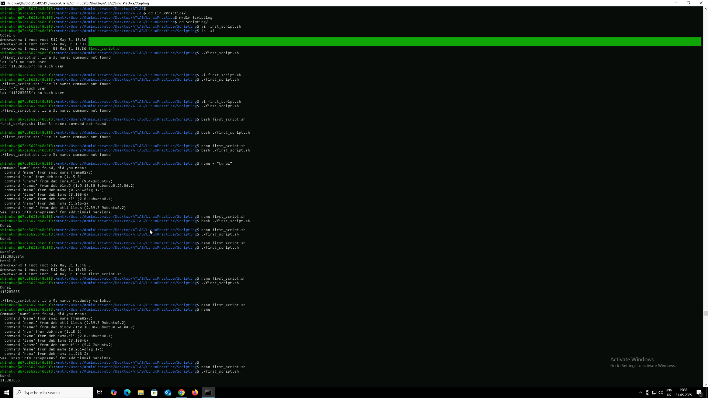

Q32. Now will unset or delete the variables.  
Ans.   
 declare +r name  
 unset name

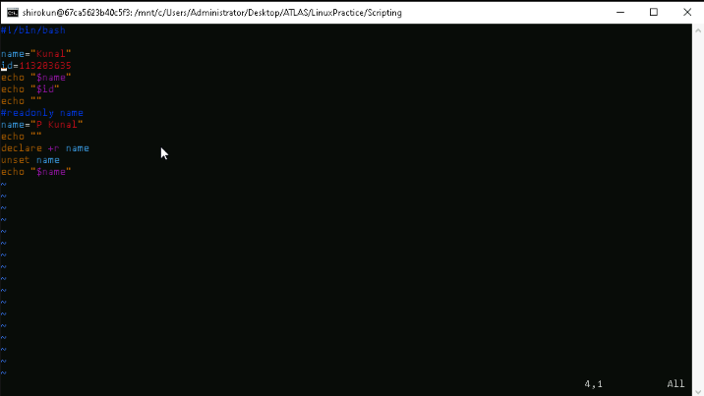

Q33. Can u try to add a list of your friends’ names in an array and try to printout?  
Ans. Yes,  
 friends[0]=”Javed”  
 friends[1]=”Goboy”  
 friends[2]=”Shubham”  
 friends[3]=”Nirupama”  
 friends[4]=”Sumana”  
 echo “First index: ${friends[0]}”  
 echo “Fourth index: ${friends[3]}”

Q34. Can you print all the list at once in an array.  
Ans. Yes,  
 echo ${friends[*]}  
 echo ${friends[@]}

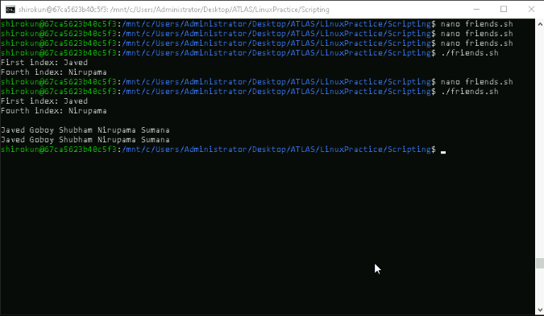

Q35. whats the output of the below snippet:  
a=0  
while [ "$a" -lt 10 ] # this is loop1  
do  
 b="$a"  
 while [ "$b" -ge 0 ] # this is loop2  
 do  
 echo -n "$b "  
 b=`expr $b - 1`  
 done  
 echo  
 a=`expr $a + 1`  
Done  
Ans.

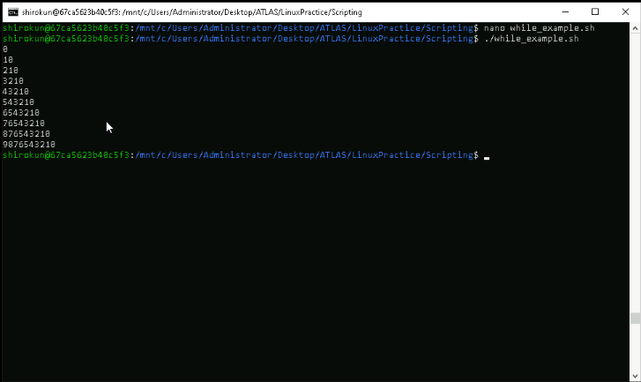

Additional task – check out short links.

