Game Design Document
Fill up the following document

- Write the title of your project.
Rush Breakout

- What is the goal of the game?
To destroy all the bricks by repetitivly bouncing a ball off the paddle into them

- Write a brief story of your game.
Your goal is to breack all the bricks before the entire stack of bricks crosses the bottom edge,every brick row is a different color and the highest score you can achive is 150 each brick shall give you 5 points each and will be broken and disappear

- Which are the playing characters of this game?
- Playing characters are the ones who respond to the user based on the input from the user.
- Cars, monkeys, dinos, wizards, etc., are the playing characters in the game.

Number | Character Name | What can this character do?
1 | PADDLE(controled by the user) | Bounce the ball and move left and right with the mouse
2 | BALL(indirectly controled by the user) | Breakes the bricks and gets you 5 points each
3
4
5
6
7
8

- Which are the Non-Playing Characters of this game?
- Non-Playing characters are the ones that don't have an action or behavior when the user interacts with the game.
- Hurdles, stones, bananas, coins, etc., are non-playing characters in the game.

Number | Character Name | What can this character do?
1 | BRICKS(30 in total with six bricks in each row) | Gradually the stack keeps moving down and can be broken by the ball to give you points
2
3
4
5
6
7
8

Draw your imagination of this game. What does this game look like?
- Draw the game either on your computer or on paper.
- Add images of the game scenes to show each of the playing and non-playing characters at least once.
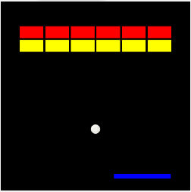

How do you plan to make your game engaging?
By adding scores,sounds,AI effect to the brickstack so that it gradually moves down,concept of infinite lives

