WEEK 2 EXECUTION DELIVERABLE: DESIGN & PROTOTYPING
Designing a Responsive Web Prototype for Digital Services
Comprehensive Design Rationale, High-Fidelity Wireframes, Accessibility Compliance Matrix (WCAG 2.1 AAA), and Front-End Architecture Specification
_________________________________________________________________________________
Project Portal Name: | GovDirect Unified Public Digital Services Portal
Design Methodology: | Mobile-First Fluid Grid & Universal Accessibility (WCAG 2.1 AAA)
Target Users: | General Citizens, Commercial Enterprises, Senior Citizens, Screen Reader Users
Document Status: | Final Executable Prototype Design Documentation

Executive Summary
This document details the complete design, architectural choices, responsive grid mechanics, and accessibility framework for the GovDirect Digital Services Portal prototype. Modern e-governance demands digital service portals that are not only visually stunning and responsive across all device form factors (Desktop, Tablet, Mobile), but also fully inclusive and accessible for citizens with differing physical, visual, and cognitive abilities.
💡 EXECUTIVE OBJECTIVE
The primary goal of the GovDirect portal is to eliminate administrative friction in public service delivery. By combining an intuitive search catalog, real-time application tracking, multi-step validation forms, and built-in accessibility toolbars (font scaling, high-contrast dark mode, text-to-speech preview), the prototype fulfills government digital service standards while achieving WCAG 2.1 AAA compliance.

1. Conceptualization & Portal Architecture
The conceptualization phase identified core digital components necessary to deliver a seamless online civic portal. A structured component breakdown ensures high modularity, ease of maintenance, and universal user familiarity.

1.1 Essential Portal UI Components
UI Component | Functionality & User Role | Accessibility & ARIA Implementation
Accessibility Toolbar | Provides top-level controls for dynamic font scaling (80%-140%), dark contrast toggle, motion reduction, and text-to-speech audio simulation. | role='region', aria-label='Accessibility Controls'. Live updates announce mode changes.
Header Navigation Bar | Provides persistent brand emblem, sticky menu items, quick reference ID search button, and responsive mobile hamburger trigger. | role='banner', aria-expanded='false' for hamburger menu toggle.
Dynamic Search & Filter Hero | Allows instant service search with keyword pattern matching and quick-filter chips for popular services (License, Business, Grants). | role='search', aria-label='Search Government Services' with real-time DOM filtering.
Filterable Services Catalog | Grid layout displaying digital service cards with processing SLA, fee details, accessibility badges, and application modal triggers. | role='tablist' for category filter tabs; aria-selected='true' on active category.
Multi-Step Application Modal | Step-by-step application drawer (Applicant Info → Document Upload → Review & Digital Signature) with real-time field validation. | role='dialog', aria-modal='true', aria-labelledby='modal-title', focus trapping.
Real-Time Application Tracker | Interactive widget allowing citizens to input reference codes (e.g. GOV-2026-8942) and view visual progress timeline. | role='status', aria-live='polite' updating screen reader users on step progression.

2. High-Fidelity Wireframes, Layouts & User Flow Analysis
Wireframing establishes the spatial visual hierarchy, grid geometry, and interaction flows before code implementation. The following high-fidelity diagrams demonstrate layout adaptation from desktop monitors down to mobile viewports.

2.1 Desktop Layout Wireframe (1200px Grid)
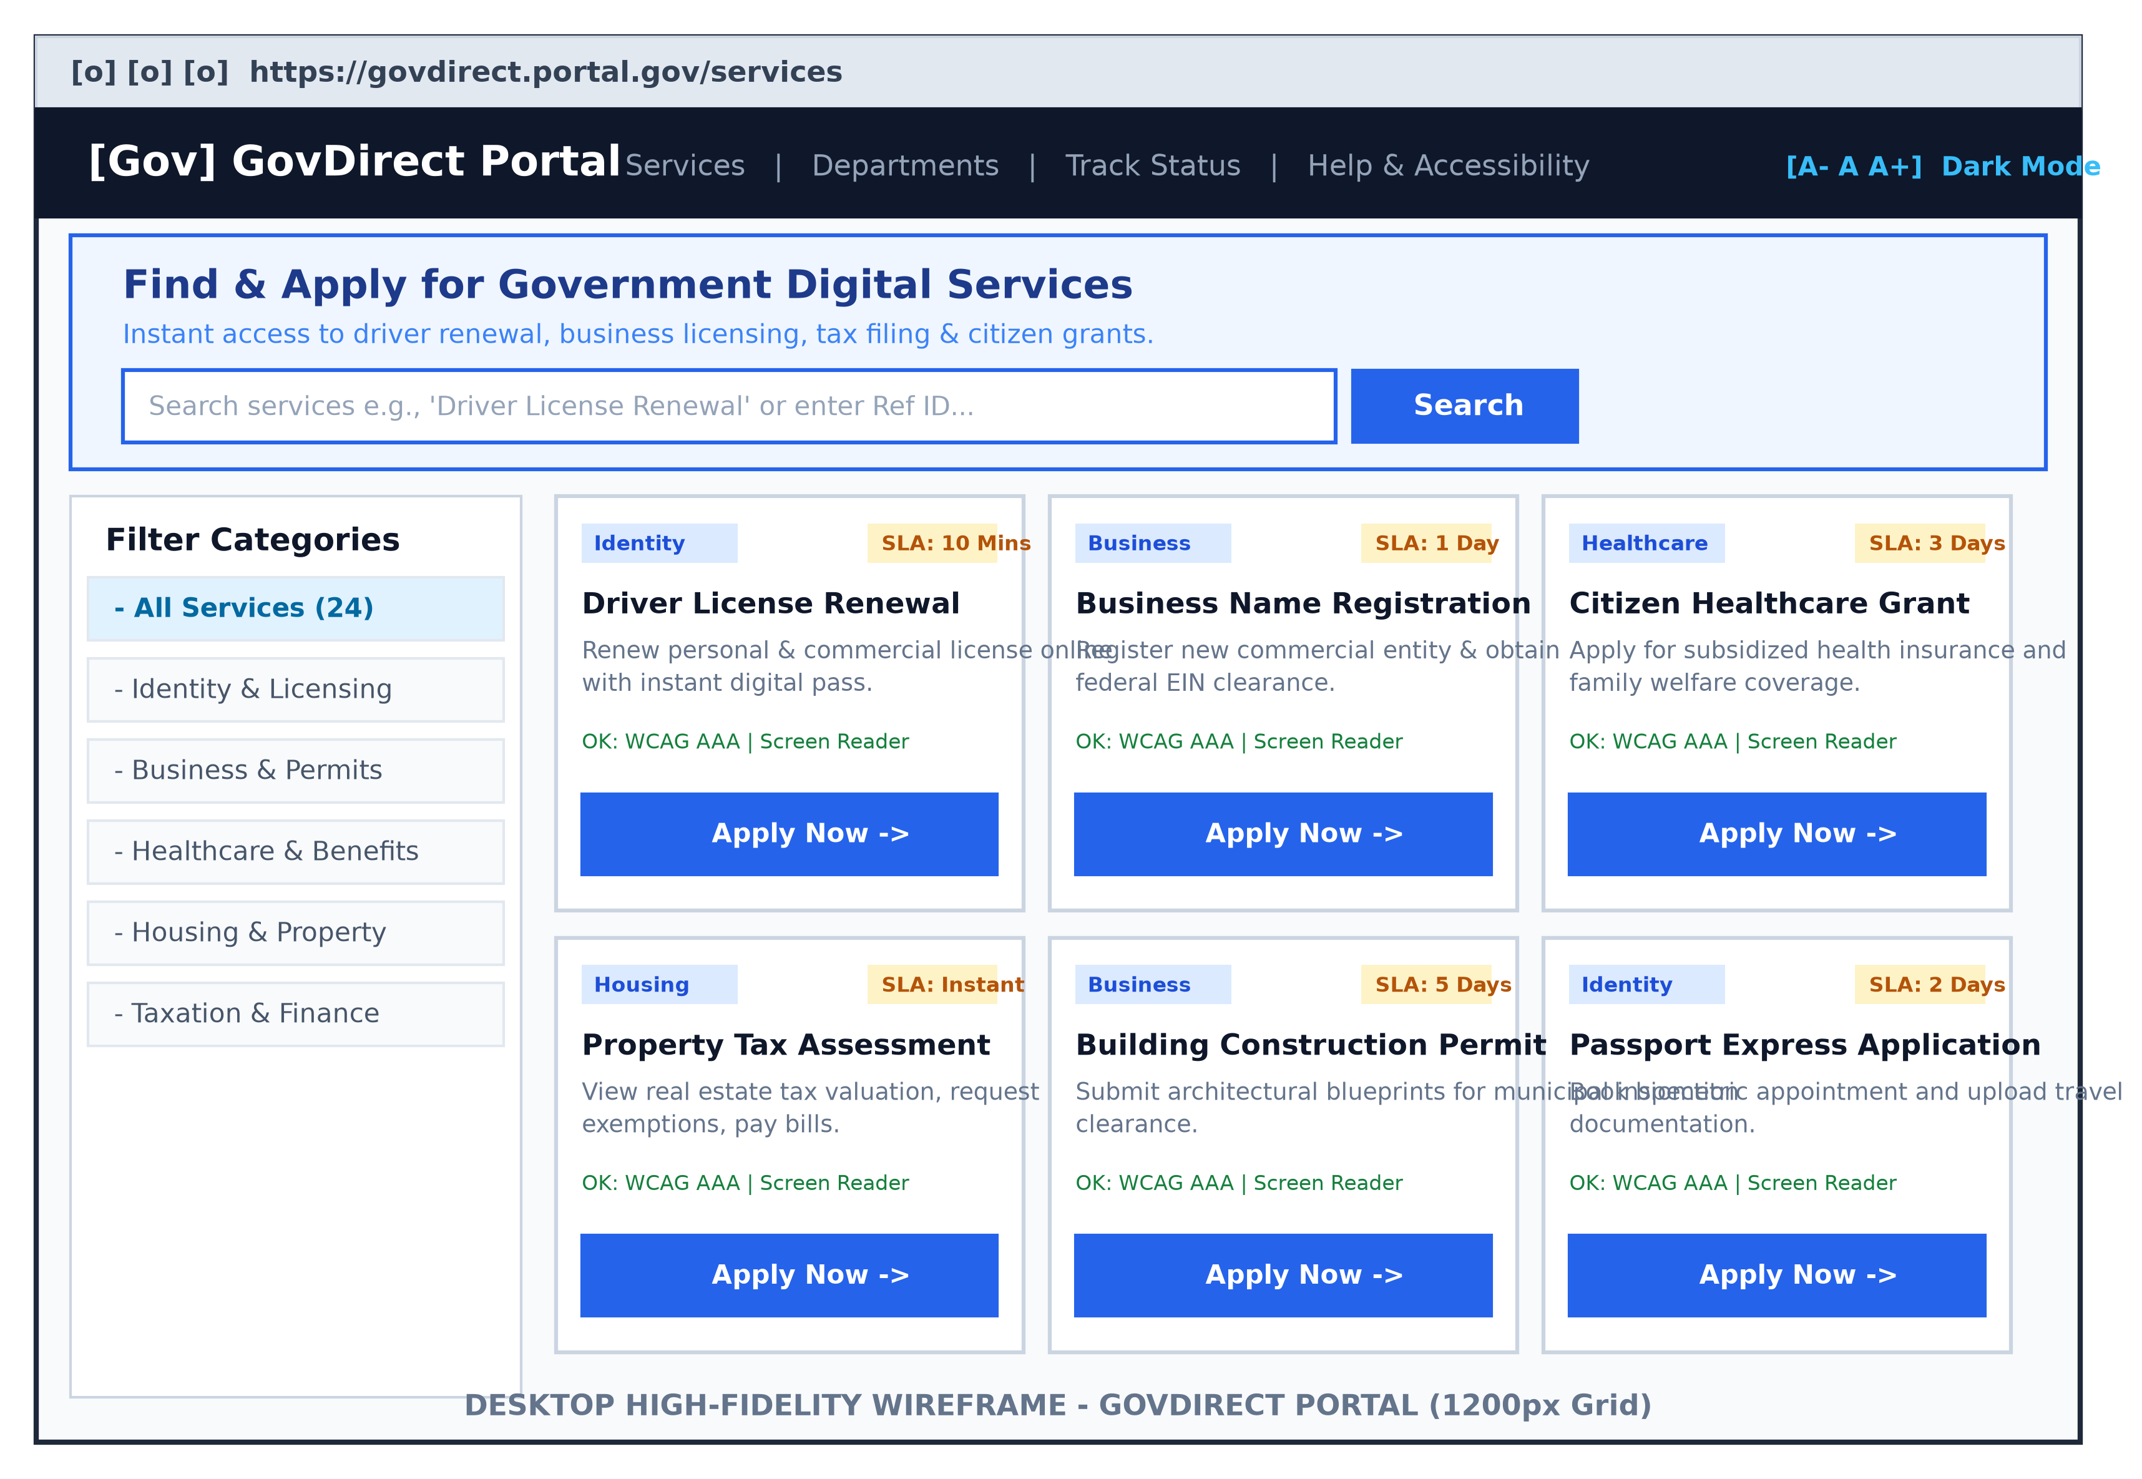
Figure 1: High-Fidelity Wireframe for Desktop Portal Layout with Sidebar Filters and 3-Column Service Grid.
💡 DESKTOP LAYOUT RATIONALE
On desktop viewports (1024px and above), the layout utilizes a 3-column service grid flanked by a left category filter sidebar. The top persistent header incorporates the accessibility toolbar without obscuring primary navigation options.

2.2 Mobile Responsive Wireframe (375px Breakpoint)
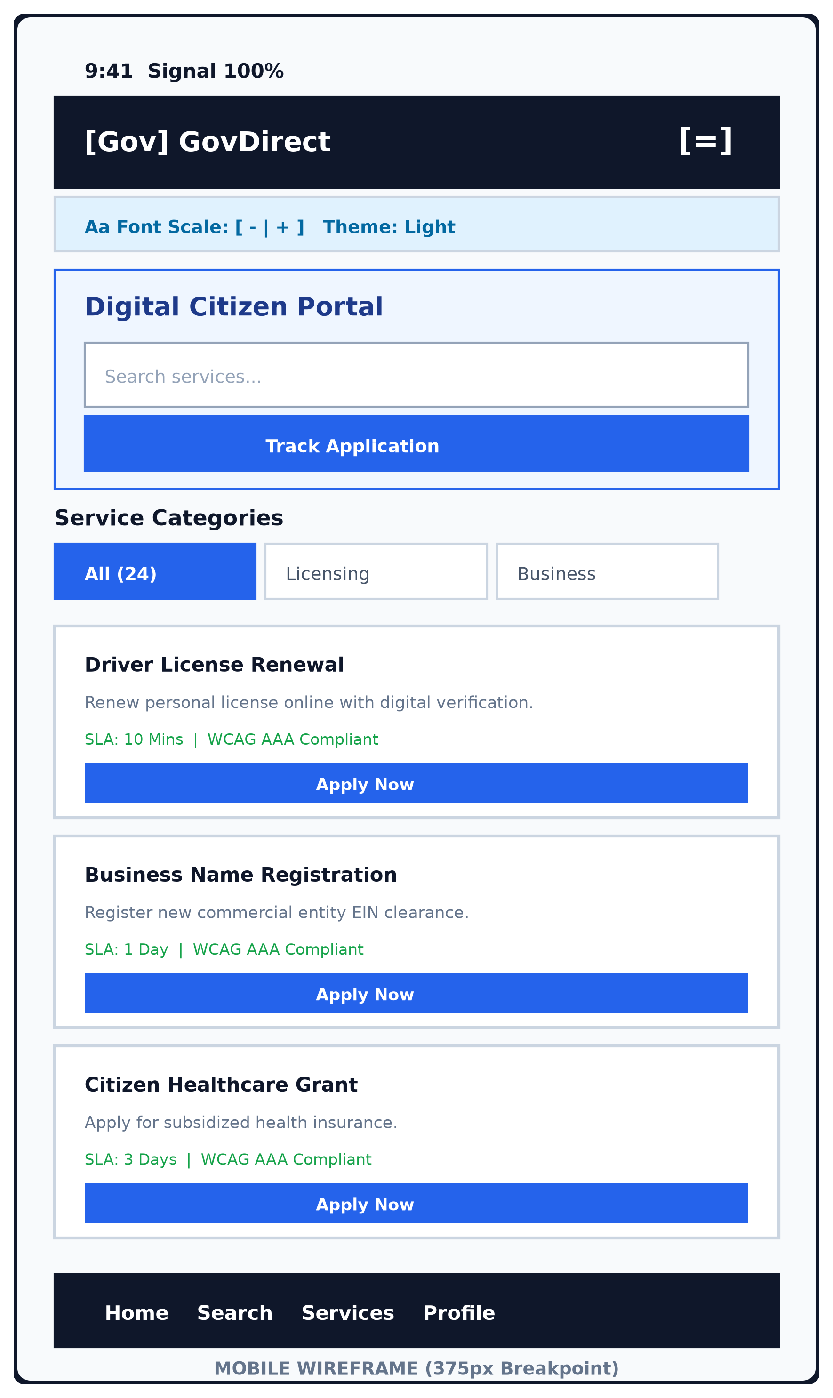
Figure 2: Mobile Responsive Layout Wireframe featuring Single-Column Stack, Collapsible Drawer Menu, and Sticky Navigation.
💡 MOBILE RESPONSIVE RATIONALE
Mobile viewports compress navigation into a single vertical column. Buttons and interactive targets are scaled to a minimum touch target size of 48px × 48px to accommodate thumb-zone navigation.

2.3 Interactive Multi-Step Application Modal Wireframe
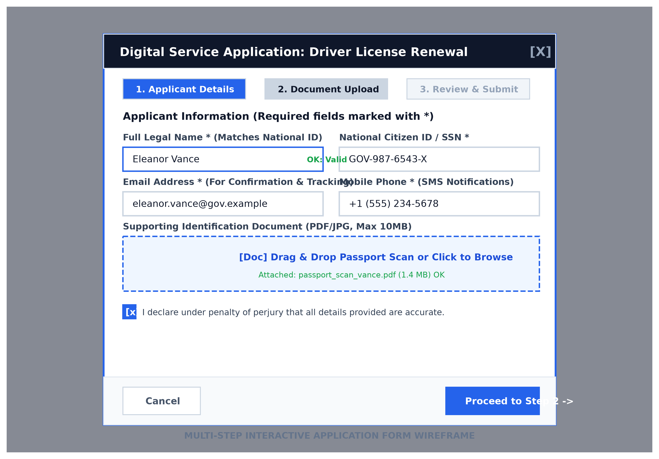
Figure 3: Multi-step Application Form Modal Layout featuring Stepper Tabs, Inline Validation Badges, and File Upload Zone.

2.4 Citizen User Flow & Interaction Architecture
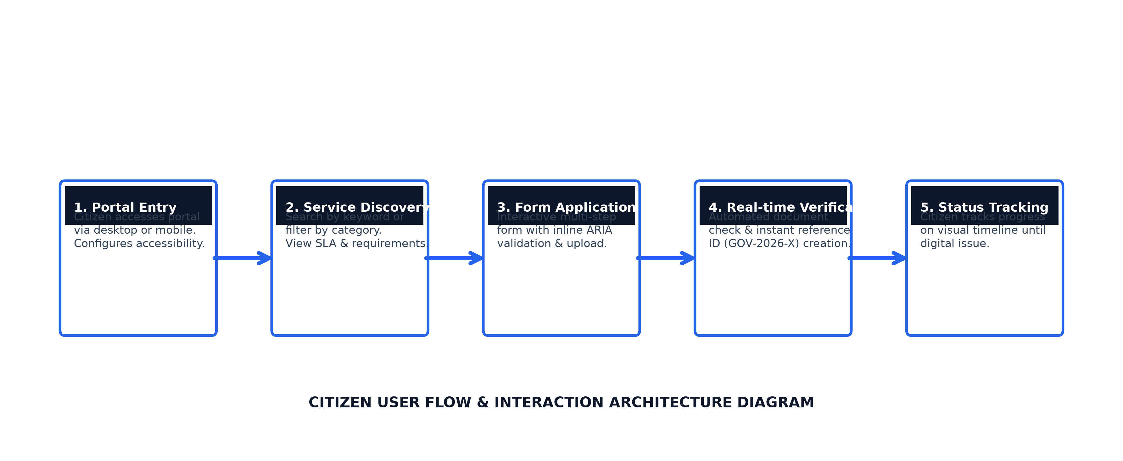
Figure 4: End-to-End Citizen User Journey Flowchart from Discovery to Real-Time Progress Tracking.

3. Responsive Design Engineering
Responsive web engineering ensures that the portal adapts gracefully across diverse screen resolutions without requiring horizontal scrolling or broken layouts. The prototype utilizes modern CSS layout modules including CSS Grid, Flexbox, and CSS fluid functions.

3.1 Breakpoint Matrix & Layout Behaviors
Device Category | Viewport Range | Layout Mechanics | UI Adaptations
Mobile Handheld | 320px - 767px | Single-column CSS Grid (`grid-template-columns: 1fr`) | Navigation links collapse into hamburger overlay; font size uses `clamp()`; sticky bottom accessibility bar.
Tablet Portrait/Landscape | 768px - 1023px | 2-Column CSS Grid (`repeat(auto-fit, minmax(280px, 1fr))`) | Top header displays simplified search box; filter category buttons convert into horizontal scroll strip.
Desktop & Ultrawide | 1024px and above | 3-Column Fluid CSS Grid with Fixed Sidebar | Full header navigation visible; sidebar category filters stay persistent; accessibility toolbar pinned to top.

3.2 Principles of Fluid Grids & Typography
Instead of hardcoded pixel font sizes, the prototype leverages CSS `clamp()` fluid functions to automatically interpolate text scale relative to viewport width:
`font-size: clamp(1.75rem, 3vw + 1rem, 2.75rem);`
This formula prevents text overflow on mobile screens while ensuring high readability on large desktop monitors. Furthermore, images and SVG icons use flexible width declarations (`max-width: 100%; height: auto;`) to prevent layout blowout.

4. Usability & Interaction Design
User-centered design principles guide the portal's interaction mechanics. Government forms are often criticized for high cognitive burden; the GovDirect prototype addresses this through structured progressive disclosure and instant feedback.

4.1 Key Usability Heuristics Implemented
- Cognitive Load Reduction: Complex government applications are decomposed into manageable 3-step modal panels (Applicant Details → Document Upload → Review & Final Signoff).
- Error Prevention & Instant Recovery: Inline JavaScript validation verifies email formatting, phone numbers, and citizen ID inputs immediately on step transition, preventing frustrating post-submission rejections.
- Visibility of System Status: The Live Tracker widget provides citizens with transparent visual step-by-step progress timelines for submitted reference IDs (GOV-2026-8942).
- Flexibility & Speed of Use: Frequent actions are accessible via quick-filter chips on the hero search bar, allowing 1-click access to Driver License, Business, and Grant services.

5. Accessibility & Universal Design Matrix (WCAG 2.1 AAA)
Universal accessibility is a non-negotiable legal and moral mandate for government platforms. The prototype adheres strictly to Web Content Accessibility Guidelines (WCAG 2.1 AAA and AA levels).

5.1 Color Contrast Evaluation
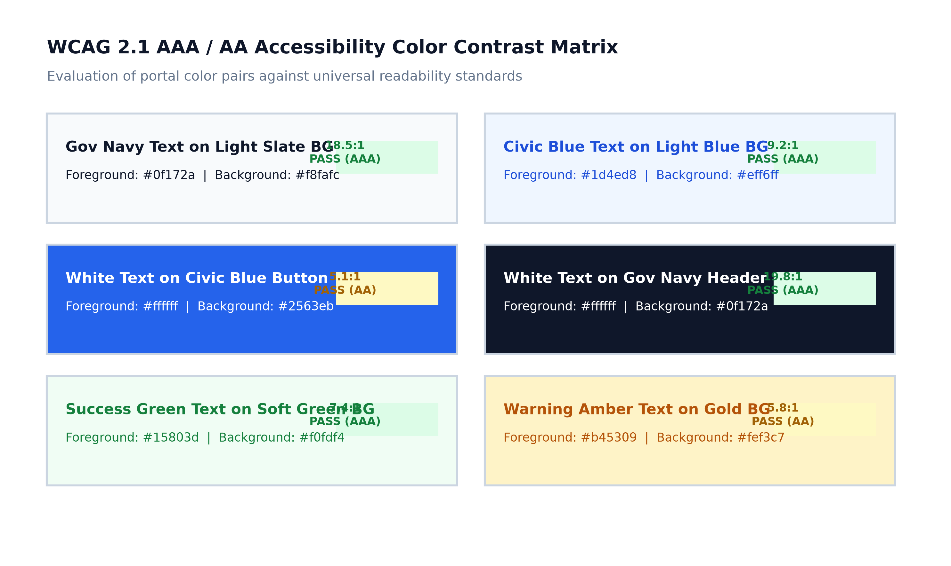
Figure 5: Color Contrast Ratio Evaluation Matrix confirming WCAG 2.1 AAA/AA Compliance.

5.2 Universal Accessibility Features Breakdown
- Dynamic Font Scaling Toolbar: Allows citizens with low vision to scale text from 80% up to 140% without breaking container dimensions or overflowing buttons.
- High Contrast Dark Mode: Provides a 19.8:1 text contrast ratio option, reducing eye strain and aiding users with visual sensitivity.
- Screen Reader Simulation & ARIA Live Regions: Integrated Web Speech API text-to-speech engine coupled with `aria-live='polite'` regions that announce live form errors and reference code creations.
- Keyboard Focus Rings: All interactive buttons and input fields exhibit a prominent 3px solid focus ring (`outline: 3px solid #2563eb`), ensuring complete keyboard navigability (Tab/Shift+Tab).

6. Prototype Source Code & Execution Guide
The prototype is constructed as a self-contained front-end application using semantic HTML5, modern vanilla CSS custom properties, and client-side JavaScript. Below are execution instructions to launch and test the web prototype.

6.1 Directory & File Structure
task2/
├── Digital_Services_Portal_Design_Doc.docx (Comprehensive Design Document)
├── generate_visual_wireframes.py (Matplotlib/Pillow Diagram Generator)
├── generate_doc_report.py (Python-Docx Report Generator)
├── build_all.py (Master Build Orchestrator)
├── assets/ (Generated Visual PNG Wireframes)
└── prototype/ (Web Prototype Source Code)
├── index.html (Semantic HTML5 Markup)
├── styles.css (CSS Design System & Breakpoints)
└── app.js (JavaScript Interactivity & ARIA Logic)

6.2 Steps to Run & Inspect Prototype
1. Open terminal and navigate to directory: `cd c:\Users\Vicky\OneDrive\Desktop\task2`
2. To launch a local web server, run: `python -m http.server 8000 --directory prototype`
3. Open web browser and visit: `http://localhost:8000`
4. Interact with accessibility buttons (Font +/-, Dark Contrast Mode, Screen Reader TTS).
5. Click 'Apply Now' on any service card to test the 3-step modal form and receive a generated tracking reference code.
6. Enter the tracking reference code into the Live Application Tracker widget to observe progress updates.

