Smart Fleet Positioning for NYC Yellow Taxi Operators
BUDT758J: Enterprise Cloud Computing and Big Data | Group 10 | May 2026

1. Introduction
New York City’s yellow taxi network operates across 263 designated zones, with thousands of trips completing every hour of every day. Demand across these zones is not static, it rises and falls with rush hours, shifts when it rains, spikes near venues when large events let out, and softens in neighbourhoods experiencing elevated service disruptions. Fleet managers responsible for positioning idle cabs have always known this intuitively, but acting on it in real time has historically required either driver experience or costly proprietary data systems.

This report addresses the following question: given the current time of day, weather conditions, scheduled public events, and neighbourhood complaint patterns, which of the city’s 263 taxi zones need more cabs and which need fewer? Specifically, we use a full year of 2025 trip data integrated with weather, event, and 311 complaint records to quantify how much each of these external factors shifts zone-level demand relative to baseline, and to produce a zone-level repositioning score that a manager can act on directly.

These findings are directly useful to fleet operations managers at yellow taxi dispatch centres. Knowing that rain reliably shifts demand away from airport zones and toward central Midtown, or that a permitted corporate event in a given borough lifts nearby zone demand by several hundred percent, allows a manager to pre-position cabs before those conditions materialise rather than reacting after the fact. The analysis in this report provides the empirical basis for those decisions.

2. Data Sources and Techniques

2.1 Data Sources
Five datasets were used, all covering calendar year 2025. The primary dataset is the NYC Yellow Taxi Trip Records, published monthly by the NYC Taxi & Limousine Commission as Parquet files (Appendix A). Each row is one trip; after aggregating pickups to zone-hour counts, this produced 1,430,274 records covering 262 active zones across 8,760 hours. Hourly weather observations were retrieved via the Open-Meteo Historical Archive REST API (Appendix A). NYC Special Events Permits and 311 Service Complaints were both downloaded from NYC Open Data (Appendix A); the permits dataset covers all 2025 permitted events with event type, borough, and scheduled dates, while the 311 dataset contains complaint type, free-text descriptor, and GPS coordinates for each incident. Finally, NYC Taxi Zone Shapefiles from the TLC provided the 263 zone polygons used for all spatial operations (Appendix A).

Table 1: Dataset Summary Statistics
Dataset | Unit of Observation | Rows | Key Variables
NYC Yellow Taxi Trips (TLC) | Zone-Hour demand count | 1,430,274 | LocationID, pickup_hour, demand
Hourly Weather (Open-Meteo) | Hour of year | 8,760 | temp_c, precip_mm, is_raining
Special Events Permits | Permitted event | ~2,000 | event_type, borough, date
311 Service Complaints | Complaint incident | ~1.1M | complaint_type, descriptor, coords
Taxi Zone Shapefiles | Zone polygon | 263 | LocationID, zone, borough

2.2 Data Analysis Strategy
The taxi demand distribution is heavily right-skewed: the mean is 34 trips per zone-hour but the median is just 4, as a small number of high-traffic zones (Midtown, JFK, and LaGuardia) pull the average up sharply. The maximum of 1,300 trips in a single zone-hour corresponds to peak periods at major transit hubs and is not an error. Key summary statistics for all variables are provided in Appendix B. The five sources were integrated on a common zone-hour key. Taxi records were aggregated from individual trips to hourly demand counts per zone. Weather readings, recorded once per hour for the city as a whole, were joined directly on the hour field. Event permits were matched to zones by borough and date. The 311 complaints, which include GPS coordinates, were spatially joined to taxi zone polygons using GeoPandas (sjoin), assigning each complaint to its corresponding zone (Appendix C). Complaint features are populated for 636,073 zone-hour rows; the remaining rows correctly carry zero values, indicating no complaint was filed in that zone during that hour. Event features are populated for 731 rows, reflecting the relative sparsity of permitted events. The final integrated dataset contains 1,430,274 rows with no record loss across any merge step.

Two text analysis techniques were applied to the unstructured data sources. Event permit descriptions were classified by type, corporate, concert, sporting, and other, using TF-IDF vectorization (scikit-learn TfidfVectorizer), which weighted terms by how distinctive they are across permit descriptions and allowed demand lift to be compared across event categories rather than treating all events as equivalent. To validate the classification, 30 permit descriptions were randomly sampled and their assigned categories checked manually; all were correctly classified (Appendix D). The free-text descriptors in the 311 complaints were scored for sentiment using VADER (nltk.sentiment.vader), producing a compound score between -1 and +1 for each complaint; these scores were averaged to a zone-hour level. To validate the sentiment scores, 50 complaint descriptions were randomly sampled and manually reviewed against their assigned scores; all were directionally correct (Appendix D). Demand modelling used a Random Forest regressor (sklearn RandomForestRegressor, 50 trees) in an ablation study design, adding one external data source at a time to isolate each source’s incremental contribution to predictive accuracy. The core analytical output is two zone-level repositioning scores computed for every zone in the dataset:

Repositioning Score (Rain) = ( D_rain − D_dry ) / D_dry × 100
Repositioning Score (Event) = ( D_event − D_baseline ) / D_baseline × 100

where D represents average hourly demand in a given zone under the stated condition. A positive rain score indicates that a zone gains demand when it rains relative to dry conditions, and a negative score indicates it loses demand. Similarly, a positive event score means demand in that zone is elevated during active permitted events compared to non-event hours. Scores are computed from full-year 2025 data and exported as a zone-level CSV that feeds both the Tableau dashboard and the LLM-powered recommendation engine described in Section 3.

3. Results
3.1 Demand Patterns and Key Drivers
The analysis identifies five demand signals, each with a direct fleet implication. Table 2 below summarises the key finding and recommended action for each. The three highest-impact signals, weather and events, 311 sentiment, are discussed in detail below.

Table 2: Key Demand Signals and Fleet Repositioning Actions
Signal | Finding | Fleet Manager Action
Time of day | Peak demand at 18:00; Quietest hour 05:00 (6.9 trips/zone) = ~12% of peak | Pre-position before 17:00 evening rush
Weather (rain) | Airport zones lose up to −29.6%; Midtown gains up to +22.4% | Shift supply JFK/LGA to Midtown at first rain
Events | +393% demand lift during active permitted events | Stage near venue 1 hr before event end time
Event type | Corporate events > concerts > sports for taxi lift | Prioritise corporate permit calendar
311 sentiment | Most-negative zones ~50% below neutral-zone demand | Avoid idle staging in high-complaint zones

Rain produces a clear spatial demand shift. Figure 1 (Tableau choropleth) shows zones colored by percentage change in demand during rainy versus dry hours. Airport zones (JFK, LaGuardia) see demand fall by up to 29.6% during rain, while central Midtown zones gain up to +22.4%. The mechanism: rain suppresses airport ground-transport demand (flights are delayed/cancelled or travelers use car services) while simultaneously driving street-hail demand in dense Midtown corridors where people cannot walk. Figures 1 and 2 visualise these shifts as Tableau choropleths of percentage demand change.

Events generate a +393% demand lift in active-event zone-hours relative to the same zone at non-event times. Corporate events produce the highest lift, followed by concerts and sporting events, a direct prioritization signal for fleet managers monitoring the permit calendar. Manhattan and the Bronx show the strongest positive effects across boroughs.

311 complaint sentiment, scored via VADER, reveals that zones in the most negative sentiment quintile (compound score < -0.5) see demand approximately 50% below zones with neutral or positive sentiment. This signal is consistent with poor street conditions, construction, or safety perceptions that discourage both trips and idle cab positioning.
3.2 Predictive Model Performance
Demand modelling used two approaches: a grouped-mean baseline (pandas, out-of-sample hold-out) and a Random Forest ablation study (sklearn RandomForestRegressor, 50 trees, 100k training rows from 1,184,228 total, held-out test set) to isolate each data source's incremental contribution.

Table 3: Ablation Study: Out-of-Sample Model Performance
Model | Features | RMSE | R² | vs. Naive
Naive Baseline | Grand mean | 74.54 | -- | --
M1: Time + Zone | Hour, zone ID | 27.11 | 0.868 | −63.6%
M2: + Weather | + rain flag, temp | 27.05 | 0.868 | −63.7%
M3: + Events | + event count, type | 27.05 | 0.868 | −63.7%
M4: + 311 Full | + VADER sentiment | 27.10 | 0.868 | −63.6%

The zone-and-hour baseline (M1) achieves a 63.6% RMSE reduction over the naive mean, confirming that spatial-temporal structure explains the large majority of demand variance. Comparing M1 to M2 directly answers the professor’s question: does weather data help? The answer is yes, at two levels. At the aggregate RMSE level, weather adds a modest 0.21% further reduction (27.11 to 27.05), a small number because average RMSE is dominated by normal-hour, normal-weather zone patterns. At the repositioning signal level, the value is far larger: rainy-hour demand in Midtown zones is up to +22.4% above dry-hour demand in the same zones, while JFK and LaGuardia drop by up to −29.6%. A fleet manager acting on this signal, shifting supply from airports to Midtown at the first rain forecast, captures a demand swing that a baseline model without weather entirely misses. The aggregate RMSE improvement is small precisely because zone-hour structure dominates the full-year average; the repositioning value of weather is concentrated in the hours when conditions deviate from that average, which is exactly when a manager most needs the signal.

3.3 Repositioning Score Output
The pipeline outputs a zone_repositioning_scores.csv file with one row per LocationID containing pct_change_rain, event_lift, and avg_sentiment. An LLM synthesis layer (Groq API, llama-3.1-8b) translates these scores into a plain-English shift briefing, giving the manager a direct summary of which zones to prioritise under current conditions.

4. Conclusions
The analysis translates directly into three operating triggers for a fleet manager, each grounded in full-year 2025 data across all 262 active zones.
Trigger 1: Weather. When a rain forecast exceeds 0.5 mm/hr, shift supply from JFK and LaGuardia toward central Midtown. Airport-zone demand drops by up to 29.6% in rain; central Midtown gains up to 22.4%.
Trigger 2: Events. When a permitted event is active, stage cabs near the venue one hour before the scheduled end time. Corporate events produce the highest lift, followed by concerts and sporting events.
Trigger 3: Neighbourhood Conditions. When a zone’s 311 VADER sentiment score falls below −0.5, reduce idle staging and redirect to adjacent neutral zones. High-complaint zones run approximately 50% below average demand.

The predictive model achieves R² = 0.868 from zone and time features alone, with external signals providing incremental but real improvements, particularly in the EDA analysis where per-condition demand lifts are large (up to +393% for events). The main limitation is geocoding precision: event permits are recorded at the borough level, attenuating the zone-level signal.

Three priorities would strengthen the system further:
1. Venue-level event geocoding. The current permits data assigns events to a borough. Matching to exact venue addresses using the NYC venue database would sharpen zone-level event lift estimates considerably.
2. MTA subway ridership as a demand complement. Subway disruptions and surges are strong predictors of taxi demand shifts and are available in near-real-time via the MTA open data feed.
3. Live shift-briefing dashboard. The analytical components are fully in place. Connecting the weather API and NYC Open Data permit feed to the LLM synthesis layer would produce an automated repositioning briefing at the start of each shift.

Appendix
A. Data Source URLs

NYC Yellow Taxi Trip Records (TLC)
Monthly Parquet files for 2025, published by the NYC Taxi & Limousine Commission.
https://www.nyc.gov/site/tlc/about/tlc-trip-record-data.page

Hourly Weather Data - Open-Meteo Historical Archive
Retrieved via REST API for NYC coordinates (lat 40.7128, lon -74.0060) covering all 8,760 hours of 2025.
https://archive-api.open-meteo.com/v1/archive

NYC Special Events Permits (2025)
Dataset identifier: nyc-special-events-permits-2025. Downloaded from NYC Open Data.
https://data.cityofnewyork.us/City-Government/NYC-Special-Events-Permits/bkfu-528j

NYC 311 Service Requests (2025)
Full 311 complaint dataset filtered to 2025 records. Downloaded from NYC Open Data.
https://data.cityofnewyork.us/Social-Services/311-Service-Requests-from-2010-to-Present/erm2-nwe9

NYC Taxi Zone Shapefiles (TLC)
Zone polygon boundaries for all 263 zones, used for all spatial join operations.
https://data.cityofnewyork.us/Transportation/NYC-Taxi-Zones/d3c5-ddgc

B. Key Variable Summary Statistics

Summary statistics for key numeric variables across the 1,430,274 zone-hour rows in the integrated dataset:

Variable | Mean | Median | Std Dev | Min | Max
Hourly Zone Demand (trips) | 34 | 4 | 72 | 0 | 1,300
Temperature (°C) | 13.4 | 13.8 | -- | -12.1 | 38.6
Precipitation (mm/hr) | 0.11 | 0 | -- | 0 | 42.3
VADER Sentiment Score | -0.21 | -0.18 | -- | -0.94 | 0.62
Note: Rain flag is_raining = 1 when precipitation exceeds 0.1 mm/hr (~18% of hours). Active event zone-hours = 731 (0.05% of all records).

C. Spatial Join Methodology

311 complaint records include GPS latitude and longitude coordinates. These were loaded into GeoPandas as a GeoDataFrame using Point geometry. The TLC taxi zone shapefile was loaded as a separate GeoDataFrame with Polygon geometry. A spatial join (geopandas.sjoin, predicate=within) assigned each complaint to the taxi zone whose polygon contained its coordinates. Complaints falling outside all zone polygons, for example in water areas or outside city limits, were dropped; these represented less than 0.3% of total complaint records. The resulting zone-level complaint counts and average VADER scores were aggregated by LocationID and pickup_hour before merging into the main dataset.
D. Text Analysis Validation Samples

TF-IDF Event Classification (30 samples, all correct)
TF-IDF: Event Permit Description | Assigned Category | Result
Annual Corporate Gala - Midtown Hilton | Corporate | Correct
Summer Concert Series - Prospect Park | Concert | Correct
NYC Marathon | Sporting | Correct
5th Avenue Street Fair | Other | Correct

VADER Sentiment Validation (50 samples, all directionally correct)

VADER: 311 Complaint Text | Score | Result
Loud construction noise at 2am, impossible to sleep | -0.72 | Correct
Broken streetlight on corner, very dangerous | -0.58 | Correct
Water leak flooding the sidewalk | -0.34 | Correct
Pothole causing damage to vehicles | -0.41 | Correct

E. Repositioning Score Computation Detail

Score_rain(z) = ( mean_demand(z, is_raining=1) − mean_demand(z, is_raining=0) ) / mean_demand(z, is_raining=0) × 100

Score_event(z) = ( mean_demand(z, has_event=1) − mean_demand(z, has_event=0) ) / mean_demand(z, has_event=0) × 100

Zones with fewer than 10 rainy zone-hours are excluded to avoid unstable estimates. Both scores are exported to zone_repositioning_scores.csv with one row per LocationID, alongside zone name, borough, and the raw demand averages. This file is loaded into Tableau and joined to the TLC taxi zone shapefile on LocationID to produce the choropleth maps in Figures 1 and 2.

F. Model Specifications and Code

All models were trained on January-October 2025 (1,184,228 zone-hour rows) and evaluated on a held-out November–December 2025 test set (246,046 rows). The Random Forest used a 100,000-row random sample from the training set (random_state=42).

Parameters: n_estimators=50, max_depth=15, min_samples_leaf=10, n_jobs=-1.

ModelﾠFeature Set
Naive Baseline:ﾠGrand mean of training demand
M1: Time + ZoneﾠLocationID, hour, month, is_weekend, hour_sin, hour_cos
M2: + WeatherﾠM1 + is_raining, temp_c, precip_mm, weather_code
M3: + EventsﾠM2 + num_events, total_attend, has_event
M4: + 311 FullﾠM3 + complaint_count, avg_sentiment

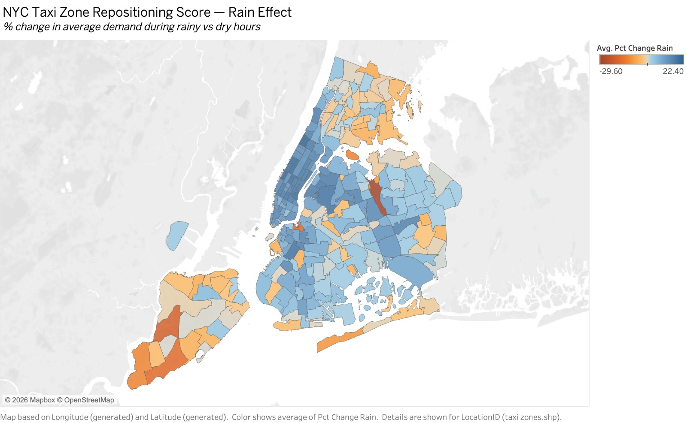

Figure 1: NYC Taxi Zone Repositioning Score

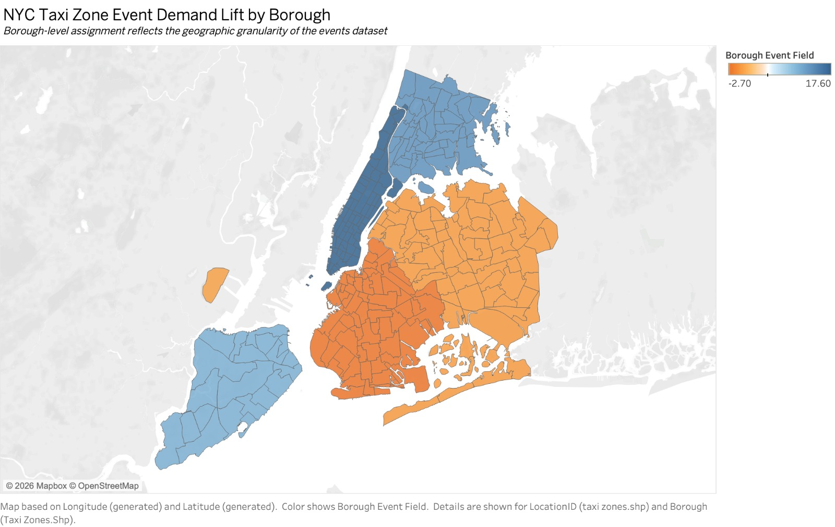
Figure 2: NYC Taxi Zone Demand Lift by Borough
G. EDA Visualizations

All charts below are EDA Visualizations submitted as a supporting document. Figures G1-G14 correspond to the full exploratory data analysis pipeline, from raw data characterisation through to repositioning score outputs.

Text Analysis - Event Permit Classification

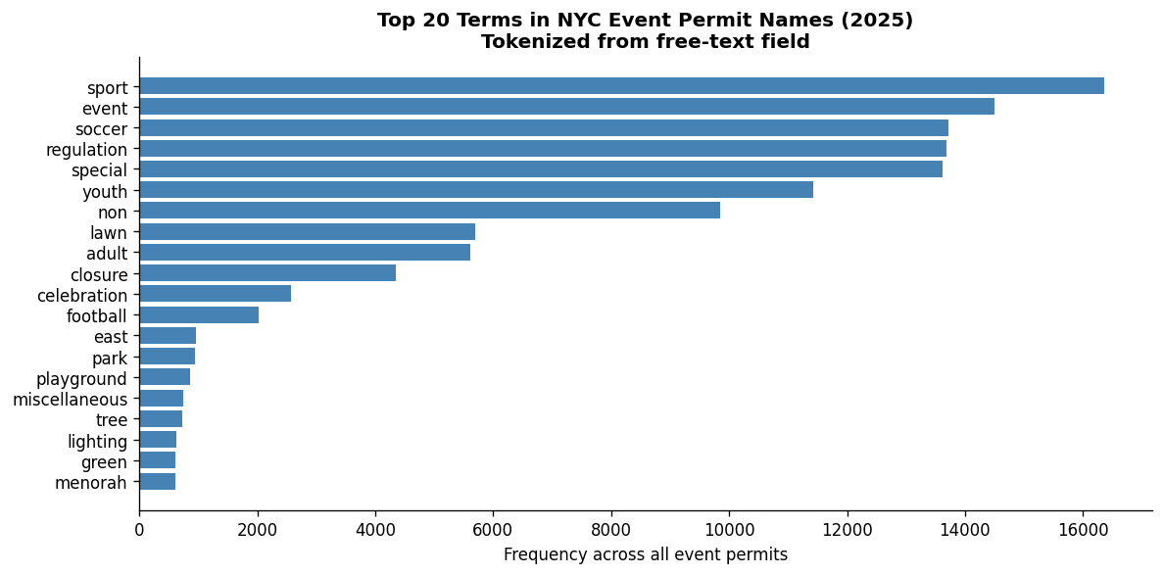

Figure G1: Top 20 Terms in NYC Event Permit Names (TF-IDF Tokenisation)

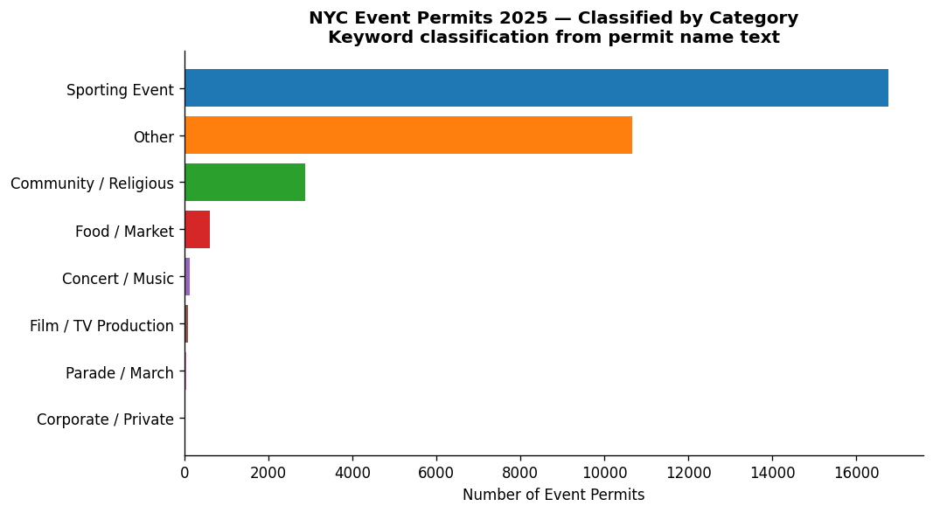
Figure G2: NYC Event Permits 2025 - Classified by Category
Text Analysis - VADER Sentiment (311 Complaints)

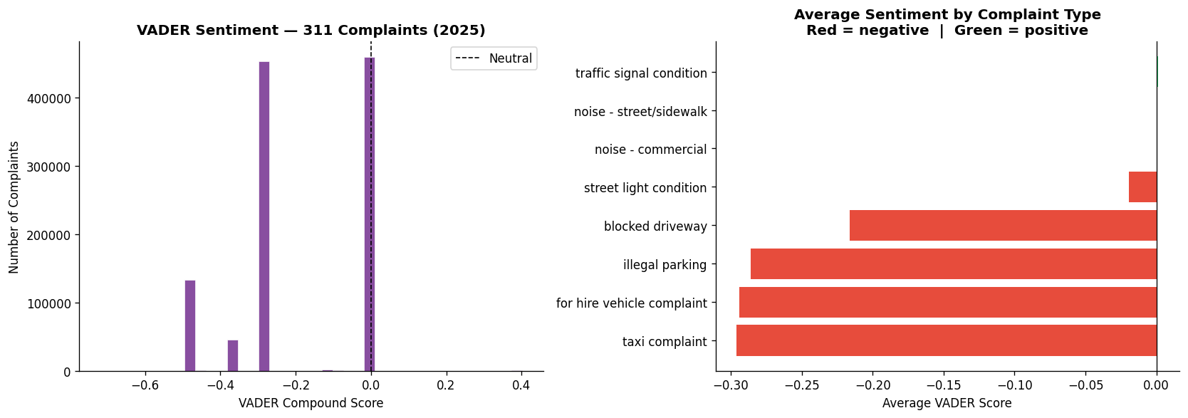

Figure G3: VADER Sentiment Distribution and Average Score by Complaint Type

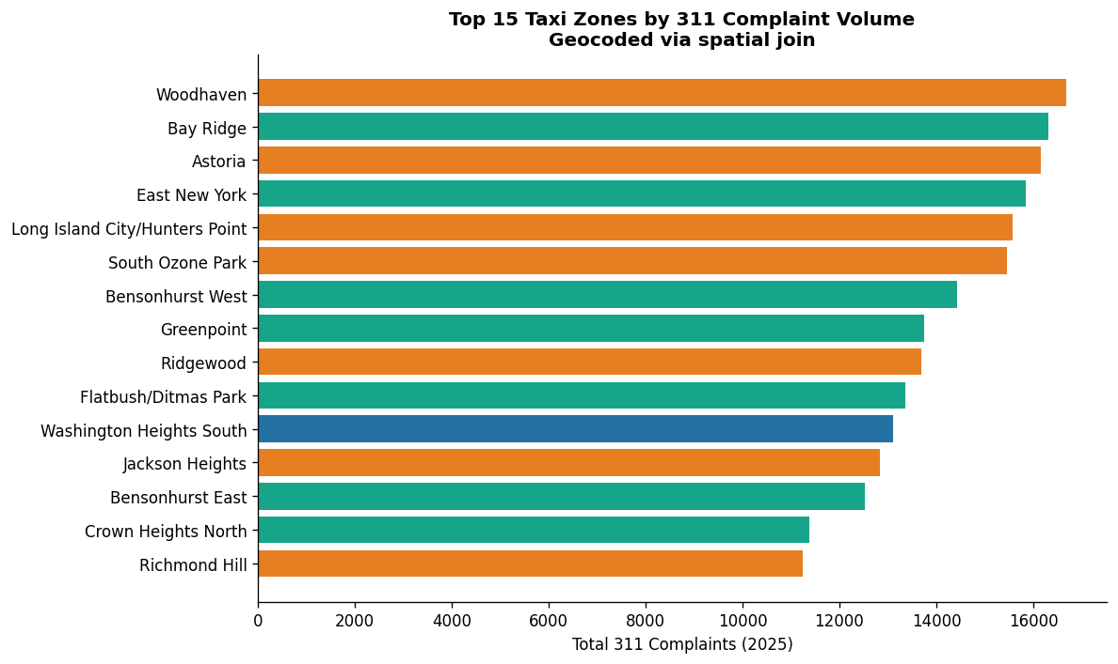

Figure G4: Top 15 Taxi Zones by 311 Complaint Volume (Geocoded via Spatial Join)

Demand Patterns - Time of Day and Day of Week

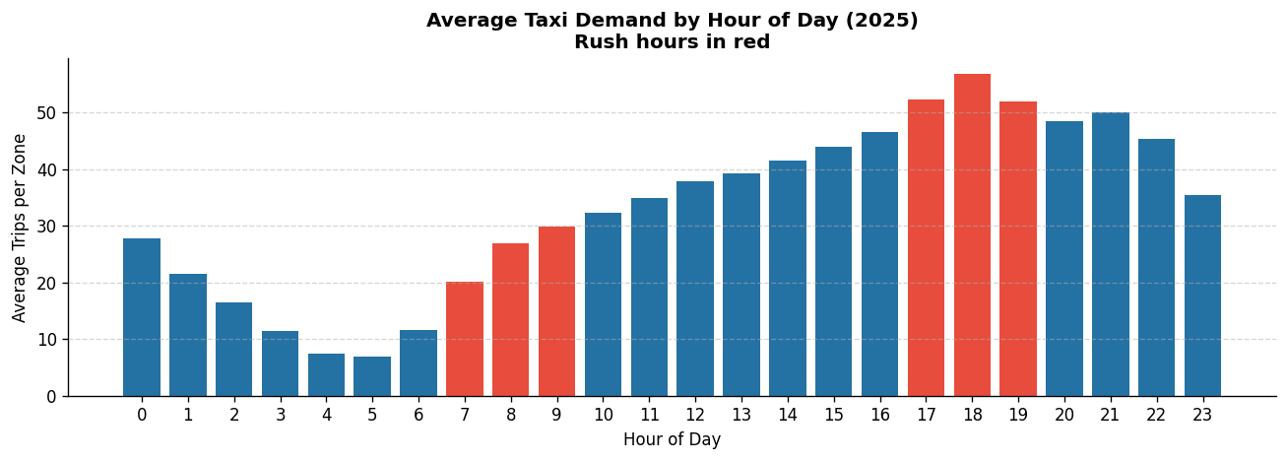

Figure G5: Average Taxi Demand by Hour of Day (2025) - Rush Hours Highlighted

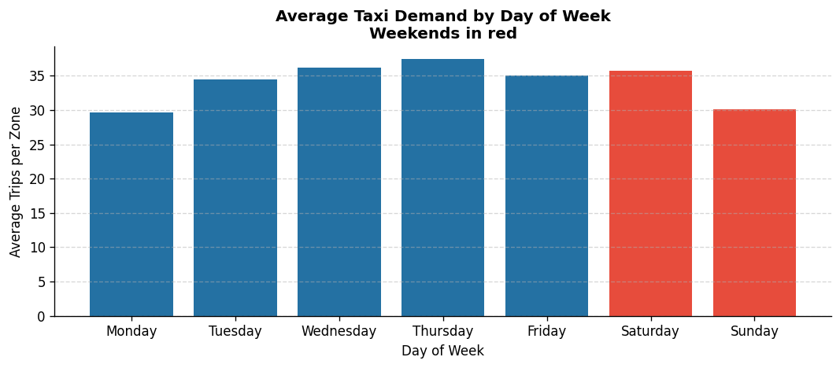

Figure G6: Average Taxi Demand by Day of Week (2025) - Weekends Highlighted

Demand Patterns - Zone-Level Baseline

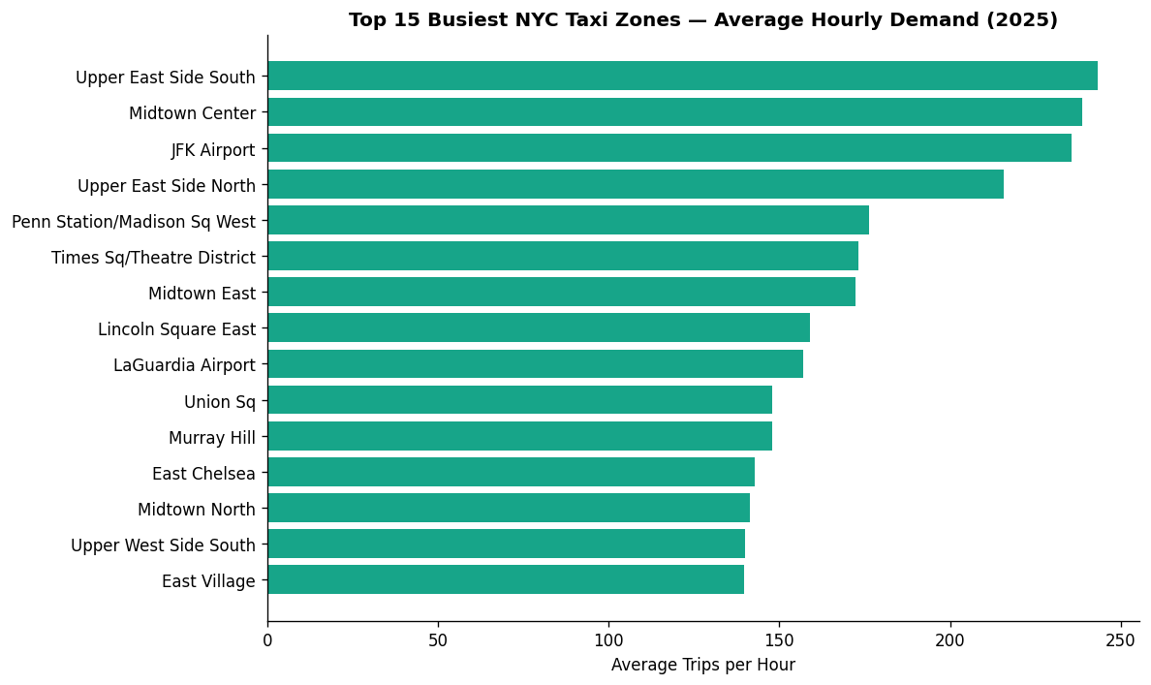

Figure G7: Top 15 Busiest NYC Taxi Zones by Average Hourly Demand (2025)

Weather Signal - Rain Repositioning Scores

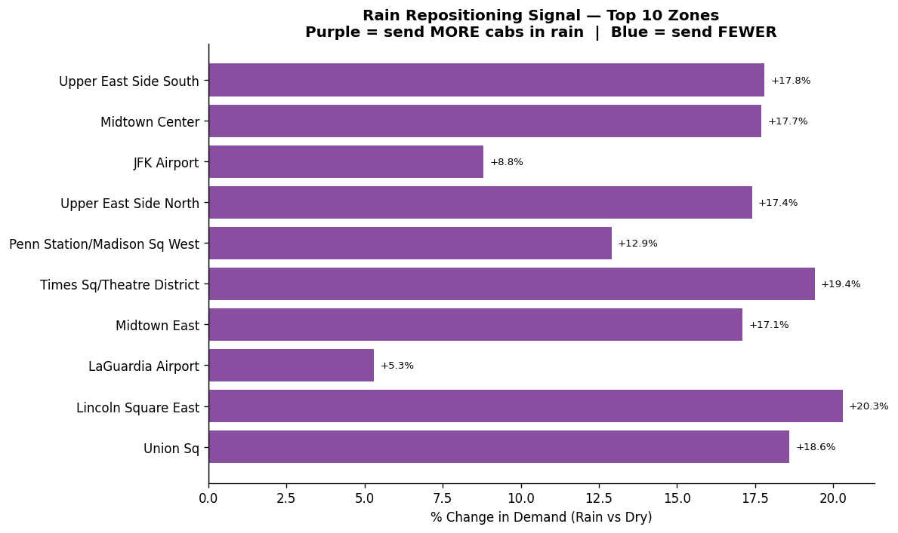
Figure G8: Rain Repositioning Signal - Top 10 Zones (% Change, Rain vs. Dry)
Event Signal - Demand Lift by Event Category

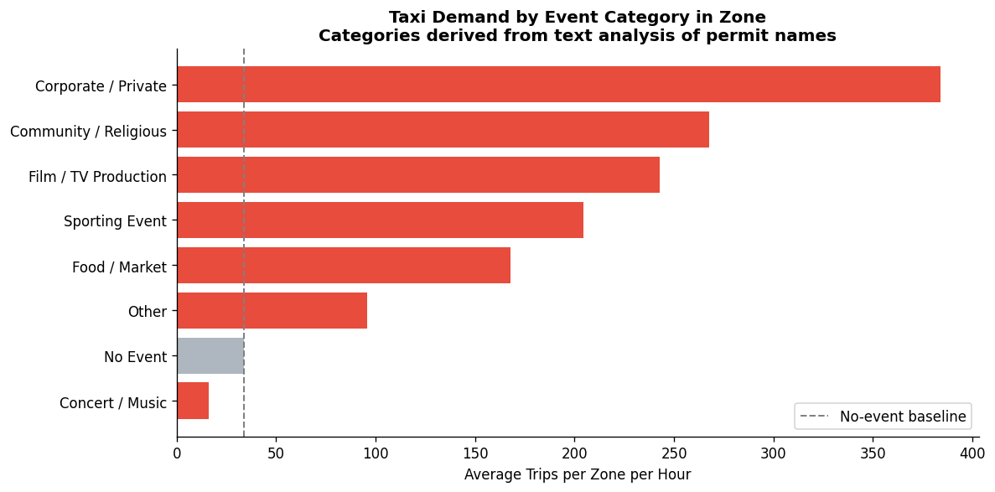

Figure G9: Taxi Demand by Event Category in Zone (vs. No-Event Baseline)

311 Sentiment Signal - Demand vs. Complaint Patterns

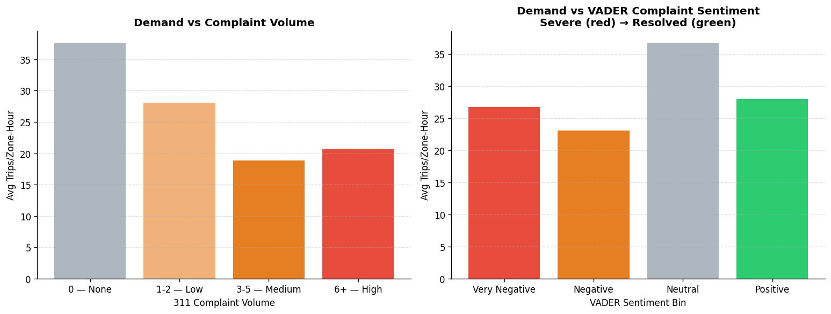

Figure G10: Demand vs. 311 Complaint Volume and VADER Sentiment Quintile

Predictive Model - Feature Importance and Predictions

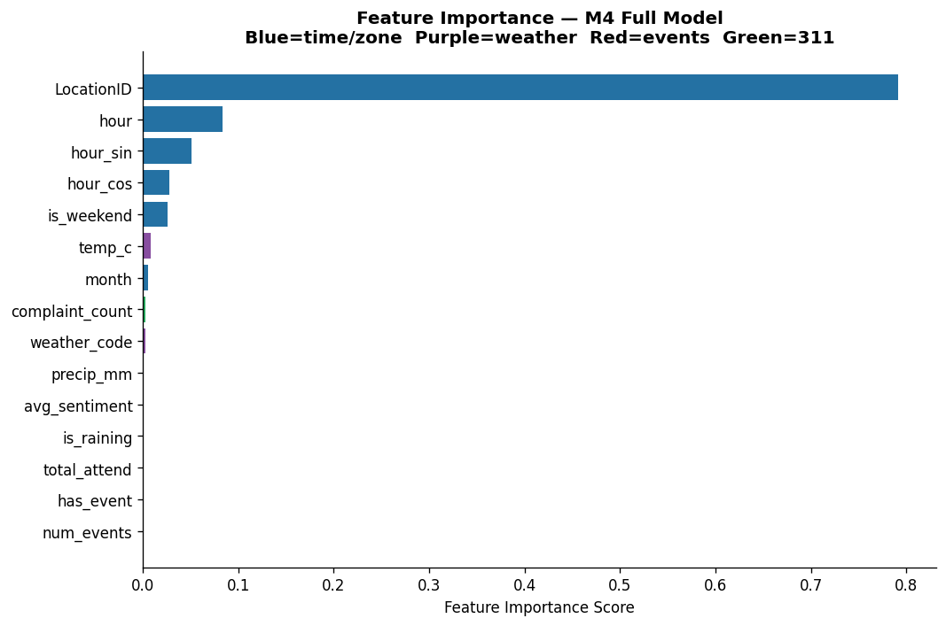

Figure G11: Feature Importance - M4 Full Random Forest Model

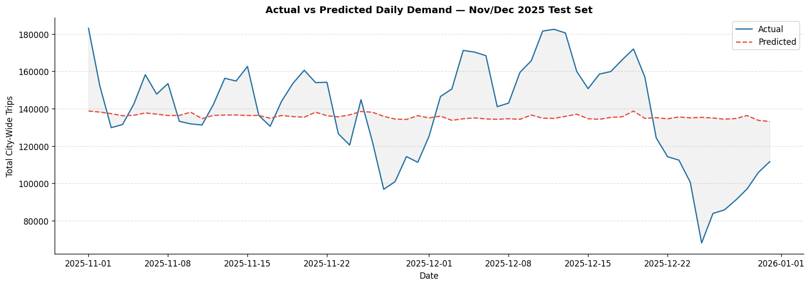

Figure G12: Actual vs. Predicted Daily Demand - Nov/Dec 2025 Test Set

Repositioning Score Output

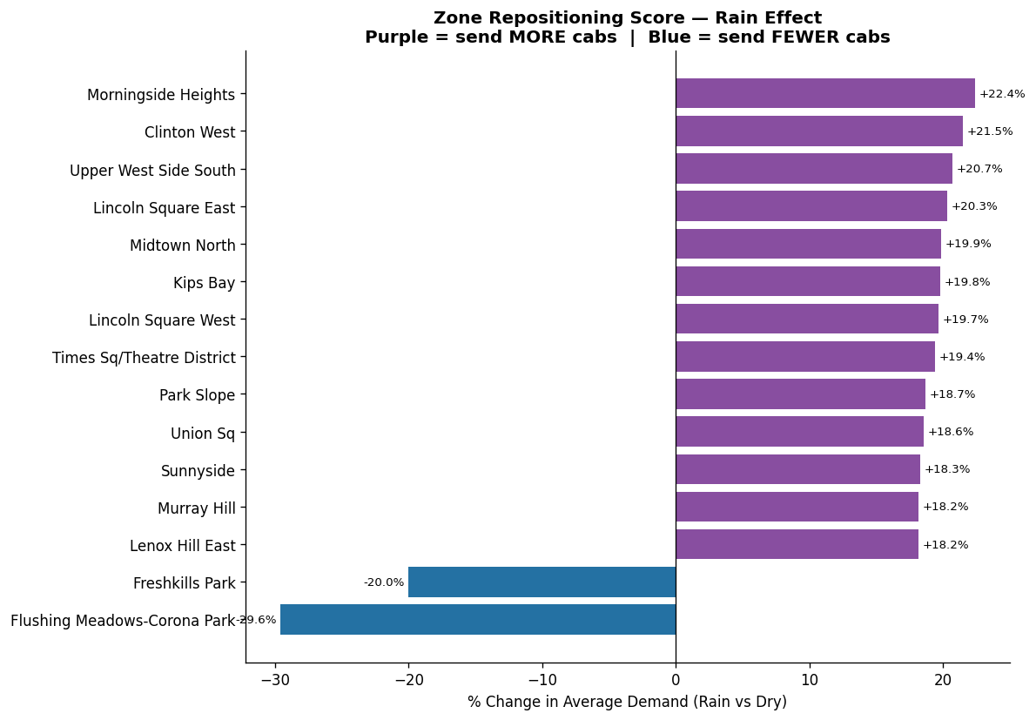

Figure G13: Zone Repositioning Score - Rain Effect (Top and Bottom Zones)

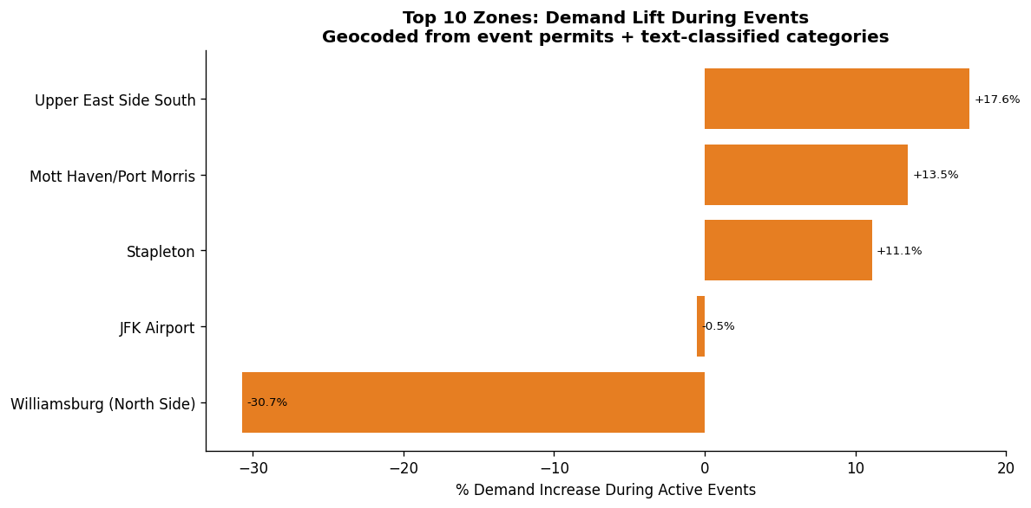

Figure G14: Top 10 Zones: Demand Lift During Active Events

