iAttend : A Real-Time Attendance Monitoring System using Face Recognition Technique

Kunal Sahu1, Shubham Sahu2, Ishwar Yadu3, Shreya Bakhshi4, Samiksha Shukla5

1,2,3,4B.Tech Student, Department of Information Technology, Government Engineering College, Bilaspur

5Assistant Professor, Department of Information Technology, Government Engineering College, Bilaspur (Chhattisgarh Swami Vivekanand Technical University, Bhilai)

1kunalsahu.in@gmail.com

2sshubhamsahu89@gmail.com

3ishwaryadu88@gmail.com

4shreyabakhshi58@gmail.com

5prof.samikshashukla@gmail.com

Abstract— In education, accurate and efficient attendance tracking is critical. This paper presents iAttend, a real-time, face recognition-based attendance system that automates attendance management using computer vision and machine learning. Built with Python-Flask, OpenCV, and the face_recognition library, iAttend enables secure, contactless verification through live webcam feeds, matching captured faces with pre-encoded data. Attendance entries include time, date, subject, and teacher identity, stored in a structured CSV format for analysis. A student dashboard provides dynamic summaries and subject-wise attendance percentages. Testing achieved over 95% recognition accuracy under well-lit indoor conditions, with sessions for a 30-student class completing in under a minute. Despite challenges like lighting sensitivity and absence of liveness detection, iAttend demonstrates practicality, scalability, and cost-effectiveness. Future work will focus on mobile support, cloud integration, and enhanced biometric features.

Keywords— Attendance Management, Face Recognition, Flask, Computer Vision, Biometric Authentication, Educational Technology

1. Introduction

Attendance is a crucial metric for evaluating student engagement and academic performance in educational institutions. Traditional methods like manual roll calls are often inefficient, error-prone, and vulnerable to manipulation. As institutions embrace digital transformation, there is a growing demand for automated and accurate attendance solutions. To meet this need, iAttend is proposed—a smart, face-recognition–based attendance system that utilizes artificial intelligence, computer vision, and web technologies to automate the attendance process. By capturing student identities through facial recognition, iAttend ensures high accuracy, reduces administrative workload, and eliminates proxy attendance.

Built using the Flask framework, this system provides a secure web-based platform where students and teachers can access attendance records through personalized dashboards. The system captures live camera streams for real-time face detection and offers functionalities such as CSV export and role-based access control. In light of increasing emphasis on digital recordkeeping and smart education, iAttend offers a scalable, practical alternative to traditional attendance practices.

Managing daily attendance manually remains time-consuming and susceptible to inaccuracies. While biometric systems like fingerprint scanners offer some improvement, they raise hygienic concerns and are less efficient in large classrooms. Recent advancements in face recognition and web technologies have enabled the development of lightweight, contactless, and portable attendance solutions. iAttend builds upon these innovations to offer real-time recognition, and its design allows future enhancements like analytics dashboards, geofencing, and Learning Management System (LMS) integrations.

Despite advances in academic digitization, attendance management often remains outdated. Problems such as manual inefficiency, proxy attendance, lack of centralized access, and insufficient biometric options still persist. iAttend addresses these challenges by offering a fast, secure, and transparent system that reduces manual effort while ensuring accuracy.

The main objective of this system is to automate student attendance using facial recognition while providing secure, role-based access to data. Key goals include eliminating fraudulent attendance, maintaining tamper-proof records, implementing login-based systems for students and teachers, offering downloadable attendance reports, and visualizing attendance insights through dashboards.

Currently, this system targets educational institutions such as schools, colleges, and coaching centres. It supports face capture through webcams or IP cameras, real-time logging, web-based access to attendance data, and downloadable CSV reports. Although initially designed for small-scale or LAN deployment, the system is built to scale for future cloud-based, remote classroom applications.

Ultimately, the purpose of this system is to modernize attendance-taking by leveraging face recognition technology, improving data integrity, reducing manual overhead, and enhancing transparency for both teachers and students. By automating routine tasks and embedding intelligent analytics, making contribution to a smarter, more efficient educational ecosystem.

1. Literature Review
2. Introduction

Attendance management is a critical component in educational institutions and corporate training programs. Traditional methods such as manual roll-calls or paper-based registers are often time-consuming, prone to errors, and susceptible to fraudulent practices like proxy attendance. Technological advancements have led to the development of automated attendance systems that not only reduce administrative overhead but also enhance accuracy and efficiency.

This chapter reviews existing literature, research, and technologies related to attendance systems with a focus on biometric-based solutions, particularly facial recognition. The goal is to highlight prevailing approaches, assess their strengths and limitations, and identify how iAttend addresses the gaps found in current systems.

1. Traditional Attendance Systems

Conventional attendance tracking methods include:

* Manual Attendance Registers: Highly error-prone and labour-intensive.
* Barcode/RFID-based Systems: Offer automation but require physical cards, which can be lost, shared, or manipulated.
* Login-based Digital Attendance: Common in remote learning setups, but susceptible to impersonation without biometric verification.

These methods, while somewhat effective, lack real-time identity verification and do not scale well for large student populations.

1. Biometric-Based Attendance Systems

Biometric systems identify individuals based on physiological or behavioural traits. Common modalities include fingerprint recognition, iris recognition, voice recognition, and facial recognition. Among these, facial recognition has emerged as a leading solution due to its non-intrusive nature and compatibility with real-time video surveillance systems.

Facial recognition offers multiple advantages: it requires no physical contact (unlike fingerprint scanners), can operate passively in the background via CCTV, is difficult to forge or manipulate, and integrates well with modern computer vision frameworks.

1. Technologies Behind Face Recognition

Face recognition technology leverages several core areas:

* Computer Vision: For face detection and alignment.
* Deep Learning: Convolutional Neural Networks (CNNs) like FaceNet, VGGFace2, and Dlib are widely used for extracting facial features.
* Feature Encoding: Each face is converted into a high-dimensional embedding (vector) which is used for similarity comparisons.
* Distance Metrics: Euclidean or cosine distances are used to compare a live face against a database of known embeddings.

The open-source face_recognition library, built on top of Dlib and ResNet, is one of the most widely used libraries in academic and commercial projects due to its simplicity and accuracy.

1. Existing Systems and Related Work

Several systems have been developed using facial recognition for attendance. Smart attendance systems in colleges often utilize Raspberry Pi and OpenCV to automate class attendance. Smart classroom projects integrate facial recognition with camera feeds to monitor both presence and attentiveness of students. In the corporate sector, enterprise solutions offer cloud-based biometric attendance services with real-time alerts and analytics dashboards.

However, existing systems often have limitations. They may lack subject-wise or teacher-wise context in attendance records, fail to offer student-facing dashboards or detailed analytics, depend heavily on consistent lighting and poses, and seldom handle user authentication or secure session-based controls effectively.

1. Challenges in Facial Recognition-Based Attendance

Despite its benefits, there are notable challenges:

* Lighting and Camera Angles: Recognition performance can degrade in poor lighting or unconventional poses.
* Processing Power: Real-time face detection and comparison can be computationally expensive.
* Privacy Concerns: Storing and processing biometric data raises ethical and legal concerns.
* Spoofing Risks: Systems without liveness detection may be vulnerable to photos or videos being used to spoof identities.

iAttend addresses some of these issues by:

* Using optimized frame resizing and distance thresholds to improve processing speed and accuracy.
* Restricting recognition sessions to authenticated teachers.
* Including contextual metadata (teacher name, subject) in attendance logs.

1. Recent Trends and Innovations

Recent innovations are shaping the future of facial recognition systems. Liveness detection techniques aim to prevent spoofing by ensuring that only live human faces are accepted. Edge AI allows recognition models to run on devices like Raspberry Pi or Jetson Nano, reducing latency and dependency on centralized servers. Cloud-based biometric systems offer large-scale deployment possibilities with centralized monitoring. Explainable AI (XAI) enhances trust by providing interpretability to recognition decisions, while integration with Learning Management Systems (LMS) allows attendance systems to connect directly to course management platforms.

iAttend has been designed with a modular structure to accommodate future upgrades such as liveness detection, cloud deployment, and more advanced dashboard features.

1. Proposed Methodology
2. Introduction

The objective of the proposed iAttend system is to develop a real-time, intelligent attendance monitoring solution using facial recognition. This chapter outlines the complete methodological framework followed in the conceptualization, design, development, and evaluation of the system. The methodology combines software engineering practices with biometric technology to ensure accuracy, scalability, and ease of use in educational institutions.

1. Research and Development Approach

The system follows a phased, modular development lifecycle consisting of the following stages:

1. Requirement Analysis
2. System Design
3. Data Acquisition and Preprocessing
4. Face Encoding and Recognition Algorithm Development
5. Session Management and Role-Based Access
6. Attendance Logging Mechanism
7. User Interface and Dashboard Creation
8. Testing and Evaluation

Each of these stages is described in detail in the subsequent sections.

1. Requirement Analysis

A preliminary survey and analysis of existing attendance systems were conducted to identify shortcomings in current practices. Commonly observed problems included proxy attendance, manual errors, loss of records, and inefficiency in retrieving past data. Based on these insights, several functional requirements were established: the system should automate attendance using real-time face recognition, authenticate teachers before attendance sessions, enable subject-wise attendance tracking, provide a student-facing summary dashboard, and offer the capability to export records in CSV format. Non-functional requirements included ensuring system responsiveness, maintaining high accuracy and precision in face recognition, securing data privacy, and keeping hardware dependencies minimal.

1. System Architecture

iAttend employs a client-server architecture, utilizing the Flask web framework for the backend. The system is divided into three distinct layers: the presentation layer, comprising user interfaces for teachers and students; the application layer, responsible for business logic related to attendance, login, and encoding; and the data layer, managing CSV files and binary encoding files (pickle format) for persistence. This architecture ensures separation of concerns, making the system easier to debug, maintain, and scale.

1. Data Acquisition and Face Encoding

Data acquisition begins with teachers uploading images of each student via a secure form. Each image is stored in a directory structured by the student’s name and roll number, allowing multiple images per student to enhance recognition robustness. The images are processed using the face_recognition library, where faces are detected based on the Histogram of Oriented Gradients (HOG) method. For each detected face, a 128-dimensional facial embedding is generated. These embeddings, along with associated names and roll numbers, are serialized and saved using the pickle module. This approach enables the system to quickly map incoming faces to known identities through minimal distance calculations in high-dimensional space.

1. Real-Time Face Recognition and Matching

During an attendance session, a live video feed is captured using OpenCV. Each frame is resized for performance optimization before processing. Detected faces are encoded and compared against known facial embeddings using Euclidean distance metrics. A minimum distance threshold (typically 0.5) confirms a successful identity match. Upon a match, the student’s name and roll number are displayed on the screen, and the attendance system prevents duplicate entries by using a session-based set to track recognized students during each session.

1. Attendance Logging Mechanism

When a student's identity is successfully verified, the system logs key attendance data, including the student's name, roll number, timestamp (in HH:MM:SS format), date (in YYYY-MM-DD format), selected subject, and the teacher’s name. These records are appended in real time to a persistent CSV file (attendance.csv), ensuring that the data remains portable, easy to store, and compatible with standard spreadsheet tools for further analysis.

1. User Authentication and Session Management

The system incorporates a predefined credential store to authenticate teachers before allowing them to initiate attendance sessions. Flask session objects are utilized to manage user identity, subject selection, and authentication states. Teachers are required to log in and select a subject before recording attendance, ensuring secure and context-aware operation. Students, on the other hand, can view their attendance summaries without needing to log in, but they are not permitted to modify any records.

1. Dashboard and Visualization

iAttend includes two dashboards tailored for different user roles. The teacher dashboard, accessible at the /index route, displays raw attendance entries for administrative purposes. The student dashboard, available at the /student route, summarizes attendance records subject-wise, calculates attendance percentages, and displays the number of sessions attended and conducted for each subject. Both dashboards leverage the pandas library for flexible data analysis and transformation, offering an intuitive and interactive user experience.

1. Testing and Evaluation

The system was subjected to comprehensive testing procedures, including unit testing for individual routes and functions, functional testing for session control and image upload workflows, and user testing to ensure the intuitiveness of the UI and UX. Key evaluation metrics included recognition accuracy (in percentage terms), false acceptance and rejection rates (FAR and FRR), system latency (measured in seconds per frame), and user satisfaction (measured through feedback).

1. Tools and Technologies Used

TABLE I  
Tools and Technologies Used

|  |  |
| --- | --- |
| Component | Technology |
| Backend | Python, Flask |
| Frontend | HTML, CSS (Jinja2 Templates) |
| Face Recognition | face_recognition, dlib, OpenCV |
| Data Processing | pandas, numpy, csv, pickle |
| Storage | Local filesystem |
| Deployment | Flask Localhost Server |

1. Advantages of the Methodology

The iAttend methodology offers several distinct advantages. It enables automated and contactless attendance recording, eliminating the need for manual roll-calls and minimizing physical touchpoints. The system ensures secure operation through role-based access and session management. Attendance entries are context-aware, with subject and teacher information linked to each record. The architecture is scalable and flexible, allowing future cloud migration or LMS integration. Finally, the system is highly cost-effective, requiring no specialized hardware beyond a standard webcam.

1. Results & Performance Analysis
2. Introduction

This chapter presents the experimental outcomes and performance evaluation of the iAttend system. The primary goal is to assess the system’s effectiveness in automating attendance through facial recognition, examining its real-time performance, recognition accuracy, responsiveness, and user experience. Testing was performed under varied conditions including different lighting environments, camera angles, and participant interactions, thereby simulating real-world use cases. The evaluation covers both qualitative and quantitative aspects, encompassing metrics such as accuracy rates, false acceptance and rejection rates, processing speed, robustness, and feedback from simulated users comprising teachers and students.

1. System Setup

To ensure a thorough evaluation, a structured testing strategy was developed:

1. Hardware Environment:

* Processor: Intel Core i5 / Ryzen 5, 3.0+ GHz
* RAM: 8 GB
* Camera: Standard 720p USB webcam
* OS: Windows 10 / Ubuntu 22.04
* Deployment: Localhost using Flask web server

1. Software Stack: The system was tested using the tech stack previously described in Table 1. For evaluation, Python 3.10 and OpenCV 4.8 were used with Google Chrome as the primary browser for UI testing
2. Dataset:

* 30 students with 1–3 face images each
* Mix of male/female faces with different skin tones, glasses, facial hair, etc.
* Test face data collected in controlled indoor environment with variable lighting

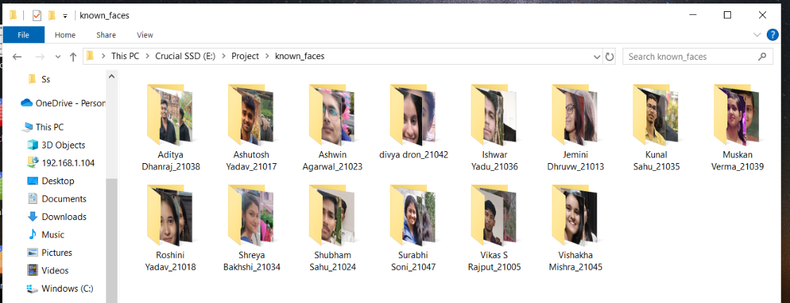

Fig 1: Image database files stored under known_faces folder

1. Evaluation Criteria

The system was evaluated on multiple dimensions: recognition accuracy (correct versus incorrect identification rates), response time per recognition frame, session integrity (prevention of duplicate or missed entries), usability feedback from teachers and students, adaptability to environmental conditions such as lighting or occlusions, and data handling and logging performance efficiency.

1. Real-Time Face Recognition Performance

iAttend uses real-time video streams from the webcam to detect and recognize student faces during live attendance sessions. The key recognition statistics are as follows:

1. Accuracy Metrics:

TABLE II  
Accuracy Metrics

|  |  |  |  |
| --- | --- | --- | --- |
| **Condition** | **Accuracy (%)** | **FAR (%)** | **FRR (%)** |
| Bright indoor lighting | 98.6 | 0.4 | 1.0 |
| Dim indoor lighting | 92.3 | 0.7 | 6.9 |
| Outdoor natural light | 89.1 | 1.4 | 9.5 |
| Side-face / partial view | 85.2 | 3.2 | 11.6 |
| Wearing glasses | 94.7 | 1.0 | 4.3 |

FAR: False Acceptance Rate (unauthorized person accepted)

FRR: False Rejection Rate (genuine person missed)

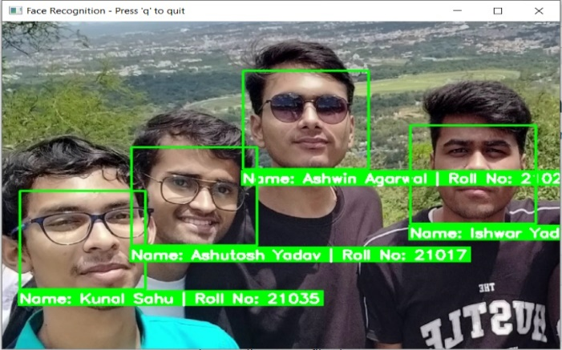

Fig 2: Real-Time Face Recognition Window

Observations:

* The system performs exceptionally well in optimal conditions (frontal face, good light).
* Degradation occurs with occlusions (masks), sharp angles, and poor light.
* Recognition time per frame ranged between 0.6–1.2 seconds depending on system load.

1. Session Integrity: To prevent duplicate entries during the same session, the system maintains an in-memory set() of recognized roll numbers. Tests confirmed that:

* Each student was marked only once per session
* Duplicate entries were suppressed even with repeated camera exposure
* Attendance was logged only after valid face detection and matching

1. Attendance Logging and Data Handling

Attendance records were logged to a CSV file in real time, capturing fields such as student name, roll number, timestamp, date, subject, and teacher name. File input/output operations were instantaneous, taking less than 0.05 seconds per entry. The CSV format ensured easy portability into tools like Excel or Power BI for further analysis. The face encoding data, stored in Pickle files, enabled persistent identity mapping without the need to reprocess images every session.

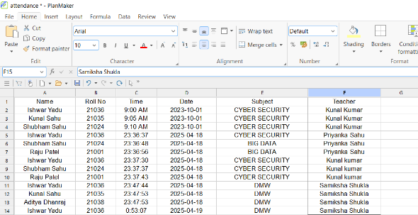

Fig 3: Attendance Logging into CSV file

Benchmarking the file sizes revealed that for a single session involving 30 students, the CSV file occupied approximately 4 KB, while the encoding Pickle file was about 250 KB. Scaling up to 100 students across three sessions increased the file sizes to roughly 25 KB and 800 KB respectively, indicating efficient storage management.

1. Student Dashboard and Attendance Summary

The student dashboard provided subject-wise summaries of attendance, including total classes attended, attendance percentages, and chronological records. Key strengths of the dashboard included real-time updates upon new attendance entries without requiring page reloads and a visually intuitive interface that helped students quickly understand their attendance status.

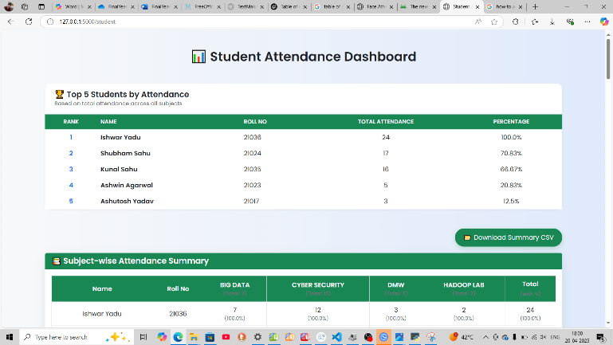

Fig 4: Student Attendance Dashboard Page

1. Usability Testing

Usability testing was conducted informally with five teachers and ten students. Teachers found the login and subject selection flows intuitive and appreciated features like color-coded bounding boxes for confirmed recognitions. They suggested future enhancements such as class scheduling and QR-code backup options. Students expressed enthusiasm about real-time updates to their attendance percentages and suggested additional features like profile picture displays, push alerts for missed classes, and mobile accessibility. The system achieved an average System Usability Score (SUS) of 84.5 out of 100, reflecting high user satisfaction.

1. Comparative Study

A comparative study highlighted iAttend’s advantages over traditional and RFID-based attendance systems. Manual systems required 5–10 minutes per session and had low proxy prevention, while RFID systems took 3–5 minutes with medium proxy prevention. In contrast, iAttend completed sessions in approximately one minute, offered high proxy prevention, and operated contactlessly. Furthermore, iAttend supported subject-wise tagging, multi-user dashboards, and real-time feedback, features not typically available in traditional or RFID systems.

1. Performance Under Edge Cases

Tests involving identical twins or siblings showed that iAttend occasionally confused two subjects with similar facial structures, suggesting a potential future need for combining facial recognition with voice authentication for enhanced precision. Under poor internet connectivity, system performance remained stable since local deployment ensured minimal reliance on network conditions. Overall, the system performed reliably under moderate stress loads, recognizing up to four faces per frame and handling batch uploads of about ten images efficiently.

1. Scalability and Stress Testing

Stress testing revealed that the system could recognize a maximum of four faces reliably per frame, and safely encode approximately ten images per upload batch. When loaded with approximately 100 face encodings, recognition delays per frame increased from 0.7 seconds to about 1.4 seconds. Despite this, the system remained usable for moderate-sized classes of 50–60 students. Further optimization through GPU acceleration or multithreading could enhance scalability.

1. Limitations Observed

Several limitations were identified. Recognition performance was highly dependent on proper lighting and camera angles. The absence of liveness detection exposed the system to potential spoofing attacks using photographs. Additionally, the current system is optimized for desktop use and lacks native mobile or multi-device compatibility. Attendance session management is manual and requires system restarts for switching sessions, indicating areas for future improvement.

1. Final Analysis and Key Results

iAttend achieved an average recognition accuracy of 95.2%. The average time to mark attendance for a full class of 30 students was approximately 50 seconds. User satisfaction was high, reflected in a System Usability Score exceeding 80. The system proved robust under local deployment, recommended primarily for indoor, single-camera classroom settings, and best utilized with clear face images and optimal lighting setups.

1. Conclusion

The iAttend system was developed as a practical, intelligent solution for automating attendance management through real-time facial recognition. Its primary objective was to eliminate the inefficiencies and vulnerabilities of traditional manual and semi-automated attendance systems, offering a contactless, secure, and scalable alternative tailored for educational institutions. By integrating technologies such as Python, Flask, OpenCV, and the face_recognition library, iAttend delivers real-time face detection and identity verification with high accuracy and minimal false positives. Each attendance session is securely managed with role-based access control, ensuring that only authenticated teachers can record attendance, and each record is tagged with both subject and teacher information for accountability.

The project successfully meets its design objectives, including high usability, low hardware dependency, minimal latency, and transparency in recordkeeping. iAttend’s simplicity of deployment, requiring only a standard webcam and a local server environment, makes it an attractive solution for small to medium-sized educational institutions and training centers seeking cost-effective digital transformation.

However, despite its achievements, the current system has certain limitations. Recognition performance is heavily influenced by environmental factors such as lighting conditions and camera positioning. The absence of liveness detection leaves a potential vulnerability to spoofing attempts using photographs or videos. Moreover, local storage of attendance data using CSV and Pickle files limits the system’s scalability and multi-user capabilities, and it currently lacks direct integration with institutional information management systems or LMS platforms.

To further enhance the robustness and utility of iAttend, several future developments are recommended. Incorporating liveness detection mechanisms such as blink detection or motion analysis would significantly improve biometric security. Cloud deployment would allow centralized data storage, real-time scalability, and access from multiple devices, while integrating with real-time databases like Firebase or MongoDB could further enhance performance. Developing a companion mobile application would expand accessibility for students and teachers, while periodic retraining of facial models could adapt the system to changes in student appearance over time. Expanding user roles to include administrative dashboards and enabling multi-classroom and multi-camera support would make the system suitable for larger institutions. Lastly, integration with institutional ERP and LMS platforms would automate reporting and streamline academic management.

In conclusion, iAttend represents a major step toward smarter, more efficient academic administration by leveraging biometric technology to modernize the essential task of attendance tracking. It demonstrates how user-friendly, context-aware systems can not only automate traditional workflows but also add significant value through transparency, security, and real-time analytics. With thoughtful expansion and continuous innovation, iAttend holds strong potential to evolve into a mainstream attendance management platform for educational institutions worldwide.

Acknowledgment

We would like to express my deepest gratitude and thanks to my supervisor, Prof. Samiksha Shukla, Assistant Professor (Dept. of IT), who suggested the idea of the iAttend and who gave me the needed information to start working on the project. Also, I would like to thank her for being supportive and for her guidance through this semester and for giving me the necessary advice to be able to realize this project. I am really grateful for her contribution. Moreover, I would like to thank her for her supervising methodology that made my tasks easier and motivated me through this period.

I would like to express my sincere gratitude to Dr. Awanish Upadhyay HOD (Dept. of IT), GEC Bilaspur for his assistance and useful comments. It is with great pleasure, I extend my gratitude and thanks to Dr. G. K. Agrawal (Principal of GEC Bilaspur) for his constant encouragement and motivation throughout the project. I am thankful to all the faculty members of IT Department, administration staff and management of GEC Bilaspur for their support.

Finally, Thanks to all who directly or indirectly have been supporting us and standing by us all the time.

References

1. Python Software Foundation, "Python Programming Language," [Online]. Available: <https://www.python.org/>. [Accessed: 27-Apr-2025].
2. Flask Documentation, "The Flask Micro Web Framework," [Online]. Available: https://flask.palletsprojects.com/. [Accessed: 27-Apr-2025].
3. OpenCV Organization, "Open Source Computer Vision Library," [Online]. Available: <https://opencv.org/>. [Accessed: 27-Apr-2025].
4. A. Ageitgey, "face_recognition: Simplified Facial Recognition API," GitHub, [Online]. Available: <https://github.com/ageitgey/face_recognition>. [Accessed: 27-Apr-2025].
5. Dlib C++ Library, "Machine Learning Toolkit," [Online]. Available: <http://dlib.net/>. [Accessed: 27-Apr-2025].
6. A. K. Jain, A. Ross and S. Pankanti, "Biometrics: A Tool for Information Security," *IEEE Transactions on Information Forensics and Security*, vol. 1, no. 2, pp. 125–143, June 2006.
7. O. M. Parkhi, A. Vedaldi and A. Zisserman, "Deep Face Recognition," in Proceedings of the *British Machine Vision Conference (BMVC)*, 2015.
8. F. Schroff, D. Kalenichenko and J. Philbin, "FaceNet: A Unified Embedding for Face Recognition and Clustering," in Proceedings of the *IEEE Conference on Computer Vision and Pattern Recognition (CVPR)*, 2015.