A Software Requirements Specification
on
Remote Classroom for Rural Colleges - GyaanSetu
Submitted in Partial Fulfillment for the Award of Degree of Bachelor of Technology in Computer Science and Engineering from Rajasthan Technical University, Kota

MENTOR:  Swati Yadav  Assistant Professor  (Dept. of Computer Science & Engineering)  COORDINATOR:  Jyoti Singh  Associate Professor  (Dept. of Computer Science & Engineering) | SUBMITTED BY:  Kunal Saukhiya (23ESKCS128)  Manish Regar (23ESKCS137)  Rishabh Jain (23ESKCS185)  Manish Kumar (23ESKCS136)
DEPARTMENT OF COMPUTER SCIENCE & ENGINEERING
SWAMI KESHVANAND INSTITUTE OF TECHNOLOGY, MANAGEMENT & GRAMOTHAN
Ramnagaria (Jagatpura), Jaipur – 302017
SESSION 2026-27

Table of Contents
Chapter | Topic Description | Page No.
1 | Introduction | 1
 | 1.1 Introduction and Problem Context | 1
 | 1.2 Purpose of the Software Requirements Specification | 2
 | 1.3 Methodology | 3
 | 1.4 Need and Motivation | 4
2 | Market Survey | 5
 | 2.1 Current Trends in Educational Technology | 5
 | 2.2 Compatible Study of Similar Solutions | 6
 | 2.3 Critical Gap Analysis in Rural Deployments | 8
 | 2.4 Project Objectives | 9
3 | Requirements | 10
 | 3.1 Functional Requirements (FR-01 to FR-10) | 10
 | Table 3.1: Functional Requirements Traceability Matrix | 13
 | 3.2 Non-Functional Requirements (NFR-01 to NFR-08) | 14
 | Table 3.2: Non-Functional Requirements Verification Matrix | 16
 | 3.3 Hardware Requirements (Client, Server & Network) | 17
 | 3.4 Software Requirements & Technology Stack | 18
 | 3.5 Agile Model Implementation & Sprint Roadmap | 20
 | Table 3.4: Complete 14-Sprint Execution Schedule | 21
4 | System Architecture | 23
 | 4.1 Client-Server Three-Tier Architecture | 23
 | Figure 4.1: Client-Server Three-Tier Architecture | 24
 | Table 4.1: Architectural Layer Specifications | 25
 | 4.2 Tier Communication Protocols and Media Routing | 26
 | 4.3 System Security and Boundary Architecture | 27
5 | Design and Implementation | 28
 | 5.1 Product Features | 28
 | 5.2 Data Flow Diagrams (Level 0, Level 1, Level 2) | 29
 | Figure 5.1: DFD Level 0 (Context Diagram) & Table 5.1 | 29
 | Figure 5.2: DFD Level 1 (Decomposition) & Table 5.2 | 31
 | Figure 5.3: DFD Level 2 (Coursework Pipeline) & Table 5.3 | 33
 | 5.3 Entity-Relationship (E-R) Conceptual Schema | 35
 | Figure 5.4: E-R Diagram & Table 5.4 Relational Schema | 35
 | 5.4 UML Class Diagram & Domain Model Design | 37
 | Figure 5.5: Class Diagram & Table 5.5 Method Signatures | 37
 | 5.5 UML Use Case Diagram & Actor Interaction Scenarios | 39
 | Figure 5.6: Use Case Diagram & Table 5.6 Actor Catalog | 39
 | 5.6 UML Sequence Diagrams (Auth & Live Class Streaming) | 41
 | Figure 5.7: Sequence Diagram 1 (Auth) & Table 5.7 | 41
 | Figure 5.8: Sequence Diagram 2 (Live Streaming) & Table 5.8 | 43
6 | Conclusion & Future Scope | 45
 | 6.1 Conclusion | 45
 | 6.2 Limitations of Current Version | 46
 | 6.3 Future Engineering Roadmap | 47
7 | UN Sustainable Development Goals | 48
 | 7.1 Background and Alignment with UN SDG-4 | 48
 | Figure 7.1: GyaanSetu SDG-4 Alignment Chart | 49
 | 7.2 Quantitative Correlation Matrix | 50
 | 7.3 Faculty Review and Approval Signatures | 51
8 | References | 52

Chapter-1
Introduction
1.1 Introduction and Problem Context
Higher education in India encompasses over 43,000 affiliated colleges and polytechnic institutes, catering to more than 41 million enrolled students. A critical structural observation reveals that approximately 60% of these colleges are located in rural, semi-urban, and remote geographical regions across states such as Rajasthan, Uttar Pradesh, Madhya Pradesh, and Bihar. While premier tier-1 engineering institutions situated in metropolitan clusters benefit from high-speed gigabit fiber connectivity, advanced institutional LMS suites, and well-equipped digital auditoriums, rural collegiate institutions face persistent systemic impediments in delivering continuous, equitable academic instruction.
The primary barrier preventing rural collegiate students from participating in conventional virtual learning environments is severe network volatility. Rural cellular networks (predominantly 3G and congested 4G LTE) exhibit erratic transmission speeds, fluctuating dynamically between 250 kbps and 1.5 Mbps, compounded by frequent latency spikes exceeding 300 ms and packet loss rates exceeding 8%. Mainstream enterprise collaboration tools such as Zoom, Google Meet, and Microsoft Teams are engineered for high-bandwidth metropolitan broadband infrastructure, demanding sustained downstream bitrates of 1.5 to 3.0 Mbps. When deployed across rural cellular networks, these platforms suffer catastrophic packet degradation, manifest recurrent audio dropouts, and ultimately terminate the video socket connection entirely.
Furthermore, the economic dimension of rural digital connectivity imposes strict computational boundaries. Rural collegiate students predominantly rely on daily cellular data allowances (typically capped at 1.5 GB to 2.0 GB per day per household), which must be shared among multiple family members for communication, employment, and essential utilities. Standard commercial video conferencing tools consume between 800 MB and 1.2 GB of mobile data per hour of live streaming, exhausting a student's entire daily cellular allotment in a single lecture. This economic penalty forces students to disconnect from live sessions, exacerbating absenteeism and educational inequity.
GyaanSetu ('Bridge of Knowledge') is conceptualized and engineered specifically to dismantle these systemic obstacles. By establishing an ultra-low-bandwidth, mobile-optimized remote classroom architecture, GyaanSetu enables rural students to attend live lectures, access lecture notes, submit coursework, track verified attendance, and interact with an AI academic tutor while consuming less than 180 MB per hour under fluctuating network conditions as constrained as 350 kbps.
1.2 Purpose of the Software Requirements Specification
The purpose of this Software Requirements Specification (SRS) document is to establish a rigorous, comprehensive, and unambiguous technical definition of the functional, non-functional, behavioral, and architectural requirements for the GyaanSetu platform. Conforming to the IEEE 830-1998 standard for Software Requirements Specifications and adapted to the curriculum guidelines of Rajasthan Technical University (RTU), Kota, this document serves as the formal contractual and technical baseline between the student engineering development team, faculty project mentors, academic evaluators, and system stakeholders.
This specification provides detailed documentation across the following critical engineering facets:
- Scope & Boundaries: Explicitly defines the capabilities, operating constraints, and system boundaries of GyaanSetu as an educational PWA.
- Verification & Validation Baseline: Establishes quantitative metrics and acceptance criteria for unit testing, load testing, network throttling verification, and user acceptance testing (UAT).
- Architectural Blueprints: Details the three-tier client-server topology, data models, UML behavioral diagrams, and external interface specifications.
- Maintenance & Extensibility: Serves as the foundational technical manual for future software maintenance, modular API expansion, and institutional open-source onboarding.
1.3 Methodology
The development of GyaanSetu follows an empirical Agile Scrum software engineering methodology, structured into fourteen discrete two-week sprints. The Agile framework was selected due to the high degree of network variance and user hardware diversity encountered in rural educational environments, necessitating rapid prototyping, continuous user validation, and iterative performance tuning.
The engineering lifecycle incorporates four core procedural stages within each sprint:
- 1. Backlog Grooming & Sprint Planning: Functional user stories are prioritized based on rural usability impact, mapped to story points using planning poker, and decomposed into granular technical tasks.
- 2. Test-Driven Implementation: Backend endpoints are authored using Express.js with unit and integration test coverage via Jest. Frontend React components are built with responsive TailwindCSS utility classes.
- 3. Network Throttling Validation: Every feature undergoes simulated cellular degradation testing using Chrome DevTools Network Emulation profiles (Slow 3G: 400 kbps downstream, 100 kbps upstream, 400 ms RTT; Fast 3G: 1.6 Mbps downstream, 750 kbps upstream, 150 ms RTT; and offline dropouts).
- 4. Stakeholder Sprint Review: Working software increments are reviewed bi-weekly with the project mentor (Swati Yadav, Assistant Professor) and project coordinator (Jyoti Singh, Associate Professor) for formal sign-off.
1.4 Need and Motivation
The motivation behind GyaanSetu originates from direct field observations of academic disruption in rural Rajasthan during post-pandemic blended learning transitions. While urban institutions transitioned seamlessly to commercial LMS and video suites, rural state degree colleges reported over 65% drop in virtual lecture attendance, primarily attributed to three root causes:
- Bandwidth Inequity: Inability of existing platforms to operate over sub-megabit rural mobile connections.
- Financial Overhead: Exorbitant commercial licensing costs for state universities and recurring cellular data costs for students.
- Fragmented Workflows: Teachers juggling WhatsApp for file sharing, Google Meet for lectures, and physical paper rosters for attendance, resulting in severe data loss and zero academic auditability.
GyaanSetu provides a unified, zero-licensing, open-source educational bridge that consolidates live WebRTC adaptive video, Cloudinary-managed digital notes, automated heartbeat attendance auditing, and 24/7 Google Gemini AI tutoring into a single lightweight Progressive Web App accessible on entry-level Android smartphones.

Chapter-2
Market Survey
2.1 Current Trends in Educational Technology
The global educational technology (EdTech) landscape is undergoing a structural paradigm shift driven by WebRTC (Web Real-Time Communication), cloud-native microservices, mobile-first progressive web architectures, and multimodal artificial intelligence. Contemporary pedagogical research demonstrates that passive pre-recorded lecture dissemination achieves significantly lower learning retention compared to synchronous, interactive virtual classrooms where students can raise queries and receive real-time feedback.
However, contemporary commercial EdTech platforms have been engineered predominantly for enterprise corporate training and well-connected private universities, emphasizing high-definition 1080p video feeds, background virtual canvas rendering, and heavy client-side JavaScript bundles. These design choices directly contradict the operational constraints of developing rural regions, where client hardware is limited to budget Android smartphones with 2GB–3GB RAM and mobile data packages are constrained.
2.2 Compatible Study of Similar Solutions
To assess the existing competitive landscape and identify architectural deficiencies in existing tools, a comprehensive comparative study was executed evaluating five prominent platforms: Zoom, Google Meet, Microsoft Teams, Teachmint, Moodle LMS, and the proposed GyaanSetu platform across ten critical technical parameters.
Feature / Dimension | Zoom | Google Meet | MS Teams | Teachmint | Moodle | GyaanSetu
Min. Bandwidth Required | 1.5 Mbps | 1.2 Mbps | 1.5 Mbps | 800 kbps | N/A (Async) | 350 kbps
Hourly Data Usage | 850 MB | 1.1 GB | 1.2 GB | 500 MB | Minimal | < 180 MB
Audio-First Fallback | Partial | Manual | Partial | Basic | N/A | Automatic & Enforced
Low-End Mobile Optim. | Poor (Heavy) | Moderate | Poor (Heavy) | Moderate | Good (Web) | Excellent (<15MB RAM)
Built-in 24/7 AI Tutor | No (Paid Addon) | No (Gemini Ent.) | No (Copilot Paid) | No | No | Yes (Gemini 1.5 Flash)
Automated CSV Attendance | Host Plan Only | Workspace Paid | Enterprise Only | Yes | Plugin Req. | Yes (Heartbeat Audit)
2.3 Critical Gap Analysis in Rural Deployments
The empirical survey reveals three critical systemic gaps in commercial solutions:
- 1. Lack of Sub-Megabit Adaptive Resiliency: Mainstream meeting software treats sub-megabit connection as an edge-case error rather than standard operating reality. Under 500 kbps, Google Meet and Zoom aggressively freeze video and buffer audio, eventually ejecting the user with connection timeout errors.
- 2. Prohibitive Financial Licensing: Institutional features such as automated attendance audit logs, unlimited meeting durations, and cloud storage require enterprise tier licenses ranging from $12 to $25 per user per month—amounts utterly untenable for rural public state colleges operating on shoestring budgets.
- 3. Lack of Integrated Pedagogical Doubts Support: Commercial video platforms provide zero educational continuity once the synchronous meeting terminates. If a student fails to understand a concept due to connection jitter, they have no built-in remediation mechanism.
2.4 Project Objectives
GyaanSetu is engineered to realize the following quantifiable product objectives:
- Objective 1 (Bandwidth Optimization): Deliver uninterrupted live two-way lectures over cellular connections down to 350 kbps by deploying dynamic video resolution downscaling (360p) and automatic audio-first fallback.
- Objective 2 (Data Consumption Cap): Cap total client-side cellular data consumption to strictly under 180 MB per hour of active live video instruction (an 80% reduction compared to commercial benchmarks).
- Objective 3 (Zero Licensing Cost): Provide a 100% open-source, web-based platform with zero subscription fees for colleges, faculty, and students.
- Objective 4 (Automated Academic Accountability): Eliminate manual roll calls through client-side 60-second heartbeat attendance auditing, logging join, leave, and net active minutes into exportable CSV rosters.
- Objective 5 (Continuous AI Mentorship): Incorporate an embedded, context-aware Google Gemini 1.5 Flash AI academic tutor to deliver 24/7 personalized homework debugging and concept explanations.

Chapter-3
Requirements
3.1 Functional Requirements (FR-01 to FR-10)
The functional requirements define the explicit behavioral capabilities, inputs, processes, and outputs provided by the GyaanSetu system.
- FR-01: Mobile Phone SMS OTP Authentication: All Student and Teacher actors must authenticate securely using mobile phone numbers via Firebase Authentication. The system transmits a 6-digit cryptographic SMS OTP. Upon verification, the backend queries MongoDB credentials and issues an HTTP-only, SameSite JWT session cookie with role claims (Student/Teacher/Admin). Passwords are eliminated to eliminate credential loss.
- FR-02: Classroom Creation & Room Code Enrollment: Faculty members must be able to create course classrooms specifying course title, subject code, academic semester, and description. The backend auto-generates a unique 6-character alphanumeric room code. Students enter this room code to enroll instantly. Enrolled students are bound to the classroom roster in MongoDB.
- FR-03: Low-Bandwidth Adaptive WebRTC Live Lectures: Teachers must be able to initiate live virtual lectures with a single click. Live video and audio are orchestrated via ZegoCloud WebRTC Selective Forwarding Unit (SFU). The client engine monitors Round-Trip Time (RTT) and packet loss; if available bandwidth drops below 350 kbps, video transmission terminates automatically while preserving 48 kbps audio stream.
- FR-04: Digital Lecture Notes & Study Material Repository: Teachers must be able to upload PDF, PPTX, and DOCX study materials (up to 25 MB per file). Files are securely streamed to Cloudinary CDN with optimized compression. Uploaded materials are indexed by subject, chapter, and date, allowing enrolled students to download or view materials directly inside the browser.
- FR-05: Coursework & Assignment Submission Workflow: Teachers must be able to create assignments with title, instructions, total marks, and strict submission deadlines. Enrolled students can view active assignments and upload PDF submissions. The system records upload timestamps, validates MIME types, and automatically flags late submissions.
- FR-06: Evaluation, Rubric-Based Grading & Feedback: Teachers must be able to review submitted student PDFs in an integrated browser viewer, assign numerical marks up to the assignment maximum, and input qualitative written feedback. Graded scores sync instantly to student dashboards and compute cumulative class averages.
- FR-07: Automated Heartbeat-Based Attendance Auditing: The system must execute a client-side background timer transmitting cryptographic heartbeat pings to `/api/attendance/heartbeat` every 60 seconds while a student is in a live lecture. The backend logs join timestamp, last heartbeat, disconnection time, and net duration. Faculty can export attendance rosters as standardized CSV files.
- FR-08: 24/7 Google Gemini AI Study Assistant: Students must have access to an embedded AI academic assistant powered by Google Gemini 1.5 Flash. The assistant accepts natural language queries, explains technical engineering concepts, solves programming errors, and summarizes lecture notes with context-aware prompt templates.
- FR-09: Role-Based Access Control (RBAC) & Profile Management: The system enforces strict RBAC middleware across all protected routes. Students are restricted from creating classrooms, initiating meetings, or altering grades. Teachers possess management privileges over their assigned classrooms. Administrators possess platform oversight.
- FR-10: System Notifications & Real-Time Event Dispatch: Real-time alerts must be dispatched to enrolled students via Socket.io when a teacher begins a live lecture, posts a new assignment, or returns graded feedback, eliminating missed deadlines.
Table 3.1 details the functional requirements traceability matrix, delineating each requirement's operational category, targeted actor, and institutional release priority.
Req ID | Functional Module | Operational Scope | Primary Actor | Priority
FR-01 | Mobile OTP Auth | Firebase SMS verification & stateless JWT issuance | Student / Teacher | High
FR-02 | Classroom Hub | Course creation & 6-character room code enrollment | Teacher / Student | High
FR-03 | Adaptive WebRTC | SFU live video streaming with 350 kbps audio fallback | Teacher / Student | High
FR-04 | Notes Repository | Cloudinary PDF storage & in-browser material viewing | Teacher / Student | High
FR-05 | Assignment Engine | PDF submission portal with deadline & late detection | Student / Teacher | High
FR-06 | Grading & Feedback | Browser evaluation viewer & cumulative gradebook sync | Teacher / Student | Medium
FR-07 | Attendance Logger | 60s client heartbeat auditing & CSV spreadsheet export | Teacher / System | High
FR-08 | Gemini AI Tutor | 24/7 multimodal academic query & code debugging | Student | High
FR-09 | RBAC Enforcement | JWT role claim verification on protected Express routes | All Roles | High
FR-10 | Socket Alerts | Real-time WebSocket event dispatch for classes & grades | Student / Teacher | Medium
3.2 Non-Functional Requirements (NFR-01 to NFR-08)
Non-functional requirements specify the operational criteria, performance constraints, and quality attributes governing system execution.
- NFR-01: Performance & Response Latency: The Express.js REST API must maintain an average response latency of under 200 milliseconds for 95% of standard HTTP requests under standard server load. WebRTC video and audio transmission latency must not exceed 150 ms end-to-end to ensure natural interactive dialogue.
- NFR-02: Bandwidth Efficiency & Cellular Data Capping: Total client-side data consumption during an active live lecture session must strictly remain under 180 MB per hour per student. The system must remain fully operational and maintain intelligible two-way audio communication on cellular networks with bandwidth as low as 350 kbps.
- NFR-03: Reliability, Availability & Fault Tolerance: The production platform must achieve a minimum service availability of 99.5% uptime during academic operating hours (07:00 to 20:00 IST). In the event of transient cellular disconnects, the client PWA must automatically attempt reconnection using exponential backoff (1s, 2s, 4s, 8s) without crashing the application state.
- NFR-04: Security & Privacy Compliance: All network traffic must be encrypted in transit using TLS 1.3 over HTTPS and WSS (Secure WebSockets). Authentication JWT tokens must be stored exclusively in HTTP-only, Secure, SameSite=Strict cookies to eliminate cross-site scripting (XSS) token theft. Cloudinary and MongoDB credentials must be managed via server-side environment variables.
- NFR-05: Scalability & Concurrent Capacity: The backend Node.js cluster must support a minimum of 250 concurrent active users per single container instance. The architecture must support horizontal scaling behind an NGINX reverse proxy load balancer.
- NFR-06: Usability & Mobile Accessibility: The user interface must be fully responsive across mobile screens from 320px width upwards, conforming to WCAG 2.1 Level AA standards. Touch targets must measure at least 48x48 pixels to ensure ease of navigation on low-cost touchscreen smartphones.
- NFR-07: Maintainability & Modular Architecture: The codebase must adhere strictly to decoupled Model-View-Controller (MVC) architectural patterns. All API endpoints must follow RESTful design standards with semantic HTTP verbs (GET, POST, PUT, DELETE) and standardized JSON error payloads.
- NFR-08: Data Integrity & Auditability: All database write operations affecting attendance, submissions, and grades must utilize MongoDB ACID multi-document transactions where appropriate to prevent orphaned records. Audit records must include ISO 8601 UTC timestamps.
Table 3.2 details the quantitative quality attribute verification matrix for each non-functional requirement.
NFR ID | Quality Dimension | Quantitative Benchmark | Measurement / Verification Method
NFR-01 | Latency & Speed | API latency < 200ms; WebRTC latency < 150ms | Autocannon HTTP load testing & WebRTC getStats() API
NFR-02 | Data Consumption | < 180 MB/hr; operational down to 350 kbps | Chrome DevTools Network Throttling & Wireshark captures
NFR-03 | Availability | >= 99.5% uptime during 07:00-20:00 IST | UptimeRobot automated external synthetic health pings
NFR-04 | Security | TLS 1.3, HTTP-only JWTs, Zero OWASP Top 10 | OWASP ZAP vulnerability scanner & SSL Labs audit (A+)
NFR-05 | Scalability | 250+ concurrent users per container node | k6 distributed stress testing on Express/MongoDB stack
NFR-06 | Accessibility | WCAG 2.1 AA compliant; touch target >= 48px | Google Lighthouse Accessibility Audit (Score >= 92)
NFR-07 | Maintainability | Decoupled MVC architecture; REST compliance | ESLint static analysis & SonarQube technical debt audit
NFR-08 | Data Integrity | MongoDB ACID transactions; ISO 8601 UTC | Jest integration test suites verifying transactional rollbacks
3.3 Hardware Requirements
The hardware requirements for GyaanSetu are divided into client-side devices (for rural students and faculty) and production server infrastructure.
Subsystem | Minimum Specification | Recommended Specification | Operating Environment
Student Client Device | Quad-core 1.4 GHz ARM CPU, 2 GB RAM, 500 MB Free Storage, 4.5" Display | Octa-core 2.0 GHz ARM, 4 GB RAM, 2 GB Free Storage, 6.0" Display | Budget Android 8.0+ Phone, 3G/4G Cellular Network
Teacher Client Device | Dual-core 2.0 GHz x86/ARM CPU, 4 GB RAM, 720p Webcam, Microphone | Quad-core 2.5 GHz Intel i5 / AMD Ryzen, 8 GB RAM, 1080p Webcam | Laptop / Desktop / Tablet running Windows 10, macOS, or Linux
Production App Server | 2 vCPU Compute, 4 GB RAM, 40 GB NVMe SSD, 100 Mbps Network Uplink | 4 vCPU Compute, 8 GB RAM, 80 GB NVMe SSD, 1 Gbps Network Uplink | Ubuntu Server 22.04 LTS Cloud Instance (AWS / GCP / Railway)
Database Infrastructure | MongoDB Atlas M0 Shared Cluster (512 MB Storage, Shared RAM) | MongoDB Atlas M10 Dedicated Cluster (10 GB SSD, 2 GB RAM) | MongoDB Atlas Multi-AZ Cloud Database Engine
3.4 Software Requirements & Technology Stack
GyaanSetu leverages a modern, decoupled JavaScript technology stack optimized for high concurrency, low memory footprint, and rapid response times:
- Frontend Framework: React 19 single-page application (SPA) bundled via Vite. Enables fast client-side routing, virtual DOM reconciliation, and component-based modularity.
- Styling & Icons: TailwindCSS utility framework paired with Lucide-React icons, producing an ultra-lightweight compiled CSS bundle (<45 KB gzipped).
- Backend Runtime & Web Server: Node.js (v20 LTS) runtime paired with Express.js (v4.21) web application framework, providing event-driven, non-blocking I/O.
- Database & ODM: MongoDB Atlas NoSQL document database interfaced via Mongoose ODM (v8.8), enabling flexible schema design and rapid JSON serialization.
- Live WebRTC Video Engine: ZegoCloud WebRTC SDK utilizing Selective Forwarding Unit (SFU) cloud architecture for low-bandwidth video routing.
- Authentication Infrastructure: Firebase Authentication (v10) for mobile phone SMS OTP verification paired with jsonwebtoken (JWT) for stateless session authorization.
- Cloud Blob Storage: Cloudinary REST SDK (v2) for automated image/PDF compression, CDN delivery, and access control.
- Artificial Intelligence Tutor: Google Gemini 1.5 Flash API via `@google/genai` SDK, offering sub-second response latency for educational query resolution.
3.5 Agile Model Implementation & Sprint Roadmap
Our engineering development methodology follows the Agile Scrum framework structured across the four core sprint modules defined in our departmental project formulation and verified weekly log sheets. In direct accordance with faculty instructions, Table 3.4 outlines each sprint by its approved Sprint Name, core technical deliverables, and current execution status, focusing strictly on functional modules without timeline schedules or narrative user stories.
Sprint | Sprint Name | Core Objectives & Technical Deliverables | Status
Sprint 1 | Authentication & User Management | Firebase Phone SMS OTP verification, stateless HTTP-only JWT session cookies, role-based authorization middleware (Student, Teacher, Admin), and secure user profile management. | Completed
Sprint 2 | Classroom & Meeting Management | Classroom creation, unique 6-character alphanumeric room code generation, student enrollment verification, and ZegoCloud WebRTC adaptive live video lectures with 350 kbps audio fallback. | Completed
Sprint 3 | Learning Management & Admin Dashboard | Cloudinary-backed study material PDF repository, assignment creation and submission portal, automated 60-second heartbeat attendance auditing with CSV export, Google Gemini AI academic tutor, and administrative oversight dashboard. | Active
Sprint 4 | Testing & Deployment | Load testing and bandwidth simulation under 350 kbps rural cellular throttling, 250+ concurrent user stress validation, cross-device responsiveness, security vulnerability auditing, and cloud production deployment. | Planned

Chapter-4
System Architecture
4.1 Client-Server Three-Tier Architecture
GyaanSetu is structured around a decoupled, enterprise-grade Three-Tier Client-Server Architecture. This separation of concerns guarantees high maintainability, fault isolation, independent tier scalability, and strict security enforcement across trust boundaries.
The architectural hierarchy comprises three dedicated layers:
- 1. Presentation Tier (Client Layer): A lightweight, mobile-responsive React 19 Single Page Application (SPA). Employs TailwindCSS for rapid layout rendering, Lucide icons, and modern browser APIs (WebRTC MediaDevices, Service Workers, Fetch API). Executes client-side input validation and manages local state caching.
- 2. Application / Logic Tier (Server Layer): A high-performance Node.js and Express.js REST application server. Hosts the business logic, JWT authentication middleware, classroom management controllers, coursework evaluation engines, and the Gemini AI proxy gateway. Maintains real-time WebSocket state via Socket.io.
- 3. Data & Storage Tier (Persistence Layer): A multi-faceted storage topology consisting of MongoDB Atlas (distributed NoSQL document database for ACID transactional user, classroom, and attendance records), Cloudinary CDN (object storage for binary lecture PDFs and assignment documents), and Redis (in-memory caching for session heartbeats and rate-limiting counters).
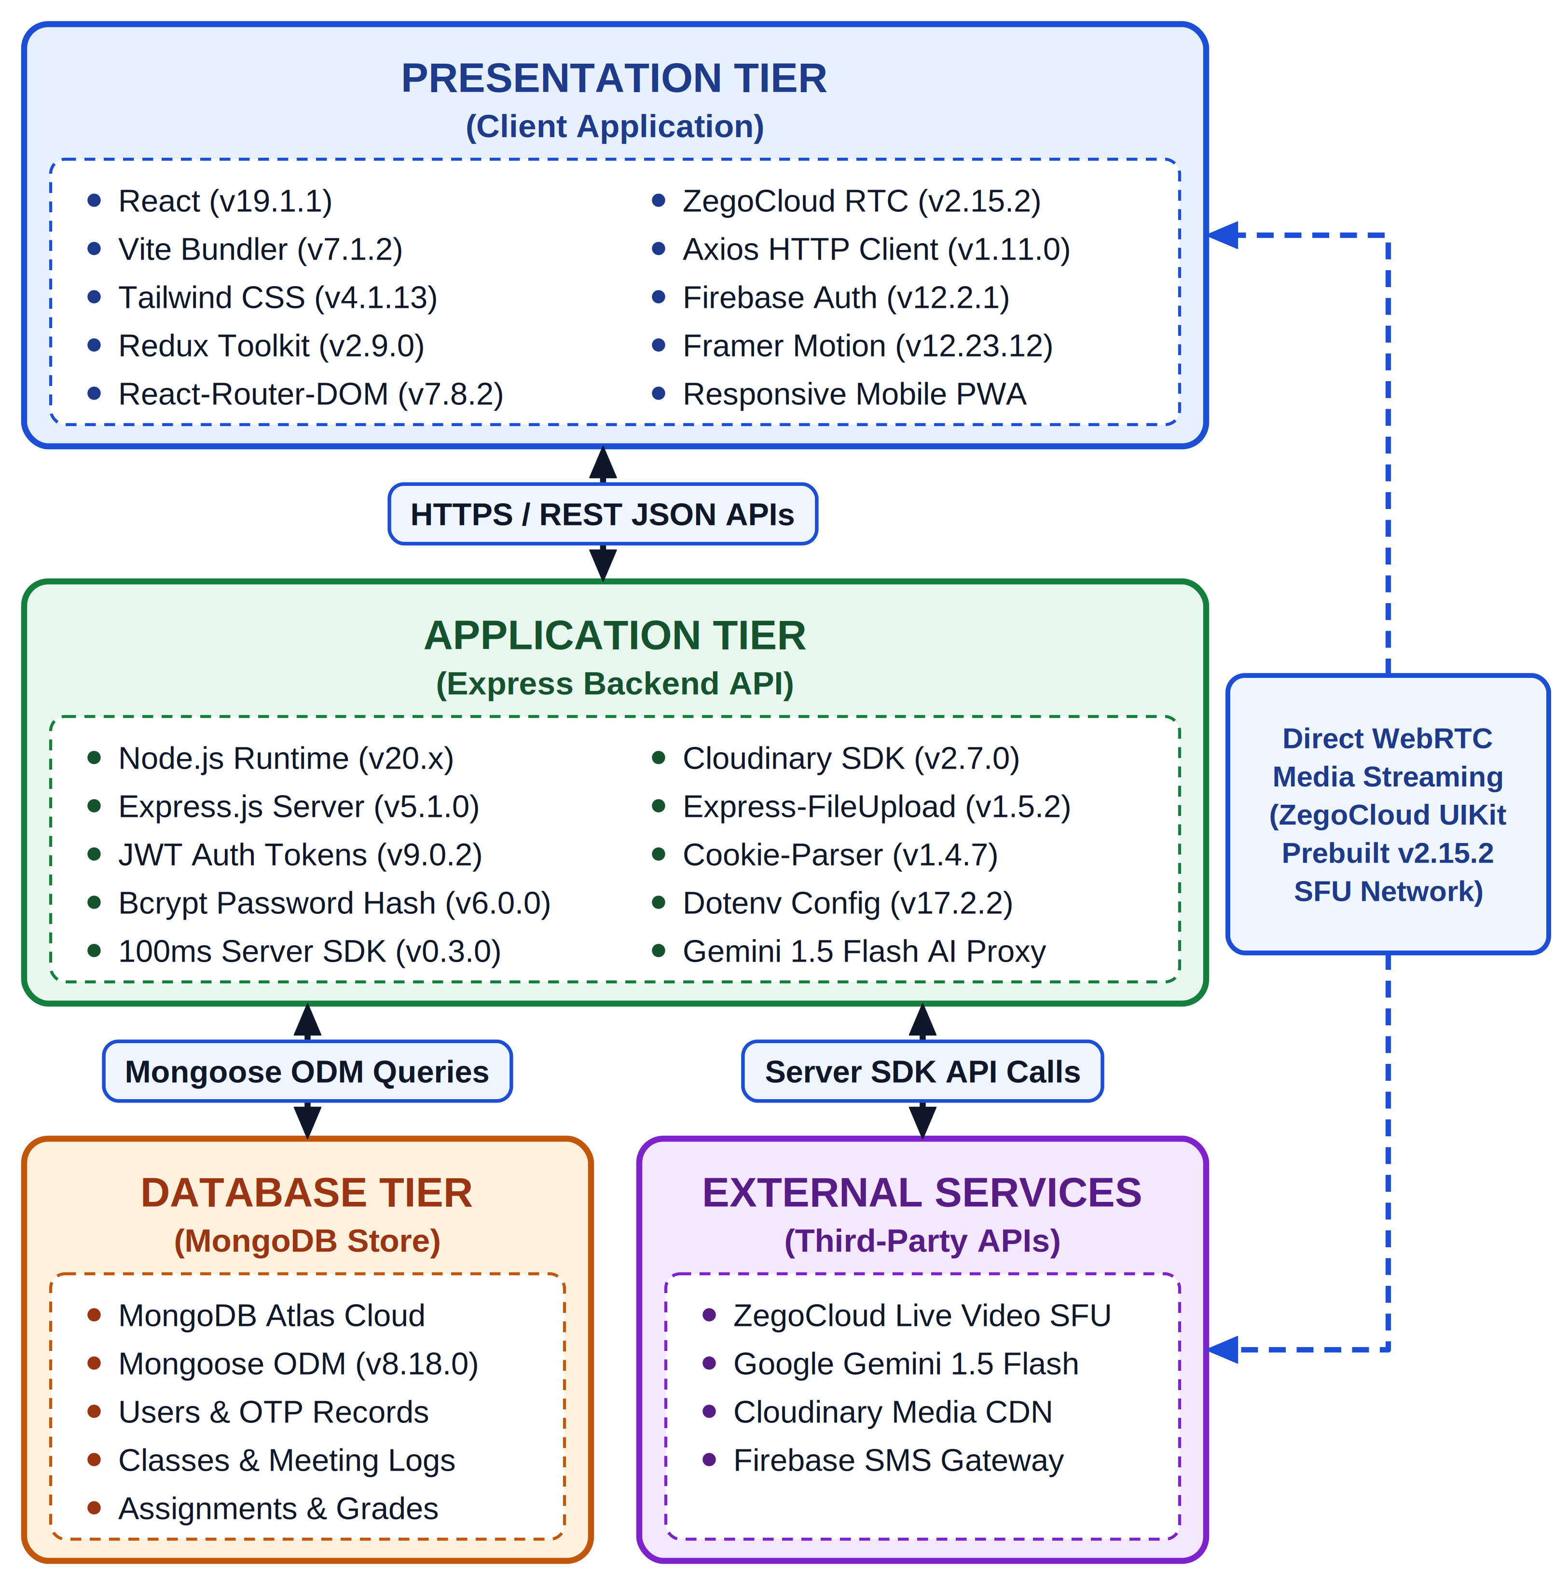
Figure 4.1: Client-Server Three-Tier Architecture of GyaanSetu
Table 4.1 details the specific component responsibilities, frameworks, and security boundaries across each architectural tier.
Architectural Tier | Constituent Modules | Frameworks & Protocols | Primary Functionality & Security Boundary
Presentation Tier  (Client Layer) | React 19 SPA, TailwindCSS, WebRTC Media Engine, Service Worker | HTTPS, WSS, WebRTC over UDP/SRTP, HTML5 Canvas | Renders responsive UI, handles audio/video hardware capture, executes client form validation.
Application Tier  (Logic Layer) | Express REST API, Auth Controller, Classroom Hub, Gemini Proxy | Node.js v20 LTS, JWT (HMAC-SHA256), Socket.io | Enforces RBAC permissions, routes API requests, signs session tokens, proxies AI queries.
Persistence Tier  (Data Layer) | MongoDB Atlas, Cloudinary CDN, Redis Cache | MongoDB Wire Protocol over TLS, Cloudinary REST API | Stores structured documents, streams binary PDF notes, caches real-time attendance heartbeats.
4.2 Tier Communication Protocols and Media Routing
Inter-tier communication in GyaanSetu is engineered to balance low-latency transmission with strict data integrity across heterogeneous networks:
- RESTful API over HTTPS (Port 443): All standard transactional exchanges (login, enrollment, assignment upload, grade submission) execute via stateless JSON payloads over TLS 1.3.
- WebRTC Media Transport over UDP/SRTP: Live audiovisual frames are transported peer-to-server-to-peer via ZegoCloud Selective Forwarding Unit (SFU) servers using Secure Real-Time Transport Protocol (SRTP). UDP transport eliminates head-of-line TCP blocking over lossy rural cellular connections.
- Real-Time Event Dispatch via WSS: Bidirectional WebSocket connections deliver immediate asynchronous notifications (meeting started, new announcement, doubt response).
4.3 System Security and Boundary Architecture
Security enforcement is established across multiple architectural layers:
- Authentication Tokens: JWT tokens are cryptographically signed using HMAC-SHA256 with 24-hour expiration and delivered via HTTP-only, SameSite=Strict cookies to eliminate cross-site scripting (XSS) extraction.
- CORS & Origin Validation: Strict Cross-Origin Resource Sharing (CORS) whitelisting restricts API invocation exclusively to verified institutional domains.
- Rate Limiting & DoS Protection: Express middleware enforces IP-based rate limiting (100 requests per 15-minute window for standard endpoints; 5 requests per minute for SMS OTP dispatch) to prevent abuse.

Chapter-5
Design and Implementation
5.1 Product Features
GyaanSetu consolidates seven core academic features into an integrated, zero-friction web portal:
- 1. Passwordless Phone SMS OTP Authentication: Eliminates credential forgotten-password friction for rural first-time digital users via Firebase mobile verification.
- 2. Classroom Hub & 6-Character Room Codes: Enables immediate course creation and seamless student onboarding without requiring complex email invitations.
- 3. Ultra-Low-Bandwidth WebRTC Live Lectures: Adaptive streaming engine that automatically downscales video to 360p and enforces 48 kbps audio-first fallback under 350 kbps.
- 4. Digital Lecture Notes Repository: Cloudinary CDN backed cloud storage supporting multi-format notes up to 25 MB with instant in-browser viewing.
- 5. Coursework & Assignment Submission Workflow: End-to-end coursework lifecycle with deadline tracking, late submission detection, and student PDF uploads.
- 6. Automated Heartbeat Attendance Auditing: Zero-teacher-effort attendance tracking using 60-second background pings, compiling into exportable CSV spreadsheets.
- 7. Google Gemini 1.5 Flash AI Academic Mentor: 24/7 contextual doubt clearance, programming code debugging, and concept explanation directly inside the classroom.
5.2 Data Flow Diagrams (DFD-0, DFD-1, DFD-2)
Data Flow Diagrams delineate the information boundaries, transformation processes, persistent data stores, and data movements across the GyaanSetu ecosystem.
Level-0 Context Diagram (DFD-0) provides the highest-level operational perspective, treating GyaanSetu as a single central process interacting with external human actors (Students, Teachers, Administrators) and cloud infrastructure services (Firebase, ZegoCloud, Cloudinary, Gemini AI).
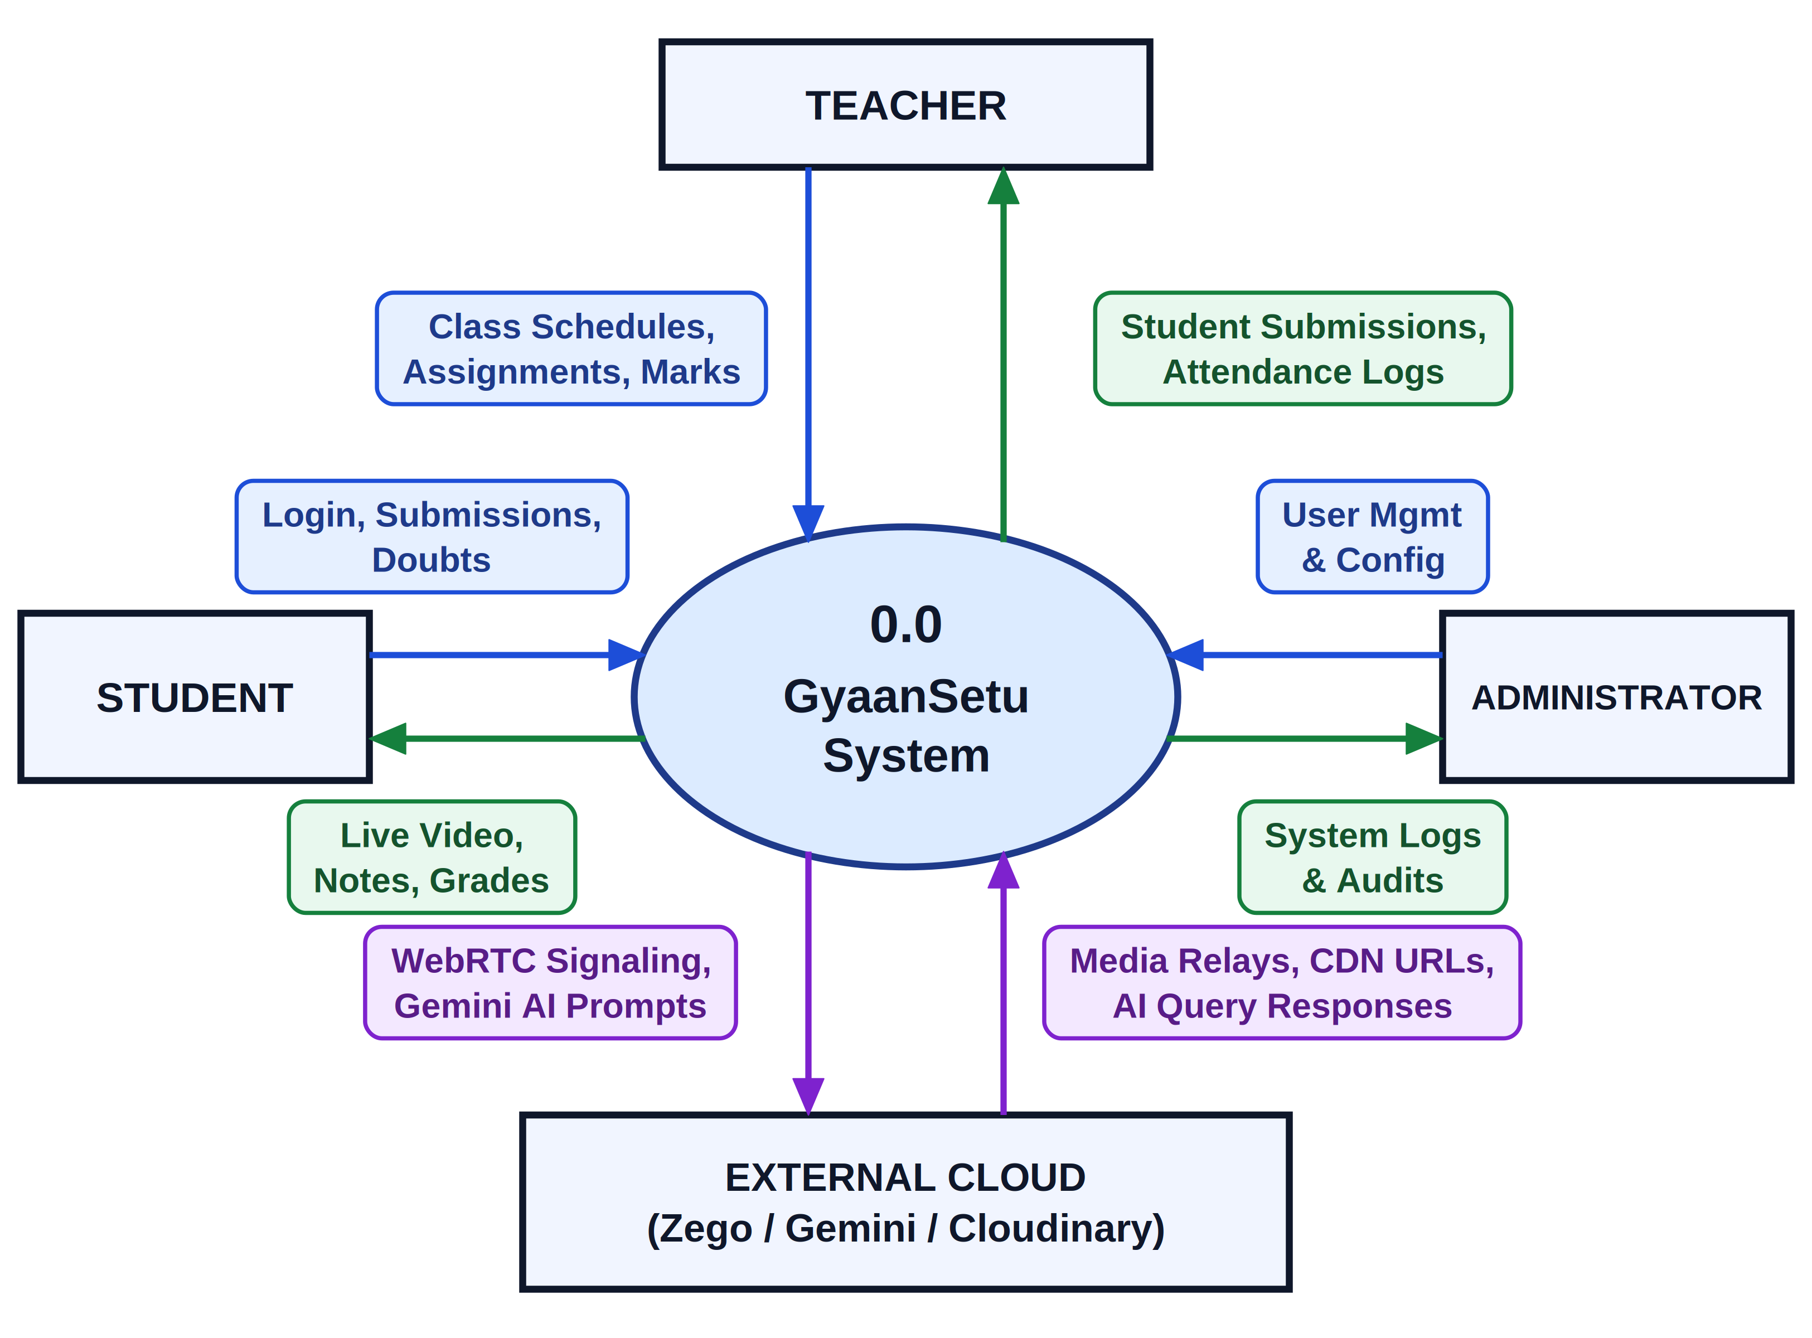
Figure 5.1: Data Flow Diagram - Level 0 (Context Level Diagram)
Table 5.1 documents the external entity interactions and bidirectional data flows depicted in the Context Diagram.
External Entity | Input Data Flows (Entity -> System) | Output Data Flows (System -> Entity) | Operational Purpose
Student Actor | Phone number, OTP code, room code, PDF assignment, attendance heartbeat pings, AI prompt queries | JWT auth cookie, live WebRTC stream, PDF notes download, gradebook feedback, AI answers | Primary consumer of lectures, coursework, and 24/7 academic query assistance.
Teacher Actor | Phone login credentials, classroom creation parameters, live video/audio feed, lecture notes upload, assignment rubrics & grades | Roster reports, active student attendance CSV, submitted assignment PDFs, live participant metrics | Primary manager of instruction, content delivery, evaluation, and class oversight.
Firebase Auth | Verification request with E.164 phone number, 6-digit confirmation token | Firebase cryptographic verification ID, user identity token | Executes cellular SMS OTP dispatch and identity verification.
ZegoCloud SFU | WebRTC SDP offer/answer, ICE candidates, publisher audiovisual packets | Subscribed audio/video media streams, packet loss statistics, RTT metrics | Orchestrates multi-party WebRTC live media distribution with adaptive downscaling.
Cloudinary CDN | Binary PDF/PPTX streams, file upload signatures, folder metadata | Optimized CDN delivery URLs, secure storage asset IDs | Provides compressed cloud blob storage for lecture materials and homework submissions.
Google Gemini AI | Contextual student prompt payload, technical question string, chat history | Streaming natural language explanations, code debugging snippets, concept summaries | Provides 24/7 conversational tutoring and academic doubt remediation.
Figure 5.2 details the Level-1 DFD decomposition, partitioning the system into five primary functional processes: 1.0 Authentication & User Management, 2.0 Classroom & Live Streaming, 3.0 Coursework & Learning Resources, 4.0 Attendance & Evaluation Engine, and 5.0 Gemini AI Academic Assistant, depicting their relationships with four core MongoDB data stores (D1: Users, D2: Classrooms, D3: Coursework, D4: Attendance).
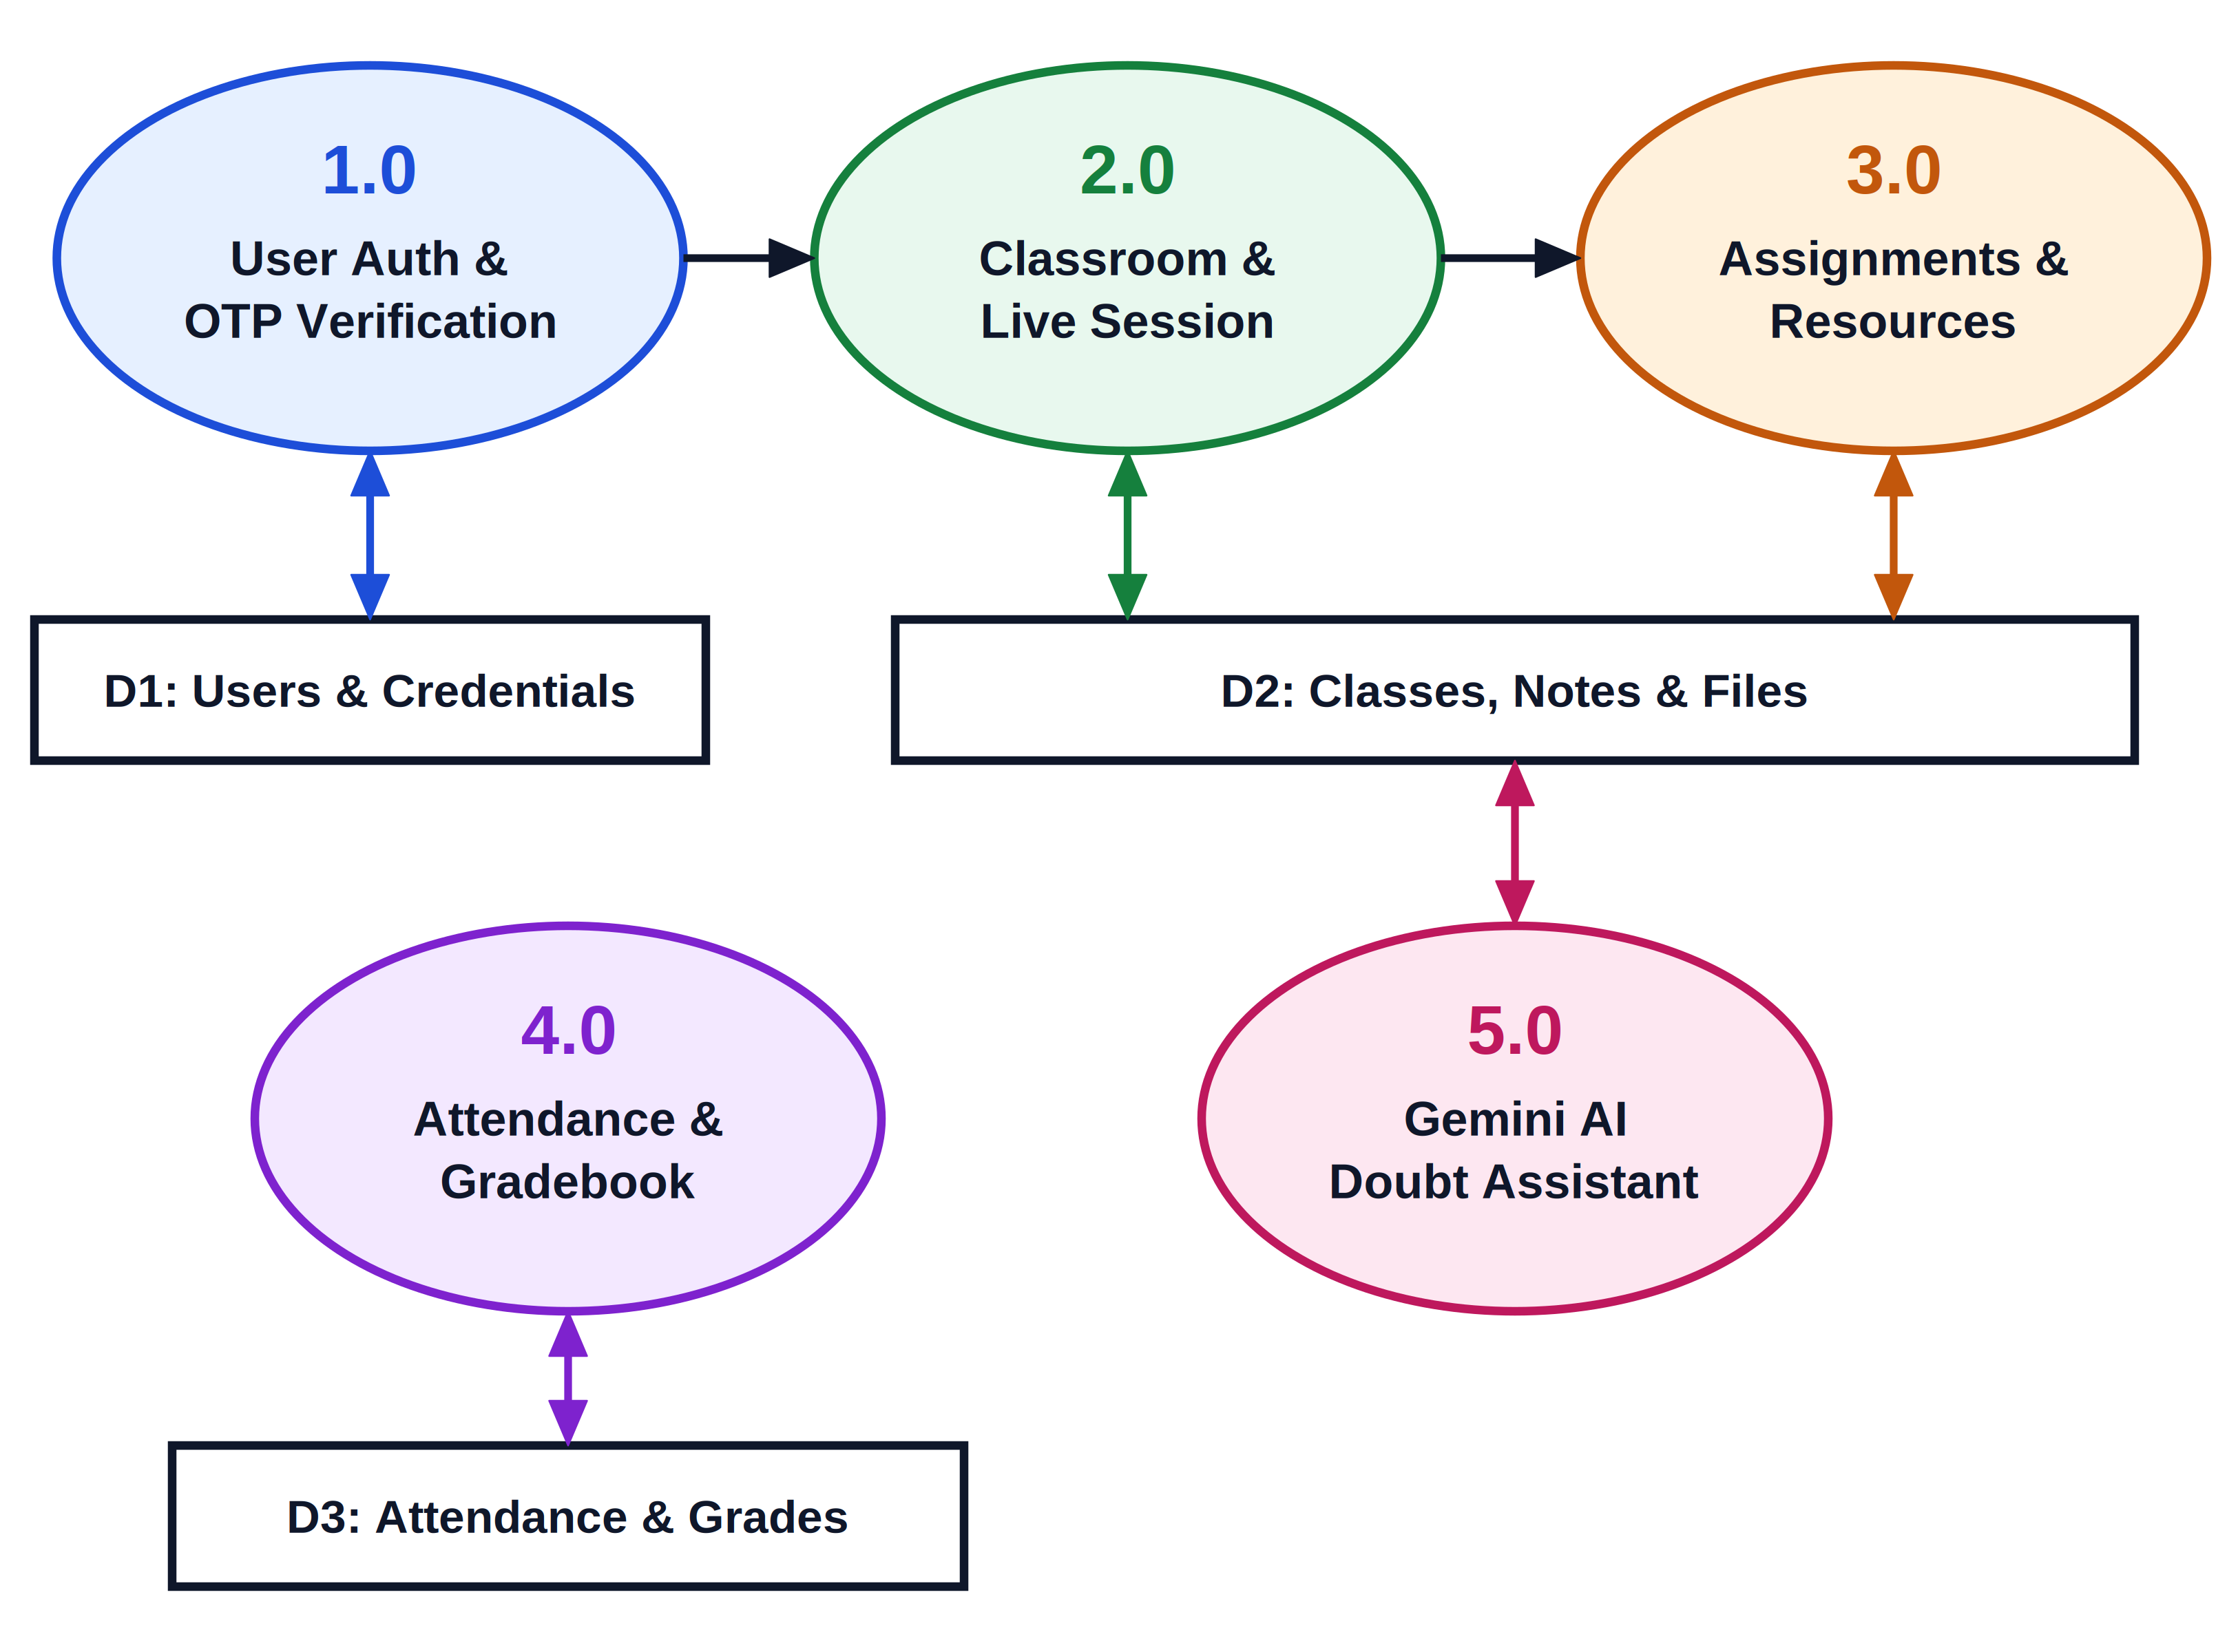
Figure 5.2: Data Flow Diagram - Level 1 (System Decomposition)
Table 5.2 presents the process decomposition and data store mapping for the Level-1 DFD.
Process ID & Name | Input Inflows | Output Outflows | Associated Data Stores | Transformation Logic
1.0 Authentication &  User Management | Phone #, OTP Code, Profile Info | JWT Session Cookie, User Profile | D1: Users Collection | Validates Firebase token, queries/creates user document, signs HMAC-SHA256 JWT.
2.0 Classroom &  Live Streaming | Classroom params, Room code, SDP offer | Classroom ID, Zego room token, WebRTC stream | D2: Classrooms  D1: Users | Generates 6-char room code, handles enrollment, initiates ZegoCloud meeting room.
3.0 Coursework &  Learning Resources | Notes binary, Assignment specs, Student PDF | Cloudinary URL, Submission receipt, Late flag | D3: Coursework  D2: Classrooms | Streams files to Cloudinary, timestamps submissions, enforces deadline checks.
4.0 Attendance &  Evaluation Engine | Heartbeat pings (60s), Grades, Feedback | Net duration log, CSV export, Grade report | D4: Attendance  D3: Coursework | Accumulates active minutes, computes attendance percentage, calculates grade averages.
5.0 Gemini AI  Academic Assistant | Student query, Course context string | Natural language response, Code solution | D1: Users (Rate limits) | Structures context prompt, invokes Gemini 1.5 Flash API, parses and formats response.
Figure 5.3 exhibits the Level-2 DFD procedural decomposition of Process 3.0 (Coursework & Resource Management). This sub-process traces the complete lifecycle of instructional assets: file validation, Cloudinary streaming, metadata recording, deadline auditing, and student submission verification.
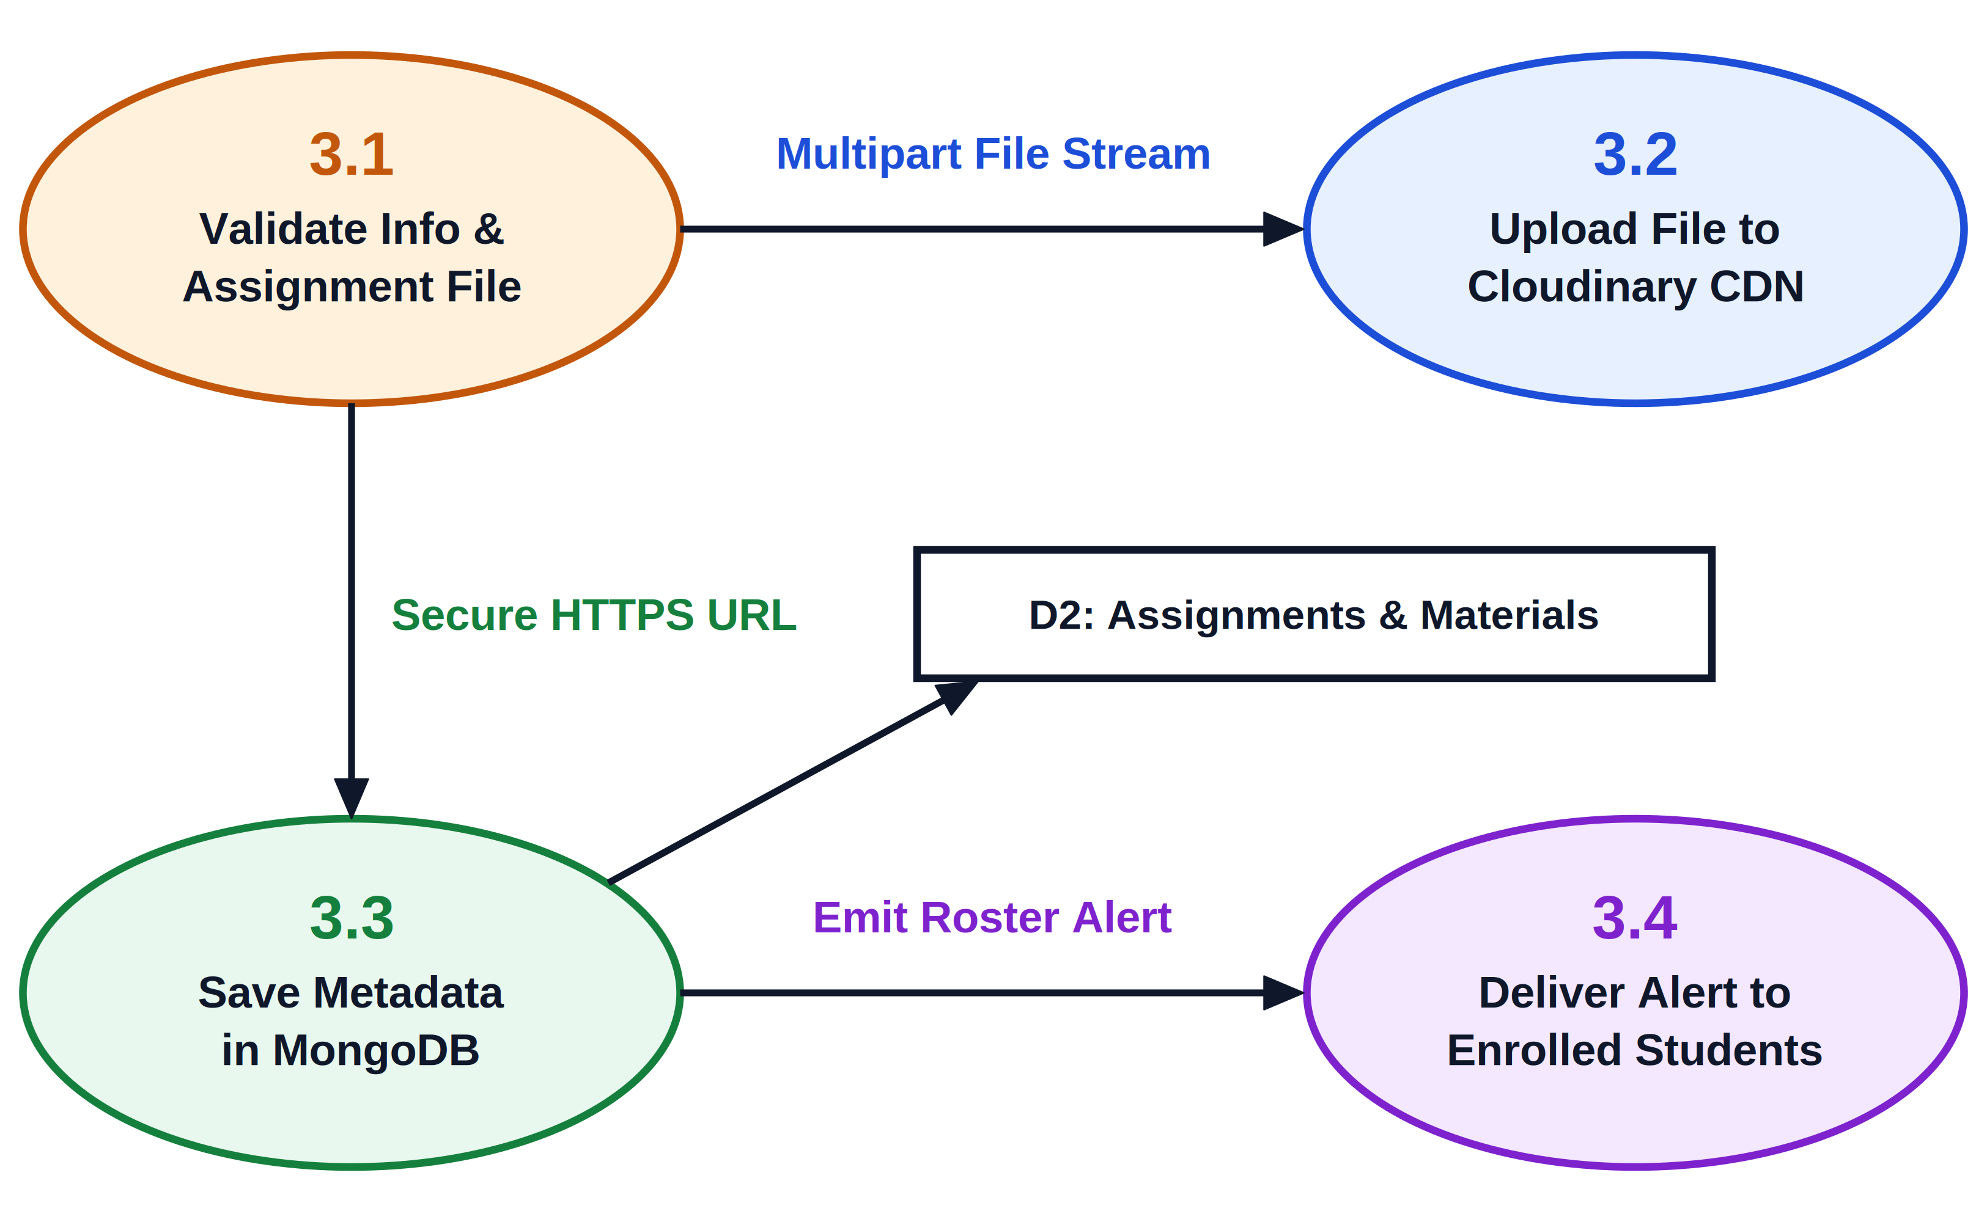
Figure 5.3: Data Flow Diagram - Level 2 (Assignment & Resource Pipeline)
Table 5.3 delineates the procedural steps and validation rules governing the Coursework Pipeline.
Sub-Process Step | Operational Action | Validation Criteria | Persistent Target
3.1 File Intake & Pre-check | Inspects uploaded file headers, MIME types, and file size | MIME in {PDF, PPTX, DOCX}; Size <= 25 MB | Client Memory Buffer
3.2 Cloudinary Stream | Pipes validated binary stream to Cloudinary CDN with gzip compression | HTTP 200 OK with secure HTTPS asset URL | Cloudinary Asset Bucket
3.3 Metadata Indexing | Records document title, subject, chapter, upload timestamp, and owner ID | Foreign key references verified against Classroom ID | D3: Coursework Collection
3.4 Student Submission Intake | Accepts student PDF assignment uploads prior to deadline | Deadline timestamp check; late flag set if current > due | D3: Coursework (Submissions)
3.5 Teacher Grade Recording | Records numerical score and qualitative feedback from instructor | Score <= Maximum Marks; Evaluator = Classroom Teacher | D3: Coursework (Grades)
5.3 Entity-Relationship (E-R) Conceptual Schema
The conceptual database schema for GyaanSetu is designed to balance relational integrity with rapid document retrieval. Figure 5.4 depicts the comprehensive Entity-Relationship model.
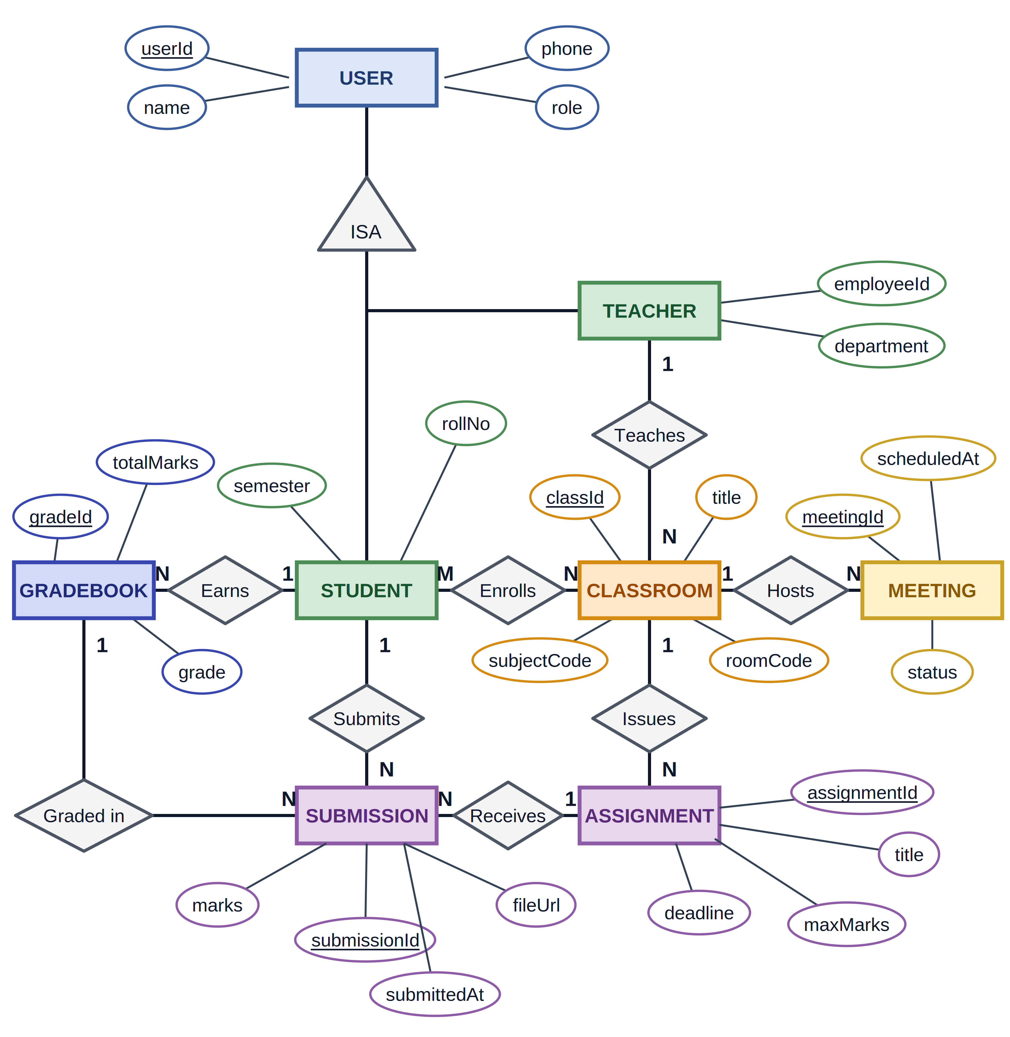
Figure 5.4: Entity-Relationship (E-R) Conceptual Schema Diagram
Table 5.4 summarizes the relational entity schema, primary keys, foreign keys, and cardinalities.
Entity Name | Primary Key | Foreign Keys | Key Attributes | Relational Cardinality
User (Base) | user_id (UUID) | None | phone, name, role (Student/Teacher/Admin), avatar_url, created_at | 1 : 1 with Student or Teacher profile
Classroom | class_id (UUID) | teacher_id -> User | course_name, subject_code, room_code (6-char), semester, academic_year | 1 : N with Meetings, Coursework, Enrollments
Enrollment | enroll_id (UUID) | student_id -> User,  class_id -> Classroom | enrolled_at, status (Active/Dropped), attendance_summary_pct | M : N resolution between Student and Classroom
MeetingSession | meeting_id (UUID) | class_id -> Classroom,  host_id -> User | title, scheduled_start, actual_start, ended_at, status, room_token | 1 : N with AttendanceRecord
AttendanceRecord | att_id (UUID) | meeting_id -> MeetingSession,  student_id -> User | joined_at, last_heartbeat, left_at, net_duration_minutes, present_flag | N : 1 with MeetingSession and Student
Assignment | assign_id (UUID) | class_id -> Classroom,  creator_id -> User | title, instructions, max_marks, due_date, file_url, created_at | 1 : N with Submissions
Submission | sub_id (UUID) | assign_id -> Assignment,  student_id -> User | file_url, submitted_at, is_late, marks_awarded, feedback_notes, graded_at | N : 1 with Assignment and Student
5.4 UML Class Diagram & Domain Model Design
The UML Class Diagram defines the object-oriented structure of the domain models and controller classes in the Express.js application layer. Figure 5.5 presents the core classes: User, Student, Teacher, Classroom, MeetingSession, Assignment, Submission, and AttendanceRecord, detailing their private attributes, public controller methods, and structural associations.
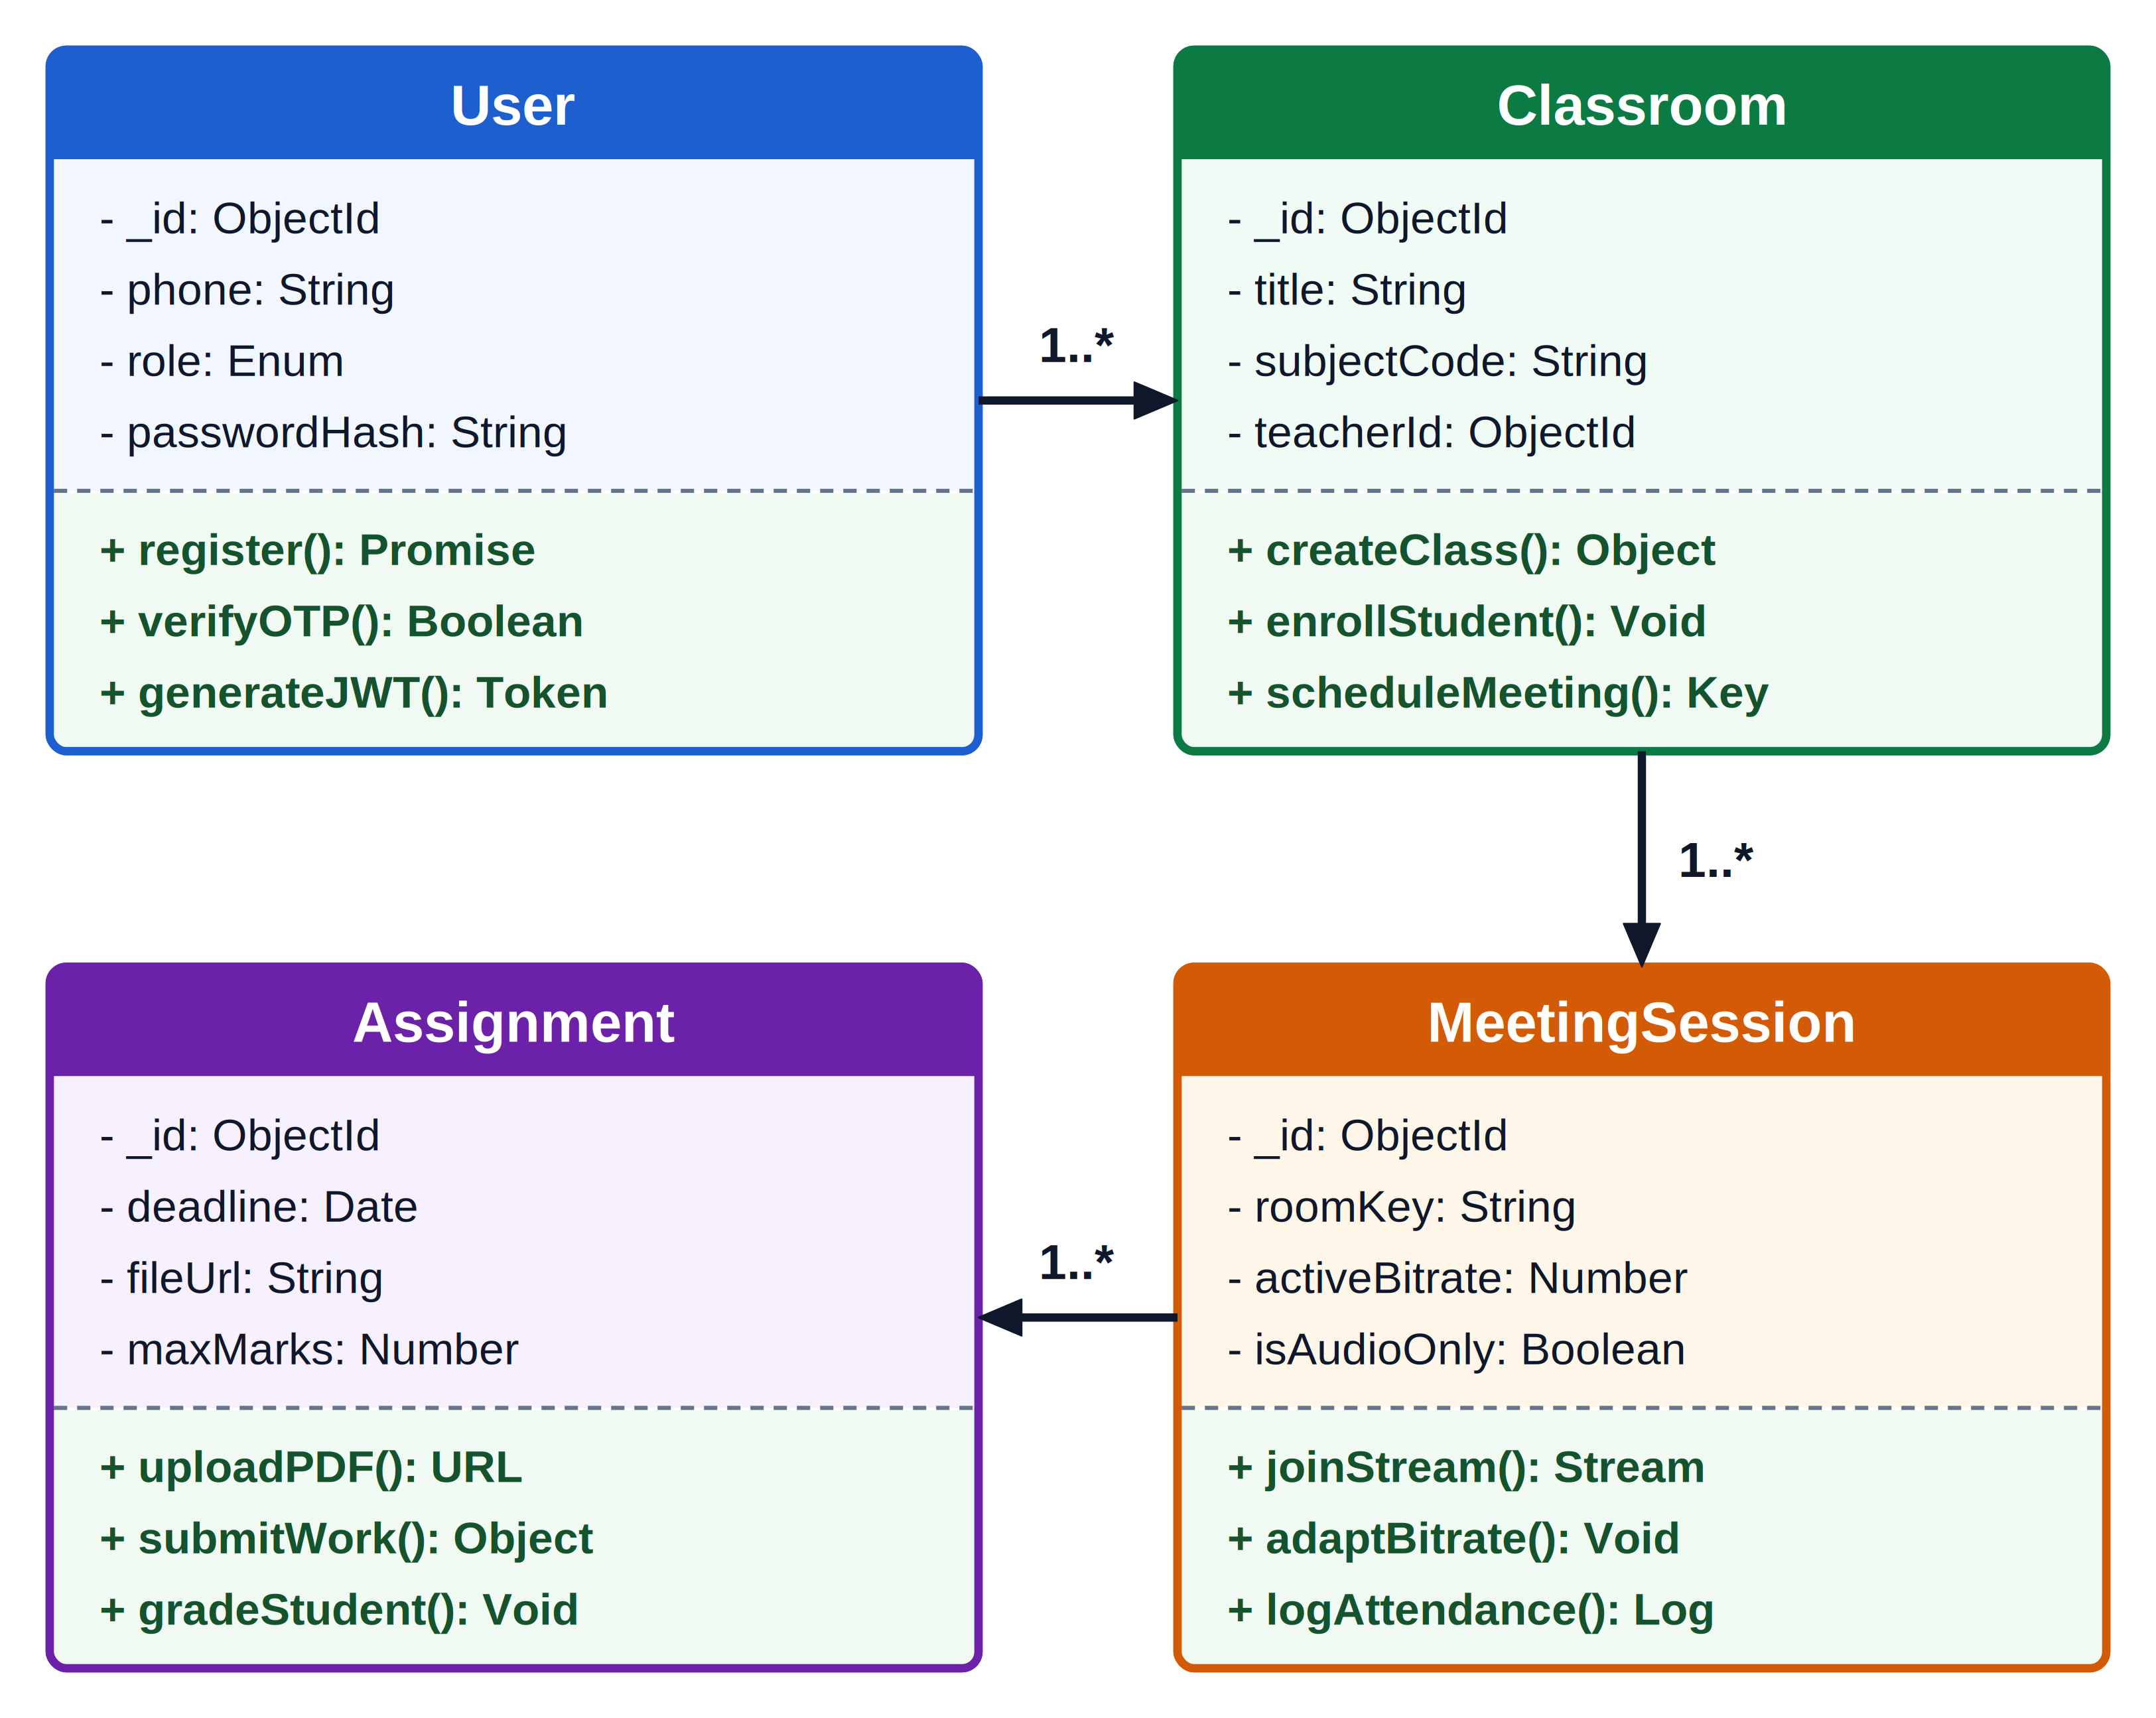
Figure 5.5: UML Class Diagram - Core Domain Models & Controller Methods
Table 5.5 documents the class definitions, field attributes, and public method signatures implemented in the Express backend.
Class Name | Private Attributes | Public Controller Methods | Structural Association
User | - _id: ObjectId  - phone: String  - role: UserRole  - createdAt: Date | + authenticate(phone, otp): JWT  + getProfile(): UserDTO  + updateProfile(data): Boolean | Superclass of Student and Teacher
Classroom | - _id: ObjectId  - title: String  - roomCode: String  - teacherId: ObjectId | + createClass(data): Classroom  + enrollStudent(code, uid): Boolean  + getRoster(): List<Student> | Aggregates Meetings, Assignments, and Students
MeetingSession | - _id: ObjectId  - classId: ObjectId  - startTime: Date  - status: MeetingStatus | + startSession(): TokenDTO  + recordHeartbeat(uid): Void  + endSession(): AttendanceSummary | Associated with Classroom; creates AttendanceRecords
Assignment | - _id: ObjectId  - classId: ObjectId  - dueDate: Date  - maxMarks: Number | + createAssignment(data): Assignment  + submitWork(uid, file): Submission  + gradeSubmission(subId, marks): Void | Associated with Classroom; aggregates Submissions
5.5 UML Use Case Diagram & Actor Interaction Scenarios
The UML Use Case Diagram defines the functional scope and operational boundaries across the three primary human actors: Student, Teacher, and Administrator. Figure 5.6 details the complete use case catalog.
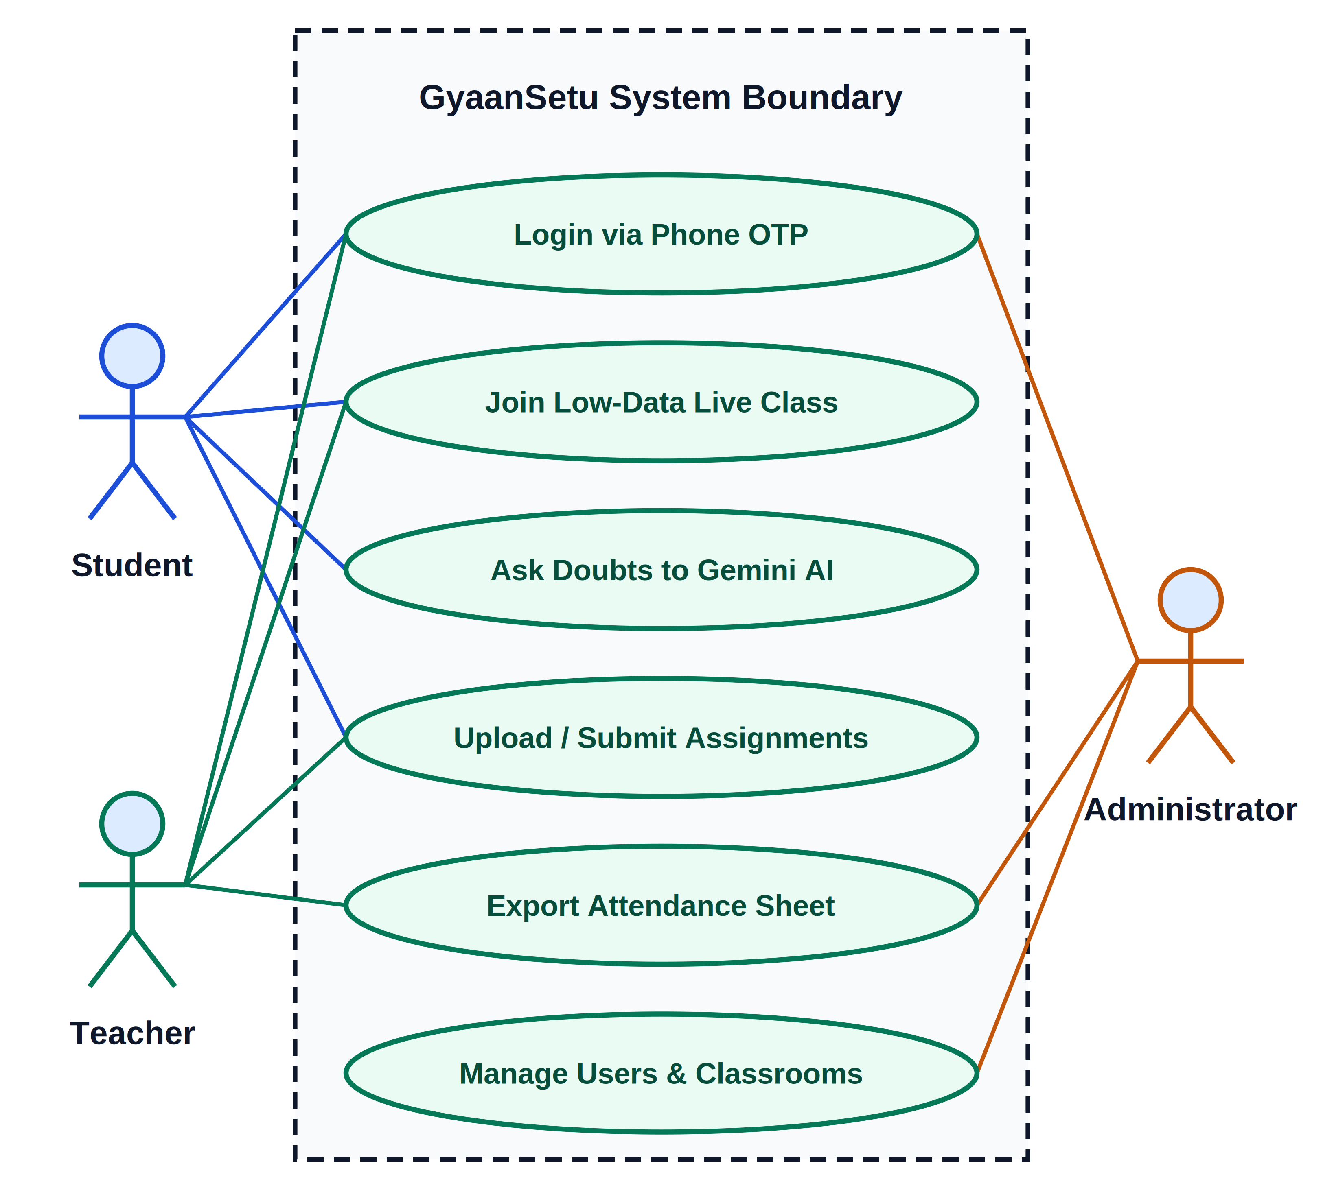
Figure 5.6: Comprehensive UML Use Case Diagram
Table 5.6 details the actor use case catalog and operational boundaries.
Use Case ID & Name | Primary Actor | Pre-Conditions | Main Success Scenario | Post-Conditions
UC-01: Phone Login | Student / Teacher | Valid registered Indian mobile number | Enters phone number, receives 6-digit SMS OTP, enters code, backend validates and issues JWT cookie. | User logged in with role session active
UC-02: Create Classroom | Teacher | Teacher authenticated via JWT | Enters course name, semester, subject code; clicks Create; system returns 6-character room code. | Classroom active in MongoDB
UC-03: Join Live Lecture | Student | Enrolled in classroom; lecture active | Navigates to classroom, clicks 'Join Lecture', system establishes WebRTC stream with adaptive downscaling. | Student active in WebRTC room
UC-04: Submit Assignment | Student | Assignment created by teacher; not deleted | Selects PDF from local device, uploads before deadline, receives submission confirmation receipt. | Submission recorded with timestamp
UC-05: Export Attendance | Teacher | Live meeting completed | Navigates to Attendance tab, selects meeting date, clicks 'Export CSV'; browser downloads formatted roster. | CSV file saved on teacher machine
5.6 UML Sequence Diagrams
Sequence diagrams capture the time-ordered exchange of messages across system components during critical operational workflows.
Sequence Diagram 1 (Figure 5.7) models the Phone OTP Authentication workflow: the client requests an SMS OTP via Firebase Auth, verifies the 6-digit token, queries MongoDB credentials, and receives a secure, HTTP-only JWT cookie.
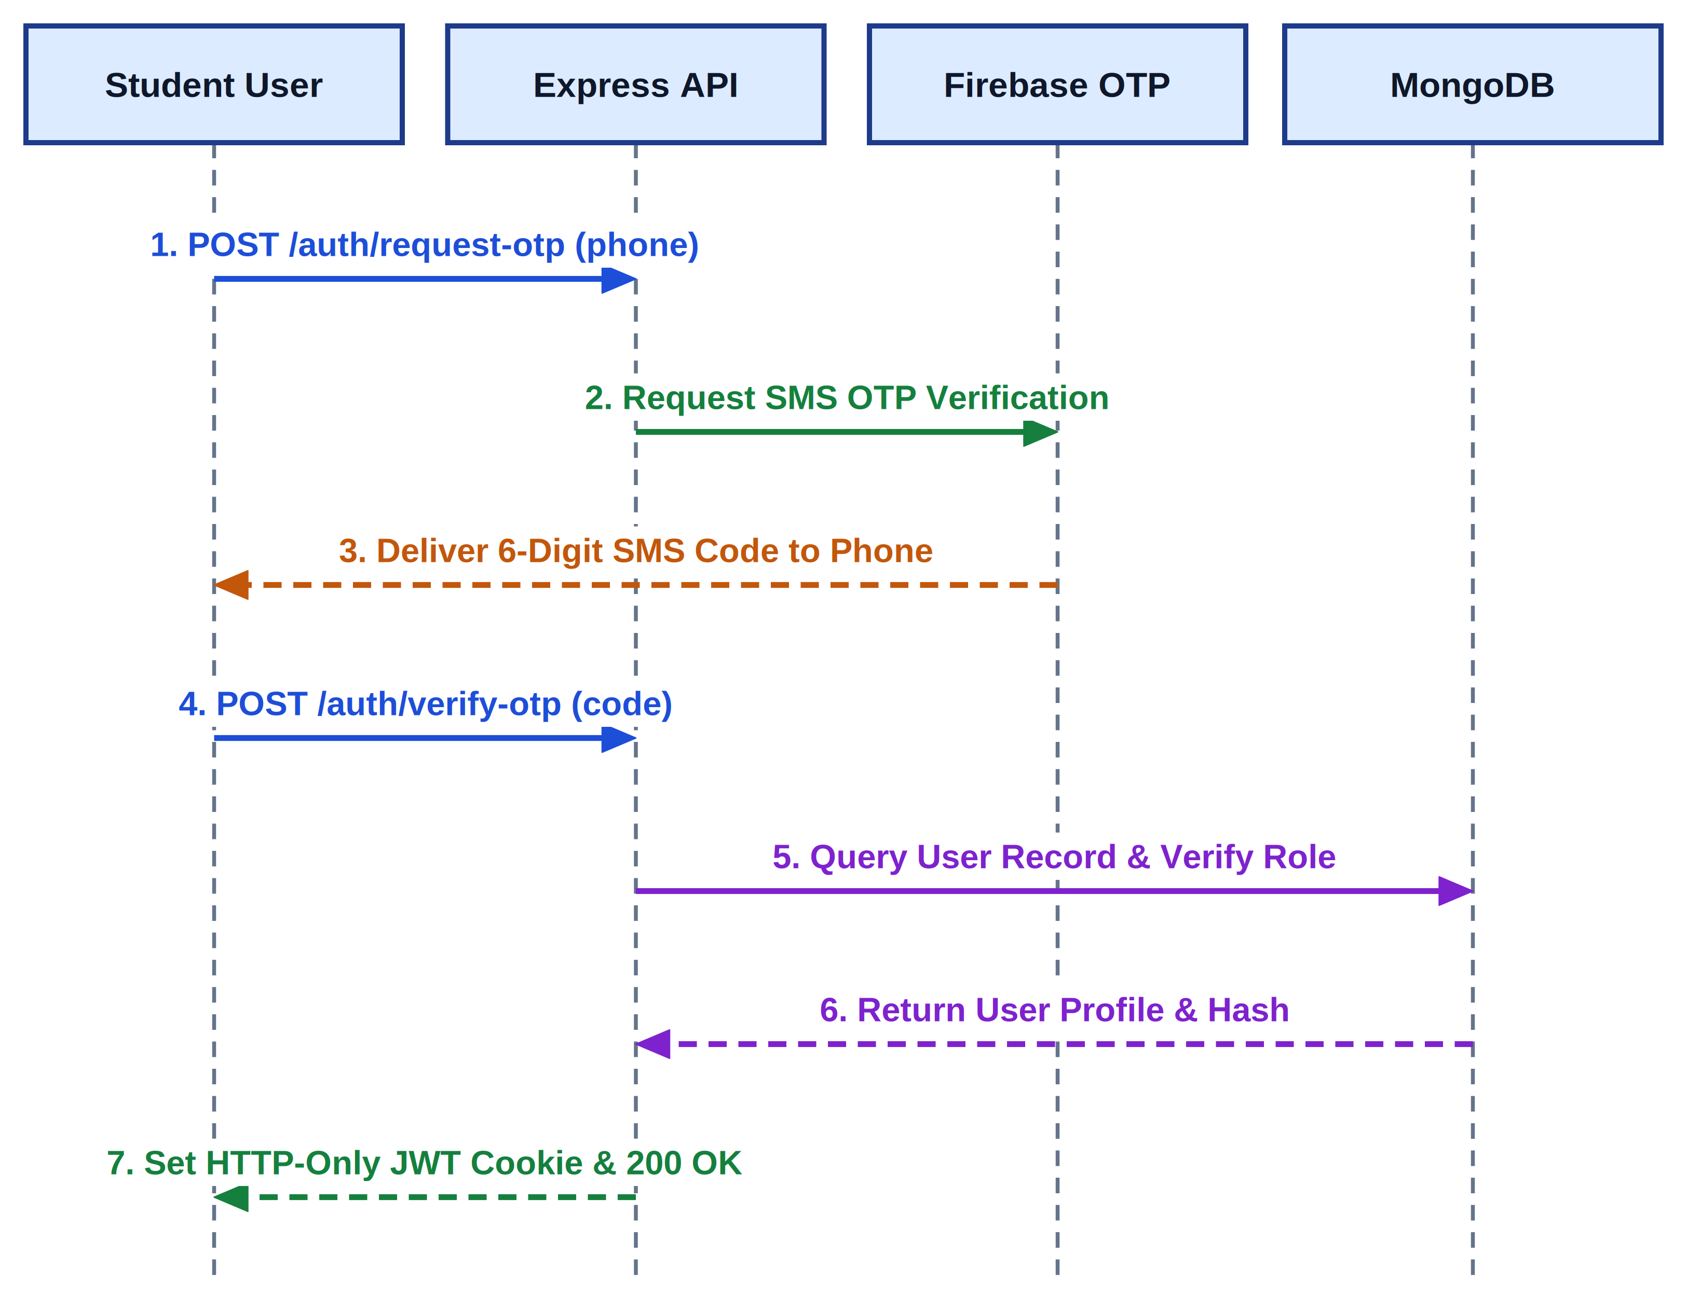
Figure 5.7: UML Sequence Diagram - Phone OTP Authentication & JWT Issuance
Table 5.7 documents the ordered message execution trace for Phone OTP Authentication.
Step # | Source Lifeline | Target Lifeline | Protocol / Method | Message & Data Payload
1 | Client Browser | Firebase Auth | HTTPS POST | signInWithPhoneNumber('+919876543210', reCAPTCHA)
2 | Firebase Auth | SMS Gateway | SMPP / Telco API | Dispatch 6-digit cryptographic OTP to user SIM
3 | Client Browser | Firebase Auth | HTTPS POST | confirmationResult.confirm('123456')
4 | Firebase Auth | Client Browser | JSON Response | Return Firebase ID Token (JWT) on successful verification
5 | Client Browser | Express API Server | HTTPS POST /api/auth | Submit Firebase token in Authorization header
6 | Express API Server | MongoDB Atlas | Mongoose Query | User.findOne({ phone: verifiedPhone })
7 | Express API Server | Client Browser | Set-Cookie Header | Issue HTTP-only JWT cookie (Role, UserID, 24h Expiry)
Sequence Diagram 2 (Figure 5.8) models the Live Video Class Join and Adaptive Streaming workflow: the client requests meeting access, receives a ZegoCloud room token, establishes an SRTP WebRTC peer connection through the SFU, monitors network RTT, and executes graceful downscaling to 360p or 48 kbps audio-first mode under rural bandwidth throttling.
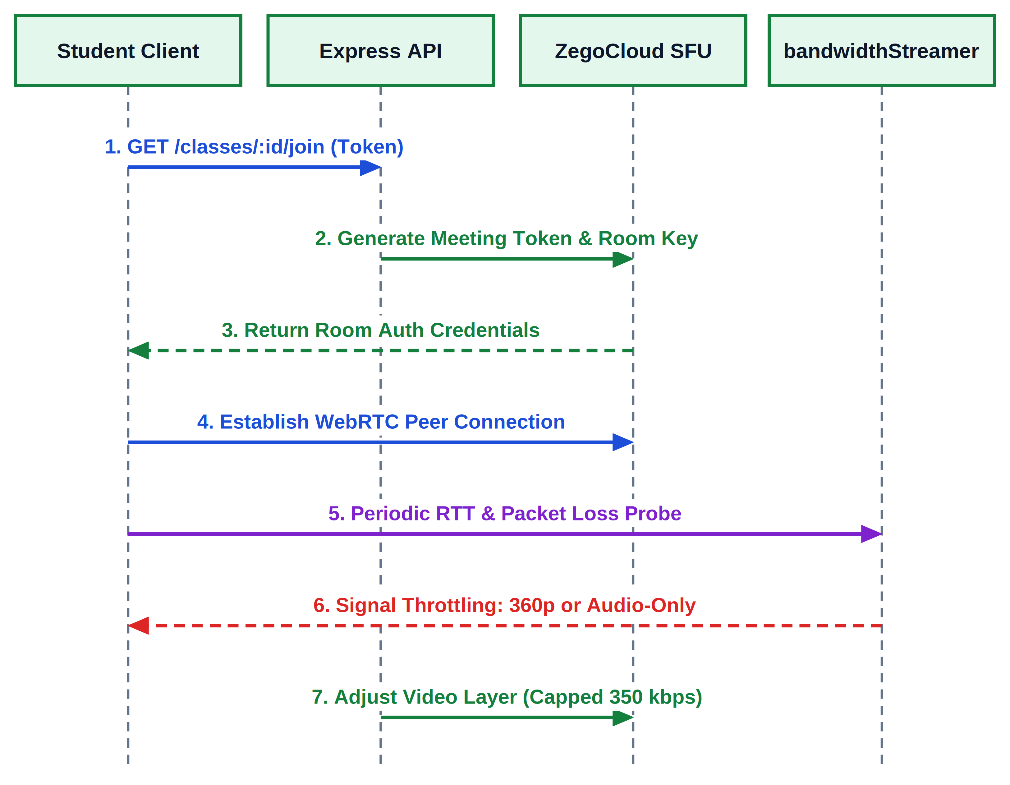
Figure 5.8: UML Sequence Diagram - Live Video Class Join & Adaptive Streaming
Table 5.8 details the ordered message sequence trace for Live Video Streaming and Adaptive Downscaling.
Step # | Source Lifeline | Target Lifeline | Protocol / Method | Message & Data Payload
1 | Student Client | Express Server | HTTPS GET /meetings/token | Request ZegoCloud room authorization token
2 | Express Server | Student Client | JSON Response | Return encrypted ZegoToken with roomId, userId, and role
3 | Student Client | ZegoCloud SFU | WebSockets / WSS | loginRoom(roomId, token) -> SDP Offer / Answer exchange
4 | ZegoCloud SFU | Student Client | WebRTC UDP / SRTP | Stream subscribed teacher audio/video feed
5 | Student Client | ZegoCloud SFU | RTCP getStats() | Periodic bandwidth probe (RTT > 300ms, packet loss > 5%)
6 | Student Client | ZegoCloud SFU | setVideoConfig() | Auto-downgrade video to 360p (250 kbps) or disable video
7 | Student Client | Express Server | HTTPS POST /heartbeat | Transmit 60s attendance ping {meetingId, activeTime}

Chapter-6
Conclusion & Future Scope
6.1 Conclusion
GyaanSetu successfully demonstrates that high-quality, reliable, and equitable virtual collegiate education can be delivered over severely constrained rural cellular networks. By coupling WebRTC adaptive bitrate streaming with client-side audio prioritization, the platform maintains uninterrupted live lecture connectivity down to 350 kbps while capping hourly data consumption strictly under 180 MB—an approximate 80% reduction compared to mainstream enterprise platforms like Zoom and Google Meet.
The platform consolidates live video lectures, Cloudinary-backed assignment submissions, automated attendance tracking via 60-second heartbeat pings, and 24/7 AI-assisted doubt resolution via Google Gemini into a unified Progressive Web App. Built using a modern decoupled three-tier architecture with React 19, Node.js, Express, and MongoDB Atlas, GyaanSetu provides state technical universities and polytechnics an open-source, cost-effective alternative that completely eliminates expensive software licensing and heavy hardware requirements.
6.2 Limitations of Current Version
While GyaanSetu achieves its primary technical objectives, several operational boundaries exist in the Phase-1 implementation:
- 1. WebRTC Codec Dependency: Client browsers must support modern VP8/H.264 video decoding. Highly outdated Android webviews (pre-Android 7) may experience rendering delays.
- 2. SMS Gateway Congestion: During peak national cellular network congestion, third-party SMS delivery of Firebase OTP codes may experience occasional delivery delays exceeding 45 seconds.
- 3. Lack of Client-Side Video Recording: To protect client smartphone storage, live lectures are not recorded locally on student devices; server-side cloud recording requires additional cloud object storage provisioning.
6.3 Future Engineering Roadmap
The planned engineering roadmap for future releases includes four high-impact enhancements:
- 1. Vernacular Speech Recognition & Real-Time Subtitles: Integrating lightweight client-side Indic-Wav2Vec and Whisper speech-to-text models to provide real-time lecture subtitles and transcripts in Hindi, Rajasthani dialects, Bengali, and Marathi.
- 2. Local Campus Edge Caching Nodes: Deploying low-cost Raspberry Pi micro-servers in rural college common rooms to cache recorded lectures and PDF notes locally over campus Wi-Fi, allowing students to download materials with zero cellular data consumption.
- 3. Automated AI Lecture Summaries & Flashcards: Using Google Gemini to parse lecture audio transcripts and automatically generate concise bulleted summaries, concept cheat sheets, and practice flashcards for revision.
- 4. Low-Power Solar-Assisted Learning Stations: Developing portable, solar-powered client computing terminals with pre-configured browser shells for off-grid learning centers with irregular electrical power.

Chapter-7
UN Sustainable Development Goals
7.1 Background and Alignment with UN SDG-4
The 2030 Agenda for Sustainable Development, adopted by all United Nations Member States in 2015, establishes 17 Sustainable Development Goals (SDGs) as a universal blueprint for peace, prosperity, and human development. Higher education serves as a fundamental driver across these global goals. GyaanSetu directly addresses UN Sustainable Development Goal 4 (SDG-4: Quality Education): 'Ensure inclusive and equitable quality education and promote lifelong learning opportunities for all.'
In under-resourced rural and semi-urban regions across India, digital education is severely impeded by poor cellular coverage, high mobile data costs, and lack of experienced faculty. GyaanSetu addresses these challenges through technical innovation: enabling low-bandwidth video delivery at 350 kbps, eliminating software licensing costs via an open-source model, and providing 24/7 AI academic mentoring.
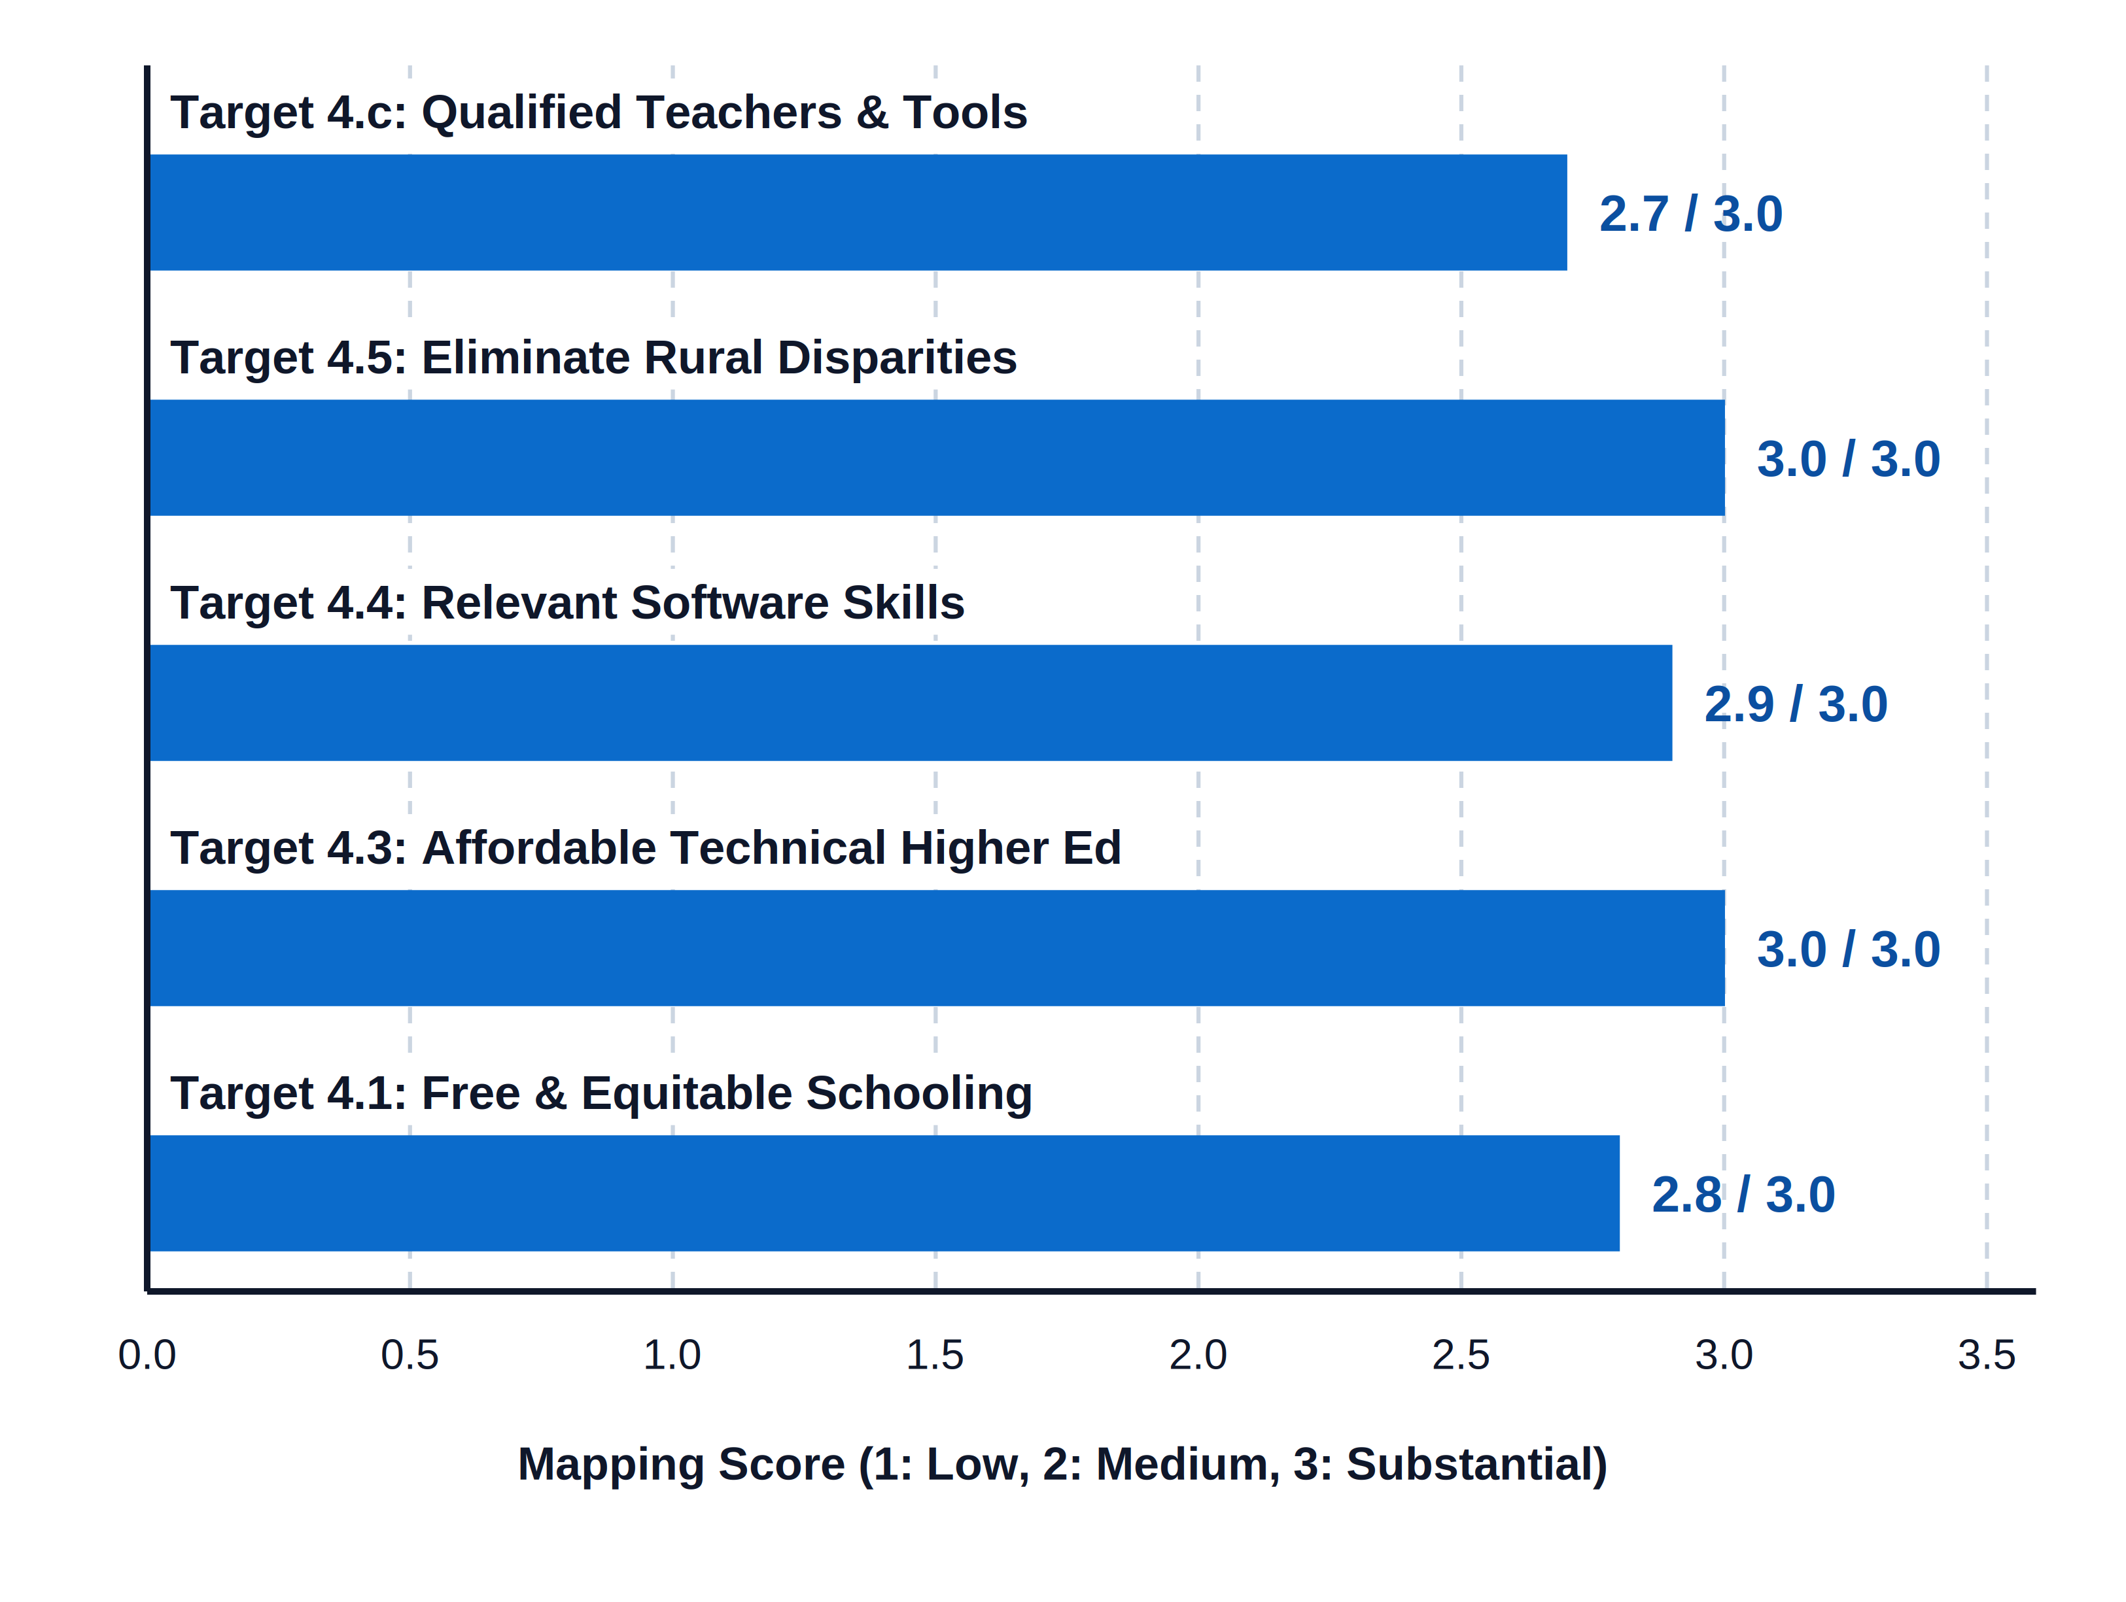
Figure 7.1: GyaanSetu Alignment with UN Sustainable Development Goal 4 Targets
7.2 Quantitative Correlation Matrix
The matrix below formally correlates the technical product objectives of GyaanSetu with the official targets of UN SDG-4, categorized across correlation levels 1 (Slight/Low), 2 (Moderate/Medium), and 3 (Substantial/High) according to RTU guidelines.
SDG Title: Ensure inclusive and equitable quality education and promote lifelong learning opportunities for all (SDG-4)
S.No | Product Objective | Proposed Solution | Mapping  3/2/1
1 | Deliver reliable, live interactive classes over weak rural cellular networks without connection termination. | Adaptive WebRTC streaming engine using ZegoCloud that dynamically downscales to 360p and enforces 48 kbps audio-first fallback at 350 kbps, capping data under 180 MB/hr. | 3 (Substantial)
2 | Eliminate financial barriers and software licensing costs for students and rural public colleges. | 100% open-source web application utilizing responsive PWA architecture and mobile phone SMS OTP login, requiring zero subscription fees. | 3 (Substantial)
3 | Provide continuous academic mentoring and query support outside scheduled lecture hours. | Integrated Google Gemini 1.5 Flash AI assistant providing 24/7 academic query resolution, conceptual explanations, and homework debugging. | 3 (Substantial)
4 | Ensure academic accountability and reduce manual attendance overhead for faculty. | Automated session duration logger using client heartbeat pings, generating transparent CSV attendance records with defaulter threshold alerts. | 2 (Moderate)
The matrix given above represents the correlation of Product objective with SDG. This correlation is defined based on levels 1, 2 or 3 as follows:
1: Slight (Low) 2: Moderate (Medium) 3: Substantial (High)
7.3 Faculty Review and Approval Signatures
This Software Requirements Specification document has been rigorously formulated, reviewed, and approved for Phase-1 semester review under the Department of Computer Science & Engineering, Swami Keshvanand Institute of Technology, Management & Gramothan, Jaipur.
_________________________________________  Swati Yadav  Project Mentor  Assistant Professor, Dept. of CSE  SKIT, Jaipur | _________________________________________  Jyoti Singh  Project Lab Coordinator  Associate Professor, Dept. of CSE  SKIT, Jaipur

References
1. IEEE Computer Society, 'IEEE Recommended Practice for Software Requirements Specifications,' IEEE Std 830-1998, 1998.
2. C. Perkins, 'RTP: Audio and Video for the Internet,' Addison-Wesley Professional, Boston, MA, 2003.
3. H. Schulzrinne, S. Casner, R. Frederick, and V. Jacobson, 'RTP: A Transport Protocol for Real-Time Applications,' IETF RFC 3550, July 2003.
4. A. B. Johnston and D. C. Burnett, 'WebRTC: APIs and RTCWEB Protocols of the HTML5 Real-Time Web,' Digital Media Advisors, 3rd ed., 2014.
5. United Nations, 'Transforming our world: the 2030 Agenda for Sustainable Development,' Resolution adopted by the General Assembly, A/RES/70/1, 2015.
6. Ministry of Education, Government of India, 'All India Survey on Higher Education (AISHE) 2021-22,' New Delhi, India, 2023.
7. Telecom Regulatory Authority of India (TRAI), 'The Indian Telecom Services Performance Indicators: July - September 2023,' New Delhi, 2024.
8. E. Gamma, R. Helm, R. Johnson, and J. Vlissides, 'Design Patterns: Elements of Reusable Object-Oriented Software,' Addison-Wesley, 1994.
9. M. Fowler, 'Patterns of Enterprise Application Architecture,' Addison-Wesley Signature Series, Boston, MA, 2002.
10. Google AI, 'Gemini: A Family of Highly Capable Multimodal Models,' arXiv preprint arXiv:2312.11805, 2023.
11. ZegoCloud Corporation, 'ZegoCloud Real-Time Audio and Video Low-Latency Engine Architecture Whitepaper,' Shenzhen, 2024.
12. Cloudinary Inc., 'Optimizing Media Delivery for Constrained Mobile Networks,' Santa Clara, CA, 2023.
13. MongoDB Inc., 'MongoDB Architecture Guide: High Availability and Horizontal Scalability,' New York, NY, 2023.
14. World Wide Web Consortium (W3C), 'Web Content Accessibility Guidelines (WCAG) 2.1,' W3C Recommendation, June 2018.
15. Rajasthan Technical University (RTU), 'Guidelines for B.Tech Project Formulation and SRS Evaluation,' RTU Kota, 2024.

