A PROJECT TITLE

ON

Renewable Energy Output Prediction Using XGBoost and LightGBM

project report submitted in partial fulfilment of the requirements for the Course

MACHINE LEARNING

BACHELOR OF TECHNOLOGY

In

A.Y.: 2026-27

By

Jaswanth Reddy — 2520030284

Meghanadh Sai Reddy — 2520030274

Kunal — 2520030275

Under the Esteemed guidance of

Ravinder

Assistant Professor, CSE

Department of Computer Science and Engineering

Abstract
This project presents a machine learning system for predicting solar photovoltaic AC power output using XGBoost and LightGBM. The implementation uses the Solar Power Generation Data dataset containing generation and weather-sensor records from two solar plants at 15-minute intervals. The implemented pipeline loads and merges plant generation and weather information, validates timestamps and numerical fields, removes duplicates and invalid required values, clips negative AC power values to zero, and creates time-based and cyclic features. The final model inputs are ambient temperature, module temperature, irradiation, hour, minute, day, month, day of week, hour sine, and hour cosine, with AC_POWER as the continuous target.
A chronological 80:20 train-test split is used to respect the time order of the data. XGBoost and LightGBM regressors are trained with fixed project parameters and evaluated using Mean Absolute Error (MAE), Root Mean Square Error (RMSE), and R². In the reproduced execution, XGBoost achieved MAE 37.8787, RMSE 121.6129, and R² 0.8630, while LightGBM achieved MAE 36.9710, RMSE 121.1118, and R² 0.8641. The results indicate that both models capture the relationship between weather/time variables and AC power effectively, with LightGBM giving slightly lower error and slightly higher R² in this experiment.
The project also produces exploratory analysis plots, correlation analysis, feature-importance plots, actual-versus-predicted results, metric comparison charts, CSV result files, and saved model files. A Streamlit application in app/app.py loads the trained models and allows a user to enter weather and time values to obtain an AC-power prediction.
Keywords: Solar power forecasting; Renewable energy; XGBoost; LightGBM; AC power prediction; Machine learning

1. Introduction

1.1 Purpose of the Project
Solar photovoltaic generation varies with environmental and temporal conditions. Changes in irradiation, module temperature, ambient temperature, and time of day can cause large changes in AC power output. Accurate output prediction can support energy planning, scheduling, operational monitoring, and better use of available renewable generation. The stakeholders include solar plant operators, energy planners, grid operators, researchers, and users of renewable-energy management systems.
A machine learning approach is useful because the relationship between weather conditions, time variables, and PV output is nonlinear. Tree-based gradient boosting models can learn nonlinear interactions from tabular data without requiring numerical feature scaling. This project therefore compares two widely used gradient-boosting regressors—XGBoost and LightGBM—using the same processed inputs and the same chronological test set.

1.2 Problem Statement
The problem is formulated as a supervised regression task. Given weather and time-related inputs for a solar plant observation, the system predicts the corresponding AC_POWER value. The expected output is a continuous numerical estimate of AC power. Because the target is continuous, classification measures such as accuracy, precision, recall, F1-score, ROC-AUC, and a conventional confusion matrix are not appropriate for the implemented model; MAE, RMSE, and R² are used instead.

1.3 Existing Methods and Disadvantages
Existing approaches include persistence or rule-based estimation, physical/engineering models, classical statistical models, and machine learning or deep learning forecasting models. Simple approaches can be easy to implement but may not capture nonlinear weather-to-power relationships. Physical models can require detailed system parameters and reliable physical measurements. Deep learning models can capture temporal patterns but may require more data, tuning, and computational resources.
Tree-based machine learning methods reduce some of these practical difficulties for tabular datasets, but their performance still depends on data quality, feature selection, temporal splitting, and parameter settings. Using random train-test splitting on time-series data can also create leakage-like evaluation problems. This project therefore uses a chronological split and excludes generation columns such as DC_POWER, DAILY_YIELD, and TOTAL_YIELD from the predictors of AC_POWER to avoid direct target leakage.

1.4 Proposed System
The proposed system follows a reproducible pipeline: load the two-plant generation and weather files; merge records by DATE_TIME and PLANT_ID; clean timestamps and required numerical fields; remove duplicates; clip negative AC_POWER values; create time and cyclic features; split the data chronologically into 80% training and 20% testing; train XGBoost and LightGBM; generate predictions; calculate MAE, RMSE, and R²; save models and prediction results; and visualize model performance. The expected contribution is a simple, reproducible comparison of two gradient-boosting algorithms for solar AC-power prediction.

1.5 Research Objectives( atleast 4)
- 1. Prepare and validate a solar generation and weather dataset for AC-power regression.
- 2. Perform systematic data cleaning and exploratory analysis.
- 3. Engineer relevant time-based and cyclic features while avoiding target leakage.
- 4. Develop and train XGBoost and LightGBM regression models.
- 5. Evaluate both models using MAE, RMSE, and R².
- 6. Compare prediction accuracy and training time and discuss practical use.

2. Literature Survey (recent studies from 2-3 years)
Ten recent studies from 2023–2026 were reviewed to position the project within current photovoltaic forecasting research. The studies cover XGBoost, LightGBM, hybrid models, feature engineering, uncertainty quantification, and ensemble forecasting.
S.No. | Title | Reference with DOI | Problem / gap | Objective | Methods | Inference | Future direction
1 | Photovoltaic Power Prediction Model Using Pre-train and Fine-tune Paradigm Based on LightGBM and XGBoost | Ye, Zhao & Deng (2023), Procedia Computer Science 224, 407–412. DOI: 10.1016/j.procs.2023.09.056 | Different plants and conditions reduce generalization. | Improve multi-plant PV prediction. | LightGBM + XGBoost with pre-training/fine-tuning. | Combined representation learning improves multi-plant prediction. | Test broader climates and larger plant collections.
2 | Short-Term Prediction of PV Power Based on Combined Modal Decomposition and NARX-LSTM-LightGBM | Gao et al. (2023), Sustainability 15(10), 8266. DOI: 10.3390/su15108266 | PV series are nonlinear, stochastic and non-smooth. | Improve short-term PV forecasting. | EMD/EEMD/CEEMDAN + NARX + LSTM + LightGBM. | Hybrid decomposition and boosting improved short-term accuracy. | Extend to wind/load and more operating conditions.
3 | Short-Term Photovoltaic Output Prediction Based on Decomposition and Reconstruction and XGBoost under Two Base Learners | Xu et al. (2024), Energies 17(4), 906. DOI: 10.3390/en17040906 | Rapid high/medium-frequency PV changes are difficult to model. | Improve short-term output prediction. | ICEEMDAN + Bagging-XGBoost + SSA tuning. | Decomposition and optimized XGBoost improved tracking of rapid changes. | Test additional decomposition and ensemble strategies.
4 | Seasonal short-term photovoltaic power prediction based on GSK–BiGRU–XGboost considering correlation of meteorological factors | Xiong et al. (2024), Journal of Big Data 11, 164. DOI: 10.1186/s40537-024-01037-x | Seasonal behavior changes forecasting patterns. | Use correlation and seasonal information. | Pearson selection + BiGRU + XGBoost + GSK weighting. | Season-aware combination models can improve prediction. | Investigate more climates and adaptive windows.
5 | Prediction of energy production in a building-integrated photovoltaic system using machine learning algorithms | Zoubir et al. (2024), Procedia Computer Science 236, 75–82. DOI: 10.1016/j.procs.2024.05.007 | Building PV output depends on weather and time. | Compare ML regressors for PV energy production. | RF, DT, XGBoost, LightGBM, CatBoost + weather/time features. | LightGBM performed strongly in the reported comparison. | Validate on more building types and seasons.
6 | Enhancing Photovoltaic Energy Forecasting with Machine Learning: A Comparison Study of XGBoost, LightGBM and LSTM Models | Vargas, Martinez & Loo (2024), IEEE LA-CCI. DOI: 10.1109/LA-CCI62337.2024.10814763 | Need comparable ML/DL evaluation. | Compare XGBoost, LightGBM and LSTM. | Historical PV + meteorological features; MSE, RMSE, MAE, R². | XGBoost and LightGBM were competitive; XGBoost led in the reported study. | Explore hybrid models and parameter optimization.
7 | Enhanced Short-Term Photovoltaic Power Prediction using a Hybrid Improved Whale Optimization Algorithm with XGBoost | Subramani et al. (2024), IEEE SPECon. DOI: 10.1109/SPECon61254.2024.10537570 | PV volatility makes short-term prediction difficult. | Improve XGBoost through optimization. | Improved Whale Optimization Algorithm + XGBoost. | Optimization can improve short-term PV forecasting. | Test robustness across plants and seasons.
8 | Forecasting rooftop photovoltaic solar power using machine learning techniques | Singh et al. (2025), Energy Reports 13, 3616–3630. DOI: 10.1016/j.egyr.2025.03.005 | Small rooftop datasets and nonlinear output behavior. | Assess ML methods for rooftop PV forecasting. | Multiple ML regression models including XGBoost. | XGBoost showed strong performance in the reported experiments. | Use larger rooftop datasets and additional weather inputs.
9 | WBML-PV: Window-based machine learning for ultra-short-term photovoltaic power forecasting | Naqvi, Chong & Tayara (2025), IFAC Journal of Systems and Control 34, 100342. DOI: 10.1016/j.ifacsc.2025.100342 | Ultra-short-term PV is volatile and uncertain. | Improve accuracy and efficiency with windowed ML. | Window-based LightGBM and XGBoost + Optuna + uncertainty analysis. | Windowed boosting reduced error and training time versus several baselines. | Extend uncertainty-aware models to more sites.
10 | Physics-informed voting ensemble for solar power generation forecasting: integrating domain knowledge with machine learning | Naghapushanam, Jeevarathinam & Sankari (2026), Energy Informatics 9, 3. DOI: 10.1186/s42162-025-00604-7 | Pure data-driven models may miss physical relationships. | Combine domain knowledge with ML ensembles. | Physics-informed features + GBR + LightGBM + XGBoost voting. | Physics-informed ensemble improved forecasting performance on a Kaggle solar dataset. | Evaluate transferability and real-time deployment.

3. Methodology

3.1 Proposed System Flow Diagram
The implemented workflow is: dataset loading → generation/weather merge → data cleaning → feature engineering → chronological 80/20 split → XGBoost and LightGBM training → prediction → regression evaluation → result visualization and model saving.
The code uses DATE_TIME and PLANT_ID for merging. SOURCE_KEY is not used as a merge key because the generation and weather files use it for different entity types. The target AC_POWER is kept separate from predictors.
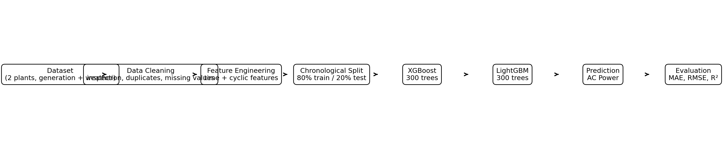
Figure 1. Implemented project flow from raw solar data to model evaluation.

3.2 Dataset Description
The project uses the Solar Power Generation Data dataset with two solar plants. In the reproduced execution, the merged dataset contained 136,472 rows covering 15 May 2020 to 17 June 2020 at 15-minute intervals. The continuous target is AC_POWER. The implemented predictor set contains three measured environmental variables—AMBIENT_TEMPERATURE, MODULE_TEMPERATURE and IRRADIATION—and seven time/cyclic variables: HOUR, MINUTE, DAY, MONTH, DAY_OF_WEEK, HOUR_SIN and HOUR_COS. Humidity and wind speed are not part of the implemented dataset/code and are therefore not used by the trained models.

3.3 Experimental Setup
The implementation is Python-based and was reproduced using Python with pandas, NumPy, Matplotlib, scikit-learn, XGBoost, LightGBM, joblib, and Streamlit. The project can be developed in VS Code or a Jupyter environment. The provided requirements file specifies minimum versions: pandas ≥2.0, numpy ≥1.24, matplotlib ≥3.7, scikit-learn ≥1.3, xgboost ≥2.0, lightgbm ≥4.0, joblib ≥1.3, and streamlit ≥1.30. The project was also tested in a Windows PowerShell workflow in the user's D: drive project directory.

3.4 Data Preprocessing
- Data inspection and schema validation: generation and weather CSV files are loaded for Plant 1 and Plant 2; DATE_TIME is converted to datetime; required columns are checked.
- Duplicate removal: exact duplicate rows are removed using drop_duplicates().
- Missing-value treatment: rows with invalid DATE_TIME or missing required target/input values are removed. In the reproduced run, 136,472 rows remained after cleaning, equal to the raw merged row count.
- Outlier/validity treatment: AC_POWER is clipped at zero because negative solar AC power is not meaningful for this target. No additional statistical outlier filtering is implemented.
- Categorical encoding: not required because the final model feature set contains only numerical environmental and time-derived variables.
- Numerical scaling: not required because XGBoost and LightGBM are tree-based models and the implemented code does not standardize the numeric inputs.
- Target preparation: AC_POWER is used directly as a continuous regression target.
- Train/test split: the data are sorted chronologically and split 80% for training and 20% for testing, avoiding random shuffling across time.

3.5 Exploratory Data Analysis
Exploratory analysis generated power-over-time, irradiation-versus-power, temperature-versus-power, and feature-correlation visualizations. These plots are used to understand temporal variation, environmental relationships, and potential predictor relevance.
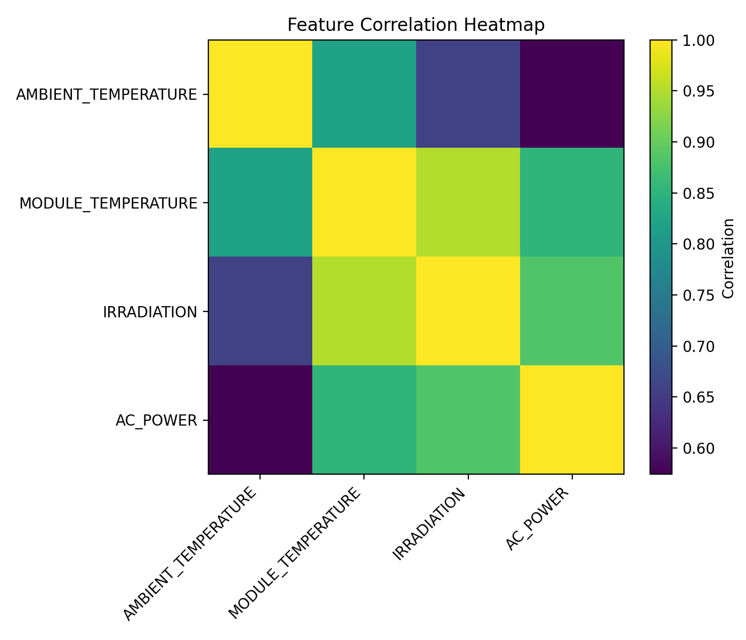
Figure 5. Correlation heatmap of selected environmental variables and AC power.
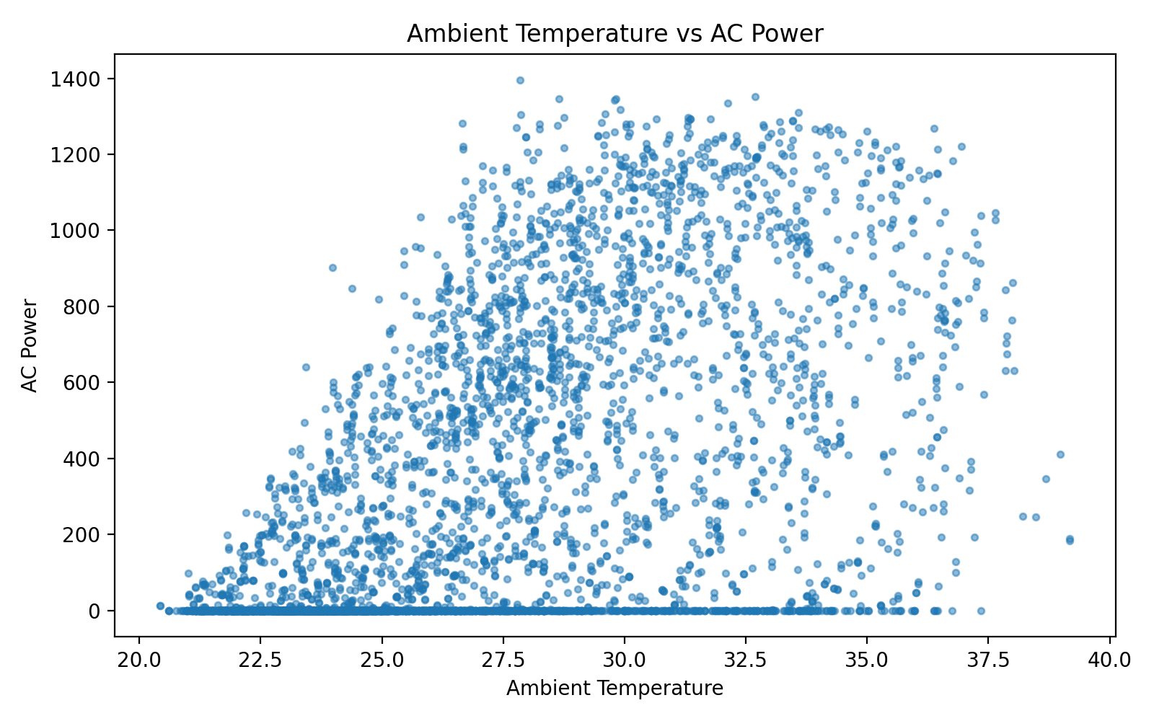
Figure 4. Ambient temperature versus AC power.
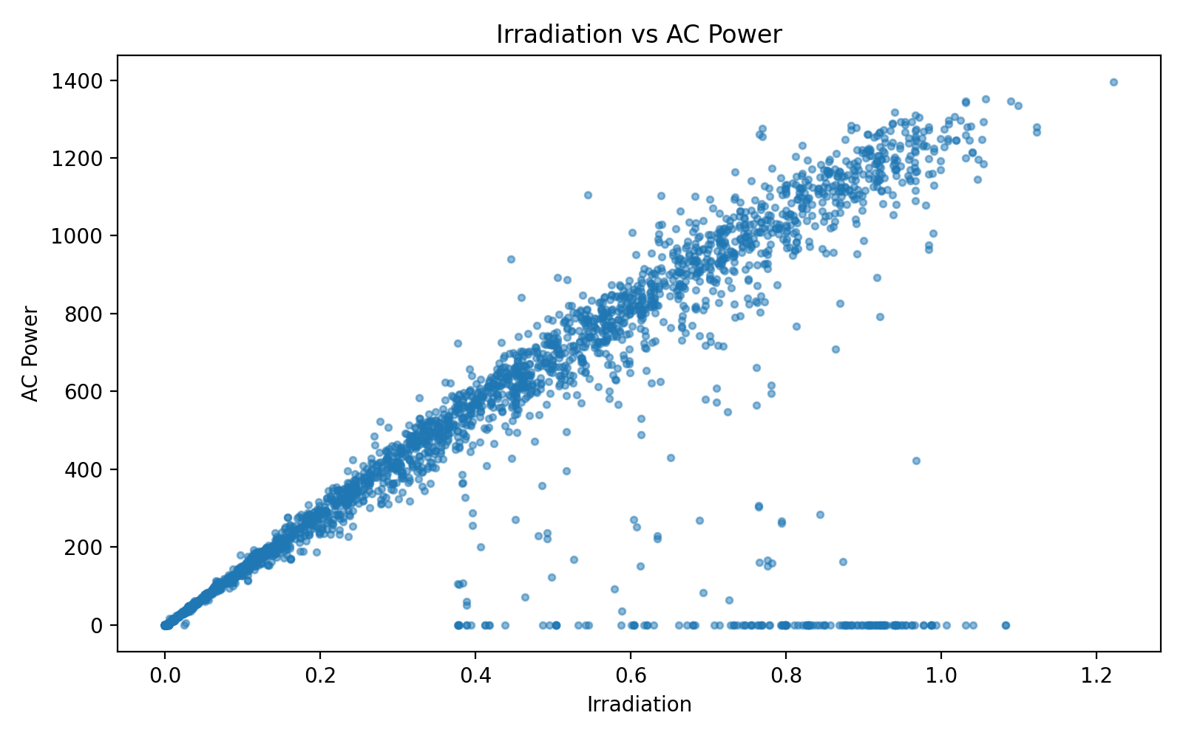
Figure 3. Irradiation versus AC power.
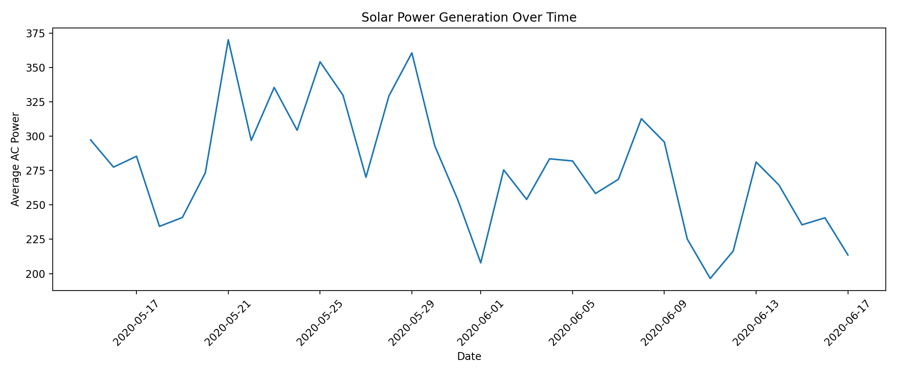
Figure 2. Average solar AC power over time.

3.6 Feature Engineering and Feature Selection (if applicable)
Feature engineering extracts HOUR, MINUTE, DAY, MONTH, and DAY_OF_WEEK from DATE_TIME. Hour is also represented cyclically using sine and cosine so that the end and beginning of the daily cycle are represented as close values. The final ten features are: AMBIENT_TEMPERATURE, MODULE_TEMPERATURE, IRRADIATION, HOUR, MINUTE, DAY, MONTH, DAY_OF_WEEK, HOUR_SIN, and HOUR_COS. DC_POWER, DAILY_YIELD, and TOTAL_YIELD are not used as predictors because they are generation-related variables that can leak information about the target AC_POWER.

3.7 Model Building and Training
Two regression models are trained on the same training set. XGBoost uses XGBRegressor with n_estimators=300, learning_rate=0.05, max_depth=6, min_child_weight=1, subsample=0.90, colsample_bytree=0.90, objective='reg:squarederror', random_state=42, and n_jobs=-1. LightGBM uses LGBMRegressor with n_estimators=300, learning_rate=0.05, num_leaves=31, max_depth=-1, subsample=0.90, colsample_bytree=0.90, objective='regression', random_state=42, and n_jobs=-1. The models are trained on the 80% chronological training set and evaluated on the final 20% chronological test set.

3.8 Hyperparameter Tuning(if applicable)
The current code does not implement GridSearchCV, RandomizedSearchCV, Bayesian optimization, or k-fold cross-validation. The reported experiment uses fixed hyperparameters selected for the project. This is an important limitation and a direct opportunity for future improvement. Automated tuning and time-series cross-validation should be added in a later version.

3.9 Model Evaluation
The evaluation uses regression metrics. MAE measures the average absolute prediction error; RMSE gives greater weight to larger errors; and R² measures the proportion of target variance explained by the model. A conventional classification confusion matrix is not applicable because AC_POWER is continuous. The report therefore uses correlation heatmap, actual-versus-predicted plots, feature importance, and metric comparison charts instead.

4. Results and Discussion

4.1 Preprocessing Results
The raw merged dataset contained 136,472 rows and the cleaned dataset also contained 136,472 rows in the reproduced run. The final model-ready dataset contains 14 columns: DATE_TIME, PLANT_ID, PLANT_NUMBER, the ten model features, and AC_POWER. The 80/20 chronological split produced 109,177 training rows and 27,295 testing rows. No categorical encoding or numerical scaling was required.
Measure | Result
Raw merged rows | 136,472
Rows after cleaning | 136,472
Rows removed in this run | 0
Training rows (80%) | 109,177
Testing rows (20%) | 27,295
Model input features | 10
Target | AC_POWER

4.2 Model Performance
Metric interpretation: lower MAE and RMSE indicate smaller prediction errors, while higher R² indicates that more variance in AC_POWER is explained by the model.
Model | MAE | RMSE | R² | Training Time (s) | Interpretation
XGBoost | 37.8787 | 121.6129 | 0.8630 | 0.4464 | Strong regression performance
LightGBM | 36.9710 | 121.1118 | 0.8641 | 0.4825 | Slightly lower error and slightly higher R²

4.3 Visual Results and discussion
The implemented project does not use a classification confusion matrix or ROC curve because AC_POWER is a continuous regression target. The available visual results include the actual-versus-predicted plot, XGBoost and LightGBM feature-importance plots, and metric comparison charts.
The prediction plot shows that both models follow the observed AC-power pattern. Irradiation is the dominant feature in both model-importance outputs, while temperature and time features provide additional information. LightGBM has slightly lower MAE and RMSE and a slightly higher R² in this run. The difference is small, so the two models are closely matched for this experiment. Generalization beyond the tested period should be validated with longer time ranges, additional sites, and time-series cross-validation.
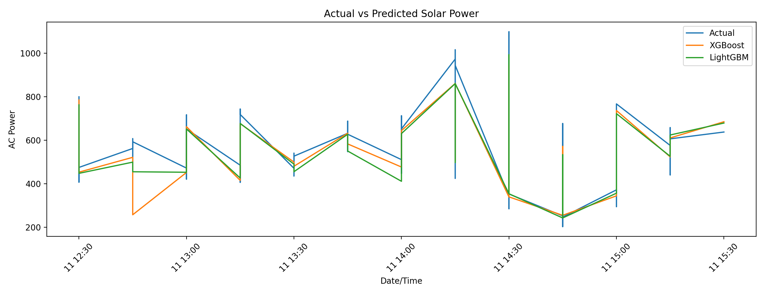
Figure 6. Actual AC power compared with XGBoost and LightGBM predictions.
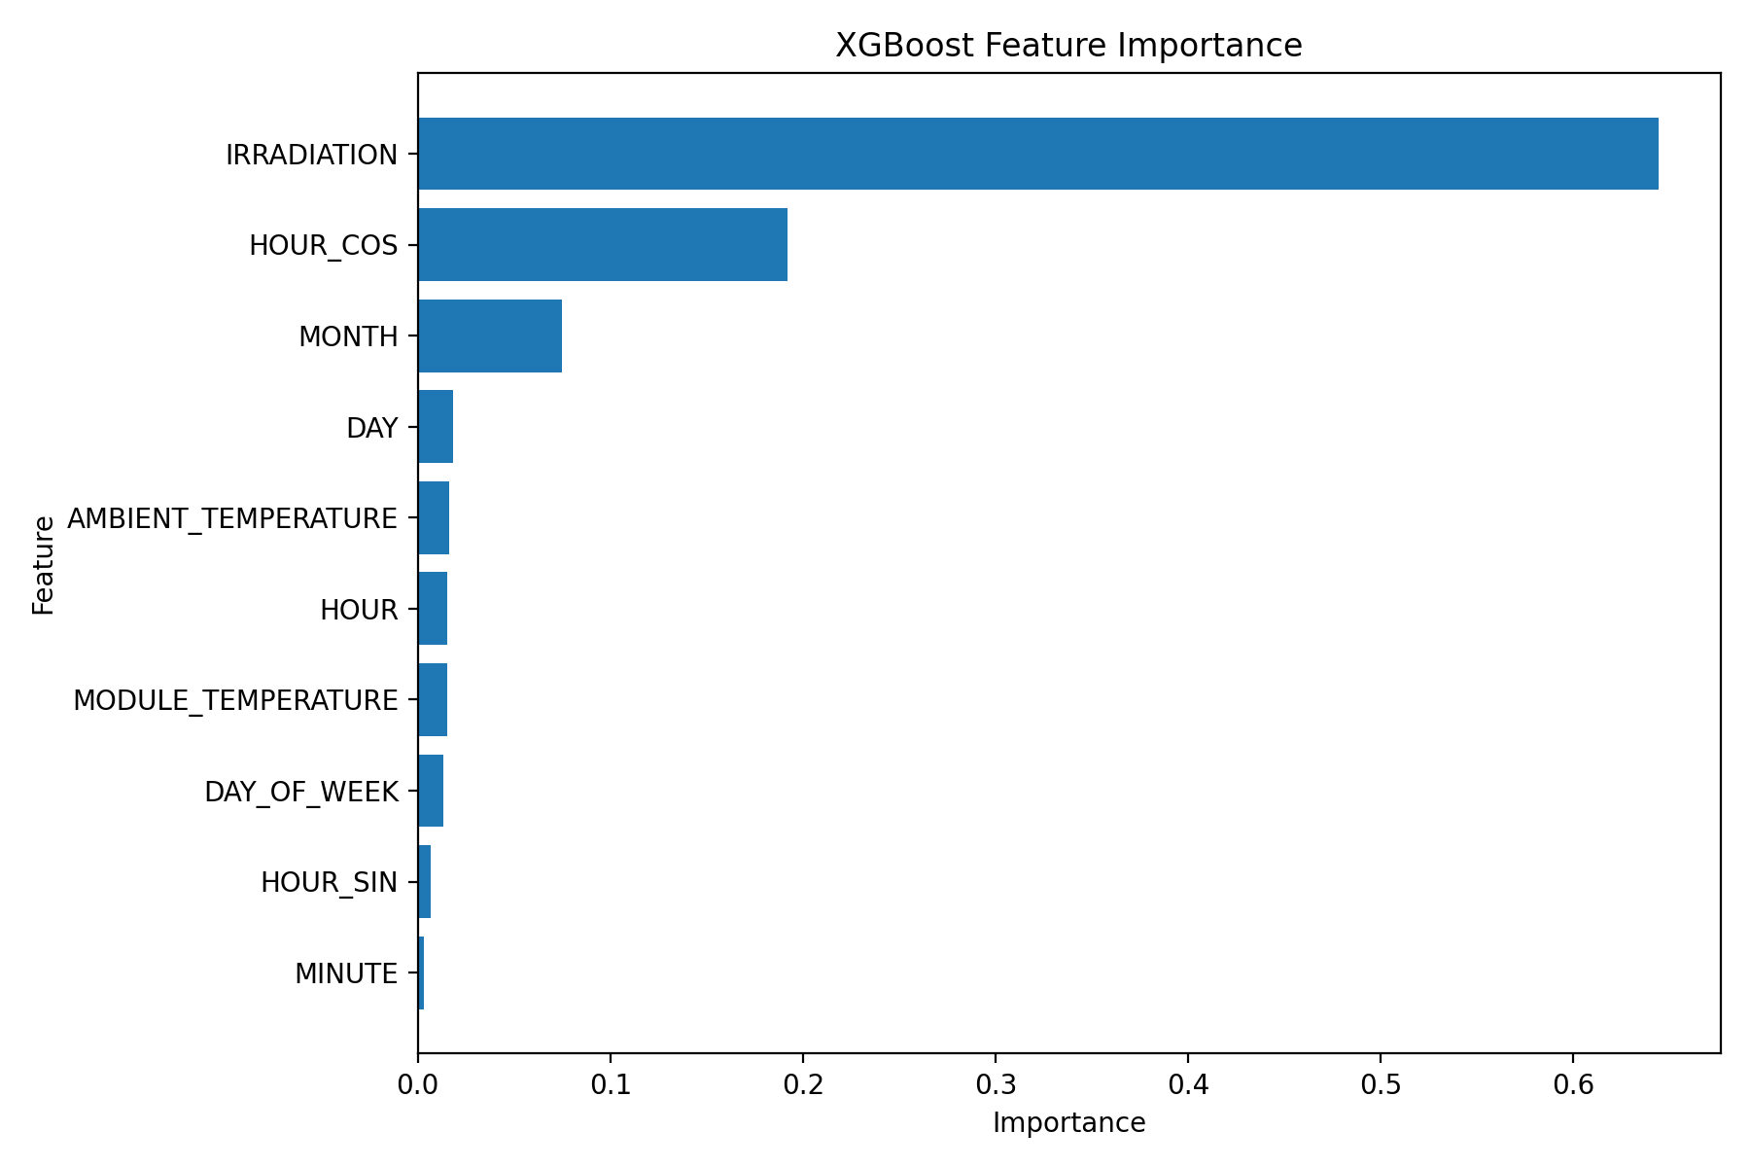
Figure 7. XGBoost feature importance.
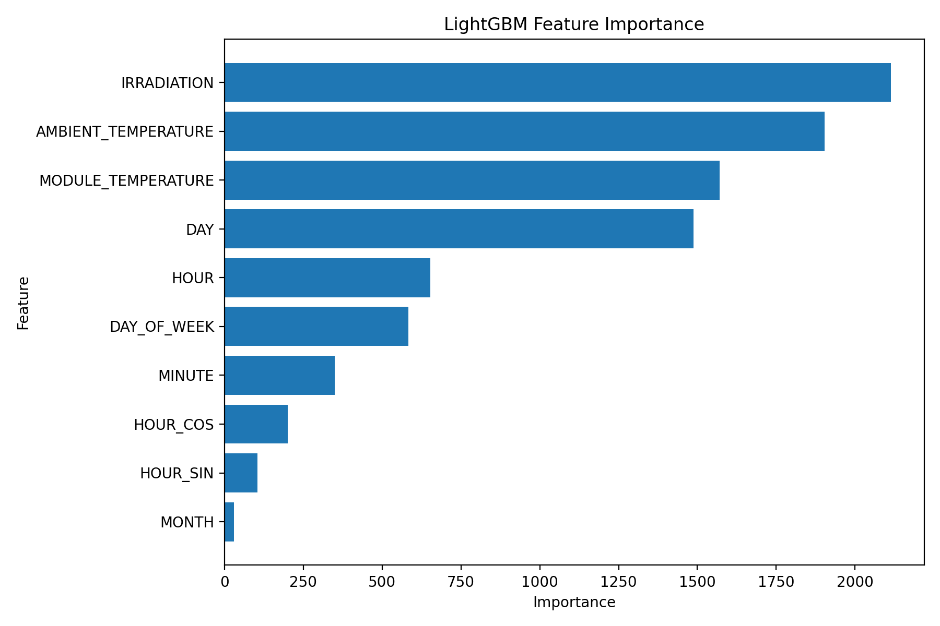
Figure 8. LightGBM feature importance.
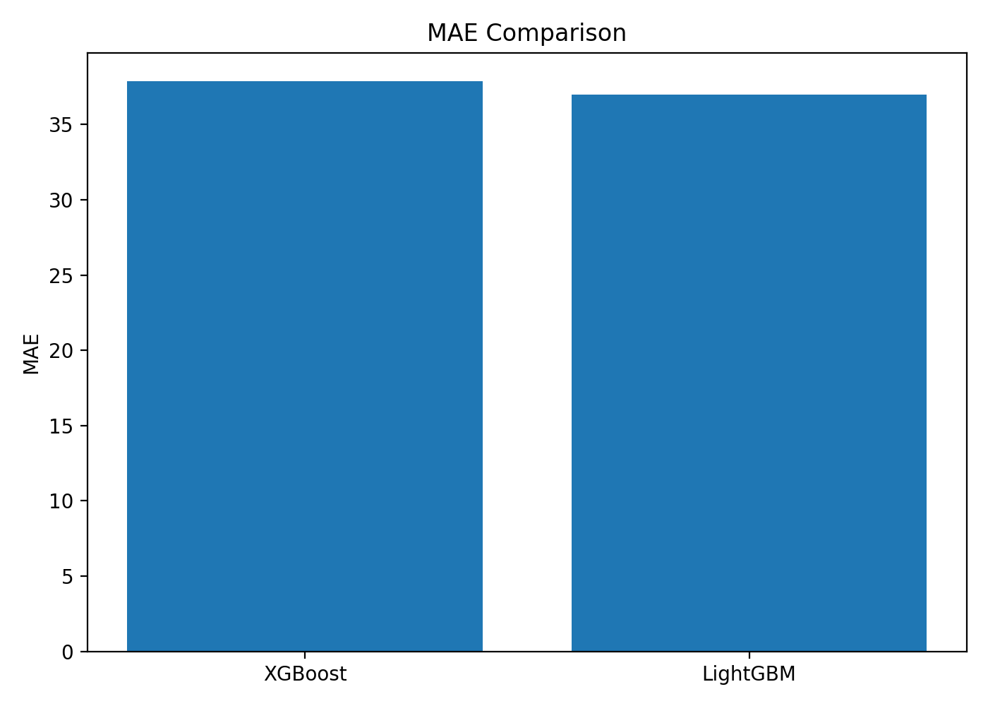
Figure 9. MAE comparison.
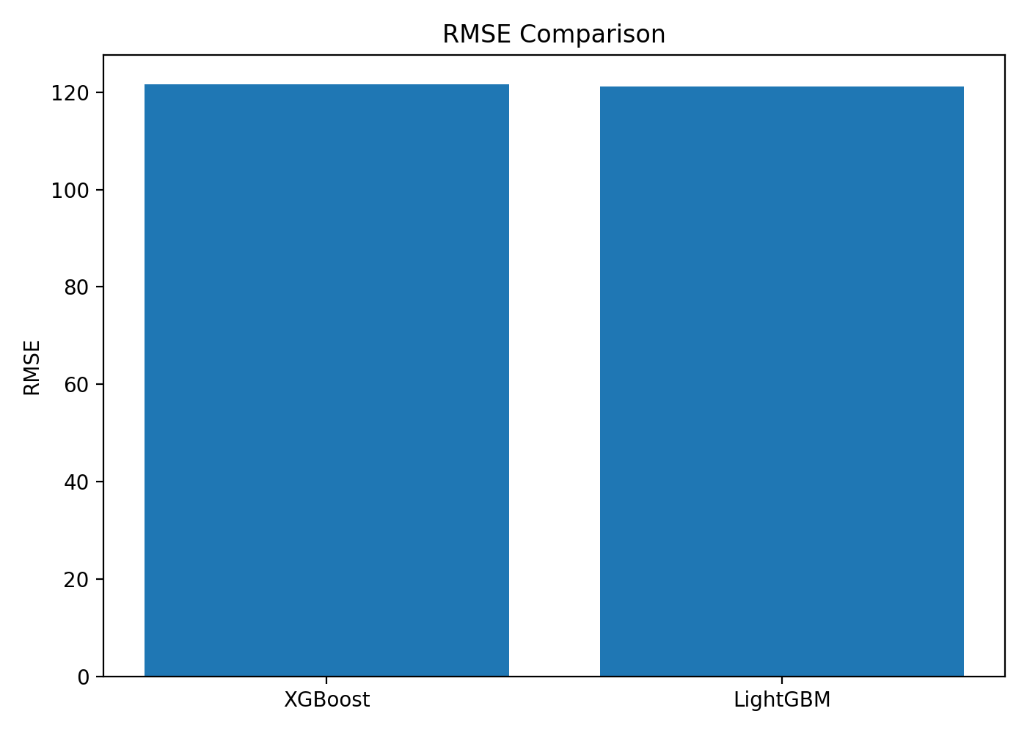
Figure 10. RMSE comparison.
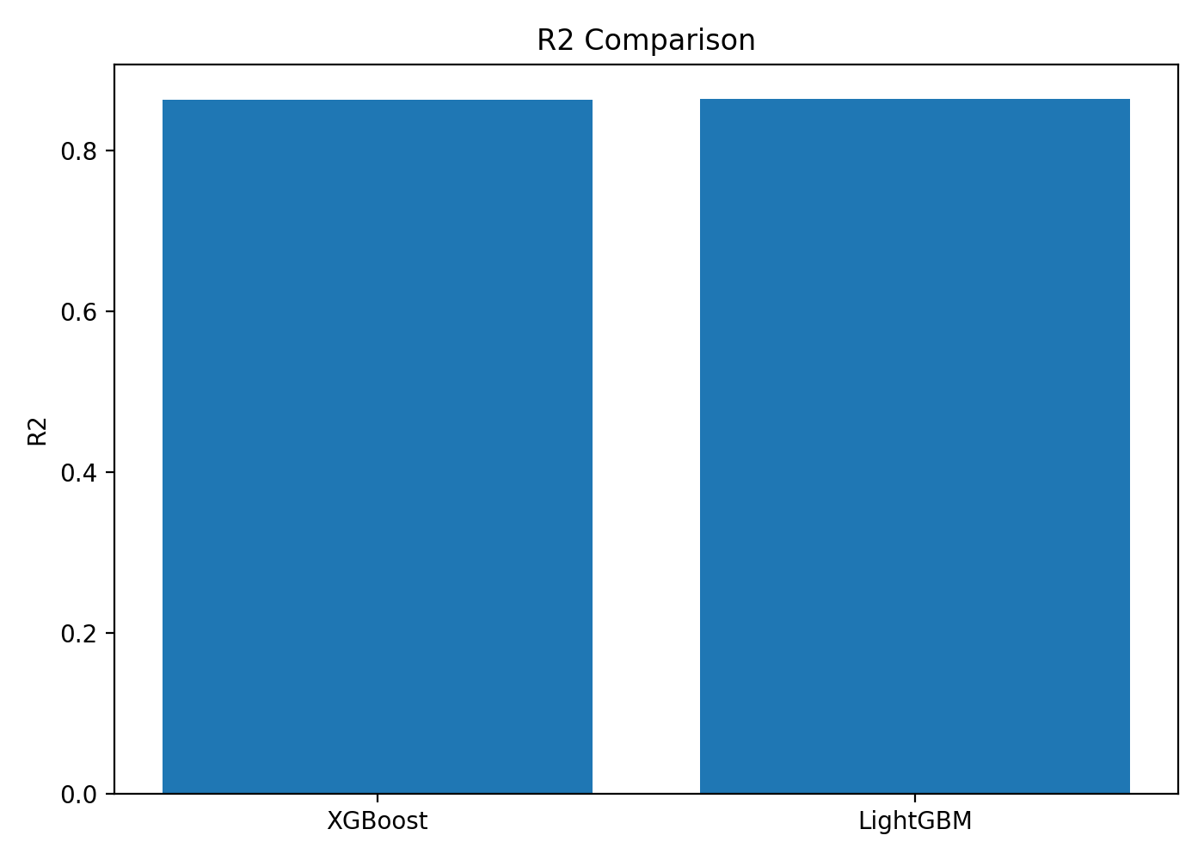
Figure 11. R² comparison.
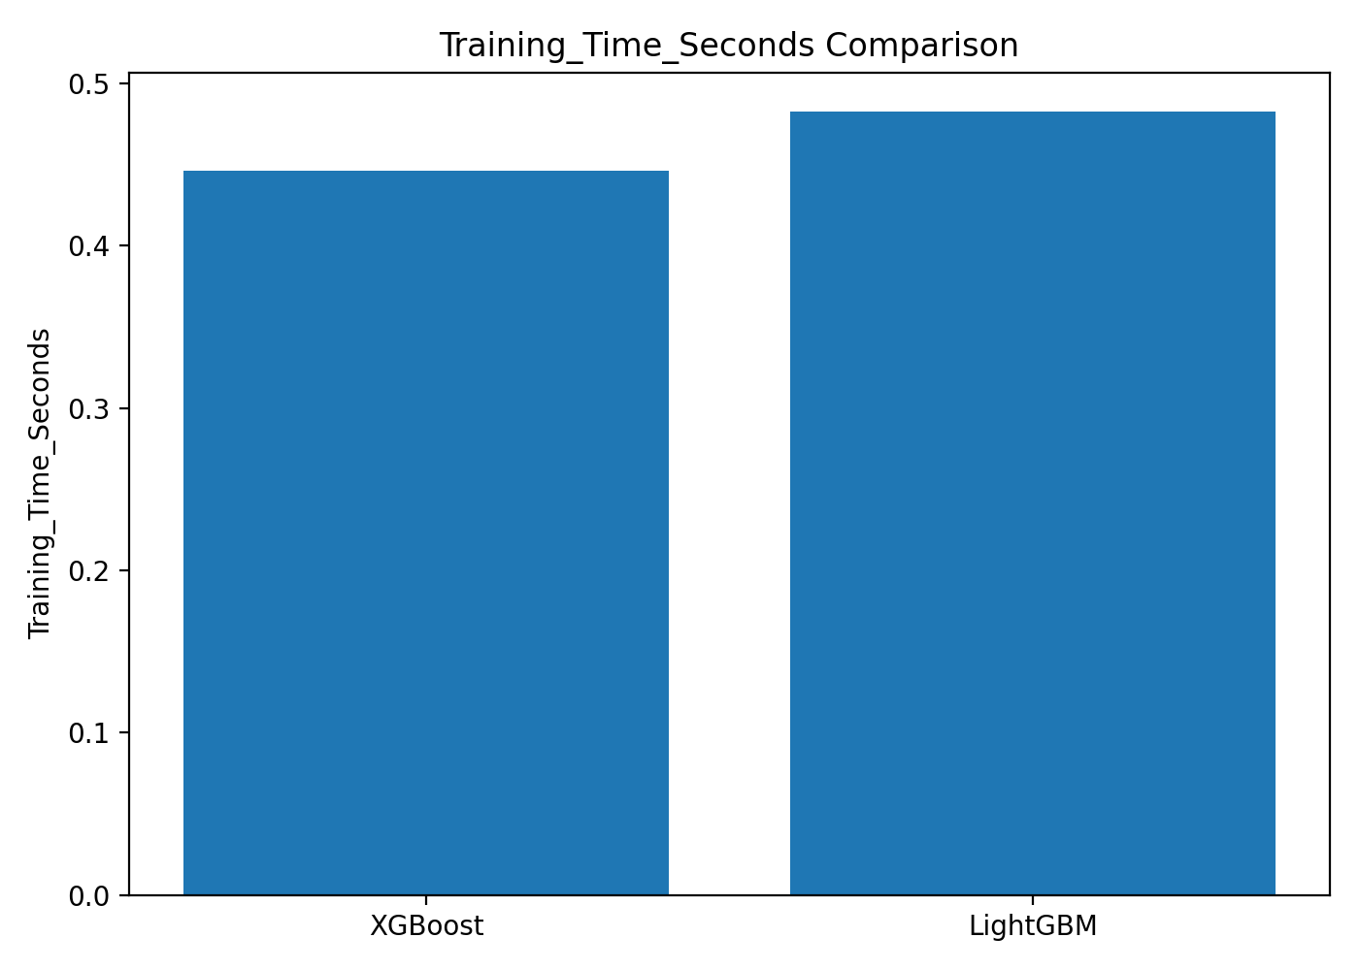
Figure 12. Training-time comparison.
4.4 Limitations
The present implementation is intentionally simple. It uses a relatively short historical period, fixed model hyperparameters, no automated cross-validation/tuning, and a limited set of weather variables. The weather-generation merge is performed on DATE_TIME and PLANT_ID because SOURCE_KEY has different meanings in the generation and weather files. The results are therefore specific to this dataset, preprocessing pipeline, chronological split, and execution environment. The reported training times are also hardware-dependent.

5. Conclusion
This project developed a reproducible machine learning pipeline for solar photovoltaic AC-power prediction using XGBoost and LightGBM. The pipeline loads two-plant generation and weather data, performs cleaning, engineers time and cyclic features, uses a chronological 80/20 split, trains both regressors, and evaluates them using MAE, RMSE, and R². In the reproduced execution, XGBoost achieved MAE 37.8787, RMSE 121.6129, and R² 0.8630, while LightGBM achieved MAE 36.9710, RMSE 121.1118, and R² 0.8641. LightGBM therefore gave slightly lower errors and slightly higher R² in this experiment. The project also generates EDA plots, feature-importance charts, prediction results, comparison charts, saved models, and a Streamlit prediction interface. The system demonstrates the practical use of gradient-boosting regression for renewable-energy output prediction.

6. Future Work
- • Use larger datasets covering multiple seasons, locations, and operating conditions.
- • Add humidity, wind speed, cloud cover, numerical weather prediction, and lagged historical power features when available.
- • Apply time-series cross-validation and automated hyperparameter optimization.
- • Compare additional models such as Random Forest, CatBoost, HistGradientBoosting, LSTM, GRU, and Transformer architectures.
- • Add prediction intervals and uncertainty quantification for operational planning.
- • Use SHAP or other explainable-AI techniques for detailed feature and prediction interpretation.
- • Monitor model drift and schedule retraining when plant or weather behavior changes.

7. References
The following references were selected from recent 2023–2026 literature and the dataset source used in this project. DOI details should be rechecked by the team before final institutional submission.
[1] Ye, J., Zhao, B., & Deng, H. (2023). Photovoltaic Power Prediction Model Using Pre-train and Fine-tune Paradigm Based on LightGBM and XGBoost. Procedia Computer Science, 224, 407–412. DOI: 10.1016/j.procs.2023.09.056.
[2] Gao, H., Qiu, S., Fang, J., Ma, N., Wang, J., Cheng, K., Wang, H., Zhu, Y., Hu, D., Liu, H., & Wang, J. (2023). Short-Term Prediction of PV Power Based on Combined Modal Decomposition and NARX-LSTM-LightGBM. Sustainability, 15(10), 8266. DOI: 10.3390/su15108266.
[3] Xu, W., Wang, Z., Wang, W., Zhao, J., Wang, M., & Wang, Q. (2024). Short-Term Photovoltaic Output Prediction Based on Decomposition and Reconstruction and XGBoost under Two Base Learners. Energies, 17(4), 906. DOI: 10.3390/en17040906.
[4] Xiong, G., Zhang, J., Fu, X., Chen, J., & Mohamed, A. W. (2024). Seasonal short-term photovoltaic power prediction based on GSK–BiGRU–XGboost considering correlation of meteorological factors. Journal of Big Data, 11, 164. DOI: 10.1186/s40537-024-01037-x.
[5] Zoubir, Z., Es-sakali, N., Er-Retby, H., & Mghazli, O. (2024). Prediction of energy production in a building-integrated photovoltaic system using machine learning algorithms. Procedia Computer Science, 236, 75–82. DOI: 10.1016/j.procs.2024.05.007.
[6] Vargas, J., Martinez, R., & Loo, L. (2024). Enhancing Photovoltaic Energy Forecasting with Machine Learning: A Comparison Study of XGBoost, LightGBM and LSTM Models. Proceedings of the 2024 IEEE Latin American Conference on Computational Intelligence. DOI: 10.1109/LA-CCI62337.2024.10814763.
[7] Subramani, S., Hari, S., Asha, K., Raj, F. D., et al. (2024). Enhanced Short-Term Photovoltaic Power Prediction using a Hybrid Improved Whale Optimization Algorithm with XGBoost. 2024 Second International Conference on Smart Technologies for Power and Renewable Energy. DOI: 10.1109/SPECon61254.2024.10537570.
[8] Singh, U., Singh, S., Gupta, S., Alotaibi, M. A., & Malik, H. (2025). Forecasting rooftop photovoltaic solar power using machine learning techniques. Energy Reports, 13, 3616–3630. DOI: 10.1016/j.egyr.2025.03.005.
[9] Naqvi, S. K. H., Chong, K. T., & Tayara, H. (2025). WBML-PV: Window-based machine learning for ultra-short-term photovoltaic power forecasting. IFAC Journal of Systems and Control, 34, 100342. DOI: 10.1016/j.ifacsc.2025.100342.
[10] Naghapushanam, M., Jeevarathinam, B., & Sankari, C. (2026). Physics-informed voting ensemble for solar power generation forecasting: integrating domain knowledge with machine learning. Energy Informatics, 9, 3. DOI: 10.1186/s42162-025-00604-7.
[11] Kaggle. Solar Power Generation Data. Dataset source: https://www.kaggle.com/datasets/anikannal/solar-power-generation-data.

Signature of the Guide Course Instructor

