E-Commerce Sales Performance Analytics
Data Analytics Internship Project Report

1. Project Overview
This project demonstrates an end-to-end Data Analytics workflow for an e-commerce business: data preparation, data-quality checks, KPI calculation, trend analysis, category analysis, regional analysis, channel analysis, visualization, insights and business recommendations.
The project uses a reproducible synthetic dataset containing 1,200 e-commerce transactions for 2025. The data is generated inside the Python program with a fixed random seed, so the project can be run without proprietary data or a separate dataset download.

2. Objectives
- Measure revenue and profitability.
- Track monthly sales performance.
- Identify high-performing product categories.
- Compare regional profitability.
- Compare sales channels.
- Convert analysis results into practical business recommendations.

3. Tools and Technologies
Python, Pandas, NumPy and Matplotlib. The code can be executed in VS Code, Jupyter Notebook or Google Colab.

4. Key KPIs
KPI | Value
Total Revenue | ₹7,328,061.58
Total Profit | ₹2,070,172.88
Total Orders | 1,200
Average Order Value | ₹6,106.72
Profit Margin | 28.25%

5. Monthly Revenue Trend
Monthly revenue is visualized to identify changes in sales performance and support planning for inventory and marketing.
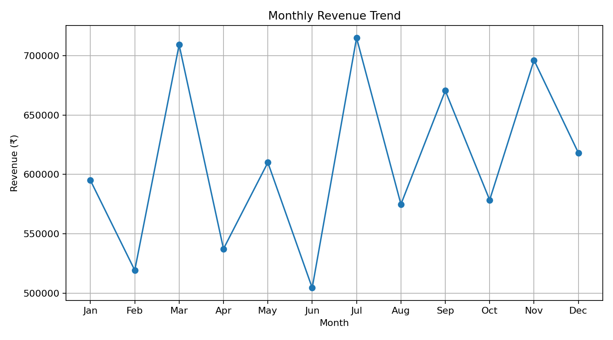

6. Revenue by Category
Category-level revenue comparison helps identify product groups contributing strongly to sales.
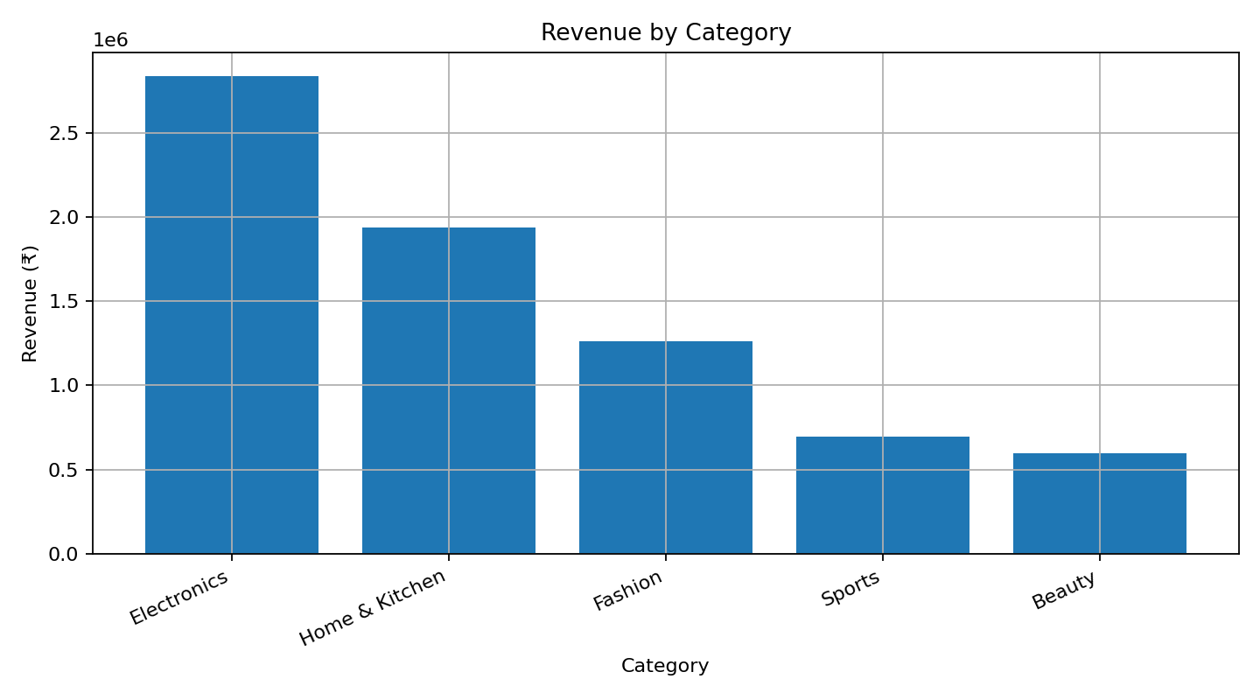

7. Profit by Region
Regional profit comparison shows where sales are translating into stronger business returns.
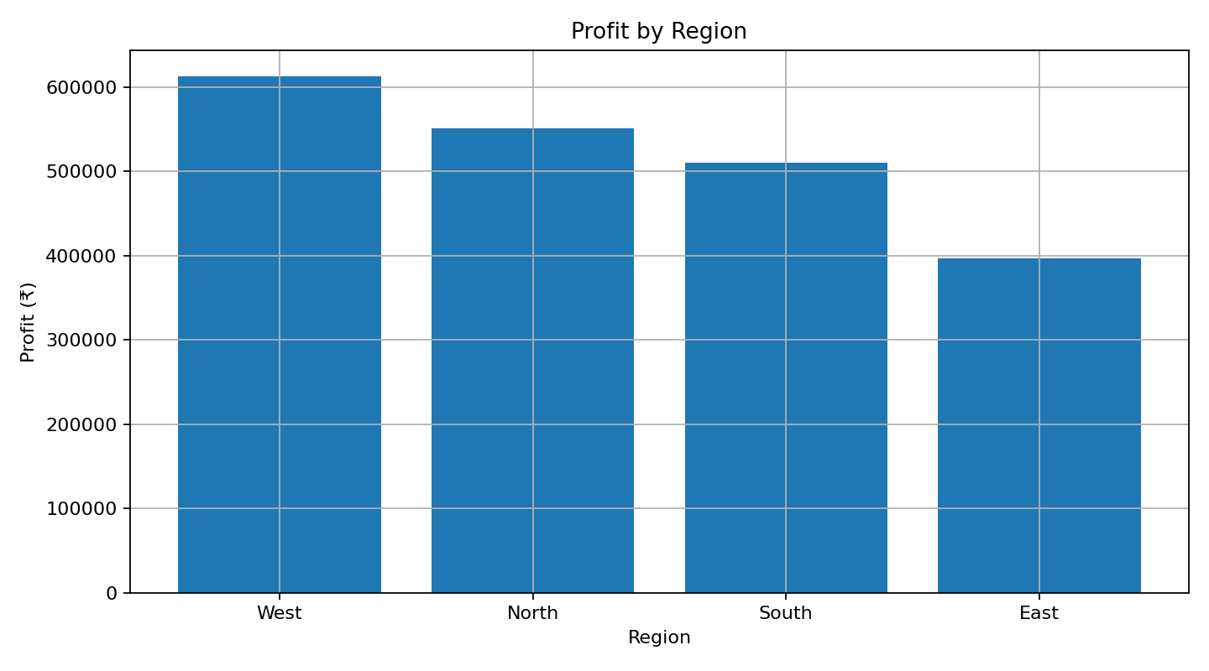

8. Revenue by Sales Channel
Channel comparison helps understand the contribution of website, mobile app and marketplace sales.
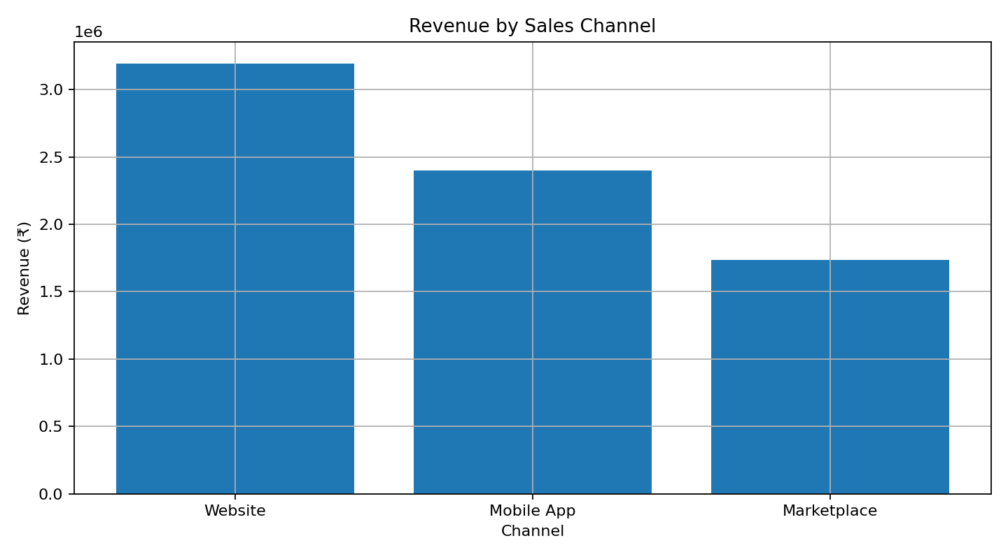

9. Business Insights
- Revenue should be monitored month by month to identify periods requiring corrective action.
- The highest-revenue category in this project is Electronics.
- The highest-revenue region in this project is West.
- The highest-revenue channel in this project is Website.
- Profitability should be considered alongside revenue because high sales do not automatically mean the highest profit.

10. Recommendations
- Track monthly revenue and investigate significant deviations.
- Prioritize inventory and marketing around high-performing categories.
- Review regional profit before allocating promotional budgets.
- Compare sales channels regularly and improve weaker channels.
- Monitor discounting because discounts reduce realized revenue.

11. Conclusion
The project demonstrates how transaction-level data can be converted into KPIs, visual analysis and business recommendations. The workflow can be extended with SQL, Power BI or predictive modelling in a future version.

12. Project Deliverables
- Python code file
- requirements.txt
- README.md
- Project Report
- GitHub repository

