Garbage Collection
- Heap memory of the object only allow two types of variables: instance variable and instance read only variable.
- static and static readonly are out of bound for G.C and handled by CLR.
- **G.C is only meant for instance and instance readonly variable.
- Myclass obj = new Myclass(), Here obj act as a refernce pointer in Stack which point to the memory addresso the class in HEAP.
- Four types of Heap Memory: Code Heap, SOH(Simple object Heap Memory), LOH(Large Object Heap), Process HEAP Memory.
- G.C is the feature of the CLR which clear the Memory allocated to the instance and instance readonly variables in the Heap Memory.
- CLR is also Known as MScoriee.
- Heap Memory is divided into Generations.
- If the size of the class memory is less than 85kb then it is called as Simple Object HEAP Memory(SOH).
- If Class memory is equal to or larger than 85kb then it is called as large object Heap Memory.
- if Size is less than 85KB then it Goes to then Generation 0.
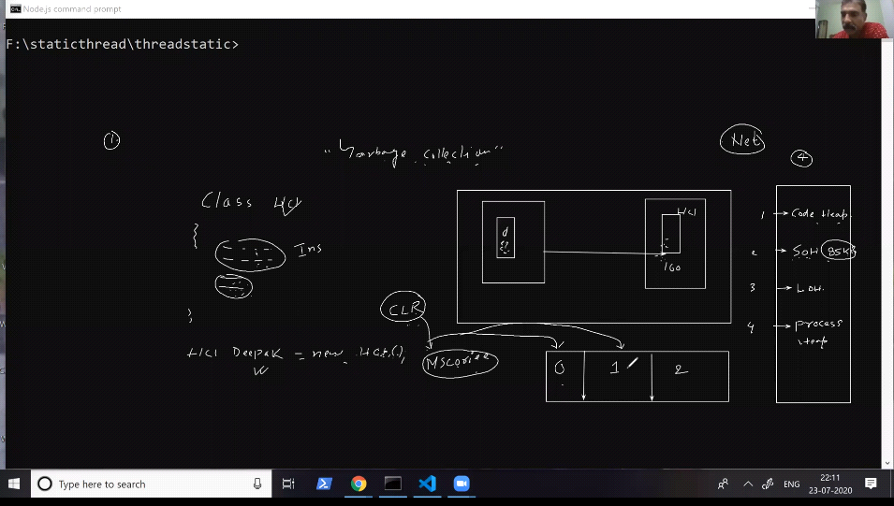
- If greater than 85kb then it is stored in Generation 1.

What for the Static and static readonly ?
- High Frequency Heap Memery (HFH)
- Static variables and static readonly variable is stored in App domain by the CLR and HFH keep a reference of the variables in the App domain. That's why they are said to be Global Variable.
- A process can have multiple threads and a Single Instance can be allocated to all the threads belong the a Single process.(Global Nature of static and static readonly).
- **Cons: Single instance and multiple threads is never safe and an attempt to change value by one thread can be reflected to other threads.
Thread Static Architecture
- Static variable can be made thread safe One instance, One variable is Followed.
- eg. Single PC multiple User, changes by one user is not reflected in other user Desktops.
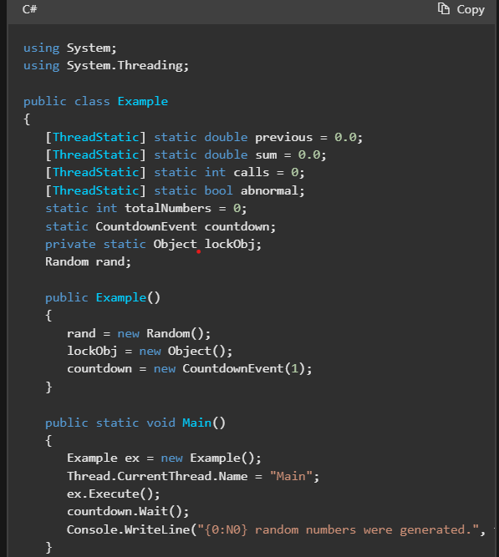
- A static field marked with ThreadStatic Attribute is not shared between threads. A single instance per thread.
- eg. One department, One Canteen.
- Whenever we want to call multiple thread Simultaneously then use Thread.Join().This method blocks the Second thread till the execution of the first thread completed and it releases the
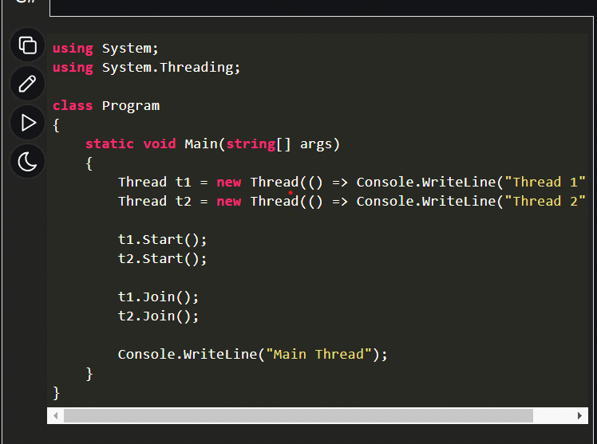

Q1. What are Generations?
The heap is organized into generations so it can handle long-lived and short-lived objects. Garbage collection primarily occurs with the reclamation of short-lived objects that typically occupy only a small part of the heap. There are three generations of objects on the heap: •Generation 0. This is the youngest generation and contains short-lived objects. An example of a short-lived object is a temporary variable. Garbage collection occurs most frequently in this generation. Newly allocated objects form a new generation of objects and are implicitly generation 0 collections, unless they are large objects, in which case they go on the large object heap in a generation 2 collection. Most objects are reclaimed for garbage collection in generation 0 and do not survive to the next generation. •Generation 1. This generation contains short-lived objects and serves as a buffer between short-lived objects and long-lived objects. •Generation 2. This generation contains long-lived objects. An example of a long-lived object is an object in a server application that contains static data that is live for the duration of the process.
Q2. Why 85kb is set are the limit for the Heap Categorization?
Q3. Life of App domain? Scope of App domain?

Delegates

