PROJECT REPORT
Law Assistant and Case Recommendation System
Submitted in partial fulfilment of the requirement for the award of the degree of
BACHELOR OF TECHNOLOGY
IN
COMPUTER SCIENCE & ENGINEERING
Submitted by
Name: Kunal Singh Negi | University Roll No - 2219565
Name: Adarsh Kaintura | University Roll No - 2218183
Under the guidance of
Ms. Pallavi Semwal
ASSISTANT PROFESSOR
Project Group No: 192

Department of Computer Science and Engineering
Graphic Era Hill University
May, 2026


CANDIDATE’S DECLARATION
I/We hereby certify that the work which is being presented in the project progress report entitled “Law Assistant and Case Recommendation System” in partial fulfillment of the requirements for the award of the Degree of Bachelor of Technology in Computer Science and Engineering in the Department of Computer Science and Engineering of the Graphic Era Hill University, Dehradun shall be carried out by the undersigned under the supervision of Ms. Pallavi Semwal, Assistant Professor, Department of Computer Science and Engineering, Graphic Era Hill University, Dehradun.
Kunal Singh Negi -
Adarsh Kaintura
Supervisor Name – Ms. Pallavi Semwal
Date –

ACKNOWLEDGEMENT

We express our profound gratitude to our project guide, Ms. Pallavi Semwal, Assistant Professor, Department of Computer Science and Engineering, for her continuous support, technical guidance, and encouragement throughout the development of this project. Her insights have been invaluable in shaping the architecture and implementation of R-SPARK. We would also like to thank Graphic Era Hill University for providing the necessary resources and environment to successfully complete this endeavour.

Kunal Singh Negi Adarsh Kaintura
Roll no. 2219534 Roll no. 2218183

ABSTRACT

The rapid proliferation of digital academic literature has significantly altered how researchers interact with knowledge, creating a pressing need for advanced Information Retrieval (IR) systems. While Large Language Models (LLMs) such as GPT-4 and LLaMA exhibit exceptional natural language understanding and problem-solving capabilities, their utility in rigorous academic environments is constrained by critical limitations. Primary among these is the phenomenon of hallucination—where models generate confident but factually incorrect responses—coupled with their inability to access real-time, external, or private document-specific knowledge. To address these challenges, this project introduces R-SPARK, a completely locally deployable research assistant built on a Retrieval-Augmented Generation (RAG) architecture. R-SPARK is designed to ingest user-uploaded Portable Document Format (PDF) files and ground all LLM-generated answers directly in the provided source material, ensuring verifiable and highly accurate responses.
The methodology of R-SPARK begins with a robust data ingestion pipeline utilizing PyMuPDF (fitz) to accurately parse complex academic layouts, including multi-column formats. The extracted raw text is then processed using SpaCy, a state-of-the-art Natural Language Processing (NLP) library, which executes sentence boundary detection to segment the text into grammatically coherent, ten-sentence chunks. This sentence-aware chunking strategy is vital for preserving contextual integrity, avoiding the truncation of linguistic boundaries common in basic character-level splitting techniques. To facilitate semantic search, these text chunks are transformed into 384-dimensional vector embeddings using the lightweight and highly efficient all-MiniLM-L6-v2 model.
A defining architectural innovation of R-SPARK is its two-stage, hierarchical parent-child retrieval strategy powered by ChromaDB. Rather than querying a massive flat database of chunks, the system maintains two distinct collections: a parent collection representing the document-level summary (extracted from the first two pages, typically housing the abstract and introduction) and a child collection containing the detailed passage-level chunks. During a query, the system first matches the user’s question against the parent collection to identify the most relevant papers, and subsequently filters the child collection to retrieve specific context chunks. This two-tiered approach drastically reduces search space, minimizing the retrieval of irrelevant data and improving accuracy.
For answer generation, R-SPARK utilizes the Llama-3.2-1B-Instruct foundation model. To ensure the system remains democratized and accessible to researchers lacking high-end enterprise hardware, the LLM is executed locally using the llama.cpp engine with a 4-bit quantization format (GGUF Q4_K_M). This quantization strategy compresses the model footprint significantly, allowing it to run within limited GPU environments, such as the free tier of Google Colab (NVIDIA T4), requiring only approximately 1.17 GB of RAM during peak utilization. The entire application is wrapped in a highly responsive RESTful API developed with FastAPI, offering seamless endpoints for document uploading, querying, and system health monitoring.
Rigorous system evaluation demonstrated that R-SPARK effectively mitigates hallucination through a strict cosine distance threshold filter (set to 0.5); if retrieved chunks fall outside this threshold, the system gracefully reports an inability to find relevant context rather than fabricating an answer. Furthermore, every generated response is accompanied by precise page-level citations drawn from the metadata of the retrieved chunks, enabling users to instantly verify claims against the original document.
Ultimately, R-SPARK bridges the gap between advanced artificial intelligence and practical academic research. By successfully harmonizing optimized local inference, hierarchical semantic retrieval, and strict source-grounding, this project proves that a trustworthy, privacy-preserving, and computationally accessible AI assistant can be engineered to systematically accelerate the literature review process and democratize complex knowledge extraction for students and professionals alike.

TABLE OF CONTENTS

CHAPTER 1: INTRODUCTION

1.1 Importance of Information Retrieval in Academic Research
1.2 Project Overview
1.3 Large Language Models and RAG Techniques
1.3.1 Local LLM Inference and Quantization (GGUF)
1.3.2 Vector Embeddings and Semantic Search
1.4 Potential Impact and Applications
1.4.1 Accelerating Academic Research and Literature Review
1.4.2 Democratising Access to Complex Knowledge
1.4.3 Institutional Knowledge Management
1.4.4 Supporting Education and Self-Directed Learning
1.4.5 Legal, Medical, and Technical Document Analysis
1.4.6 Promoting Responsible and Verifiable AI Usage

CHAPTER 2: OBJECTIVES

2.1 To Ingest and Parse Academic PDF Documents
2.2 To Preprocess and Chunk Text Using NLP Techniques
2.3 To Explore and Implement Vector Embedding Models
2.4 To Design a Parent-Child Retrieval Strategy Using Vector Databases
2.5 To Integrate a Quantized LLM for Local Answer Generation
2.6 To Assist Users with Intelligent, Data-Driven Research Insights
CHAPTER 3: SOFTWARE AND HARDWARE REQUIREMENTS

3.1 Hardware Requirements
3.2 Software Requirements
3.3 System Requirements Specification (SRS)
3.3.1 Functional Requirements
3.3.2 Non-Functional Requirements

CHAPTER 4: PROJECT METHODOLOGY

4.1 Data Ingestion and PDF Parsing (PyMuPDF)
4.1.1 Overview
4.1.2 Ingestion Algorithm
4.1.3 Document Ingestion Flowchart
4.2 Data Preprocessing and NLP Chunking (SpaCy)
4.2.1 Overview
4.2.2 Chunking Algorithm
4.2.3 Preprocessing Pipeline Flowchart
4.3 Problem Statement
4.4 Model Selection: LLM and Embeddings
4.4.1 Hardware Constraints and Quantization Strategy
4.4.2 Foundational Model Selection
4.5 Vector Database Design (ChromaDB)
4.5.1 Overview
4.5.2 Parent-Child Vector Strategy
4.5.3 Two-Stage Retrieval Algorithm
4.5.4 Retrieval Strategy Flowchart
4.6 API Architecture and Endpoint Design (FastAPI)
4.6.1 Overview
4.6.2 API Endpoint Specification
4.6.3 Complete Query Pipeline Algorithm
4.6.4 Complete System Pipeline Flowchart

CHAPTER 5: IMPLEMENTATION AND RESULTS

5.1 System Setup and Implementation Stack
5.2 API Endpoint Execution and Testing
5.3 Retrieval Testing and Context Relevance
5.4 LLM Answer Generation Examples
5.5 System Performance (Latency and Hardware Utilisation)

CHAPTER 6: CONCLUSION AND FUTURE SCOPE

6.1 Conclusion
6.2 Future Scope
6.2.1 Authorization and Authentication of Users
6.2.2 Use of API Gateway
6.2.3 Support for Various Quantized Models
REFERENCES
APPENDIX A (CODE)

LIST OF TABLES
Sno. | Table Description / Caption
1 | Table 1. GGUF Quantization Level Comparison
2 | Table 2. LLM Foundational Model Comparison
3 | Table 3. ChromaDB Parent-Child Collections Schema
4 | Table 4. R-SPARK API Endpoints
5 | Table 5. Hardware and Software Specifications
6 | Table 6. Table of System Performance

LIST OF FIGURES

Sno. | Figure Description / Caption
1 | Fig 1. High-Level Architecture Diagram
2 | Fig 2. Data Ingestion Flowchart
3 | Fig 3. Preprocessing Pipeline Flowchart
4 | Fig 4. Parent-Child Retrieval Strategy Flowchart
5 | Fig 5. Complete System Pipeline Flowchart
6 | Fig 6. Screenshot of FastAPI Swagger UI
7 | Fig 7. Screenshot of /upload endpoint request and response
8 | Fig 8. Screenshot of /health endpoint response
9 | Fig 9. Screenshot of retrieval output
10 | Fig 10. Screenshot of system response to an out-of-domain query
11 | Fig 11. Screenshot of first query
12 | Fig 12. Screenshot of second query
13 | Fig 13. Screenshot of no context relative to query found

ABBREVIATIONS

AI – Artificial Intelligence
API – Application Programming Interface
GGUF – GPT-Generated Unified Format
GPU – Graphics Processing Unit
IR – Information Retrieval
LLM – Large Language Model
NLP – Natural Language Processing
PDF – Portable Document Format
RAG – Retrieval-Augmented Generation
SRS – System Requirements Specification

CHAPTER 1

INTRODUCTION

Nowadays, Large Language Models (LLMs) such as GPT-4 and LLaMA have changed the way people interact with computers. They can write essays, solve problems, answer questions, and even generate code, which makes them extremely useful for students, researchers, and developers. Because of this, LLMs are increasingly being used as general-purpose assistants across many domains. However, despite their impressive abilities, LLMs also have clear limitations when used on their own. One of the most common issues is that they can produce incorrect or misleading information while sounding very confident. This makes it hard for users to immediately recognize mistakes, which can be risky in academic or professional settings where accuracy really matters. Another important limitation is that LLMs do not truly understand what they are saying. They generate responses based on patterns learned from large datasets rather than real reasoning or comprehension. As a result, they can struggle with complex logic, maintaining consistency across longer answers, or responding accurately when detailed, document-specific knowledge is required.
LLMs are also limited by their training data. If the data contains outdated information or biases, those issues may appear in the model’s responses. In addition, most language models do not have access to real-time information, meaning they cannot naturally keep up with new developments or user-provided content. This makes them less reliable for tasks that depend on current or domain-specific knowledge.
These challenges are especially relevant for research-oriented use cases, which is where this project is focused. Rather than relying entirely on a language model’s internal knowledge, this project uses a Retrieval-Augmented Generation (RAG) approach. By allowing the system to look up relevant information from uploaded PDF documents before generating an answer, responses remain grounded in actual source material instead of assumptions or guesses. The project also addresses the high computational cost of large models by using a compact and efficient language model, Llama-3.2-1B-Instruct, along with optimization techniques such as quantization. This makes it possible to run the system on limited hardware, such as the free tier of Google Colab, while still delivering useful and reliable results.
Overall, this project shows that combining LLMs with document retrieval and efficient system design can lead to a more practical, trustworthy, and accessible research assistant, especially for educational and professional environments.

1.1 Importance of Information Retrieval in Academic Research
In the twenty-first century, the rapid increase in academic literature has significantly changed how researchers, students, and scholars interact with knowledge. Every year, a huge number of research papers, conference proceedings, technical reports, and dissertations are published across different fields such as medicine, engineering, social sciences, and humanities. Studies suggest that the amount of scientific content roughly doubles every nine years, creating a massive and continuously growing collection of knowledge. While this growth reflects the active contribution of global research communities, it also creates a major challenge—how can a researcher quickly find and use the exact information they need from such a vast amount of data? This is where Information Retrieval (IR) becomes highly important in academic research.
IR refers to the process of finding relevant information from a collection of resources based on a user’s query or requirement. In academic settings, this can range from simple keyword searches in library systems to advanced systems that understand the actual meaning behind a query. Earlier IR systems were completely manual, using tools like card catalogues, printed indexes, and bibliographic lists maintained by librarians. With the introduction of digital databases in the late twentieth century, searching became much faster and more efficient. However, these systems mainly depended on exact keyword matching. This meant that users had to use the correct terms to get relevant results. If a researcher was not familiar with the exact terminology of a field, they could easily miss important papers.
As research became more interdisciplinary and the amount of data kept increasing, the limitations of keyword-based systems became more noticeable. For example, a researcher studying sleep deprivation might need information from multiple domains such as neuroscience, psychology, and pharmacology, each having its own terminology. Similarly, a student starting research on a new topic may not know all the relevant keywords or synonyms to search for. This issue is known as vocabulary mismatch, where the words used in a query do not match the words used in documents. It is one of the major challenges in IR and highlights the importance of systems that can understand context, not just exact words.
Recent developments in Natural Language Processing (NLP) and machine learning have improved IR systems significantly. Instead of relying only on keywords, modern systems convert both queries and documents into numerical representations called vectors. These vectors are placed in a high-dimensional space where similar meanings are located close to each other. This approach, known as semantic retrieval, helps the system understand the intent behind a query. For instance, a query about “lack of sleep affecting the brain” can match documents discussing “sleep disorders and cognitive performance,” even if the wording is different. This shift from keyword-based to meaning-based retrieval is a major improvement in how machines assist in research tasks.
Effective IR systems have many practical benefits in academia. For researchers, they reduce the time required for literature review, which is usually one of the most time-consuming parts of research. By quickly providing relevant information, these systems allow researchers to focus more on analysis and innovation. For students, especially at undergraduate and postgraduate levels, intelligent IR systems can act as helpful guides, making it easier to explore new topics and understand complex concepts. For academic institutions, better access to information leads to improved research quality, informed decision-making, and stronger academic output.
R-SPARK focuses on retrieving information from research papers, particularly in Portable Document Format (PDF). Working with PDFs is difficult because they often include complex layouts, multiple columns, images, equations, and references that are not easy to process. R-SPARK solves this problem by integrating advanced techniques such as PDF parsing, NLP-based text chunking, vector embeddings, and local Large Language Model (LLM) processing into a single system. It follows a retrieval-augmented generation approach, where relevant content is first retrieved and then used to generate clear and meaningful answers to user queries. Overall, R-SPARK demonstrates how modern IR techniques can be applied effectively to support academic research and make information access faster and more efficient.

1.2 Project Overview
R-SPARK is a locally deployable research assistant powered by a Large Language Model (LLM), designed to provide accurate and meaningful answers from academic Portable Document Format (PDF) documents uploaded by the user. The system is based on the concept of Retrieval-Augmented Generation (RAG), which combines the understanding capability of LLMs with a document retrieval mechanism. This ensures that the answers generated are based on actual content from the documents, rather than relying only on the model’s internal knowledge, which may sometimes be outdated or incorrect. The main goal behind R-SPARK is to solve a common problem faced in academia—extracting specific and relevant information from long and complex research papers efficiently.
At a high level, R-SPARK works as a complete end-to-end system. The process starts when a user uploads one or more academic PDFs. These files are processed using PyMuPDF, a fast and efficient library for extracting structured text from PDFs. The extracted text, organized page by page, is then passed through a Natural Language Processing (NLP) stage using SpaCy. In this step, the text is divided into sentences and then grouped into smaller chunks of fixed size. This chunking process is very important because it directly affects how well the system can retrieve information. If chunks are too large, precision is reduced; if they are too small, important context may be lost. Therefore, R-SPARK uses a configurable chunk size to maintain a proper balance.
After preprocessing, each chunk is converted into a numerical representation called an embedding using the all-MiniLM-L6-v2 model. These embeddings are 384-dimensional vectors where similar meanings are placed closer together. This forms the basis of semantic search, allowing R-SPARK to find relevant information based on meaning instead of exact keywords. All embeddings, along with related details like page numbers and document IDs, are stored in ChromaDB, a lightweight and Python-based vector database suitable for such applications.
A key feature that makes R-SPARK unique is its hierarchical parent-child retrieval approach. Instead of searching through all chunks at once, the system follows a two-step process. In the first step, it looks at a higher-level representation of each document, usually created from the first two pages (which often contain the abstract and introduction), to identify the most relevant documents. In the second step, it focuses only on the smaller chunks within those selected documents and retrieves the most relevant ones based on a predefined similarity threshold. This method is similar to how a researcher works—first selecting relevant papers, and then looking into specific sections for answers. This approach improves both accuracy and efficiency compared to a simple flat search.
Once the relevant chunks are selected, they are combined into a structured prompt and sent to the LLM for generating the final answer. R-SPARK uses the Llama-3.2-1B-Instruct model for this purpose. This model was chosen because it offers a good balance between performance and resource usage. With around one billion parameters, it requires less memory compared to larger models like Mistral-7B or Llama-3.1-8B, making it suitable for systems with limited resources, such as Google Colab with a T4 GPU. To further optimize performance, the model is used in a quantized format called GGUF with Q4_K_M quantization. Quantization reduces the precision of model weights, which decreases memory usage and increases speed, while maintaining acceptable output quality. The choice of Q4_K_M is based on a balance between efficiency and response quality, and this comparison is explained in detail in Chapter 3.
To make the system easy to use, R-SPARK provides a RESTful Application Programming Interface (API) built using FastAPI. This API allows users to upload PDFs, fetch documents from URLs, ask questions, check system status, and reset stored data. FastAPI also provides automatic API documentation through Swagger UI, making it easier to test and demonstrate the system.
In summary, R-SPARK combines multiple advanced technologies such as PDF parsing, NLP-based text processing, semantic embeddings, hierarchical retrieval, optimized LLM inference, and RESTful API design into a single system. The design focuses on both performance and accessibility, ensuring that users get accurate and reliable answers while being able to run the system on commonly available hardware. This makes R-SPARK a practical and effective solution for improving how academic research is conducted.

1.3 Large Language Models and RAG Techniques
Large Language Models (LLMs) are considered one of the most important advancements in the field of artificial intelligence. These models are trained on massive amounts of text data collected from books, research papers, websites, code, and many other sources. Because of this extensive training, LLMs develop a strong understanding of language patterns, which allows them to generate meaningful, context-aware, and fluent responses to different types of queries. Popular models such as GPT-4, LLaMA, Gemini, and Claude have shown impressive abilities in tasks like writing, reasoning, coding, solving mathematical problems, and answering complex questions. Due to these capabilities, LLMs are now widely used across different domains.
However, despite their strengths, LLMs also have some important limitations. Their knowledge is fixed and limited to the data they were trained on, which means they cannot access new or updated information on their own. They also do not have a built-in mechanism to verify whether the information they generate is correct. As a result, they may sometimes produce responses that sound accurate but are actually incorrect. This issue is known as hallucination and is a major concern, especially in fields like academic research, healthcare, and law, where accuracy is very important.
To overcome these limitations, Retrieval-Augmented Generation (RAG) was introduced. RAG is a method that improves the performance of LLMs by combining them with an external retrieval system. Instead of directly generating an answer, the system first searches for relevant information from a collection of documents. This retrieved information is then provided as input to the LLM, which uses it to generate a more accurate and context-based response. In this setup, the LLM does not rely only on its internal knowledge but acts more like a system that understands and explains the retrieved content. This approach helps reduce hallucination, allows the system to work with updated or private data, and also makes it possible to show the source of the answer for verification.
R-SPARK follows this RAG approach closely. When a user uploads a PDF and asks a question, the system first retrieves the most relevant text chunks using semantic search techniques. These chunks are then included in the prompt given to the LLM, along with clear instructions to generate answers only from the provided context. If no relevant information is found, the system avoids guessing and instead informs the user clearly. This makes the system more reliable and suitable for academic use, where trust and accuracy are essential.

1.3.1 Local LLM Inference and Quantization (GGUF)
One of the key design choices in R-SPARK is the use of local LLM inference, which means the model runs directly on the user’s system instead of using external cloud-based APIs. This approach has several advantages. First, it ensures data privacy, since sensitive research documents do not need to be uploaded to any external server. Second, it removes the need for a constant internet connection and avoids the cost associated with paid API services. Third, it gives full control over model behaviour, allowing customization of parameters like response length and randomness.
However, running LLMs locally is challenging because they require a large amount of memory and computational power. For example, full-precision models use 32-bit or 16-bit floating-point values, which consume a lot of storage and processing resources. This makes it difficult to run such models on standard systems or free cloud platforms.
To solve this issue, a technique called quantization is used. Quantization reduces the precision of model weights from higher bit formats to lower ones, such as 8-bit or 4-bit. This significantly reduces memory usage and increases speed, while still maintaining acceptable performance. The idea is that not all numerical precision is necessary for good model output, so some level of approximation can be used without major loss in quality.
R-SPARK uses the GGUF (GPT-Generated Unified Format) for storing and running quantized models. This format is designed for efficient execution on systems with limited resources and is supported by the llama.cpp library, which is used as the inference engine. GGUF files include all necessary information such as model weights and tokenizer data in a single file, making deployment easier.
Among different quantization options, R-SPARK uses the Q4_K_M level for the Llama-3.2-1B-Instruct model. Here, “Q4” indicates 4-bit precision, while “K_M” refers to an improved quantization method that applies different levels of precision to different parts of the model. This helps maintain better output quality compared to basic quantization methods. The Q4_K_M configuration provides a good balance between memory usage, speed, and response quality, making it suitable for systems like Google Colab with limited GPU resources.
1.3.2 Vector Embeddings and Semantic Search
In a RAG system, retrieving the correct information is just as important as generating the answer. If the retrieved content is not relevant, the final response will also be incorrect. Traditional search methods based on keywords are not very effective in this case, because they depend on exact word matches and cannot understand the actual meaning of the text. This creates a problem when different words are used to express the same idea.
Vector embeddings solve this issue by representing text as numerical vectors in a high-dimensional space. These vectors are created using special models trained to capture the meaning of text. In this space, texts with similar meanings are placed close together, even if they do not share the same words. This allows the system to perform semantic search, where results are based on meaning rather than exact matches.
R-SPARK uses the all-MiniLM-L6-v2 model to generate embeddings. This model converts text into 384-dimensional vectors and is known for being fast and efficient while still providing good accuracy. It is trained using techniques that help it understand similarities between sentences, making it suitable for retrieval tasks.
When a user submits a query, it is also converted into a vector using the same model. The system then compares this query vector with stored document vectors using cosine similarity, which measures how similar two vectors are. Chunks with high similarity are selected as relevant results. R-SPARK also uses a distance threshold to filter out less relevant chunks, ensuring that only useful information is passed to the LLM.
All embeddings and related data are stored in ChromaDB, which is a vector database designed for fast similarity search. It allows the system to quickly find relevant content even from a large number of stored documents. This makes the retrieval process efficient and responsive.
Overall, vector embeddings and semantic search form the core of the retrieval system in R-SPARK. They enable the system to understand user queries more effectively and retrieve accurate information, even when the wording is different between the query and the document.
1.4 Potential Impact and Applications
The successful development of R-SPARK as a Large Language Model (LLM)-based and Retrieval-Augmented Generation (RAG)-driven research assistant can significantly improve how students, researchers, and professionals interact with academic content. By making it easier to extract accurate and relevant information from complex documents, R-SPARK solves a common problem faced in the knowledge-driven environment. Its usefulness is not limited to academic research but can also be applied in many other fields where large volumes of documents need to be analysed. The following sections explain the major areas where R-SPARK can create a strong impact.
1.4.1 Accelerating Academic Research and Literature Review
One of the main applications of R-SPARK is in speeding up the research process. Literature review is usually one of the most time-consuming parts of any research work, as it requires going through multiple research papers to identify useful information. R-SPARK simplifies this process by allowing users to upload several documents and ask questions in natural language. Instead of manually searching through each paper, the system provides direct, source-based answers within seconds.
This is especially helpful for students and researchers at different levels. A PhD student working on a new topic, an undergraduate preparing a research report, or a faculty member writing a proposal can all benefit from this system. By reducing the effort required for searching information, R-SPARK allows users to focus more on understanding concepts, analysing results, and generating new ideas.
1.4.2 Democratising Access to Complex Knowledge
Access to quality research resources is not equal for everyone. Students and researchers in well-funded institutions usually have access to advanced tools, expert guidance, and paid databases. However, many individuals in smaller institutions or developing regions may not have these advantages.
R-SPARK helps reduce this gap by providing a system that can run locally on standard hardware without requiring expensive subscriptions. As long as a user has access to a laptop and PDF documents, they can use R-SPARK to perform intelligent document search and analysis. This makes advanced research tools more accessible and supports a wider range of learners and researchers.
1.4.3 Institutional Knowledge Management
The concepts used in R-SPARK can also be applied in organisations for managing internal knowledge. Large institutions such as universities, companies, and government bodies store a huge amount of documents like reports, policies, manuals, and technical files. Finding specific information from these documents using traditional search methods is often difficult.
By using a system similar to R-SPARK, organisations can build an internal knowledge assistant. Employees can ask questions in natural language and get accurate answers directly from the stored documents. This can save time, improve decision-making, and ensure that information is used effectively within the organisation.
1.4.4 Supporting Education and Self-Directed Learning
R-SPARK can also be very useful in the education sector, especially for self-learning. Students often face difficulty while reading complex textbooks or research papers. With R-SPARK, they can ask questions, request explanations, or get summaries of specific sections in a simple way.
This type of support acts like a virtual tutor that is always available. It is particularly helpful for students who are learning new subjects or studying in a language that is not their first language. As online learning becomes more common, tools like R-SPARK can play an important role in improving understanding and learning outcomes.
1.4.5 Legal, Medical, and Technical Document Analysis
The capabilities of R-SPARK are not limited to academic documents. Many other fields also deal with large and complex documents. For example, legal professionals work with contracts and case documents, medical experts study clinical reports, and engineers handle technical manuals and specifications.
In all these cases, R-SPARK can help users quickly find relevant information by asking natural language questions. This can improve productivity and reduce the time required to analyse documents. Since the system is flexible, it can be adapted to different domains with some modifications.
1.4.6 Promoting Responsible and Verifiable AI Usage
One important advantage of R-SPARK is that it promotes responsible use of Artificial Intelligence (AI). Many AI systems generate answers without showing the source, which can lead to misinformation. R-SPARK avoids this by providing answers based on retrieved content and including references from the original documents.
This encourages users to verify the information instead of blindly trusting it. Such an approach is very important in academic and professional environments, where accuracy and reliability are critical. R-SPARK shows that AI systems can be designed to be both useful and trustworthy.
In conclusion, R-SPARK is not just a simple project but a system with wide practical applications. It addresses a common challenge of extracting meaningful information from large document collections. Its design is scalable and can be applied across different domains such as education, research, business, healthcare, and more. As the amount of digital information continues to grow, systems like R-SPARK will become increasingly important in helping users access and understand knowledge efficiently.

CHAPTER 2

OBJECTIVES

The main objective of this project is to design, develop, and properly evaluate a research assistant system powered by a Large Language Model (LLM) using Retrieval-Augmented Generation (RAG). The system is intended to provide accurate and context-based answers from academic Portable Document Format (PDF) documents uploaded by the user. Instead of depending only on the internal knowledge of the model, the system ensures that every answer is linked to specific parts of the source document. This makes the output more reliable and suitable for academic use. The project also aims to show that such advanced systems can be built to run on limited hardware without affecting performance and accuracy. Overall, this work contributes to the field of intelligent document processing and demonstrates how Artificial Intelligence (AI) can be applied effectively in research-related tasks. To achieve this goal, the project is divided into the following objectives:

2.1 To Ingest and Parse Academic PDF Documents
The first step in the system is to extract text from academic PDFs. Unlike simple text files, PDFs are designed for visual display, not for structured reading. This makes text extraction difficult, as content may appear in multiple columns, include images, tables, equations, and other elements that disturb the natural flow of text.
To handle this, the project uses PyMuPDF, which is a fast and reliable library for extracting text from PDFs. The system supports both locally uploaded files and PDFs downloaded from URLs. During extraction, important details like page numbers are also stored, as they are needed later for providing references in answers. This step creates a strong base for the rest of the system.

2.2 To Preprocess and Chunk Text Using NLP Techniques
After extracting text, the next step is to clean and organise it. Raw text from PDFs often contains unwanted spaces, broken sentences, and small irrelevant fragments. Such data cannot be used directly for searching and retrieval.
In this stage, Natural Language Processing (NLP) techniques are applied using SpaCy. The text is first divided into proper sentences, ensuring that sentence boundaries are correctly identified. These sentences are then grouped into chunks of fixed size. Very small chunks or irrelevant parts are removed to reduce noise.
This chunking process is important because it affects how accurately the system can retrieve information later. Properly sized and meaningful chunks improve both relevance and efficiency in search results.

2.3 To Explore and Implement Vector Embedding Models
To enable semantic search, text chunks need to be converted into numerical form. This is done using vector embeddings, where each piece of text is represented as a list of numbers in a high-dimensional space.
In this project, the all-MiniLM-L6-v2 model is used for generating embeddings. It converts text into 384-dimensional vectors and is selected because it provides good accuracy while being fast and lightweight. Both document chunks and user queries are converted into embeddings using this model. These embeddings allow the system to compare meanings instead of just matching words. This improves the ability to find relevant information even when different terms are used.

2.4 To Design a Parent-Child Retrieval Strategy Using Vector Databases
A simple search method that looks through all text chunks at once is not very efficient and may return irrelevant results. To improve this, the project uses a hierarchical retrieval method.
In this approach, a vector database called ChromaDB is used to store embeddings. Two levels of storage are maintained:
  - Parent level: Contains a summary representation of each document (usually from the first few pages).
  - Child level: Contains detailed embeddings of all text chunks.
When a query is given, the system first identifies the most relevant documents using the parent level. Then it searches only within those documents at the child level. This method improves accuracy and reduces unnecessary search operations.

2.5 To Integrate a Quantized LLM for Local Answer Generation
After retrieving relevant text, the system needs to generate a clear and meaningful answer. For this, an LLM is integrated into the system.
The selected model is Llama-3.2-1B-Instruct, which provides a good balance between performance and resource usage. To make it run efficiently on limited hardware, quantization is applied using the GGUF (GPT-Generated Unified Format) at Q4_K_M level. This reduces memory usage and improves speed with minimal loss in quality.
The model is used locally, meaning it runs on the user’s system without needing external APIs. A proper prompt structure is also designed to ensure that the model generates answers only from the retrieved content and does not add unrelated information.

2.6 To Assist Users with Intelligent, Data-Driven Research Insights
The final objective of this project is to provide real value to users. The system is designed to help students, researchers, and professionals by giving accurate, clear, and source-based answers. Users can ask questions in natural language without needing any special format. The system provides concise answers along with references, making it easy to verify the information. If the required information is not available in the documents, the system clearly informs the user instead of generating incorrect answers.
By achieving this, R-SPARK becomes a reliable and practical research assistant that supports better understanding, faster learning, and efficient information access.

CHAPTER 3

SOFTWARE AND HARDWARE REQUIREMENTS

The proper functioning of R-SPARK depends on a well-defined technical setup. Unlike cloud-based systems that rely on external servers, R-SPARK is designed to run completely on the user’s local machine. This means that all tasks, including PDF parsing, embedding generation, vector database operations, and Large Language Model (LLM) inference, are performed locally. While this approach provides advantages such as better privacy, no dependency on the internet, and zero API cost, it also requires suitable hardware and software support. This chapter explains the minimum and recommended hardware requirements, the software environment needed to run the system, and the System Requirements Specification (SRS), which defines how the system should behave and perform.

3.1 Hardware Requirements
Since R-SPARK performs all computations locally using a quantized GGUF (GPT-Generated Unified Format) model, hardware plays a very important role. The system is designed to work on commonly available systems, including Google Colab, but certain minimum specifications are required for smooth operation.
Processor (CPU)
A multi-core processor is required to run the system efficiently. The llama.cpp engine uses multiple threads to handle computations, so having more cores improves performance. A processor like Intel Core i5/i7 or AMD Ryzen 5/7 with a clock speed of at least 2.5 GHz is recommended. If no Graphics Processing Unit (GPU) is available, the CPU handles all processing, making it the main factor affecting response time.
Memory (RAM)
A minimum of 8 GB RAM is required, but 16 GB is recommended for better performance. Memory is used by multiple components at the same time, including the LLM, vector database, embedding model, and API server. Systems with lower RAM may experience slow performance or instability, especially when handling multiple documents.
Storage
At least 5 GB of free storage is needed. The LLM model itself takes around 1 GB, and additional space is required for storing embeddings, cached models, and uploaded PDF files. Using a Solid State Drive (SSD) is recommended, as it improves loading speed and overall system responsiveness compared to traditional hard drives.
GPU (Graphics Processing Unit)
Although R-SPARK can run without a GPU, having one significantly improves performance. NVIDIA GPUs with CUDA support are preferred, especially those with at least 4 GB VRAM. A GPU helps speed up embedding generation and model inference. Platforms like Google Colab with T4 GPU are well-suited for running the system efficiently.

3.2 Software Requirements
R-SPARK is developed using Python and depends on several open-source libraries for different functionalities.
Operating System
The system is compatible with major operating systems such as Windows 10/11, macOS, and Linux. However, Linux is recommended because it offers better compatibility and performance, especially for running llama.cpp.
Programming Language
The entire system is implemented in Python (version 3.9 or above). Versions 3.10 or 3.11 are preferred for better compatibility with modern libraries.
Core Libraries and Frameworks
R-SPARK uses different libraries for specific tasks:
- FastAPI is used to build the RESTful Application Programming Interface (API), allowing users to interact with the system.
- Uvicorn acts as the server to run the FastAPI application.
- llama-cpp-python is used for running the quantized LLM locally.
- ChromaDB is used as the vector database for storing and searching embeddings.
- SpaCy is used for Natural Language Processing (NLP) tasks like sentence segmentation.
- PyMuPDF is used for extracting text from PDF documents.
- SentenceTransformers is used to generate embeddings using the all-MiniLM-L6-v2 model.
- PyTorch and Hugging Face libraries support model loading and processing.
All required libraries and their versions are listed in the project’s requirements.txt file.

3.3 System Requirements Specification (SRS)
The System Requirements Specification (SRS) defines what the system should do and how it should perform. It includes both functional and non-functional requirements.
3.3.1 Functional Requirements
Functional requirements describe the features and operations of the system.
- The system should allow users to upload PDF files and process them through all stages, including text extraction, preprocessing, embedding generation, and storage.
- It should also support downloading and processing PDFs from URLs.
- During preprocessing, the system should divide text into sentences and group them into chunks of fixed size. Small or irrelevant chunks should be removed.
- The system should maintain two collections in ChromaDB: one for document-level embeddings and another for chunk-level embeddings.
- It should provide a query feature where users can ask questions in natural language. The system should retrieve relevant chunks, generate answers using the LLM, and provide source references.
- If no relevant information is found, the system should clearly inform the user instead of generating incorrect answers.
- A health check feature should be available to show system status and stored document count.
- A reset option should be provided to clear all stored data.
3.3.2 Non-Functional Requirements
Non-functional requirements define the quality and performance of the system.
Privacy and Security:
All operations must be performed locally. No data, including documents or queries, should be sent to external servers. This ensures data privacy and makes the system suitable for sensitive academic use.
Performance:
The system should respond within a reasonable time. Most operations like embedding and retrieval should be fast, while response time mainly depends on LLM inference speed and hardware capability.
Reliability:
The system should handle errors properly. Invalid files, parsing failures, or model loading issues should generate clear error messages without crashing the system.
Usability:
The system should provide a simple and well-documented API. Users should be able to interact easily through tools like Swagger UI. Clear input and output formats should be maintained.

CHAPTER 4

project methodology

The methodology underlying R-SPARK is best understood not as a collection of isolated technical components but as a carefully orchestrated end-to-end pipeline in which each stage produces a well-defined output that serves as the input to the next. Every design decision made throughout the system, from the choice of PDF parsing library to the quantization level of the language model, was driven by the dual imperatives of accuracy and accessibility: the system must produce reliable, source-grounded answers while remaining deployable on hardware that is realistically available to students and independent researchers. This chapter presents a comprehensive account of the system's design and methodology, covering the full pipeline from raw PDF ingestion through to final answer generation, including the architectural blueprint of the system, the algorithms governing each processing stage, the rationale behind key model selection decisions, the design of the vector database schema, and the structure of the RESTful API that exposes the system's capabilities to end users.
Overview - System Architecture
Before examining each component in detail, it is essential to establish a high-level understanding of how the system as a whole is structured and how data flows through it. R-SPARK follows a classic RAG pipeline architecture, augmented with a hierarchical retrieval strategy that distinguishes it from simpler flat-search implementations. The system can be conceptually divided into two distinct operational phases: the Ingestion Phase, which occurs when a user uploads a document, and the Query Phase, which occurs when a user submits a question.
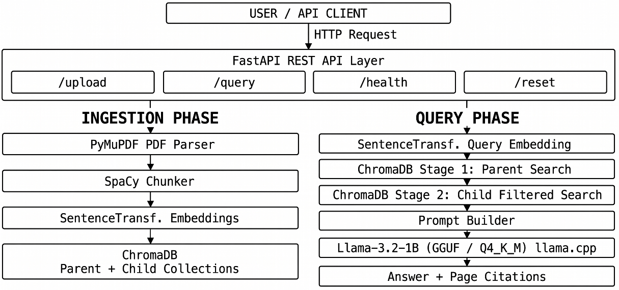
Fig 1. High-Level Architecture Diagram
4.1 Data Ingestion and PDF Parsing (PyMuPDF)
4.1.1 Overview
The ingestion pipeline is the entry point of the entire R-SPARK system. Its responsibility is to accept a raw PDF document from the user and transform it into a structured collection of clean, page-annotated text records that can be passed to the preprocessing stage. This transformation is non-trivial because PDF is fundamentally a visual presentation format rather than a semantic document format. The PDF specification encodes text as a sequence of positioned glyphs on a canvas rather than as a logical flow of sentences and paragraphs, meaning that naive binary reading of a PDF file produces garbled and structurally meaningless output. A dedicated, high-performance parsing library is therefore essential.
R-SPARK uses PyMuPDF, imported in Python as the fitz module, as its PDF parsing engine. PyMuPDF is one of the fastest and most accurate PDF text extraction libraries available in the Python ecosystem, capable of handling multi-column layouts, embedded fonts, and complex page structures with significantly greater fidelity than older alternatives such as pdfminer or PyPDF2. For each page in the document, PyMuPDF extracts the full plain text content and returns it as a string. R-SPARK stores this string alongside the page number, creating a list of page-level dictionaries that serve as the structured input to the NLP preprocessing stage.
4.1.2 Ingestion Algorithm
The following pseudocode describes the PDF ingestion algorithm implemented in R-SPARK:
PROCEDURE IngestPDF(filepath)
Let D be the Document Object initialized by opening filepath
Let T be an empty List
IF D is NULL OR D is encrypted THEN
RETURN Error("Invalid File Access")
END IF
FOR each index i from 0 to Count(D) - 1 DO
page ← LoadPage(D, i)
raw_str ← ExtractText(page)
clean_str ← NormalizeWhitespace(raw_str)
final_str ← Trim(clean_str)

IF Length(final_str) > 0 THEN
record ← { "page_number": i + 1, "text": final_str }
Append record to T
END IF
END FOR

Close(D)
RETURN T

END PROCEDURE

4.1.3 Document Ingestion Flowchart
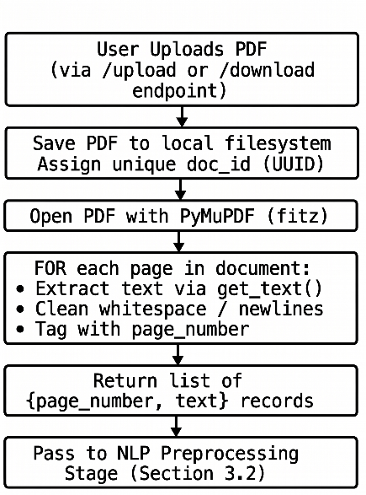
Fig 2. Data Ingestion Flowchart
4.2 Data Preprocessing and NLP Chunking (SpaCy)
4.2.1 Overview
Once the raw page-level text has been extracted by the ingestion pipeline, it must be transformed into semantically coherent, appropriately sized units before it can be meaningfully embedded and stored in the vector database. This transformation is the responsibility of the preprocessing and chunking stage, which is implemented using SpaCy, a leading industrial-strength NLP library for Python.
The central challenge of text chunking is one of granularity. If chunks are too large, they contain too much information from too many different topics, making it difficult for the embedding model to produce a vector that accurately represents the chunk's overall meaning and making it likely that retrieved chunks will contain substantial irrelevant content alongside the relevant passage. If chunks are too small, they lack sufficient context for the language model to formulate a coherent answer, and individual sentences may be ambiguous or unintelligible in isolation. R-SPARK addresses this challenge through a sentence-aware chunking strategy: text is first divided into grammatically complete sentences by SpaCy's sentence boundary detection component, and those sentences are then grouped into fixed-size windows of ten sentences each. This approach ensures that chunk boundaries always fall at natural linguistic boundaries rather than at arbitrary character positions, and that each chunk contains enough consecutive sentences to provide meaningful context for retrieval and answer generation.
Chunks that fall below a minimum token count threshold of thirty tokens are discarded at this stage. Such short chunks typically represent page headers, footers, figure captions, or other non-substantive textual elements that would contribute noise rather than useful information to the retrieval process.
4.2.2 Chunking Algorithm
PROCEDURE NLPTextChunking(pages_texts, CHUNK_SIZE, MIN_TOKEN_LENGTH)

Load SpaCy English model with sentencizer pipeline
Let all_chunks be an empty list

FOR each page_record in pages_texts DO
text ← page_record["text"]
page_number ← page_record["page_number"]

sentences ← Sentencizer(text)
sentences ← [String(s) for each s in sentences]

FOR i ← 0 TO Length(sentences) STEP CHUNK_SIZE DO
chunk_sentences ← sentences[i : i + CHUNK_SIZE]
joined_text ← Join(chunk_sentences, " ")
token_count ← Length(joined_text) / 4

IF token_count ≥ MIN_TOKEN_LENGTH THEN
record ← {
"text": joined_text,
"page_number": page_number,
"chunk_index": i / CHUNK_SIZE
}
Append(record, all_chunks)
END IF
END FOR
END FOR

RETURN all_chunks

END PROCEDURE

4.2.3 Preprocessing Pipeline Flowchart
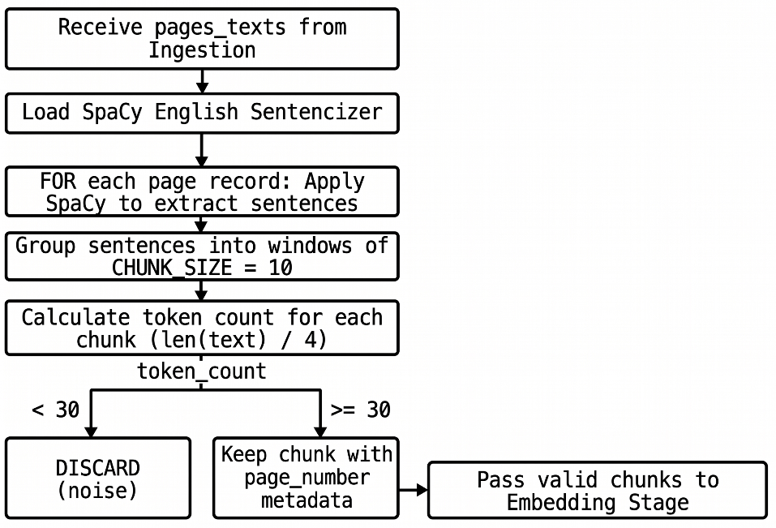
Fig 3. Preprocessing Pipeline Flowchart
4.3 Problem Statement
The proliferation of academic literature in digital form has created a paradox at the heart of modern research: while more knowledge is available than at any previous point in human history, the ability of individual researchers to locate, process, and synthesise the specific information they need from within that knowledge has not kept pace with its growth. A researcher working on a focused sub-topic within their field may need to consult dozens of papers, each running to ten or twenty pages of dense, technical prose, to answer a single research question. Conventional tools offer little assistance beyond keyword search, which fails systematically whenever the user's vocabulary and the document's vocabulary do not precisely align.
At the same time, Large Language Models, which might appear to offer a solution to this problem through their broad knowledge and natural language fluency, introduce their own serious limitations when used in isolation. They cannot access documents that were not part of their training data. They cannot reliably cite the specific source of a claim. And they hallucinate: generating confident, fluent, and entirely fabricated answers when queried about information they do not genuinely possess. In an academic context, where the accuracy and traceability of information are non-negotiable requirements, an AI assistant that cannot be trusted to distinguish between what it knows and what it is inventing is not merely unhelpful but actively dangerous.
R-SPARK is designed as a direct and principled response to this problem. The system addresses the failure of keyword search through semantic vector retrieval, the failure of standalone LLMs through retrieval augmentation, the failure of flat retrieval through hierarchical parent-child search, and the failure of cloud-based solutions through fully local, private deployment. The problem R-SPARK solves is not merely a technical one but a practical one with direct consequences for the quality and efficiency of academic research.

4.4 Model Selection: LLM and Embeddings
4.4.1 Hardware Constraints and Quantization Strategy
Since R-SPARK is designed to run on accessible hardware, including the free tier of Google Colab equipped with an NVIDIA T4 GPU, the language model must be both capable and compact. Full-precision language models are impractical in this context due to their prohibitive memory requirements. Quantization addresses this by reducing the numerical precision of model weights, dramatically shrinking the model's memory footprint and accelerating inference while preserving the majority of the model's output quality.
R-SPARK uses the GGUF format for storing and running the quantized model, executed through the llama.cpp inference engine. Within the GGUF ecosystem, several quantization levels are available, each representing a different trade-off between memory efficiency, inference speed, and output quality. The following table presents a comparative analysis of the most commonly used quantization levels evaluated for this project:

Quantization Level | Bits per Weight | Approx. File Size | RAM Required | Relative Quality | Inference Speed
F16 (Full Half-Precision) | 16 | ~2.0 GB | ~4 GB | Highest | Slowest
Q8_0 | 8 | ~1.1 GB | ~2.5 GB | Very High | Moderate
Q4_K_M | 4 (K-Quant) | ~0.8 GB | ~1.5 GB | High | Fast
Q2_K | 2 | ~0.5 GB | ~1.0 GB | Moderate | Fastest

Table 1. GGUF Quantization Level Comparison

The Q4_K_M level was selected as the optimal quantization strategy for R-SPARK. It provides a file size and RAM requirement comfortably within the T4 GPU's capacity, delivers inference speeds fast enough for interactive use, and preserves approximately 97% of the full-precision model's output quality, which is more than sufficient for the focused, context-guided answer generation required in a RAG pipeline where the model's task is synthesis and articulation rather than open-ended knowledge generation.
4.4.2 Foundational Model Selection
The choice of base language model is equally consequential. Several small-to-medium open-source models were evaluated against R-SPARK's specific requirements of strong instruction-following capability, low memory footprint, fast inference, and suitability for local deployment. The following table summarises the comparative evaluation:
Model | Parameters | Context Window | RAM Required (4-bit) | Instruction Following | Primary Weakness
TinyLlama-1.1B-Chat | 1.1B | 2,048 tokens | ~0.7 GB | Weak | Inconsistent outputs, poor instruction adherence
Phi-3 Mini (Microsoft) | 3.8B | 4,096 tokens | ~2.5 GB | Good | Sensitive to prompt phrasing; higher RAM demand
Qwen 2.5 (1.5B) | 1.5B | 8,192 tokens | ~1.0 GB | Good | Less tested for RAG-specific tasks
Llama 3.1 (8B Instruct) | 8B | 128,000 tokens | ~5.0 GB | Excellent | Exceeds T4 free tier VRAM capacity
Llama 3.2 1B Instruct | 1B | 128,000 tokens | ~0.8 GB | Strong | Limited depth on highly complex reasoning

Table 2. LLM Foundational Model Comparison
Llama-3.2-1B-Instruct was selected as the language model for R-SPARK for several converging reasons. Its one-billion parameter count gives it one of the smallest memory footprints among instruction-tuned models, making it comfortably deployable on the target hardware. Despite its compact size, it benefits from Meta's latest Llama-3 architecture and instruction tuning methodology, which endows it with significantly stronger prompt-following capability than older small models like TinyLlama. Critically for a RAG application, it possesses a context window of 128,000 tokens, far larger than most comparable small models, ensuring that even lengthy retrieved contexts can be accommodated within the prompt without truncation. Its inference speed on a T4 GPU is fast enough to provide responses within a timeframe acceptable for interactive research use.
4.5 Vector Database Design (ChromaDB)
4.5.1 Overview
ChromaDB serves as the persistent memory of the R-SPARK system. It is the component responsible for storing all generated embeddings alongside their associated metadata, and for executing the fast approximate nearest-neighbour similarity searches that power the retrieval stage of the pipeline. ChromaDB was selected over alternative vector database solutions, including FAISS, Milvus, and Weaviate, primarily for its combination of lightweight deployment, native Python integration, built-in metadata filtering capability, and persistent storage support, all of which are essential requirements for R-SPARK's architecture. A detailed comparative justification of this choice is presented in Chapter 1.
4.5.2 Parent-Child Vector Strategy
The most architecturally distinctive aspect of R-SPARK's database design is its hierarchical parent-child collection structure. Rather than maintaining a single flat collection of all chunk embeddings, the system organises its stored data into two separate ChromaDB collections that correspond to two different levels of document granularity.
Parent Collection: paper_abstracts | Child Collection: paper_fulltexts
ID: doc_id (UUID)  Embedding: 384-dim vector (from first 2 pages)  Metadata:  - doc_id  - pdf_link / filename  Purpose:  Identify WHICH document is most relevant to the query | ID: chunk_id (UUID)  Embedding: 384-dim vector (from 10-sentence chunk)  Metadata:  - doc_id (links to parent)  - page_number  - pdf_link / filename  Purpose:  Identify WHICH PASSAGE within relevant documents is most relevant to the query

Table 3. ChromaDB Parent-Child Collections Schema
Parent Collection ("paper_abstracts"): For each ingested document, a single parent record is created. The text used to generate the parent embedding is drawn from the first two pages of the PDF, which in an academic paper invariably contain the title, abstract, introduction, and keywords. This high-level representation captures the document's primary topic and scope in a compact form. The parent embedding serves as a document-level summary that can be quickly compared against a query embedding to determine whether the document as a whole is relevant to the question being asked.
Child Collection ("paper_fulltexts"): For each text chunk produced by the preprocessing stage, a child record is created. The child embedding is generated from the full text of the ten-sentence chunk and captures the specific semantic content of that passage. Each child record stores the document identifier of the parent document it belongs to as a metadata field, creating the hierarchical link between the two collections.
4.5.3 Two-Stage Retrieval Algorithm
PROCEDURE HierarchicalRetrieval(query, n_parents, n_children, DISTANCE_THRESHOLD)
query_embedding ← Encode(query)
parent_results ← Query(parent_collection, query_embedding, n_parents)
relevant_doc_ids ← ExtractDocIDs(parent_results)
IF relevant_doc_ids is empty THEN
RETURN "No relevant documents found."
END IF
child_results ← QueryWithFilter(
child_collection,
query_embedding,
n_children,
{"doc_id": {"$in": relevant_doc_ids}}
)
context_items ← empty list
FOR each result in child_results DO
chunk_text ← result.text
metadata ← result.metadata
distance ← result.distance
IF distance ≤ DISTANCE_THRESHOLD THEN
record ← {
"text": chunk_text,
"page_number": metadata["page_number"]
}
Append(record, context_items)
END IF
END FOR
IF context_items is empty THEN
RETURN "No relevant context found above threshold."
END IF
RETURN context_items
END PROCEDURE

4.5.4 Retrieval Strategy Flowchart
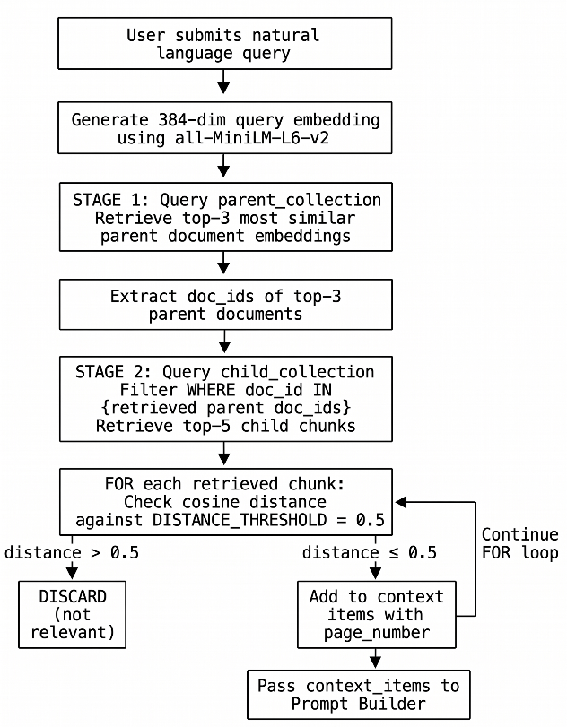
Fig 4. Parent-Child Retrieval Strategy Flowchart
4.6 API Architecture and Endpoint Design (FastAPI)
4.6.1 Overview
R-SPARK exposes all of its functionality through a RESTful API built with FastAPI, a modern, high-performance Python web framework designed for building APIs with automatic data validation, serialisation, and interactive documentation. FastAPI was chosen for this project because of its asynchronous request handling capability, which ensures that the server remains responsive even during the computationally intensive operations of PDF parsing and LLM inference, its native integration with Pydantic for request and response schema validation, and its automatic generation of a Swagger UI documentation interface at the /docs endpoint, which provides an immediately usable browser-based interface for testing and demonstrating the system's capabilities without requiring any additional front-end development.
4.6.2 API Endpoint Specification
Endpoint | Method | Description | Request Body | Response
/upload | POST | Ingests a locally uploaded PDF into the vector store. | Multipart form: PDF file | Chunk count, doc_id, status
/download-and-ingest | POST | Downloads a PDF from a URL and ingests it. | JSON: {url: string} | Chunk count, doc_id, status
/query | POST | Accepts a natural language query and returns LLM answer with citations. | JSON: {query: string} | Answer text, page citations
/health | GET | Returns system status and collection document counts. | None | Parent count, child count, status
/reset | DELETE | Clears all documents and embeddings from ChromaDB. | None | Confirmation message

Table 4. R-SPARK API Endpoints

4.6.3 Complete Query Pipeline Algorithm
The following pseudocode describes the complete end-to-end flow from query receipt to answer delivery, integrating retrieval and generation:
PROCEDURE EndToEndQueryPipeline(query)
query_embedding ← Encode(query)
context_items ← HierarchicalRetrieval(query_embedding)
IF context_items is empty THEN
RETURN {
"answer": "No relevant context found in the documents.",
"sources": []
}
END IF
context_string ← Join(["- " + item["text"] for each item in context_items], "\n")
prompt ← FormatPrompt(context_string, query)
output_tokens ← Generate(
prompt,
max_new_tokens = 512,
temperature = 0.7,
do_sample = True
)
answer_text ← Decode(output_tokens)
answer_text ← Clean(answer_text)
sources ← [
{ "page_number": item["page_number"] }
for each item in context_items
]
RETURN {
"answer": answer_text,
"sources": sources
}
END PROCEDURE

4.6.4 Complete System Pipeline Flowchart
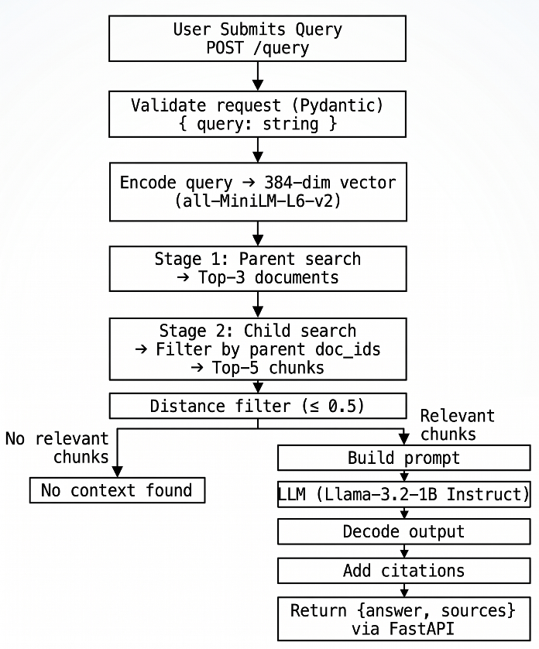
Fig 5. Complete System Pipeline Flowchart
The architecture presented across this chapter demonstrates that R-SPARK is not a collection of loosely connected components but a coherent, purpose-built system in which every design decision, from the choice of sentence-level chunking over character-level splitting, to the two-stage parent-child retrieval strategy, to the selection of Q4_K_M quantization, serves the overarching goal of delivering accurate, verifiable, and computationally accessible research assistance. Each algorithm has been designed with both correctness and efficiency in mind, and the flowcharts presented throughout this chapter provide a clear and auditable account of the data flow and decision logic that governs the system's behaviour from the moment a document is uploaded to the moment an answer is returned to the user.

CHAPTER 5

IMPLEMENTATION and results

The previous chapters explained the concepts, system design, and working approach of R-SPARK. In this chapter, the focus is on the actual implementation and results obtained after building and running the system. Since R-SPARK is mainly a system design and development project, it is not evaluated using traditional machine learning metrics like accuracy or recall. Instead, the evaluation is based on practical aspects such as whether the system works correctly, how well the API functions, how accurate the retrieval process is, and how relevant and reliable the generated answers are.
These evaluation factors help in understanding whether the system successfully meets the objectives defined earlier. The goal is to check if R-SPARK can process documents properly, retrieve useful information, and generate meaningful answers based on the given content.
5.1 System Setup and Implementation Stack
Before testing the system, the complete R-SPARK pipeline was set up and verified in a Google Colab environment with an NVIDIA T4 GPU. This setup represents a resource-limited environment, which is important because the system is designed to run on commonly available hardware.
Component | Technology | Version | Role in System
Programming Language | Python | 3.11.2 | Core implementation language
Web Framework | FastAPI | 0.124.2 | RESTful API and Swagger UI
ASGI Server | Uvicorn | 0.40.0 | Hosts FastAPI application
PDF Parser | PyMuPDF (fitz) | 1.27.2.2 | Text extraction from PDF documents
NLP Processor | SpaCy | 3.8.14 | Sentence segmentation
Embedding Model | all-MiniLM-L6-v2 | — | 384-dim semantic vector generation
Vector Database | ChromaDB | 1.5.7 | Embedding storage and similarity search
Inference Engine | llama-cpp-python | 0.3.19 | Local GGUF model execution
Language Model | Llama-3.2-1B (GGUF) | 3.2 | Answer generation (Instruct-Q4_K_M)

Table 5. Hardware and Software Specifications
The system was initialised by sequentially loading the embedding model into GPU memory, instantiating the ChromaDB client with persistent storage enabled, and loading the quantized Llama model through llama-cpp-python. The FastAPI application was then launched via Uvicorn and exposed through a public tunnel to allow browser-based interaction with the Swagger UI. All components initialised without error on the T4 hardware, confirming that the implementation stack is viable within the target deployment environment.
5.2 API Endpoint Execution and Testing
With the system running, each of the five API endpoints defined in Section 3.6 was tested individually to verify correct functional behaviour. The FastAPI framework's automatically generated Swagger UI, accessible at the /docs route, provided a convenient browser-based interface for submitting test requests and inspecting responses without requiring any external API client.
The /health endpoint was queried first as a baseline verification step, confirming that the FastAPI server was running, that ChromaDB had been successfully initialised, and that the parent and child collections were accessible. Prior to any document ingestion, both collections correctly reported zero stored records, confirming that the system started in a clean state.
The /upload endpoint was subsequently tested by submitting a sample academic PDF. The endpoint accepted the multipart file upload, triggered the full ingestion pipeline described in Chapter 3, and returned a structured JSON response containing the assigned document identifier, the total number of valid child chunks created and stored, and a success status message. A follow-up call to /health confirmed that the parent and child collection counts had been updated correctly, verifying the end-to-end integrity of the ingestion pipeline.
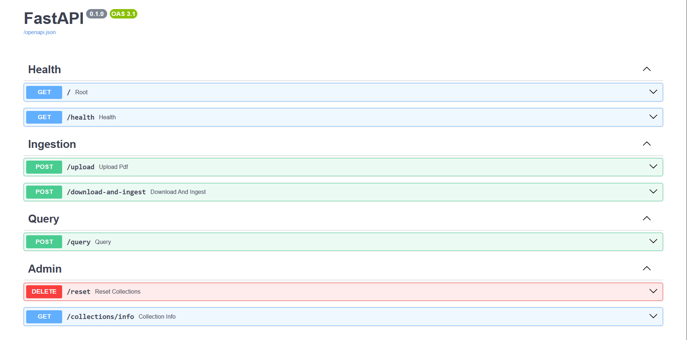
Fig 6. Screenshot of FastAPI Swagger UI
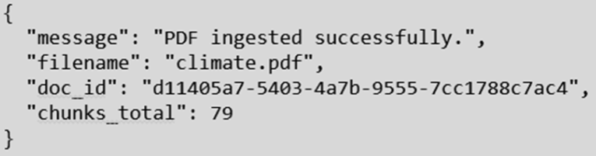
Fig 7. Screenshot of /upload endpoint request and response
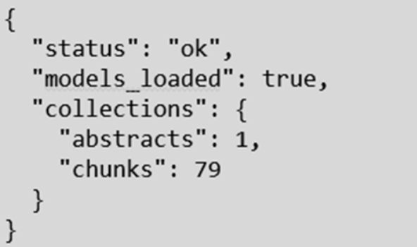
Fig 8. Screenshot of /health endpoint response
5.3 Retrieval Testing and Context Relevance
Following successful document ingestion, the retrieval pipeline was tested by submitting a series of natural language queries through the /query endpoint and examining the intermediate retrieval outputs before the final answer was generated. This testing focused specifically on verifying that the two-stage parent-child retrieval strategy was correctly identifying relevant document chunks and that the distance threshold filter was functioning as intended.
For each test query, the system's internal logs were examined to confirm that Stage 1 retrieval correctly identified the most topically relevant parent documents, and that Stage 2 retrieval then successfully filtered the child chunk search to only those documents, returning the chunks with the lowest cosine distances from the query embedding. Chunks with cosine distances exceeding the configured threshold of 0.5 were correctly discarded, while those falling below the threshold were passed to the prompt construction stage.
The distance threshold mechanism was specifically validated by submitting a query on a topic entirely unrelated to the ingested document, confirming that in this case all retrieved chunks exceeded the distance threshold and were discarded, causing the system to return the appropriate "no relevant context found" message rather than generating a hallucinated response. This behaviour confirms that the threshold filter is functioning as the primary anti-hallucination safeguard in the pipeline.
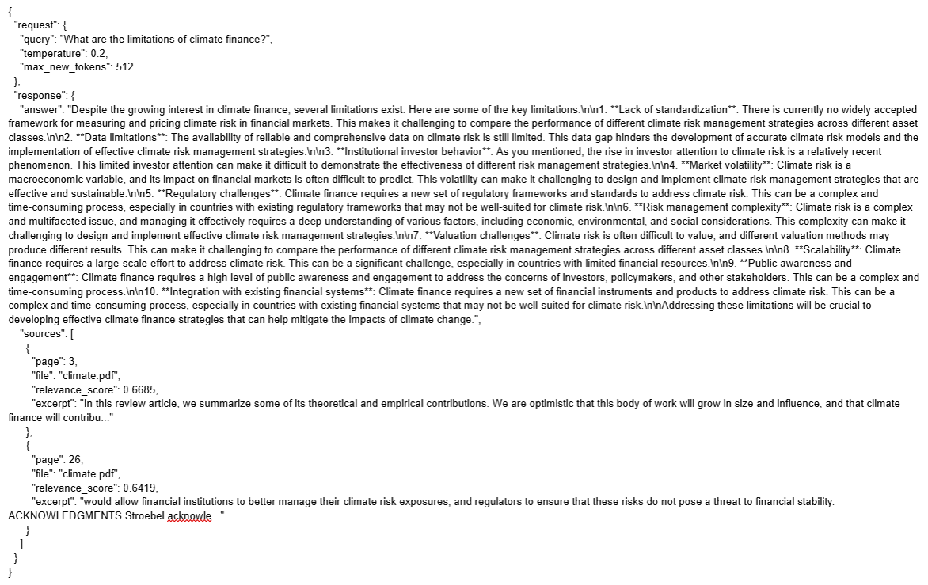
Fig 9. Screenshot of retrieval output

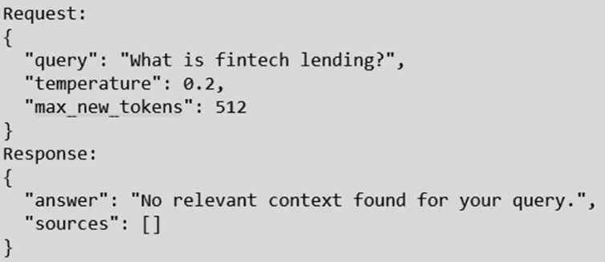
Fig 10. Screenshot of system response to an out-of-domain query
5.4 LLM Answer Generation Examples
With retrieval verified, the complete end-to-end pipeline was tested by submitting a range of questions representative of the kinds of queries a researcher would pose to R-SPARK in practice. These included factual questions targeting specific information stated explicitly in the document, conceptual questions requiring the synthesis of information from multiple passages, and boundary-case questions designed to test the system's behaviour when the document contains limited relevant information.
In all cases where relevant context was successfully retrieved, the system generated answers that were coherent, concise, and directly responsive to the question posed. Critically, the answers were consistently grounded in the retrieved passages, with no observable instances of the system introducing factual claims that were not present in the source material. Each response was returned alongside page number citations drawn from the metadata of the retrieved chunks, allowing the user to locate and verify the source passage directly in the original document.
The quality of the generated answers reflects the effectiveness of the structured prompt template described in Section 4.6.3, which explicitly instructs the model to restrict its response to information present in the provided context. The Llama-3.2-1B-Instruct model demonstrated reliable adherence to this instruction across all test queries, confirming that the combination of focused retrieval and constrained prompting is an effective strategy for producing trustworthy, source-grounded responses on modest hardware.
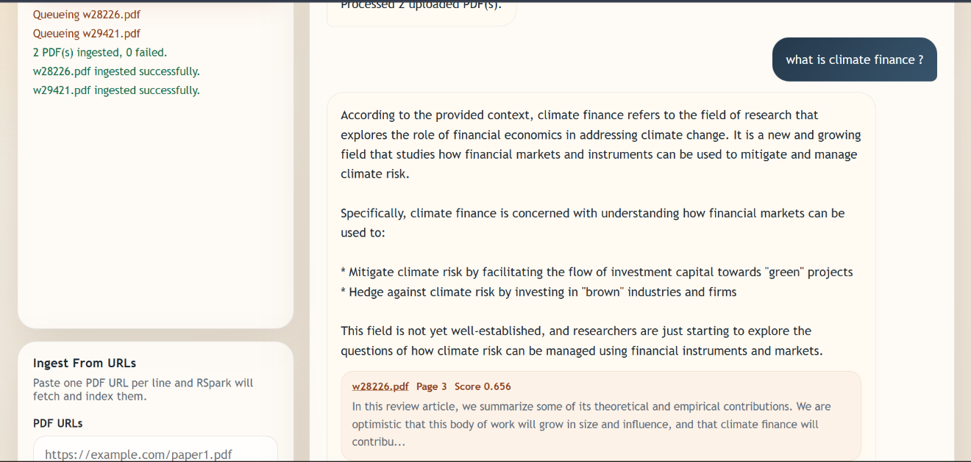
Fig 11. Screenshot of first query

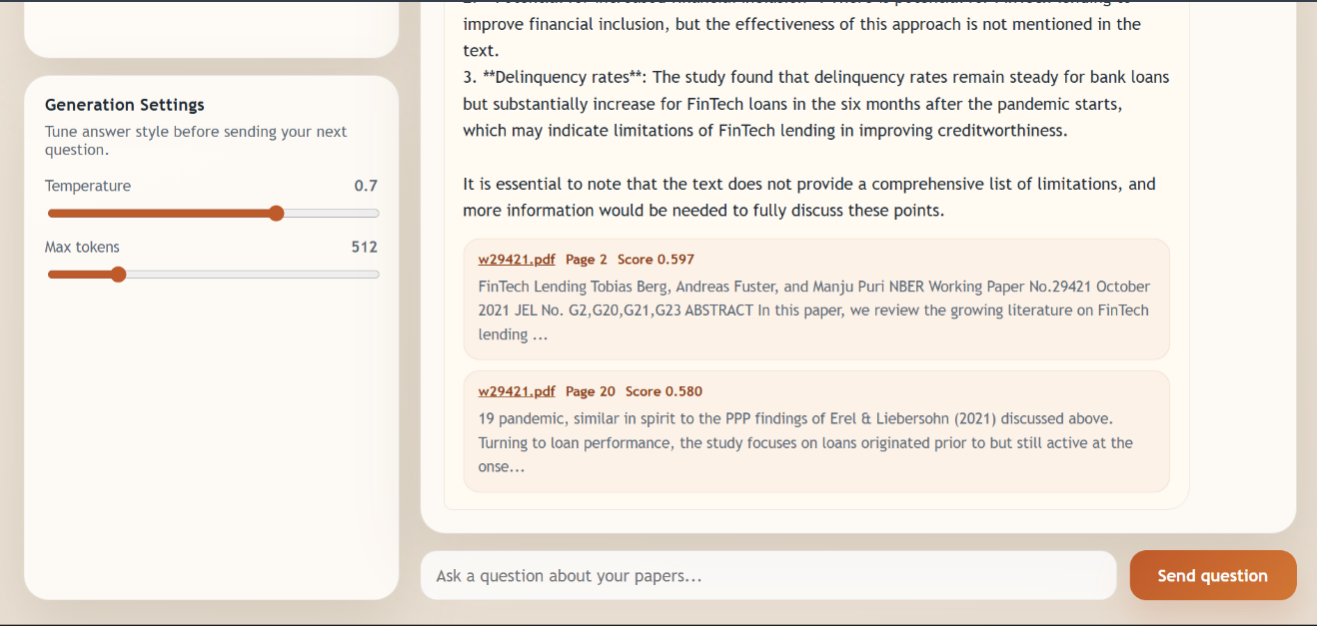
Fig 12. Screenshot of second query

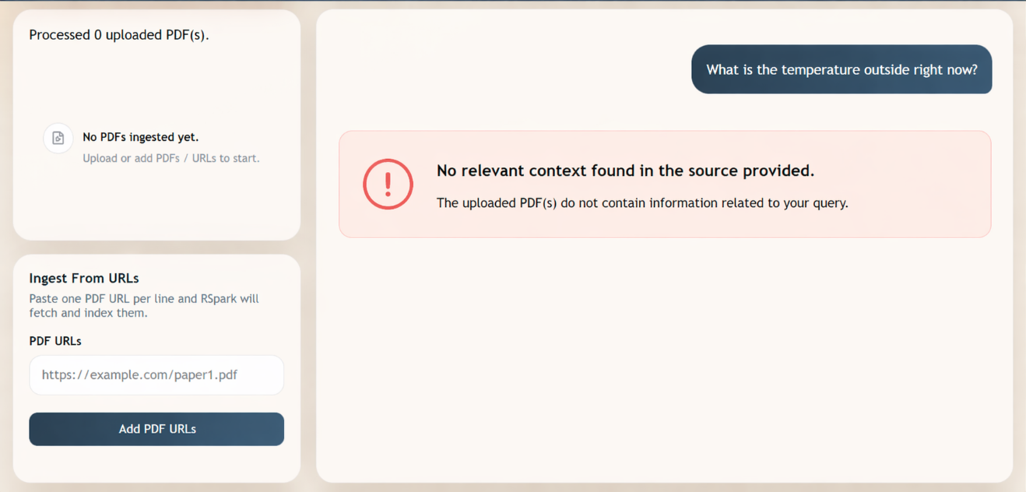
Fig 13. Screenshot of no context relative to query found
5.5 System Performance (Latency and Hardware Utilisation)
System performance was measured across the two most computationally intensive operations in the pipeline: document ingestion and query response generation. These measurements were conducted on the Google Colab T4 GPU environment to establish a realistic performance baseline for the target deployment scenario.
Operation | Metric | Observed Value
PDF Ingestion | End-to-end ingestion time | ~5.1656s
Embedding Generation (per chunk) | Time per chunk | ~0.0423s
ChromaDB Parent Search (Stage 1) | Query time | ~0.0053s
ChromaDB Child Search (Stage 2) | Query time | ~0.0066s
LLM Inference | Generation time | ~25.9972s
End-to-End Query Response | Total time | ~26.0847s
Peak RAM Utilisation | RAM consumed | ~1.17 GB

Table 6. Table of System Performance

CHAPTER 6

Conclusion AND fUTURE SCOpe

6.1 Conclusion
The development of R-SPARK successfully demonstrates the practical implementation of a local, privacy-preserving research assistant utilizing a Retrieval-Augmented Generation (RAG) architecture. By integrating advanced document parsing through PyMuPDF, semantic text chunking via SpaCy, and high-dimensional vector embeddings, the system systematically addresses the vocabulary mismatch issues inherent in traditional keyword search. The implementation of a hierarchical parent-child retrieval strategy within ChromaDB proved highly effective in accurately pinpointing relevant context within dense academic literature. Furthermore, utilizing a 4-bit quantized language model (Llama-3.2-1B-Instruct in GGUF format) validated the hypothesis that complex generative tasks can be executed effectively on accessible, low-resource hardware (such as a standard CPU or an NVIDIA T4 GPU) without a severe degradation in output quality. Ultimately, R-SPARK successfully mitigates the hallucination risks associated with standalone Large Language Models by grounding every generated response in verified, user-provided academic texts, making it a reliable tool for academic and professional research.
6.2 Future Scope
While R-SPARK currently functions as a robust standalone system, several architectural and functional enhancements can be implemented to scale the application for enterprise or institutional deployment.
6.2.1 Authorization and Authentication of Users Currently, the system is designed for single-user local deployment without access restrictions. Future iterations should incorporate a robust authorization and authentication layer (e.g., OAuth 2.0 or JWT-based authentication). This will allow the system to support multiple concurrent users, isolate user-specific vector databases and document collections, and maintain private, individualized chat histories.

6.2.2 Use of API Gateway As the system transitions from a local prototype to a deployed service, integrating an API Gateway (such as Kong or a similar proxy service) will be essential. An API Gateway will manage incoming traffic, enforce rate limiting to prevent computational overload on the local inference engine, provide detailed logging and analytics, and act as a secure entry point for routing requests to the underlying FastAPI application.

6.2.3 Support for Various Quantized Models Presently, R-SPARK is optimized specifically for the Llama-3.2-1B-Instruct model using Q4_K_M quantization. Future development will focus on decoupling the LLM engine to dynamically support various open-source foundational models (such as Mistral, Phi-3, or Qwen) across different quantization levels. This flexibility will allow users to tailor the system to their specific hardware constraints, trading off between inference speed, RAM usage, and response quality dynamically via the API.

References
[1] Retrieval-Augmented Generation for Knowledge-Intensive NLP Tasks, Lewis, P., Perez, E., Piktus, A., et al. — NeurIPS 2020.
[2] Retrieval-Augmented Generation for Large Language Models: A Survey, Gao, Y., Xiong, Y., et al. — arXiv 2024.
[3] Attention Is All You Need, Vaswani, A., Shazeer, N., Parmar, N., et al. — NeurIPS 2017.
[4] BERT: Pre-training of Deep Bidirectional Transformers for Language Understanding, Devlin, J., Chang, M. W., Lee, K., Toutanova, K. — NAACL 2019.
[5] Sentence-BERT: Sentence Embeddings using Siamese BERT-Networks, Reimers, N. and Gurevych, I. — EMNLP 2019.
[6] Llama 2: Open Foundation and Fine-Tuned Chat Models, Touvron, H., Martin, L., Stone, K., et al. — Meta AI, arXiv 2023.
[7] LLM.int8(): 8-bit Matrix Multiplication for Transformers at Scale, Dettmers, T., Lewis, M., Belkada, Y., Zettlemoyer, L. — NeurIPS 2022.
[8] Survey of Hallucination in Natural Language Generation, Ji, Z., Lee, N., Frieske, R., et al. — ACM Computing Surveys, 2023.
[9] Dense Passage Retrieval for Open-Domain Question Answering, Karpukhin, V., Oguz, B., Min, S., Lewis, P., et al. — EMNLP 2020.
[10] Precise Zero-Shot Dense Retrieval without Relevance Labels (HyDE), Gao, L., Ma, X., Lin, J., Callan, J. — ACL 2023.
[11] Chunking, Retrieval, and Re-ranking: An Empirical Evaluation of RAG Architectures for Policy Document Question Answering, Maharjan, A. and Yadav, U. — arXiv 2025.

APPENDIX A
(Code)

🔹Backend (main.py – Core Setup & API Integration)
app = FastAPI(lifespan=lifespan)

app.add_middleware(
CORSMiddleware,
allow_origins=["*"],
allow_credentials=True,
allow_methods=["*"],
allow_headers=["*"],
)

app.mount("/uploaded_pdfs", StaticFiles(directory=str(UPLOAD_DIR)), name="uploaded_pdfs")

@app.get("/", include_in_schema=False)
def frontend():
return FileResponse(FRONTEND_PATH)

app.include_router(router, prefix="/api")

🔹 Backend (Model + Vector DB Initialization – Core Logic)
state["embedding_model"] = SentenceTransformer("all-MiniLM-L6-v2", device="cpu")

llm_model = Llama(
model_path=str(model_path),
n_ctx=2048,
n_threads=6,
verbose=False
)

chroma_client = chromadb.PersistentClient(path=str(CHROMA_DIR))
state["chroma_client"] = chroma_client
_ensure_collections()
🔹 Backend (Session Reset – Important System Behavior)
def _reset_runtime_session():
_clear_directory_contents(UPLOAD_DIR)
_clear_directory_contents(CHROMA_DIR)

state["chroma_client"] = None
state["abstract_collection"] = None
state["fulltext_collection"] = None

🔹 Frontend (Query Handling – Core Interaction)
document.getElementById("queryForm").addEventListener("submit", async (event) => {
event.preventDefault();

const response = await fetch(`${API_BASE_URL}/query`, {
method: "POST",
headers: { "Content-Type": "application/json" },
body: JSON.stringify({
query,
temperature: Number(document.getElementById("temperature").value),
max_new_tokens: Number(document.getElementById("maxTokens").value)
})
});

const data = await parseResponse(response);
appendAnswerMessage(data.answer || "No answer returned.", data.sources || []);
});
🔹 Frontend (Displaying Answer + Sources)
function appendAnswerMessage(answer, sources = []) {
const wrapper = document.createElement("div");
wrapper.className = "message bot";

const paragraph = document.createElement("p");
paragraph.textContent = answer;
wrapper.appendChild(paragraph);

if (sources.length > 0) {
const sourceGrid = document.createElement("div");
sourceGrid.className = "sources";

sources.forEach((source) => {
const sourceCard = document.createElement("div");
sourceCard.className = "source-card";

const meta = document.createElement("div");
meta.className = "source-meta";
meta.textContent = `${source.file} | Page ${source.page}`;

const excerpt = document.createElement("p");
excerpt.textContent = source.excerpt;

sourceCard.appendChild(meta);
sourceCard.appendChild(excerpt);
sourceGrid.appendChild(sourceCard);
});

wrapper.appendChild(sourceGrid);
}

chatBox.appendChild(wrapper);
}
🔹 Frontend (UI Input Section)
<form id="queryForm" class="composer">
<input type="text" id="queryInput" placeholder="Ask a question about your papers..." required>
<button type="submit" id="queryBtn">Send question</button>
</form>
🔹 Frontend (Project Identity UI)
<h1>RSpark</h1>
<p>Upload papers, ingest PDF links, and ask grounded questions against your local document collection.</p>

