Of all the wild animals, the destruction brought about by elephants is the most pervasive for their wide ranging behavior, fidelity to their home range, large appetite, propensity and ability to destroy properties. Asian elephants are particularly attracted to food crops because they are more palatable, more nutritious and have lower secondary defences than wild browse plants (Sukumar 1990). This is perhaps why the crop damage by elephants is reported to be the one of the most widespread issues and thus has been a root cause of human-elephant conflict across the elephant range countries (Schultz 1986, Kiss 1990, West and Brechin 1991). For example, an elephant eats around 200 kg of food per day (Sukumar 2003) and a single elephant can destroy a hectare of crops in a very short time; a small herd can decimate a farmer's livelihood overnight. Often, the people who suffer these attacks are already economically and nutritionally vulnerable, and the loss of crops and livestock can have grave impacts on their income and food consumption. Such attacks can also lead to human injury and/or death. For example, the records show that in India alone, about 150 - 200 people on average were killed by elephants each year during 1980 – 2000 (Sukumar 2003). Hence, the field reports across the elephant range countries both in Asia and Africa describe local antipathy to elephants beyond that expressed for any other wildlife. This animosity is an ominous sign for future survival of the elephants, especially in the context of increasing trend toward a decentralized wildlife management throughout the elephant range countries. Owing to this, it becomes imperative to raise public tolerance of elephants, and to do so the management should first try to find answers to the questions such as, why does human- elephant conflict occur? How serious is the impact of conflict on the livelihoods and lives of people? How can we protect vulnerable individuals from the costs of conflict while maintaining elephants for regional and global benefits?

# HUMAN-WILDLIFE CONFLICT IN THE TERAI REGION OF NEPAL

The southern lowland of Nepal which forms a part of the Gangetic plain is commonly known as the Terai region. The area covers about 23% of the total land area (CBS 2001) and is composed of alluvial and fertile land that extends from westernmost part of the country to the eastern limit along a 900 km stretch. Representing little over 55% of country’s cultivated lands, the Terai is considered to be the bread basket of the country and housing five most important protected areas,

it also serves as the critical habitat for many endangered and charismatic species including, Tiger (*Panthera tigris*), Rhinoceros (*Rhinoceros unicornis*), Elephant (*Elephas maximus*), etc.

Over the last half century, this region experienced a massive population growth (3.0% during 1991- 2001) induced by inter-regional migration and immigration. The population density here has reached 330 persons/km2, which is more than double the national average. Consequently, more and more wildlife habitats are being converted to settlements, agricultural lands and other forms of land-use in order to cater the needs of the growing population. For example, over 65% of forest areas were converted for agricultural extension in the valley of Chitwan between 1961 and 1977 (Gurung 1983). Other studies show that the forest area in the Terai decreased at an annual rate of 1.3 percent between 1978-1991. This has pushed wild animals into the isolated patches of habitats as provided by the existing protected areas. Such ‘packing’ of wild animals into habitat pockets (Ratnam 1984) together with increased cultivated area and human movement in wildlife habitats (Blair *et al.* 1979) have been attributed as the most proximate causes of the conflict between humans and wildlife. Judging by the poverty rate of over 30 % and the average wage of approximately 1 US $ a day (NLSS 2005), the loss due to human-wildlife conflict can have serious consequences in the local household economy in the Terai of Nepal.

The nature and intensity of conflict in Nepal, however is believed to vary between eastern and western Terai. In the western Terai, the slower economic development activities coupled by later migration from the mountains might have minimized the rate of habitat degradation relative to the eastern Terai. Apart from this, planned land use such as the establishment of protected areas, delineation of buffer zones, launching of the Terai Arc Landscape (TAL) program and Western Terai Landscape Program by WWF and other conservation initiatives, such as Bardia Conservation Program, Bardia Integrated Conservation Program, Parks and People, etc. might also have played an important role in maintaining wildlife habitats while providing significant economic benefits to local people for living with wildlife in the western Terai. On the contrary, with the improvement in habitats, the wildlife populations and/or their mobility are also expected to increase thereby possibly raising HWC incidences. The people receiving benefits from the conservation initiatives, on the other hand, are more likely to tolerate the wildlife damage and be positive towards conservation (Studsrod and Wegge 1995). However, no study has yet been

undertaken to substantiate this, nor is any analysis done to ascertain the factors causing the differential intensities of HWC between these two regions.

WWF through its Asian Rhino and Elephant Action Strategy (AREAS), envisages conserving endangered large mammal species and their habitats by adopting landscape-based approach that goes beyond isolated protected areas and addresses issues of land-use practices in the surrounding areas. Improved decision making about rural lands requires careful consideration of how ecological information and analyses can inform specific planning and policy needs.

With proactive social, economic, and biological analysis, AREAS believes that a balance can be struck so that wild species get the secure core areas and forest corridors they need, while people can pursue agriculture, forestry, and other forms of land-use in a more clearly planned and sustainable manner. Hence, WWF Nepal program commissioned this study to compare the various dimensions of human-wildlife conflict, with particular reference to human-elephant conflict (HEC) in the eastern and western Terai of Nepal. The specific objectives of this study are as follows:

* To compare nature, extent and intensity of human-elephant conflict in the Western and Eastern Terai of Nepal
* Quick analysis of the occurrence and intensity of other HWC
* To determine the impacts of conflict on wildlife populations
* To document the nature and intensity of damages due to HWC in the local economy.
* To explore major causes giving rise to HWC
* To analyze effectiveness of current mitigation measures
* To document economic benefits received by local communities from living with wildlife
* To assist WWF in analyzing historical changes in landuse/landcover as a result of conservation initiatives undertaken in the region
* To discuss the effect of land use change on HEC and provide its economic implications

# METHODOLOGY

## Study site selection

We selected the three sectors, Bahundangi VDC of Jhapa District in the eastern Terai, Mahendra Nagar Municipality of Shuklaphanta Wildlife Reserve, and six buffer zone VDCs of the Bardia National Park (i.e. Shivpur, Neulapur, Baganaha, Magaragadi, Manau and Patabhar) in the western Terai of Nepal (Fig. 1), hereafter referred to as Jhapa, Shukla and Bardia, respectively. The major characteristics of these sites are outlined in the Table (Table 1). In doing so, our attempt here is primarily focused on assessing the impact of land use change on the nature and extent of HEC along the ‘edge habitats’ (boarder areas between settlement and the home ranges of elephant).

**Table 1. Major characteristics of the study sectors**

|  |  |  |  |  |
| --- | --- | --- | --- | --- |
| Sector | Region | Approx. population  size | Human densitya  (persons/km2) | Land  management |
| Jhapa | Eastern | 80 (Thousless 1993) | 451.7 (CBS 2001) | Non protected  area |
| Shukla | Western | 20 (Velde 1997) | 573.06 (Anon. 2004) | Protected area |
| Bardia | Western | 80 (Pradhan 2007) | 416.67 (CBS 2001) | Protected area |

a Human densities are given for sampled VDCs/Municipalities within each study sector.

We acknowledge the complex interplay of other explanatory variables such as, population dynamics and behavioral ecology of elephants (Sukumar and Gadgil 1988, Sukumar 1990, 1991, Hoare 1999), habitat heterogeneity and other landscape attributes (for e.g. shape) (Nellemann et al. 2002) etc. in describing the nature and extent of HEC. We could not include these factors in our analysis as they were beyond the scope of this study. Thus, our report should be evaluated in this context. We however, believe that our results would be useful in understanding the issues as specified in the objectives and also serve as baseline information for further works particularly dealing with the HEC in Nepal.

**Figure 1. Map of Nepal showing the locations of three study sectors, Jhapa, Bardia and Shukla.**

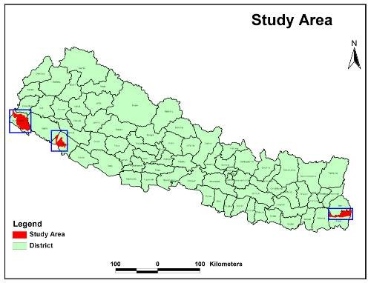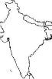

CHINA

INDIA

**Sukla**

**Bardia**

**Jhapa**

## Site description

### Jhapa District

Within the district of Jhapa, Bahundangi Village Development Committee (VDC) is reported to be one of the sites with most frequent HEC incidents (Velde 1997). The 54 km2 Bahundangi VDC (26o 30’ N, 88o 0’ E) is located about 10 km north of the East-West Highway and is bordered by the Indian district of Darjeeling in the east (Fig. 2). Spreading across an altitudinal range of 125 to 381 m., the climate here is subtropical with April and May as the warmest period (27.2oC to 41.5oC) and January as the coolest period (0.3 oC to 19.2oC). Most of the rainfall (annual average 2336 mm) occurs during monsoon in the months of June to September. The district has about 30% of forest area and sal forest is the dominant forest type followed by mixed hardwood forest (*Adina cardifolia*, *Terminalia chebula*, *Terminalia blerica*, *Lagerstroemia parviflora*) and Chirpine (*Pinus roxburghii*) forest.

The people here are migrated from the hills and they comprise various ethnic groups mainly belonging to Bahun, Chhetri, Newar, Rai, Damai, Kami, etc. Agriculture constitutes the major occupation and the primary crops are rice, wheat, maize and lentils. Among cash crops, ginger, coconuts beetle nuts and tea are commonly grown. Apart from this, people also keep livestock such as cow (*Bos indicus*), buffalo (*Bubalus* sp.), goat (*Capra hircus*), and pig (*Sus* sp.) to supplement their livelihood.

Elephants of Eastern Terai region are considered to be a part of population of about 80 individuals, who spend most of their time in India (Thouless 1993). Bahundangi VDC is located in the gateway as the elephants enter Nepal from West Bengal by crossing the Mechi River (Plate 2, Velde 1997). Within Bahundangi VDC, the ward no 1, 2, 6, 8 and 9 are known to be most frequently visited by the problem elephants as they lie along side of the Mechi River (Yadav 2003, Bhandari 2004). Hence, we focused our household surveys and field observation in these ‘frontline’ settlements (Hoare 1999) (Fig. 2).

**Plate 2. Elephant route in the boarder between India (on the right side) and Nepal (on the left side) across the Mechi River in Jhapa (Source: Field Survey 2007)**

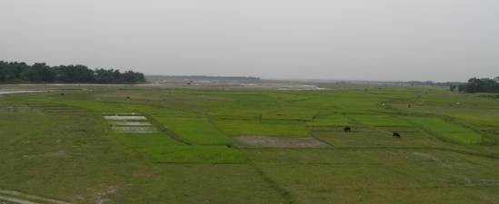

**Figure 2. Map showing the sites with the most frequent Human-Elephant Conflict incidents (HEC) within the Bahundangi VDC of the Jhapa study sector.**

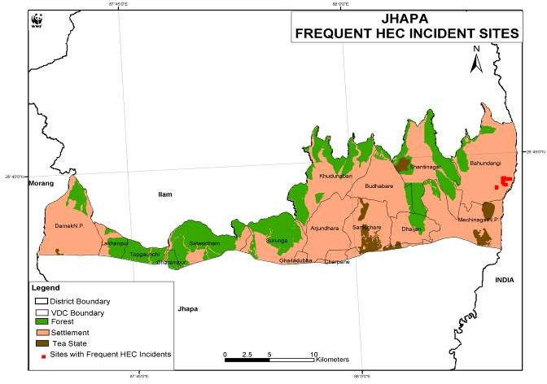

As for the conservation initiatives, some activities are being undertaken by District Forest Office and the District Soil Conservation Office. The activities in connection with HEC are also being particularly dealt by the District Development Committee, Village Development Committee and the District Administration office. Apart from this, the local people have also formed an organization called ‘Hatti Niyantran Committee’ in order to look after the issues pertaining to the HEC. However, more effective integrated conservation activities seem lacking in the area. Absence of organizations such as WWF, IUCN and NTNC in the area also reflects it.

### Bardia National Park (BNP) and Buffer Zone

Located in the Bardia and Banke District of the western Terai and covering 968 km2, Bardia National Park (81o 15’E and 28o 30’N) is the largest protected area in the Terai. In contrast to

many other isolated habitat fragments in the western part of the Terai landscape of northern India and Nepal, narrow natural corridors still connect BNP with Shuklaphanta Wildlife Reserve in the west, Katarniaghat Wildlife Sanctuary and Dudhwa National Park in India to the south, and a large tract of government forest to the east. The Park spreads across Chure hills in the north and riverine flood plain in the south within the altitudinal range of 152 to 1441 m. The climate here is subtropical monsoonal type with three distinct seasons: cool-dry (November to February), hot dry (March to June) and monsoon (July to October). Average annual rainfall amounts to 1500 mm and it occurs mostly between June and September, somewhat later than the rest of the country (Bolton 1976). Average temperature in the cool season drops to 10 oC in January while in the hot dry season temperature may rise up to 41 oC in May (Dinerstein 1979). Seven major vegetation types (Jnawali and Wegge 1993) are distributed in the landscape complexes comprised by Karnali floodplain, the Babai river, Churia hills (Bhuju et al. 2007). Sal forest is the most widely distributed as it covers 70 percent of the total area. Khair-Sissoo Forest is the pioneer association occurring alongside the rivers. Moist riverine forest is patchily distributed in depressions along the watercourse. The well drained flat lands were mostly occupied by the mixed hard wood forests. In addition to this, three types of grasslands viz. floodplain grasslands, wooded grasslands and phantas have been located in the park in flood plain areas, forest edges and in the previously cultivated areas, respectively.

BNP has the Nepal’s largest population of elephants that roam between the Park and adjacent forested areas in India. It also contains the largest biomass of ungulates per km2 reported from anywhere in Asia, and these include endangered swamp deer (*Cervus duvauceli*), spotted deer (*Axis axis*), hog deer (*Axis porcinus*), sambar deer (*Cervus unicolor*), nilgai antelope (*Boselaphus tragocamelus),* and the four-horned antelope (*Tetracerus quadricornis)* (Andersen and Naess, 1993). The Karnali floodplain also harbors a population of rhinoceros (*Rhinoceros unicornis*) which had been relocated from Chitawan Natitonal Park. The park is also well known for leopard (*Panthera pardus*) and one of the highest recorded tiger (*Panthera tigris*) densities in the world (Wegge et al. 2004).

Following rapid habitat destruction that started after the eradication of malaria in the 1950’s, the elephant population in the BNP reached the brink of functional extinction, consisting of less than

20 seasonal visitors (Bolton 1976). However, in 1994 the number of elephants increased abruptly due to immigration, probably from India (Velde 1997), and the current resident population is estimated at approximately 80 animals (Pradhan 2007). With increasing population size, animals are expected to move outside particularly in the eastern sector of the national park thereby raising a potential for conflict with the humans inhabiting there (Pradhan 2007). Among the most heavily affected Buffer Zone VDCs, we focused our household surveys in the selected wards within the VDCs of Shivpur, Neulapur, Baganaha, Magaragadi, Manau and Patabhar (Fig. 3).

**Figure 3. Map showing the sites with most frequent Human-Elephant Conflict (HEC) incidents within the VDCs of Sivapur, Neulapur, Baganaha, Magaragadi, Manau and Patabhar in the Bardia study sector.**

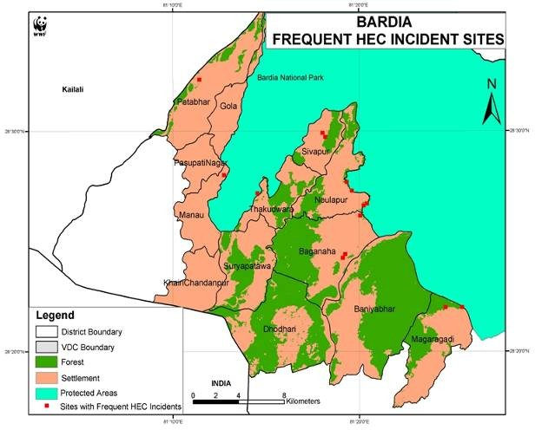

In order to address the park-people conflict, the 327 km2 of area around BNP was declared as the Buffer Zone in 1996. Historically, the Buffer Zone area was settled by the Tharu people, but as a result of substantial immigration over the last 60 years the present population has become ethnically mixed. The majority of the villagers live in a subsistence economy in which land and livestock holdings are the principle economic assets. Paddy (*Oryza sativa*), Maize (*Zea mays*), Wheat (*Tricticum aestivum*), Lentil (*Lens culinaris*), and Mustard (*Brassica campestris*), are the principle crops and are mostly grown for domestic consumption. Livestock is economically important as a source of milk, manure, draft-power, and cash income.

The park is being managed by the Department of National Parks and Wildlife Conservation (DNPWC) and the Nepalese Army is guarding and enforcing the existing rules and regulations including controlling poachers, stopping illegal fishing, checking boundaries, preventing encroachment into the park, and preventing livestock grazing and extraction of resources by local inhabitants. Besides this, other partner agencies are also assisting DNPWC’s conservation and development efforts. Among them the key institutions include, WWF, NTNC, CARE Nepal and UNDP. Bhuju et al. (2007) outlined some of the major achievements made in recent years as follows:

* Seven agroforestry plots have been established in nearly 1600 hectares thereby providing benefits to 2137 households over a period of three years from May 2000 to April 2003
* A well functional community health centre has been established at Thakurdwara
* About 893 km2 of additional area has been proposed to extend the park in line with ‘Gift to the Earth’ initiatives
* The number of tourists visiting the park has been increased by 14% per year
* In order to compensate for losses incurred due to HWC, endowment funds such as the ‘Rahat Kosh’, Apatkalin Kosh’ have been established

Apart from this, local communities are also greatly benefited by the extensive community forests of the buffer zone. The community forests here, not only provide the much needed forest products to local households but also are the constant source of income for the Buffer Zone User Committees.

### Shuklaphanta Wildlife Reserve (SWR) and Buffer Zone

The 305 km2 Shuklaphanta Wildlife Reserve (80o 14’ E and 28o 55’ N) is located in the district of Kanchanpur in the western most Terai of Nepal. It is bordered by Mahendranagar Municipality in the north and Indian state of Uttar Pradesh in the south and east across the Mahakali River. SWR has subtropical monsoonal climate with three distinct seasons viz., cool-dry (late September to mid February), hot-dry (February to mid June), and monsoon (mid June to late September). The mean monthly rainfall is about 1500 mm and about 90 percent of it occurs during monsoon. Average temperature goes as high as 37oC in the hot dry season and drops to 7 oC in the cool dry season (Baral 1999). Due to its topography which ranges from the slopes of the Churia hill to the vast flood plains within an altitudinal span of 174m to 1386m, the area consist diverse ecosystems. Sal forest predominates the higher elevations along the Churia foot hills, whereas the lower flat flood plains consist mosaic of habitats made up of grasslands, wet lands and riverine deciduous forests. Covering nearly 20 per cent of total area, the grassland is the biggest continuous land use of the reserve. Khair-Sissoo forest is found along the Mahakali river in the sounthern boundary of SWR. The reserve is also a home to the largest existing herds of swamp deer (*Cervus duvaucelli*). Other mammalian fauna of interest especially with reference to HWC include tiger, elephant, hog deer, barking deer (*Muntiacus muntjak*), wild boar (*Sus scrofa*), monkey (*Macaca mulata*), and porcupine (*Hystrix indica*).

Although no specific census have yet been undertaken to ascertain the elephants numbers in the park, Velde (1997) estimated about 15-20 elephants entering Nepal from India. Most of the incidences of HEC is known to occur in the villages bordering the parks southern and northern boundaries (Velde 1997). In the present study, we selected the five wards viz. 13, 14, 15, 18, and 19 of the Mahendranagar municipality which are situated adjacent to north-western boundary of the park with reportedly highest intensity of HWC (Baral 1999) (Fig. 4).

**Figure 4. Map showing the sites with most frequent Human-Elephant Conflict (HEC) incidents in the Mahendra Nagar Muinipality of Shukla study sector.**

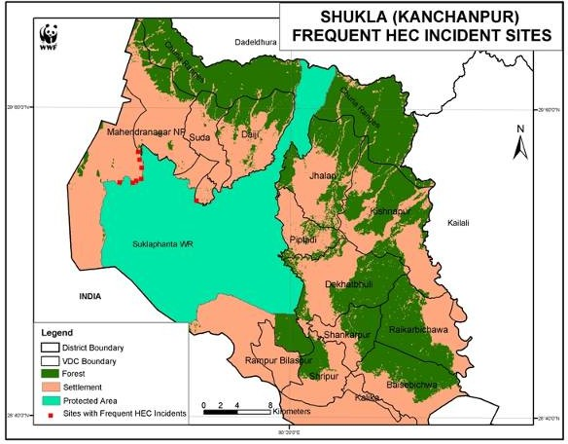

Of late, 243 km2 area surrounding the park was declared as Buffer Zone which is currently inhabited by 111,783 people (Anon. 2004). Tharus comprise indigenous inhabitants of this area. As with the other parts of Terai, the immigration of people from hills outnumbered Tharu people in recent years and subsequently formed a community with mixed ethnic groups. Agriculture is the major economic enterprise and people here cultivate paddy, maize, wheat, mustard, peas and other lentils. In addition to this, they also raise multiple species of livestock such as cow, buffalo, ox, goat and sheep.

Regarding the conservation and the management of the park, the SWR was initially designated as Royal Hunting Reserve in 1969. Later, in 1976 it was gazetted as Royal Shuklaphanta Wildlife Reserve (Anon. 2006) and in late 1980s about 150 km2 area towards eastern side of the park was extended to link the flood plains of the Terai to Churia hills so as to facilitate the seasonal migration of wildlife. The government’s effort through DNPWC is assisted by various conservation agencies such as WWF Nepal, NTNC and UNDP. More importantly perhaps is the WWF Nepal’s involvement in launching the Western Terai Landscape Complex Project (WTLCP) to bring about landscape level conservation in and around SWR. Bhuju et al. (2007) documented following significant achievements made in recent years in SWR.

* Maintenance of six water holes, 22 km trench, and 10 km of barbed wire fence
* Construction of three ‘machans’, and 22 km of fire lines
* Two poaching units established in order to control the poaching and illegal slaughter of wild animals.
* Nominated by CITES as A site for Monitoring of Illegally killed elephants (MIKE)
* Formation of a Tiger Conservation Action Plan to increase the number of breeding tigers
* Establishment of 422 user groups (DNPWC/PCP 2002)
* Development of databases and annual and five-year plans of 40 user groups with the technical and financial support of the SWR/PCP (DNPWC/PCP 2002).

## Data collection

### Ethnographic data

Prior to data collection, extensive literature surveys and discussions with the key persons were undertaken to locate the sites with the highest incidences of HEC in and around Bardia National Park, Shuklaphanta Wildlife Reserve, and Jhapa District (Fig. 2, 3 & 4). We then collected ethnographic data in these sites by employing combination of social survey methods involving participatory techniques (focal group discussions and key informant interview), structured questionnaire survey of households (plate 4) and on-site observations. Our queries were designed to solicit information such as the general socio-economic status of the community, issues of HWC currently being faced in each site such as the number of incidences, extent of damage to wildlife and humans, economic implications of that damage, attitude and behavior of humans in

**Table 6. Rate of change of forest cover over time**

|  |  |  |  |  |  |  |  |
| --- | --- | --- | --- | --- | --- | --- | --- |
|  | **Forest cover** | **Forest cover** | **Change in forest** | **Rate of** | **Forest Cover** | **Change in** | **Rate of** |
| **District** | **1990/91** | **2000/01** | **cover** | **change** | **2006/07** | **forest** | **change** |
|  | **(ha)** | **(ha)** | **(ha)** | **(%)** |  | **cover** |  |
| Jhapa | 12,880 | 12,892 | -12 | -0.009 | 12,844 | -48 | -0.05 |
| Bardia | 14,096 | 12,979 | -1117 | -0.80 | 14,677 | +1698 | +1.87 |
| Shukla | 35,559 | 33,554 | -2005 | -0.56 | 32,167 | -1387 | -0.60 |

## Human-Wildlife Conflict (HWC)

Over 90 percent of respondents in each sector reported that they faced problems from wildlife. Crop damage was the most common problem in all sectors, with Bardia and Jhapa reporting the highest (both sectors > 80%) and about equal frequency of incidents (Plate 5, Fig. 9a, 2 = 2.85, df = 2, P = 0.24). Shukla had significantly lower frequency of crop damage incidences compared to other two sites (2 = 45.85, df = 2, P < 0.01). Nonetheless, damage to properties occurred more often in Shukla than that in Bardia and in Jhapa (Fig. 9b, 2 = 69.32, df = 2, P < 0.01). Other types of problems such as loss of and injury to livestock (Fig. 9c) and human lives (Fig. 9d) were reported to occur in all sectors but not as significant as that of the aforementioned problems.

**Plate 5. Crop damage by wild elephants in Bardia (Source: Field survey)**

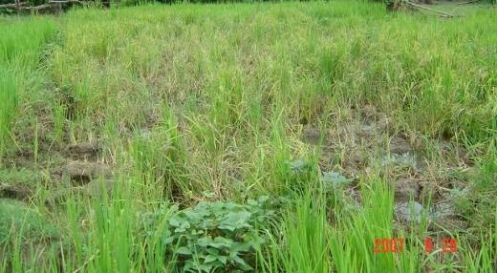

Wild elephant was categorized as the animal with the highest level of threat in all three sectors (Threat level > 4.0) and was the sole problem animal in Jhapa (Fig. 10). The people of Bardia and Shukla were also equally concerned about wild boar and spotted deer. A megaherbivore rhino, carnivores leopard and tiger, and an omnivore monkey posed a moderate level of threat to the people in Bardia (Threat level 2.0 to 4.0) whereas people in Shukla listed all of them except monkey in the lowest threat category (Threat level < 2.0). Likewise other herbivores such as nilgai, swamp deer and porcupine were considered as a moderate level of threat in Shukla but it was listed in the lowest threat category in Bardia.

**(9c) Injured/killed livestock crops 100**

**80**

**Always**

**Sometimes Never**

**60**

**40**

**20**

**0**

**Jhapa**

**Bardia**

**Shukla**

**(9d) Attacked/injured/killed humans**

**Always**

**100 Sometimes**

**80 Never**

**60**

**40**

**20**

**0**

**Jhapa Bardia Shukla**

**R esp o ndents (% )**

**Respondents (%)**

Regarding the population status of problem animals, nearly all the respondents from Jhapa and Bardia suggested that the elephant population was increasing (Fig. 11a), while little over 60 percent respondents in Shukla were not sure about trend of elephant population in their area and the another 30% believed that their population was stable (Fig.11, 2 = 383.49, df = 6, P < 0.01).

**Figure 9. Types of problems faced by local communities**

**(9a) Damaged crops**

**100**

**80**

**Always**

**Sometimes Never**

**60**

**40**

**20**

**0**

**Jhapa**

**Bardia**

**Shukla**

**(9b) Damaged properties**

**100**

**80**

**Always**

**Sometimes Never**

**60**

**40**

**20**

**0**

**Jhapa**

**Bardia**

**Shukla**

**R e s ponde nts (% )**

**R e s pon de nts (% )**

Likewise, majority of people from Shukla and Bardia reported that the populations of spotted deer (Fig. 11b) and wild boar (Fig. 11c) were also on the increase (both species, 2 > 390.34, df

**Increasing level of threat**

= 6, P < 0.01). The numbers of other species included in the moderate threat category in Bardia such as tiger (Fig. 11d), rhino (Fig. 11f), langur (Fig. 11g), and leopard (Fig. 11h) were also reported to be increasing by the majority of respondents (all, 2 > 324.78, df = 6, P < 0.01). Furthermore, most respondents from Shukla were not sure of the population status of their moderate threat category animals such as nilgai (Fig. 11i), swamp deer (Fig. 11e) and porcupine (Fig. 11j) (all, 2 > 117.91, df = 6, P < 0.01) except for langur which they believed to be increasing (2 = 338.59, df = 6, P < 0.01). Also, most respondents were generally not sure of the population status of lower threat category animals in all the three sectors.

**Figure 10. Threat level of problem animals as perceived by the people in Jhapa, Bardia and Sukla**



**Jhapa**

**5**

**Bardia**

**4**

**Sukla**

**3**

**2**

**1**

**Figure 11. Peoples’ perception on population status of problem animals**

**100**

**Jhapa Bardia Sukla**

**80**

**60**

**40**

**20**

**0**

**Increasing Stable Decreasing Not sure**

**(11d) Tiger**

**100**

**Jhapa Bardia Sukla**

**80**

**60**

**40**

**20**

**0**

**Increasing**

**Stable**

**Decreasing**

**Not sure**

**(11f) Rhino**

**100**

**Jhapa Bardia Sukla**

**80**

**60**

**40**

**20**

**0**

**Increasing**

**Stable**

**Decreasing**

**Not sure**

**(11a) Elephant**

**100**

**Jhapa Bardia Sukla**

**80**

**60**

**40**

**20**

**0**

**Increasing**

**Stable**

**Decreasing**

**Not sure**

**(11b) Spotted deer**

**100**

**Jhapa Bardia Sukla**

**80**

**60**

**40**

**20**

**0**

**Increasing**

**Stable**

**Decreasing**

**Not sure**

**(11c) Wild boar**

**100**

**Jhapa Bardia Sukla**

**80**

**60**

**40**

**20**

**0**

**Increasing**

**Stable**

**Decreasing**

**Not sure**

**(11e) Swamp deer**

**R e s pon de n ts (% )**

**R e s pon de nts (% )**

**R e s pon de nts (% )**

**R e s pon de nts (% )**

**R e s pon de nts (% )**

**Respondents (%)**

**100**

**Jhapa Bardia Sukla**

**80**

**60**

**40**

**20**

**0**

**Increasing**

**Stable**

**Decreasing**

**Not sure**

**(11g) Langur**

**100**

**Jhapa Bardia Sukla**

**80**

**60**

**40**

**20**

**0**

**Increasing**

**Stable**

**Decreasing**

**Not sure**

**(11h) Leopard**

**100**

**Jhapa Bardia Sukla**

**80**

**60**

**40**

**20**

**0**

**Increasing**

**Stable**

**Decreasing Not sure**

**(11j) Porcupine**

**Respondents (%)**

**R e s pon de nts (% )**

**Respondents (%)**

**R e s pon de nts (% )**

## Human – Elephant conflict (HEC)

**100**

**Jhapa Bardia Sukla**

**80**

**60**

**40**

**20**

**0**

**Increasing Stable Decreasing Not sure**

**(11i) Nilgai**

*Because of these life threatening burglars, our boys here are facing problem in finding a mate for no girls are willing to live in a village where they have to spend every night with fear. – Shankar Luintel, Bahundangi VDC*

The respondents of the three sectors differed in their experiences of negative interactions with problem elephants (2 = 88.70, df = 2, P < 0.01) mainly because Shukla had a fewer respondents reporting the problems than Bardia and Jhapa (2 = 86.33, df = 1, P < 0.01). The proportion of respondents with negative experiences with elephant, however did not differ in the later two sectors (2 = 0.001, df = 1, P = 0.97), and over 90% people here reported that they had faced one

or more problems with elephant. Low elephant density coupled by the existing large tracts of ‘edge’ forests in Shukla could be the reason for relatively low HEC intensity. It was also reported during a focal group discussion that the HEC takes place in Shukla mainly around the villages where the reserve has established elephant stable ‘hattisar’ with a few female elephants. The bull elephants damages crops and properties around these villages mostly during the period when they come for the estrous females in the hattisar.

Regarding the nature of HEC, crop raiding was the most common problem in all three sectors followed by property damage and the threats to people (Fig. 12). Comparing between sites, Jhapa and Bardia had highest and about equal number of respondents responding to these problems than that of Shukla (Fig. 12). Elephants although the generalist feeders need food plants with certain level of protein content. When the protein content of wild food plants of elephants fall below the minimum level needed by elephant for their maintenance, they generally raid crops particularly paddy, maize and millet which contain higher protein level (Sukumar 2003).

**Figure 12. Community experiences of negative interactions with problem elephants**

**Others**

**Jhapa Bardia Sukla**

**Harm or disturbances to livestock**

**Threats to family members**

**Property damage**

**Crop damage**

**0**

**20**

**40**

**60**

**80**

**100**

**Respondents (%)**

### The trend of conflict

Nearly all people in Jhapa and Bardia expressed that the frequency of encounter with the elephants together with the incidences of crop and property damage was on the increase. However, relatively fewer people in Bardia and Shukla than in Jhapa agreed that human causalities were increasing. Likewise, it is interesting to note that close to 80 percent respondents in Jhapa thought that there was an increase in retaliatory killing of elephants (Plate 6) while most respondents (> 90%) denied this statement in Shukla and Bardia.

**Plate 6. An injured elephant in Bahundangi, Jhapa (Photo courtesy of Mr. Shankar Luitel)**

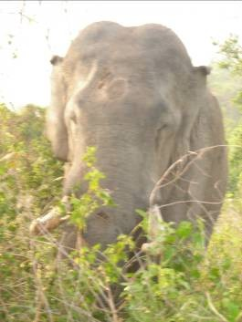

During our field surveys, we observed the widespread application of electric fencing in Jhapa (Plate 7) that was directly obtained through the national grid using high voltage electricity. Through focal group discussions later, we found out that four elephants have been killed through electrocution in recent years.

**Plate 7. ‘Electric fence’ in Jhapa - Gabion wire connected to main electricity line**

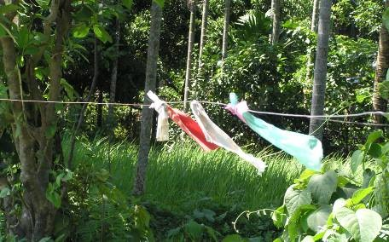

### Season, time of damage

The season and time of damage were similar in all three sectors. Two peak seasons for crop raiding were identified, one during maize or wheat maturing time (June – July) and other paddy maturing time (September – November). Most of the crop raiding and property damage by elephants were reported to occur in night. The elephants spend the day time inside the park or close to the edge forest areas.

A study carried out in Africa (Osborn 2004) and in India (Sukumar 1989) indicated that the onset of crop raiding and the quality of wild food toward the end of the wet season are linked. Sukumar (1989) further commented that protein content of wild food plants dropped far below the minimum level needed by elephant for maintenance during the late wet season. At this time, which was also the peak raiding season, the maturing finger millet and paddy crops had much higher protein levels. Maize cobs, which are selectively plucked by elephants, had protein levels even higher than in fresh growth of tall grasses.

### Key causative factors

**100**

**80**

**Jhapa Bardia Shukla**

**60**

**40**

**20**

**0**

**Strongly Agree**

**Agree**

**Unsure Disagree Strongly**

**Disagree**

**(15b) Shrinking habitat**

The respondents in the study area reported a few key causative factors regarding HEC. Nearly everyone in the three sectors agreed that increasing population of elephants was causing problem (Fig. 15a). Most people in Jhapa supported the opinion that elephants were causing problem because of the shrinking habitat (Fig. 15b). The respondents from Bardia, however were divided as nearly half of the respondents agreed with the statement and the other half denied. Contrary to this, the people from Shukla strongly rejected this statement. This is not surprising considering the large intact patches of existing forests in Shukla compared to Jhapa. Moreover, the respondents from Shukla strongly agreed that elephants were attracted to crops because of their natural preference (Fig. 15c). Bardia and Jhapa also supported this statement but not as strongly as did by Shukla. A majority of respondents especially in Shukla, subscribed to the view that one of the key causes of HEC was the inefficiency of the current protection measures (Fig. 15d). Behavioural flexibility of elephants thereby enabling them to quickly modify their foraging strategies in response to the protective measures are also believed to be one of the major reasons for this .

**Figure 15. Some of the key causative factors perceived by communities regarding conflict**

**100**

**80**

**60**

**40**

**20**

**Jhapa**

**Bardia Shukla**

**0**

**Strongly Agree**

**Agree**

**Unsure Disagree Strongly**

**Disagree**

**(15a) Increased elephant population**

**Respondents (%)**

**R e s ponde nts (% )**

**100**

**Jhapa**

**80**

**Bardia**

**60**

**Shukla**

**40**

**20**

**0**

**Strongly Agree Unsure Disagree Strongly Agree Disagree**

**(15d) Inefficient protection measures**

### Impact of land transformations and habitat fragmentation on the extent of crop damage by elephants

**100**

**80**

**Jhapa**

**Bardia Shukla**

**60**

**40**

**20**

**0**

**Strongly Agree Agree**

**Unsure Disagree Strongly**

**Disagree**

**(15c) Natural attraction to crops**

**R e s ponde nts (% )**

**R e s ponde nts (% )**

The percentage settlement area (settlement coverage) and the extent of economic loss due to crop damage by elephants was positively and significantly correlated (Fig. 16) indicating that transformation of elephant habitats to other uses (settlement, agriculture etc.) is highly likely to result in the increased economic losses from crop damage. The coefficient of determination *r2* here implies that about 36 percentages of the total variation in the economic loss can be attributed to the land transformation.

**Figure 16. Impact of land transformation on the economic loss due to crop damage by elephants**

**rs = 0.73 (p < 0.01)**

**r2 = 0.36**

**20000**

**10000**

**0**

**50**

**60**

**70**

**80**

**90**

**100**

**Settlement coverage (% of VDC area)**

**Crop loss (NRs/Hh/Year)**

Like the effect of settlement coverage, the habitat fragmentation, as reflected by the ratio between habitat frontage and the forest cover also had positive association with the crop damage (Figure 17). Moreover, it is interesting to note that the fragmentation of habitats can be attributed to about 50 percent of total variation in the economic loss which is nearly 15 percent more than that explained by the settlement coverage alone. This possibly indicates the importance of taking into account of the shape and distribution of the habitat patches over the landscape while examining the intensity of human – elephant conflict.

**Figure 17. Impact of habitat fragmentation on the economic loss due to crop damage by elephants**



**Ratio of habitat frontage and forest area**

**0.06**

**0.05**

**0.04**

**0.03**

**0.02**

**0.01**

**0**

**0**

**10000**

**rs = 0.68 (p = 0.01)**

**r2 = 0.49**

**20000**

**Crop loss (NRs/Hh/Year)**

These results have the important management implication when we consider increasing fragmentation and the declining forest cover, especially in Shukla (Fig. 8). Despite the current low magnitude of elephant damage in Shukla (Fig. 13), it is likely that the intensity of HEC will increase in coming days if the above relationships hold true. Moreover, our results on the temporal pattern of crop loss to elephants showed that there was an increasing trend of loss of paddy to the elephants in Shukla in the recent years, which further attests to the aforementioned statement (Fig. 14).

### Measures undertaken to mitigate HEC

The severity of the problem is reflected by various measures undertaken at the community level to mitigate HEC in all the sectors. Most people applied one or more measures to cope with HEC (Fig. 18). Among them, chasing with fire, use of noise and explosives, and regularly guarding the fields were the most widely used measures in all the sectors. Apart from this, high voltage electric fence in Jhapa and improved fencing (mainly, digging trenches and planting hedgerows) in Shukla were also commonly practiced.

**Figure 18. Some of the measures undertaken to mitigate conflict**

**100**

**80**

**60**

**40**

**20**

**Others Chasing with fire Electric fencing**

**Using noise and explosive Regularly watching the wildlife Improved fencing in agriculture field**

**0**

**Sukla**

**Bardia**

**Jhapa**

**No preventive measures**

### Effectiveness of existing measures in mitigating HEC

*Elephants are always one step ahead of us human beings in this ‘arms race’ of offenses and defenses. They develop counter measures in no time in response to the techniques that we apply to drive them away. – Manoj Thapa, Bahundangi VDC*

Despite the wide spread application of measures *v.i.z.* chasing with fire, use of noise and explosives, and regularly guarding fields, these were not considered to be effective in mitigating HEC by the people of Bardia and Jhapa (Plate 8 and 9, Fig 19). This agrees well with Sukumar (2003) whereby he observes that these techniques are merely effective to drive away inexperienced crops raiders, whereas veteran raiders, usually adult bulls or even some family groups are difficult to be fooled. The respondents from Shukla, however showed clear

preference for these measures. Likewise, electric fencing was rated positively by Jhapa while the respondents in Bardia and Shukla were unsure about its effectiveness (Fig. 19).

**100**

**Jhapa Bardia Shukla**

**80**

**60**

**40**

**20**

**0**

**Poor**

**Fair**

**Good Excellent Unsure**

**Improving fencing in the agriculture field**

**100**

**Jhapa Bardia Shukla**

**80**

**60**

**40**

**20**

**0**

**Poor**

**Fair**

**Good Excellent Unsure**

**Using noise and explosive**

**100**

**Jhapa Bardia Shukla**

**80**

**60**

**40**

**20**

**0**

**Poor**

**Fair**

**Good Excellent Unsure**

**Chasing with fire**

**100**

**Jhapa Bardia Shukla**

**80**

**60**

**40**

**20**

**0**

**Fair**

**Good**

**Excellent**

**Unsure**

**Electric fencing**

**R e s pon de nts (% )**

**R e s pon de n ts (% )**

**R e s pon de nts (% )**

**Figure 19. Effectiveness of existing measures in mitigating HEC**

**100**

**Jhapa Bardia Shukla**

**80**

**60**

**40**

**20**

**0**

**Poor**

**Fair**

**Good Excellent Unsure**

**Regularly watching the wildlife**

**R e s pon de nts (% )**

**R e s pon de nts (% )**