Pandit Deendayal Energy University (PDEU), Gandhinagar

Weekly Progress Report - 9

Name of the Student 1 | Hetanshi Bhatt
Roll Number of Student 1 | 22BPC156
Name of the Student 2 | Kunal Solanki
Roll Number of Student 2 | 22BCP131
Project Title | Combating Digital Misinformation: Deepfake Detection Using Deep Neural Networks
Name of the Supervisor (Mentor) at PDEU | Dr. Samir Patel
Week Number | Week 9
Progress made in Week:

The week was fully dedicated to executing the definitive training run for the project's core detection model, leveraging the optimization results from the previous week.

Final Training Run with Optimized XceptionNet
  - Model Used: Fine-tuned XceptionNet.
  - Configuration: The final, full-epoch training run was conducted using the best set of hyperparameters (Learning Rate, Weight Decay, and Augmentation strengths) identified by the Optuna study in Week 8.
  - Objective: To maximize the model's performance and generalization capacity on the training data.
  - Performance Achievement: The optimal parameters successfully utilized the model's capacity, resulting in strong, stable validation performance:
  - Artifact: The final best-performing model weights were saved (final_xception_optuna.pth) and are ready for the crucial final evaluation stage.
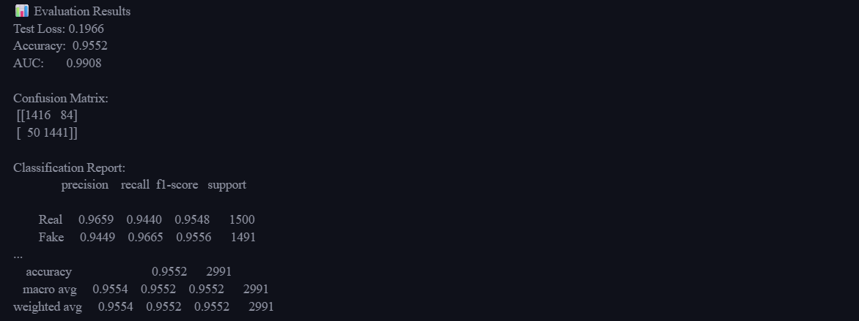

Hetanshi Bhatt | Kunal Solanki | Samir Patel
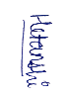 | 
Name and Signature of Student 1 | Name and Signature of Student 2 | Name and Signature of Supervisor (Mentor)

