Digital Literacy Project Report

Name: Kunal Pawar
Registration Number: 25BCE10486
A Course: CSE0001 Digital Literacy
Program: B.Tech Computer Science and Engineering
University: VIT Bhopal University

Introduction

Digital literacy refers to the ability to use digital devices, internet services, and online platforms in a safe and effective manner. In today's academic environment, students depend on digital tools for learning, communication, and project work.

The main aim of this project was to develop practical knowledge of digital platforms such as GitHub, coding websites. Google Forms, and professional communication methods. The project also focused on understanding cyber safety and responsible use of online resources.

All the tasks were completed step by step and organized in a GitHub repository. This report explains each task along with the work performed and learning outcomes.

Task 1 - Infographic Creation

In this task, a digital infographic was created using Canva to explain the concept of digital literacy. The infographic included topics such as basic digital tools, safe internet usage, and responsible online behaviour.

A suitable template was selected in Canva, and the content was added in a simple and clear format. After completing the design, the infographic was downloaded and uploaded to the GitHub repository.

This task helped in understanding how to present information visually using digital tools.

Task 2- Digital Portfolio

In this task, profiles were created on different online platforms such as GitHub, LinkedIn, HackerRank and Kaggle. These platforms are important for building a professional online presence.

Basic details such as education and course information were added to the profiles. Screenshots of all profiles were taken and uploaded to the repository as proof of work.

This task helped in understanding how digital platforms can be used for learning and future career development.

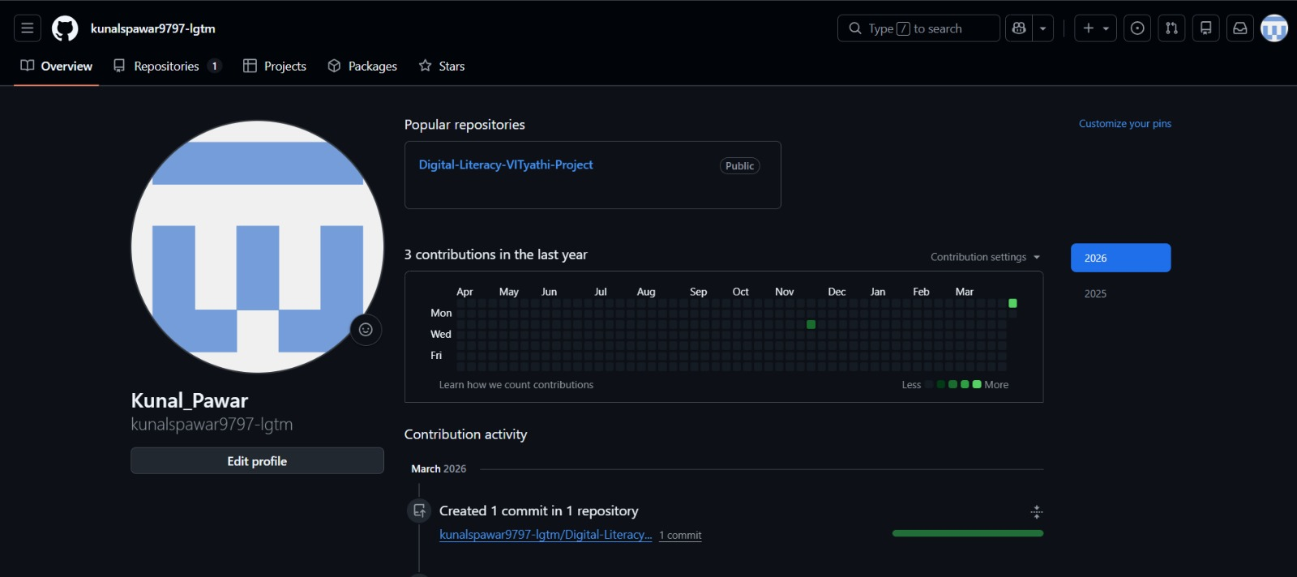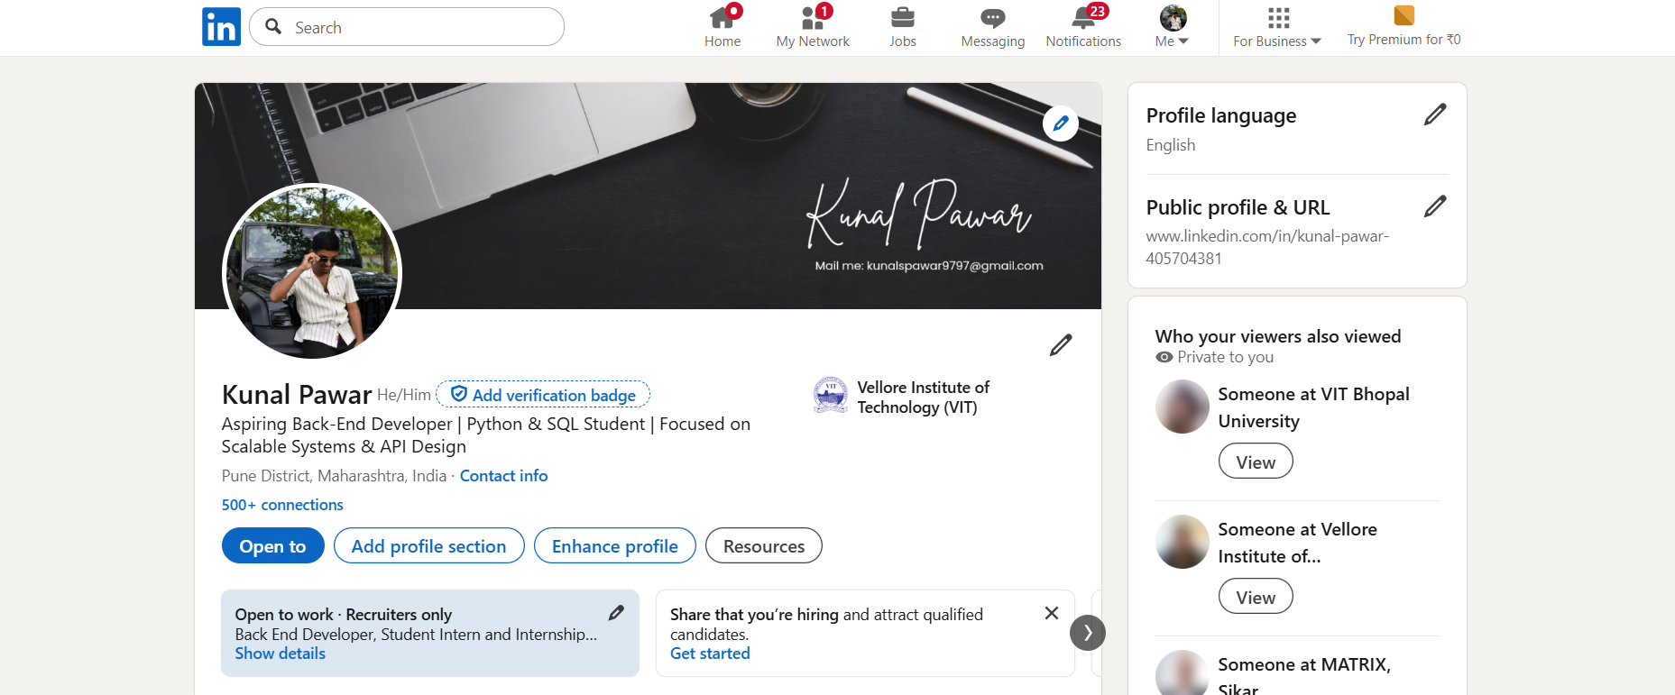

Task 3 - Coding Platform and Google Form

This task involved using a coding platform and creating a Google Form. An account was created on HackerRank, and basic problems were solved to understand how coding platforms work.

A Google Form was created with multiple questions related to digital literacy. The form included different types of questions and was connected to a response sheet.

Screenshots of both the coding platform and the Google Form were uploaded to the repository. This task helped in learning online collaboration and data collection tools.
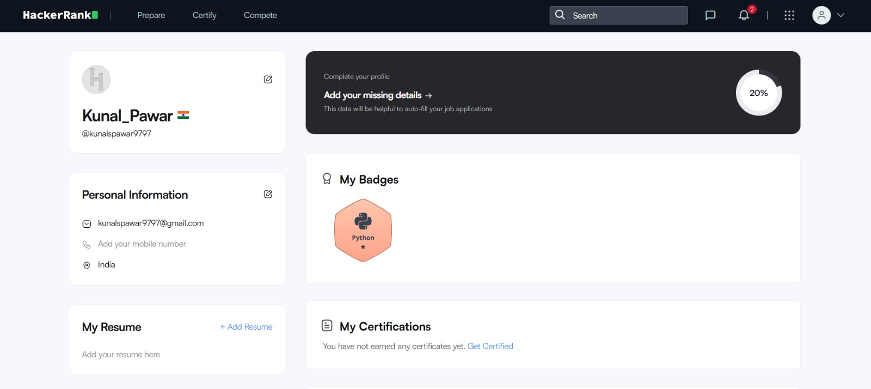

Task 4 - Email and Social Media Etiquette

In this task, two professional emails were written to understand formal communication. One email was written for assignment submission, and the other was related to internship inquiry.

A checklist of social media do's and don'ts was also prepared to understand responsible online behaviour.

This task helped in improving communication skills and understanding proper usage of social media platforms.

Task 5-Cybercrime Case Study

In this task, a case study on online UPI fraud was prepared. The case explained how attackers trick users into making payments through fake requests or messages.

A prevention checklist was also created, including safety measures such as venrying payment requests, avoiding unknown links, and not sharing personal details.

This task helped in understanding cyber risks and how to stay safe while using digital platforms.

Cybercrime Case Study +IBM Online UPI Fraud

Online UPI fraud is a common cybercrime where attackers trick users into sending money through fake payment requests or messages. This type of froud is increasing due to the widespread use of digital payment applications.

In a typical case, a person receives a message or phone call claiming to be from a bank or payment service The attacker may send a UPI collect request and ask the user to approve it for receiving money. Many users do not understand this and approve the request, which results in money being transferred from their account instead of receiving it.

In some cases, fraudsters also send fake QR codes or links and ask üsers to scan or click them. Once the user enters their details of opproves the payment, the money is lost

This case shows that lack of awareness abour digital payments can lead to financial loss. Users should always verify payment requests and understand how UPI transactions work before taking any action.

UPI and Cybercrime Prevention Tips

1. Never approve unknown UPI payment requests.
2. Always read payment message carefully before confirming.
3. Do not scan QR codes sent by unknown people.
4. Do not trust calls claiming to be from bank officials.
5. Never share OTP, PIN, or account details.
6. Use secure and official payment applications only.
7. Check transaction details before completing payment.
8. Avoid clicking on suspicious payment links.
9. Enable mobile banking alerts for all transactions.
10. Immediately report fraud to cybercrime.gov.in or call 1930.

Conclusion

This project helped in developing practical knowledge of digital tools and platforms. It improved skills such as creating content, managing online profiles, writing professional emails, and understanding cyber safety.

The use of GitHub for organizing all tasks also helped in learning how to present work in a structured manner, Overall, this project was useful in building essential digital skills required for students.

GitHub Profile: https://github.com/shreebhere64-code
LinkedIn Profile: https://www.linkedin.com/in/kunal-pawar-405704381/
HackerRank Profile: https://www.hackerrank.com/profile/shreyash 25bce11
Google_Form:https://docs.google.com/forms/d/e/1FAIpQLSeekKU@PTBsxhkwEA/a2-XGw6JxRHLHBLWDE4etrOPk9Og/viewform?usp-publish-editor

