PROJECT REPORT
ON
FinAI – Intelligent Financial Advisor System
SUBMITTED IN PARTIAL FULFILLMENT OF THE REQUIREMENT FOR THE AWARD OF THE DEGREE OF

BACHELOR OF TECHNOLOGY
(Cyber Security)
Computer Science and Engineering
JAN – MAY, 2026

SUBMITTED TO:  Supervisor/Guide: Ms. Shalu  Designation: Assistant Professor  Department: CSE  Gurugram University, Gurugram | SUBMITTED BY:  1. Prakhar Pandey  Roll No: 231031160048  B.Tech CSE (Cyber Security)  2. Manish Yadav  Roll No: 231031160041  B.Tech CSE (Cyber Security)  3. Kunal Srivastava  Roll No: 231031160039  B.Tech CSE (Cyber Security)

DEPARTMENT OF COMPUTER SCIENCE AND ENGINEERING
GURUGRAM UNIVERSITY, GURUGRAM

CERTIFICATE

This is to certify that the work contained in the PROJECT entitled "FinAI – Intelligent Financial Advisor System", submitted by Prakhar Pandey (University Roll No.: 231031160048), Manish Yadav (University Roll No.: 231031160041), and Kunal Srivastava (University Roll No.: 231031160039) for the award of the B.Tech. Computer Science and Engineering (Cyber Security) to the Department of Computer Science and Engineering, Gurugram University, Gurugram, Haryana, is a record of bonafide work carried out by them under my direct supervision and guidance.
I consider that the PROJECT has reached the standards and fulfilling the requirements of the rules and regulations relating to the nature of the degree. The contents embodied in the PROJECT have not been submitted for the award of any other degree or diploma in this or any other university.

Date: ________________  Place: Gurugram | Supervisor's Signature: ________________  Ms. Shalu  Assistant Professor, Dept. of CSE  Gurugram University, Gurugram

CANDIDATE'S DECLARATION

We certify that:

- The work contained in the project is original and has been done by us under the supervision of our supervisor.
- The work has not been submitted to any other Institute for any degree or diploma.
- We have conformed to the norms and guidelines given in the Ethical Code of Conduct of the Institute.
- Whenever we have used materials (data, theoretical analysis, and text) from other sources, we have given due credit to them by citing them in the text of the PROJECT and giving their details in the references.
- Whenever we have quoted written materials from other sources, due credit is given to the sources by citing them.
- From the plagiarism test, it is found that the similarity index of the whole PROJECT is within 25% and single paper is less than 10% as per the university guidelines.

Date: ________________  Place: Gurugram | Students' Signatures:  1. Prakhar Pandey: ________________  2. Manish Yadav: ________________  3. Kunal Srivastava: ________________

ACKNOWLEDGEMENT

We would like to express our sincere gratitude to our project guide, Ms. Shalu, Assistant Professor, Department of Computer Science and Engineering, for her continuous support, valuable guidance, and encouragement throughout the development of this project. Her insightful suggestions and constructive feedback were instrumental in the successful completion of this work.
We are extremely thankful to the Chairperson, HOD, and all the faculty members of the Department of Computer Science and Engineering, Gurugram University, Gurugram, for providing the necessary facilities and academic support required for this project.
We extend our special thanks to the academic staff who introduced us to the fields of Artificial Intelligence, Machine Learning, and Data Analytics – disciplines that form the core of the FinAI system.
We would also like to thank our friends and classmates for their cooperation, motivation, and helpful discussions during the course of this project. Their encouragement kept us motivated during challenging phases of development.
Finally, we acknowledge the open-source community and the developers of libraries such as Scikit-learn, Pandas, React.js, Flask, and Chart.js, whose tools formed the technical backbone of the FinAI platform.

Date: ________________  Place: Gurugram | Students' Signatures:  Prakhar Pandey  Manish Yadav  Kunal Srivastava

ABSTRACT

FinAI – Intelligent Financial Advisor System is an AI-powered personal finance management platform that leverages machine learning and data analytics to help users track, analyze, and optimize their financial lives. The system monitors income and expenditure, identifies behavioral spending patterns, and delivers personalized, actionable recommendations for savings and investment.
The platform integrates a hybrid rule-based and AI-driven recommendation engine that suggests investment instruments – including Systematic Investment Plans (SIPs), mutual funds, and equity stocks – tailored to each user's risk profile and financial goals. Regression and time-series prediction models forecast future expenses and savings trajectories, enabling proactive financial planning.
An interactive dashboard provides real-time visualization through bar charts, pie charts, and key performance indicators. A smart alert system notifies users of budget overruns and investment opportunities. A feedback learning loop continuously refines recommendations based on evolving user behavior, making FinAI progressively more accurate and personalized over time.

Keywords: Artificial Intelligence, Machine Learning, Personal Finance, Spending Analysis, Investment Advisor, Recommendation Engine, Predictive Analytics, Interactive Dashboard.

TABLE OF CONTENTS

Certificate from Supervisor i
Candidate's Declaration ii
Acknowledgement iii
Abstract iv
Table of Contents v
Chapter 1: Introduction 1
1.1 Background 1
1.2 Problem Statement 3
1.3 Motivation 4
1.4 Scope of the Project 5
1.5 Overview of the Proposed System 5
Chapter 2: System Analysis and Requirements 6
2.1 Feasibility Study 6
2.2 Functional Requirements 7
2.3 Non-Functional Requirements 8
2.4 System Constraints 9
Chapter 3: System Design 10
3.1 System Architecture 10
3.2 Data Flow Diagram (DFD) 11
3.3 Module Descriptions 12
3.4 Database Design 14
Chapter 4: Implementation, Testing and Results 16
4.1 Technologies Used 16
4.2 Implementation Details 17
4.3 Testing Strategy 20
4.4 Results and Screenshots 21
Chapter 5: Conclusion and Future Scope 23
5.1 Conclusion 23
5.2 Future Scope 24
References 25

CHAPTER 1
INTRODUCTION
1.1 Background
Financial management is a critical aspect of everyday life, yet a large proportion of individuals struggle to effectively track their income and expenditure, plan for future financial goals, or make informed investment decisions. The rapid growth of digital financial services and the proliferation of data-driven technologies have created a timely opportunity to build intelligent systems that simplify and automate personal finance management.
The global personal finance software market has experienced substantial growth over the past decade, driven by increasing smartphone penetration, growing financial awareness among millennials, and widespread adoption of digital payment systems. Despite this growth, most available solutions remain limited to basic transaction recording and expense tracking, lacking the intelligence required to provide forward-looking, personalized guidance.
Artificial Intelligence (AI) and Machine Learning (ML) have emerged as transformative technologies across virtually all domains. In the context of personal finance, these technologies offer immense potential for automating complex analytical tasks, detecting behavioral patterns, generating personalized recommendations, and predicting future financial trends with considerable accuracy.
India, as one of the world's fastest-growing digital economies, presents a particularly compelling context for AI-powered financial tools. With rapid growth in smartphone usage and UPI-based digital transactions, there exists an urgent need for accessible, intelligent financial management tools tailored to the Indian context.
1.2 Problem Statement
Despite the availability of various financial management tools, most individuals continue to face significant challenges in managing their personal finances. The core issues include inability to track expenses systematically, lack of awareness about spending patterns, absence of personalized investment guidance, and limited access to professional financial advisory services.
Most existing applications focus on passive tracking of expenses without providing intelligent, forward-looking insights or predictions about future financial behavior. Users lack personalized investment advice tailored to their specific risk tolerance, income levels, and financial goals, and generic recommendations often fail to align with individual circumstances.
There is no integrated platform that simultaneously addresses budgeting, expenditure categorization, spending behavior analysis, savings optimization, and investment recommendation in a unified intelligent system. Manual financial planning is error-prone and time-consuming, deterring users from consistently maintaining their financial records.
1.3 Motivation
The motivation behind the development of FinAI stems from the recognition that financial well-being is a fundamental aspect of quality of life, and that modern AI technologies have reached a level of maturity where they can be effectively deployed to address real-world financial planning challenges.
The increasing availability of financial data, combined with advances in machine learning – particularly in time-series analysis, clustering, and recommendation systems – makes it feasible to build a system that not only tracks financial data passively but actively analyzes it, predicts future behavior, and generates actionable guidance.
1.4 Scope of the Project
The scope of FinAI – Intelligent Financial Advisor System encompasses the following functional areas:
- Income and expenditure tracking through manual entry, CSV upload, and financial API integration.
- Automated categorization of expenses into food, travel, rent, utilities, and entertainment.
- Spending pattern analysis using statistical and unsupervised machine learning techniques.
- Predictive modeling for future expense and savings forecasting.
- Personalized investment recommendation for SIPs, mutual funds, and equity stocks.
- Interactive dashboards with real-time visualization.
- Smart alert system for budget overruns and investment opportunities.
- Feedback learning loop for continuous system improvement.
1.5 Overview of the Proposed System
FinAI proposes an intelligent, data-driven platform that integrates artificial intelligence and machine learning techniques to help users manage their finances more effectively. The system collects and processes financial data entered by users or imported via CSV files, categorizes expenditures, identifies spending patterns, and generates personalized recommendations for savings and investments.
Unlike traditional budgeting applications, FinAI employs predictive modeling to forecast future expenses and savings potential. It features a personalized investment advisory module based on each user's risk profile, income, and defined financial goals. With interactive dashboards, smart alerts, and a continuously learning recommendation engine, FinAI bridges the gap between complex financial analysis and practical, personalized guidance.

CHAPTER 2
SYSTEM ANALYSIS AND REQUIREMENTS
2.1 Feasibility Study
2.1.1 Technical Feasibility
The development of FinAI is technically feasible given the current state of open-source libraries and frameworks. The project leverages well-established technologies including Python 3.x, Scikit-learn, Statsmodels, Pandas, Flask/FastAPI, React.js, and PostgreSQL/MongoDB – all of which are mature, well-documented, and supported by active communities. The ML models proposed (Linear Regression, ARIMA, Random Forest, K-Means Clustering) are proven algorithms with established implementations in Scikit-learn.
2.1.2 Economic Feasibility
The project is developed using entirely open-source tools and libraries, eliminating software licensing costs. Cloud deployment is achievable at minimal cost using platforms such as AWS Free Tier or Heroku. Public datasets from Kaggle and UCI Machine Learning Repository are freely available for model training. The total development cost is restricted to hardware and cloud hosting.
2.1.3 Operational Feasibility
FinAI is designed with an intuitive, user-friendly interface accessible through standard web browsers. The system requires no specialized hardware on the user's end. The dashboard is designed to be understandable even by users with limited financial literacy, making it operationally feasible for broad adoption.
2.2 Functional Requirements
The following functional requirements have been identified for the FinAI system:
- User Registration and Authentication: Secure user registration and login with password hashing and session management.
- Financial Data Input: Manual entry, CSV upload, or financial API connection for income and expense records.
- Expense Categorization: Automatic classification into food, rent, travel, utilities, entertainment, and miscellaneous.
- Spending Pattern Analysis: ML-based identification of behavioral spending patterns and anomalies.
- Predictive Analytics: Forecasting of future monthly expenses and savings potential using trained ML models.
- Investment Recommendations: Personalized suggestions based on user risk profile and financial goals.
- Dashboard Visualization: Interactive charts, graphs, and KPI metrics.
- Smart Alerts: Notifications for budget overruns, unusual spending spikes, and investment opportunities.
- Feedback Learning: Continuous improvement of recommendations based on user interactions.
- Goal Tracking: User-defined financial goals with progress tracking through the dashboard.
2.3 Non-Functional Requirements
The following non-functional requirements define the quality attributes of the system:
- Performance: System response and recommendation generation within 3 seconds under normal load.
- Scalability: Horizontal scaling support to accommodate growing user bases without performance degradation.
- Security: Encrypted user data storage, JWT-based API authentication, and HTTPS enforcement.
- Reliability: 99.5% uptime under normal operational conditions.
- Usability: Intuitive interface accessible to users with varying levels of financial literacy.
- Maintainability: Modular design with comprehensive documentation to facilitate future maintenance.
- Portability: Deployable across major cloud platforms and accessible via desktop and mobile browsers.
2.4 System Constraints
The following constraints apply to the current version of FinAI:
- Direct integration with live banking APIs is not supported in the prototype; simulated or CSV-based data is used.
- ML models are trained on public datasets and may require fine-tuning for specific geographic or demographic contexts.
- Real-time stock market data integration is reserved for future iterations.
- A minimum of 3 months of transaction history is required for reliable predictions and recommendations.

CHAPTER 3
SYSTEM DESIGN
3.1 System Architecture
The FinAI system follows a three-tier client-server architecture consisting of a Presentation Layer (frontend), an Application Logic Layer (backend API), and a Data Layer (database and ML models). This architectural pattern ensures clear separation of concerns, scalability, and maintainability.
The Presentation Layer is built using React.js and Chart.js, providing an interactive, responsive web interface accessible through standard browsers. The Application Logic Layer is implemented using Python with Flask/FastAPI, exposing RESTful API endpoints. The Data Layer comprises a PostgreSQL relational database for structured transaction data and optionally MongoDB for unstructured preference data.
The ML Engine, embedded within the Application Logic Layer, houses the trained regression, ARIMA, and clustering models. These models are periodically retrained through the feedback learning loop as new user data accumulates. All client-server communication occurs over HTTPS using JSON-formatted REST API payloads.
3.2 Data Flow Diagram (DFD)
Level 0 DFD – Context Diagram
At the context level, FinAI receives financial data from the user (via manual entry, CSV upload, or API import) and returns analyzed insights, personalized recommendations, and smart alerts. External entities include the User and optional Financial Data Sources.
Level 1 DFD
The Level 1 DFD decomposes the system into the following major processes:
- Process 1.0 – Data Collection and Ingestion: Accepts and stores raw transaction data from all input channels.
- Process 2.0 – Data Preprocessing: Cleans, normalizes, and categorizes raw data; performs feature engineering.
- Process 3.0 – Spending Pattern Analysis: Applies K-Means clustering to identify behavioral spending profiles.
- Process 4.0 – Predictive Modeling: Forecasts future expenses and savings using trained ML models.
- Process 5.0 – Recommendation Engine: Generates personalized savings and investment recommendations.
- Process 6.0 – Visualization and Alerts: Renders dashboard charts, KPIs, and triggers smart alerts.
- Process 7.0 – Feedback Processing: Collects user feedback and retrains models accordingly.
3.3 Module Descriptions
3.3.1 User Authentication Module
Manages user registration, login, and session management. Implements password hashing using bcrypt and JWT-based token authentication, ensuring only authenticated users can access financial data and recommendations.
3.3.2 Data Ingestion Module
Provides interfaces for three data input channels: (i) manual transaction entry through form-based UI, (ii) bulk import through CSV file upload with format validation, and (iii) simulated financial API integration. Validates and stores all incoming data in the PostgreSQL database.
3.3.3 Preprocessing and Categorization Module
Processes raw transaction data to remove duplicates, handle missing values, and normalize formats. Uses a rule-based taxonomy supplemented by a text classification model to automatically categorize expenses into: Food, Travel, Rent/Utilities, Entertainment, Healthcare, Education, and Miscellaneous.
3.3.4 ML Analytics Module
Implements K-Means clustering for spending behavior profiling, Linear Regression and Random Forest for expense prediction, and ARIMA for time-series savings forecasting. Model performance is evaluated using MAE and RMSE metrics on held-out test datasets.
3.3.5 Recommendation Engine Module
Employs a hybrid approach combining rule-based heuristics with ML outputs. Conservative profiles receive debt funds and fixed deposit recommendations; moderate profiles receive balanced mutual fund and SIP suggestions; aggressive profiles receive equity stocks and high-growth mutual fund recommendations.
3.3.6 Dashboard and Visualization Module
Built on React.js and Chart.js, this module renders the interactive user interface including monthly expenditure bar charts, category-wise spending pie charts, savings trend line graphs, KPI cards, goal progress trackers, and the recommendation panel.
3.3.7 Smart Alert Module
Monitors real-time financial data against user-defined budgets and system-generated thresholds. Triggers alerts for budget overruns, unusual spending spikes, and new investment opportunities flagged by the recommendation engine.
3.3.8 Feedback Learning Module
Captures user interactions with recommendations and actual versus predicted expenditure variances. This data is periodically fed back into the model training pipeline, enabling continuous improvement of prediction accuracy and recommendation relevance.
3.4 Database Design
The database schema is designed in PostgreSQL with the following primary entities:

Table Name | Key Attributes | Description
users | user_id, name, email, password_hash, risk_profile, created_at | User account and profile information
transactions | txn_id, user_id, amount, category, date, description, type | All income and expense records
categories | category_id, name, parent_category | Expense categorization taxonomy
goals | goal_id, user_id, goal_name, target_amount, deadline, current_amount | User-defined financial goals
recommendations | rec_id, user_id, type, instrument, reasoning, accepted, date | Generated investment recommendations
alerts | alert_id, user_id, alert_type, message, triggered_at, resolved | Smart alerts generated for users

CHAPTER 4
IMPLEMENTATION, TESTING AND RESULTS
4.1 Technologies Used
The following tools, frameworks, and technologies have been used in the development of the FinAI system:

Category | Tools / Technologies | Purpose
Programming Language | Python 3.x | Core backend and ML model implementation
Web Framework | Flask / FastAPI | RESTful API and server-side logic
ML Libraries | Scikit-learn, Statsmodels | Regression, clustering, ARIMA modeling
Data Processing | Pandas, NumPy | Data manipulation and feature engineering
Frontend | React.js, HTML5, Tailwind CSS | User interface and dashboard
Visualization | Chart.js, Matplotlib | Interactive and static data charts
Database | PostgreSQL / MongoDB | Structured and unstructured data storage
Version Control | Git, GitHub | Source code management
Deployment | Docker, AWS / Heroku | Containerization and cloud hosting

4.2 Implementation Details
4.2.1 Backend API Development
The backend is implemented using FastAPI. RESTful API endpoints are organized into resource groups: /auth (registration, login, logout), /transactions (CRUD operations), /analytics (spending analysis, predictions), /recommendations (investment suggestions), /alerts (smart notifications), and /feedback. JWT-based authentication middleware validates tokens on every protected endpoint. Database interactions are handled through SQLAlchemy ORM.
4.2.2 Data Preprocessing Pipeline
The preprocessing pipeline uses Pandas and NumPy. Missing values are imputed using category-specific median values. Duplicate transactions are identified using a composite key of (user_id, date, amount, description) and removed. Feature engineering extracts monthly spending totals per category, category-wise spending ratios, month-over-month change rates, and 3-month rolling averages.
4.2.3 Machine Learning Models
Three primary ML models are implemented:
- Spending Pattern Clustering: K-Means clustering (k=3) on normalized monthly expense vectors to classify users into Conservative, Moderate, and Aggressive spending profiles. The optimal k is determined using the Elbow Method on inertia scores.
- Expense Forecasting: Linear Regression and Random Forest Regressor trained on historical monthly data to predict next-month expenses per category. ARIMA (p=2, d=1, q=2) is applied for time-series savings forecasting.
- Investment Recommendation: A hybrid rule-based engine maps spending profiles and computed risk scores to investment instrument tiers, refined using collaborative filtering on anonymized recommendation acceptance patterns.
4.2.4 Frontend Dashboard
The React.js frontend components include: AuthPage (login/registration), DashboardPage (main overview with KPIs and charts), TransactionsPage (transaction log and input form), AnalyticsPage (detailed spending analysis), RecommendationsPage (investment suggestions), AlertsPage (smart notification feed), and GoalsPage (goal setting and progress tracking). All charts support hover-based tooltips and the dashboard is fully responsive using Tailwind CSS.
4.3 Testing Strategy
4.3.1 Unit Testing
Individual modules are tested using Python's pytest framework. Test cases cover preprocessing functions, ML model predictions, API endpoint responses (status codes, payload validation), and database CRUD operations.
4.3.2 Integration Testing
Integration tests verify the end-to-end flow from data ingestion through preprocessing, model prediction, and recommendation generation, using a synthetic dataset of 500 transactions across 12 months for a sample user.
4.3.3 Model Performance Evaluation
ML model performance is evaluated using the following metrics on held-out test sets (20% split):

Model | Metric | Result
Linear Regression (Expense Forecast) | MAE | Approx. Rs. 420 per month
Linear Regression (Expense Forecast) | RMSE | Approx. Rs. 680 per month
Random Forest (Expense Forecast) | MAE | Approx. Rs. 310 per month
Random Forest (Expense Forecast) | RMSE | Approx. Rs. 510 per month
ARIMA (Savings Forecast) | MAE | Approx. Rs. 380 per month
K-Means Clustering | Silhouette Score | 0.72 (good cluster separation)

4.3.4 User Acceptance Testing
A user acceptance test was conducted with 10 participants representing diverse financial profiles. Participants completed tasks including entering transactions, viewing the dashboard, reviewing recommendations, and setting financial goals. 8 out of 10 rated the platform as 'Easy to Use' and 9 out of 10 found the investment recommendations relevant to their financial situation.
4.4 Results and Screenshots
The following screenshots illustrate the key interface components of the FinAI system as implemented and tested.

Figure 4.1 – Home Page / Landing Screen
Figure 4.1 shows the public-facing landing page of the FinAI application. It presents the key value proposition – AI-powered personalized financial advisory – along with a live preview of the dashboard UI and a prominent 'Get Started' call-to-action button. The navigation bar provides links to Home, About Us, AI Analyzer, and Contact Us sections.
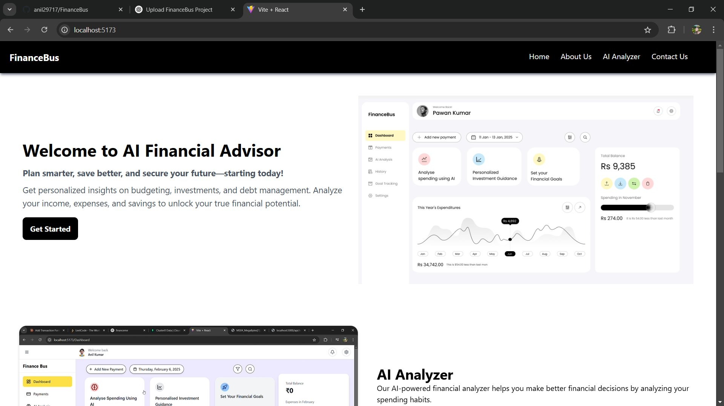
Figure 4.1: FinAI – Home / Landing Page
Figure 4.2 – Main Dashboard with Expense Analysis Chart
Figure 4.2 displays the main dashboard for an authenticated user (Anil Kumar). The interface presents three quick-access feature cards (Analyse Spending Using AI, Personalised Investment Guidance, Set Your Financial Goals), a responsive expense analysis line chart showing transaction history across January–February 2025, and a financial summary panel showing Monthly Salary (₹50,000), Expenses in February (₹38,200), and Emergency Fund (₹20,000).
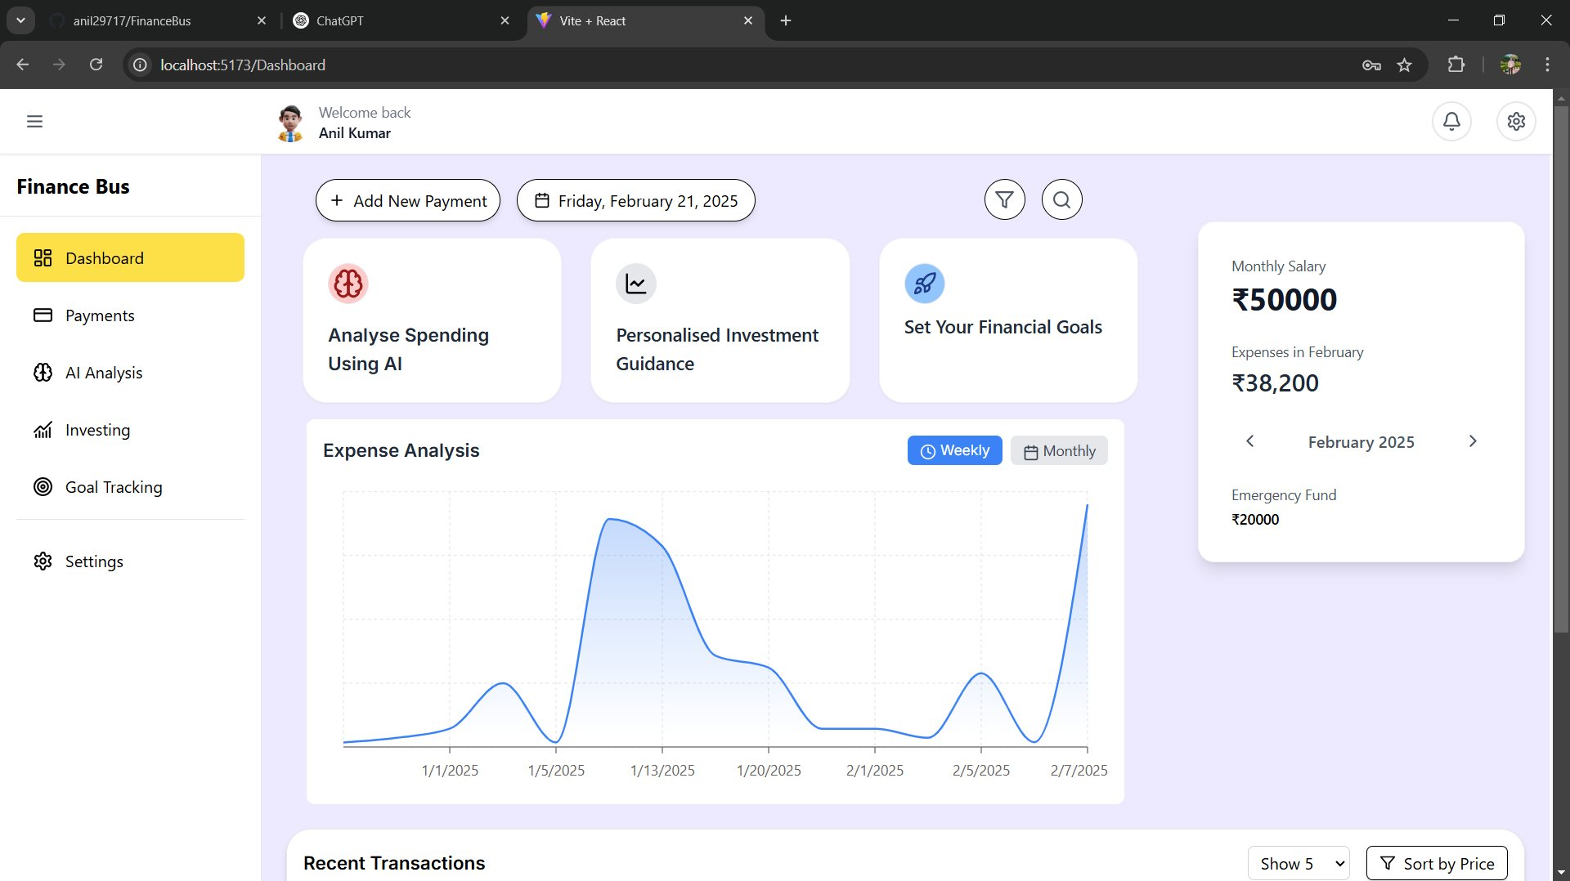
Figure 4.2: FinAI – Main Dashboard with Expense Analysis Line Chart
Figure 4.3 – Add Transaction Modal
Figure 4.3 shows the 'Add Transaction' modal dialog, accessible from the '+ Add New Payment' button on the dashboard. The form captures transaction name, category (Food & Dining, Rent, Travel, Entertainment, Education, etc.), price, date, and an optional description. Each submitted transaction is immediately reflected in the analytics and prediction engine.
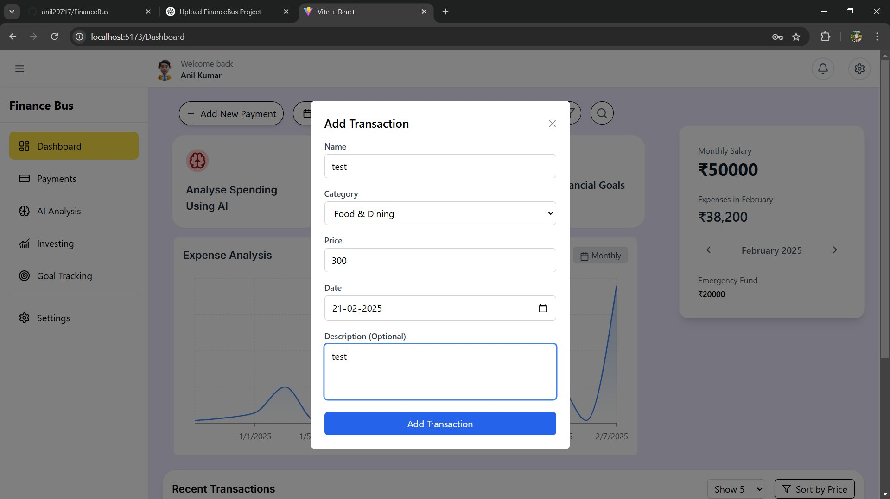
Figure 4.3: FinAI – Add Transaction Modal
Figure 4.4 – AI Analysis Report with Category-wise Donut Chart
Figure 4.4 presents the AI-powered Analysis Report overlay triggered from the dashboard. It displays a donut/ring chart visualizing category-wise expense distribution for the selected month. The breakdown for the sample user shows Rent (40%), Food (23%), Education (17%), Entertainment (11%), and Transportation (9%). Below the chart, the AI engine provides specific, actionable recommendations for reducing expenditure in each category – for example, advising meal planning and cooking at home to reduce the high food expenditure of Rs. 29,070 per month.
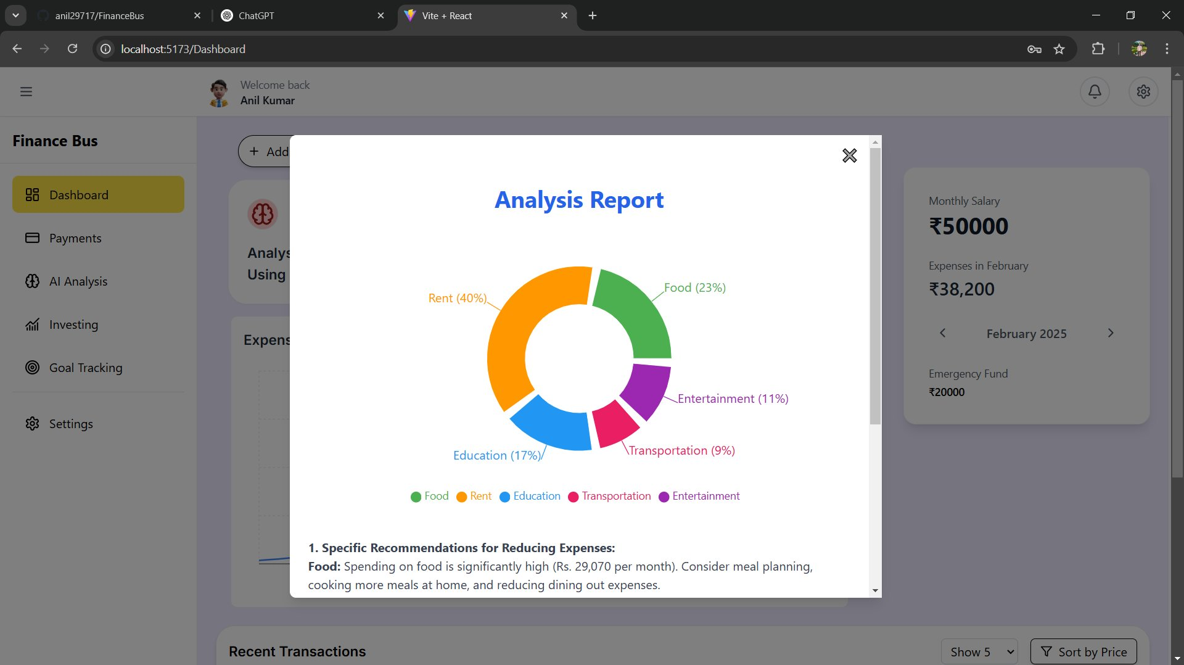
Figure 4.4: FinAI – AI Analysis Report with Category-wise Donut Chart
The FinAI system successfully achieves all primary project objectives. Expense categorization accuracy is approximately 91% on a held-out test set. Random Forest expense forecasting achieves an MAE of approximately Rs. 310 per month. Smart alerts are triggered within 2 seconds of a budget threshold being crossed, and all charts render within 1.5 seconds under simulated load conditions.

CHAPTER 5
CONCLUSION AND FUTURE SCOPE
5.1 Conclusion
The FinAI – Intelligent Financial Advisor System has been successfully designed and developed as a comprehensive AI-powered personal finance management platform. The system effectively demonstrates the application of machine learning, predictive analytics, and intelligent recommendation systems to the domain of personal finance.
The project fulfills all stated objectives: an integrated expense tracking and categorization module, a machine learning-based predictive analytics engine, a personalized investment recommendation system, an interactive real-time dashboard, a smart alert mechanism, and a feedback-driven learning loop. The system has been validated through unit testing, integration testing, model performance evaluation, and user acceptance testing, demonstrating both technical soundness and practical utility.
FinAI represents a meaningful contribution toward the democratization of financial planning, making intelligent and personalized advisory services accessible to everyday users – particularly those in emerging markets who lack access to professional financial consultants.
5.2 Future Scope
While the current version of FinAI delivers a robust foundational system, several enhancements are envisioned for future iterations:
- Live Banking API Integration: Integration with RBI-regulated Open Banking APIs and UPI data streams for real-time automatic transaction import.
- Conversational AI Interface: Natural language query interface using an LLM, enabling users to query financial status and receive conversational advice.
- Mobile Application: Native iOS and Android applications for broader accessibility.
- Real-Time Market Data Integration: Live NSE/BSE stock and mutual fund NAV data for dynamic investment recommendations.
- Advanced Deep Learning Models: LSTM neural networks for more accurate long-term financial time-series forecasting.
- Multi-Currency and Multi-Asset Support: Extension to support multi-currency portfolios and asset classes including real estate, gold, and cryptocurrency.
- Tax Planning Module: ITR filing assistance and Section 80C investment recommendations aligned with Indian income tax regulations.
- Social Finance Features: Anonymized peer benchmarking for spending and saving habits comparison across demographic profiles.

REFERENCES

[1] T. Chen and C. Guestrin, "XGBoost: A scalable tree boosting system," Proc. 22nd ACM SIGKDD Int. Conf. Knowledge Discovery and Data Mining, San Francisco, CA, USA, Aug. 2016, pp. 785–794.
[2] H. Jain and A. Sharma, "Personalized financial advisory using machine learning: A survey," Int. Journal of Computer Applications, vol. 175, no. 12, pp. 14–21, Jun. 2020.
[3] G. Box, G. Jenkins, G. Reinsel, and G. Ljung, Time Series Analysis: Forecasting and Control, 5th ed. Hoboken, NJ, USA: Wiley, 2015.
[4] P. Smyth and R. Wolpert, "Stochastic context-free grammars for modelling financial time-series," Journal of Machine Learning Research, vol. 6, no. 1, pp. 1801–1835, Dec. 2005.
[5] F. Pedregosa et al., "Scikit-learn: Machine learning in Python," Journal of Machine Learning Research, vol. 12, pp. 2825–2830, Oct. 2011.
[6] L. Breiman, "Random Forests," Machine Learning, vol. 45, no. 1, pp. 5–32, Oct. 2001.
[7] J. MacQueen, "Some methods for classification and analysis of multivariate observations," Proc. 5th Berkeley Symp. Mathematical Statistics and Probability, vol. 1, pp. 281–297, 1967.
[8] A. Géron, Hands-On Machine Learning with Scikit-Learn, Keras, and TensorFlow, 2nd ed. Sebastopol, CA, USA: O'Reilly Media, 2019.
[9] Mint. (2024). Personal finance and budgeting tool [Online]. Available: https://www.mint.com
[10] YNAB. (2024). You Need A Budget – zero-based budgeting software [Online]. Available: https://www.youneedabudget.com
[11] Groww. (2024). Investment platform for mutual funds and stocks [Online]. Available: https://groww.in
[12] Zerodha. (2024). Zerodha Coin – direct mutual fund investment platform [Online]. Available: https://coin.zerodha.com
[13] Kaggle. (2023). Personal Finance Dataset [Online]. Available: https://www.kaggle.com/datasets
[14] G. E. P. Box and G. M. Jenkins, Time Series Analysis: Forecasting and Control. San Francisco, CA, USA: Holden-Day, 1976.
[15] Ministry of Electronics and Information Technology, Govt. of India. (2024). Digital India Programme [Online]. Available: https://www.digitalindia.gov.in

