DUAL-LAYER UTILITY CIRCUIT BOARD

## DESCRIPTION

The Utility Circuit Board (UCB) is a dual-layer, surface mount technology-based board designed to combine 3+ functional blocks on a single PCB. The objective is to achieve modularity, minimize repair and diagnostic issues with a form factor optimum to the SPHERICAL BOT mechanical constraints.

## FEATURES

The UCB features the following utilities:

* MP1584 - 3A, 1.5MHz, 28V Step Down Converter Logic.
* TB6612FNG – 4 mode Motor Driver Logic.
* Raspberry Pi Zero W compatibility.
* Charging Mode with Dual Series Battery input and External Supply Logic.
* Reverse current protection logic.

## APPLICATIONS

* Power Input.
* Battery Charging.
* Control In/Outs.
* High voltage conversion.
* Current Conversion.
* Reverse Input Protection.

## SOFTWARE

The schematic for PCB is designed on DxDesigner Software. The layout is designed and developed on PADS v9.5 and both these platforms are a part of software package tool suite from Mentor Graphics, Siemens. The schematic design is developed by implementing universal standard symbol library and can be used to migrate into decal layout libraries in PADS logic for layout designing. The foot print for each component is developed from scratch by referring to respective datasheet constraints for decal guidelines.

The routing for layout is developed with optimum designing rules for trace length and width. The board design ensures all requisite IPC standards and EMI, EMC considerations are met. All placements and routing are done with strictly referring to PCB layout Guidelines wherever needed and mentioned in components datasheets.

## BLOCK DIAGRAM

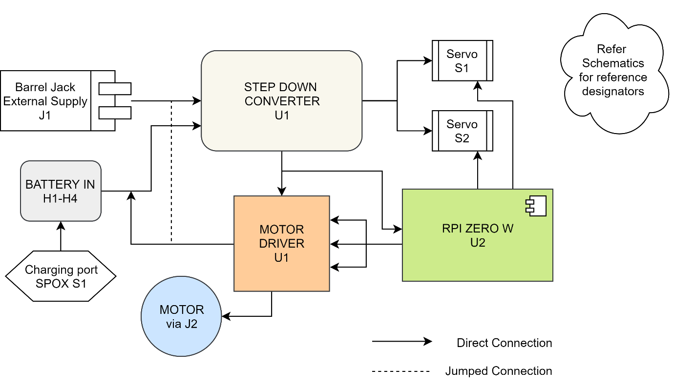

## SCHEMATICS

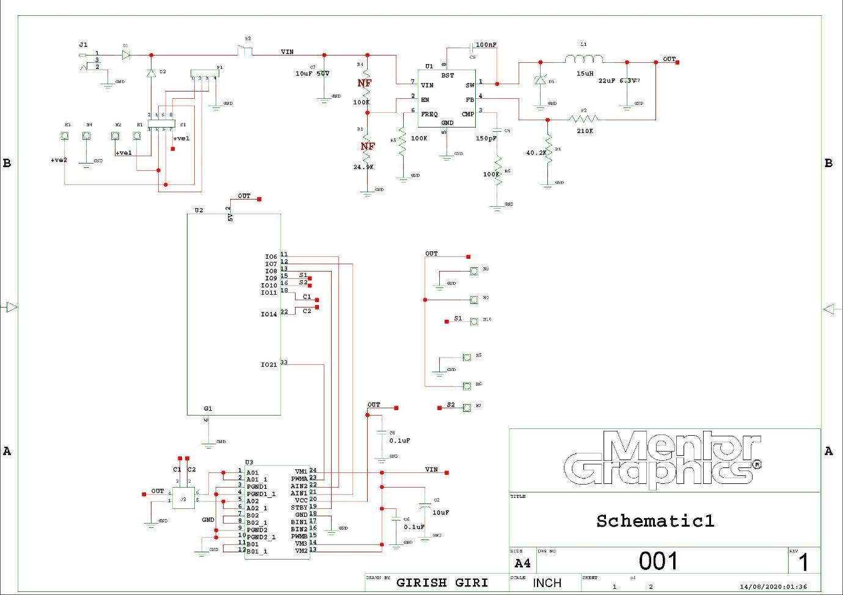

## LAYOUT

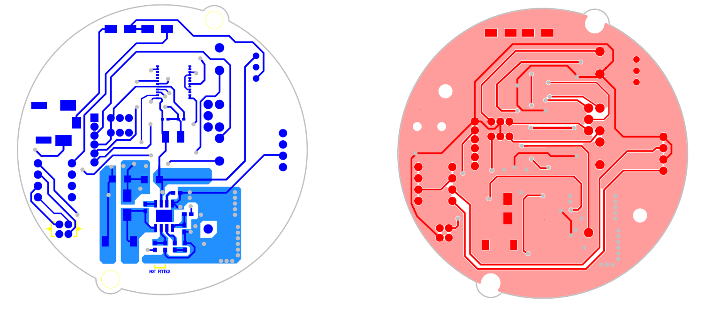

**TOP-SIDE BOTTOM-SIDE**

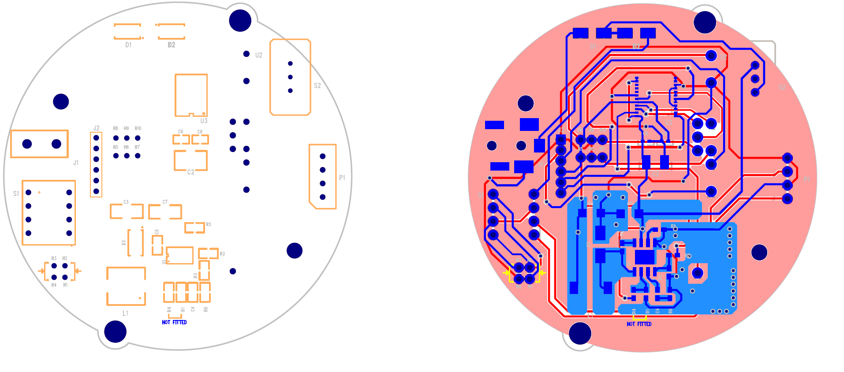

**ASSEMBLY DRAWING COMPOSITE**

# CAD MODELLING

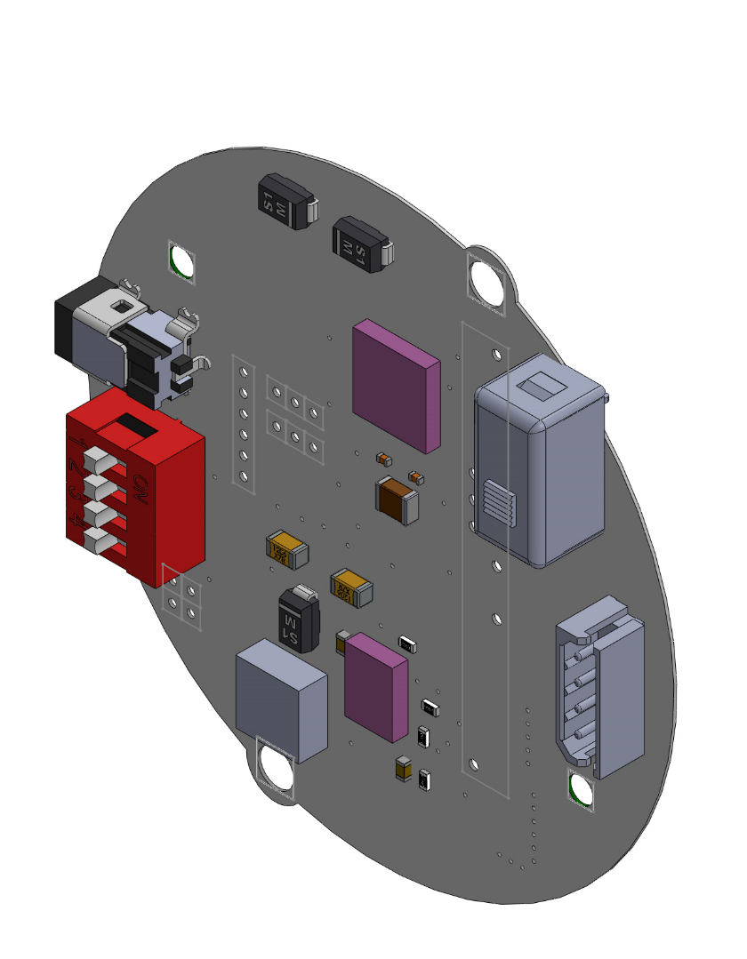

The PADS layout file designed for the PCB is exported in CAM planes to generate GERBER files for PCB Fabrication. The same Layout File can be exported in .iso format supported in CircuitWorks, which is an extension available in SolidWorks 2017. CircuitWorks allows user to view the layout design into actual 3D phase and also features editable components library which can be updated by manually searching for the part files of each component online and adding it in the same. Once all components are added, the build command generates and assembly file with available components mounted on board as shown in figure above. The above process gives a very near perfect idea about the utility board before its fabrication and assembly.

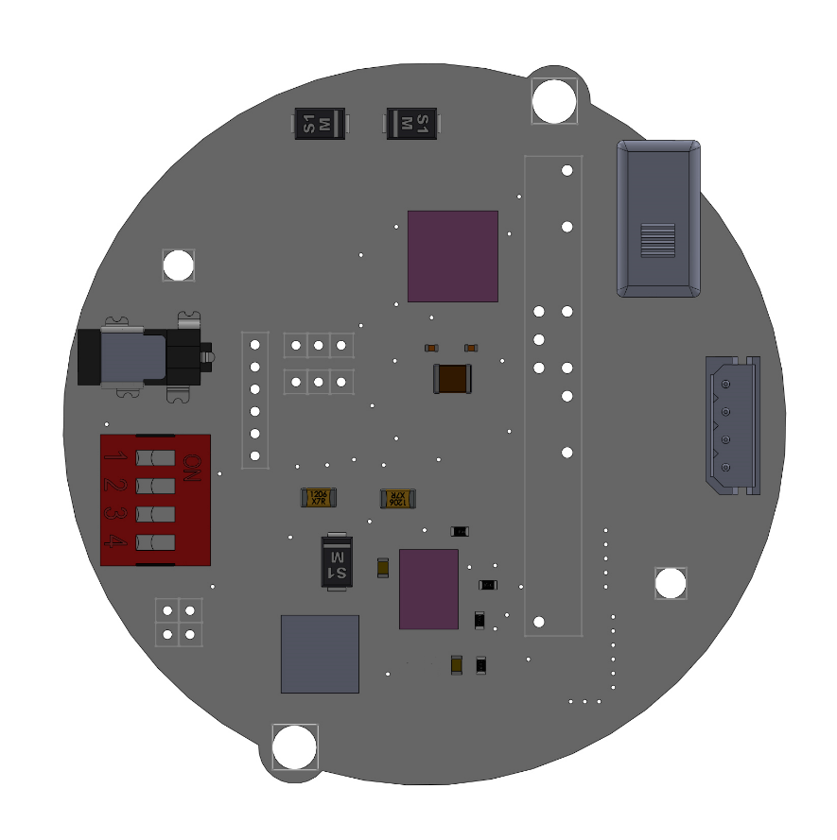

Almost all the components (SMD and Through Hole) are mounted on the top side to maintain isolation with motors at the bottom. The utility board is designed to sustain permissible current and voltage ratings provided by manufacturers, considering all safe, positive tolerance values. The components selection is based on ratings, package availability and power Endurance.

The placement of each device is done to ensure compatibility with bot mechanics, keeping accessible terminals exposed. Thermal areas and isolations are provided wherever required for heat dissipation.

# REFERENCES

Kindly refer to PCBfiles/Datasheets, BOM, Schematics and Layout Docs and CAD drawings from the “PCB Fabrication and Development” Zip folder for design logic, component values/quantity, package types, Drill Holes, Board Outline, Components datasheet for PCB Layout Guidelines, Fabricator details, and other relevant information.

.