Database System Engineering and Distributed Backend Development
Course Code: 25CS1302E
DDL,DML,DCL,TCL Commands
Name: Kunamaneni Bhavana
Roll no: 2520030003

Query 1
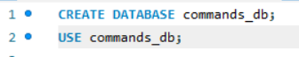
Output

Query 2
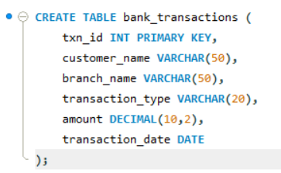
Output

Query 3
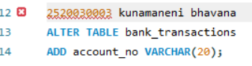
Output
Query 4
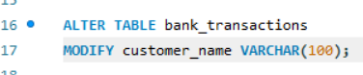
Output

Query 5
Output

Query 6
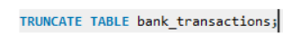
Output

Query 7
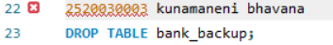

Output

Query 8
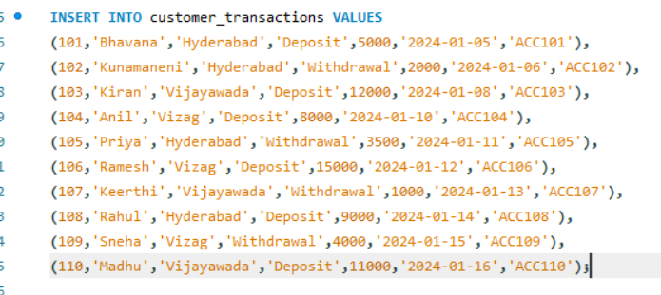
Output

Query 9
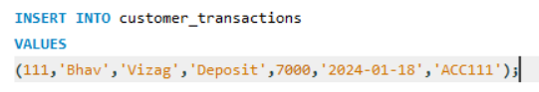
Output

Query 10
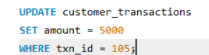
Output
Query 11
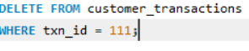
Output

Query 12
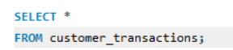
Output
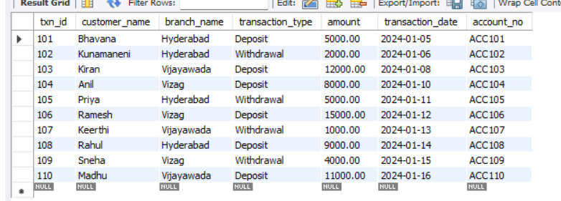
Query 13
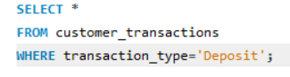
Output
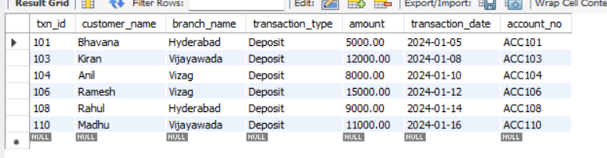

Query 14
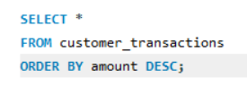
Output
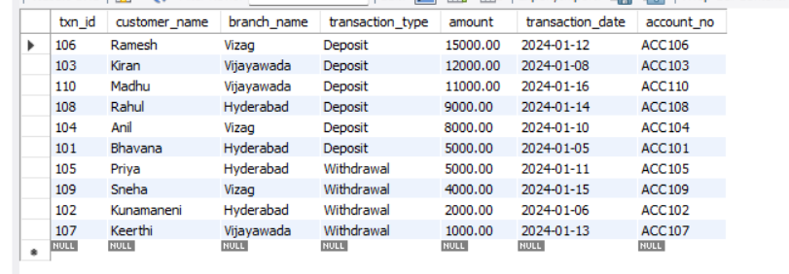

Query 15
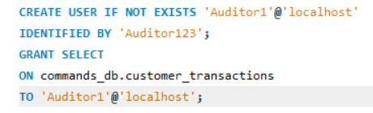

Output

Query 16
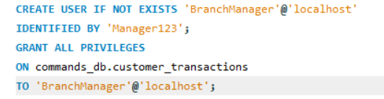
Output

Query 17
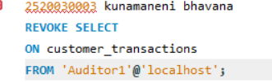
Output
Query 18
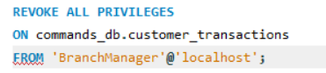
Output

Query 19
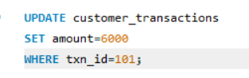
Output
Query 20
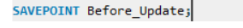
Output

Query 21
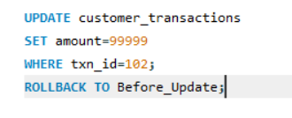
Query 22
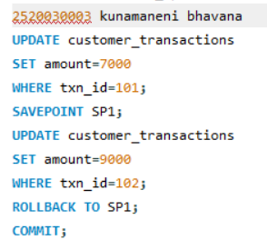
Output
