Database System Engineering and Distributed Backend Development
Course Code: 25CS1302E
WEEK-1
Name: Kunamaneni Bhavana
Roll no: 2520030003

Query 1
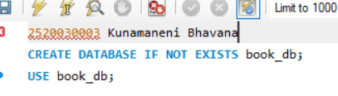
Output

Query 2
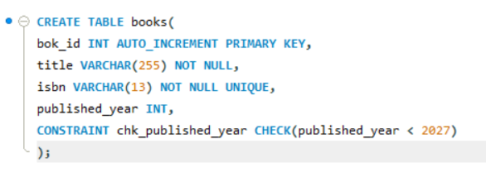
Output

Query 3
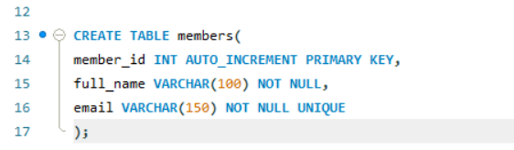
Output

Query 4
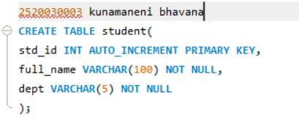
Output

Query 5
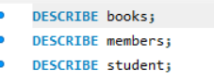
Output

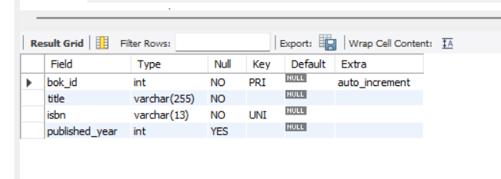
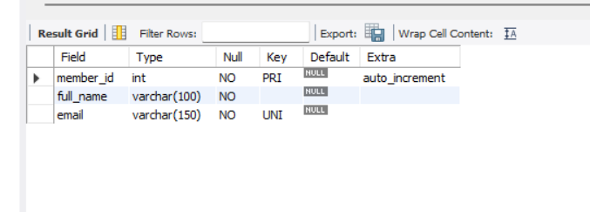
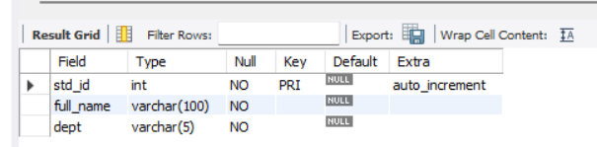

Query 6
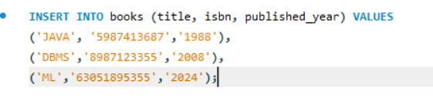
Output

Query 7
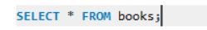
Output
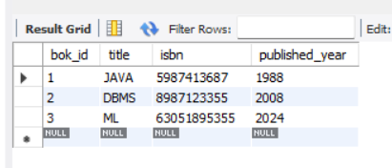
Query 8
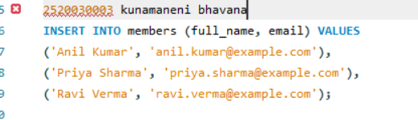
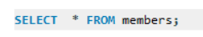
Output
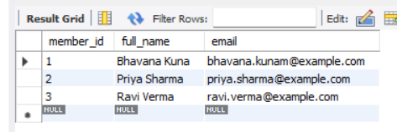

Query 9
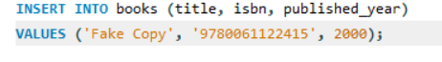
Output

Query 10
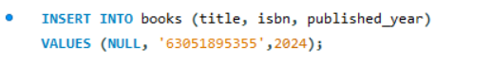
Output

