Database System Engineering and Distributed Backend Development
Course Code: 25CS1302E
WEEK-3
Name: Kunamaneni Bhavana
Roll no: 2520030003

INSERT SAMPLE DOCUMENTS

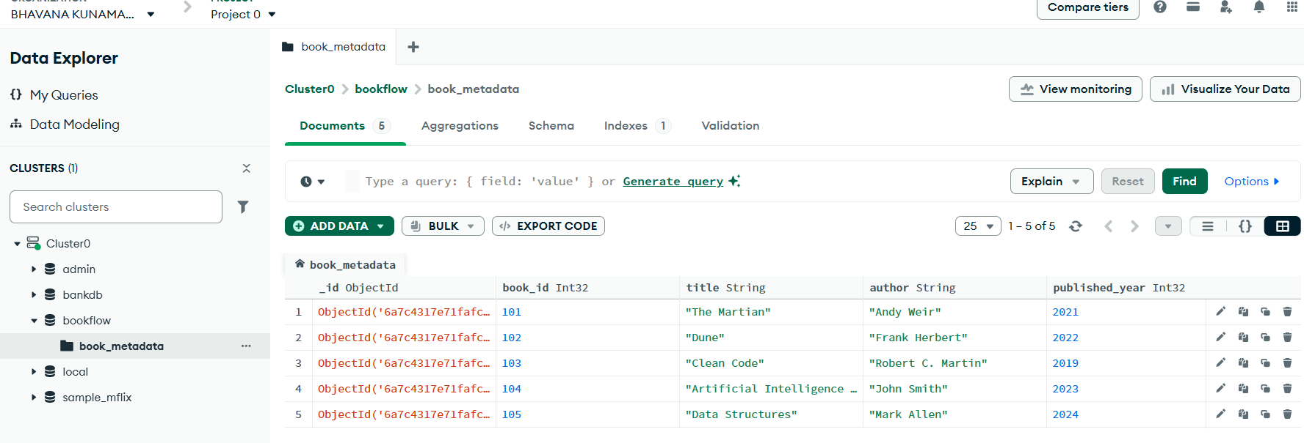

COMPARISON OPERATOR $gt
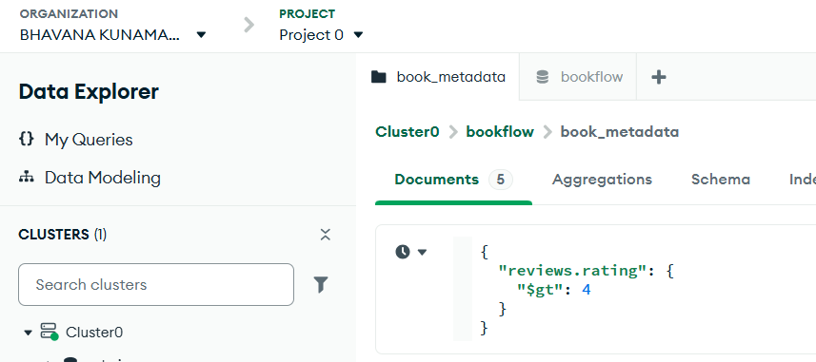
Output
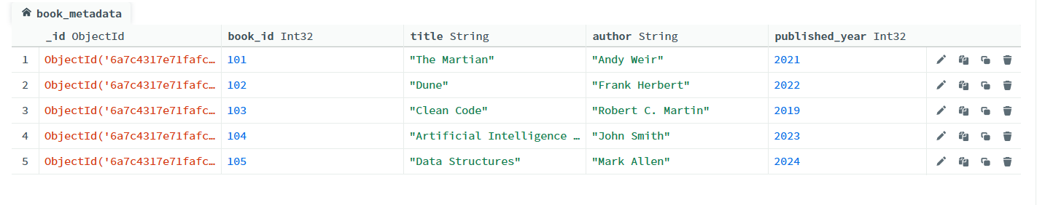

USING $IN
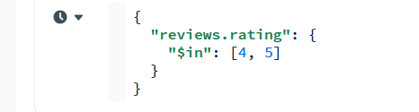
Output
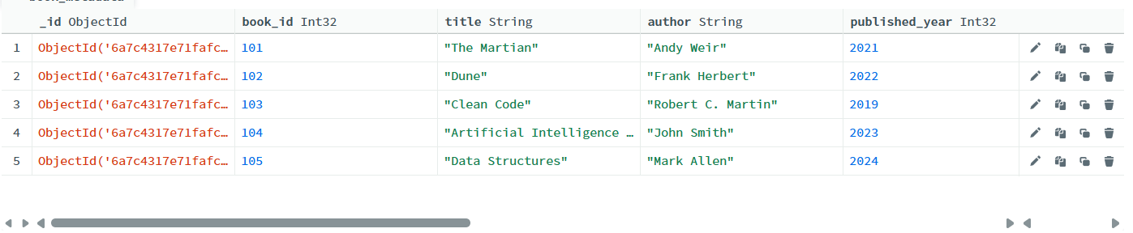

REGEX QUERY
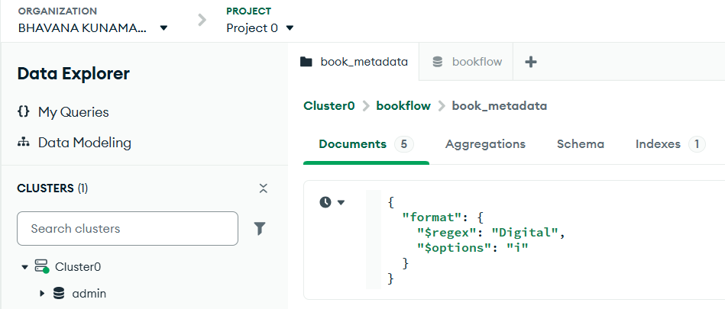
Output
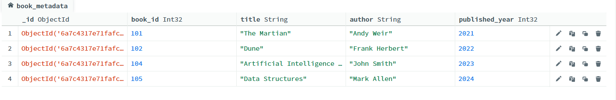

$MATCH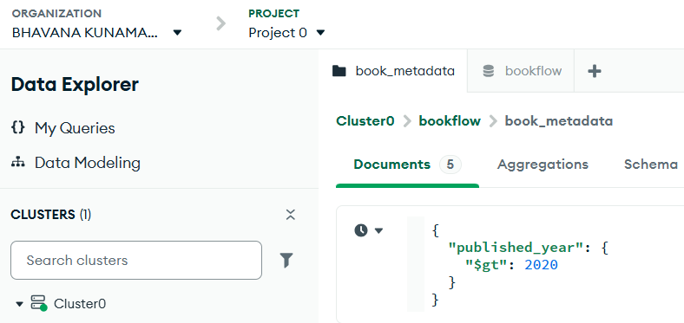

Output
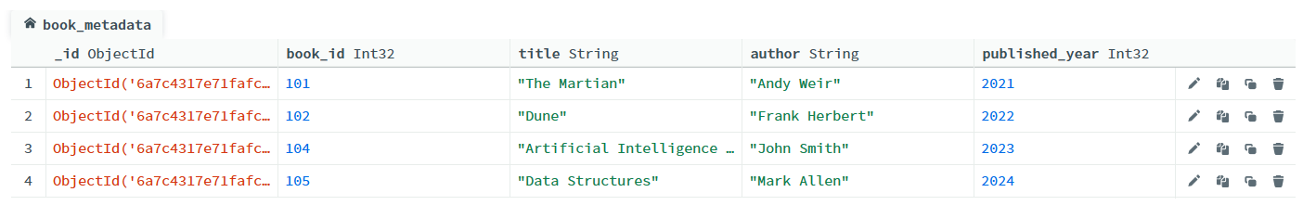

$UNWIND
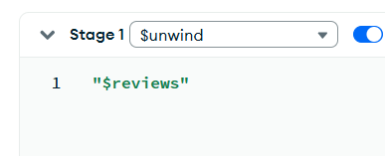

Output
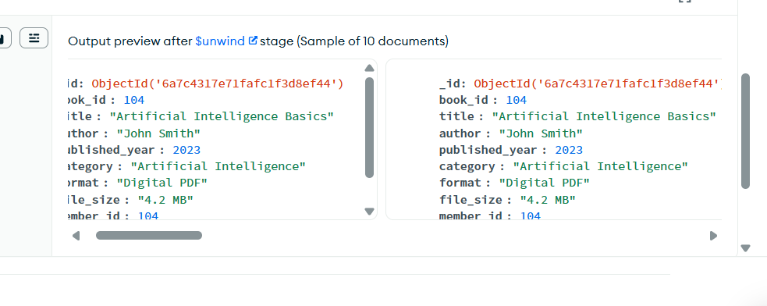

$GROUP
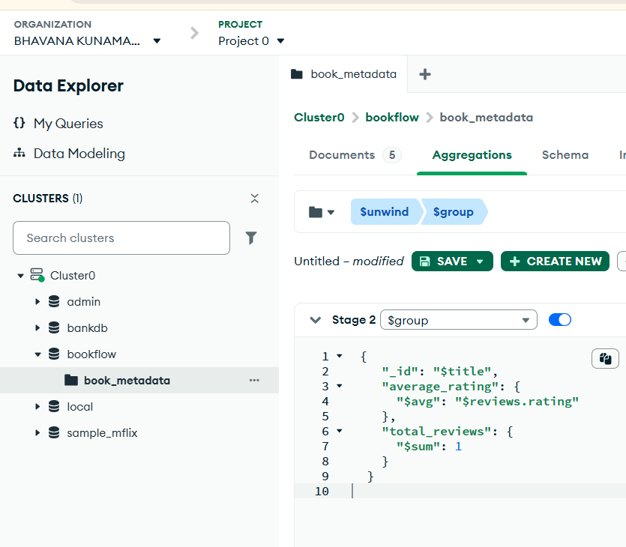
Output
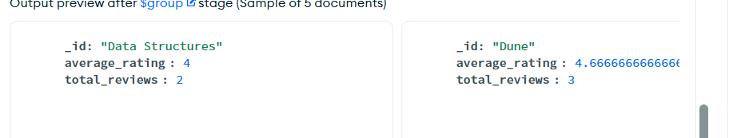

$SORT

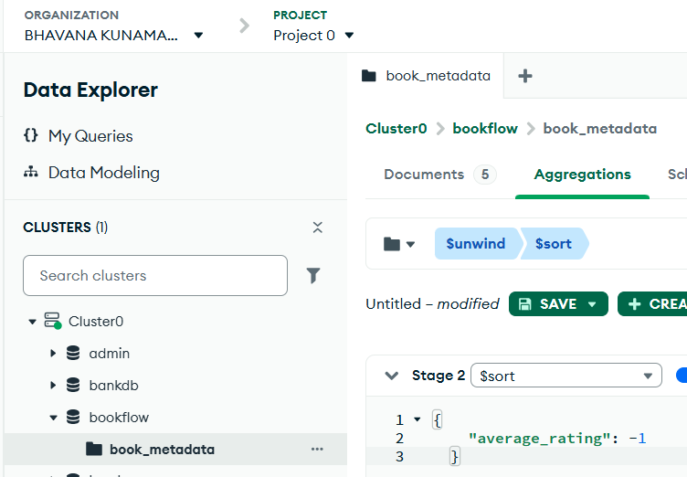
Output
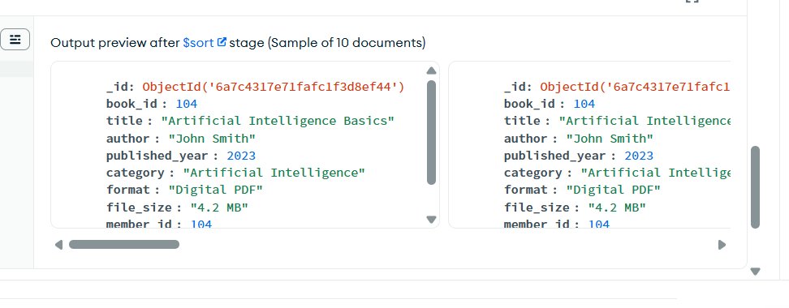

Create index text
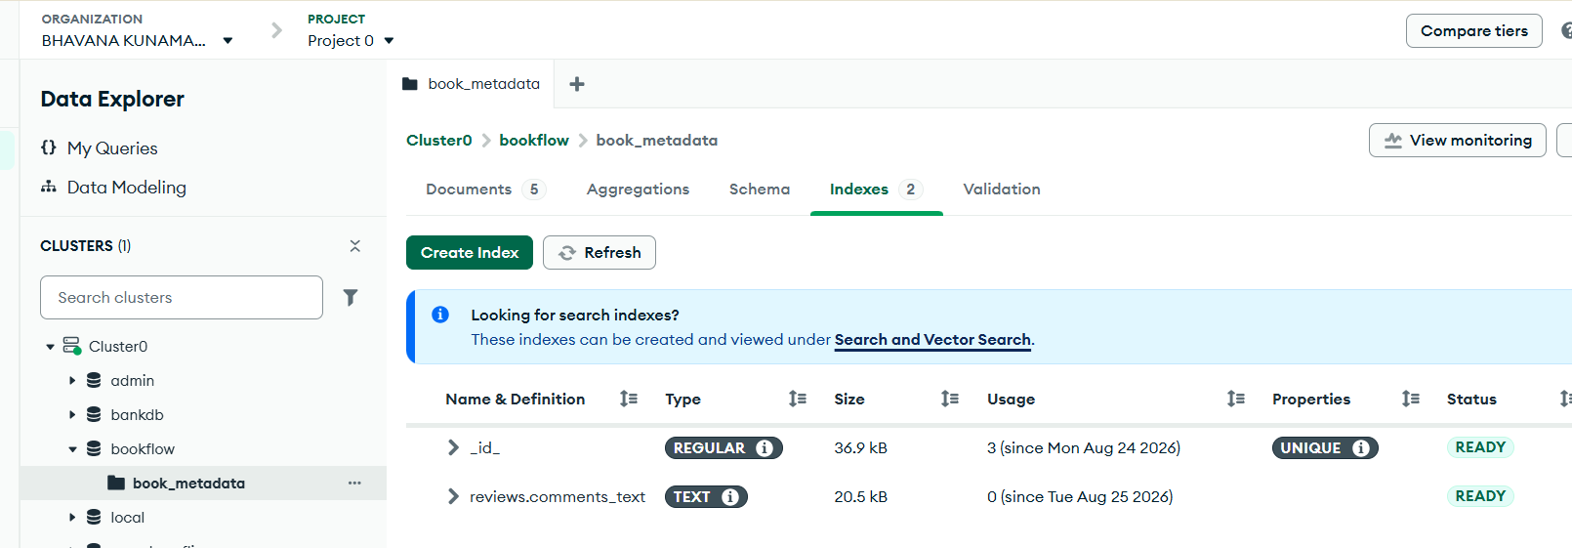

SEARCH USING TEXT INDEX
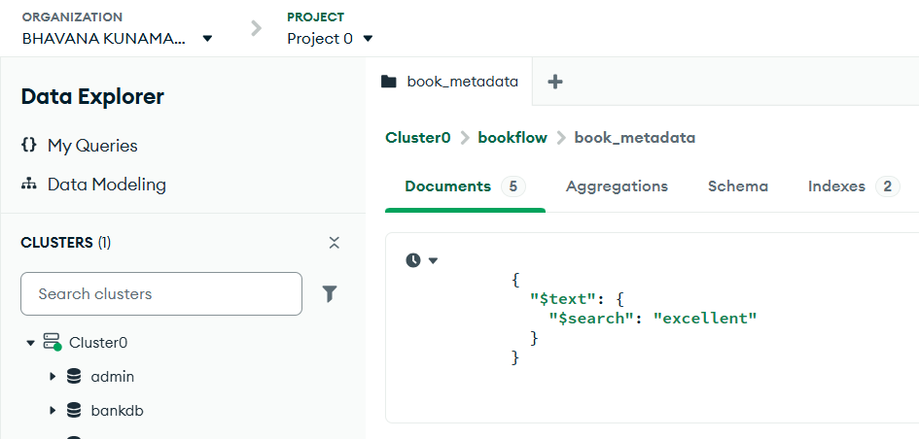
Output
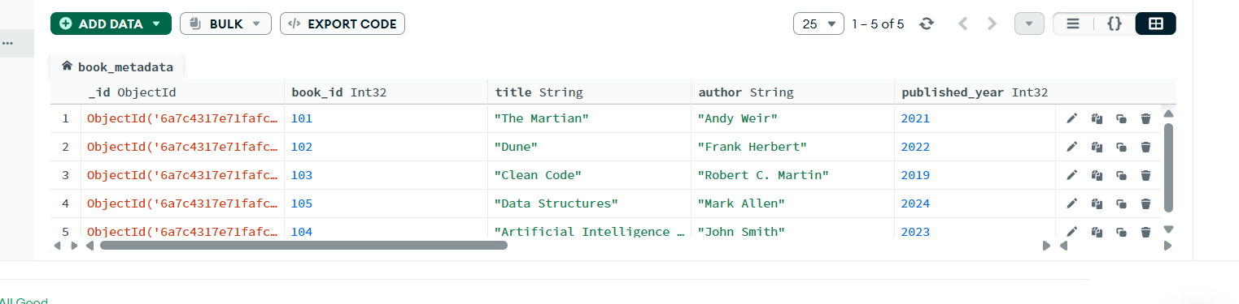

SEARCH FOR A SPECIFIC KEYWORD
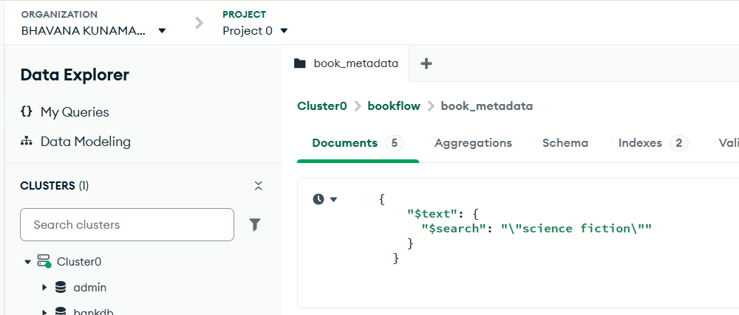
Output
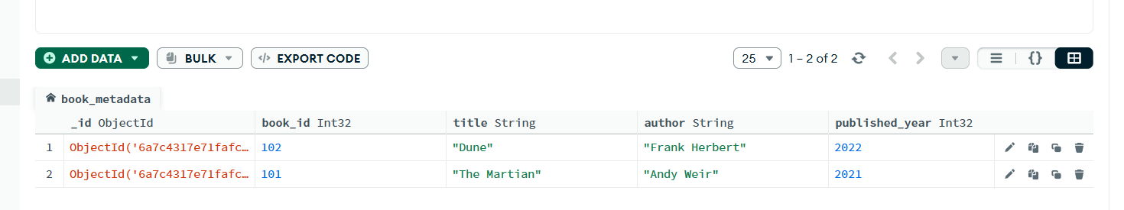

USE explain()
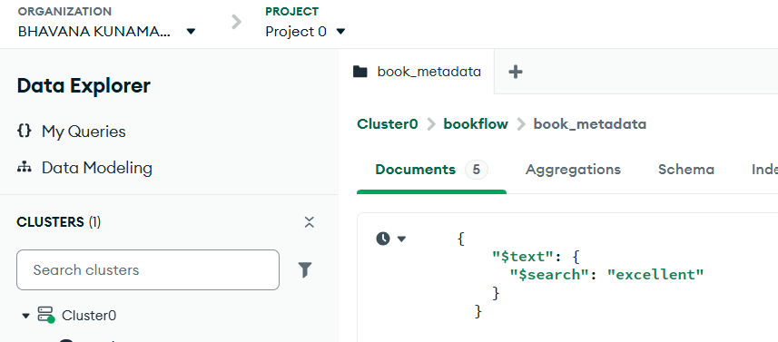

Output
