Database System Engineering and Distributed Backend Development
Course Code: 25CS1302E
WEEK-2
Name: Kunamaneni Bhavana
Roll no: 2520030003

Query 1:
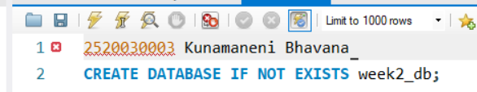
Output:
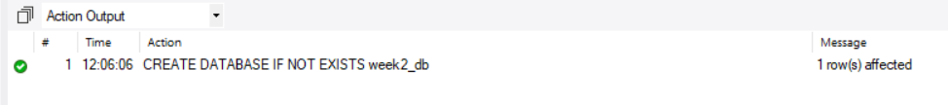

Query 2:
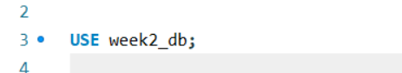
Output:

Query 3:
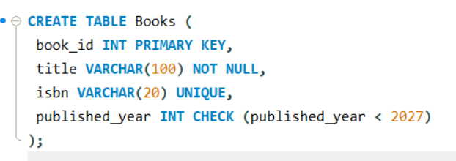
Output:

Query 4:
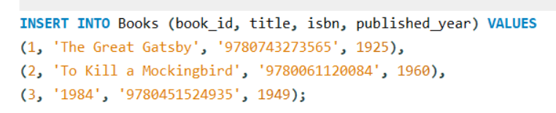
Output:

Query 5:
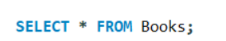
Output:
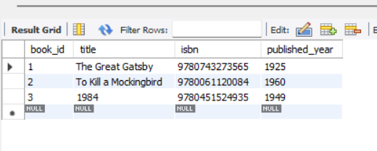

Query 6:
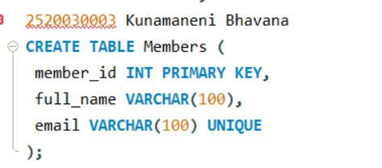
Output:

Query 7
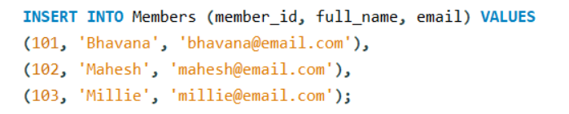
Output:

Query 8:

Output:
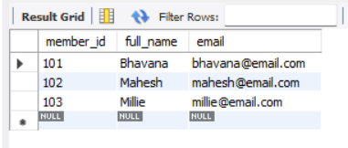

Query 9
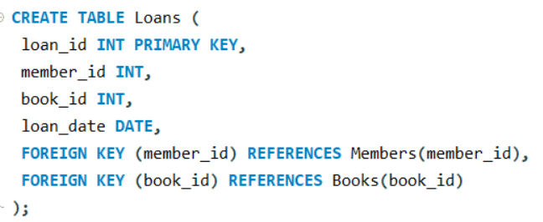
Output:

Query 10
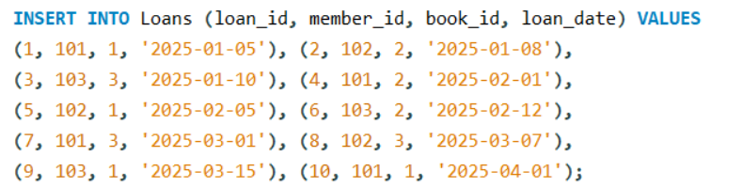
Output:

Query 11
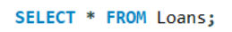
Output:
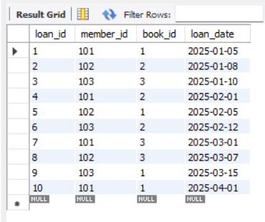
Query 12
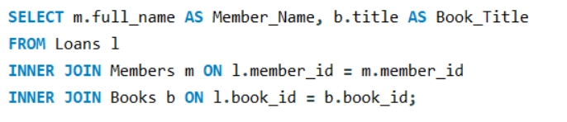
Output:
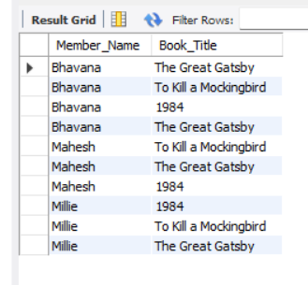

Query 13
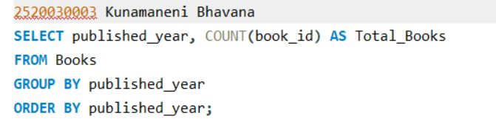
Output:
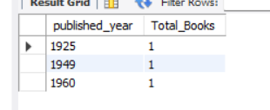
Query 14
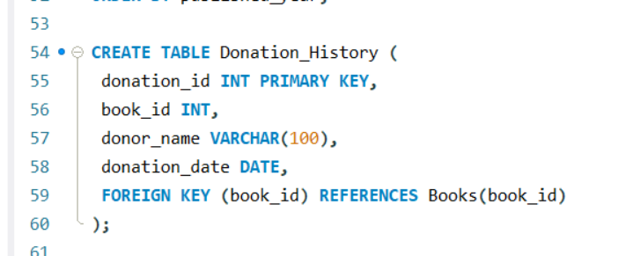
Output:

Query 15
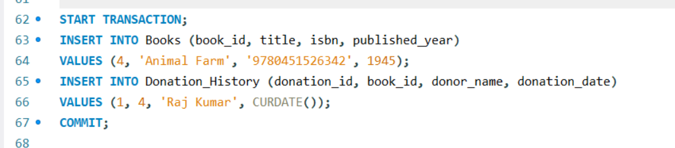
Output:
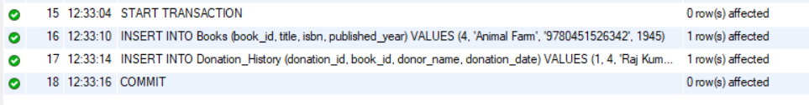

Query 16
Output:

Query 17
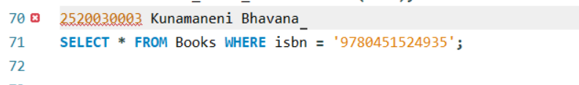
Output:
