1.

#include <bits/stdc++.h>

using namespace std;

struct Edge{

    int from, to, length;

};

struct Graph{

    int V, E;  // V-> Number of vertices, E-> Number of edges

    struct Edge *edge;

};

struct Graph *createGraph(int V, int E){

    struct Graph *graph = new Graph;

    graph->V = V;

    graph->E = E;

    graph->edge = new Edge[E];

    return graph;

}

void printArr(int dist[], int n){

    cout << "Vertex distance from start: " << endl;

    for (int i = 0; i < n; i++){

        cout << "No: " << i << "\t" << dist[i] << endl;

    }

}

void BellmanFord(struct Graph *graph, int start){

    int V = graph->V;

    int E = graph->E;

    int dist[V];

    for (int i = 0; i < V; i++){

        dist[i] = INT_MAX;

    }

    dist[start] = 0;

    // shortest path from start to any other vertex can have

    // at-most |V| - 1 edges

    for (int i = 1; i <= V - 1; i++){

        for (int j = 0; j < E; j++){

            int u = graph->edge[j].from;

            int v = graph->edge[j].to;

            int w = graph->edge[j].length;

            if (dist[u] != INT_MAX && dist[u] + w < dist[v])

                dist[v] = dist[u] + w;

        }

    }

    // check for negative-weight cycles. The above

    for (int i = 0; i < E; i++){

        int u = graph->edge[i].from;

        int v = graph->edge[i].to;

        int weight = graph->edge[i].length;

        if (dist[u] != INT_MAX && dist[u] + weight < dist[v]){

            cout << "Graph contains negative length cycle";

            return;       // If negative cycle is detected, simply return

        }

    }

    printArr(dist, V);

    return;

}

int main(){

    int V = 5;

    int E = 6;

    struct Graph *graph = createGraph(V, E);

    graph->edge[0].from = 0;

    graph->edge[0].to = 1;

    graph->edge[0].length = 4;

    graph->edge[1].from = 1;

    graph->edge[1].to = 2;

    graph->edge[1].length = 3;

    graph->edge[2].from = 1;

    graph->edge[2].to = 3;

    graph->edge[2].length = 2;

    graph->edge[3].from = 1;

    graph->edge[3].to = 4;

    graph->edge[3].length = 5;

    graph->edge[4].from = 3;

    graph->edge[4].to = 4;

    graph->edge[4].length = 1;

    graph->edge[5].from = 4;

    graph->edge[5].to = 2;

    graph->edge[5].length = 1;

    BellmanFord(graph, 0);

    return 0;

}

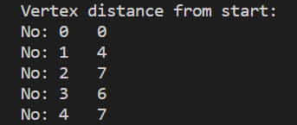

2.

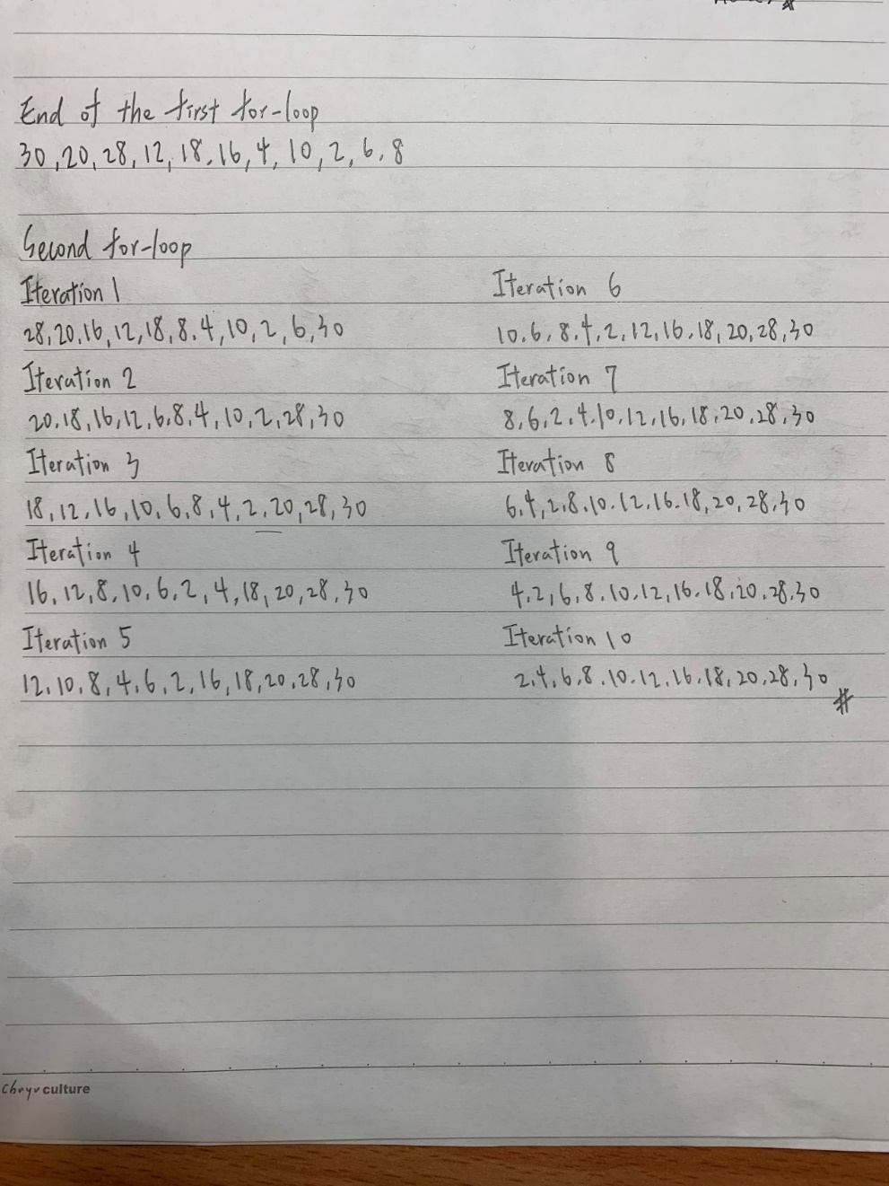

3.

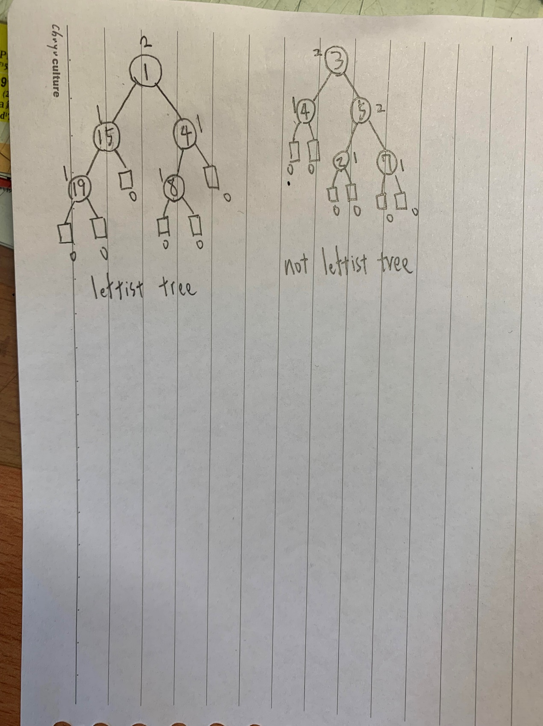

4.



5.

#include <bits/stdc++.h>

using namespace std;

struct node {

    int key;

    int element;

    struct node *left, *right;

};

struct node* newNode(int item){

    struct node* temp = new node;

    temp->key = item;

    temp->left = temp->right = NULL;

    return temp;

}

void inorder(struct node* root){

    if (root != NULL) {

        inorder(root->left);

        cout << root->key << " ";

        inorder(root->right);

    }

}

struct node* insert(struct node* node, int key,int element){

    /* If the tree is empty, return a new node */

    if (node == NULL)

        return newNode(key);

    /* Otherwise, recur down the tree */

    if (key < node->key)

        node->left = insert(node->left, key, element);

    else

        node->right = insert(node->right, key, element);

    /* return the (unchanged) node pointer */

    return node;

}

struct node* minValueNode(struct node* node){

    struct node* current = node;

    while (current && current->left != NULL)

        current = current->left;

    return current;

}

struct node* deleteNode(struct node* root, int key){

    if (root == NULL)

        return root;

    if (key < root->key)

        root->left = deleteNode(root->left, key);

    else if (key > root->key)

        root->right = deleteNode(root->right, key);

    else {

        if (root->left==NULL and root->right==NULL)

            return NULL;

        else if (root->left == NULL) {

            struct node* temp = root->right;

            free(root);

            return temp;

        }

        else if (root->right == NULL) {

            struct node* temp = root->left;

            free(root);

            return temp;

        }

        // node with two children: Get the inorder successor

        // (smallest in the right subtree)

        struct node* temp = minValueNode(root->right);

        // Copy the inorder successor's content to this node

        root->key = temp->key;

        // Delete the inorder successor

        root->right = deleteNode(root->right, temp->key);

    }

    return root;

}

int main(){

    /*   tree to create

            8

         /     \

        3      10

       / \     / \

      1   6   9   14 */

    struct node* root = NULL;

    root = insert(root, 8, 2);

    root = insert(root, 3, 3);

    root = insert(root, 1, 1);

    root = insert(root, 6, 4);

    root = insert(root, 10, 5);

    root = insert(root, 9, 4);

    root = insert(root, 14, 3);

    cout << "Inorder traversal of the given tree \n";

    inorder(root);

    cout << "\nDelete 1\n";

    root = deleteNode(root, 1);

    cout << "Inorder traversal of the modified tree \n";

    inorder(root);

    cout << "\nDelete 3\n";

    root = deleteNode(root, 3);

    cout << "Inorder traversal of the modified tree \n";

    inorder(root);

    cout << "\nDelete 8\n";

    root = deleteNode(root, 8);

    cout << "Inorder traversal of the modified tree \n";

    inorder(root);

}

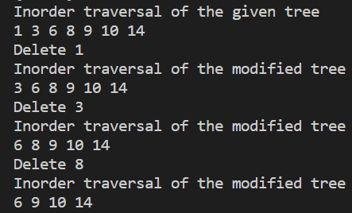

time complexity is O(h), where h is for the height.

6.

#include <iostream>

using namespace std;

struct Node {

    int data;

    int length;

    struct Node *left, *right;

};

Node* newNode(int data,int length){

    Node* temp = new Node;

    temp->data = data;

    temp->length = length;

    temp->left = temp->right = NULL;

    return temp;

}

void dfs(struct Node* node){

    if(node){

        if(node->left) node->left->length += node->length;

        if(node->right) node->right->length += node->length;

        cout << node->data << "\t\t" << node->length << endl;

        dfs(node->left);

        dfs(node->right);

    }

}

int main(){

    struct Node* v = newNode(0,0);

    v->left = newNode(1,5);

    v->right = newNode(2,9);

    v->left->left = newNode(3,3);

    v->left->right = newNode(4,2);

    cout << "vertex: " << " " << "shortest path from the root:" << endl;

    dfs(v);

    return 0;

}

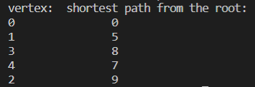

7.

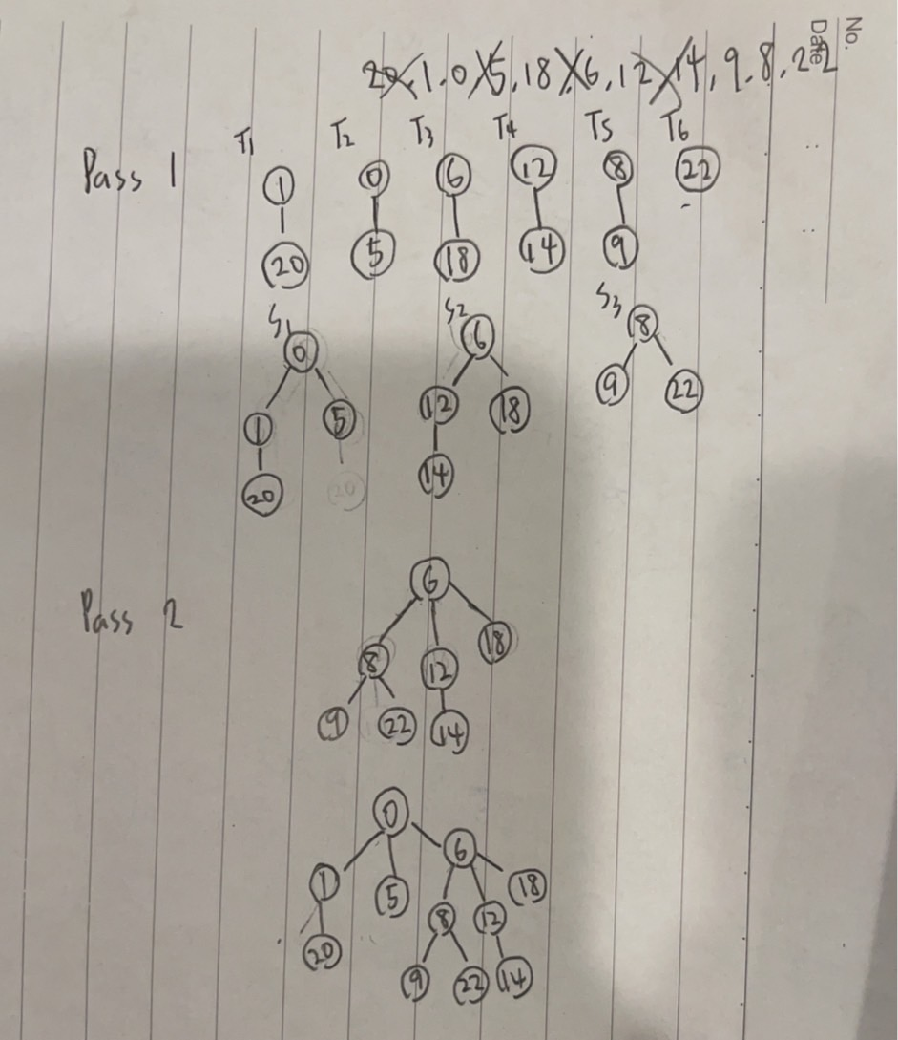

8.

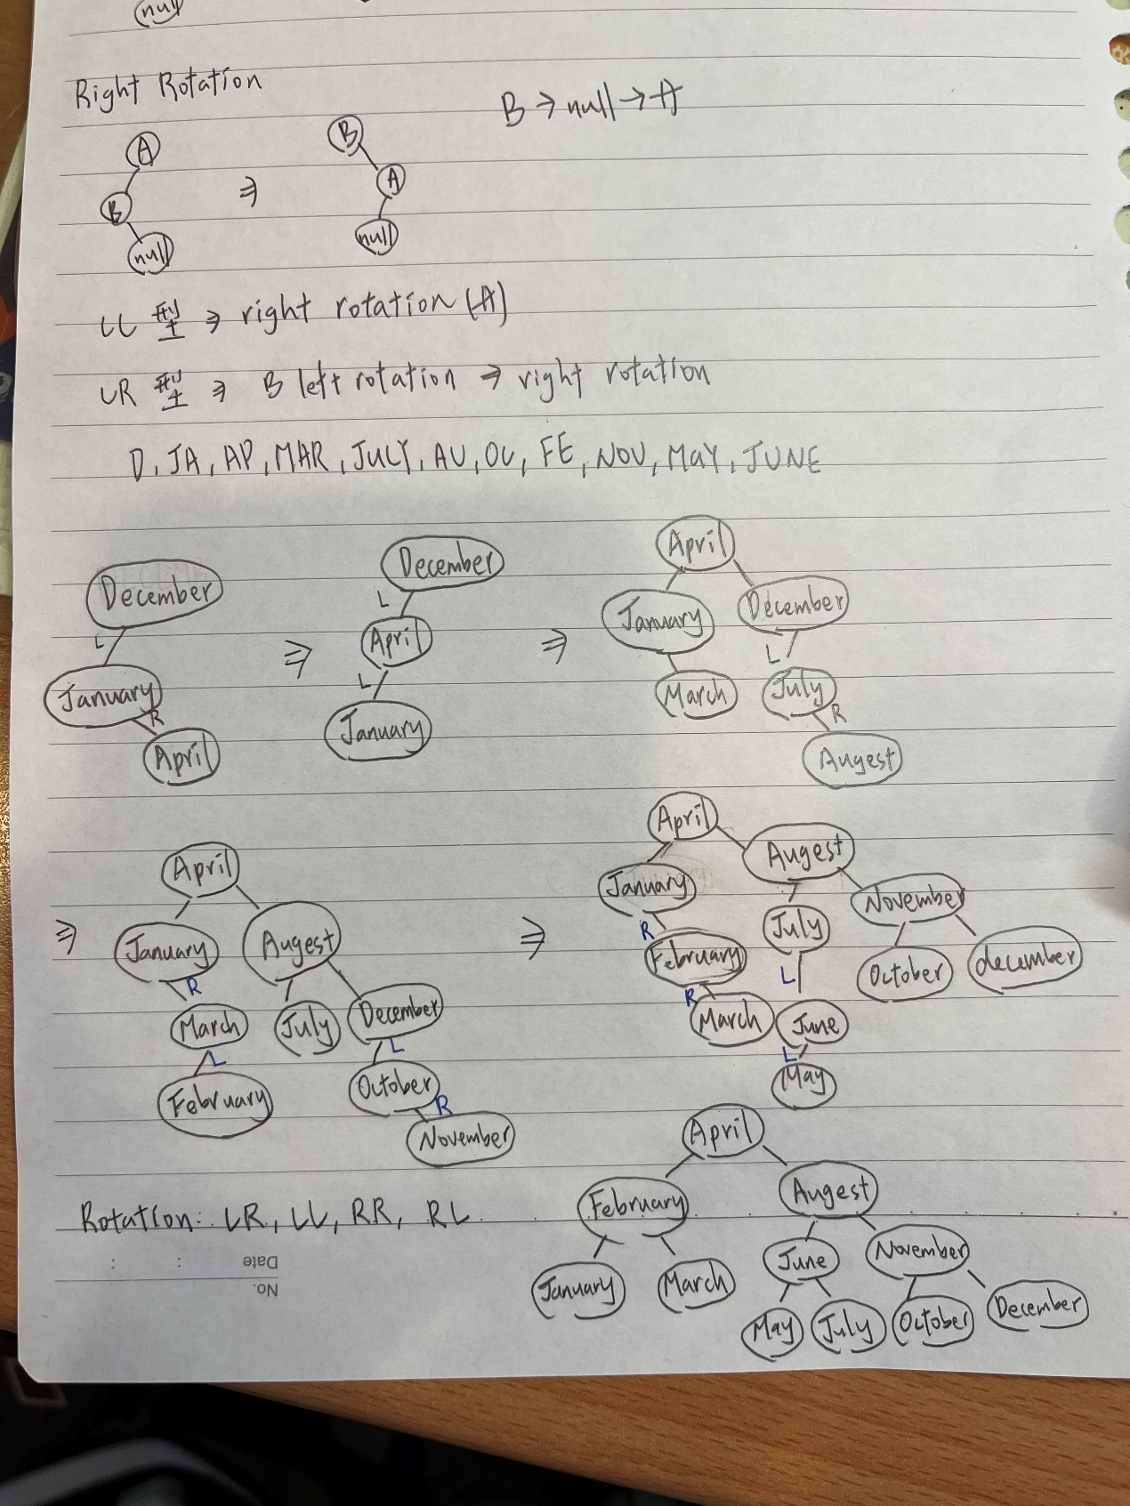

9.

#include<bits/stdc++.h>

using namespace std;

class Node{

    public:

    int key;

    Node *left;

    Node *right;

    int height;

};

// A utility function to get maximum

// of two integers

int max(int a, int b);

// A utility function to get the

// height of the tree

int height(Node *N){

    if (N == NULL)

        return 0;

    return N->height;

}

// A utility function to get maximum

// of two integers

int max(int a, int b){

    return (a > b)? a : b;

}

Node* newNode(int key){

    Node* node = new Node();

    node->key = key;

    node->left = NULL;

    node->right = NULL;

    node->height = 1;

    return(node);

}

// A utility function to right

// rotate subtree rooted with y

// See the diagram given above.

Node *rightRotate(Node *y){

    Node *x = y->left;

    Node *T2 = x->right;

    // Perform rotation

    x->right = y;

    y->left = T2;

    // Update heights

    y->height = max(height(y->left),

                    height(y->right)) + 1;

    x->height = max(height(x->left),

                    height(x->right)) + 1;

    // Return new root

    return x;

}

Node *leftRotate(Node *x){

    Node *y = x->right;

    Node *T2 = y->left;

    // Perform rotation

    y->left = x;

    x->right = T2;

    // Update heights

    x->height = max(height(x->left),

                    height(x->right)) + 1;

    y->height = max(height(y->left),

                    height(y->right)) + 1;

    // Return new root

    return y;

}

// Get Balance factor of node N

int getBalance(Node *N){

    if (N == NULL)

        return 0;

    return height(N->left) - height(N->right);

}

// Recursive function to insert a key

// in the subtree rooted with node and

// returns the new root of the subtree.

Node* insert(Node* node, int key){

    /* 1. Perform the normal BST insertion */

    if (node == NULL)

        return(newNode(key));

    if (key < node->key)

        node->left = insert(node->left, key);

    else if (key > node->key)

        node->right = insert(node->right, key);

    else // Equal keys are not allowed in BST

        return node;

    /* 2. Update height of this ancestor node */

    node->height = 1 + max(height(node->left),

                        height(node->right));

    /* 3. Get the balance factor of this ancestor

        node to check whether this node became

        unbalanced */

    int balance = getBalance(node);

    // If this node becomes unbalanced, then

    // there are 4 cases

    // Left Left Case

    if (balance > 1 && key < node->left->key)

        return rightRotate(node);

    // Right Right Case

    if (balance < -1 && key > node->right->key)

        return leftRotate(node);

    // Left Right Case

    if (balance > 1 && key > node->left->key){

        node->left = leftRotate(node->left);

        return rightRotate(node);

    }

    // Right Left Case

    if (balance < -1 && key < node->right->key){

        node->right = rightRotate(node->right);

        return leftRotate(node);

    }

    /* return the (unchanged) node pointer */

    return node;

}

void InOrder(Node *root){

    if(root != NULL){

        InOrder(root->left);

        cout << root->key << " ";

        InOrder(root->right);

    }

}

int main(){

    Node *root = NULL;

    root = insert(root, 12);

    root = insert(root, 1);

    root = insert(root, 4);

    root = insert(root, 3);

    root = insert(root, 7);

    root = insert(root, 8);

    root = insert(root, 10);

    root = insert(root, 2);

    root = insert(root, 11);

    root = insert(root, 5);

    root = insert(root, 6);

    cout << "Inorder traversal of the constructed AVL tree is: \n";

    InOrder(root);

}

10.

