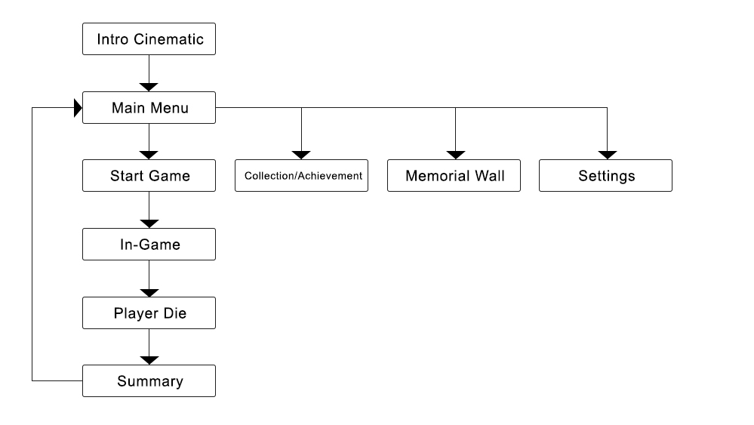

**Intro Cinematic:**

Opening screen with game logo, plus loading section.

**Main Menu:**

Main Menu to many other pages: Start game, collection/achievement, memorial wall and settings. It has a big map show the progress of adventures.

**Start Game**

Way to get in the game, after click, it will request player three random mission to complete.

With Card shuffle animation to enter the game.

**Collection / Achievement**

Documenting every adventure records of player, with index of titles, achievement, NPC, High Score, Events discovered, and Items discovered.

**Memorial Wall**

Achieve players’ adventure, how they have die, where they have been, how many days they have travel. In a map concept.

**Settings**

Adjust music, voice and language option (English and Chinese), as well as link to Wechat and Facebook.

**In-game**

The gameplay interface: cards, name, HP, MP, days, Golds, equipment and other stuffs.

**Play die**

It triggered when player’s HP becomes 0, and the way of dying is reflected by the story scenario.

**Summary**

Quick sum up of your adventure this time: days, place and events, then back to Main Menu.