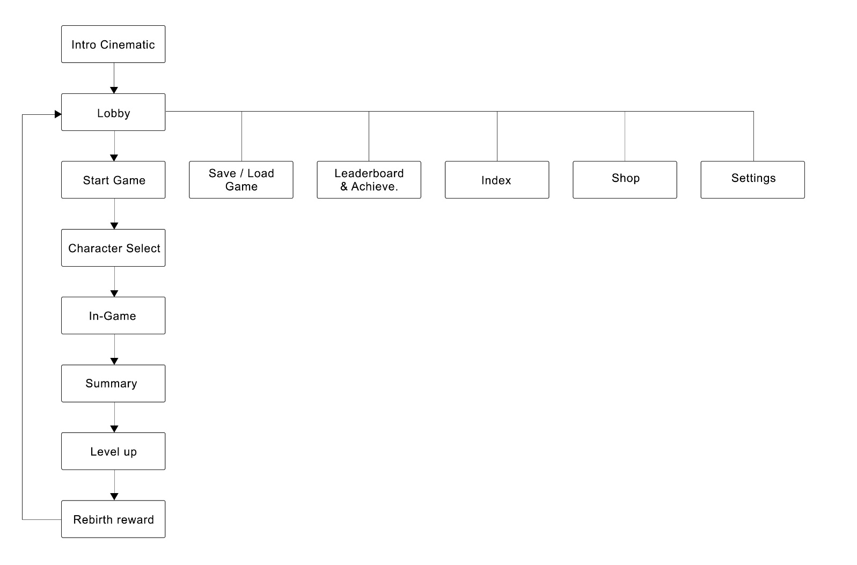

**Intro Cinematic:**

Opening screen with game logo, plus loading section.

**Lobby:**

Main Menu to many other pages: Start game, Leaderboard &Achievement, memorial wall and settings.

**Save / Load game**

Playing data can be save or load in this pop-up menu.

**Start Game**

Channel to get into the gameplay interface, after click, it will direct you to character select page.

**Character Select**

In this page, players can select the type of playable characters they want to play in the game.

**Leaderboard & Achievements**

A place to document the worldwide leaderboard by type of playable characters and personal high scores, achievements that player has done during their total playing hours, such as acquired titles and completed special targets.

**Index**

An index documenting unlock/lock stuffs such as map, town, dungeon, monsters, NPC, items and equipment.

**Settings**

Adjust music, voice and language option (Chinese, English, Spanish and Japanese),

**In-game**

At the beginning, the system gives three random missions for player, and the cards will shuffle as the system has been reset and ready for play. And the whole gameplay interface is demostrated by Card, Text, characters status, and Item sockets.

**Shop**

A place, player can do in-game purchase

**Summary**

It triggered when player’s HP becomes 0, and a summary about player’s adventure will be calculated into score (days you lived, titles you have, equipment, items)

**Level up**

The score will be transfer into Experience Points, and automatically give to the selected character for leveling up for better initial status and skills.

**Rebirth reward**

Once character level up, player will get rebirth points. And this rebirth points allow players to exchange Fortune treasure chest at Shop page.