**Event name: Underground Temple:**

**Event No.: 007**

**Total pieces: 34**

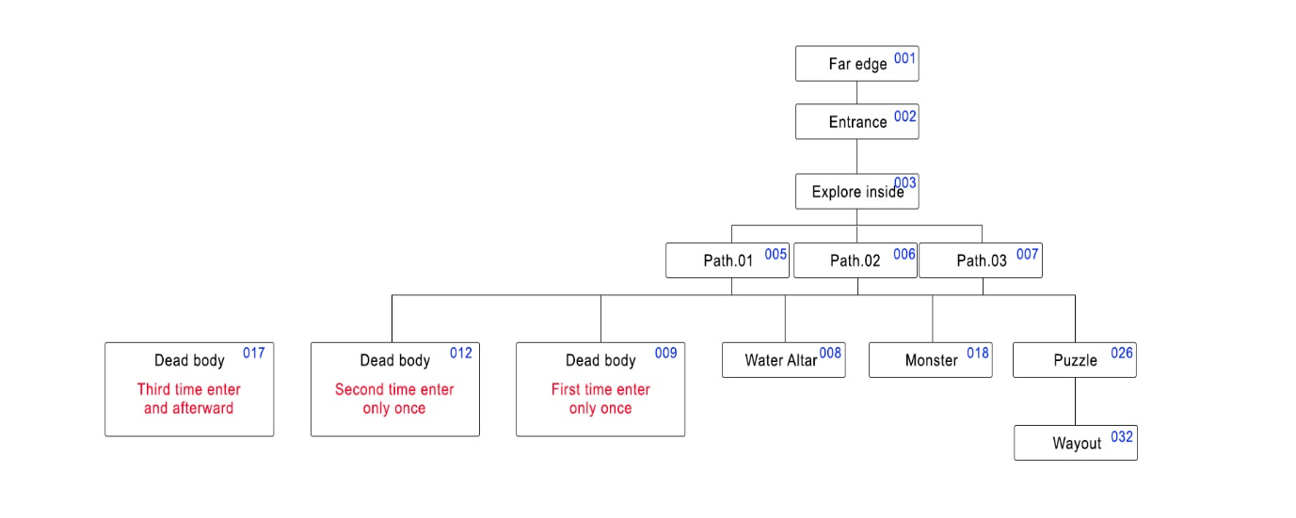

#001 After reaching the far edge of the forest, there is rocky cave entrance (Swipe) (#002)

#002 You find a hidden dungeon, and it does look a bit fishy (Explore or Leave) (#003, #004)

#003 A long and narrow slide leads you deeper to the darkness (Swipe) (#005, #006, #007)

#004 END of QUEST

#005 There are two paths ahead in front of you (Left or Right) (#008, #009, #012, #017, #018, #26)

#006 You move forward to the inside of the cave. (Swipe) (#008, #009, #012, #017, #018, #26)

#007 The cave splits in two again, which one is gonna be? (Up or Down) (#008, #009, #012, #017, #018, #26)

#008 You drink the water inside the altar and feel totally refreshed! (Swipe) ((#008, #009, #012)

**#009** A dead body lies on the floor, holding a paper note. (Examine the note or Pray to the dead) (#010 or #011)

#010 Description: Red mix blue is purple. Yellow mix Red is Orange But what is yellow mix blue?

(Swipe) (#005, #006, #007)

#011 You decided to make an homage to the body (Swipe) (#005, #006, #007)

**#012** Back into the dead man’s room, you see one wall looks weak. Might be something behind?

(Body dash to the wall or Blunt weapon hits the wall) (#013, #014)

#013 You don’t have a blunt weapon. You used your body to break the wall, it’s very painful. (Swipe)

#014 You use blunt weapon breaking the weak wall effortlessly. (Swipe) (#015)

#015 The wall falls down; you see a small chamber with a chest inside (Swipe) (#016)

#016 A box of shiny gold coins. (Swipe) (#005, #006, #007)

#017 You back to the dead man’s room again, nothing really special. (Swipe) (#005, #006, #007)

#018 A Fish tribe warrior appears! (Talk or Attack) (#019, #020)

#019 It doesn’t listen to you; seems you’ll be forced to fight! (Swipe) (#021)

#020 You VS Fish Tribe Warrior. Fight! (Swipe) (#021)

#021 Battle Result (Swipe) (#022 or #023)

#022 The enemy’s blow is lethal; you are dead (Swipe) GameOver

#023 The battle’s over. After checking the body, you pick (Spear or Armor) (#024, #025)

#024 You have obtained the Fish Warrior’s Spear (Swipe) (#005, #006, #007)

#025 You have obtained the Fish Warrior’s Armor (Swipe) (#005, #006, #007)

#026 You walk into a room that a stone statue holds two crystal balls. (Swipe) (#027)

#027 It seems like you can replace the balls on its hands with the color balls on the ground (Swipe) (#028)

#028 Puzzle Time: Move balls freely, then swipe left or right to confirm (Puzzle System) (Swipe) (#029, #030)

#029 A secret path appears behind the statue (Swipe) (#031)

#030 The floor collapses! You’ve fallen to the deep darkness (Swipe) GameOver

#031 You feel both wind and light are summoning you to the wayouts (Follow Wind or Follow Light) (#032, #033)

#032 The wind blows off from the crack of the rock, it is a wayout (Swipe) END of QUEST

#033 A monster’s lantern misguided you, you are too weak to fight such legendary creature. Run!

(Swipe) (#034)

#034 You kept running but it finally got you and consumed you. (Swipe) GameOver

#012 appear when #009 happened before

#017 appear when #012 happened before

**#009 #012 = color in green means one-time event only**

#026 appear only after 3 random events in dungeon happened.