Proposed Title **Tale Seeker** Platforms iOS, Android

Target Audience Fans of medieval fantasy novels

Male casual strategy gamers

Chinese gamers

**VISION STATEMENT**

Tale Seeker is a strategy visual novel game for a mobile platform. The player has accidentally crossed time and space to the fictitious ancient world, and the game is about how the player interacts the world with dialogue decision-makings while find a way to return back to the present day. The player will make a strategically decision on every encounter of things (by sliding the random story cards to the left or right). Decisions affect the whole story as well as the character’s life. Players must take the risk while looking for ways to return to the modern world and watch their Life fractions (Extreme Low/High cause deaths).

**THE X**

***Read based strategy game on mobile, alternative dialogue choice***

***flip your adventure in the fantasy Middle Ages.***

**CORE GAME PILLARS**

Easy catchup and play Rich-story Item to use

Dialogue choice Middle Age Stylized arts

Randomization Achievements Auto Save

**TARGET AUDIENCE / COUNTRY**

1. Fantasy medieval novels / film group:

As the world right now has great number of fantasy medieval fans already, thanks to the epic fantasy works like The Lord of the Rings and the game of thrones... and such, so, the idea is to attract this particular group of players by representing the similar fantasy moments that will make them thrill for the game.

2. Male casual gamer:

Mostly, middle age fantasy setting is much more appealing to male audiences. Furthermore, the control is easy to understand (just touch-choose from two dialogue options) for the most of gameplay. Game is design to play within 3-15mins for a round. So, it matches the needs for busy male working-class adults who can only use fragment time to play while commuting, waiting or any other relaxing moments.

3. Country: China

Largest population in the world, huge gaming community and culture, high monetary status and proportionally much cheaper ways to promote than western countries.

**CORE SELLING POINTS**

Short playtime:

The game is in a fast playing pace, players will able to finish one round of game around 3-15 mins depending on how long they could survive. Besides that, the game has the auto saving function, players can always turn on the game and back to where they were playing which is very good to play on any fragment waiting times or leisure time.

Random Birthplace & Random Encounters & Random Objectives

The story unfolded with random stuffs. That means the game has no fixed route of playing because every time you entering the world, it will appear as a new different adventure by the random birthplace, encounters and objectives.

Collections and achievements:

Playing histories will be saved thru the summary page documenting your adventures in history such as where you die, what you have got and what you have done.

In this way, player would able to compare each playing data and try to get the best score. Furthermore, for collection addictive people, they can gather collections for items, cards or even achievements of special events to fulfill the desire of finishing the whole game contents.

Deep Strategy:

The strategy comes from the choices that players need to make for the adventure, because every decision players make cause up and/or down of their life fractions and its determining your characters’ live or die.

**FEATURES**

Items to use

Player can acquire items during the trip of adventure. They have different function or purpose to use. Some can boost the life fraction, some can help you get thru difficult situations and some even can trigger special events. Players will excite and curious about the use of items, want to see what will happen if use. So, make the adventure more fun.

Map location & exploration

The map system is the navigation guide to tell where player is located while doing random route adventure. So, player would able to tell from the map which part of the story he/she haven’t touch or touch already. It helps construct the fantasy world in players mind and get more immersive to the adventure.

Karma System:

The good and evil judgement on your character, and the meter on the Karma system will alter the card pool you are going to randomize. For example, the more violent behaviors you choose to do, the eviler judgements on your character will get. And as the result, you will face more chaotic plights.

Romance & Followers

There will have some NPCs that player could try and persuade them to joining your adventure or even to start a romance with some sexy people. A successful persuade process must come with good vibe in talking, and sometime it requires using special item to make the persuade process fluent.

Help you fight vicious monsters,

Collect info on the village,

Give good advices on dialogue choice,

Keep life fraction stable,

Trigger the third dialogue choice,

**LIFE FRACTION RULES**

To keep rolling on the adventure. Players will have to make decision on the events of their adventure. Each decision will have consequence, changing the status between four pillars of the life fraction:

Strength: (or Health/Physique) this should be an add up of all physical characteristics of the character. It would be important for fighting, resisting illnesses, being chosen to become a knight, etc. Obviously, the player dies if it reaches zero.

Wealth: Amount of riches the player has at its disposition. The more you have, more power and influence you should be able to get, and it can allow the player to purchase way ore stuff (that should include lands btw).

Influence: Amount of political power and recognition the character has. It would be really interesting if that worked through areas, meaning at first if you only manage to become famous in a small village, the moment you leave it nobody knows you cause the news haven’t spread yet. The more amount you collect you can become some political character, or ask for meetings with important people, unlock special quests, and so on.

Religion (or Faith): This last one fraction would be your relation with the religious people in the world. It does not mean the more you have the bigger believer you become, but more as the equivalent version of influence but exclusively related to faith and church issues. This should allow us to create religious quests, give the player the chance to become a figure of the faith if they want to or even we could make it one of the ways of returning home, since you become kind of a saint or the like (which btw, would be awesome if we let players keep some of their initial decisions in an old game effect the future new games. I am assuming this would be mostly impossible to produce, but I think it has a lot of potential to keep people wanting to play after finishing the game once.

Overall, I think this 4 fractions cover all the needs for us to create a cool, interesting and still simple game system.

**CONTENT**

The following is a rough estimate game contents for a 4-person team with a 4-months development and research before approaching angel investors in China.

|  |  |  |
| --- | --- | --- |
| Card illustrations and random logics | UI and Other contents. | Plan for what is next? |
| Item Cards  Pistol,  Chocolate,  Pager,  Wrapping gun,  Time capsule,    Narratives/Events Cards    NPC Cards    Death Cards      Special by events:  A. Dragon and its golds  B. Magician and his crystal  C. Competition for marriage  D. The golden axe fable  E. alchemist | 1. UI Design  (Login, Gameplay, Lobby, Settings, Summary)    2. Gameplay mockups    3. Simple Unity coding to hyperlink the mockups      4. World Map      5. Website | 1. 8 months continuing dev      2. official studio    3. next project |

**BUSINESS MODEL AND MONETISATION**

PayToPlay. (Starting price at RMB 10.) Fair pricing for China market?

People are willing to spend money to "enjoy stories."

The PayToEnjoy examples can be seem on buying novels, movie tickets, games or subscribe TV channels.

Example 1: The Lord of the Rings (Google ebook) US$16.99

Example 2: The Witcher 3: Wild Hunt (Steam) US$39.99

Example 3: ‘The Hobbits’ Trilogy Grossed almost US$3 Bilion (Forbes.com)

Example 4: Game of Thrones (New York Times) Slightly more than $1 billion annually

Example 5: Reigns (Mobile game) US$2.99/copy (total US$_______)

Example 6: 80 days (Mobile game) US$4.99/copy (total US$_______)

In-game shop: Future Merchant

This is to induce the potential needs from addicted players. After they have played a while and they loved the game… they will want something more advanced more powerful to use on the adventure. Based on the needs of that, we will supply some futuristic items or magics with more powerful feature to players in microtransaction prices, such as Hoverboard, Space Gun, Delay capsule, UFO, hundreds of Rose, Invisible potion.

**GAME FLOWCHART**

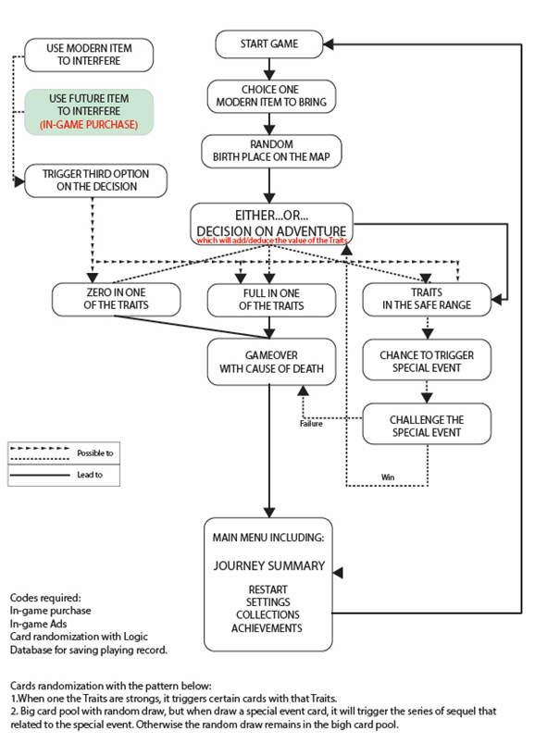

**WHY DOES THE PUBLIC WANT TO PLAY THIS GAME?**

|  |  |
| --- | --- |
| Short playing time | It doesn’t require actual sit down and play for an entire day to feel satisfied to the game. Just use some fragment moments of time on your life, you can get fun of RPG really fast. |
| Brain Teaser | Player needs to choose their routes/decisions on the adventure, and those choices will have consequence, changing the life fractions. And that is something player needs to balance in order to keep rolling on the game. |
| Popular genre | Medieval Fantasy, Visual Novel, Adventure |
| Proven market | Until Dawn, Reigns, Skyrim, Dragon age, The Bard’s Tale, 80days |

**WHY DOES THIS GAME NEED TO BE MADE?**

According to our online digging, there are not so many similar mobile game for this type of genre. And, a similar successful product Reigns by DigitalDev that related to our project has prove the market has great potential to consume the type of game we are making.

**WORK SCHEDULE**

Project Month Targets

|  |  |
| --- | --- |
| Feb (二月) | Game Design Document,  Work Schedule,  Fraction Rules,  Programming Hierarchy Chart, |
| Mar (三月) | Fraction Rules,  Lean Canvas,  High Level Visual Concept,  Art Direction,  World map concept,  Story Cards Art,  Story Card Design, |
| Apr (四月) | Story Cards Art,  Story Cards Design,  Gameplay mockups, |
| May (五月) | Story Cards Art,  Story Cards Design,  Integrate Gameplay mockups to Unity  Website (team background, project dev story) |
| Jun (六月) | Register Company,  Investor Slides,  Approach Investors, |

Team Members

|  |  |
| --- | --- |
| **Name** | **Position** |
| Kun Li | Design and Produce |
| Ziming Huang | Art & Design |
| Mikko Torvinen | Lead Art |
| Alex Ferrer | Marketing |
| Tzu Hsun Kao | Programming Consultant |