Integrated Managed Infrastructure

<Insert Customer Name>
Monthly Capacity Analysis Report-Platform

Period Covered: Month, 20XX
Date Issued: xxx

Authors: xxx

Document Overview Information

Revision History
Revision Number | Revision Date | Summary of Changes

Document Review and Approval
This document has been reviewed by:
Title | Name | E-mail ID

This document has been approved by:

Title | Name | E-mail ID
Distribution
This document has been distributed to:

Name | Company

Table of Contents
1. Introduction and Objectives 1
1.1. Data Collection Method 1
2. Current Environment 2
2.1. Scope 2
2.2. Architecture Overview 2
3. Data Collection 3
3.1. Inventory Analytics 3
3.2. Capacity Utilisation 4
3.3. Disk Space Utilization 6
3.4. Utilization Trends 7
4. Incidents Reported 8
5. Observations and Recommendations 9
Appendix 10
Detailed Utilization Charts 10

Introduction and Objectives

Data Collection Method

Data collection methods included:
- Initial server details were provided by XXXX Xxxx from its Configuration Management Database (CMDB) and from an export of the names in various Windows Active Directory domains.
- Application to Server mapping was done based on application data gathered during workshops with various application teams.
- The CiRBA toolset was used to verify the inventory of servers in the network and to collect detail server configuration and utilization information for Windows servers
- The server utilization data was collected for a period spanning 11 days (12th March till 23rd March 2010).
- Workshops were used to capture information about XXXX Xxxx organization & IT strategy, infrastructure, applications, storage; XXXX Xxxx preferences on Virtualization consolidation options, principles & parameters; and clarifications of questions arising from initial analysis of the server inventory

Current Environment

Scope

<Insert list of Inventory in-scope under IMI>
Server Name | Type | Location | IMI Service Type (Monitoring/Management/Advanced Management) | Additional Services (Base/Advanced Reporting)
Table 1: Inventory

Architecture Overview
<Insert Architecture Overview for Customers Environment>

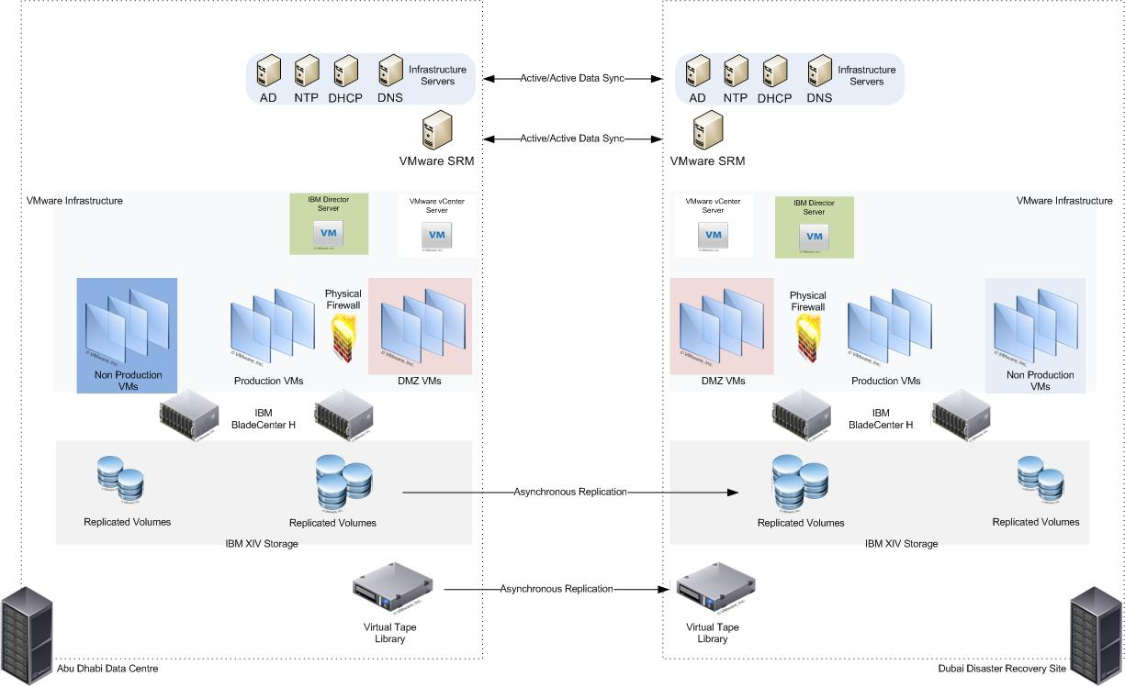
Figure 1: Architecture Overview

Data Collection

Inventory Analytics

The graph in Figure 2 shows the distribution of the current servers by operating system.

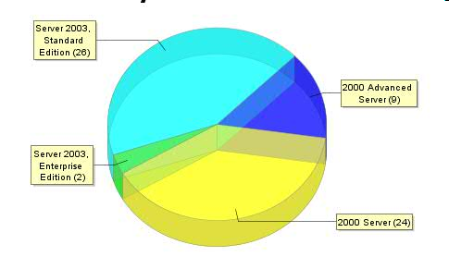
Figure 2: Server distribution by operating system

Majority of servers are Windows 2000 Servers.

The following graph shows the server distribution by the number of CPU’s

. 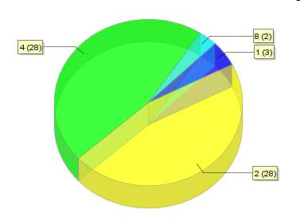

Figure 3: Servers by CPU Cores
28 servers have 4 CPU cores .Same number of servers have 2 CPU cores.

The total memory configuration distributions of the current servers are shown in the following graph. A significant number of servers are configured with 2-4GB of memory.

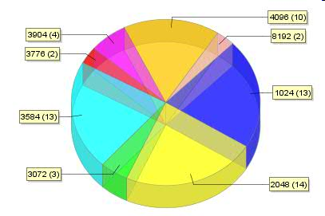

Figure 3: Memory configurations of current server fleet

Capacity Utilisation

The graph in Figure 4 shows the summary of CPU utilizations of in-scope servers based on performance monitoring data gathered. Note that the majority of servers’ CPU resources are under-utilized (average below 15%).

An extract of the key matrices for the server utilization data from the server inventory is given in Appendix A.

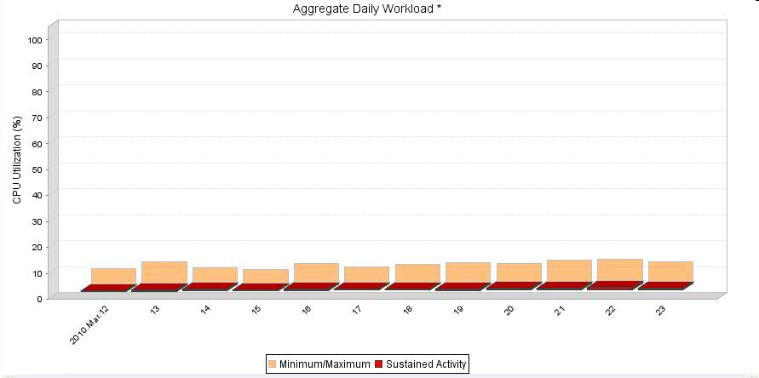
Figure 4: Average CPU utilization

The following graph shows the average memory utilization of the existing servers in scope. Note the memory utilization is relatively low with sustained utilization less than 50%. Need an update based on the current info

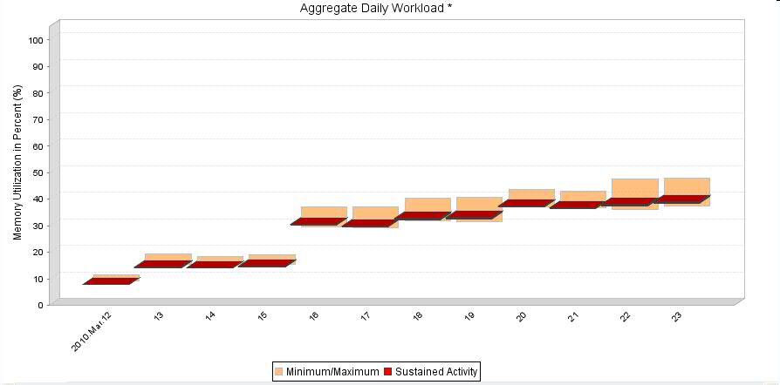
Figure 5: Memory utilization

A summary of Network and Disk I/O utilizations of in-scope servers based on performance monitoring data is shown in the following graphs(Figure 6 and 7). Note that Network utilization peaks are relatively higher at around 150 MBps while sustained activity is less than 5 MBps.
Peak I/O per second (IOPS) are touching a high of 9000. This is an important factor to consider while configuring SAN connectivity.

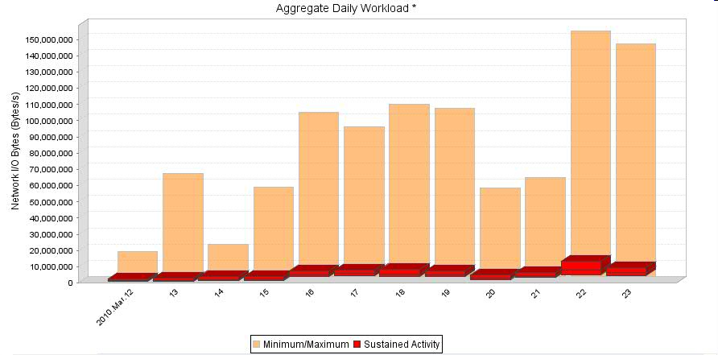
Figure 6: Network Utilization

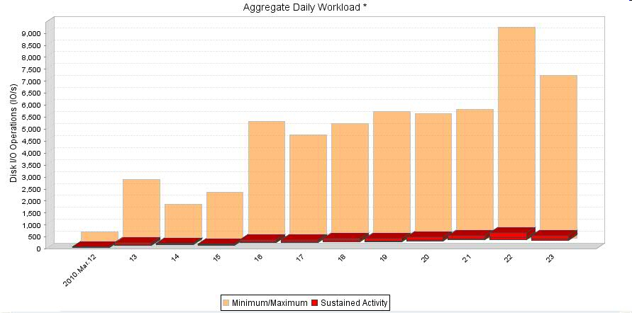

Figure 7: Disk Activity (IOPS)

Disk Space Utilization
Following is the Disk Space Utilization Site Wise for Analyzed servers (Total: 61). Per Server Disk Space Report is available in Appendix C

Drive | Provisioned(in GB) | Percentage Change over last month | Free(in GB)
C: | 900 |  | 529
D; | 1120 |  | 555
E: | 451 |  | 343
Y: | 0.635 |  | 0.626
Table 4: Disk Space Utilization for xxxx
Hewitt Way
Drive | Provisioned(in GB) | Percentage Change over last month | Free(in GB)
C: | 823 |  | 543
D; | 824 |  | 599
S: | 67 |  | 4
Y: | 0.635 |  | 0.626
Table 5: Disk Space Utilization for xxx

Utilization Trends

<Insert past 6 months trend report of Disk Space, CPU, and Memory utilization

Incidents Reported

<Insert a table of incidents reported on in-scope inventory during the reporting period>

Incident/Ticket ID | Severity | Reported/Resolved On | RCA Done? | Remarks

Observations and Recommendations

ID | Observation | Recommendation | Rationale | Impact/Benefit | Approval Details
1 | High Memory Utilization on Web Servers(Server :XX,YY) during Weekends/Holidays | Increase memory allocated to the VMware Resource Pool – Web Servers and also increase memory allocated to the Web server VMs. | Increasing memory in WebServer Resource pool would allow these applications to draw more memory when required on weekends. During weekdays the extra memory allocated is used by other VMs from the pool. | Dedicating extra memory for these VMs would have led to wastage of the memory resources during non-peak load. Allocating memory to resource pool would lead to sharing of memory resources during non-peak periods. | Approved by: <Insert Client’s approver name>  Insert Implementation Change Details

Appendix

Detailed Utilization Charts

<Insert Per Server Charts>
CPU
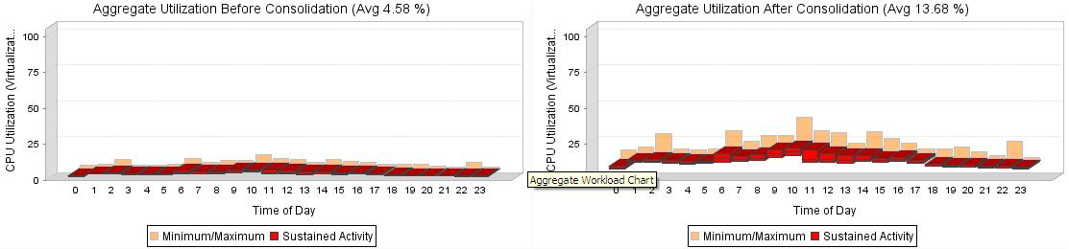

Figure 15: CPU Utilization

IOPS

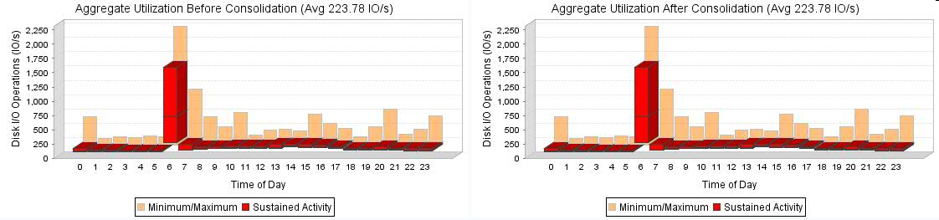
Figure 16: IOPS

Memory
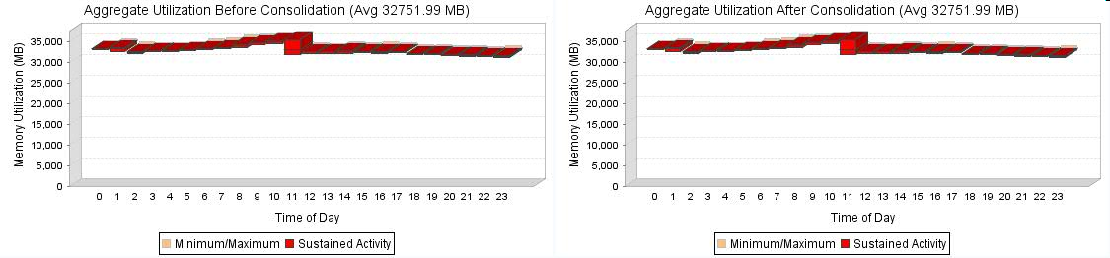
Figure 17: Memory Utilization

End of document

